* **How to Use the Expense Entry Feature**

1. Overview

Entering an expense brings the reality of actual spending into the user’s desired budget. Furthermore, entering expenses naturally incentivizes reduced spending.

For expense recording, a user has two options including typing and photographing a receipt. The steps to accomplish both are detailed below.

1. How to Enter an Expense
   1. Step 1 - As seen in **Figure 1**, a user can click on Record Expenses in the menu shown in on the left side of the screen.

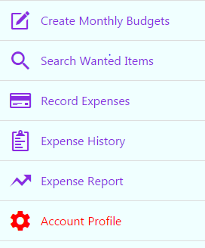

**Figure 1**. Application Menu

* 1. Step 2 – As seen in **Figure 2**, the user can type an expense manually selecting a category, typing the total spend, entering a vendor, selecting a date, and clicking submit. For added convenience, a user can take a photo of the receipt and have the information scanned automatically. When entering an amount, the user is protected from typos by being restricted from entering huge positive or negative numbers. Today’s date is also entered by default.

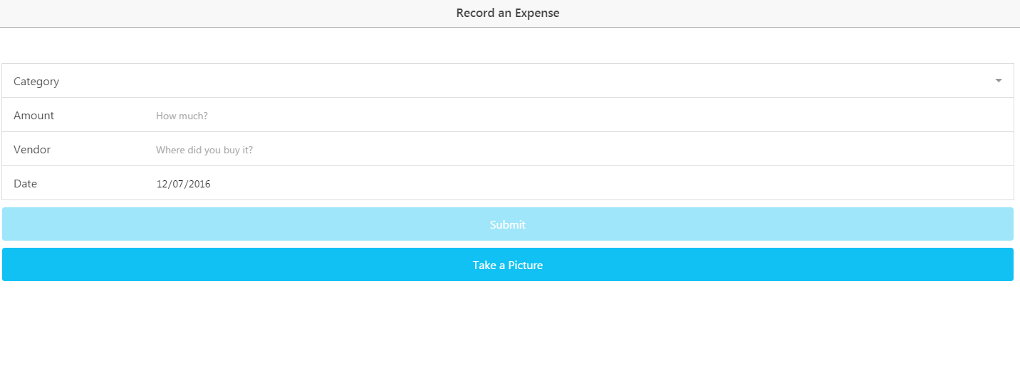

**Figure 2**. Type Expense

* 1. Step 3 – As seen in **Figure 3**, the will next see a confirmation screen with the information typed or scanned from the receipt. The user gets a final chance to check the info before clicking submit to send the data to the online storage of expense history. If the user scanned a receipt, they should see information for all of the fields except category which they will still have to select manually.

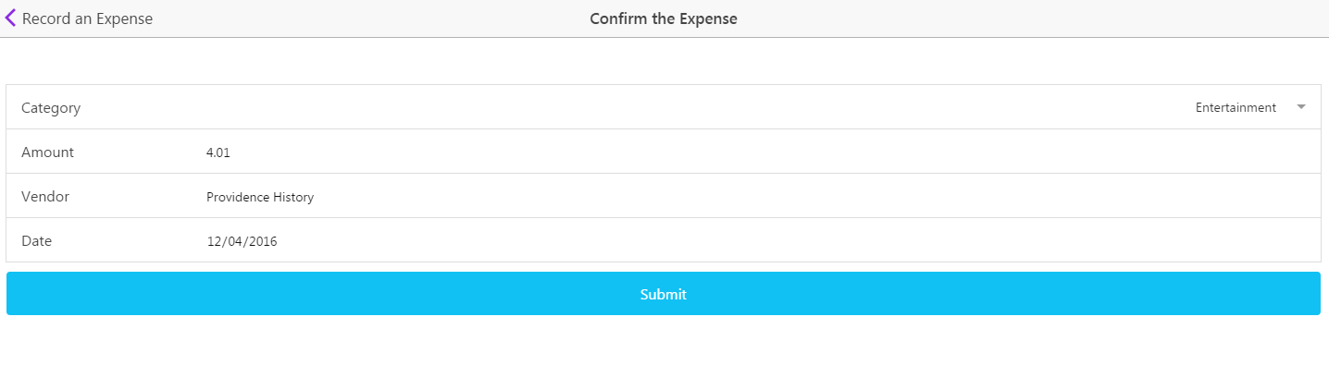

**Figure 3**. Confirm the Expense

* 1. Step 4 – Give yourself a high five for entering an expense. As seen in **Figure 4**, you can choose to enter another expense or go back to the home screen.

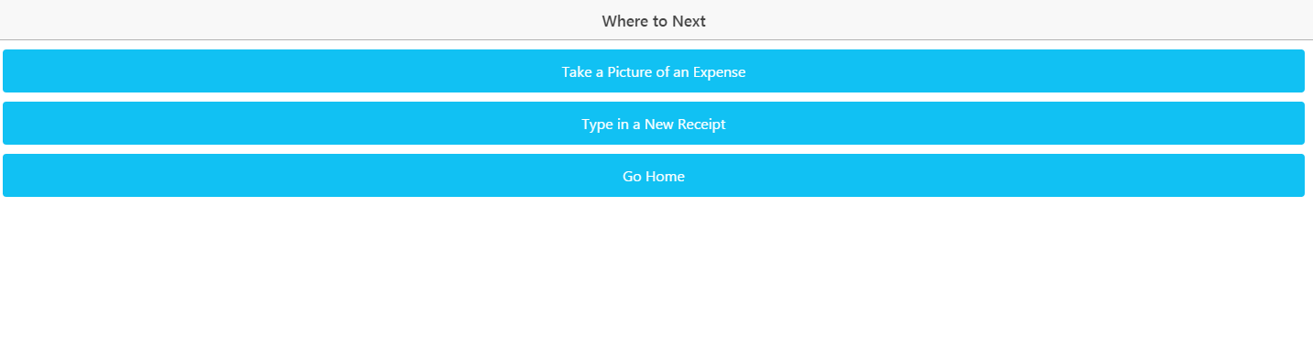

**Figure 4**. Where to Next?

* **Sample Interaction**

1. Overview

Below is a sample set of steps by the user for entering an expense along with what the user would see in the application

1. Example of Entering an Expense
   1. Step 1 - As seen in **Figure 1**, a user opens the left panel and clicks Record Expense



**Figure 1**. Application Menu

* 1. Step 2 – As seen in **Figure 2**, the user can type or photograph their expense. If taking a photo, the application takes the first line of text and sets it as the Vendor along with removing any “Welcome to” statements. For the date, the application looks for a set of numbers which have “/” or “-“ separating them in a standard date format. Finally, the total is smartly found on the receipt using a proximity



**Figure 2**. Type Expense

* 1. Step 3 – As seen in **Figure 3**, the user has a chance to see their data scanned or typed and corrected errors before a final submission. The scanning feature does not select a category for the user so they will have to select a category before the final submission. If the photo quality is poor, the user may have to correct the text before submission.



**Figure 3**. Confirm the Expense

* 1. Step 4 –. As seen in **Figure 4**, the user can enter another expense or go home.



**Figure 4**. Where to Next?

* **Error Handling**

1. Entering Expense Errors

The expense entry portion has a number of features to help a user handle errors. As seen in **Table 1**, a list is below with the corresponding error correction.

|  |  |  |  |
| --- | --- | --- | --- |
|  | **Error** | **System Response** | **Error Code #** |
| 1. | Incomplete Form | System Blocks Submission for an incomplete form. When a user touches a field and does not enter info a warning is displayed below the field |  |
| 2. | Unrealistic Dates and Years | Years longer than 1 year before the current date and 3 years after are not allows as input on the form. Amounts over +/- $10,000 are also blocked |  |
| 3. | Unavailable Session Storage | System checks for system storage and throws an Error #1 message. If seen, the user may need to update their operating system. | 1 |
| 4. | MongoDB Connection Error | System throws Error #2. Warning about the connection error. Typically getting internet access resolves the issue | 2 |
| 5. | Google Vision Connection Error | System throws Error #3. Warning about the connection error. Typically getting internet access resolves the issue | 3 |
| 6. | Write File Error | System throws Error #4. Typically granting file write permissions on the phone security prompt will fix the issue | 4 |
| 7. | Camera Error | System throws Error #5. If a camera exists on the phone, granting camera access on the security prompt should fix the error | 5 |
| 8. | Inaccurate Scanned Text | Low photo quality can cause the text read by Google Vision to appear scrambled on the confirmation screen. The user can either correct the info manually or take another picture with better lighting and a smoothed out receipt |  |

**Table 1**. Error Handling

* **Known Issues**

1. Entering Expense Known Issues

The expense entry portion has several known issues. With the limited development time and lack of experience coding Machine Learning Algorithms, the software has several limitations in what it can accomplish. As seen in **Table 2**, a list is below of the known limitations and their potential solutions.

|  |  |  |
| --- | --- | --- |
|  | **Limitation** | **Possible Solution** |
| 1. | Category Not Selected Automatically by Receipt Scan | After building a large collection of expense data, the information could be used to find correlations between Vendor Names and selected categories which could be used to predict future categories |
| 2. | Vendor Name Must be in Receipts First Line | The software looks for the vendor in the first line of a receipt while also removing a welcome statement. Once a large dataset has been created, receipt names placed elsewhere could be found by referencing a large list of known vendors in the collection. |
| 3. | Dates written as words not detected | Software only detects numerical dates delimited by “/” or “-“. Adding code to find the text of a month, the dates could be detected. |
| 4. | Poor Quality Photo Returns Incoherent Text | Although the code can clean up some text errors, a wrinkled or low light receipt returns text with many innacuracies. Using Machine Learning with a more robust language such as Java or C++ the software could learn from user responses to the error and predict the correct text despite the error |
| 5. | Internet Connection Warning Incomplete | The receipt scanning was moved from being a controller to a service. Afterwards, a lack of internet connection does not throw a proper error. A solution is to check for internet connectivity and warn the user before a photo is taken |

**Table 2**. Error Handling