2. Architecture Diagram/Sequence Diagram/Class Diagram

Software architecture is defined by New York University (NYU) as the structure of structures for a system[6]. The diagram outlines a top level view of key systems utilized such as software frameworks and API services with basic connections on how they interact.

For the *Pocket Manager* system, the architecture covers the native application, phone hardware, API services, and remote database. Ionic was the selected Framework for the native application which uses HTML5 and AngularJS to build Hybrid Applications. Major functions include the login, budget creation, scanning receipts, recording payments, fetching statistics, graphing, and budget creation. Besides hosting the actual application, the phone provides camera, screen, and data connection. Google Vision provides a text reading capability for the receipt scanning feature. For assistance categorizing transactions several APIs are being considered including Ebay. The marketing data for an item can provide valuable information on how it will be utilized by the customer and how necessary the item is to their budget. Utilization will depend on what specific algorithm is selected for categorizing an expense as a luxury or necessity and how much of the data processing is conducted within the native application. For the data storage Mongo DB will hold user statistics and budgets. Mongo DB is a free and open source database system which is considered NoSQL and relies on JSON and documents instead of tables for its structure. The system architecture is shown below in Figure 14.

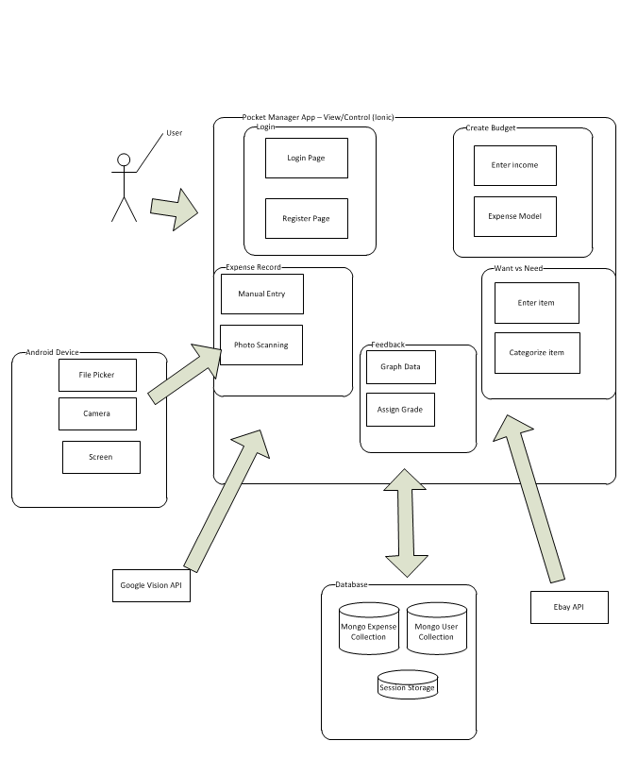

**Figure 14**. System architectural designation of the *Pocket Manager* to be developed.

* **Testing**

1. Overview

Testing of the application involved a multi-step process including pre-submission audit, unit testing, speed testing, virtual device testing, and physical device test. The process was designed to find problems in both the design of the code and features of the application.

1. Coding Audit

The following checklist is run on code at the start of testing in order to find errors early in the process and make it easy to find the root cause of a bug. The list must be completed by a group member before the coding submission is considered complete.

For the pre-submission audit, several checklists were developed to check the quality of code. The first section deals with the commenting and readability of the code. Code with clear formatting allows for easier troubleshooting and makes it easier for other users to modify code. For outside auditing and grading, clear formatting is a critical part of making it possible for outside parties to provide feedback. As a result, checking the format and documentation of code is a significant section of testing process.

If any software bugs or potential enhancements were uncovered before the submission, a description was posted as an issue. The team leader could determine how to resolve the issue by using any of the following options including accept the risk, assign someone to fix the issue, or seek outside help. Table 17 is the result of the coding audit for our system.

**Table 17**. Coding audit checklist for the *Pocket Manager* system.

|  |  |  |
| --- | --- | --- |
| **Item** | **Question/Comments** | **Response** |
| a. | Does every section have at least one comment? (about one comment for every four lines of Java/JavaScript or one for every major section of html) | More comments are needed in code, not enough for other developers to follow |
| b. | Is the code neat? (not too many blank lines) | Yes |
| c. | Is proper spelling and grammar used? | Yes |

|  |  |  |
| --- | --- | --- |
| **Item** | **Code** | **Response** |
| d. | Is the proper indentation used? | Yes |
| e. | Are variable and function names meaningful? | Yes |
| f. | Is major functionality subdivided logically into classes and activities? | Yes |
| g. | Is camel case used for functions and variables? | No, need standardization of variables |

|  |  |  |
| --- | --- | --- |
| **Item** | **Feedback** | **Response** |
| a. | Were major issues submitted to GitHub? | No major issues |
| b. | Do you have any major concerns about your code? | Lack of Standardization |

1. Unit Tests

Unit testing were tested by building small snippets of code to test sample inputs against expected outputs. Several areas were tested including the receipt recording section. The tests focused on the expense recording via camera feature which was one of the primary developed functions for this increment. The feature provides a convenient and fast way for students to record their expense.

* 1. Unit Test 1 – Upload Photo (**Figure 1)**

**Figure 1**. Take Picture Unit Test

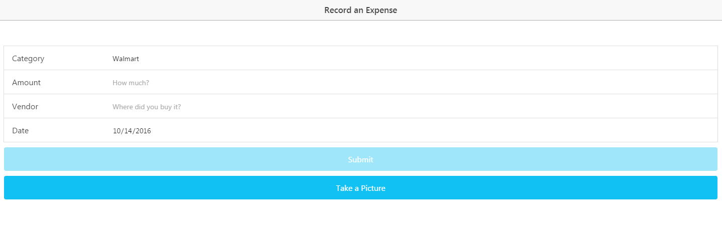

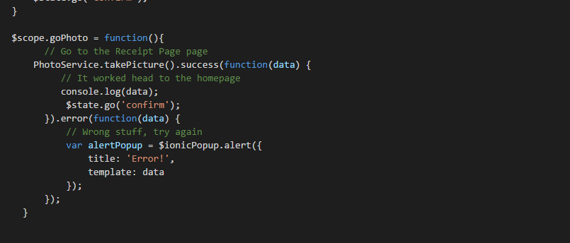

The first test looked at uploading an expense picture to Google Vision to extract the text. Even with Cordova camera, the take picture functionality was not sending data correctly to Google Vision. The issue was resolved by adding appropriate header info and sending the file using Cordova File Transfer. The final solution was developed as a service so it could be accessible by multiple constrollers.

* 1. Unit Test 2 – Extract Date from Text (**Figure 2)**

**Figure 2**. Valid Date Unit Test

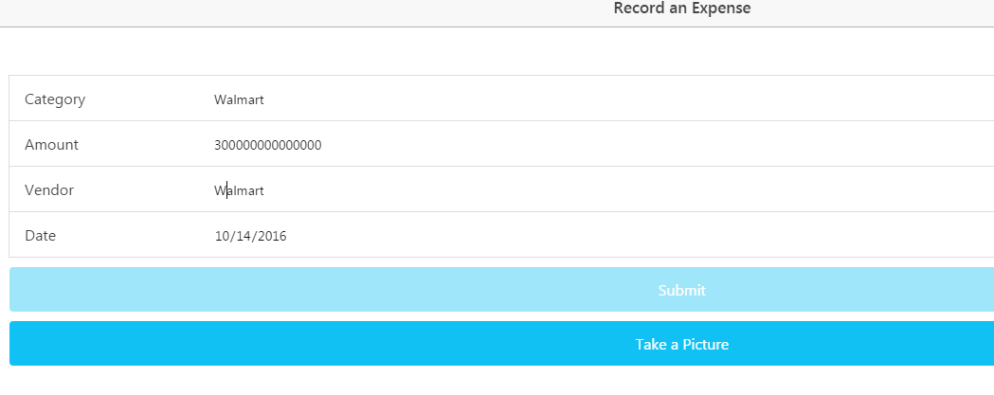

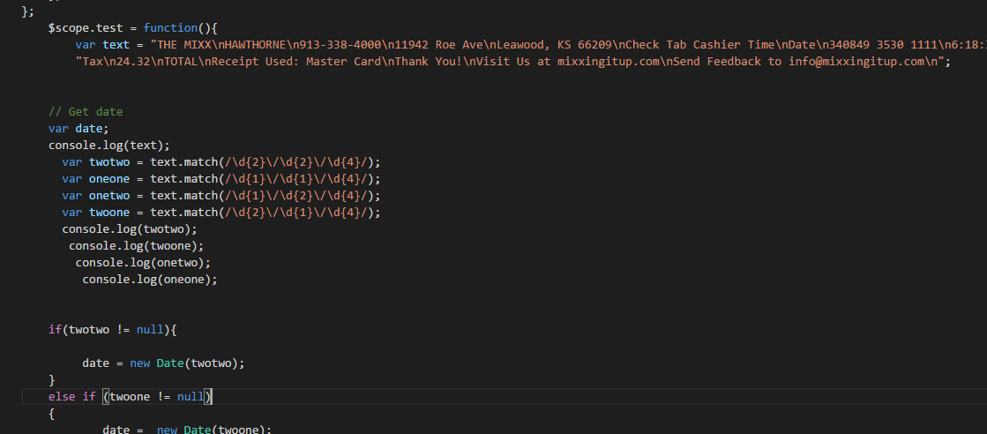

The second test examined the parsing of data successfully extracted from a receipt photo. The data is returned in JSON as a long string and the date was not easily accessible resulting in today’s date being selected by default. After the test initially failed, the text was extracted from a wide variety of receipts using a test environment and Google Vision. The text was stored in a document called Receipt Texts for Tests. Later the text was used in a test function where the vast majority of dates were found to have four digit years, use the mm/dd/yyyy format, and have ‘/’ as the delimeter. As a result, searching for the following patterns found most dates in the text including: mm/dd/yyyy, m/dd/yyyy, mm/d/yyyy, or m/d/yyyy.

* 1. Unit Test 3 – Vendor name (**Figure 3)**

**Figure 3**. Valid Date Unit Test

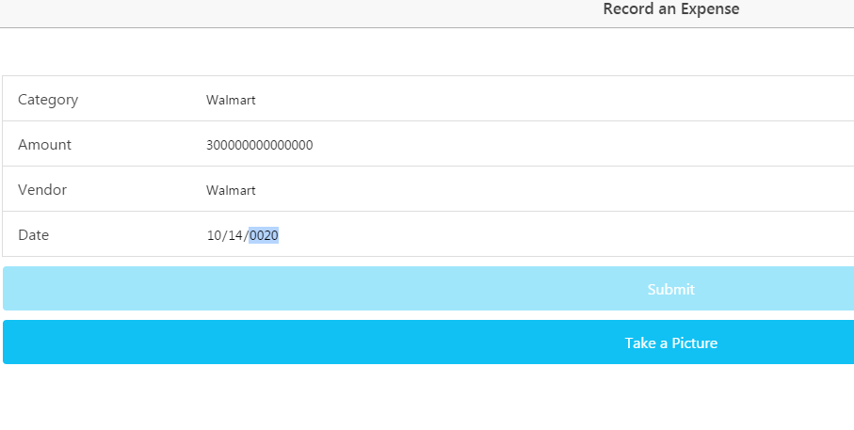

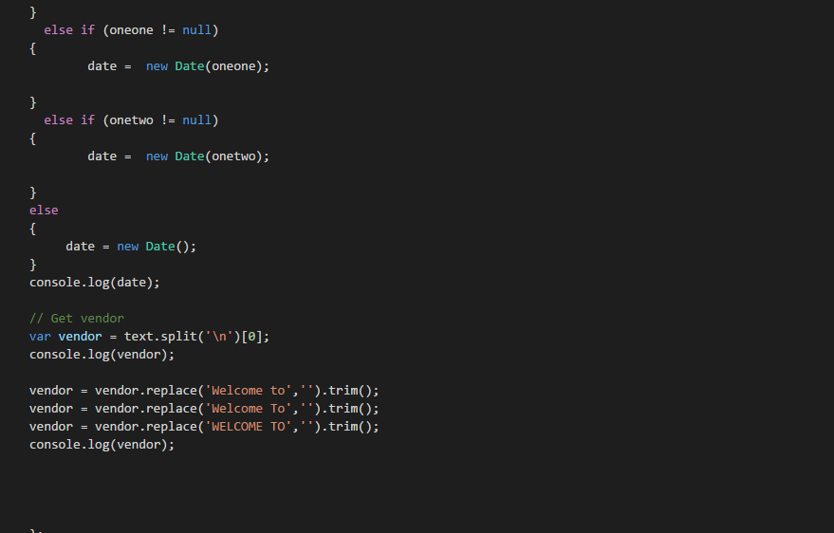

The final tests examined how to find the vendor name in the receipt text from Google Vision. As with the date, Google Vision’s deciphering of text from a large number of receipts was read and saved to a file. Using the text in a test environment, a pattern in Vendor names was discovered. Typically, the Vendor name was found in the first line of the receipt. In some cases, the name was preceded by Welcome to. By taking text up to the first “/n” and removing any “Welcome to” the Vendor name was successfully found. One case that continued to fail is if the Logo was read by Google Vision as garbled text. Future development can look at how to remove any text from the logo before searching for the vendor name.

1. Speed Tests (**Figure 4-5)**

The performance of a loading page can have a major effect on site traffic and usage. Poor performance can cause users to avoid a site or application. In addition, loading issues can increase support requests and result in poor app reviews. Since site and app visits can result in add revenue and perform user statistics which can be sold to various companies, page performance is critical to profitability.

Performance testing of page loads was completed using YSlow embedded into Google Chrome. The page is currently hosted locally and run out of the Ionic Framework. Since most pages scored very similar results, below are two samples of speed tests. For the next increment, we plan to look for a way to conduct speed tests on the App when it is loaded into a phone. Due to the Ionic Environment, current speed tests appear to highlight issues outside of our ability to optimize.

**Figure 4**. Home Page Speed Test

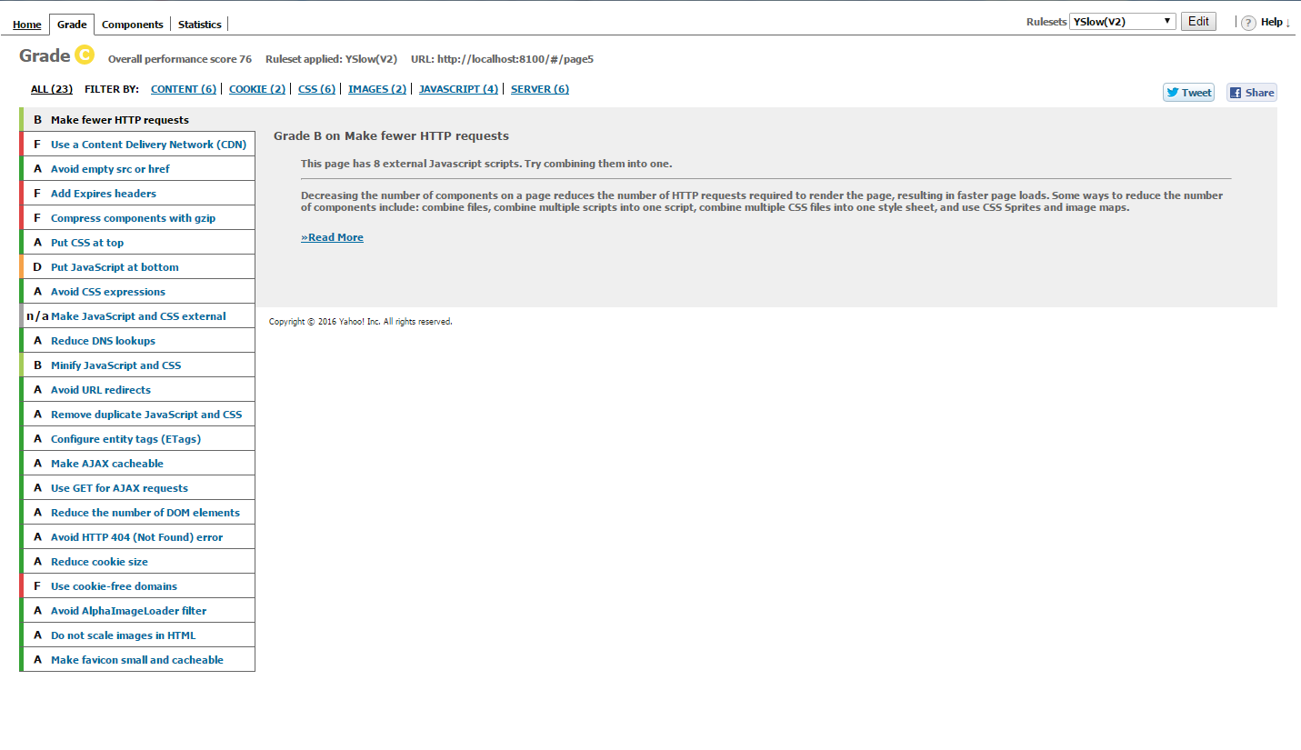

**Figure 5**. Rec Record Speed Test.

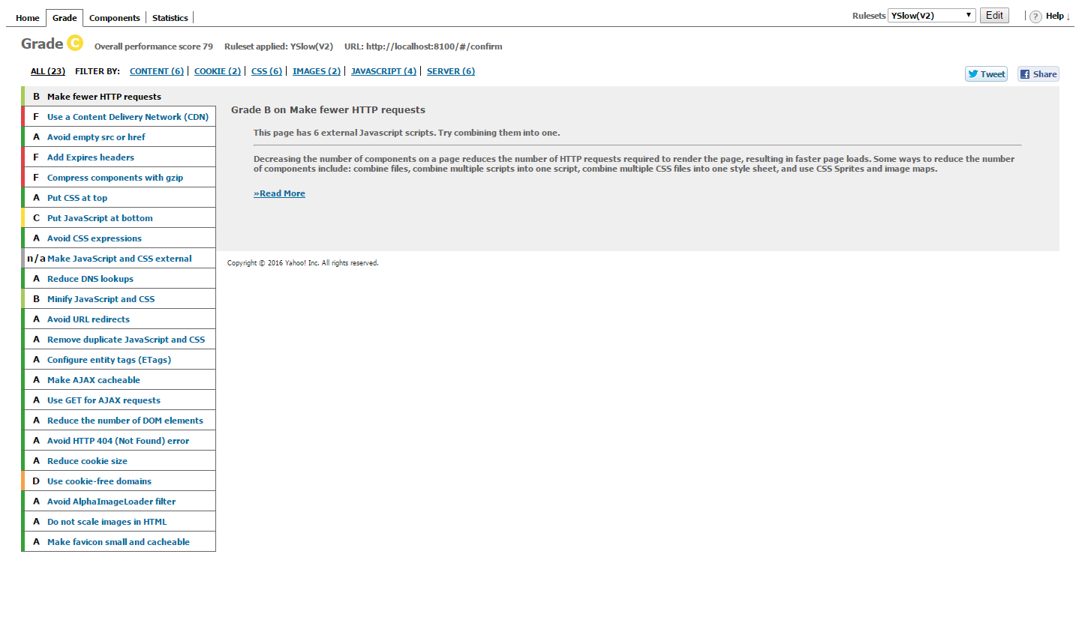

Overall speed tests averaged approx. 77 percent. Typically, fifteen areas received an ‘A’ rating. Of the poorly rated areas, most were due to the Ionic Framework or locally hosted pages. The moving JavaScript to the end of a page is an example of Ionic’s already separated application scripts being rated rated poorly. Furthermore, recommendations for Cookie Free Domains and Content Delivery Networks appear to be a byproduct of testing locally on a computer. Overall, it appears that the Ionic Framework creates a powerful hybrid application that comes with some inherit performance loss and that certain performance issues may remain until the application services are fully hosted remotely.

1. Virtual Device Test

At least two different virtual environments were used in testing

1. Android Studio Virtual Device
2. Gennymotion Virtual Device

Android Studio’s virtual device was utilized due to its close connection with Ionic. Unfortunately, it also had issues with slowing down the workstation and becoming time consuming. As a result, there was a natural incentive against exploratory testing. As a result, Gennymotion was also utilized due to its reputation for faster performance and its versatility. Special thanks goes to Dayu for purchasing the account with his own funds. (over $100)

The checklist focused on giving some broad guidelines to the exploratory approach and has two major sections. The first part covers the user interface or the look and feel of the application. The detailed evaluation is designed to insure that the basic rules of good user interface are designed. Since developers may become highly engrossed is their work, certain obvious problems may be missed due to familiarity with the work. As a result, the below checklist forces developers to check each other’s work in detail in order to catch mistakes before the software is deployed and in user hands.

The next major section involves the functionality of the application. Any new feature or modified area should be tested. In addition, the existing features should be tested to confirm that changes did not negatively affect existing functionality. Finally, the transition between major device states is tested. For example, the app can be exited and restarted to confirm no functionality is lost when reopened. In addition, the device can be restarted to confirm that the application still functions. See Table 18 for the details of our analytical results.

**Table 18**. Exploratory Testing Checklist.

|  |  |  |
| --- | --- | --- |
| **Item** | **User Interface** | **Response** |
| a. | Visibility – Are all parts of the initial page visible? | Yes, all are visible |
| b. | Alignment – Does the alignments of parts look correct? | Yes |
| c. | Color – Do the colors appear as expected? | Yes |
| d. | Screen Changes – Does the page look correct from both screen orientations? | This will be more of an issue in future increments when more buttons are on the screen |
| e. | Keyboard – Can the app features still be used if the virtual keyboard pops up? | Same as above |

|  |  |  |
| --- | --- | --- |
| **Item** | **Features** | **Response** |
| f. | Do all new features work as expected? | Yes, |
| g. | Do existing features still work? | Yes, except the user interface changed from last submission |

|  |  |  |
| --- | --- | --- |
| **Item** | **Transitions** | **Response** |
| i. | Does the app work if someone exits then opens the app again? | Yes |
| j. | Does the phone function is the app has been running for over five minutes? (test of memory leeks) | Yes |

Due to the late stage in development, the testing focused more on testing the code on a tablet instead of a virtual device. The Live Reload feature in Ionic allowed for changes to code to be tested quickly.

1. Physical Testing and User Feedback

Physical testing involves adding the app to a physical device, showing potential users, collecting feedback to utilize in future increments.

As a primary test device, we are using an Android 6 tablet in Portrait mode and an eight inch screen. The larger device makes it easier to see details of the application and evaluate behavior in depth.

The user feedback was obtained from three people with a variety of technical experience. The goal was to obtain objective feedback on the application which caught errors missed by the previous checklists and provided ideas for new features and enhancements. The form and summarized user feedback are below. (see Table 19).

**Table 19**. User feedback questions and responses.

|  |  |  |
| --- | --- | --- |
| **Item** | **Question** | **Responses** |
| a. | What do you like about the app? | Simple looks nice |
| b. | What do you dislike? | Home screen issues |
| c. | Any suggested changes? | Add a nicer background, easier navigation |

1. Going Forward

As the software increases in complexity, testing is expected to be a much more important part of the development process. The checklists developed are expected to grow and be utilized by more than one team member. TA Feedback on the process will be a critical component in what direction the testing takes.

Although current testing involved working on each person’s section separately, the final increment is expected to integrate all of the sections of the software together info one application. With the unified application, user testing is planned to give students an end to end view of the application and get their feedback on the entire application.

* **Implementation**

1. Overview

Overall, Pocket Manager uses market tested and solid components for the application implementation. On a high level the application uses a combination of Ionic on the Client side and Mongo to store data on the server side.

1. Mobile Client

On the application side the Ionic Framework was the foundation for the application. Within Ionic, HTML5 was utilized for page views and AngularJS was used for the control mechanisms. The combination created a easy to maintain platform which can interface with hardware on a wide variety of devices without having to maintain a complex set of Android libraries. Since only a few hardware components are expected to be utilized, the hybrid application allows the application to run on Android and iOS with one core set of code controlling the app.

For adding hardware interfaces, the NPM and Cordova were utilized. The camera is currently used for taking pictures of receipts. In the next increment the gallery file picker is expected to be added as an alternative to the camera.

1. Database

On the server side, Mongo was selected for the database with mLabs as the host. mLabs provided free storage for our application and the Mongo provides better performance than a traditional relational database. In addition, app development experts recommended using Mongo over other storage options such as Firebase due to the flexibility. Finally, Mongo supports simple REST requests to an API allowing us to start the application with easy to maintain and troubleshoot interfaces.

Our Mongo database on mLabs has the following connection information. (**Table 4)** Initially, one collection was configured to collect receipt information.

**Table 4.** Mongo Database Info

API - <https://api.mlab.com/api/1/databases/pocket_manager/collections/>

Collection - pocket_manager/

ApiKey - Omq-HhXv0WUnDNEVey9TQdBhsEEFDtHo

Session storage was also utilized for the initial expense collection to improve performance by minimizing the number of REST requests. In addition, the session storage allows information to be save in case the data connection is lost. Finally, the session storage gives the user a chance to confirm the information before it is sent to the database.

1. Services

Google Vision was utilized to read information from receipt pictures.

1. Going Forward

Long-term, Ionic will continue to be the application framework. An additional Mongo collection for user logins is expected to be added. Finally, Google Sign In may be utilized to keep the user from having to remember too many sets of login credentials.

* **Deployment**

1. Overview

Deployment includes leading the app onto devices, taking screenshots with detailed descriptions, and creating a wiki in GitHub. The overall purpose of the section of the process is to deliver the completed application to market (or in the case of the third increment, the teachers). With the fast pace of technology and the high cost associated with employing highly skilled developers, delivering a product early is critical for a technology startup. Deployment moves the application from the developer world to the real world of users. Both data and revenue from customers can be obtained providing critical fuel for future increments.

The deployment of Pocket Manager’s third increment focused enhancing each major application tab’s functionality. The improvements focused on a login page, registration page, wants differentiation page, budget creation, and expense recording.

1. Screenshots

Below are the primary screenshots for the application along with the detailed descriptions.

1. Login Screen (Figure 20)

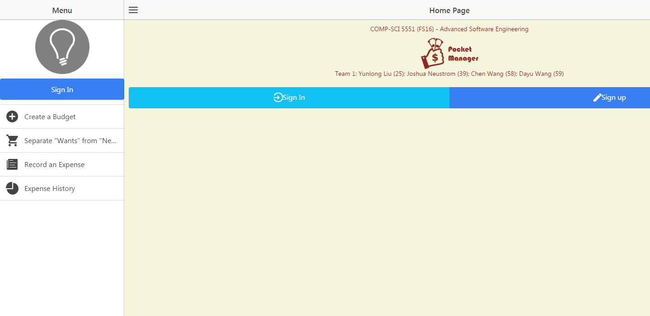

**Figure 20**. Login screen.

The initial login screen provides the users first interaction with the application. A basic username and password is requested from the user which is sent to a Mongo DB collection to see if the credentials are valid. If the combination is not valid, the user is warned and prompted again. If the combination is valid, the user is brought to the main welcome page.

For branding purposes, the Pocket Manager logo is central to the page creating a visual association in the users mind. The logo also allows for a user to know if they are using the real Pocket Manager Application.

At the head of the page is the basic group information. Although such information would be unlikely to be included in a real world app in the Android market, the title was included to help the graders and teachers easily identify the project and members.

If the user does not have an account, they can select the registration link.

Going forward, new features are expected to be added such as request help and Google Single Sign On buttons.

1. Main Menu (Figure 21)



**Figure 21**. Main Menu Screen.

The main menu screen provides the user with access to all of the main features of the application and serves as a one stop shop for the user. At the top of the list is a button for budget creation which allows a user to create a budget for spending including the top level categories of transactions and the max spending each area. Further down, a button exists for query of an item to see if the item is a luxury or necessity. The function is the key advantage of the Pocket Manager which allows a user to cut spending by having an outside source label the potential purchase as a luxury if it is not truly needed for the budget. Continuing down the list, the screen has a button for adding actual expenses in the context of what was originally budgeted. The bottom button takes the user to a big picture view of their transaction history to allow them to understand their spending habits and success in meeting the budget over the long term.

The overall look and feel from the initial login page was maintained in the main menu section to create a consistent interface for the user. Buttons respond in a similar manner with two arrows appearing when touched or hovered over by the user. Furthermore, the key project information is kept on the title section of the page.

1. Create a Budget (Figure 22)
2. 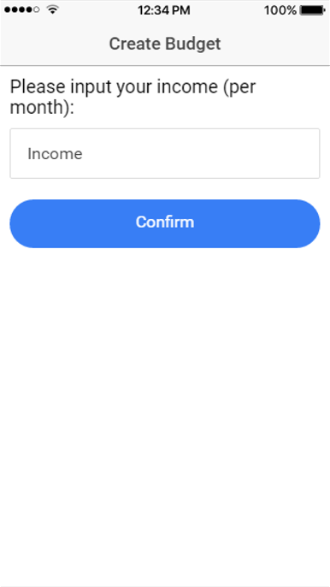 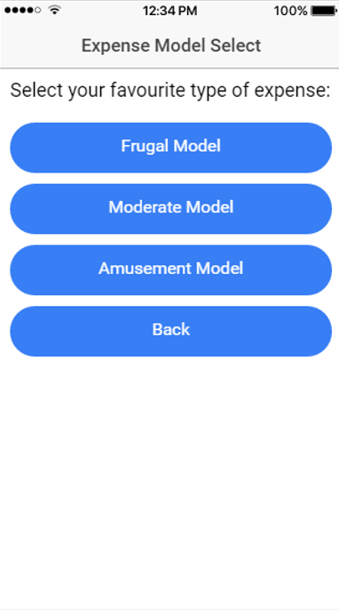

**Figure 22**. Budget Creation.

Budget creation creates broad categories to characterize expenses being recorded and sets spending thresholds for the user. By breaking down the expenses into individual categories, the user takes their overall goal in smaller bite size pieces. In addition, the categories provide some additional information that can help to characterize needs vs wants.

The budget allows the user to pick a custom amount of income per based on what the user expects to earn.

For convenience, a user has several models of expenses which can be selected. The models include Frugal, Moderate, and Amusement. Based on the model selected and income entered, a set of expense categories and amounts will be created for the user automatically. The models can help setup the budget for a user that lacks experience in building their own budget.

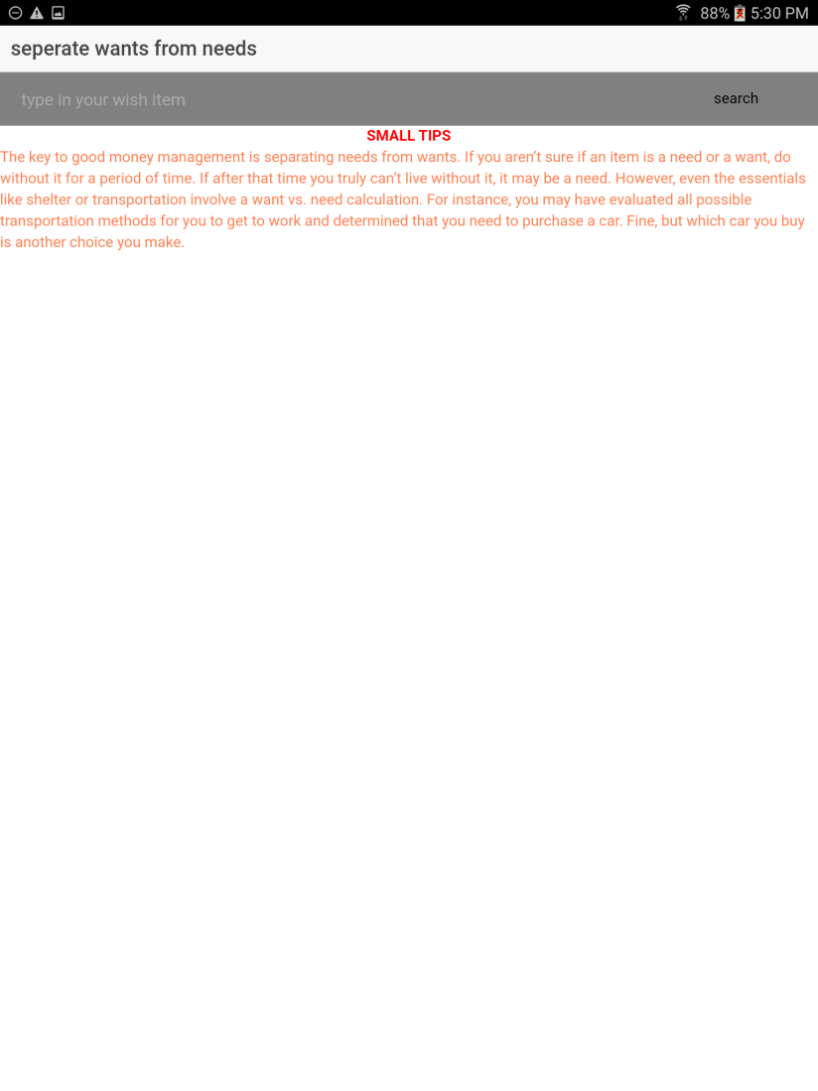

1. Separate Wants from Needs (Figure 23)

**Figure 23**. Wants vs Needs.

The wants vs needs section is one of the true value added aspects of our app which we like to call our secret sauce. Overall, the feature helps the user make smart decisions about spending. A user can submit a potential expense and the system tells them if it truly vital to their student life. The feature can use external APIs such as Ebay in combination with in house code to smartly determine if the user truly needs an item.

The final increment will continue to build on this helpful feature by creating even more intelligent categorizations of a potential expense.

1. Record An Expense (Figure 24 - 26)

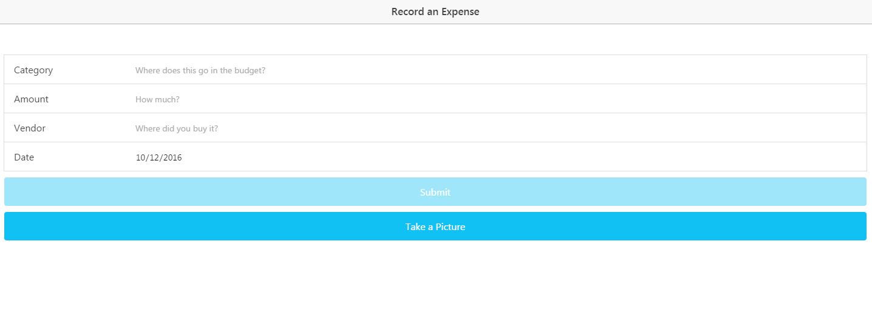

**Figure 24**. Record an Expense.

The initial expense recording page has the option to manually enter on money they have spent including the budget category, amount, vendor, and date. All fields are required and today’s date is populated into the form by default. If any field is touched and left blank, the system will warn the user. Furthermore, the amount field requires a valid number. Both dates and amounts have broad limitations on their allowable entries to protect the user from unintended entries due to the small mobile keyboard. Data from the form is stored locally to speed up performance and allow the data not to be lost if the connection is down.

A user can also take a picture of the receipt and the app will read the text off the image using Google Vision. Afterwards, the software can typically find the date and vendor name in the text and store them in session storage. Afterwards, the user is taken to a form where they can confirm or edit the information before it is sent to mLabs for long-term storage.

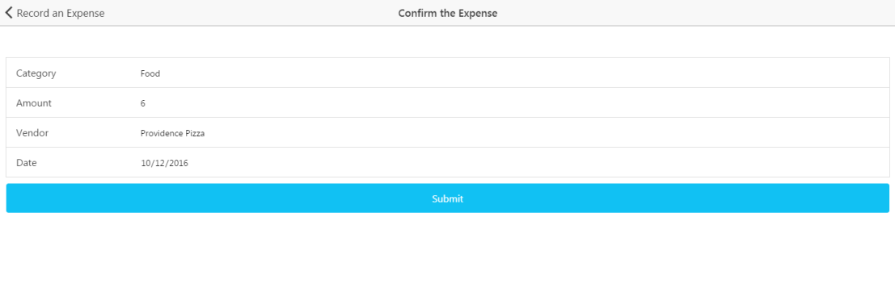

**Figure 25**. Confirm an Expense.

Going forward in increment four, the receipt reading capability via camera is expected to be upgraded so they total and category can be extracted from the text.

The next screen takes a user to a version of the form populated by their entries from the session storage. The check allows users to check data before it is sent to the remote database. The same basic form data checks are implemented from the initial expense screen. Upon submission, the data is sent to a remote Mongo Collection. Within the collection, the data is parsed to a string.

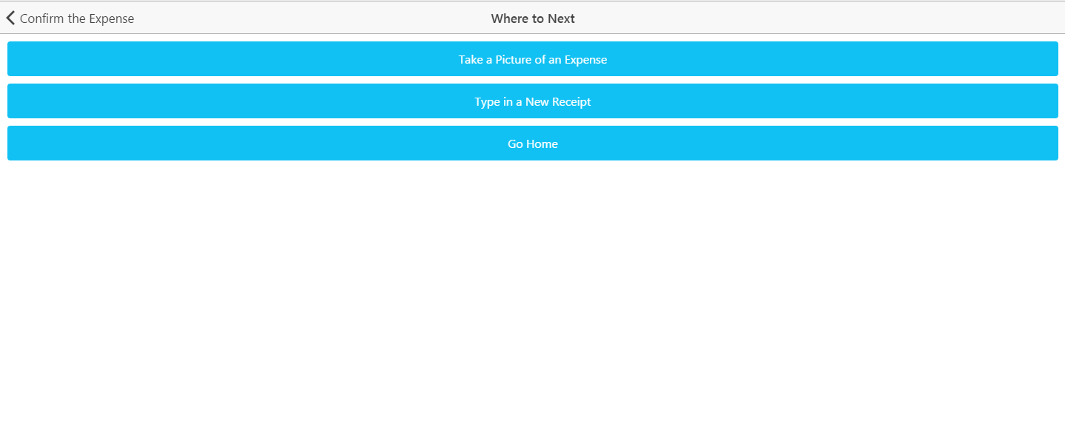

**Figure 26**. Next Expense.

For faster data entry, the user is taken to a screen where they can choose how to enter more data. The user can choose the option of receipt picture or typing an expense. Otherwise, the user can go back to the home screen of the application.

1. Expense History (Figure 27)

**Figure 27**. Expense History.

This section of the application is currently a shell providing a basic user interface with no actual functionality. In future increments, expense data will be added to the database allowing for the creation of both expense monitoring and reporting for the user. This section is planned for the final increment because the expense recording and supporting database were only recently setup.

1. Wiki Page

A Wiki page was created for Increment 3 swhich recursively includes the report. The page allows an outside user to easily understand the deliverable included in our Github source folder. In addition, the GitHub contains a source folder for all finalized code that was part of the deliverables. Furthermore, the main screenshots from the report and a copy off the report istself can also be found in the documentation folder on the GitHub site. Finally, a readme exists in the core section of our repository with the key links and the overall project info.

* Wiki – <https://github.com/dwk894/CS5551FS16_Pocket_Manager/wiki/Increment-3>
* Documentation-<https://github.com/dwk894/CS5551FS16_Pocket_Manager/tree/master/Documentation>
* Source Code - <https://github.com/dwk894/CS5551FS16_Pocket_Manager/tree/master/Source>
* Readme- <https://github.com/dwk894/CS5551FS16_Pocket_Manager/blob/master/README.md>

1. Going Forward

The last increment is expected to focus on integrating the different parts of the application into one unified application providing a seamless experience for the user. Each increment will have a separate Wiki page and the overall source and documentation structure will be maintained.

* **Bibliography**

[1] Project on Student Debt, institution: The Institute for College Access & Success  
<http://ticas.org/posd/map-state-data-2015>

[2] The Take Charge America Institute  
<https://tcainstitute.org>

[3] <https://cloud.google.com/vision>

[4] <https://docs.mongodb.com/manual>

[5] <http://www.highcharts.com/demo>

[6] <http://www.nyu.edu/classes/jcf/g22.3033-007/slides/session2/g22_3033_011_c23.pdf>