COMP-SCI 5551 (FS16) - Advanced Software Engineering

**Tutorial 10 Assignment - Due 11/02/16 by 11:59 PM**

*Dayu Wang (59)*

**Screenshots**

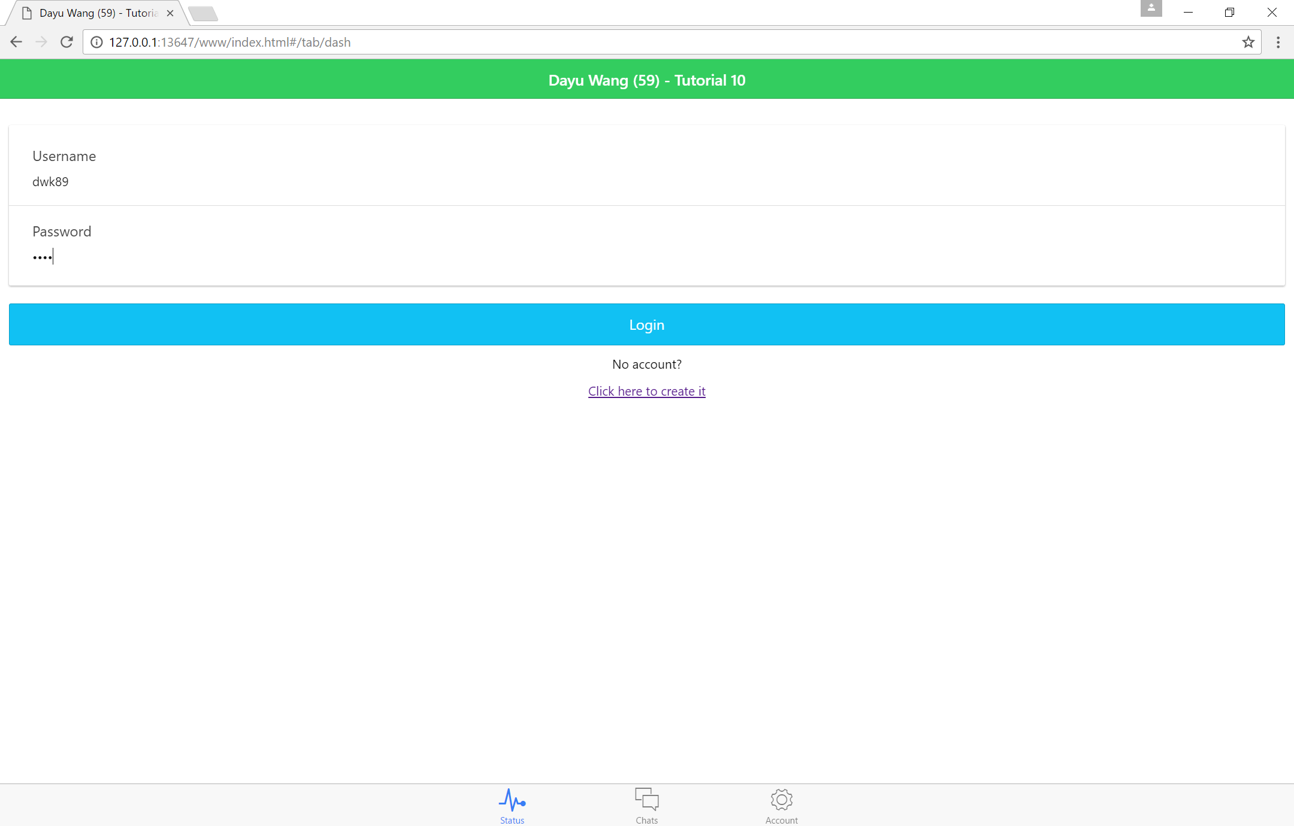

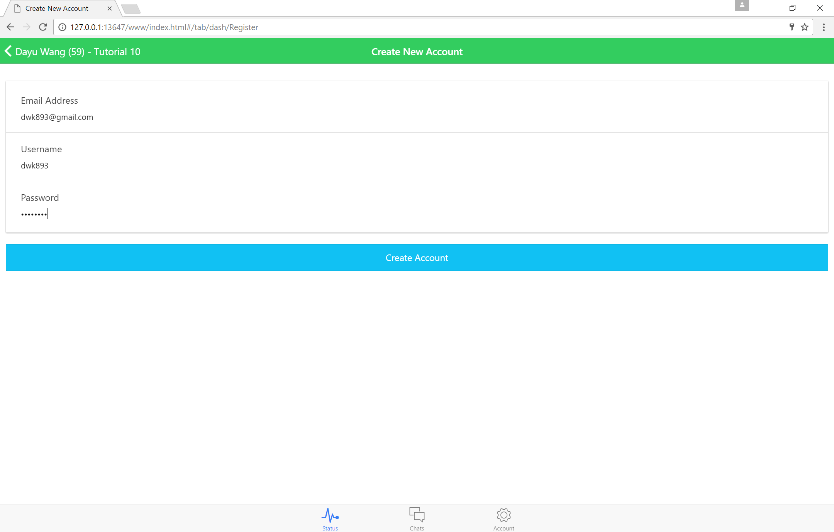

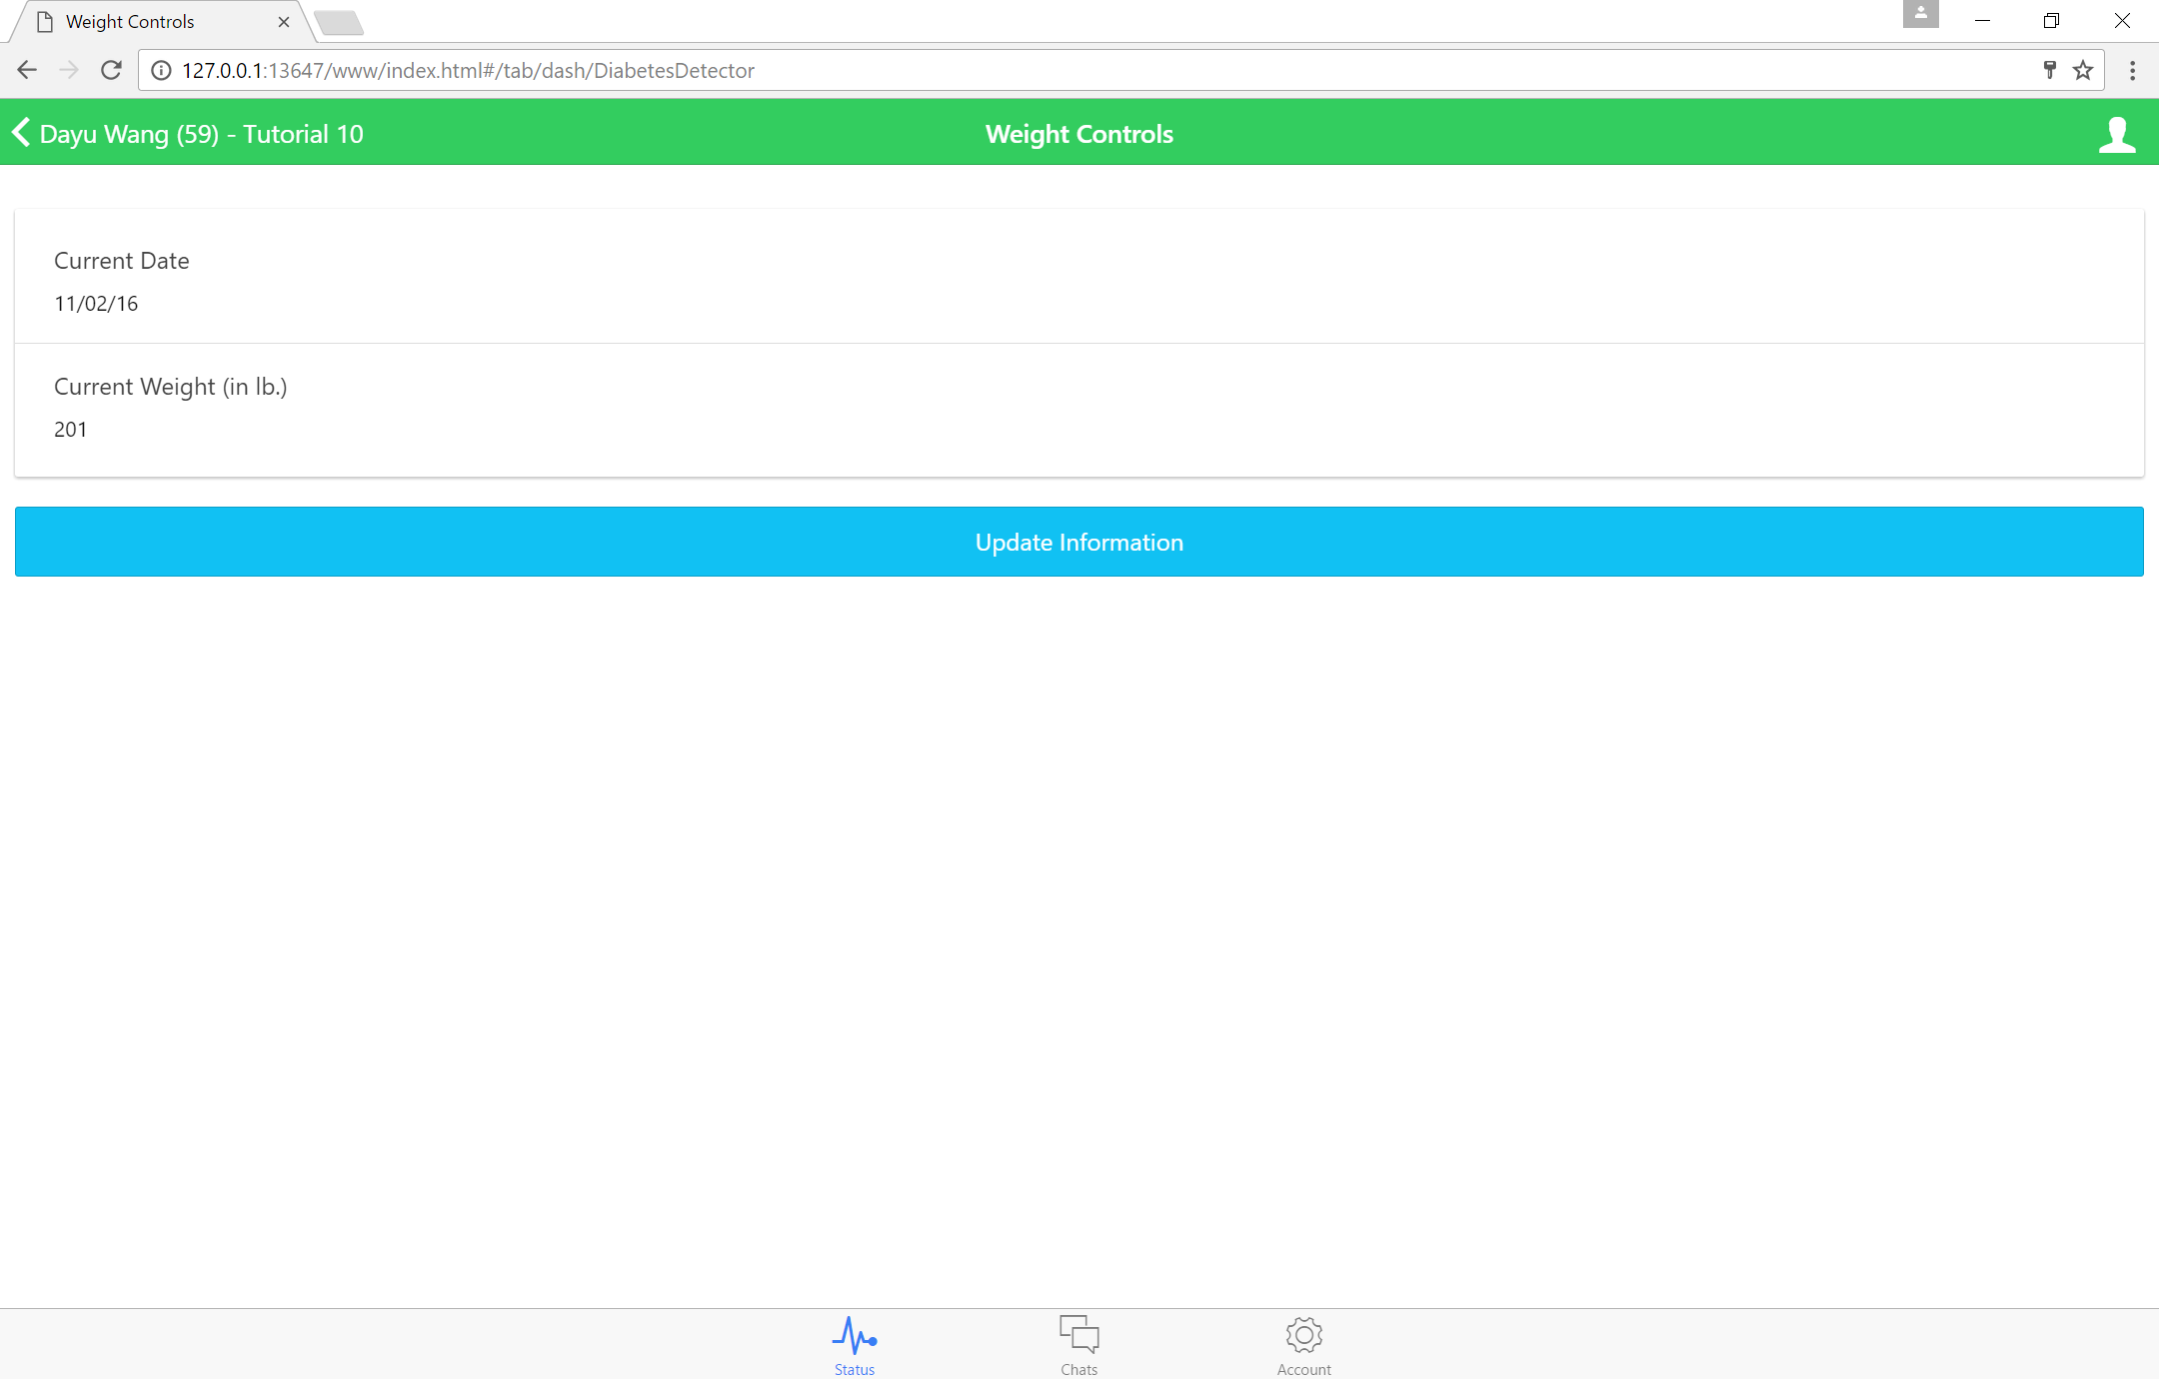

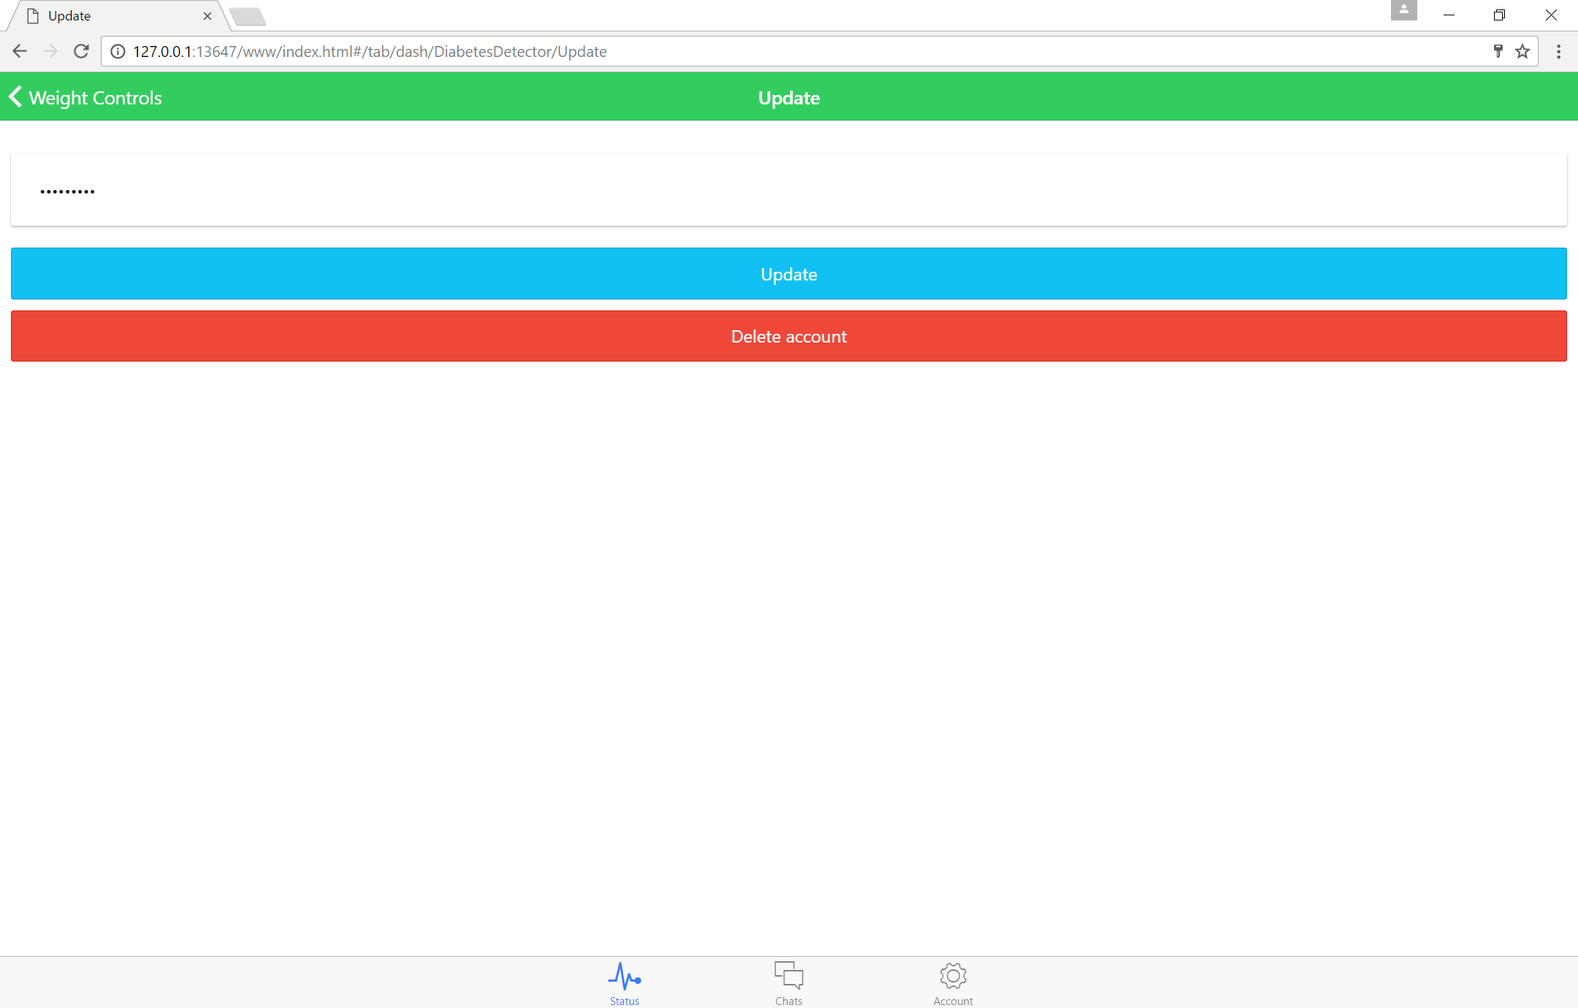

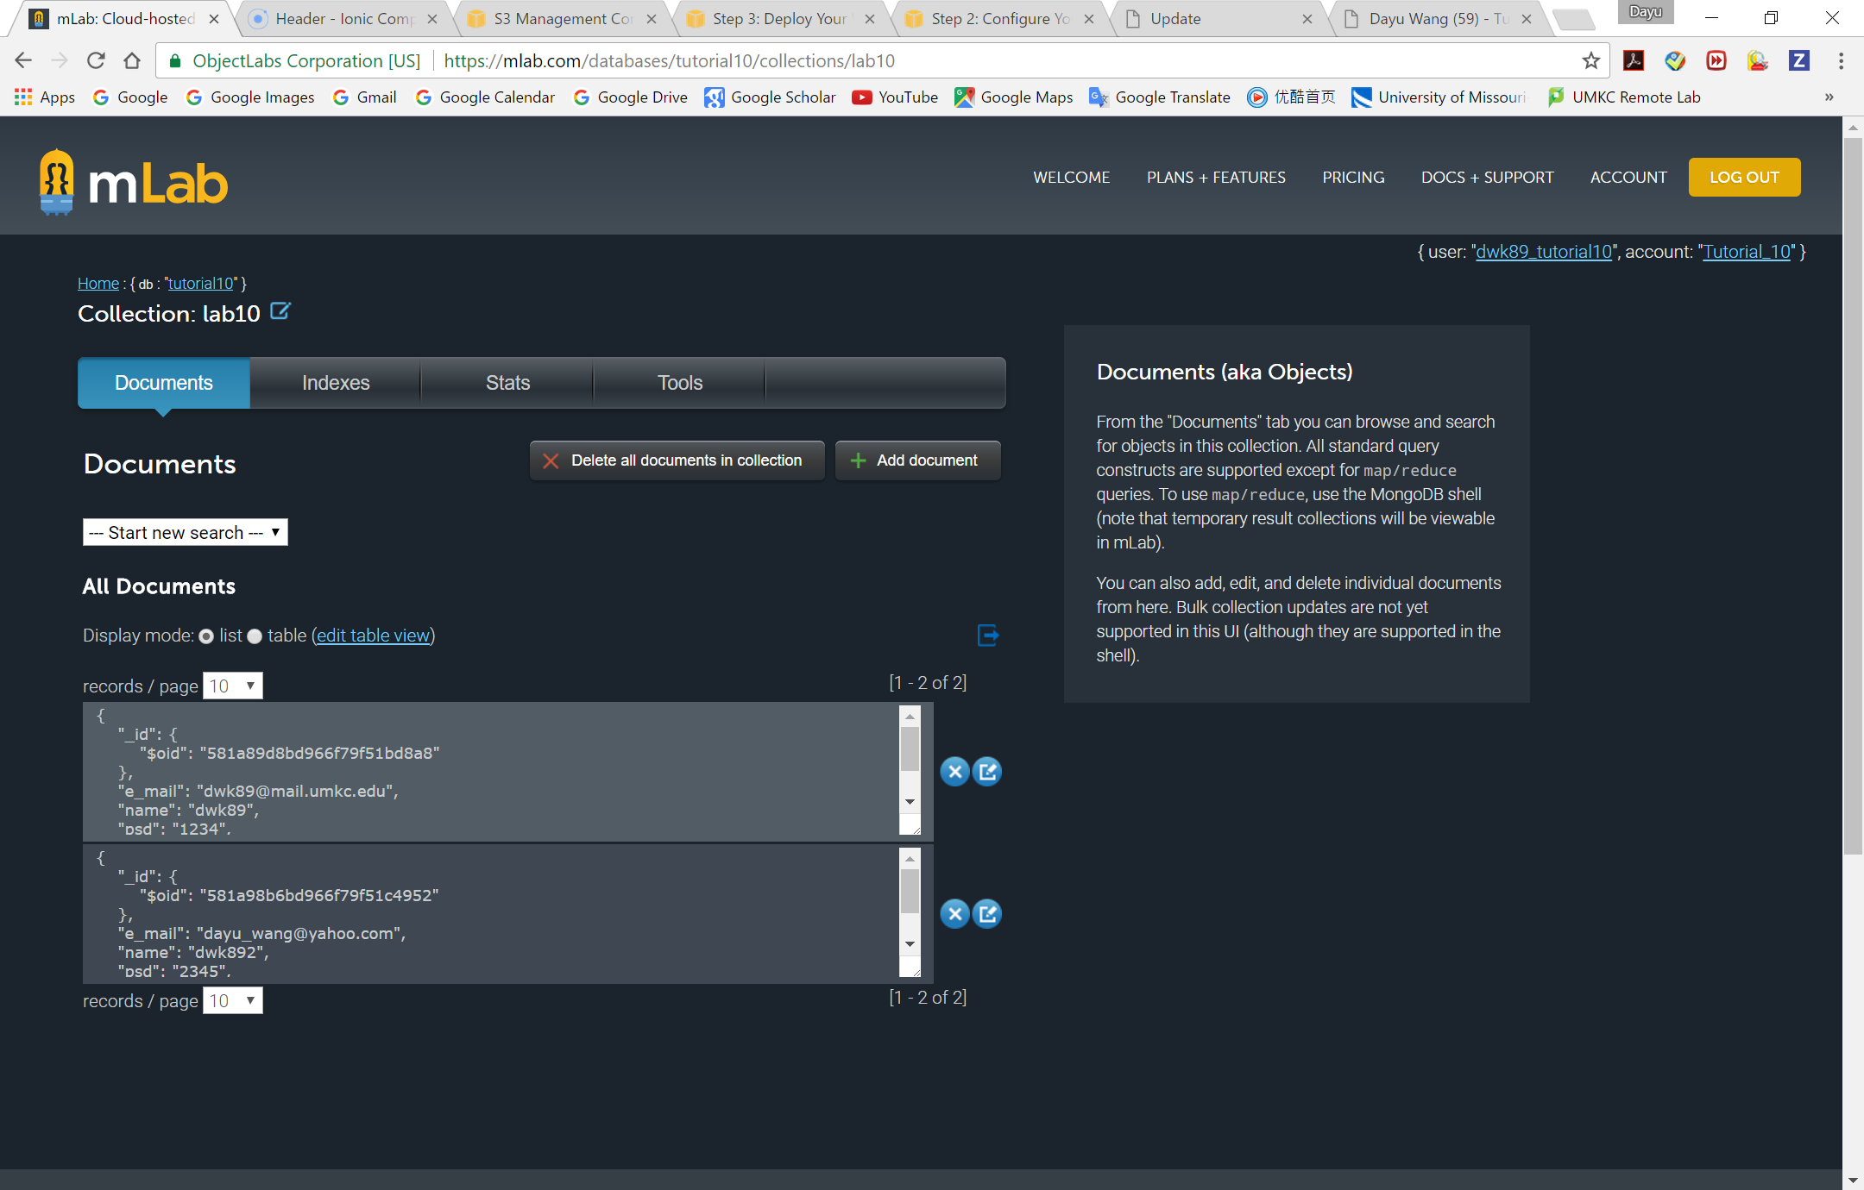

**Amazon Link**: <http://labten.s3-website-us-east-1.amazonaws.com/www/index.html>