COMP-SCI 5551 (FS16) - Advanced Software Engineering

**Tutorial 3 Assignment (Due 09/14/16)**

*Dayu Wang (59)*

1. Screenshots for Google Account Login Implementation

Initial login button

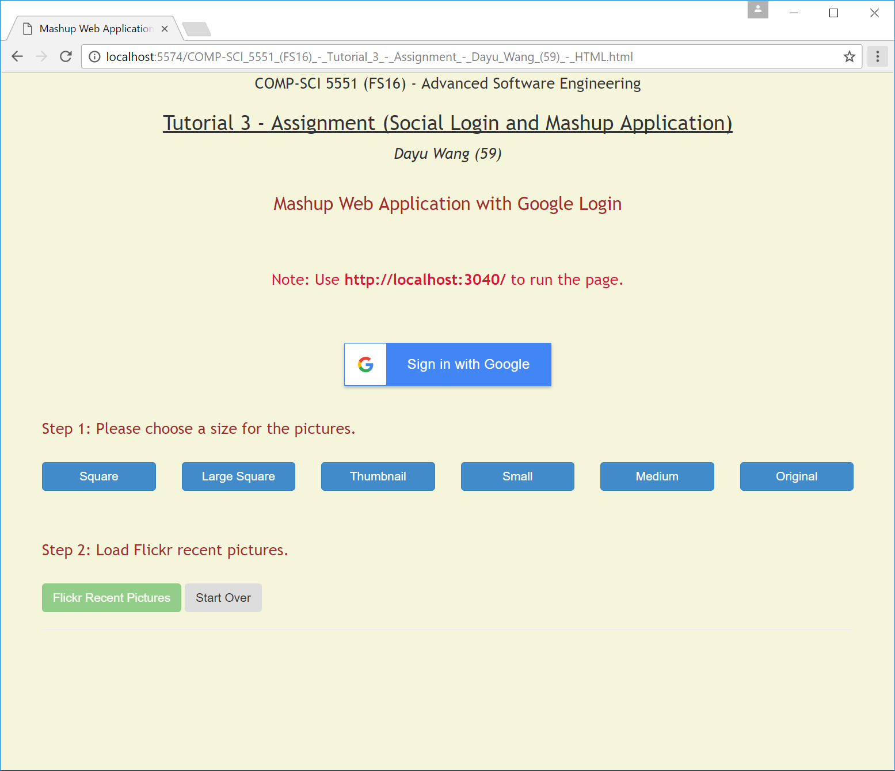

After click the login button

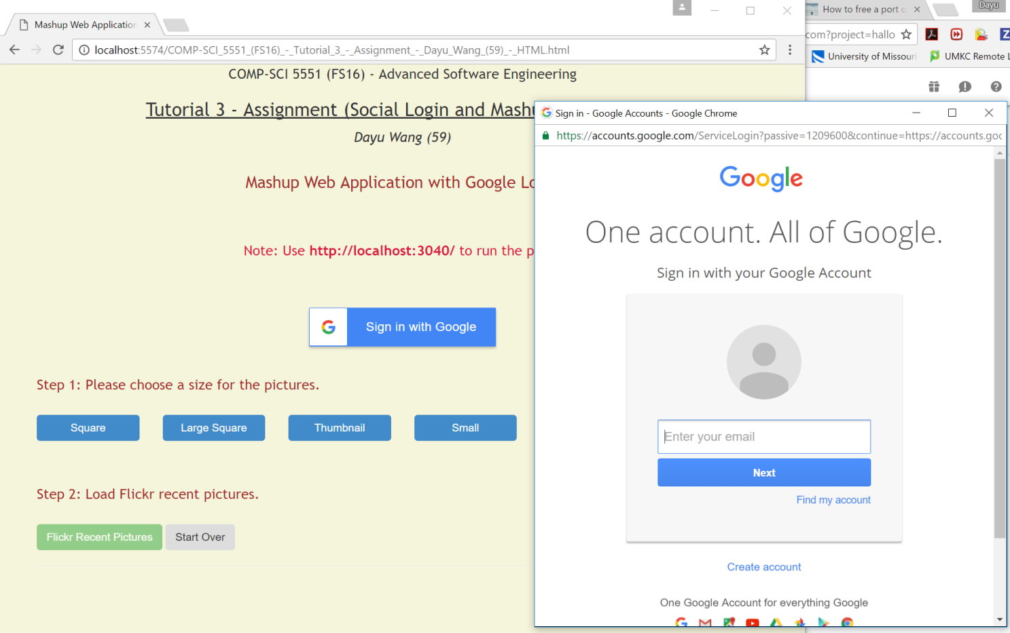

After entering the username and password

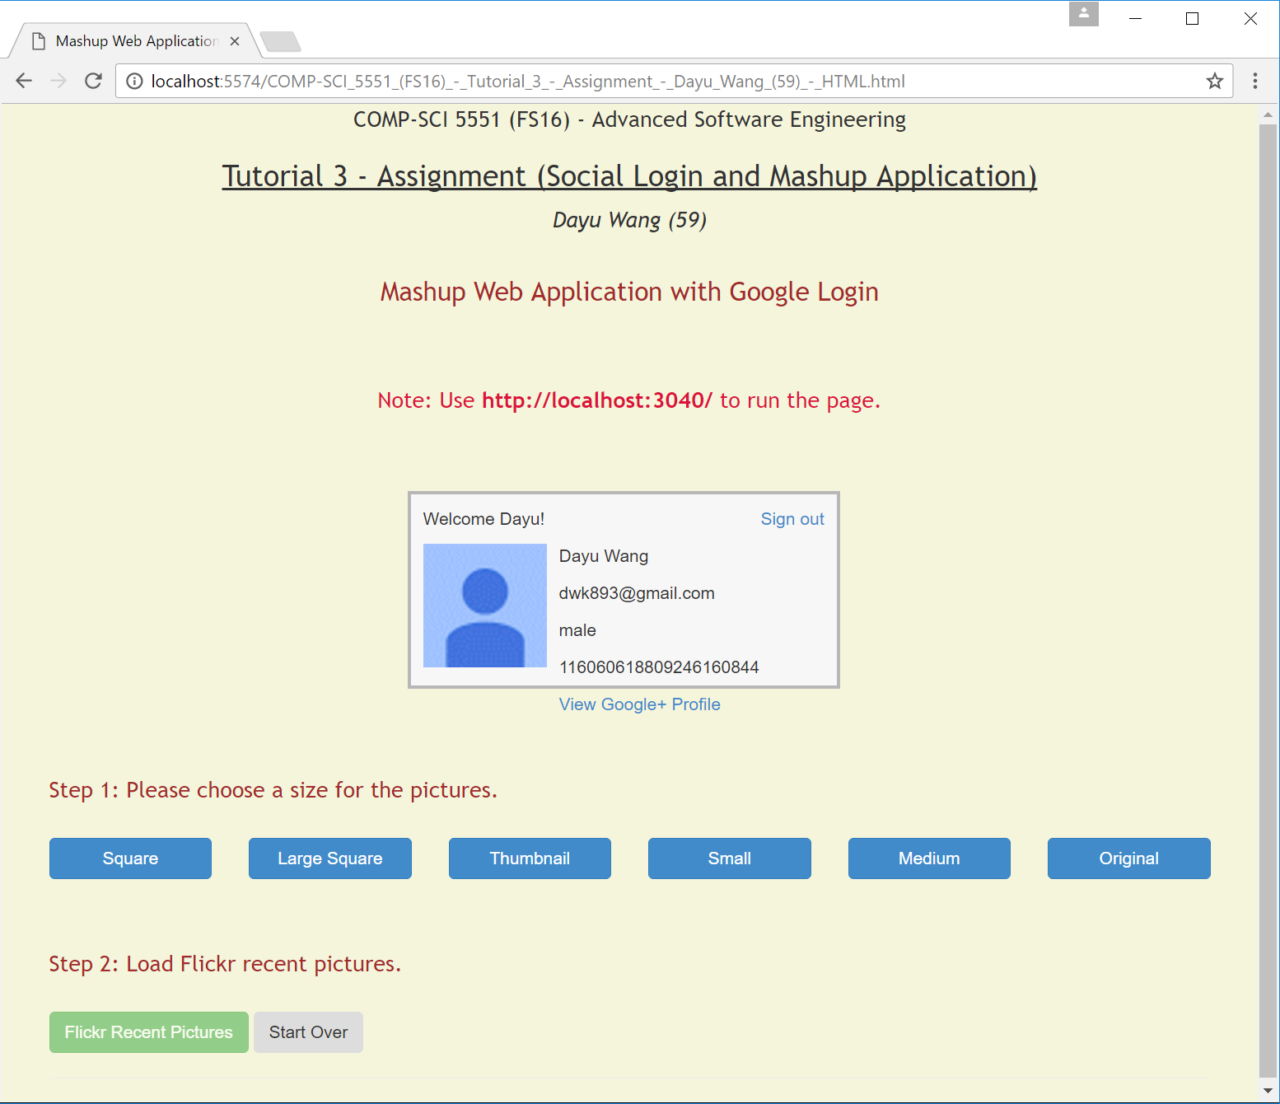

1. Screenshots for Mashup Web Application

API 1 Used: Flickr (collection of recent uploaded pictures)

API 2 Used: Alchemy Visual Recognition (identify topics for the collected pictures)

Initial UI

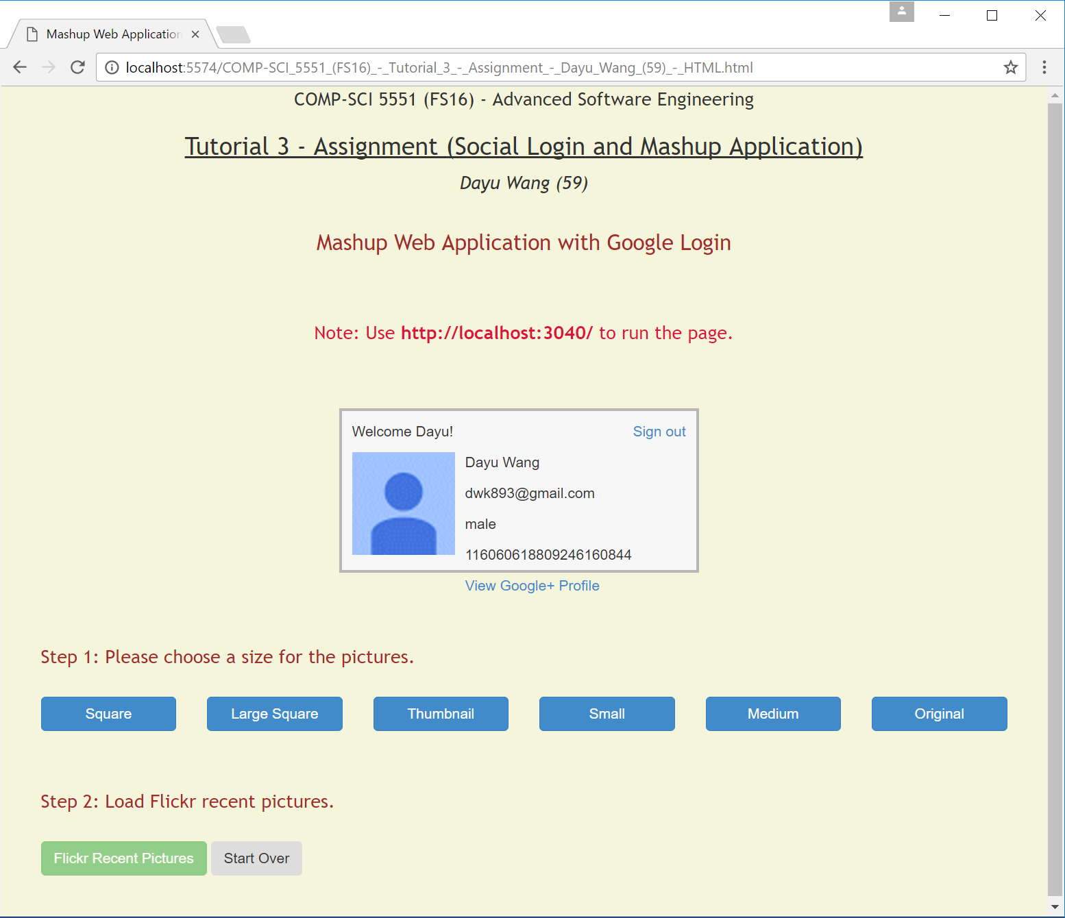

Results

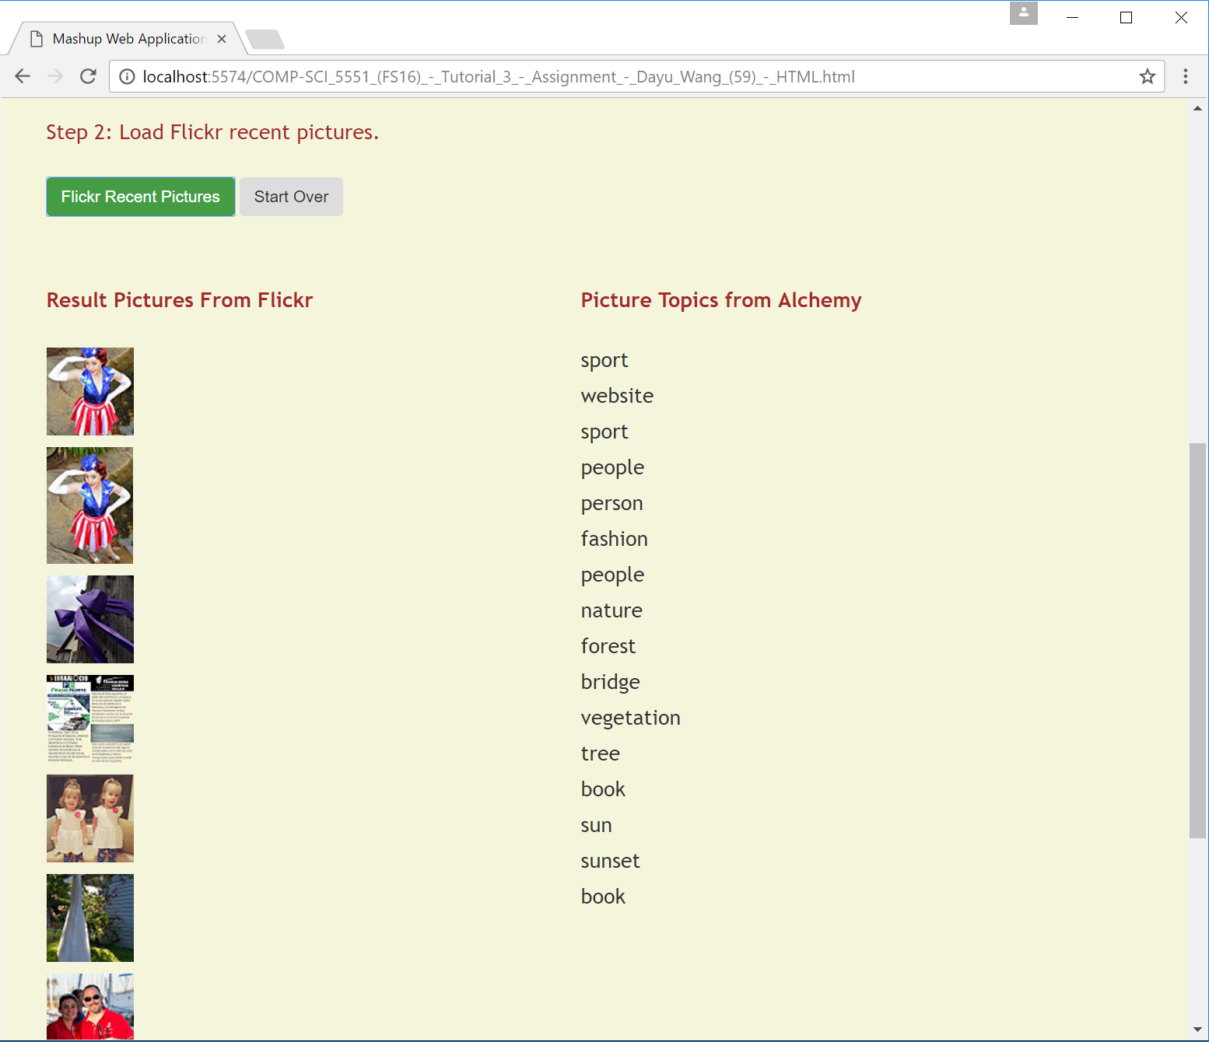

1. UI/UX - Already Shown Above
2. Screenshots for JSLint Results

