COMP-SCI 5551 (FS16) - Advanced Software Engineering

**Tutorial 5 Assignment (Due 09/28/16)**

*Dayu Wang (59)*

**Screenshots**

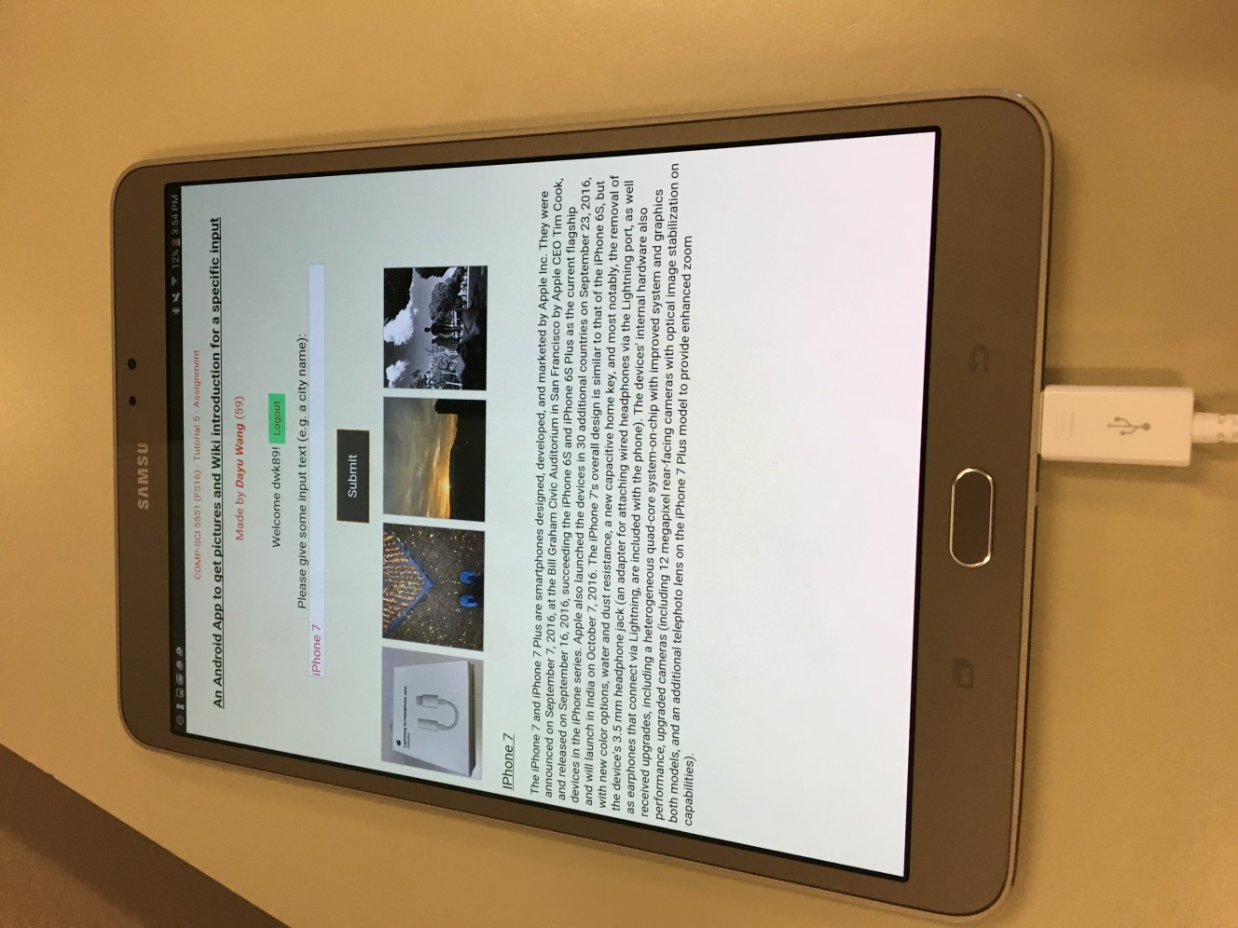

The mobile App was built on the platform of **Samsung Galaxy Tab S2 (8”)**.

Login Page

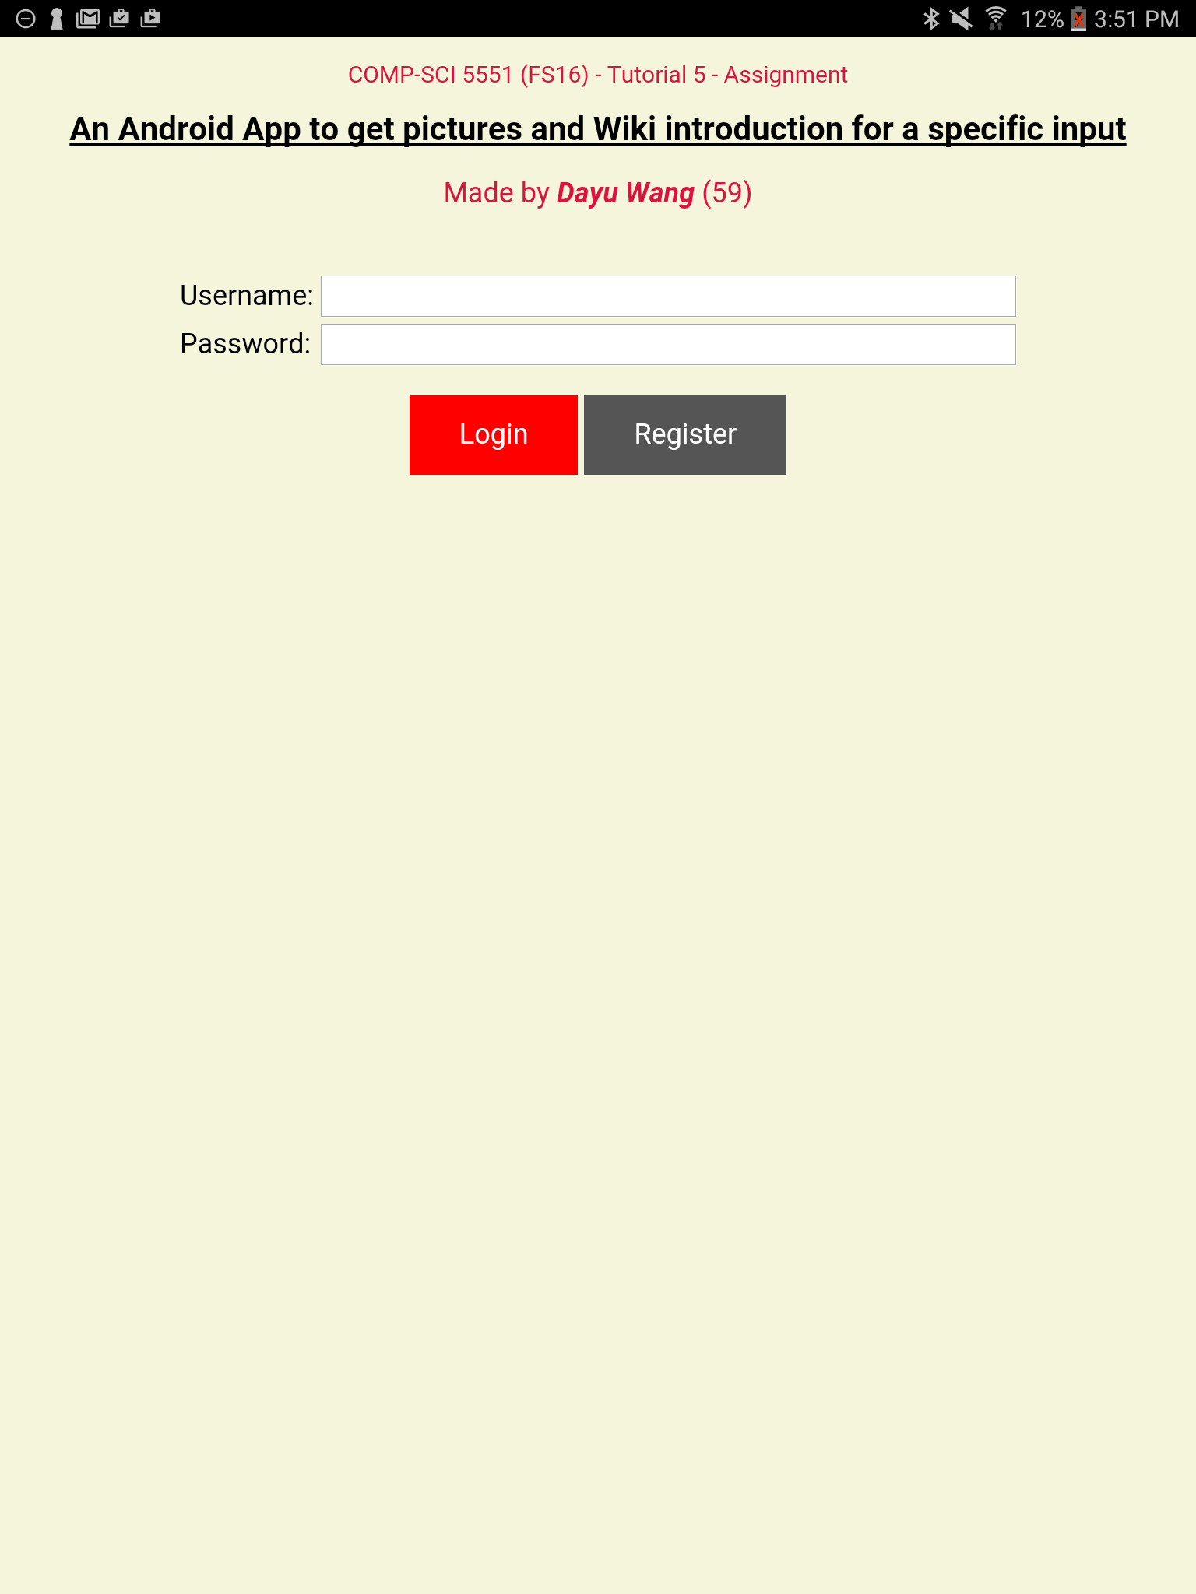

Registration Page

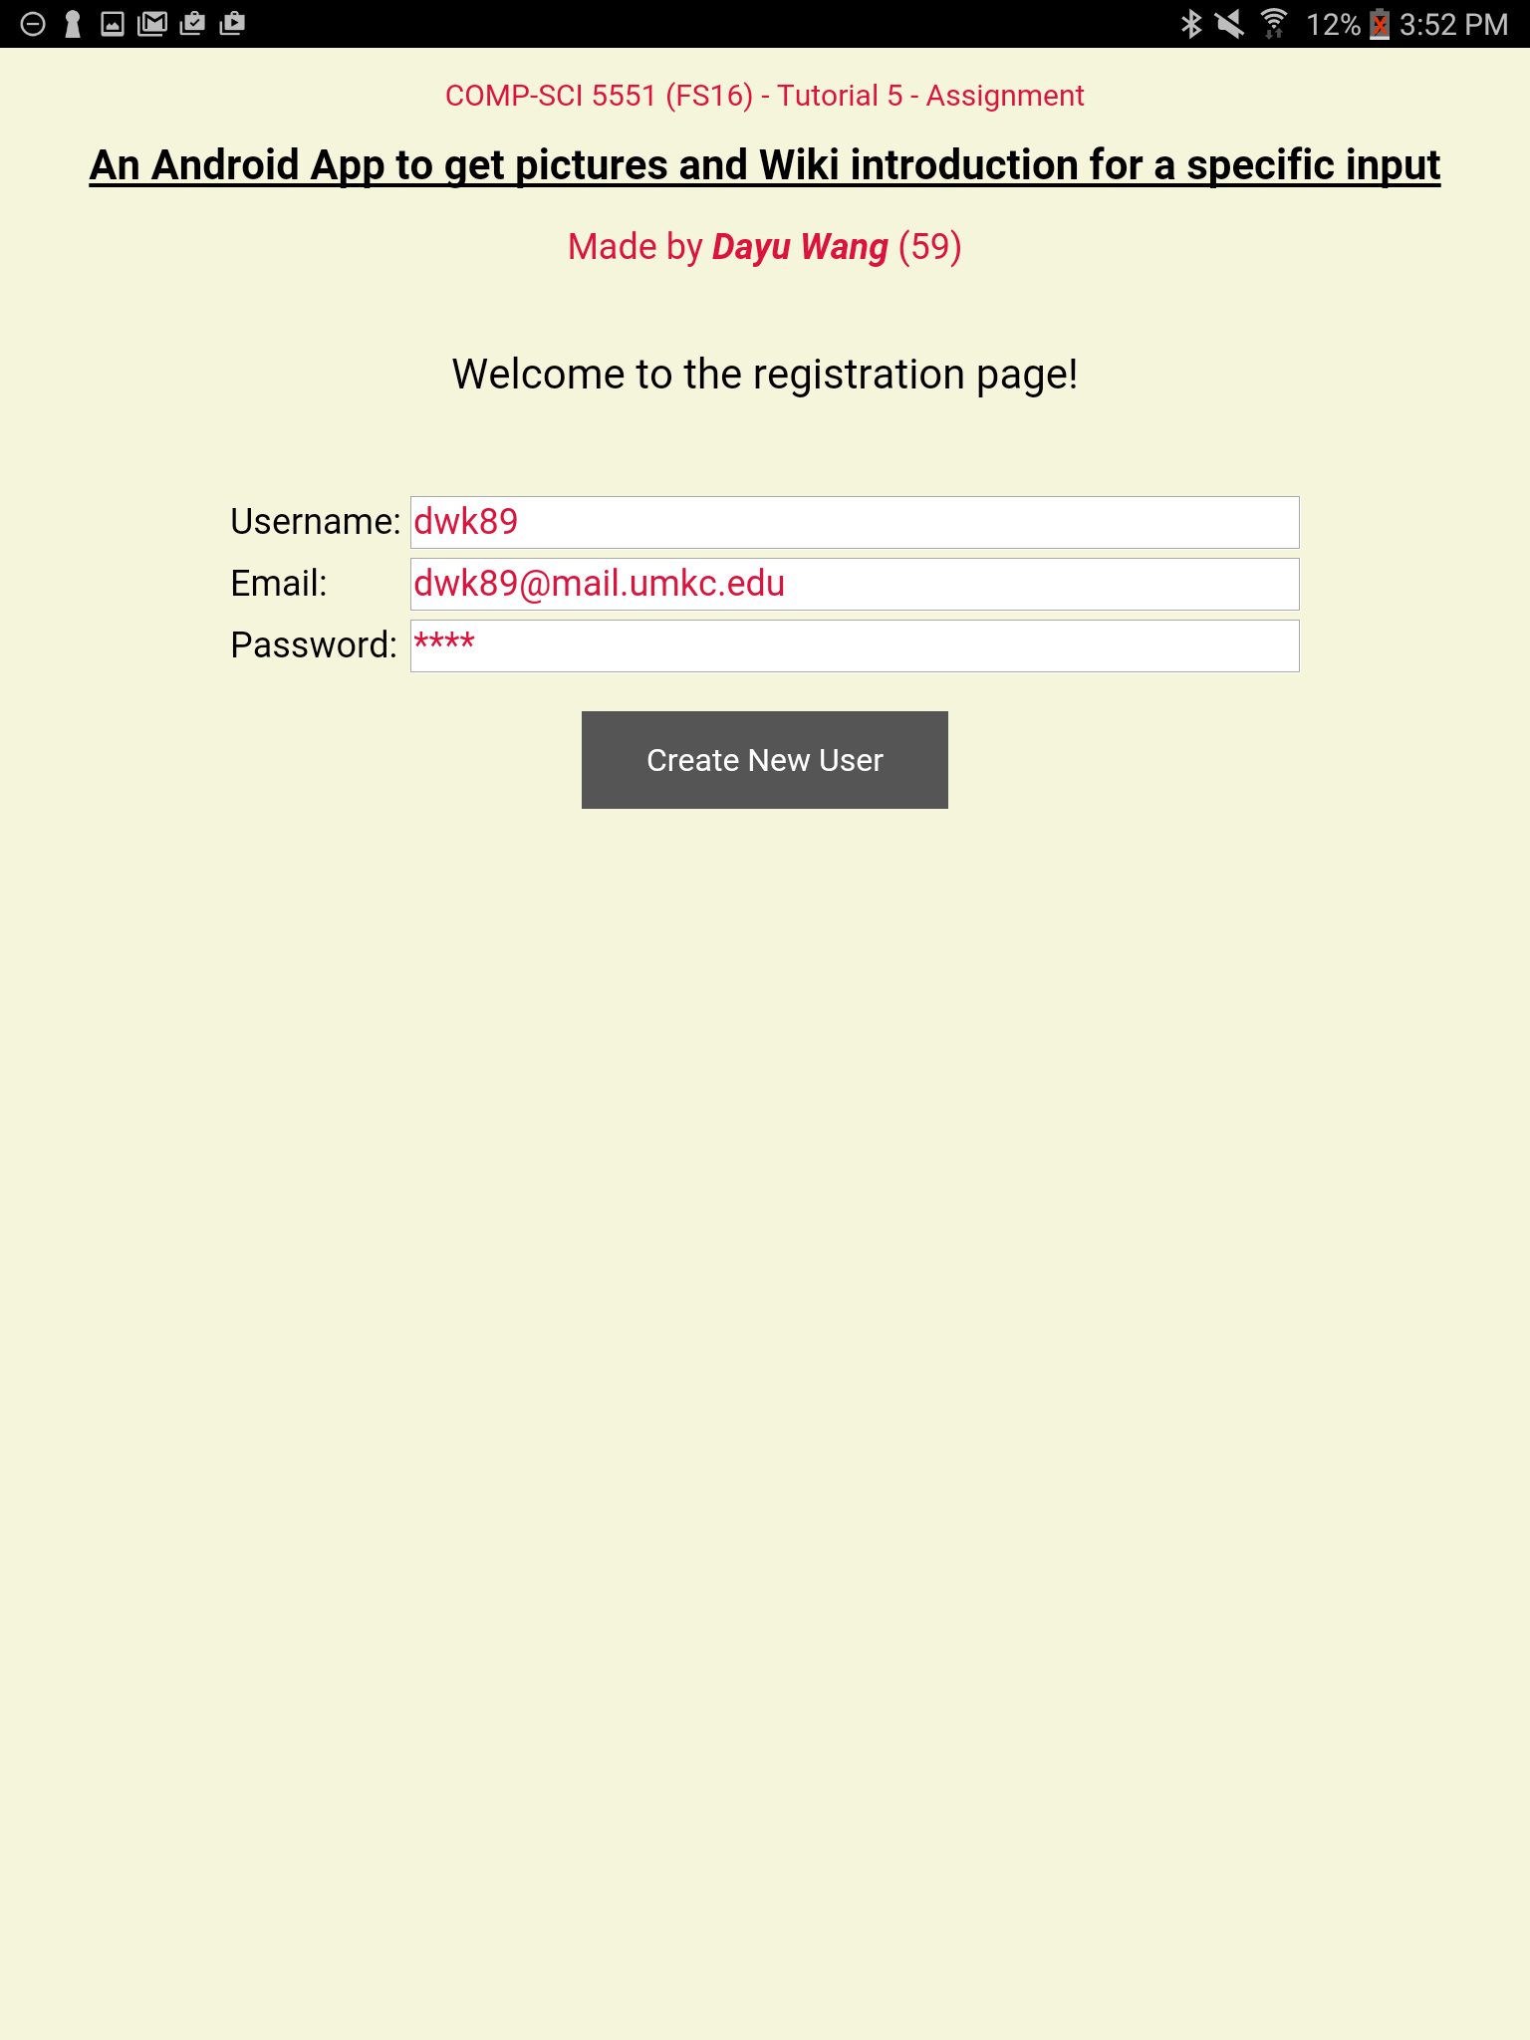

Home Page

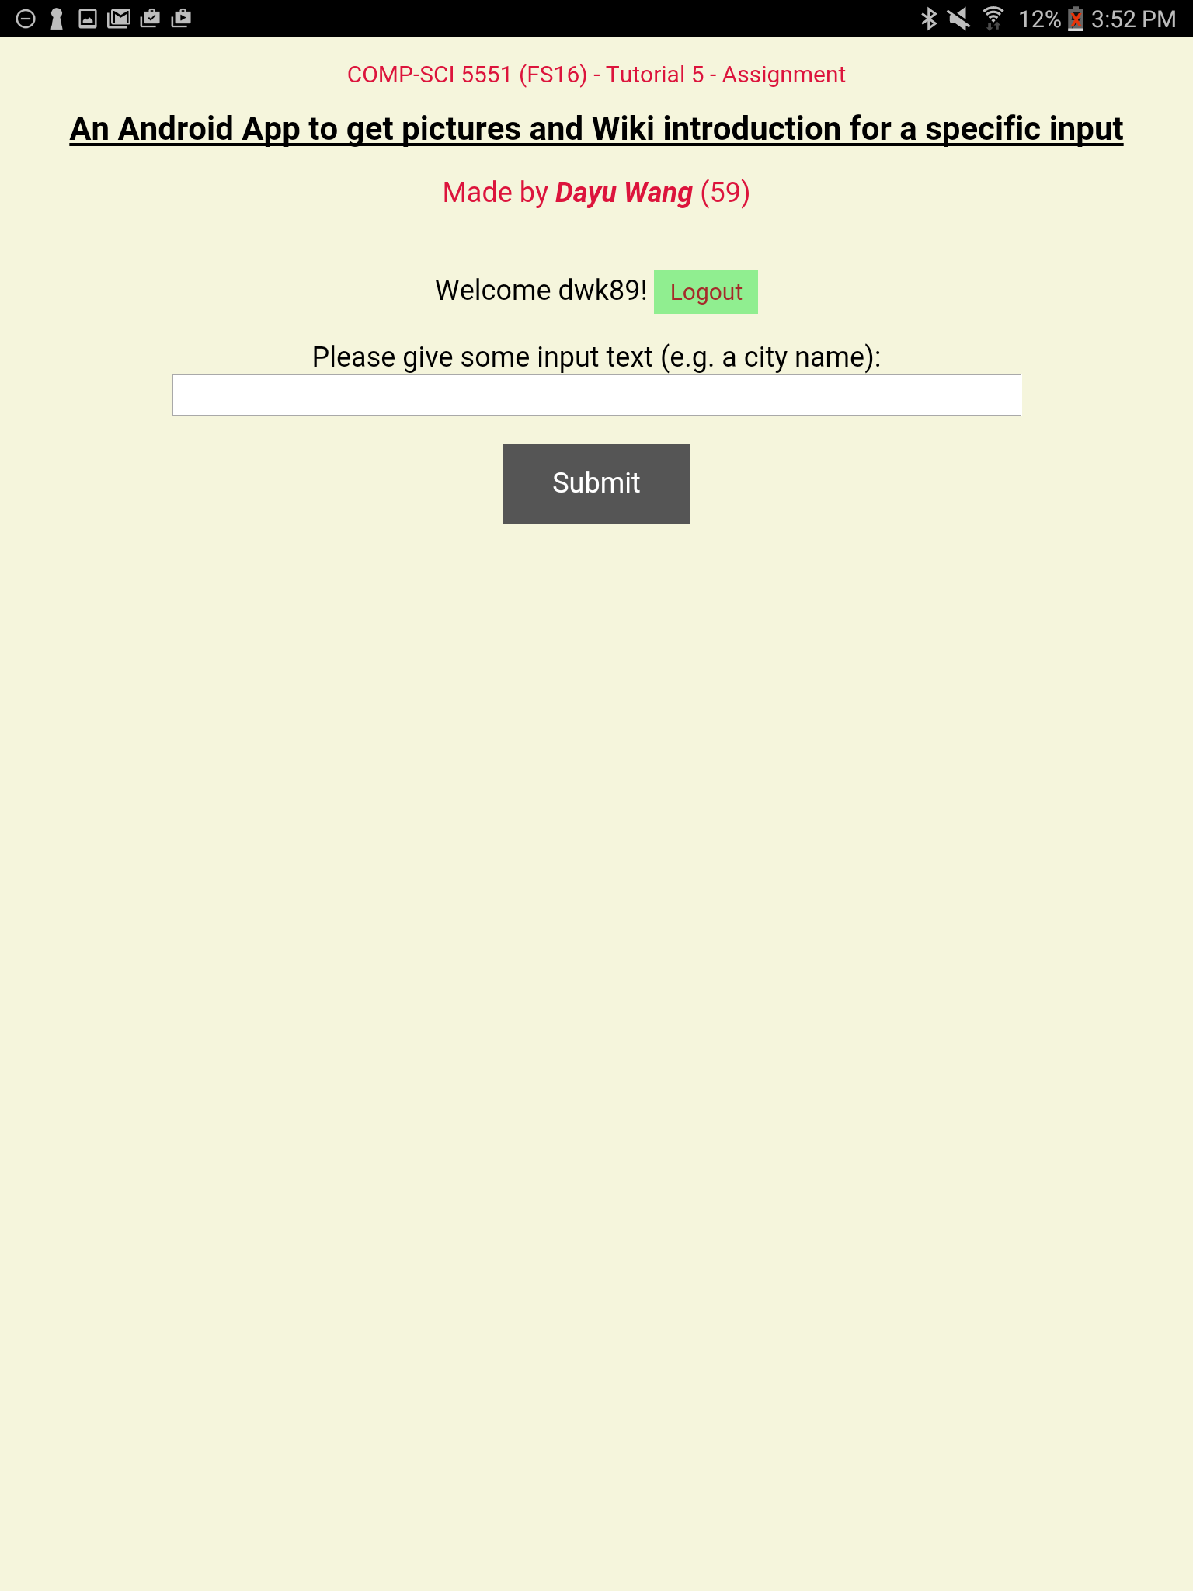

Mashup of Flickr Search API and Wiki Media API (Knowledge)

