COMP-SCI 5551 (FS16) - Advanced Software Engineering

**Tutorial 7 Assignment (Due 10/12/16)**

*Dayu Wang (59)*

1. **Screen Shots of the Built App**

**Home page** - A Wikipedia introduction collector

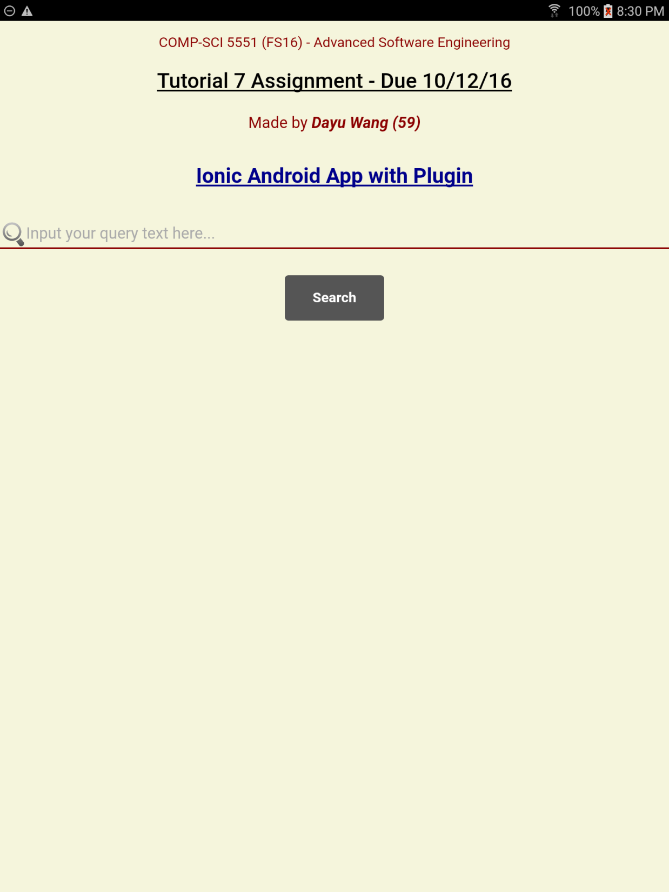

**After a Query** - “**Print**” button appears to guide the user print out the text.

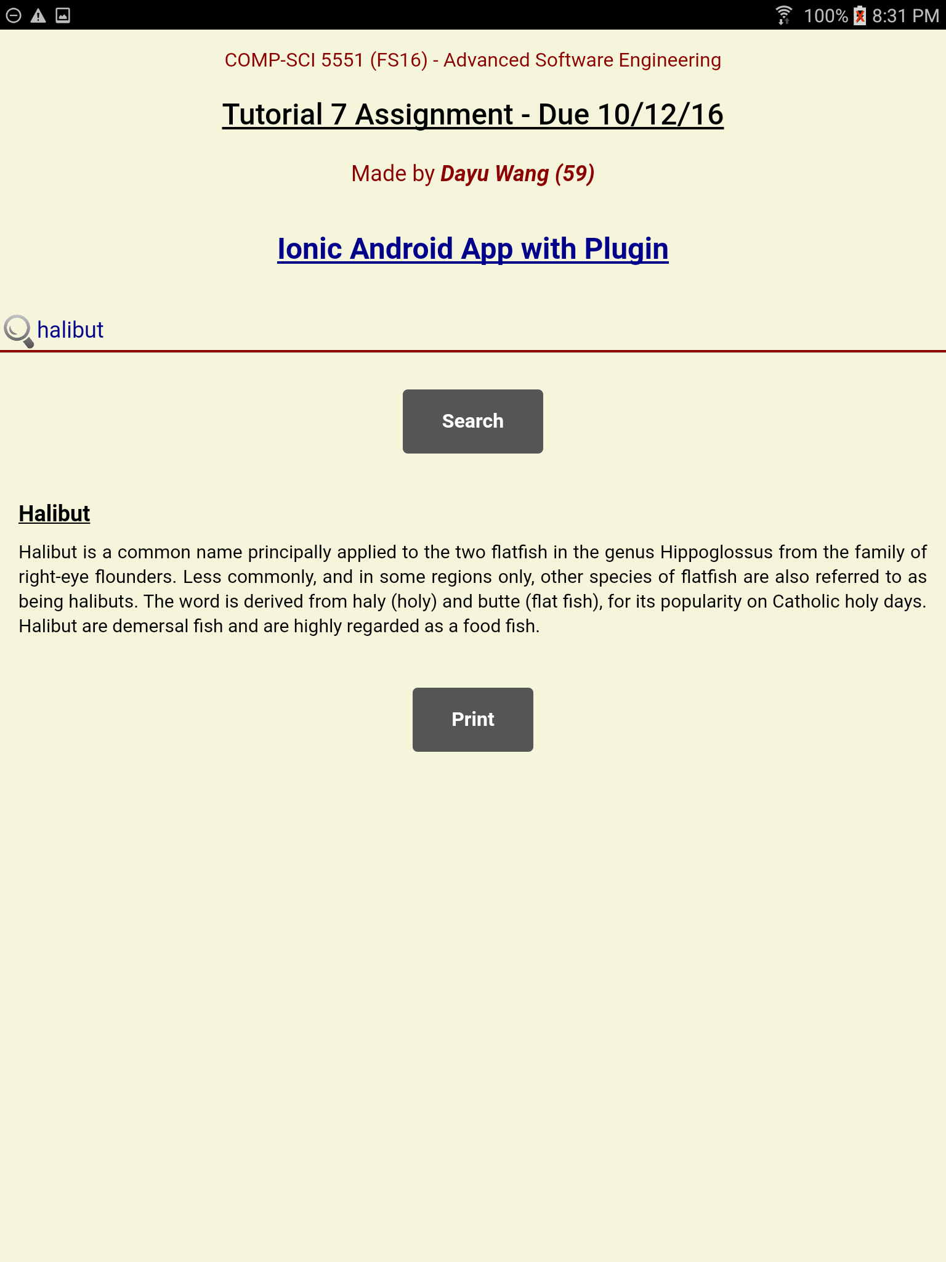

**Print Preview** - preview the context being printed out

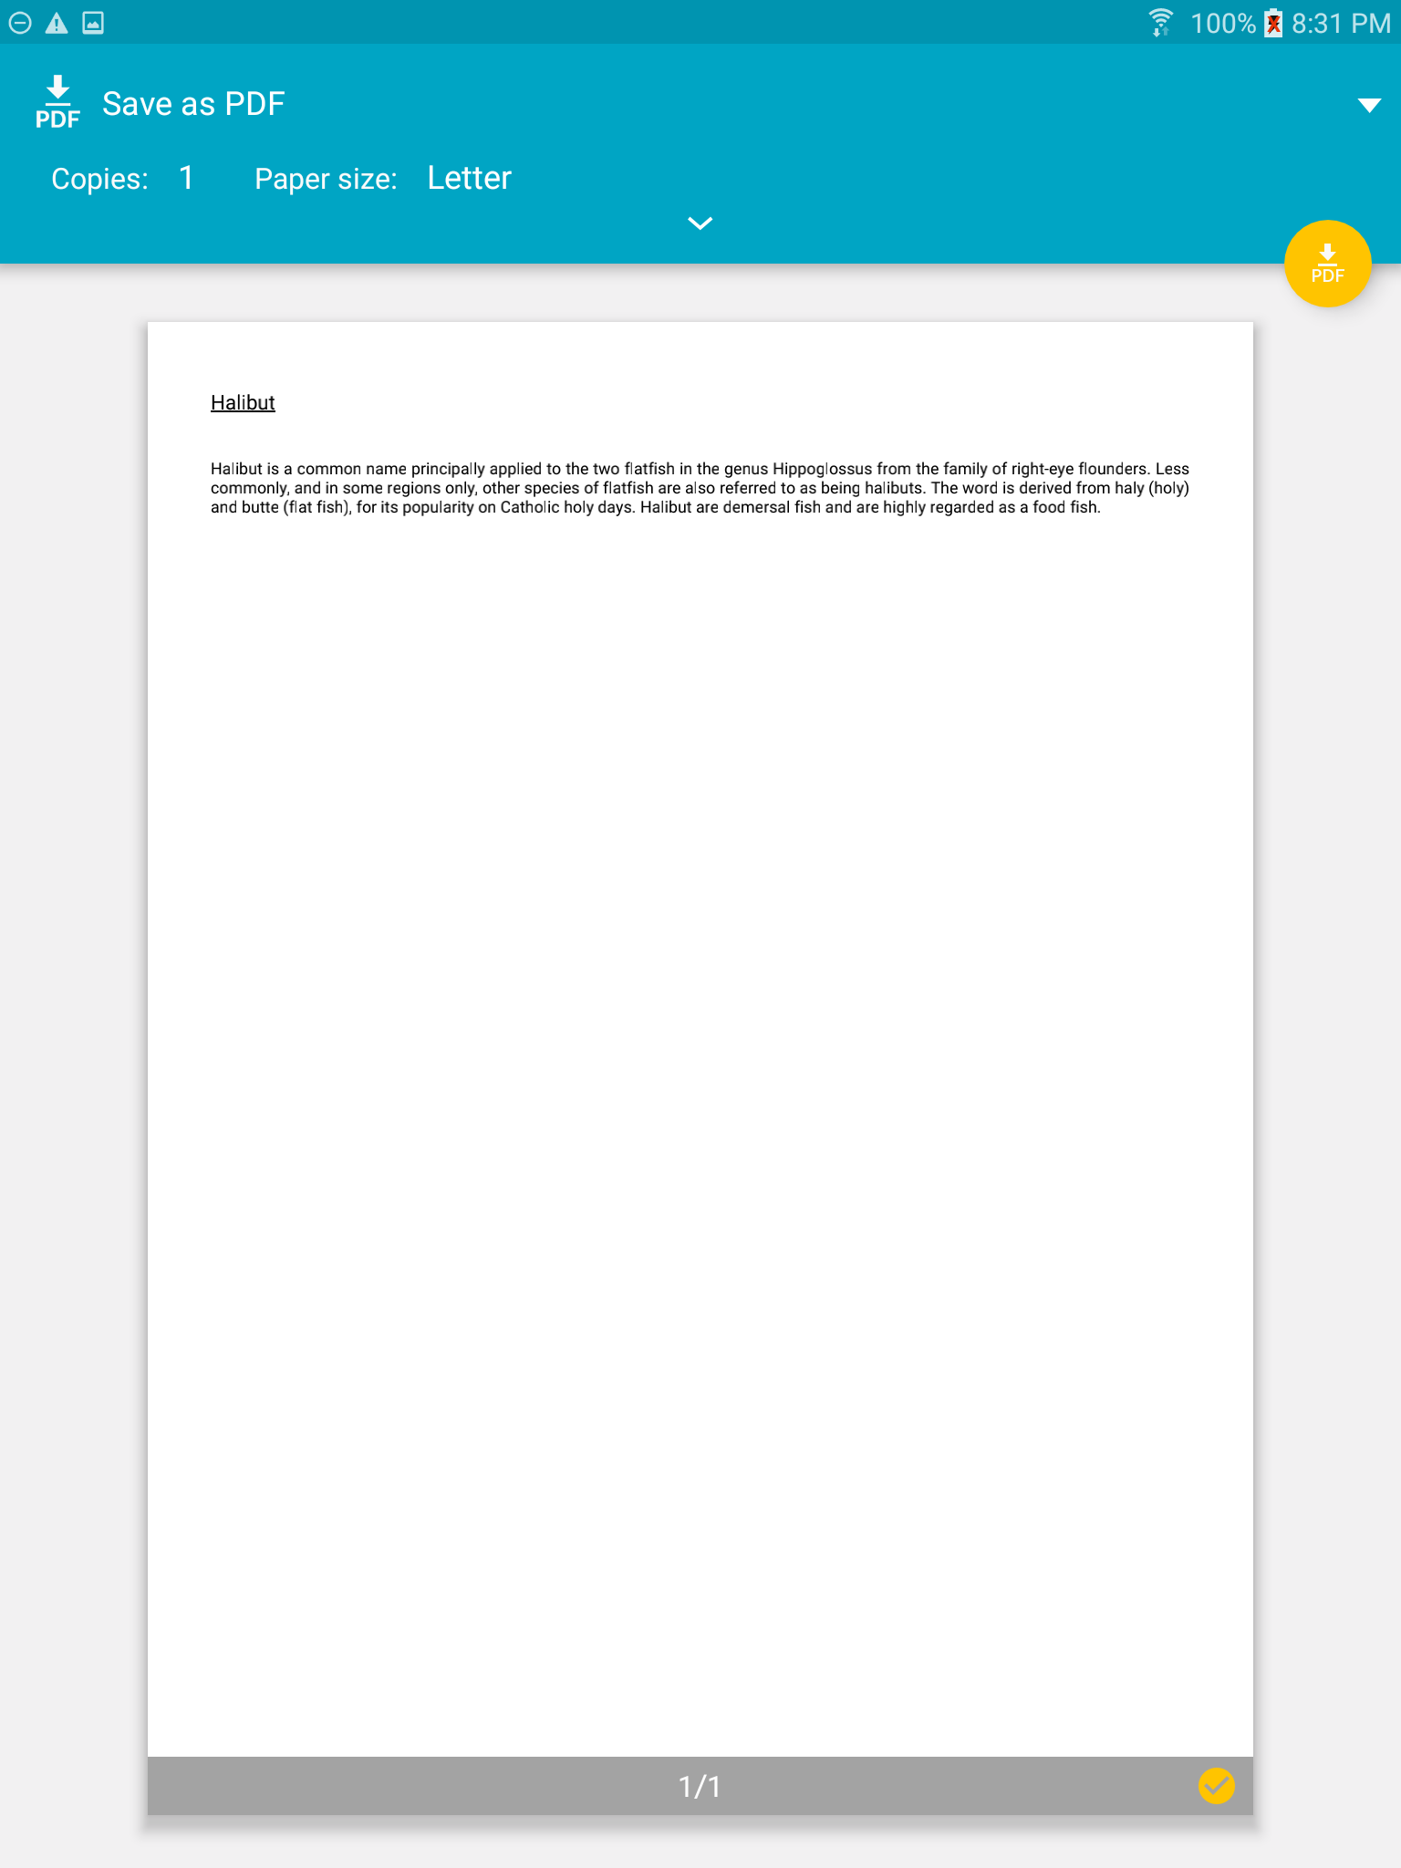

**Location** - find a location to save the printed document

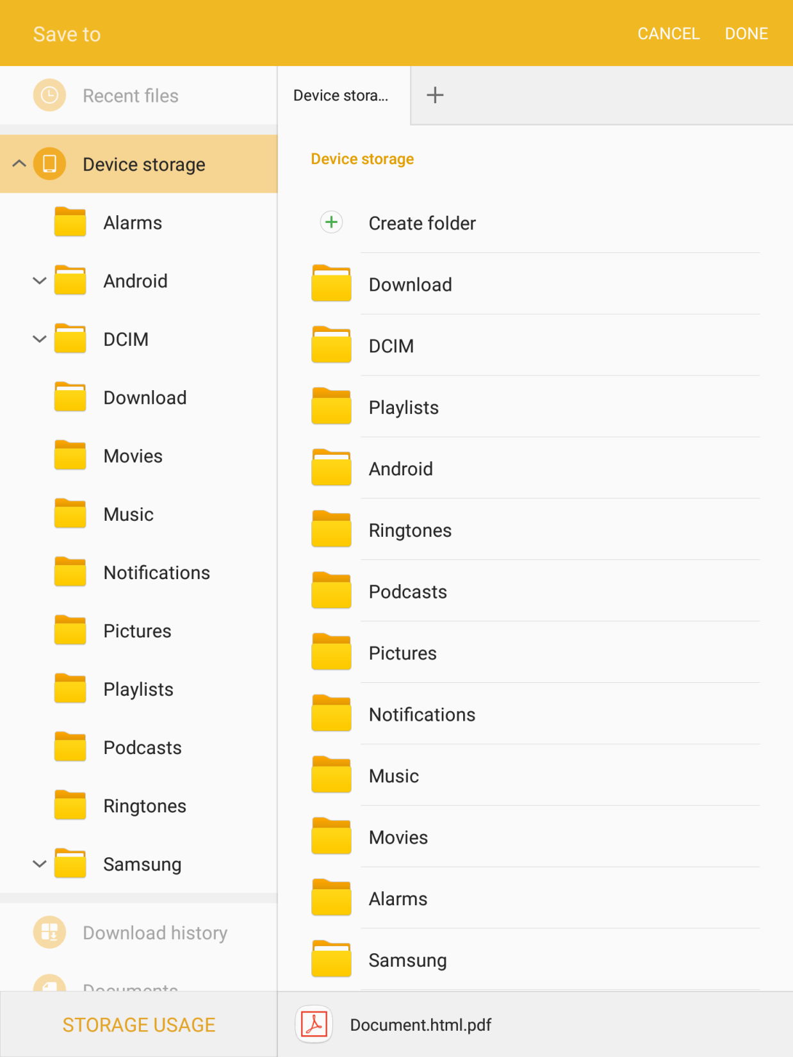

**My Files** - using “My Files” to find the printed document

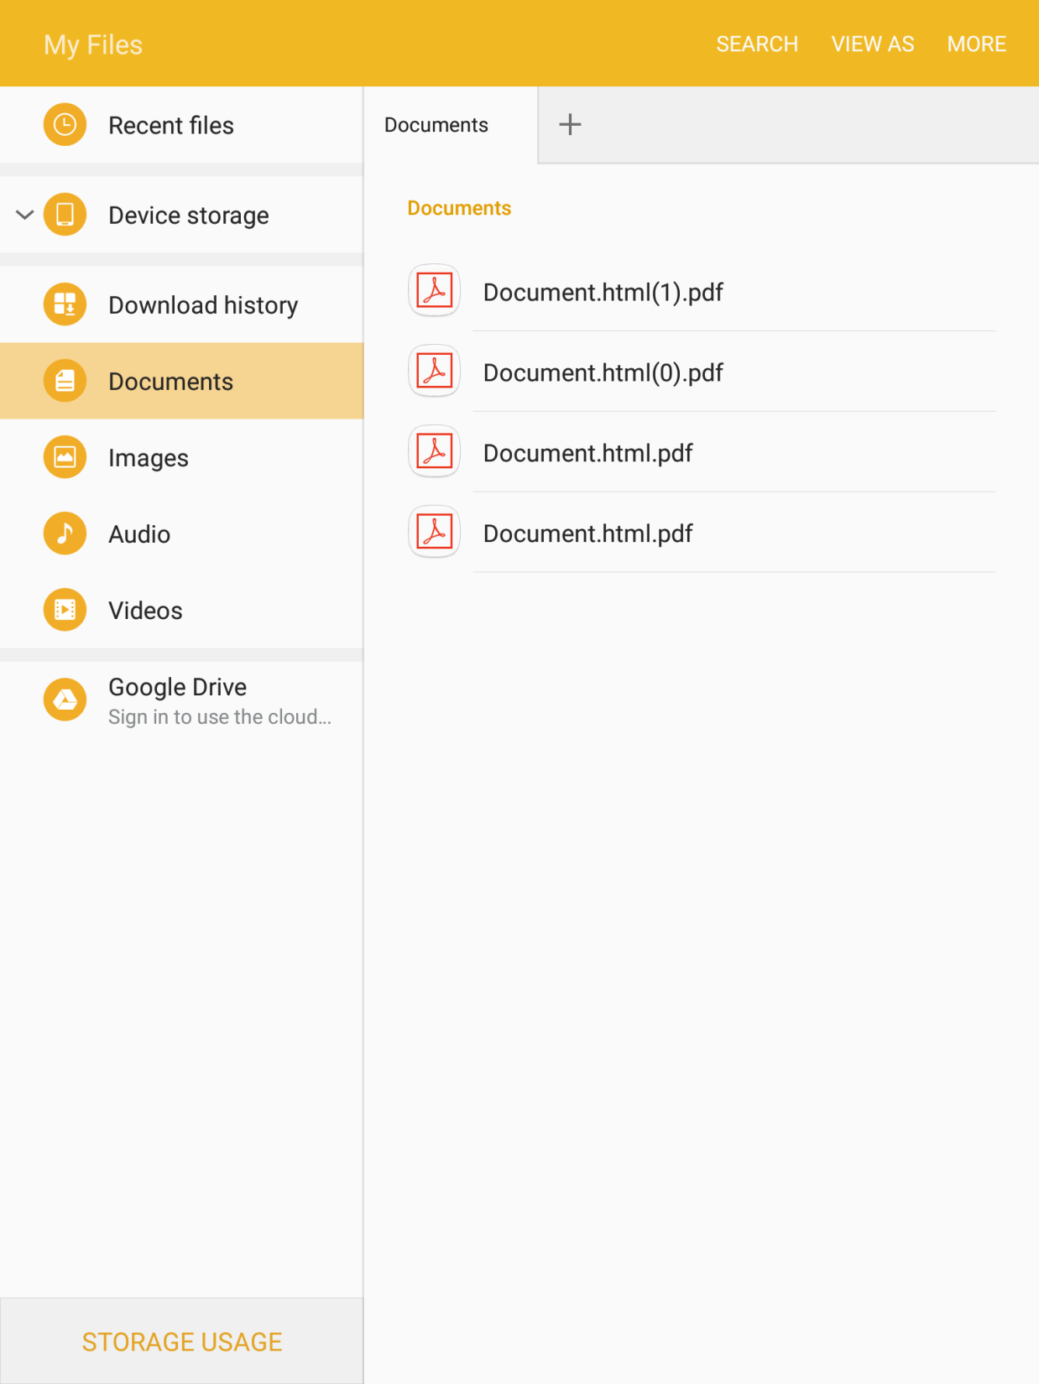

**Open the file** - open the printed document for verification

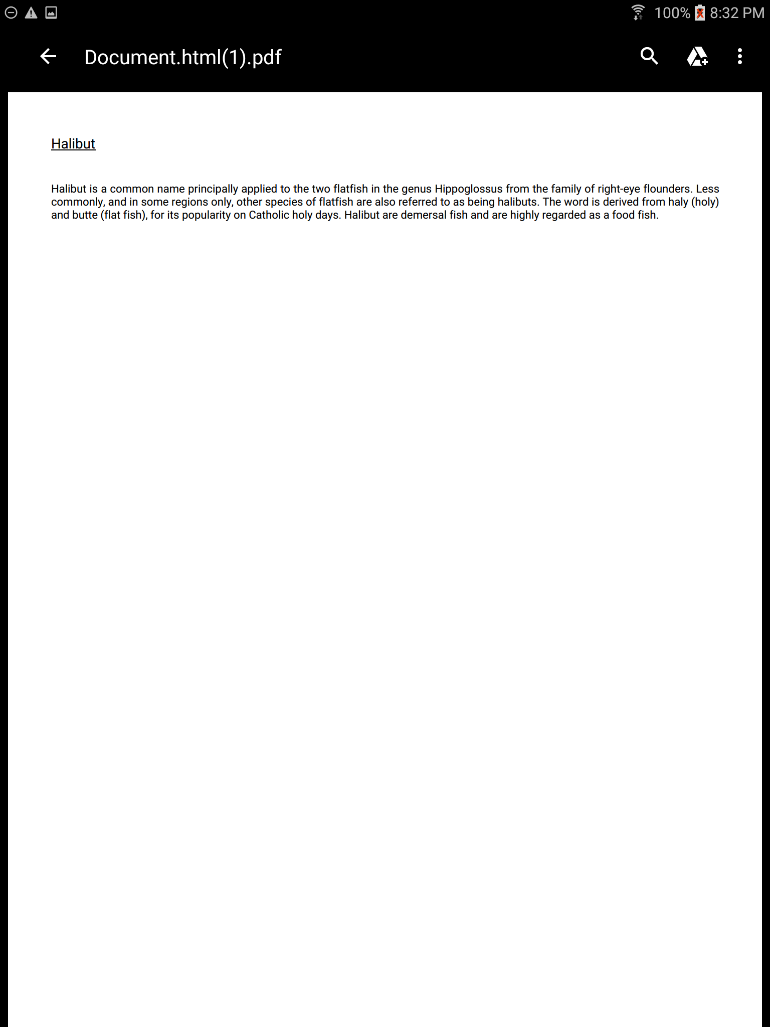

2. **Yslow Result - Grade B with Score 85**

