COMP-SCI 5551 (FS16) - Advanced Software Engineering

**Tutorial 8 Assignment (Due 10/19/16 by 23:59 PM)**

*Dayu Wang (59)*

**Screenshots**

1. Main JSP Page

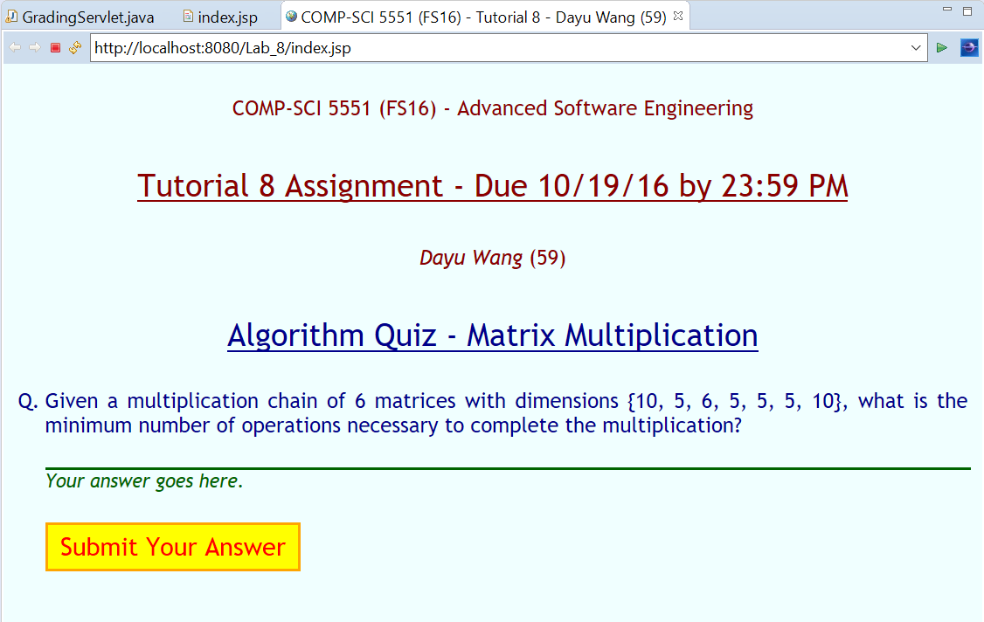

**The number of matrices and the dimension array are randomly generated each time when we load the web page.**

2. If the answer is correct…

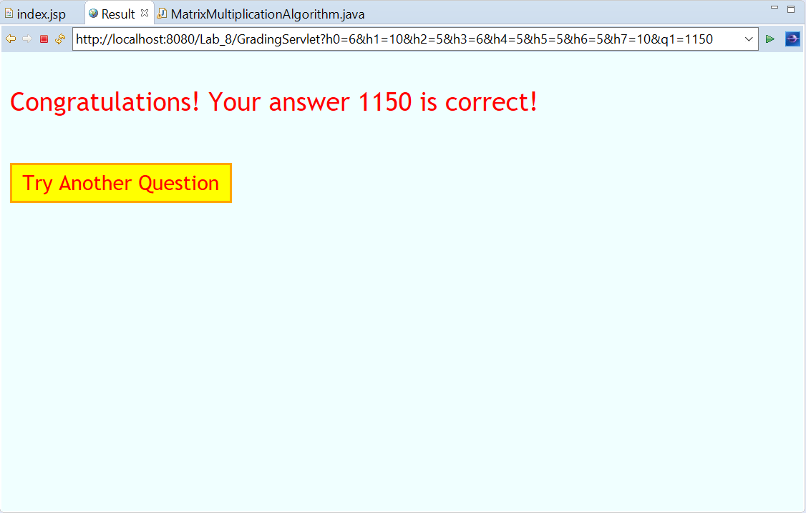

3. If the answer is NOT correct…

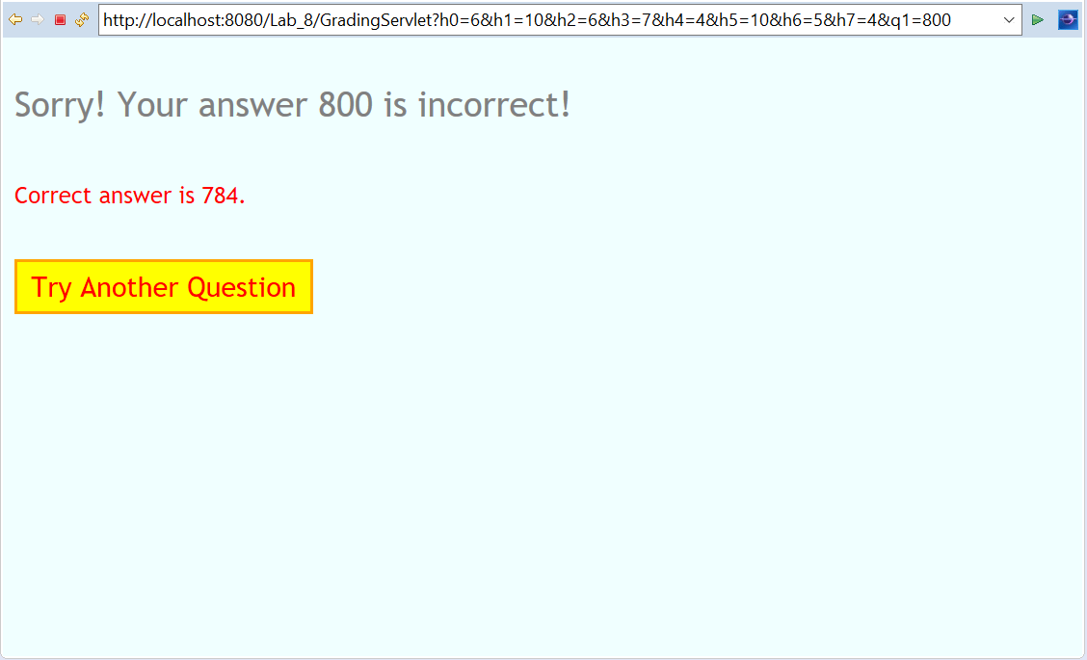

4. Junit Test Cases

