COMP-SCI 5551 (FS16) - Advanced Software Engineering

**Tutorial 1 Assignment (Due 08/31/16)**

*Dayu Wang (59)*

1. UML Diagram for a chatting application



1. ZenHub Account

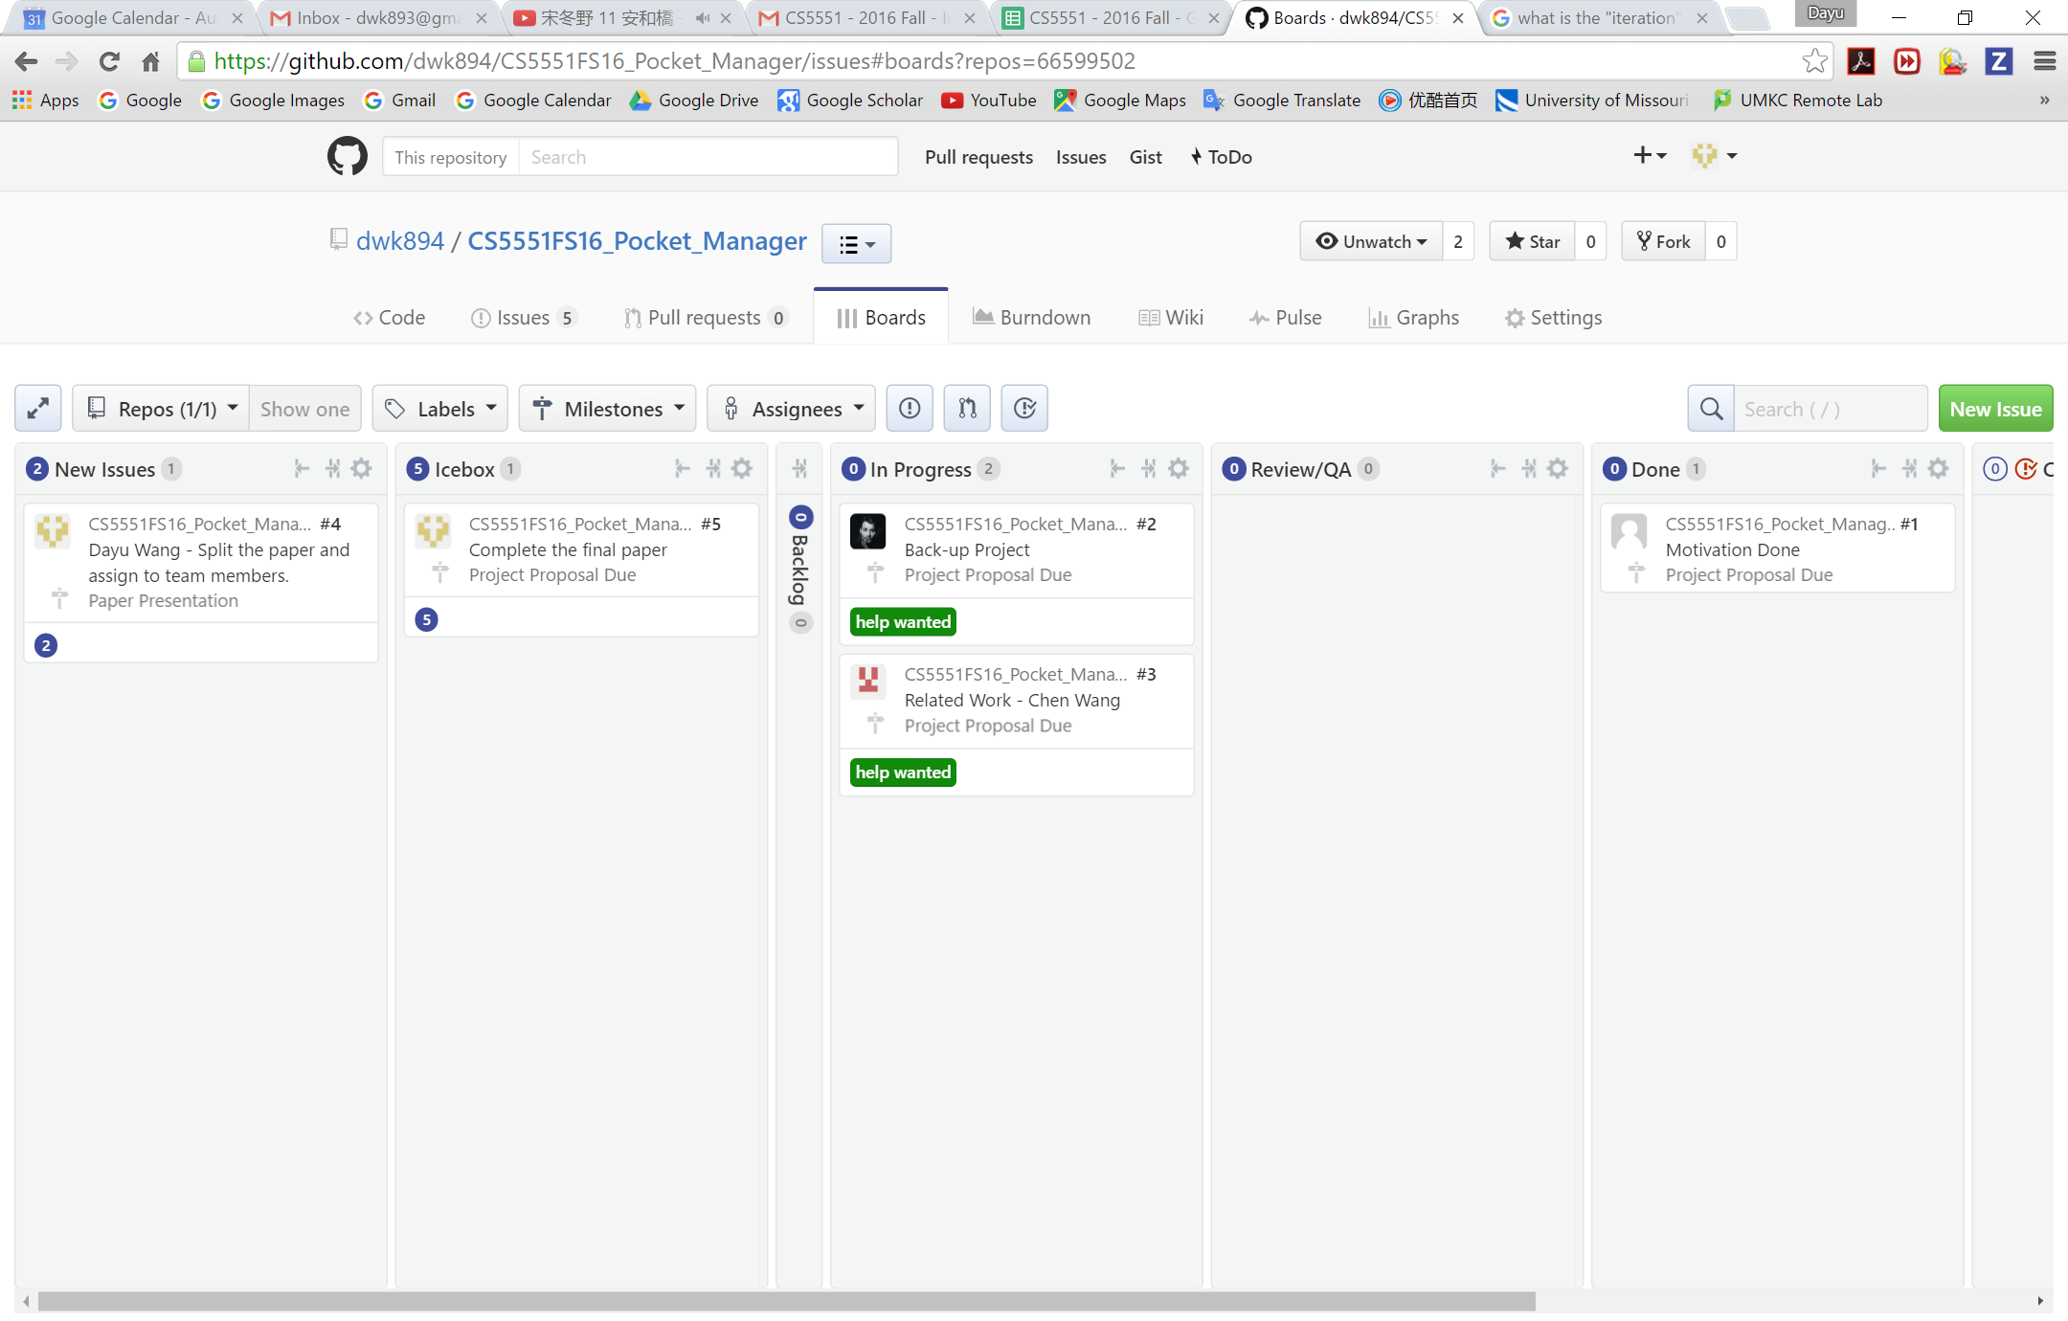

1. Wiki Page
2. GitHub Account