IDLookup.ai Visual Design Audit
Search result detail + signup form experience
First-pass assessment focused on color, backgrounds, borders, hierarchy, and conversion trust
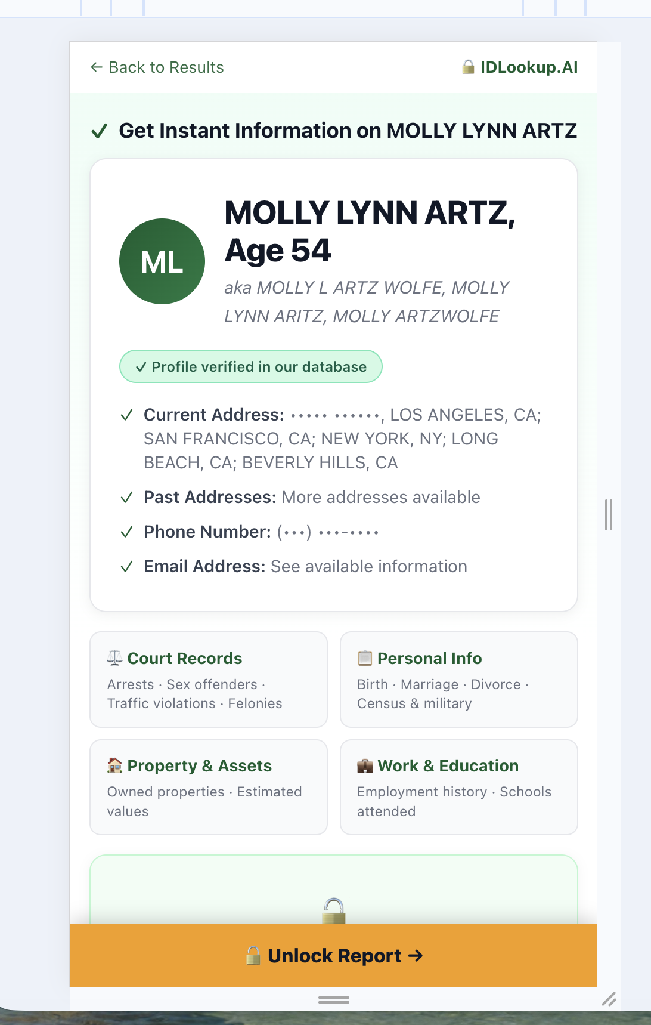
Mobile/narrow viewport screenshot
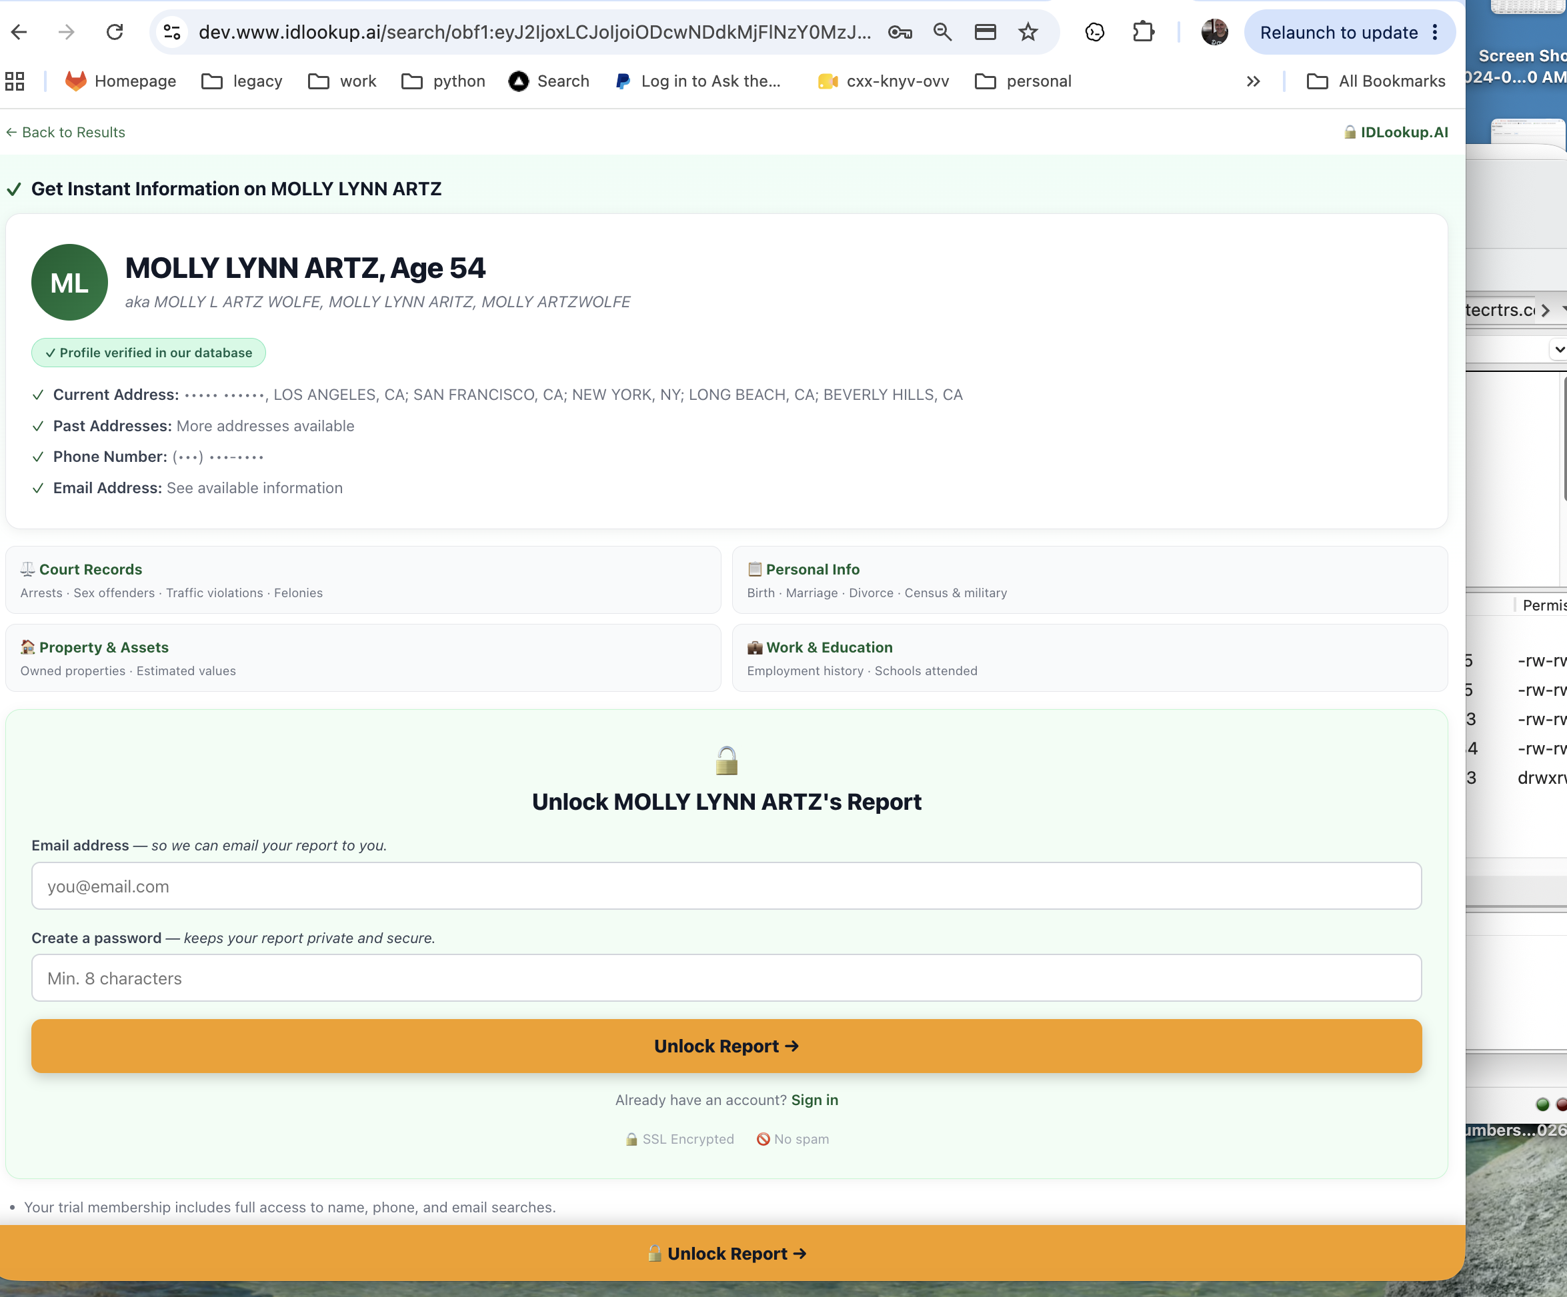
Desktop screenshot

Executive Summary
The page has a solid foundation: it feels credible, clean, and relatively trustworthy. The core issue is not layout or typography; it is the visual system. The current design relies too heavily on pale mint backgrounds, low-contrast borders, and similarly light surfaces. As a result, key information feels washed out and the eye does not naturally know where to go next.
Primary recommendation: keep the structure, but rebuild the surface system around neutral page backgrounds, white cards, stronger elevation, fewer borders, and more selective use of green. Use green for verified/secure/success states, not for broad layout containers. Preserve orange as the action color, but tune the sticky CTA so it supports rather than competes with the primary form CTA.

Scorecard
Area | Score | Comment
Overall visual design | 7.3 / 10 | Good base, but color and surface hierarchy weaken perception.
Trustworthiness | 8.5 / 10 | Clean and safe; could feel more premium with stronger hierarchy.
Typography | 8.4 / 10 | Mostly strong; refine emphasis around name/age and secondary text.
Color system | 5.8 / 10 | Too many pale green surfaces; insufficient contrast between zones.
Information hierarchy | 6.2 / 10 | Important sections have similar visual weight.
CTA prominence | 7.5 / 10 | Orange CTA is visible, but sticky bar is too dominant.
Consumer conversion | 7.1 / 10 | Could improve perceived value before signup with stronger result signals.

Main Diagnosis: The Page Is Too Light
The current page uses many surfaces with nearly the same luminance: white, off-white, mint, lighter mint, pale gray borders, gray text, and soft shadows. This produces a calm experience, but it also flattens hierarchy. When squinting at the page, the profile card, category cards, signup area, and sticky CTA compete rather than cascade.

Recommended Visual System

1. Replace broad mint surfaces with neutral backgrounds
- Use a very light neutral gray for the page background so white cards have clear separation.
- Reserve mint/green only for verified, secure, success, and database-confirmation states.
- Avoid placing green panels inside green-tinted regions; it reduces contrast and makes the signup form feel washed out.

Suggested Color Tokens
Token | Recommended Value | Use
Page Background | #F5F7FA | Overall page canvas
Surface / Card | #FFFFFF | Profile card, category cards, form card
Secondary Surface | #FAFBFC | Subtle nested areas only when needed
Primary Text | #111827 | Names, headings, CTA text
Secondary Text | #6B7280 | Aliases, descriptions, support copy
Accent Green | #15803D | Verified, checks, secure states
Success Tint | #ECFDF3 | Small verification/success badges
Action Orange | #F59E0B | Primary CTA only
Border | #E5E7EB at 50-70% opacity | Minimal separators

2. Reduce borders and rely more on elevation
- Remove most visible 1px card borders. Use either a soft shadow or a very low-opacity border, not both everywhere.
- For primary cards, use white surface + subtle shadow + no border, or border at rgba(17,24,39,0.06).
- Avoid repeated nested card treatments: border + rounded corner + shadow + tinted background on every module.

3. Rebalance green usage
- Current green appears in the hero, verification badge, signup panel, checkmarks, logo, and security affordances. This makes green stop carrying meaning.
- Use green primarily for trust: profile verified, checkmarks, secure/SSL language, and confirmation states.
- Do not use mint as the default section background. A neutral background will make the verification elements feel more intentional.

Section-by-Section Recommendations

Header / “Get Instant Information” band
- Reduce the green wash behind the headline or convert it to a neutral/white strip with a small verified/check accent.
- The headline is clear, but the mint band makes the whole top section feel like a success alert. Consider making this an informational header instead of a large green state.

Profile card
- Keep the profile card as the dominant content object. It should be pure white on a light neutral page background.
- Increase internal padding to 28-32px and make the card feel premium through spacing and shadow rather than border treatment.
- Use the empty desktop space to reinforce value: “27 records found,” “6 phone numbers,” “18 address records,” or “updated recently.”
- Make “Age 54” visually secondary to the name. It currently competes with the name because both share similar weight and scale.

Verification badge
- The current pill is too visually strong and looks somewhat interactive. Make it smaller and more informational.
- Recommended treatment: light success tint (#ECFDF3), 1px green border at low opacity, compact shield/check icon, medium-weight text.

Category cards
- The four category cards almost disappear because the borders are weak and the background is too close to the surrounding surface.
- Use pure white cards, subtle shadow, slightly stronger titles, and a small left-side accent line or icon container.
- Consider hover states on desktop: slight lift, border-color change, or icon color shift.

Signup / unlock panel
- This is the weakest section visually. The pale green panel is large and reduces contrast around the fields and CTA.
- Recommended: place the form in a white card, on the same neutral page background. Use a small lock icon and trust text for green/security cues instead of making the entire container green.
- The orange button should remain the strongest action element. Add a subtle shadow and darker hover state.

Sticky bottom CTA
- The sticky orange bar is too heavy and competes with the main CTA inside the form.
- Recommended: reduce height by 20%, or switch to a white sticky footer with an orange button inside it.
- Make it a reinforcement mechanism, not the primary visual object on the page.

Implementation Brief for Codex / Claude
Use this as a concise engineering/design prompt:
Refactor the IDLookup search-result detail/signup page visual system without changing the core layout. Replace broad mint backgrounds with a neutral page canvas (#F5F7FA). Make primary content cards white (#FFFFFF) with subtle shadow and minimal borders. Reserve green for verified/secure/success states only. Strengthen hierarchy by making the profile card the dominant object, category cards secondary, and signup form a clean white conversion card. Keep orange (#F59E0B) as the primary action color, but reduce the visual weight of the sticky bottom CTA. Standardize spacing to an 8-point grid and use design tokens for background, surface, text, border, green, success tint, and action orange.

Concrete CSS Token Starting Point
--color-page-bg: #F5F7FA;
--color-surface: #FFFFFF;
--color-surface-muted: #FAFBFC;
--color-text-primary: #111827;
--color-text-secondary: #6B7280;
--color-border-subtle: rgba(17, 24, 39, 0.08);
--color-green: #15803D;
--color-green-tint: #ECFDF3;
--color-orange: #F59E0B;
--shadow-card: 0 8px 24px rgba(17, 24, 39, 0.08);
--radius-card: 18px;
--space-1: 8px;
--space-2: 16px;
--space-3: 24px;
--space-4: 32px;
--space-6: 48px;

Priority Order
Priority | Recommendation
P0 | Change page background to neutral gray and convert main cards to white surfaces.
P0 | Remove broad mint backgrounds except verification/success states.
P0 | Reduce visible card borders; use subtle shadow and low-opacity borders.
P1 | Redesign signup panel as a white conversion card with orange CTA.
P1 | Reduce sticky CTA dominance.
P1 | Add stronger value signals inside the profile card.
P2 | Refine category card treatments with accent lines, icon containers, and hover states.
P2 | Normalize spacing to an 8-point grid.

Bottom Line
Do not redesign the whole flow yet. The fastest improvement is a surface-system pass: neutral background, white cards, fewer borders, less mint, stronger elevation, and clearer CTA hierarchy. This should make the page feel more premium, less washed out, and more conversion-oriented without requiring major product or layout changes.

