**ONLINE CAR LOAN SYSTEM**

**Design Phase**

Web Database Development

CSCI 5633-1

Fall 2018

**Group #1**

Arpit Jain – ID #15

Binjal D Patel – ID #1

Demaria Woods – ID #12

Thinh Q Tran – ID #7

Vanitha Rao – ID #24

**Table of Contents**

1. Requirements
2. Website Flowchart
3. Features
4. Sample Screenshots

**Requirements**

1. Who is the application for?

Answer: The Online Car Loan System is for people who need car loans.

1. What problems are you solving? What is it needed?

Answer: It makes the loan application processing easier. It eliminates the paper work in the present system. By providing this environment we can help to make their lives better. And develop long term relationships with the customers.

1. How do target users address the problem currently?

Answer: This environment provides easy life to people, by allowing options like they do not have to go to physical place for applying any loans.

1. How will your solution impact your users?

Answer: Users will get to informed about new exciting deals and offers. Making the interface more user-friendly, makes users lives easier.

1. What are their technical requirements or limitations?

Answer:

* Front End Design: HTML, CSS, JavaScript, AJAX, C#, ASP.NET
* Back End Design: SQL Server
* Operating System: Windows

1. When is it needed?

Answer: At the end of the semester.

1. How will it work?

Answer: There will be two modules: 1. Client 2. Administrator. Admin will take care of everything by managing all the information in the backend side.

**Website Flowchart**

Home

Apply Now

(Verify Account)

Sign In

Questions

Security

Rates

My Account

Loan Application

(Personal Info)

Recover Password

Logout

View Account Details

Edit Personal Details

Loan Application

(Enter Loan Info)

**Features**

Some of the features of the Online Car Loan System are,

* The users can browse through website.
* User must register his/her details.
* User receives the confirmation once the user is registered.
* Customer should login to see the loan details.
* If the login is successfully done, the customer is redirected to Account.
* Customer can retrieve the password by using “Recover My Password” and email will be sent to the registered email address.

**Sample Screenshots**

1. Sign In page:

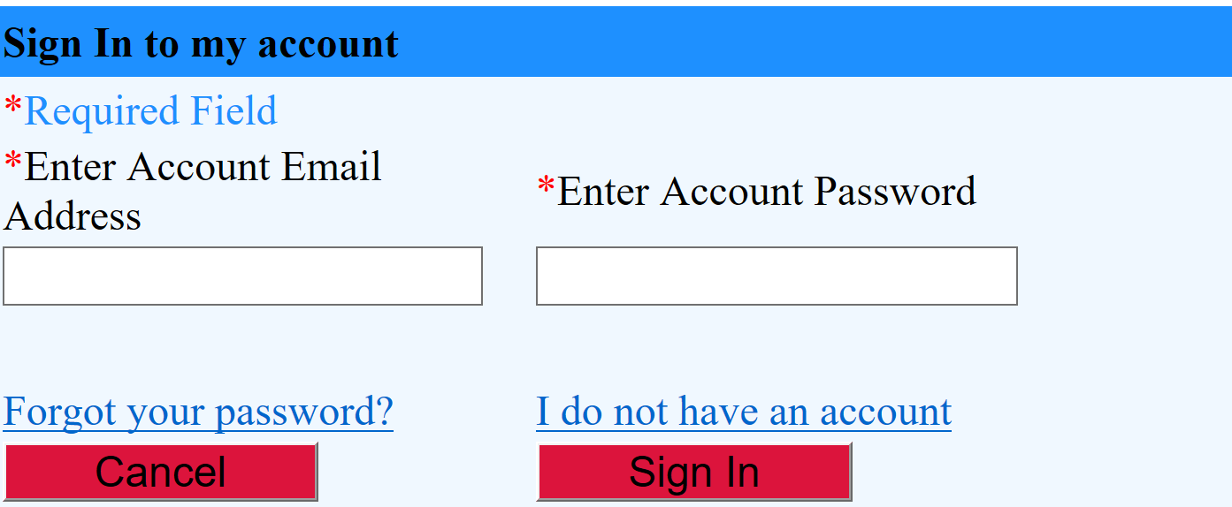

1. Rates Page:

