**Nama : Danang Tri Atmaja**

**NIM : 22.83.0826**

**Kelas : 22-TK02**

**PROGRAM PYTHON PARKIRAN**

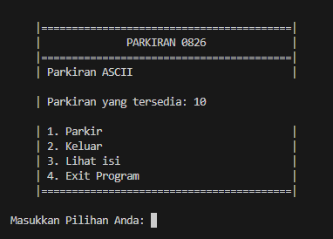

**Home Screen**



**Pilihan 1**

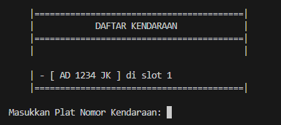

**Pilihan 2**

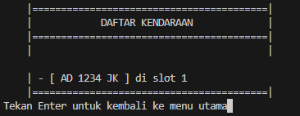

**Pilihan 3**

1. **Penjelasan Program**

Program ini ditujukan pada pintu masuk dan pintu keluar parkiran agar kendaraan tetap terdata dengan baik, ditambah dengan UI ASCII untuk meningkatkan user experience.

1. **Source Code**

import datetime

import time

import os

import numpy as np

max_parkiran = 10

parking_lot = np.zeros(max_parkiran, dtype=int) #numpy array lahan parkir

parked_vehicles = {}

log = {}

log_counter = 0

def main():

    while True:

        render_ui()

        choice = input("Masukkan Pilihan Anda: ")

        if choice == '1':

            park()

        elif choice == '2':

            render_parking_list()

            print()

            exit_parking()

        elif choice == '3':

            render_parking_list()

            input("Tekan Enter untuk kembali ke menu utama")

        elif choice == '4':

            exit_program()

        else:

            render_error("Inputan tidak Valid!")

            time.sleep(2)

def park():

    global max_parkiran

    if len(parked_vehicles) == max_parkiran:

        render_error("Parkiran Penuh!")

        time.sleep(2)

    else:

        plate_number = input("Masukkan Plat Nomor Kendaraan: ")

        print()

        plate_number = plate_number.upper()

        if plate_number in parked_vehicles:

            render_error("Kendaraan dengan Plat Nomor tersebut sudah terparkir!")

            time.sleep(2)

            return

        parking_slot = np.where(parking_lot == 0)[0][0]

        parking_lot[parking_slot] = 1

        parked_vehicles[plate_number] = parking_slot

        print("Kendaraan", plate_number, "telah diparkir di slot", parking_slot + 1)

        max_parkiran -=1

        time.sleep(2)

def exit_parking():

    global log_entry, max_parkiran

    if len(parked_vehicles) == 0:

        render_error("Tidak ada kendaraan yang terparkir di parkiran")

        time.sleep(2)

    else:

        plate_number = input("Masukkan Plat Nomor Kendaraan: ")

        print()

        plate_number = plate_number.upper()

        if plate_number not in parked_vehicles:

            render_error("Kendaraan tidak terparkir di parkiran")

            time.sleep(2)

            return

        parking_slot = parked_vehicles[plate_number]

        parking_lot[parking_slot] = 0

        del parked_vehicles[plate_number]

        print("Kendaraan", plate_number, "telah keluar dari parkiran")

        print()

        log_parking_event(plate_number)

        log_exit_event(plate_number)

        print('Biaya : Rp.',log_entry['Biaya'])

        print()

        input ("Tekan enter untuk lanjut.")

        max_parkiran +=1

def get_cost(enter_time, exit_time):

    parking_duration = exit_time - enter_time

    parking_hours = parking_duration.total_seconds() / 3600

    parking_rate_per_hour = 3000

    parking_rate_much = 5000

    if parking_hours <= 1:

        parking_cost = parking_rate_per_hour

    elif parking_hours > 1:

        parking_cost = parking_rate_much

    return parking_cost

def render_ui():

    clear_screen()

    menu = '''

    |=========================================|

    |              PARKIRAN 0826              |

    |=========================================|

    | Parkiran ASCII                          |

    '''

    print(menu)

    print("    | Parkiran yang tersedia:", max_parkiran)

    lanjut = '''

    | 1. Parkir                               |

    | 2. Keluar                               |

    | 3. Lihat isi                            |

    | 4. Exit Program                         |

    |=========================================|

    '''

    print(lanjut)

def render_error(message):

    clear_screen()

    error = '''

    |=========================================|

    |                 ERROR                   |

    |=========================================|

    |      ______                             |

    |     |  ____|                            |

    |     | |__    _ __  _ __  ___   _ __     |

    |     |  __|  | '__|| '__/ _ \ | '__|     |

    |     | |____ | |   | | | (_) || |        |

    |     |______||_|   |_|  \___/ |_|        |

    |=========================================|

    '''

    print(error)

    print(message)

def render_exit():

    clear_screen()

    exit = '''

    |=========================================|

    |             TERIMA KASIH                |

    |=========================================|

    |                                         |

    |    Terima kasih atas kunjungan Anda     |

    |=========================================|

    '''

    print(exit)

def render_parking_list():#fungsi menampilkan list kendaraan yang terparkir

    clear_screen()

    list_park = '''

    |=========================================|

    |            DAFTAR KENDARAAN             |

    |=========================================|

    |                                         |

    '''

    print(list_park)

    if len(parked_vehicles) == 0:

        print("    |            Parkiran Kosong !            |")

    else:

        for plate_number, parking_slot in parked_vehicles.items():

            print("    | - [", plate_number, "] di slot", parking_slot + 1)

    print('    |=========================================|')

def exit_program(): #fungsi keluar program dan menampilkan data data yang telah tersimpan

    render_exit()

    time.sleep(3)

    clear_screen()

    for log_entry in log.values():

        print('Plat:', log_entry['Plat'],'=====> Rp.', log_entry['Biaya'])

        print()

    input("Tekan tombol apapun untuk mengakhiri")

    exit()

def clear_screen(): #Fungsi memperbarui CLI

    os.system('cls' if os.name == 'nt' else 'clear')

def log_parking_event(plate_number):

    global log_counter, log_entry

    log_counter += 1

    log_entry = { #Dictionary menampung log keluar & masuk kendaraan

        'Plat': plate_number,

        'Waktu Masuk': datetime.datetime.now()

    }

    log[log_counter] = log_entry

def log_exit_event(plate_number):

    global log_counter

    log_entry = log[log_counter]

    log_entry['Waktu Keluar'] = datetime.datetime.now()

    masuk = log_entry['Waktu Masuk']

    keluar = log_entry['Waktu Keluar']

    log_entry['Biaya'] = get_cost(masuk, keluar)

main()

1. **Referensi**
2. <https://www.anandanesia.com/menghitung-waktu-dan-biaya-parkir-dengan-python/>
3. <https://srirahayuuu.blogspot.com/2016/10/python_11.html>
4. <https://www.erikadielsson.com/program-menghitung-biaya-parkir-python/>