|  |
| --- |
| **DMP Greater Bay Area Industrial Expo 27-30/11/2023** |

**Interpreter/Receptionist Application Form**

Company Name: Booth Number:

Contact Person: Tel:

Signature or Stamp: Email:

**Please send this form to** [**joanna.zhou@eshowyz.com**](mailto:joanna.zhou@eshowyz.com)

|  |  |  |  |  |
| --- | --- | --- | --- | --- |
| **Language** | **Daily Rate**  **(RMB)** | **Number Required** | **Gender** | **Date** |
| Chinese/English | 800 |  |  |  |
| Chinese/Japanese、Korean | 1,300 |  |  |  |
| Chinese/French | 1,400 |  |  |  |
| Chinese/German | 1,400 |  |  |  |
| Chinese/Russia | 1,400 |  |  |  |
| Chinese/Italian | 1,500 |  |  |  |
| Chinese/Spanish | 1,500 |  |  |  |
| Receptionist/hostess/model | Starting from 700 |  |  |  |

**Receiver’s Bank:**

A/C Name: ESHOW Exhibition Services Co., Ltd

A/C No.: 3602 0150 0920 1164 277

BANK NAME: INDUSTRIAL AND COMMERCIAL BANK OF CHINA

GUANGZHOU YUEXIU BRANCH

BANK ADD.: 1F N 2F, REGAL COURT, NO.550-560, TIAN HE BEI LU, TIANHE DISTRICT,

GUANGZHOU, GUANGDONG, CHINA, P.R.

POST CODE: 510630

CNAPS No.: 102581000249

SWIFT CODE: ICBKCNBJGDG

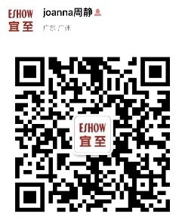

**For more information, please contact:**

Joanna Zhou

ESHOW Exhibition Services

Email: [joanna.zhou@eshowyz.com](mailto:joanna.zhou@eshowyz.com)

Mobile: +86-159-1581-1021

Website: [www.eshowyz.com](http://www.eshowyz.com)