Grid Peclet Number
The Peclet number is a non-dimensional term which compares characteristic time for diffusion (dispersion) given a length scale with the characteristic time for advection.
The wiggles start at mesh Peclet number above 2 (Unger A.J.A, Forsyth ,P.A. 1995) and the problem becomes more severe when the Peclet number increase.

Courant Number
Courant-Friedrichs-Lewy number, This parameter gives the fractional distance relative to the grid spacing traveled due to advection in a single time step
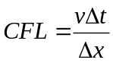
With Fourier error analysis it can be shown no matter a scheme (except fully implicit methods) is, it can not advect a wave more than one grid in each step

Diffusion number
A similar expression may be derived for systems characterized by purely diffusion transport , giving rise to diffusion number:
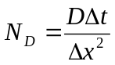
N_{D}<1

Amplitude and Phase error

