Handling Dirichlet Boundary Condition
We want to compute the following equation in the left boundary:
The terms with superscript “n” are known from previous step, and terms with superscript “n+1” must go to the left hand side (stiffness matrix).
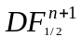= is unknown and it should be computed base on Dirichlet boundary c*
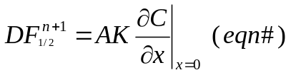 and, C(x=0) = c*(known)

x
t
n
n+1
C1
C3
C2
C*

1- C(x) = a + bx+dx² (quadratic)
what we need is 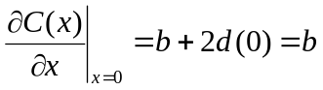
1-at x=0 → c(0) = a+ b(0)+d(0) =a=c*
2-at x=1/2 → c(1/2) = c* +b/2+ d/4
3-at x=3/2 → c(3/2) = c*+3b/2+ 9d/4 where b, d, c(1/2) and c(3/2) are unknown
If we eliminate d between equations 2, and 3 regardless of time.
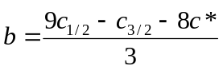
The only known value in the above is c* = c at the boundary, by replacing this in (eqn #) we may compute the changes in coefficient and right hand side matrices
2- C(x) = a + bx (linear)
what we need is 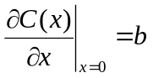
- at x=0 → c(0) = a + b(0) = C*
- at x=Δx/2 → c(1/2) = a +bΔx /2 =C* + bΔx /2
- b = (2c(1/2) – 2C* )/ Δx
where b and c(1/2) are unknowns and C* is value on the boundary
I have two questions:
1- Could you please refer me to the reference for discussion on why linear implementation of the boundary is not polluting the 2nd order scheme? (I was not able to find this implementation in my 4 CFD books)
2- Please take a look at diffuse subroutine, don’t you think the above implementation (regardless of whatever it is, linear or quadratic) must go to the unknown side (stiffness matrix), shouldn’t we add a subroutine into the code which imposes the BC on stiffness matrix and right hand side?

Recasting for FVM point of view instead of FDM

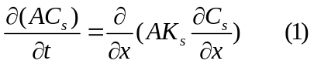

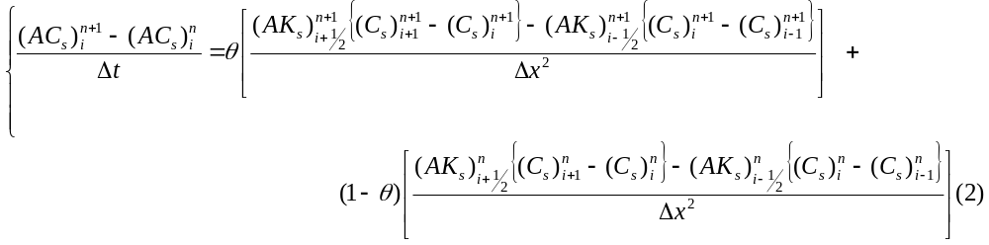

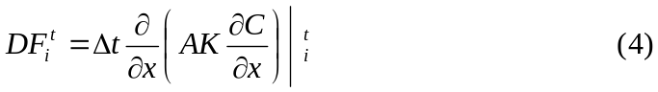
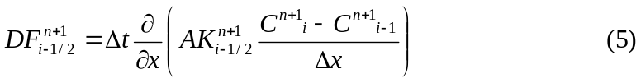

In our coding we named term 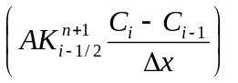the Interior Diffusive Flux
Explicit diffusive operator is 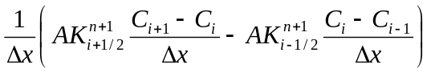

So the right hand side is

Neumann Boundary Condition
In case of Neumann boundary condition we may replace Interior Diffusive Flux at low side on cell one and high side of the last cell (ncell) with AK (given flux).

Dirichlet Boundary Condition
For the left boundary, 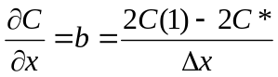

For the right boundary, 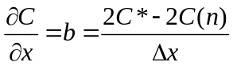

Middle line of matrix is:
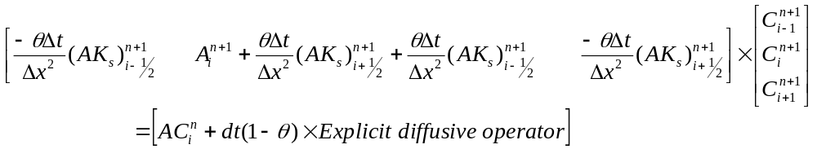

First line of the matrix is:

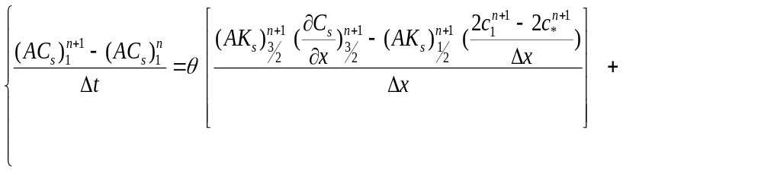
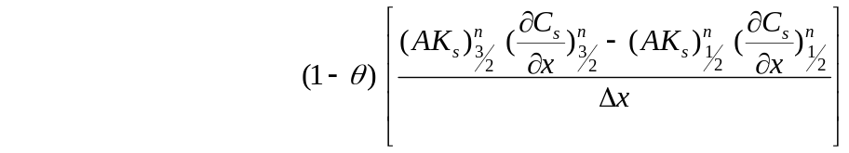
Which results:
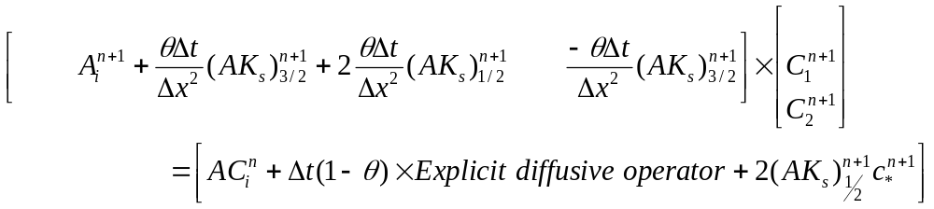
Last line of the matrix is (m is number of cells):

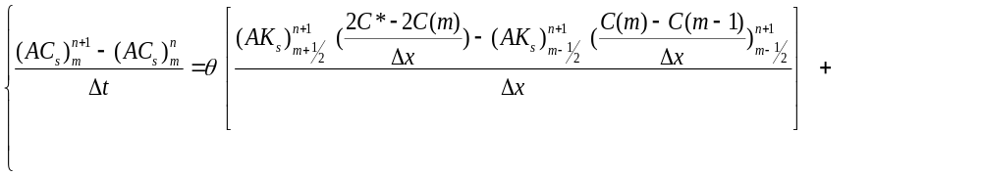
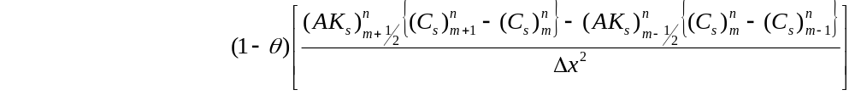
Which results:
