Solution by Zoppou and Knight 1997
- 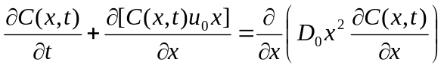 (1)
Subjected to
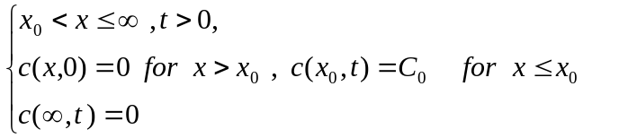
Solution is
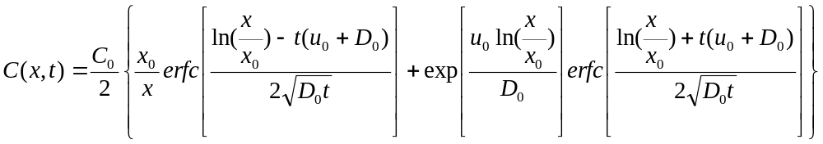(2)
Solution by Marsily (1986)
- 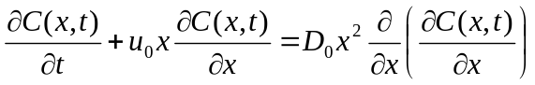 (3)
Subjected to
The above have a singularity at x=0, Substitution y=ln(x)
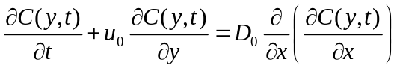 (4)
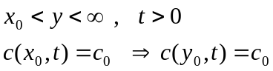
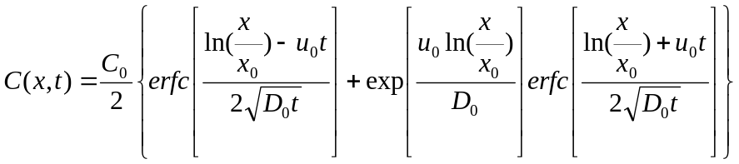 (5)
We are seeking for an analytical solution for the mass conservative form
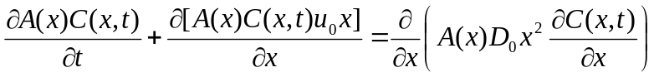 (6)
In which the continuity equation is also satisfied
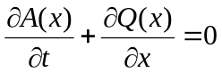 (7)
Let’s assume
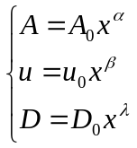 (8)
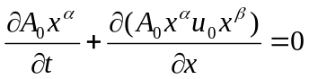 (9)
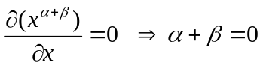(10)
If we inseart the (8) in the (6) we have:
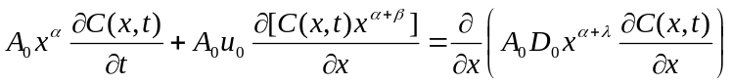 (11)
(12)
Divide by 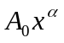
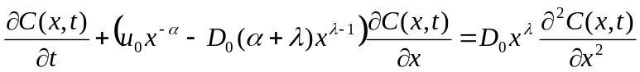 (13)
So if we chose 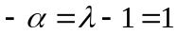 we will recast the (13) in the form of (5)
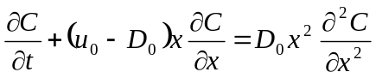 (14)
So the solution for the mass conservative advection diffusion equation with spatially variable coefficient
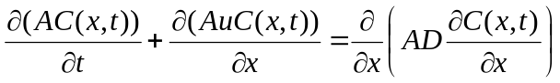 (15)
With
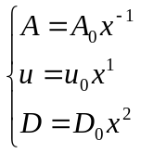
Subjected to the boundary condition of (5) is as follows
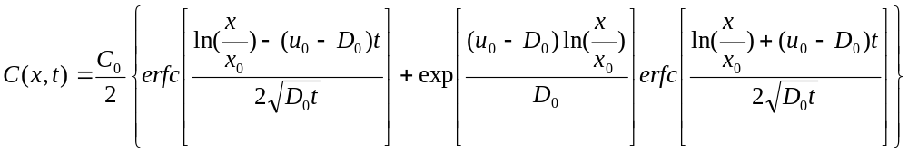(16)
(16)
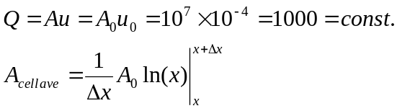
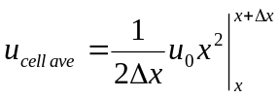
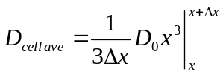
Cell average Concentration
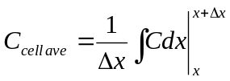
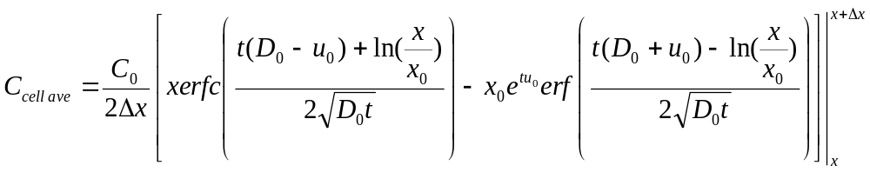
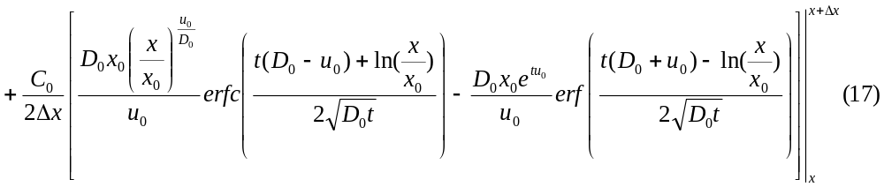
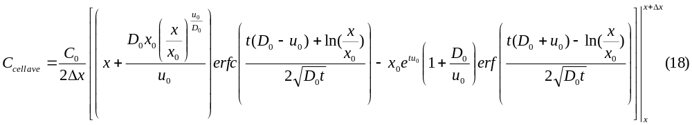

clear all
clc
close all

c0 =3;
x0 = 4096;
xl = x0 + 2048;
nt = 2^10;
nx = 256;
dx =(xl-x0)/nx;
u0 =.3*10^-3;
d0 =10^-4;
start_time = 4096;
end_time = start_time + 4096;
dt = (end_time - start_time)/nt ;
c=zeros(nx,nt);

Umax = u0 * xl
diffusion_coef = d0*x0^2
CFL = Umax / (dx/dt)

for i=1:nx;
x = x0+(i-0.5)*dx;
for j=1:nt;
t = start_time + (j-1)*dt;
c(i,j)=(c0/2)*((x0/x)*erfc((log(x0/x)-u0*t)/(2*sqrt(d0*t)))+...
exp(u0*log(x0/x)/d0)*erfc((log(x0/x)+u0*t)/(2*sqrt(d0*t))));
end
end
plot(c(:,1))
hold on
plot(c(:,nt/2),'r')
plot(c(:,nt),'k')
legend('t=0','t=T/2','t=T');

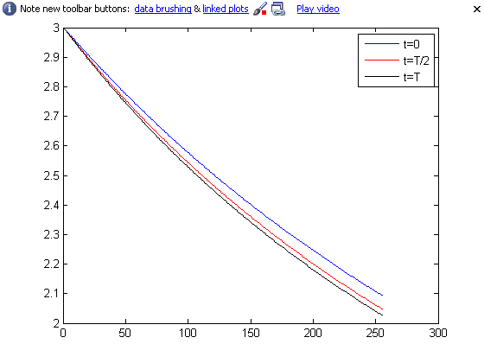
Umax = 1.8432
diffusion_coef = 1.6777e+003
CFL = 0.9216

