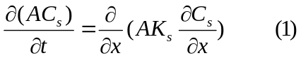

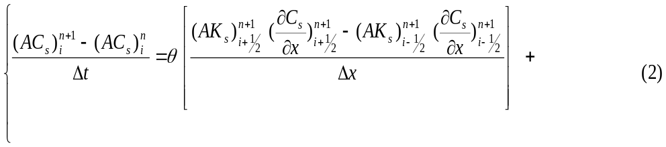
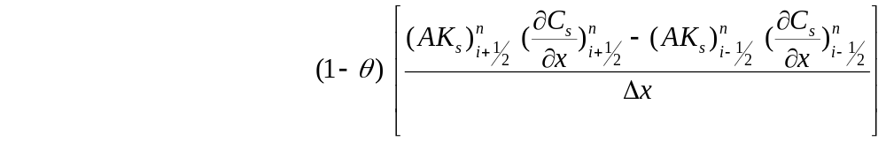
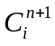
is unknown in (eq.2) and other terms are known from hydro/measurement/previous step.
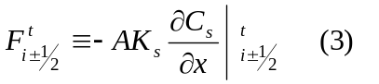

In which F is diffusive flux Re-writing (eq. 2) yields:
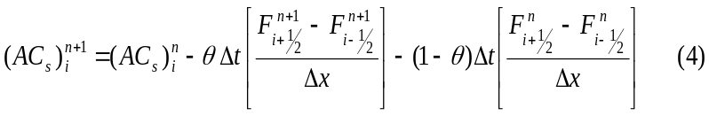
For Boundary condition:
- Neumann Boundary condition implementation

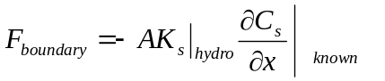

Just by replacing F in the first and last diffusive flux Neumann Boundary condition will be implemented

Middle row will be:
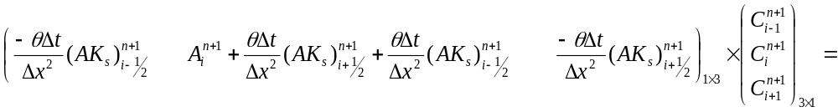
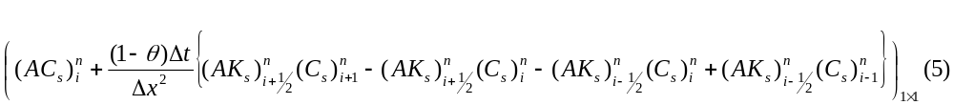
- Middle row:
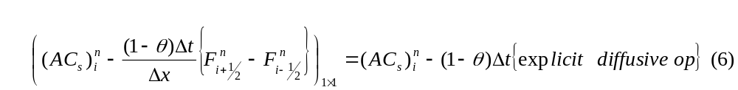

- First row: i=1
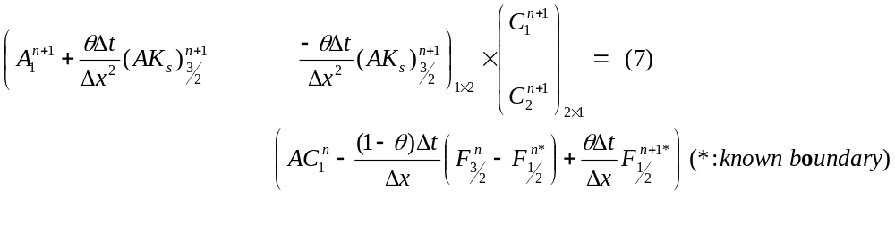

(May be it would be better to have F and F_prev?!?!?)

- Last row: i=m
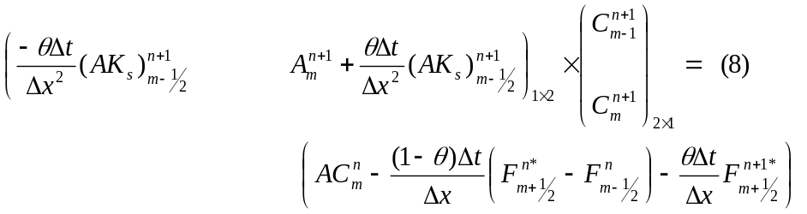

- Dirichlet Boundary condition implementation
We assume the C is known on the face of first/last cells (edges of channel)

x
t
n
n+1
C1
C3
C2
C*

1- c(x) = a + bx+dx² (quadratic)
what we need is 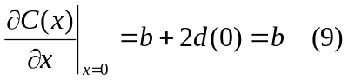
1-at x=0 → c(0) = a+ b(0)+d(0) =a=c*
2-at x=Δx /2 → c(1/2) = c* +bΔx /2+ dΔx /4
3-at x=3Δx /2 → c(3/2) = c*+3bΔx /2+ 9dΔx /4
where b, d, c(1/2) and c(3/2) are unknowns.
If we eliminate d between equations 2, and 3 regardless of time.
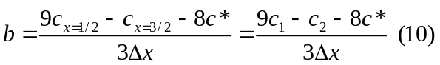
The only known value in the above is c* = c at the boundary, by replacing this in (eqn #) we may compute the changes in coefficient and right hand side matrices
2- c(x) = a + bx (linear)
what we need is 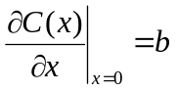
- at x=0 → c(0) = a + b(0) = c*
- at x=Δx/2 → c(1/2) = a +bΔx /2 =c* + bΔx /2
- b = (2c(1/2) – 2c* )/ Δx
where b and c(1/2) are unknowns and C* is value on the boundary

Dirichlet Boundary Condition
For the left boundary, 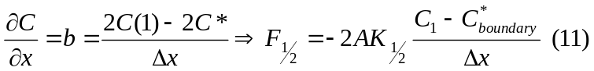

For the right boundary, 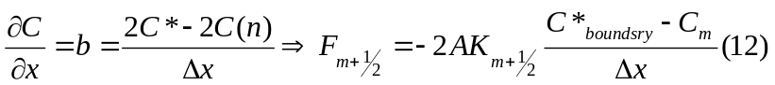
- Middle row: is the same as previous case
- First row : i=1
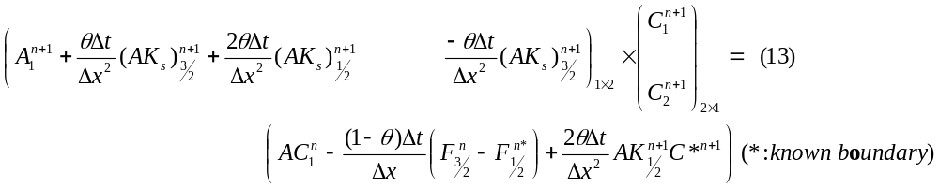
- Last row: i=m

