Main tests:
  - Advection

    - Test_advection_convergence_tidal:
Testing advection error norms convergence rate of mass which is subjected to a tidal boundary for three different mesh sizes verus an analytical solution.

    - Test_advection_convergence_uniform:
Testing advection error norms convergence rate of mass which is subjected to a tidal boundary for three different mesh sizes by sending back and then forth uniform flow.

  - Diffusion
    - Test_diffusion_convergence_single_channel:
Testing diffusion error norms convergence rate of a guassian spike of mass which is subjected to zero flux boundary for three different mesh sizes.

    - Test_diffusion_nuemann_dirichlet:
Testing diffusion error norms convergence rate of aanaliticalfunction of mass which is subjected to Nuemann boundary condition at the low side and Dirichlet boundary condition at the high side, for three different mesh sizes.

  - Source
    - Linear decay:
Testing a first order linear decay of mass in the absence of diffusion and advection, and comparison with the analytical solution.
    - Advection and Liner decay :
Testing a first order linear advection- decay of mass in the absence of diffusion, comparison of results with analytical solution.
  - Advection-Diffusion-Reaction:
Testing of ADR versus analytical solution.

Subroutine tests
    - Coarsen:
Routine for grid refinement/coarsening operations, the routine aids convergence test.
    - Error Metric:
Routine for calculating the L-1, L-2, and L-infinity measures, which is used to accompany convergence tests.
    - Example initial condition:
It can fill an array with 1D Gaussin function, rectangular, and triangular, and also fill discountiuity in a given array.
    - Log convergence:
Prints out the resuts of a convergence tests.
    - Test boundary diffusive flux:
Tests subroutine boundary diffusive flux versus hardwired values.
    - Test coarsen:
tests the coarsen subroutine versus hardwired values.
    - Test construct right hand side:
Tests construction of right hand side vector (force vector) versus hard wired input values.
    - test example initial condition:
Tests the subroutines fill Gaussian, fill triangular, fill rectangular, and fill discountinuity.
    - test extrapolate:
Tests the extrapolation part of the predictor step of the advection algorithm. And Compute upwind value of fluxes. The reference values are hard wired.
    - test gradient:
Test the subroutine of flux limeters versus hand calculted values.
    - test interior diffusive flux:
Tests the diffusion flux subroutine inside the diffusion routine.
    - test matrix solver:
Tests for matrix solver library in the diffusion routine.
    - test_prim_cons_conversion:
Testing of primitive-conservative conversion for advection routine.
    - Test prim_increment_to_conservative:
Test for subroutine primitive increment to conservative

Appendices

Analytical solution of tidal forcing in a rectangular basin
Governing equation in 2D (X-Z):
1-Continuity
Assumptions:
- u, is not function of z but vertical velocity w is a function of z
- H is constant
- Ζ << H
2- Momentum
Assumptions:
- Inviscid fluid ( interfacial and bottom friction are neglected)
- Ρ=constant
- Non-rotating reference frame (f=0)
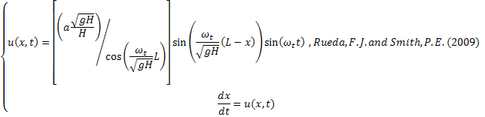
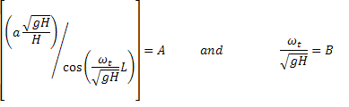
Integration will result in:
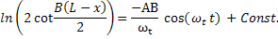
Subjected to the boundary condition u(L,t)=0
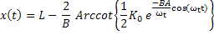
K₀ must be calculated base on boundary conditions
@t=0 : 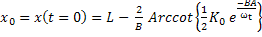
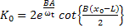 and x₀=0 domain from 1 to L?????
If L = 409600 m , H = 16m, g =9.8, a=0.5 m and ω=2pi/12.4 hr =0.506708 1/hr
A=0.4188704167062 and B=0.040465522644
K₀= 2.0680331617614*…=10.066637844459

  - The Advection Diffusion Reaction equation:
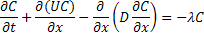
Has an analytical solution of:
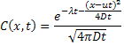
  - The diffusion equation has the analytical solution as follows:

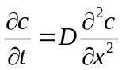
will be solved in the spatial interval 0.1 ≤ x ≤ 1 using the following Neumann boundary condition at
x = 0.1:
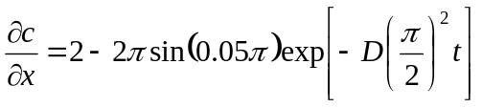
and a Dirichlet boundary condition of C = 2 @ X = 1. The dispersion models were tested for two incremental spatial spans between 3 to 192 and 25 to 3200 (number of volumes), inclusive, using a dispersivity of D = 1 and time spans and theta which guarantees stability. The results were compared against the following analytical solution to find the error. Then the three norms of error where calculated to perform test convergence and accuracy order tests
