Method of Manufacture Solution (MMS)

Basic concept
The method of manufactured solution (MMS) is a general approach to provide a certain analytical solution of the governing equation for question of model testing and verification of non-linear numerical models in rigorous procedure.
It is ideal to test a model’s correctness by comparing its numerical results with analytical solutions, however the difficulty is there is not a general non-linear solutions for the boundary value problem. Since only the numerical method is to be tested (not the physics of the problem) it would be effective if arbitrarily made non linear function can be used in model verification. The exact solution which is manufactured in this method should not necessarily be realistic, because the verification is a purely mathematical process. We want a benchmark solution that is non-trivial but analytic, and that exercises all ordered derivatives in the error expansion and all terms.
The basic concept of the MMS is to compare the correctness of CFD solvers using arbitrary manufactures function.
Let the differential equation be expressed as
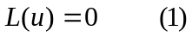
in which L denotes the differential operators and u is the variable to be solved. When a manufactures function φ is substituted into the differential equation, one would have:
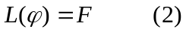
Since φ is not the solution of differential equation, the non-zero F is obtained analytically when solved numerically, the solution of this equation would be forced converge to φ with the analytical forcing term F being added to the mathematical equation of the numerical model.
The verification of a numerical model is simple because the solution of equation (2) is known: one needs only compare the difference of the manufactured analytical function, φ, and the numerical solution of equation (2). Although the function φ can be manufactured arbitrarily, it has to be non-trivial for all the terms of the involved mathematic equations to make meaningful verification tests. MMS does not require the satisfaction of any particular boundary condition other than those defined by φ along the boundaries of computational domain.

Manufactured solution for DSM2-STM verification
Governing equation:
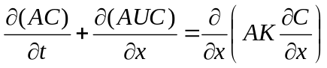
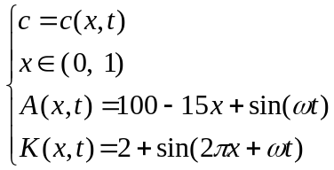
Subjected to the boundary condition:
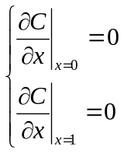
And initial condition
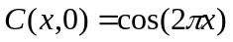

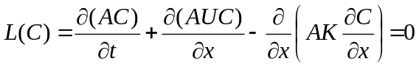
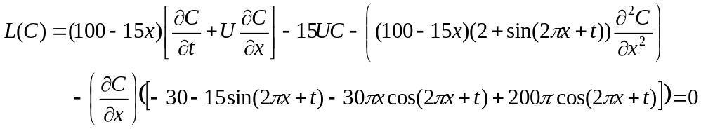
The above is governing equation in a very general form (both area and dispersion coefficient are function of time/space), since the method of manufactured solution is a general concept, any solution for C can be picked regardless of the governing equation
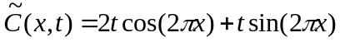//////////////////////////////////
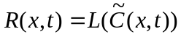
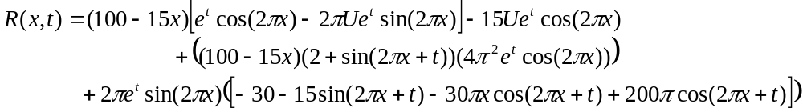
So the modified equation is:
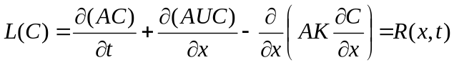
Subjected to the initial condition:
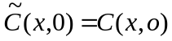
And the Neumann - Neumann (no out flow gradient) boundary condition:
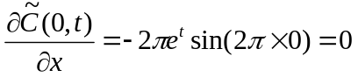
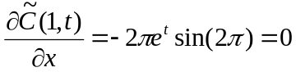
For this time dependent solution boundary values are not time dependent

Application to verification of codes

Once a non-trivial exact analytical solution has been manufactured, the solution is now used to verifying a code by performing systematic discritization convergence tests (Usually, grid convergence tests) and monitoring the convergence as Δ→0, where Δ is a measure of discritization (e.g., Δx , Δt in a FDM or FVM code).
The principle definition of “order of convergence” is based on behavior of the error of discrete solution. There are various measures (L₁, L₂, L∞), but in some sense we are always referring to the difference between discrete solution f(Δ) and the exact continuum solution
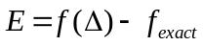
For an order p method, and for a well-behaved problem, the error in the solution E asymptotically will be proportional to 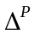. This terminology applies to every “consistent” methodology regardless of solution smoothness, thus
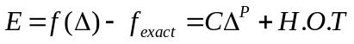
where H.O.T are higher order terms. That’s to say for smooth problems it may be possible in principle to evaluate the coefficient C and the H.O.T from the continuum solution, but as a practical matter do not do this in the accuracy verification procedure. We then monitor the numerical error norms as the grid is systematically refined. Theoretically values of 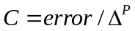 should become constant as the grid is refined for a uniformly p-th order method.

