Sediment transport related variables are as follows (some variables are included in more than one category):
- Fluid Mechanics and Hydraulics
- Sediment Properties
- Bed load transport
- Bed forms
- Suspended load
- Cohesive sediment

Variable | Dimension |  | Description | Spatial | Temporal
Fluid Mechanics and Hydraulics For Sediment Transport
ρ | ML⁻³ |  | Water density | f(salinity) | f(salinity)
g | LT⁻² |  | Gravitational acceleration | Const | Const
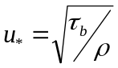(or bed shear stress) | LT⁻¹ |  | Shear velocity | Var | Var
κ | --- |  | von Karman's constant | Const | Const
ν | L²T⁻¹ |  | Kinematic viscosity of water | f(salinity) | f(salinity)
k_{s} | L |  | Effective roughness height (Nikuradse roughness length) | Var | Var
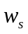 | LT⁻¹ |  | Settling velocity | Assume Const. f(ρ) | Assume Const.
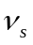 | LT⁻¹ |  | Sediment fall velocity | Assume Const. | Assume Const.
S | --- |  | Bed slope | Assume Const. (No update in geometry) | Assume Const.
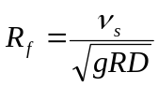 | --- |  | Dimensionless fall velocity | Assume Const  -R, ρ | Assume Const  -R, ρ
u | LT⁻¹ |  | Velocity | Var | Var
H | L |  | Depth | Var | Var
τ_{b} =ρgHS (or shear velocity) | ML⁻¹T⁻² |  | Bed shear stress | Var | Var
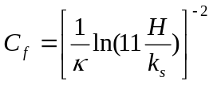 | --- |  | friction coefficient for calculating H_{S} | Var | Var
Fr | --- |  | Froude number | Var  Switch between bed load formulas | Var
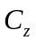(or n) | 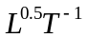 |  | Chezy coefficient | Var | Var
n (or ) | 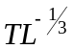 |  | Manning’s n | Var | Var
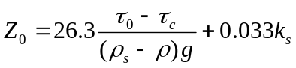 | L |  | Roughness length parameter | Var | Var
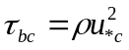 (or u*) | ML⁻¹T⁻² |  | Critical shear stress for initiation of motion | Var | Var
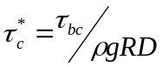 | --- |  | Dimensionless Critical shear stress | Var | Var
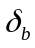 | L |  | Bed load-layer height | Var (?) | (?)
Δ | L |  | Bed form height | Assume Const. | Assume Const.
λ | L |  | Bed form length | Assume Const. | Assume Const.
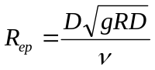 | --- |  | Particle Reynolds number | Var | Var
Sediment Properties
R= ρ_{s}/ ρ -1 | --- |  | Submerged specific gravity | Assume Const. | Assume  Cont.
D_{i} | L |  | Particle diameter | Var | Var
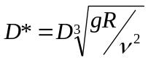 | --- |  | Dimensionless particle number | Var | Var
D₉₀ | L |  |  | Var | Var
D₅₀ | L |  |  | Var | Var
ρ_{s} | ML⁻³ |  | Sediment density | Const. | Const.(?)
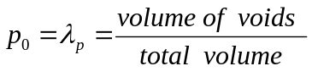  Or void ration | --- |  | Porosity | Const. | Const. (?)
V_{s} | L³ |  | Sediment Volume | Var | Var
γ_{s}= ρ_{s} × g | ML⁻²T⁻² |  | Specific weight | Const | Const
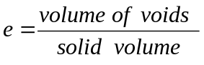  or porosity | --- |  | Void ratio | Assume Const | Assume  Const
ø | --- |  | Angel of repose | Const | Const
α | --- |  | Transverse bed slope | Const | Const
Bed load transport
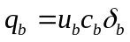 | L²T⁻¹ |  | The volume bed load transport rate per unit width | Var | Var
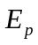 | LT⁻¹ |  | Eroded volume of particles per unit bed area per unit time | Var | Var
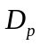 | LT⁻¹ |  | Deposited volume of particles per unit bed area per unit time | Var | Var
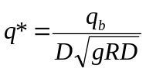 | --- |  | Einstein bed load number (dimensionless bed-load transport rate) | Var | Var
L_{S} | L |  | Particle step size | Var | Var
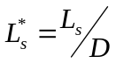 | --- |  |  | Var | Var
Bed forms
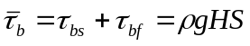 | ML⁻¹T⁻² |  | Effective boundary shear stress | Var | Var
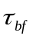 | ML⁻¹T⁻² |  | Shear stress due to form drag | Var | Var
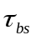 | ML⁻¹T⁻² |  | Shear stress due to skin friction | Var | Var
H_{s} | L |  | Depth in absence of bed form with same velocity | Var | Var
H=H_{s}+H_{f} | L |  |  | Var | Var
Suspended load
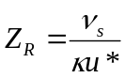 |  | --- | Rouse dimensionless number | Var | Var
C_{b} |  | --- | Near bed concentration | Var | Var
C |  | --- | Concentration | Var | Var
b |  | L | The height at which C_{b} is to be evaluated | ? | ? percent of H?
B |  | L | Channel width | Assume  Const. | Assume  Const.
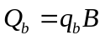 |  | L³T⁻¹ | Bed-load transport rate
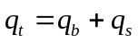 |  |  | Total volume transport | Var | Var
S_{f} |  | --- | Friction slope (energy slope) | Var | Var
S or S₀ |  | --- | Bed slope | Assume  Const | Assume  Const
Cohesive sediment
W_{s} |  | L T⁻¹ | Settling velocity | Var | Var
e_{N} |  |  | Erosion rate constant | Var | Var
T |  | θ | Absolute temperature | Assume  Const. | Assume  Const.
d_{m} |  | L | Representative mixture diameter | Var | Var
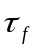 |  | M L⁻¹T⁻² | Floc strength (Pa) | Assume  Const. | Assume  Const.
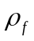 |  | ML⁻³ | Floc density | Assume  Const. | Assume  Const.

