Scaling of Advection Diffusion Reaction Equation for Sediment Transport

The equation of transport of sediment in suspension is as follows:

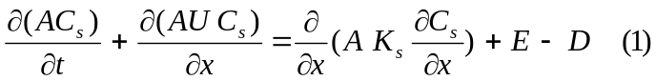
where:
A: cross section area
C_{s}: concentration of sediments
U: flow velocity
K_{s}: dispersion coefficient
E: entrainment (source)
D: deposition (sink)

Area
In the Delta A~(small 30×3 m²)
A~(medium 80×5 m²)
A~(large 1000×10 m²)

C
Range between 5- 100 mg/L or give in dimensionless (Volume/Volume)
G =2.65 → 100 mg solid particle = 37.7 cm³
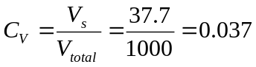
That’s to mention the governing equation (1) is not valid for non dilute mixtures (C_{v}<0.05 by Julien and C_{v}<0.04 by Bombardelli).

U
In a tidal channel U=(0.2 to 2m/s)~ 1 m/s

- Ks Longitudinal dispersion coefficient for river
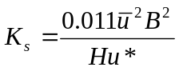 (Abbott 1993)
B: river width
H: flow depth
S ~ 0.001 (in the mountains, Red Bluff 0.005 and near the Suisun bay 0.0002 for example Colorado River is 0.000217)
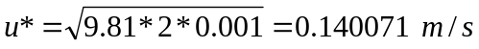
Slope is reduced as a river approaches estuary and get far from the mountains, meanwhile the depth of flow is increasing so the u* is not varies to much. As a rule of tomb u* could be considered 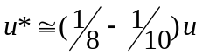
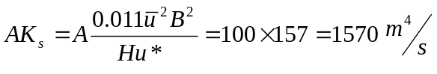
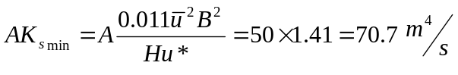
- Sink and Source (reaction) terms
Let’s assume deposition/erosion is zero and we have only erosion/deposition to get the maximum possible values.
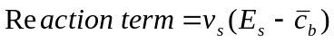
Range of particle size for suspended load (Jansen et al. 1979)
d = 0.003 mm to 0.05 mm (the usual range of suspended load, but that is to mention in flood events the maximum value of suspended load which had been measured was 0.2 mm or fine sand [Vanoni 1975])
The settling velocity will be (temperature assumed 10 ˚C)
V_{s} ≈ 0.00003 m/s to 0.0101 m/s
E_{s} ~ 10⁻³ to 10⁻¹ (Garcia and Parker 1991, 1993)
E_{s} is highly non-liner function

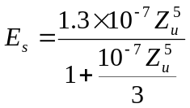
Z_{u} ~ 5-20 (page 118 Garcia’s book)

So entrainment max ~ 0.0101 m/s × 10⁻¹= 1.0×10⁻³
And deposition max ~ 0.0101 ×0.037 =- 3.7×10⁻⁴
Reaction variation range ~ ( +1.0×10⁻³ to -3.7×10⁻⁴ )
- Dimensionless numbers
  - Peclet Number;
Let’s assume the length scale is dx =1000 m (Is it correct?)
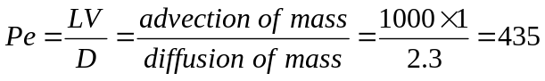
  - DamKohler Number
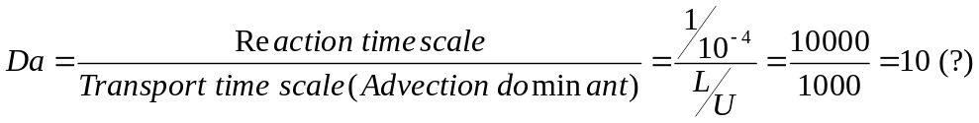
The other important restriction is λdt (λ: reaction rate) must be smaller that 0.01 to dissipate relative mass error in case of direct splitting and smaller than 0.1in case of alternate splitting method. So in case of direct splitting dt <100 sec, and dt < 1000 sec (15 min) in case of alternate splitting

