Numerical solution of the equation of sediment transport in suspension

Fabián A. Bombardelli and Kaveh Zamani
Department of Civil and Environmental Engineering
University of California, Davis.

A: Splitting of the Advection-Dispersion-Sink/Source Equation

The equation of transport of sediment in suspension is as follows:

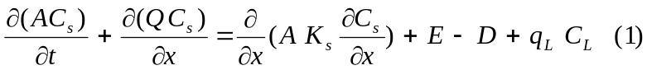
where
A: cross section area
C_{s}: concentration of sediments
Q: discharge
K_{s}: dispersion coefficient
E: entrainment (source)
D: deposition (sink)
q_{L}: lateral discharge
C_{L}: lateral flow concentration

The equation of sediment transport in suspension is mathematically an Advection-Diffusion-Reaction (ADR) equation. Through discussions with personnel from DWR, it was decided that this equation should be split in “parts” within the same time step. In other words, the advection, the dispersion and the reaction will be computed separately from results of the previous “parts.”

A1: Dispersion

1-Governing equation

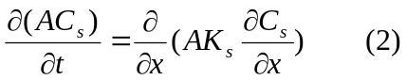
With a framework of finite-volumes/finite-differences in mind, this equation is discretized using variables evaluated at times n and n+1, as follows:

- 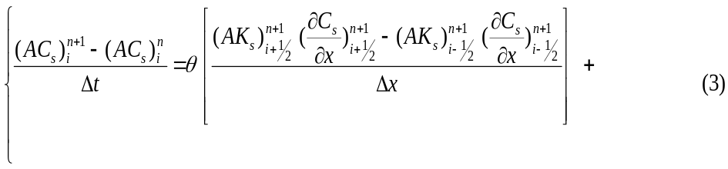
- 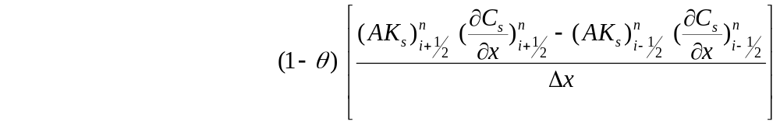
where the variables at i-1/2 and i+1/2 are evaluated at the faces of the volume i. The derivatives evaluated at the faces are obtained via simple differences in terms of the nodal values of the variables:

- 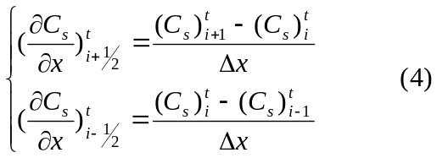

θ is a parameter which allows for setting up a explicit scheme (θ =0) or an implicit scheme (θ =1). Replacing the derivatives in the equation, it is possible to obtain:

- 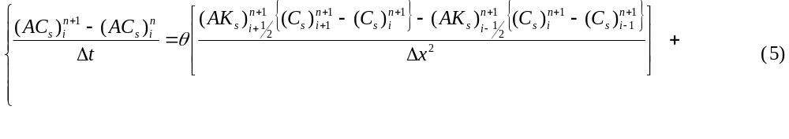
- 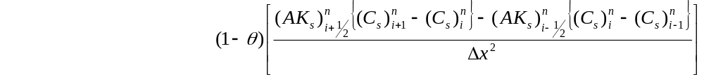

After collecting all the known variables on the right hand side of the equal sign and all the unknowns on the left hand side of the equal sign the above equation yields:
- 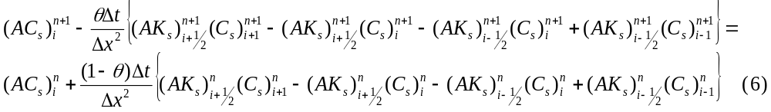

K_{s} , Δt, Δx , and A are known from HYDRO and thus it is possible to solve for C_{s}. For a given intermediate point, it is possible to write:
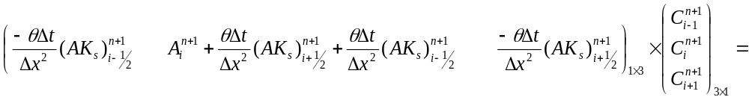
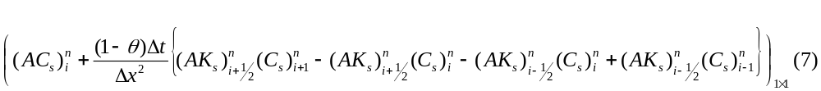
which leads to a tri-diagonal matrix. This scheme is second order in space and second order in time when θ=1/2.

2 Dirichlet Boundary Conditions at both Sides of the Domain

In this case, the values of the concentration of sediment at n+1 are assumed to be known at the boundaries. The tri-diagonal system can be written as follows:
If we define 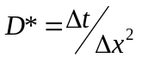

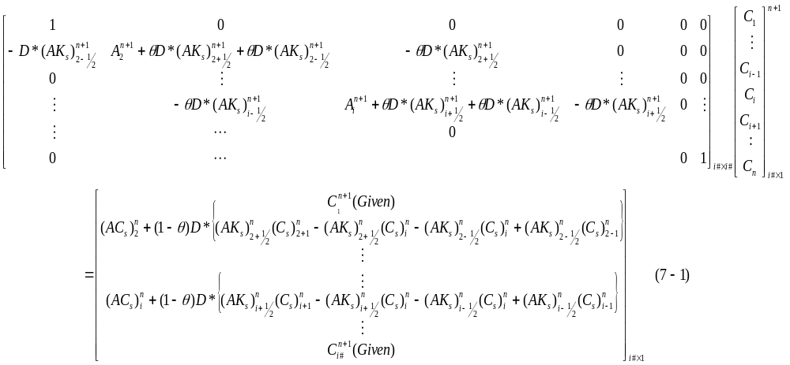

3 Neumann Boundary Condition at both Sides

We consider below two alternatives:

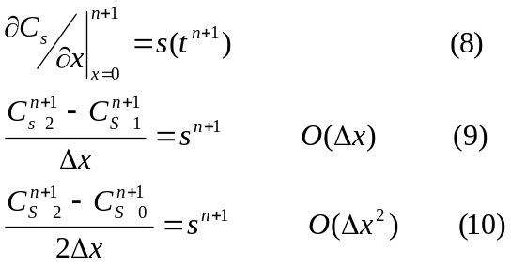
where s is the gradient on the node 1. For the second alternative, we need additional imaginary “ghost” nodes outside the domain. It is worth mentioning that the diffusion equation is very sensitive to the boundary condition, so it is desirable to have a scheme with O(Δx²) for the imaginary beyond the boundary node. So we must use central differencing for defining it. Examples for beginning point of the march (ending is just similar as this procedure) we can replace the value at node 0 with the following values where the S is the gradient at the beginning and the end are as follows:

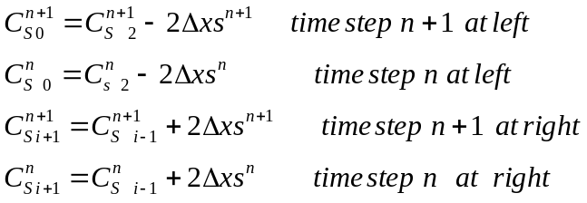

Applying the above boundary condition yields the following

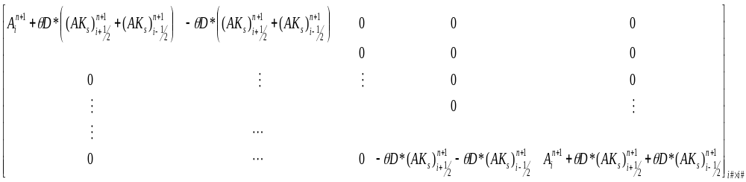
Middle lines of the above matrix is the same
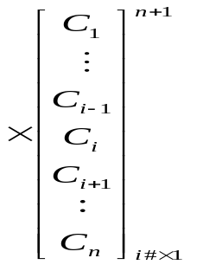

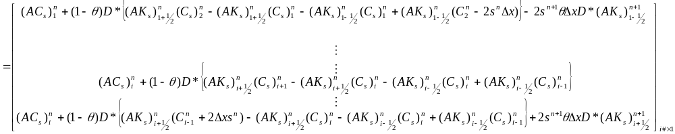(11)

A2: Advection

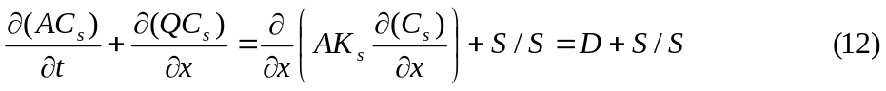

A,Q,S, and K_{s} are known from other parts:
A and Q from HYDRO
K_{s} from Diffusion
S (Sink and source come from decay, deposition and entrainment)

1- First half step:
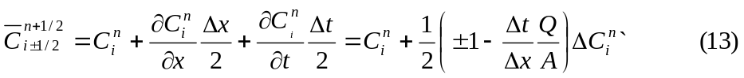
Where
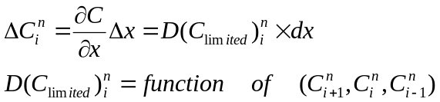

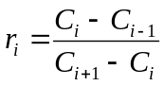
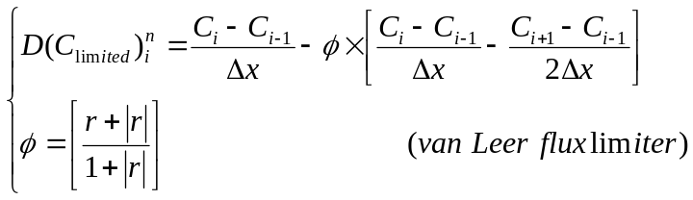
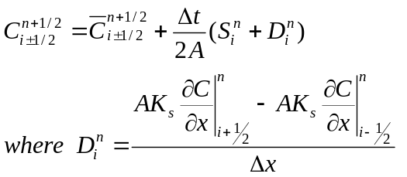

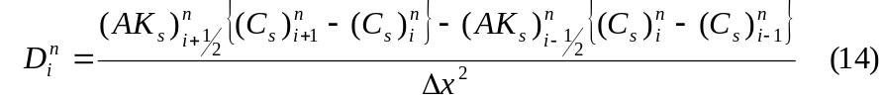

2- Second half step:

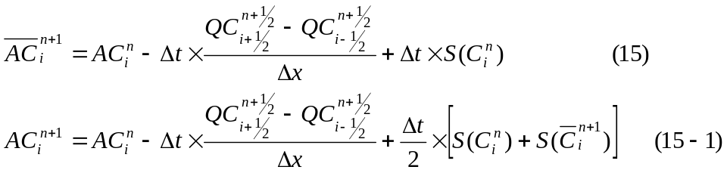

x
t
n
n+½
n+1
i-1
i+1
i
Figure 1: schematic of lax two step method

A3: Flux limiter
Flux limiters (also slope limiters) are used in high resolution schemes, to avoid the spurious oscillations (wiggles) that would otherwise occur with high order spatial discretisation schemes due to shocks, discontinuities or sharp changes in the solution domain.
van Leer (1974) flux is one of the widely used limiters, which guarantees no new maximum/ minimum formed, and it could be formulated as follows for coding proposes: (Saltzman 1994)

1- Second order van Leer flux limiter:

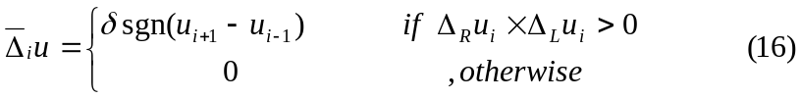
Where:
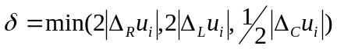
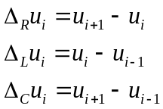
And the limited flux will be:
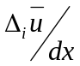

2- Fourth order van Leer flux limiter:

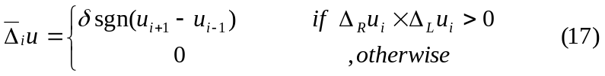
where:
Note: 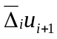 and 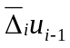 are the u which are already 2nd order flux limiter applied on them
And the limited flux will be:

B: Verification of advection and diffusion sub modules

B1: Introduction on Norms

When we are dealing with numbers we can identify them as being large or small. Arrays and vectors are function of many elements but we need to measure their size -an index for them to be small or large.

If we can find constants p ≥ 1 and c > 1 such that
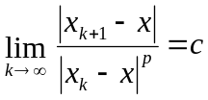 (18)
we say that convergence is of order p. If p=1 convergence is linear and the rate of convergence is c, in which c must be smaller than 1.
In solution procedures using vectors and matrices we also need a measure of convergence. Realizing that the size of a vector or matrix should depend on the magnitude of all elements in the arrays, we arrive at the definition of vector and matrix norms. By definition, a norm is a single number that depends on the magnitude of all elements in the vector or matrix. A norm should satisfy the following conditions:
1- 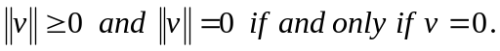 (19)
2- 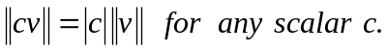 (20)
3- 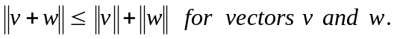 (21)

The equation 21 is triangle inequality. The following three vector norms are commonly used and called the infinity, one and two vector norms:

1- 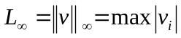 (22)

2- 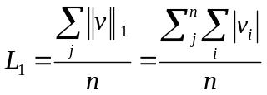 (23)

3- 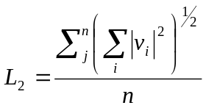 (24)

In our case we can define v as the error between U_{exact} and U_{numerical} at each point.

B2:Test cases

The explicit forms of finite-volume schemes must satisfy the following stability criteria for dispersion:
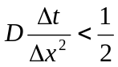 (25)
The implicit forms of the finite-volume schemes, however, are stable for all Δx and Δt and, therefore, do not need to satisfy the above stability criteria.

Two different problems were devised to test the diffusion model. In order to satisfy dispersion stability criteria for all explicit models, the temporal step size was always chosen to satisfy the dispersion stability criteria, for the particular Δx, u and D combination that was being tested.

B2-1:Convergence test for Neumann _ Dirichlet Boundary Condition

Convergence tests were performed for a case taken from Fletcher (1991), which uses a Neumann boundary condition that varies in time. In this particular case, advection and reactions are not present, meaning that only the pure dispersion term is needed from the A-D-R equation. Recalling the dispersion equation from before:

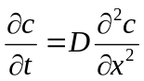 (26)

will be solved in the spatial interval 0.1 ≤ x ≤ 1 using the following Neumann boundary condition at x = 0.1:

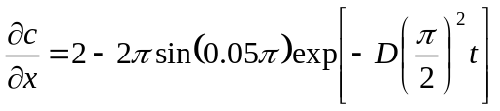 (27)
and a Dirichlet boundary condition of C = 2 @ X = 1. The dispersion models were tested for two incremental spatial spans between 3 to 192 and 25 to 3200 (number of volumes), inclusive, using a dispersivity of D = 1 and time spans and theta which guarantees stability. The results were compared against the following analytical solution to find the error. Then the three norms of error where calculated to perform test convergence and accuracy order tests

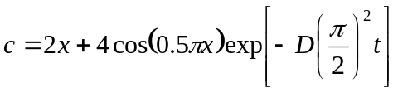 (28)

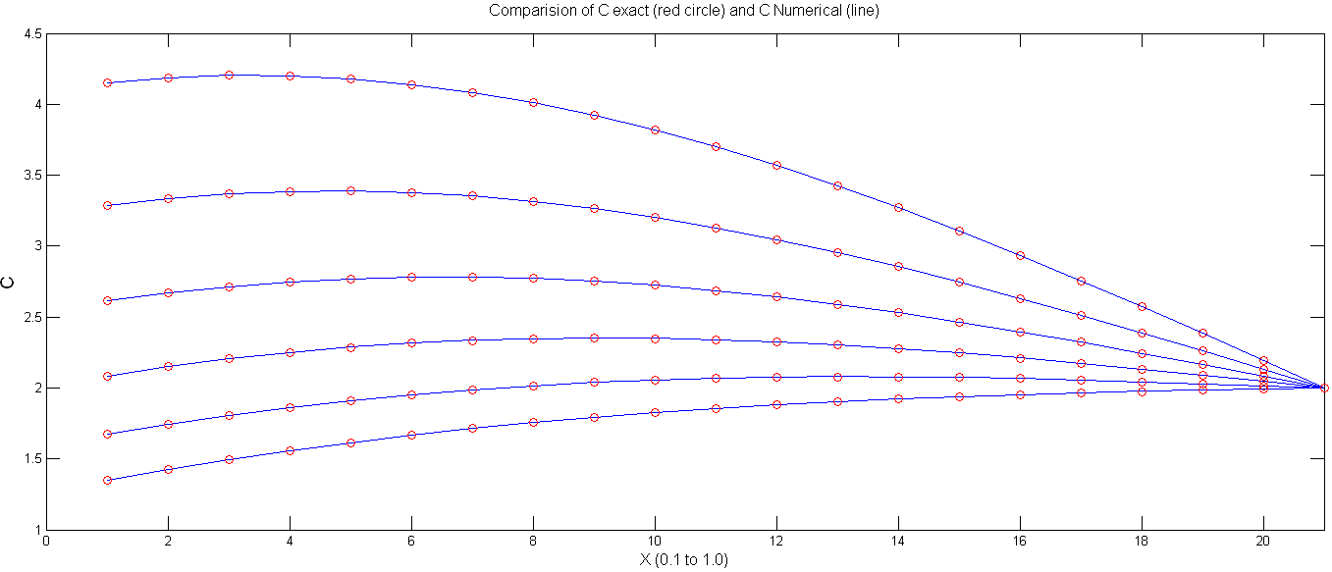
Figure 2: Comparison of numerical and exact solution for the case test case one (number of volumes =21)

Figure 2 shows the agreement of exact and numerical solution for this case. Tables 1 and 2 show the error convergence and accuracy tests for this case (N_D). As expected, the rate of error convergence after reaching appropriate number of volumes tends to 4 ( 2nd order of accuracy).

`Table 1: Errors and Norm of Errors in Different Mesh Sizes for Θ=0.5
Num of volumes | L1 | Rate of L1 change |  | L2 |  | Rate of L2 change |  | L∞ |  | Rate of L∞ change |  | Ddt/dx² |  | Stability
25 | 2.030E-03 | 1.094E+00 |  | 8.407E-07 |  | 5.355E+00 |  | 3.622E-04 |  | 3.844E+00 |  | 3.858E-01 |  | O.K
50 | 1.855E-03 | 1.025E+00 |  | 1.570E-07 |  | 5.797E+00 |  | 9.422E-05 |  | 4.090E+00 |  | 1.482E+00 |  | O.K
100 | 1.809E-03 | 1.006E+00 |  | 2.708E-08 |  | 5.760E+00 |  | 2.304E-05 |  | 4.072E+00 |  | 6.050E+00 |  | O.K
200 | 1.798E-03 | 1.001E+00 |  | 4.701E-09 |  | 5.845E+00 |  | 5.657E-06 |  | 4.151E+00 |  | 2.445E+01 |  | O.K
400 | 1.796E-03 | 1.000E+00 |  | 8.044E-10 |  | 6.301E+00 |  | 1.363E-06 |  | 4.611E+00 |  | 9.827E+01 |  | O.K
800 | 1.795E-03 | 1.993E+00 |  | 1.277E-10 |  | 6.708E+00 |  | 2.956E-07 |  | 3.385E+00 |  | 3.941E+02 |  | O.K
1600 | 9.008E-04 | 1.002E+00 |  | 1.903E-11 |  | 1.518E+00 |  | 8.732E-08 |  | 1.000E+00 |  | 1.578E+03 |  | O.K
3200 | 8.991E-04 | X |  | 1.254E-11 |  | X |  | 8.732E-08 |  | X |  | 6.317E+03 |  | O.K
Table 2: Errors and Norm of Errors in Different Mesh Sizes for Θ=0.5
Num of volumes | L1 | Rate of L1 change |  | L2 |  | Rate of L2 change |  | L∞ |  | Rate of L∞ change |  | Ddt/dx² |  | Stability
3 | 1.701E-02 | 2.895E+00 |  | 2.478E-04 |  | 8.544E+00 |  | 7.588E-01 |  | 1.204E+02 |  | 5.556E-03 |  | O.K.
6 | 5.878E-03 | 2.084E+00 |  | 2.900E-05 |  | 5.561E+00 |  | 6.300E-03 |  | 4.006E+00 |  | 2.222E-02 |  | O.K.
12 | 2.820E-03 | 1.376E+00 |  | 5.216E-06 |  | 5.604E+00 |  | 1.573E-03 |  | 4.002E+00 |  | 8.889E-02 |  | O.K.
24 | 2.050E-03 | 1.104E+00 |  | 9.307E-07 |  | 5.631E+00 |  | 3.930E-04 |  | 4.002E+00 |  | 3.556E-01 |  | O.K.
48 | 1.858E-03 | 1.026E+00 |  | 1.653E-07 |  | 5.651E+00 |  | 9.819E-05 |  | 4.007E+00 |  | 1.422E+00 |  | O.K.
96 | 1.810E-03 | 2.249E+00 |  | 2.925E-08 |  | 5.685E+00 |  | 2.450E-05 |  | 4.029E+00 |  | 5.689E+00 |  | O.K.
192 | 8.048E-04 | X |  | 5.145E-09 |  | X |  | 6.082E-06 |  | X |  | 2.276E+01 |  | O.K.

B2-2:Convergence test for Neumann _ Dirichlet Boundary Condition

The models were also tested using the Dirac delta function centered at x = 0 as the initial condition. Informally, the Dirac delta function can be described as a function that is zero everywhere but at the origin, where it is infinite. This condition is explained by Equation (29); however, it must also satisfy the identity in Equation (30).

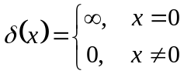 (29)

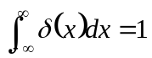 (30)
Applying the dispersion equation to the Dirac delta function results in the following Gaussian function,

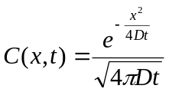 (31)
Where D is Dispersion coefficient (D=2)
Convergence tests were performed on the models using the following initial condition to represent the Dirac delta function described by Equations 29 and 30.

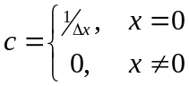 (32)

Convergence testing was performed on the case two dispersion models for the same time span of t = 4 sec, using a dispersivity of D = 2 and spatial step sizes of 2⁻¹, 2⁻², 2⁻³and 2⁻⁴. Dirichlet boundary conditions of C = 0 were used at spatial locations of x = ±100 because the theoretical concentration values at those places never rises above 10⁻⁸ during the course of the modeling period

Table 3: Errors and Norm of Errors in Different Mesh Sizes for Θ=0.5
Num of volumes | L1 | Rate of L1 change | L2 | Rate of L2 change | L∞ | Rate of L∞ change | Ddt/dx² | Stability
100 | 1.624E-02 | 1.773E+01 | 7.852E-06 | 2.473E+00 | 1.580E-03 | 2.944E+00 | 1.000E-01 | O.K
200 | 9.157E-04 | 2.600E+00 | 3.175E-06 | 3.485E+00 | 5.366E-04 | 3.816E+00 | 2.500E-02 | O.K
400 | 3.522E-04 | 2.759E+00 | 9.111E-07 | 2.222E+00 | 1.406E-04 | 3.979E+00 | 6.250E-03 | O.K
800 | 1.277E-04 | X | 4.099E-07 | X | 3.534E-05 | X | 1.563E-03 | O.K

In the figure 3 numerical solution of case 2 (D_D) and its analytical solution are supper imposed on each other.
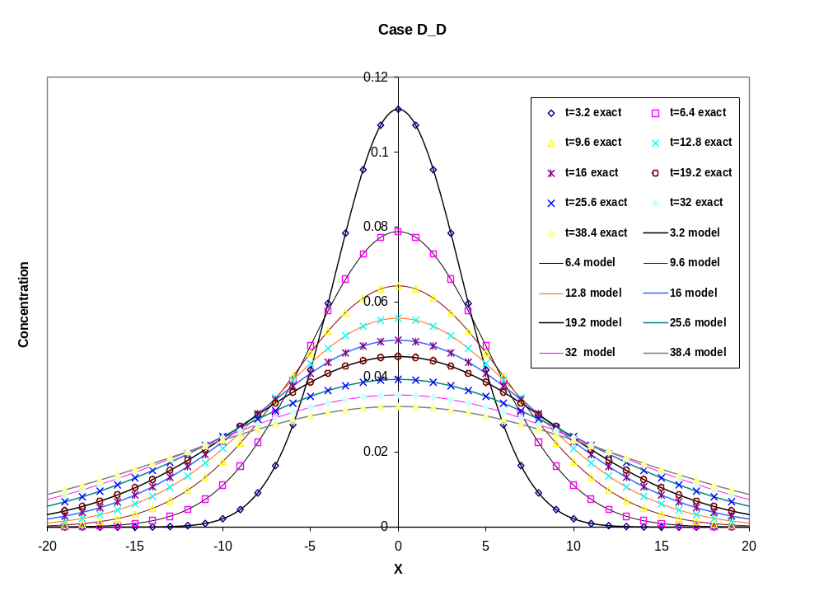
Figure 3: Exact and Numerical Solutions for Dirichlet_Dirichlet Test Case

C: Functions for Non-Cohesive Sediment Entrainment

C1: Background

Under appropriate simplifying assumptions, the one dimensional St. Venant shallow water equation takes the form:

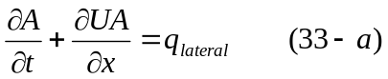

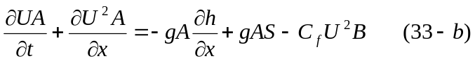

where

t=time;

x= boundary-attached (bed attached) streamwise coordinate

g=gravitational acceleration

S= bed slope which is given

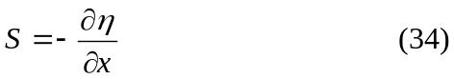

C_{f} = bed friction coefficient

The river assumed to carry a dilute suspension of sediment. An approximate form of depth averaged conservation of suspended sediment is as follows:

where

v_{s}= is the sediment fall velocity (Appendix B)

E_{r}= sediment entrainment rate

E_{s}= dimensionless rate of entrainment of bed sediment into suspension, E_{s}≡ E_{r} / v_{s}

D_{r}= volume rate of deposition per unit time per unit width.

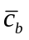= near bed value of 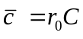
In the steady, uniform turbulent flow over a flat bed the net vertical flux (F_{sz}) of sediment just above the bed is given by:

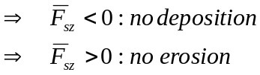

If equilibrium steady uniform suspension rate exists, there is no net normal flux of suspended sediment at the bed.
The equilibrium condition yields 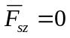

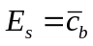 hence the entrainment rate will be given by 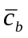.
There are many formulas for concentration sources near bed, the following formulas were selected from the books by eminent researchers of sediment transport:

C2: Entrainment formulas

C2-1 Garcia and Parker

In 1991 Garcia and Parker suggest the following formula:
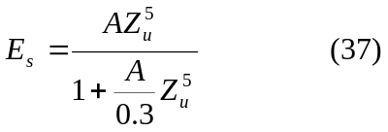
E_{s}= Sediment entrainment coefficient
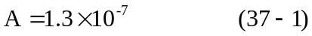
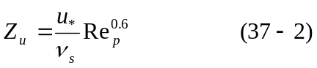
Z_{u} is a measure of the strength of shear stress but it also takes into account the particle size. Here reference level is taken to be 5% of the depth
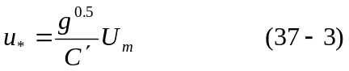
u* : shear velocity
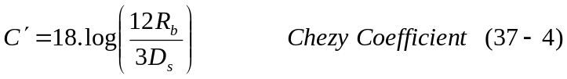
U_{m}= is the cross sectional flow velocity
R_{b}= Hydraulic radius of channel
v_{s}= sediment fall velocity (see the Appendix B)
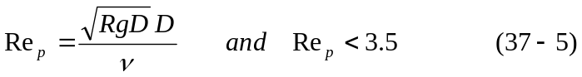
Re_{p} is particle Reynolds number

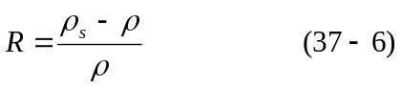

R is specific submerged gravity (1.65 for quartz particle)
g = Gravitational acceleration
D = D₅₀

In Garcia and Parker (1991) a comparison of many of other entrainment formula could be found. They have found that the relation (37) works well for fine-grained non-cohesive sediments.
We can also find u* starting from Manning equation as follows:

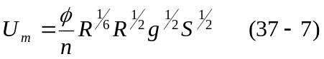
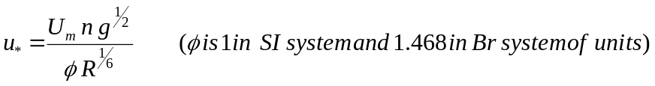
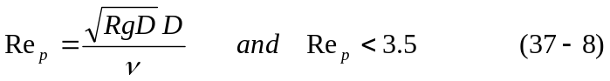

C2-2: van Rijn

Another formula that has been found to perform well is that of van Rijn (1984b)

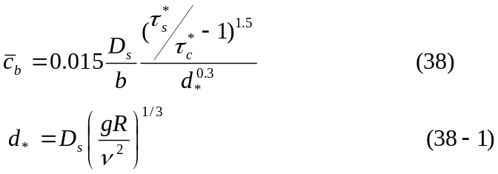

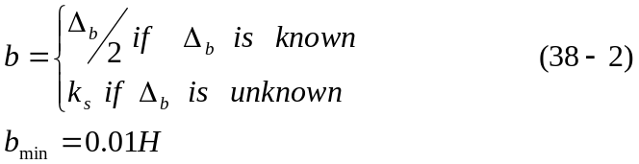

k_{s}=3D for uniform material (is effective roughness height)
Δ is a bed forms height and b=k_{s} when bed forms height is unknown
H=Total depth of flow

d*= is dimensionless particle parameter
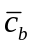: Reference concentration for equilibrium case (near bed value of mean volumetric sediment concentration)
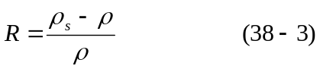
D_{s}= D₅₀
g = Gravitational acceleration
Note: here 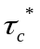denotes the dimensionless Shields stress due to skin friction
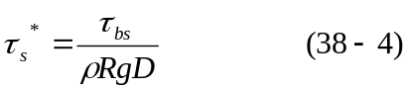
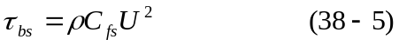
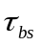 is the shear stress caused by skin friction
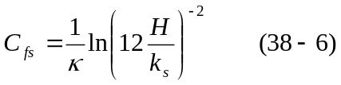
C_{fs} is the resistant coefficient
k_{s} is the effective roughness height
= von Karman constant (0.41)
This formula has been used extensively in numerical treatment of suspended sediment transport (Duan et al. 2001; Zeng et al. 2006)

C2-3: Smith and McLean

Third equation which performs well is by Smith and McLean (1977). This equation is based on Yalin early works (1963).

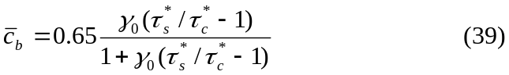
where
: Reference concentration for equilibrium case
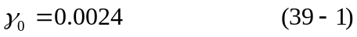

The value of b (height in which the 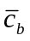is to be evaluated) is given by the following
k_{s}= is the equivalent roughness height for fixed bed

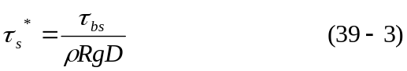
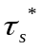is the dimensionless stress due to skin friction

is the shear stress caused by skin friction
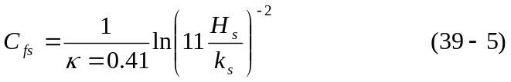

Here H_{s} is the depth in absence of bed forms (H_{s}+H_{f}=H) and H_{s} it could be expressed as:

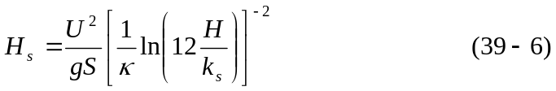

= von Karman constant (0.41)
K_{s} is the effective roughness height
S=energy slope

is dimensionless critical Shields shear stress for incipient motion (Appendix A)
The Smith and McLean formula is used extensively in benthic boundary layer flows and oceanic sedimentation (McCave 2004)

C2-4: Zyserman and Fredsoe

After the comparative analysis of different entrainment formulations, in 1994 Zyserman and Fredsoe proposed an empirical relation (40) using the Fort Collins experimental data

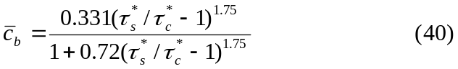
here is referred to concentration at b=2D₅₀
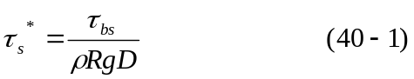
is the shields stress due to skin friction

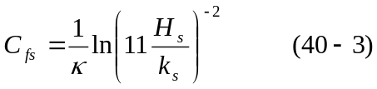
Here H_{s} is the depth in absence of bed forms, (H_{s}+H_{f}=H) and H_{s} could be expressed as:
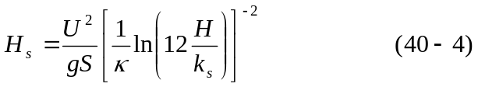
= von Karman constant (0.41)
S=energy slope
k_{s} is the effective roughness height

is dimensionless critical Shields shear stress for incipient motion
This formula is based on laboratory data, but it has been used widely in costal engineering practice (Soulsby 1997).

The 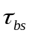 may also computed as (41)in cases the shear velocity is known:
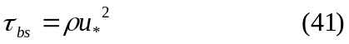

D: Fine grained sediment transport
Fine grained sediment transport is generally characterized by size composition, and plasticity. Cohesion is due to electrochemical forces acting on the particle surface. Hence the degree of cohesion depends on the ratio of particle surface area to particle weight, that is, specific surface area. Migniot (1968) showed ratio of particle settling velocity to particle size increases due to floc and cohesion.
A characteristic gauge of clay mineral cohesion is cation exchange capacity (CEC). The higher the CEC the greater the cohesion, which causes micro-meter-sized individual clay particles to coagulate or flocculate, in water to form much larger aggregates, or flocs when water salinity exceeds a critical value which depends on the clay mineral.
Kaolinite, Illite, Chlorite , and montmorillonite are the most commonly found clays, in San Francisco Bay estuary Chlorite were found (Krone 1962). As salinity increases above the critical value, floc size density, and strength vary. However, above a salinity of about 10 ppt, its effect on the floc properties is comparatively minor (Krone 1962; 1986) and there is no need to take it into calculation.

Table 4: Clay Minerals. CEC, and Critical Salinity for Flocculation
Clay mineral | Nominal  Diameter (μm) | CEC  (meq/100 g) | Critical Salinity  (ppt)
Kaolinite | 0.36 | 3-15 | 0.6
Illite | 0.062 | 10-40 | 1.1
Chlorite | 0.062 | 24-35 | Not reported
Montmorillonite | 0.011 | 80-150 | 2.4

To make assessing of transport related data possible, the basic parameters of floc in cohesive sediment should be defined. Regarding the fact that the cost of evaluation of a large number of parameters is not feasible in most technical studies, finally six parameters have been chosen to be representative of characterization of sediment in the situation in which the transport is not overwhelmingly influenced by biochemical factors;

Particle size: use the standard procedure of (ASTM 1993d), settling column bottom withdrawal test. If the organic content is greater than 10%, this test shouldn’t perform
Fall or settling velocity
Mineral decomposition: obtain types of relative quantities of the principle clay and non-clay minerals using standard X-ray diffraction tests.
Organic content: Loss of sample mass on ignition standard test (ASTM 1993d)
An alternative is to measure total organic carbon.
Cation exchange capacity: follows standard procedure for clay minerals (ASTM 1993c, SCS 1992)
Salinity: report salinity if less than about 10 ppt, At higher salinity the effect of salinity on floc structure is comparatively minor.

Settling velocity of cohesive sediment
For hindered settling of mud flocs, Mehta (1986) suggested a modified for of the well known Richardson and Zaki formula
where v_{s} is the effective settling velocity, v_{s,0} the settling velocity of a single particle in still water, k is an empirical parameter, φ_{p} is volumetric concentration of primary particle, φ_{p}= C/ρ_{s} in which C is the mass concentration and ρ_{s} the density of the sediment.
Winterwerp (2002) reasoned that the rational embedded in(42) can be applied to cohesive sediments as well. He suggested that, as each individual floc within a suspension is considered to settle in the rest of the suspension, this would result in three hindering effects:
- Return flow and wake formation. A settling particle generates a return flow and a wake. Other neighboring particles will be influenced by this and their effective settling velocity will be decreased by a factor (1- φ), where φ is the volumetric concentration of flocs.
- Viscosity. Each individual particle within a suspension is considered to fall in the remainder of that suspension which has an increased viscosity.
- Buoyancy or reduced gravity. For the same argument, an individual particle settles in a suspension with an increased bulk density. The effective settling velocity is decreased by a factor of (1-φ_{p}).
This led to a new theoretically derived formula for the hindered settling of mud flocs:
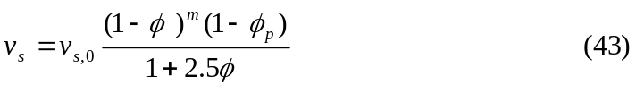
where v_{s} is the effective settling velocity, v_{s,0} the settling velocity of a single particle in still water. The volumetric concentration is herein related to the gelling concentration (≡ C/C_{gel}), in which C_{gel} is the concentration at which flocs become space-filling and form a network structure, called a gel, and a measurable strength build up. The volumetric concentration of primary particles is also related to the gelling concentration, 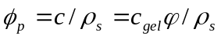
Here the 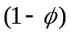accounts for the return-flow effect, 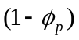accounts for the buoyancy effect and 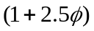accounts for augmented viscosity. The exponent “m” is an empirical parameter to account for possible non-linear effects. When the return flow effect is linear (m=1) only the volume effect of a suspension settling in a liquid is taken into account. The downward flux of sediment is thus expected to create an equal upward flux of water with sediment. When nonlinearity is taken into account, all the effects generated by a settling particle in a suspension are incorporated.
Winterwerp (2002) compared Eqn. (43) to data by fitting the model parameter and not actually using parameter values derived from data. A reasonable fit was obtained.

Appendix A: Fitted Formula to the Shields Diagram

A-1: Brownlie (1981)

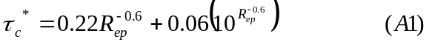
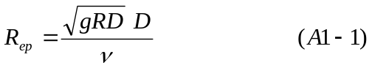
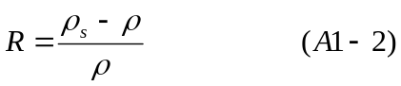
D= D₅₀
g = Gravitational acceleration
ν= kinematic viscosity of water
is dimensionless critical Shields shear stress for incipient motion
Re_{p} is particle Reynolds number

A-2: Mantz (1977)
For fine-grained sediments Shields diagram does not provide realistic results. Mantz conducted a series of experiments and observed that for fine grained non-cohesive sediments the critical shear stresses can be estimated with the following relation

The Mantz equation merges Brownlie equation for R_{ep}=4.22

Appendix B: Fall Velocity of non-cohesive sediments

Fall velocity or settling velocity is a fundamental property of a sediment particle. Falling under the gravity action a particle will reach a constant, terminal velocity once the drag is equal to the submerged weight of the particle. The range of particle sizes can be categorized in three following sizes:

a) Medium and coarse Sand, Gravel, Cobble, and Boulder; d_{s}>0.1 mm which must be calculated with Rubey’s approximation of fall velocity (Stokes’ law is not valid) b) Very fine Sand and Silt; 0.1 mm >d_{s} > 0.004 mm which can calculated by Stokes’ law
c) Clay; which is also calculated by Stokes’ law but flocculation is possible

Stokes’ law:

It is valid for small particle size (d_{s}<0.1 mm) falling in viscous fluid (Re_{p}<0.1)
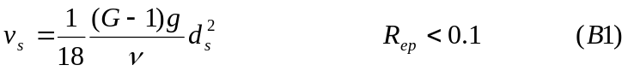

G is specific gravity and,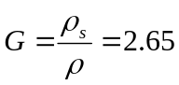 for quartz particle.

Rubey’s Formula:
Rubey’s approximation formula (B3) of fall velocity in clear water is based on drag coefficient of sand particle equation (B2):

C_{D} is the drag coefficient
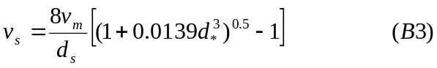
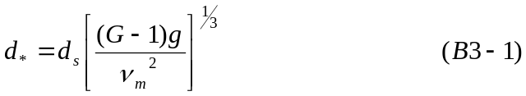
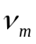 is the kinematic viscosity of water-sediment mixture.
d* is the dimensionless particle diameter

Table B1: Comparison of settling velocity of different sediment classes with stokes’s and Rubey’s formula
Sediment Class | Diameter(m) | Stokes’ Vs (m/s) | Reynolds Number | d * | Rubey Vs (m/s) | Governing Eqn | Diffrence (%)
Very fine silt | 6.00E-06 | 3.24E-05 | 1.95E-04 | 1.52E-01 | 3.25E-05 | Stokes | 0.283
Medium silt | 2.35E-05 | 4.97E-04 | 1.17E-02 | 5.95E-01 | 4.98E-04 | Stokes | 0.211
Very fine sand | 9.00E-05 | 7.29E-03 | 6.57E-01 | 2.28E+00 | 7.04E-03 | Stokes | 3.533
Fine sand | 1.80E-04 | 2.92E-02 | 5.25E+00 | 4.56E+00 | 2.32E-02 | Rubey | 20.474
Medium sand | 3.75E-04 | 1.27E-01 | 4.75E+01 | 9.50E+00 | 5.53E-02 | Rubey | 56.327
Medium gravel | 1.20E-02 | 1.30E+02 | 1.56E+06 | 3.04E+02 | 4.16E-01 | Rubey | 99.679
Small cobble | 9.60E-02 | 8.30E+03 | 7.97E+08 | 2.43E+03 | 1.18E+00 | Rubey | 99.985
Medium boulder | 7.68E-01 | 5.31E+05 | 4.08E+11 | 1.94E+04 | 3.33E+00 | Rubey | 99.999
As it is shown in the Table (B1) both Rubey’s and Stokes’ formula yield practically same results for the cases of Reynolds numbers less than one, so all the settling velocities will be calculated base on Rubey’s approximation.

Appendix C: Approximate physical properties of water at atmospheric pressure

Table C1: Approximate physical prosperities of clear water at atmospheric pressure
Temp. (ºC) | Density  ρ (kg/m³) | Specific weight γ  (N/m³) | Dynamic viscosity μ (N.s/m²) | Kinematic viscosity ν (m²/s)
0 | 1,000 | 9,810 | 1.79×10⁻³ | 1.79×10⁻⁶
5 | 1,000 | 9,810 | 1.51×10⁻³ | 1.51×10⁻⁶
10 | 1,000 | 9,810 | 1.31×10⁻³ | 1.31×10⁻⁶
15 | 999 | 9,800 | 1.14×10⁻³ | 1.14×10⁻⁶
20 | 998 | 9,790 | 1.00×10⁻³ | 1.00×10⁻⁶
25 | 997 | 9,781 | 8.91×10⁻⁴ | 8.94×10⁻⁷
30 | 996 | 9,771 | 7.97×10⁻⁴ | 8.00×10⁻⁷

Also the change in the kinematic viscosity of water “ν” with temperature in degree Celsius can be roughly estimated from relation (C1):

Miller and Poisson (1981) suggested the following equation of state for water density and salinity and temperature:
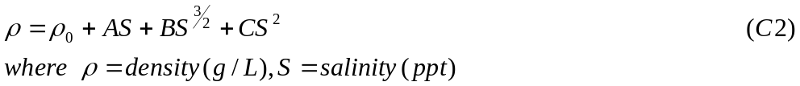
Jha and Bombardelli (2010) have shown that when the maximum volumetric concentration of sediment is less than 0.01 models developed for dilute flows work well and there is no need for corrections and any further assumptions. For flows having higher volumetric concentrations, inter-particle collisions become important and non-dilute models are necessary. Their results suggest a new limit for non-dilute flows between 2 and 5%. It is observed that the drag and virtual mass forces become important in the simulation of non-dilute flows. Also Woo et al. (1988) argued that when 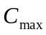> 0.04, the models developed for dilute flows do not work. Hence in cases with <0.02 it will be a rational to use dilute flow formulation.
References:

1-“Sedimentation Engineering”, Marcelo H. Garcia, ASCE 2008.

2-“Erosion and Sedimentation”, Pierre Y. Julien, Cambridge University Press 1998.

3-“Principle 0of Sediment Transport in Rivers, Estuaries, and Coastal Seas”, Leo C. van Rijn, AQUA Publications 1993.

4-“Estuarine and Coastal Fine Sediment Dynamics” J.P.Y Maa, L.P. Sanford, and D.H. Schoellhamer, Elsevier 2007.

5-“Coastal, Estuarial and Harbour Engineers’ Reference Book” M.B. Abbott, W.A. Price ,E & FN Spon 1994.

6- “An unsplit 3D upwind method for hyperbolic conservation-laws” J. Saltzman. J. computational physics. Vol:115-1 P: 153-168, 1994.

7-“ Computational Techniques for Fluid Dynamics” A.J. Fletcher, C. A. Fletcher Springer 1996.

