Solution by Zoppou and Knight 1997
- 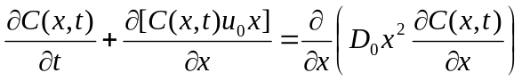 (1)
Subjected to
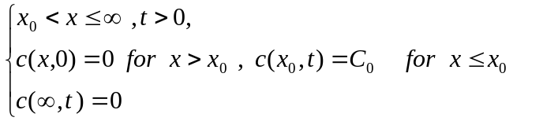
Solution is
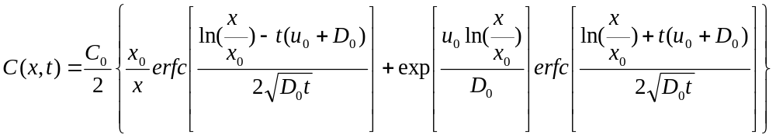(2)
Solution by Marsily (1986)
- 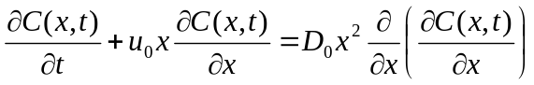 (3)
Subjected to
The above have a singularity at x=0, Substitution y=ln(x)
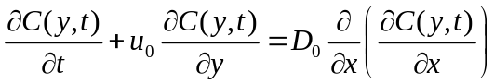 (4)
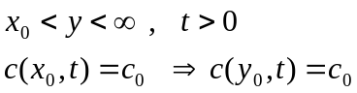
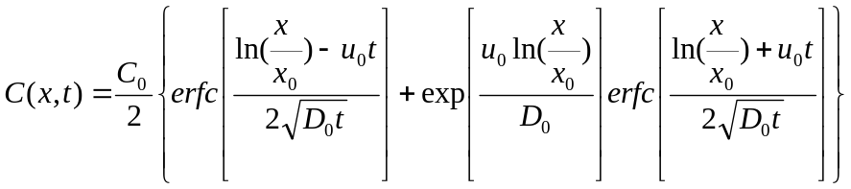 (5)
We are seeking for an analytical solution for the mass conservative form
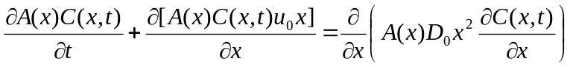 (6)
In which the continuity equation is also satisfied
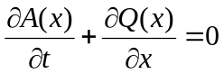 (7)
Let’s assume
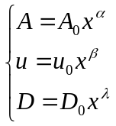 (8)
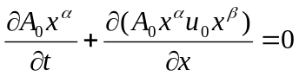 (9)
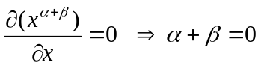(10)
If we inseart the (8) in the (6) we have:
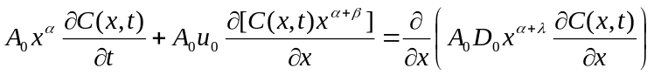 (11)
(12)
Divide by 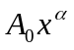
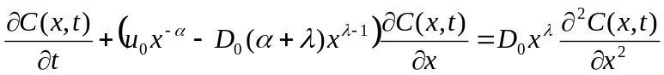 (13)
So if we chose 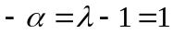 we will recast the (13) in the form of (3)
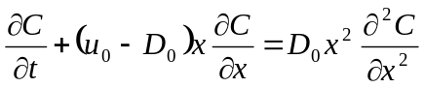 (14)
So the solution for the mass conservative advection diffusion equation with spatially variable coefficient
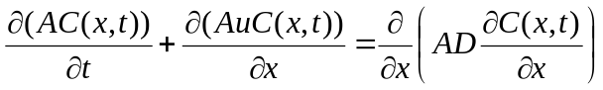 (15)
With
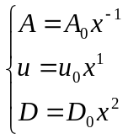
Subjected to the boundary condition of (3) is as follows
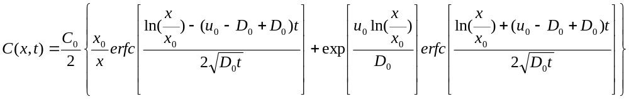
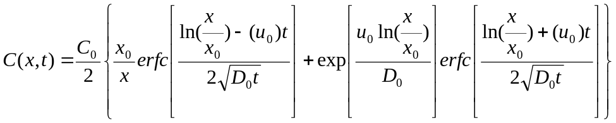 (16)
Test setup
Const |  | Start | End
Const | X | 10000 | 12048
A₀ | 10000000 | 1000 | 830.0133
D₀ | 0.000005 | 50 | 72.57715
t |  | 10000 sec | 12000 sec
V₀ | 0.0001 | 1 | 1.2048

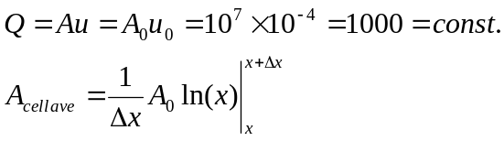
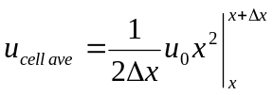
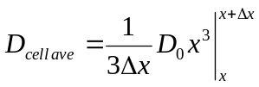

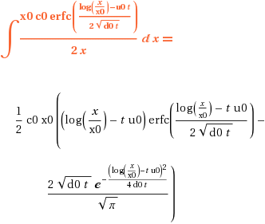

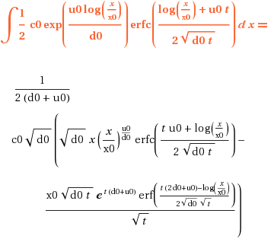

clear all
clc
close all
%%%%%%%%%%%%%%%%%%%%%%%%%%%%%%%%%%%%%%%%%%%
% the program in MATLAB to set the values of the Zoppou test
%%%%%%%%%%%%%%%%%%%%%%%%%%%%%%%%%%%%%%%%%%%
c0 =3;
x0 =10000;
xl =25000;
nt = 20;
nx = 20;
dx =(xl-x0)/nx;
u0 =10^-4;
d0 =2*10^-4;
start_time = 10000;
end_time = 55000;
dt = (end_time - start_time)/nt ;
c=zeros(nx,nt);

for i=1:nx;
x = x0+(i-0.5)*dx;
for j=1:nt;
t = start_time + (j-1)*dt;
c(i,j)=(c0/2)*((x0/x)*erfc((log(x0/x)-u0*t)/(2*sqrt(d0*t)))+...
exp(u0*log(x0/x)/d0)*erfc((log(x0/x)+u0*t)/(2*sqrt(d0*t))));
end
end
plot(c(:,1))
hold on
plot(c(:,10),'r')
plot(c(:,20),'k')
legend('t=0','t=T/2','t=T');

