Numerical solution of the equation of sediment transport in suspension

by Fabián A. Bombardelli and Kaveh Zamani
Department of Civil and Environmental Engineering, University of California, Davis.

Disclaimer: This is a work in progress and, as such, it should be taken as a draft vesion. It will be improved in the next month. The schemes presented here need to be finalized, and need to be discussed with personnel of DWR. This document serves for the purpose of informing the Technical Advisory Committee about the lines of thinking of the research. Please do not distribute.

Splitting of the Advection-Dispersion-Reaction Equation

The equation of transport of sediment in suspension is as follows:

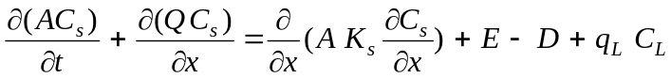
where all variables have the same meaning as in the presentation hand out.

The equation of sediment transport in suspension is mathematically an Advection-Diffusion-Reaction (ADR) equation. Through discussions with personnel from DWR, it was decided that this equation should be split in “parts” within the same time step. In other words, the advection, the dispersion and the reaction will be computed separately from results of the previous “parts.”

1 Part one: Dispersion

1.1 Governing equation
- 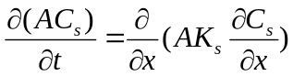

With a framework of finite-volumes/finite-differences in mind, this equation is discretized using variables evaluated at times n and n+1, as follows:

- 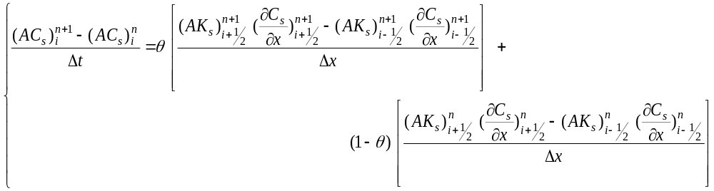
where the variables at i-1/2 and i+1/2 are evaluated at the faces of the volume i. The derivatives evaluated at the faces are obtained via simple differences in terms of the nodal values of the variables:

- 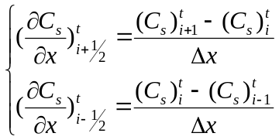

θ is a parameter which allows for setting up a explicit scheme (θ =1) or an implicit scheme (θ =0). Replacing the derivatives in the equation, it is possible to obtain:

- 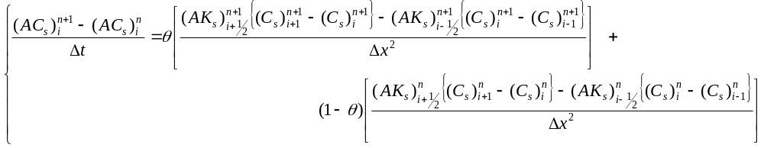

After collecting all the knowns on the right hand side of the equal sign and all the unknowns on the left hand side of the equal sign the above equation yields:
- 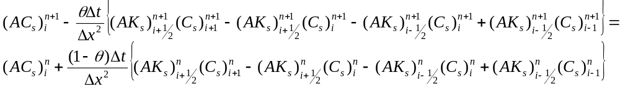

K_{s} , Δt, Δx , and A are known from HYDRO and thus it is possible to solve for C_{s}. For a given intermediate point, it is possible to write:
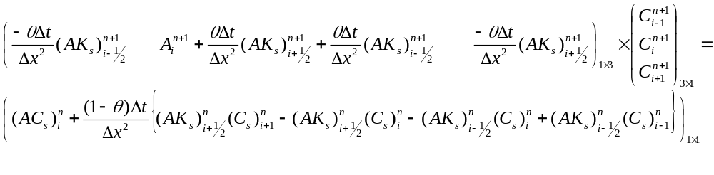
which leads to a tri-diagonal matrix. This scheme is second order in space and second order in time when θ=1/2.

1.2 Dirichlet Boundary Conditions at both Sides of the Domain

In this case, the values of the concentration of sediment at n+1 are assumed to be known at the boundaries. The tri-diagonal system can be written as follows:
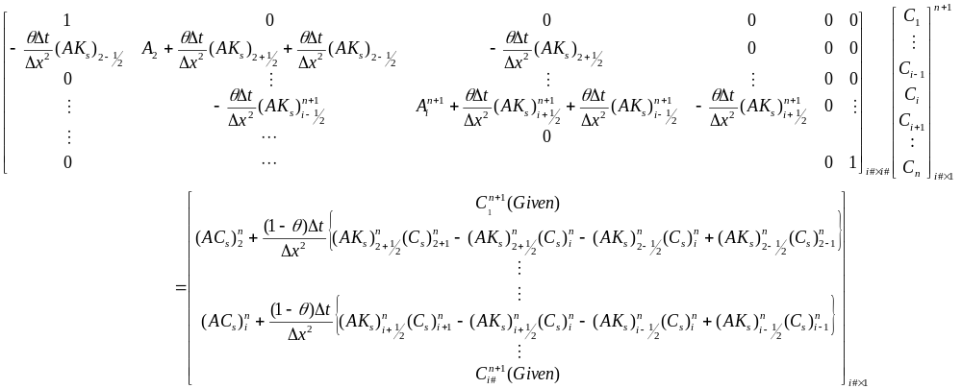

1.3 Neumann Boundary Condition at both Sides

We consider below two alternatives:

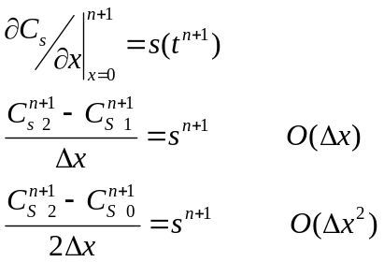
where s is the gradient on the node 1. For the second alternative, we need additional imaginary (“ghost”) nodes outside the domain. It is worth mentioning that the diffusion equation is very sensitive to the boundary condition, so it is desirable to have a scheme with O(Δx²) for the imaginary beyond the boundary node. So we must use central differencing for defining it. Examples for beginning point of the march (ending is just similar as this procedure) we can replace the value at node 0 with the following values where the S is the gradient at the beginning

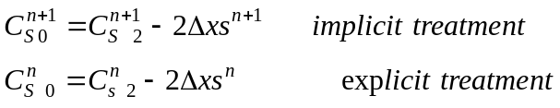

2 Part two: Advection

Solving the advection part, several problems may arise when sharp fronts are to be represented. The first and most common problem is the “numerical diffusion,” whereby the front appears to be smoothed. The second problem is the well-known “overshooting” and/or “undershooting,” by which wiggles appear upstream and downstream of the front. Higher-order schemes to solve the advection equation attempt to avoid these effects. In this work, the Flux-Based Modified Method of Characteristics will be used, which aims at avoiding spurious oscillations and at obtaining high accuracy on sharp fronts while second-order accuracy on the smooth portions of the numerical result.

2.1 Courant number smaller than 1

CFL<1

1) Equation to solve (please note that this is slightly different than the one we need to solve in the project; the similarities makes the conversion easy): 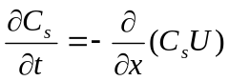
2) Discretization of second order:

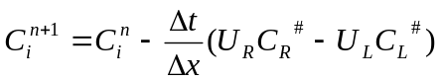

In the above equation U_{R} and U_{L} are the velocities at the left and right faces of the volume i; they are known from HYDRO. We also know 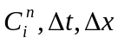, so we should calculate 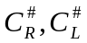. With an expansion in Taylor series, we have :

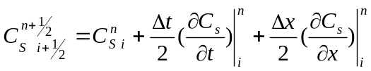
where
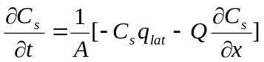
and
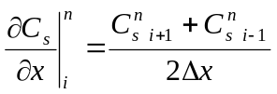
Because they are on the same characteristic line we have:
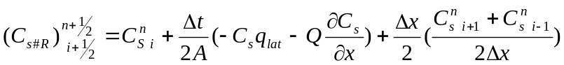

With the above method we can calculate 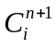

2.2 Courant number larger than1
CFL>1

We integrate the differential equation in space and time:
1) 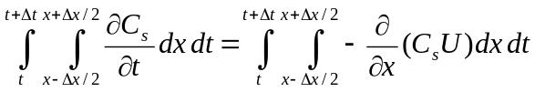

2)

3)
4)

5) 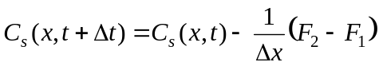

So the goal is to find the fluxes F₂ and F₁, which are the fluxes at the faces of the volumes. We assume that HYDRO provides A at the center of cells and Q at the faces, we also assume we are solving for a uniform cell size Δx=Constant. We can compute U using the discharges at the faces and the areas at the centers through averaging. The fluxes can be computed as sums involving the action of the characteristics.

i-3 i-2 i-1 i
ΔX=constant, CFL=Δx/τ₁ , X# = X_{i-½}-(CFL×t#)
t+Δt
t
t_{bot}
τ₁
τ₂
t#
x#

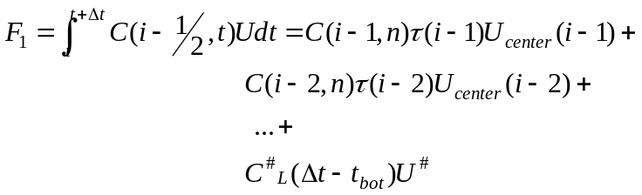

where C(i-I,n) are known from the pervious time step, U_{center}(i-I)and Δt are also known. The other terms could be calculated as follows:

- τ(i-1)= τ(i-2)=…= Δx/ CFL (space discretization is uniform)
- t_{bot}=Σ τ(i-I) before the t_{bot} becomes larger than Δt
Recall that t# is the center of last portion of time , and x# is its counterpart on a same characteristic line. We can find t# = t_{bot}+ (Δt-t_{bot})/2 and x# =x(i-½) – t# CFL
- Uc#

- 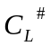

We are currently working on this portion of the analysis to have a robust methodology. The procedure closes with a flux limiter. FLux limiters are intended to avoid overshooting. A general approach can be described as follows:

The limiter works in a way that selects between two approximations, one of high order and another of low order. There exists several approximations to determine when one of these approximations will prevail, and one of such formulas is van Leer limiter. We are planning to use this limiter.

