**DEVELOPMENT OF A GENERAL TRANSPORT MODULE FOR DSM2, INCLUDING SEDIMENT TRANSPORT**

Kaveh Zamani

Fabián A. Bombardelli

James Kohne

Joseph Waltz



**Work team**

Dr. Jamie Anderson (Project Manager)

Dr. Eli Ateljevich

Mr. Patrick Luzuriaga

Dr. Kevin Kuo

**Steering committee**

Dr. Francis Chung

Mrs. Tara Smith

Davis, July 25, 2011

**Table of Contents**

**Executive summary.................................................................**

**Chapter 1: Introduction project Goals**

1.1

1.2

...

**Chapter 2: Theoretical models**

2.1

2.2

2.3

...

**Chapter 3: Numerical implementation**

3.1

3.2

...

**Chapter 4: Framework for Code testing**

4.1

4.2

**Chapter 5: Website with data on sediment transport**

5.1

**Reference**…………………………………..………………………………………………………….XX

**Appendixes:**

A1- Advection- Modified Richtmyer two-step Lax-Wendroff method……………………XX

A.2- Diffusion- Crank Nicolson Method………………………………………………………..XX

A.3- ODE Integrators………………………………………………………………………………….XX

B- Analytical Benchmark Solutions ……………………………………….…………………….XX

**list of Figures (Page Numbers may change)**

Figure 2-1: Schematic of sediment transport mechanisms in the water........................................10

Figure 4-1: Relationship between software testing components and algorithmic testing Software testing principles............................................................................................................................18

Figure 4-2: Transport algorithm testing incremental complexity..................................................19

Figure 4-3: ODE (Reaction) solver test.........................................................................................21

Figure 4-4: 3rd order accurate Runge-Kutta ODE solver..............................................................21

Figure 4-5: Diffusion single operator test, Dirichlet boundary condition.....................................22

Figure 4-6: Diffusion single operator test, Neumann boundary condition....................................23

Figure 4-7: Advection solver, test bi-directional flow, Gaussian Plume of mass, remote boundary condition........................................................................................................................................24

Figure 4-8: Advection Decay solver test, uniform flow...............................................................25

Figure 4-9: Coupling advection diffusion and reaction with zero order implementation of intermediate boundary condition...................................................................................................26

Figure 4-10: Tidal flow field, advection solver with Gaussian initial mass distribution ........................................................................................................................................................27

Figure 4-11: Tidal flow field, advection solver with sinusoidal initial mass distribution.....................................................................................................................................28

Figure 4-12: Tidal flow field, advection and reaction solvers with Gaussian initial mass distribution.....................................................................................................................................29

Figure 4-13: Tidal flow field, advection and reaction solvers with sinusoidal initial mass distribution.....................................................................................................................................29

Figure 4-14: Spatially varying flow field and dispersion coefficient, advection and dispersion (Zoppou)........................................................................................................................................30

Figure 4-15: Schematic of the algorithmic error in introduction of the source to advection solver

........................................................................................................................................................31

Figure 5‑1: The first page of Sacramento-San Joaquin Delta, sediment transport data webpage.35

Figure 5‑2: Sediment transport data categorized based on collection frequency..........................36

Figure 5‑3: Suspended sediment measurement data stations in San Francisco Bay-Delta............37

Figure 5-4: The miscellaneous links related to sediment transport and sedimentation in San Francisco Bay-Delta.......................................................................................................................38

Figure B1: schematic of Modified Richtmyer two-step Lax-Wendroff method...........................43

Figure B2: Schematic of boundary condition implementation.....................................................46

**EXECUTIVE SUMMARY**

Estuarine transport phenomena have tremendous implications on environmental processes, and therefore on ecosystem health. As a consequence, they have notable implications on local economies, and on management and planning of coastal civil works. Numerical models are usually used to increase our understanding of estuarine transport processes, and to solve practical, crucial problems associated with tidal environments. Numerical models are relatively inexpensive and they are employed as an essential tool by operators, decision makers and regulators in different estuaries of the world. In particular, diverse numerical simulations of flow and water quality have been developed for the San Francisco Bay area, and the Delta of the Sacramento and San Joaquin Rivers in California.

In 2009, the Department of Water Resources of California (DWR) and the University of California, Davis (UCD), Department of Civil and Environmental Engineering, started a project to implement new sediment transport routines into the Delta Simulation Model II (DSM2) - a one-dimensional (1D) model for flow, water quality and particle tracking in network of rivers. The ultimate goal of the project is to obtain a tool for addressing pressing problems related to sediment in the Delta, such as levee failure, marsh restoration, dredging, transport and fate of metals, etc.

After starting the project on April 2009, it was decided by DWR personnel to extend the scope of the project. The model needed to address not only sediment transport, but also the transport of any general constituent affected by the processes of advection, dispersion and reaction (sources/sinks). This general transport solver needed to be capable of handling almost all the constituents in an estuarine environment: salinity, heat, sediment, dissolved oxygen, etc. Based on this change in scope, STM (Sediment Transport Module, the name of the new set of subroutines) was designed and coded considering certain capabilities in mind. First, STM was developed in the most flexible and general manner. Second, it was designed with relative high accuracy in both time and space, to be able to deal with large domains and long simulation times. Third, it was verified in the most rigorous way, using state-of-the-art tools of the software industry. To that end, STM was coded with a meticulous attention to the Fortran data structure (to increase the computational efficiency) making use of the testing package FRUIT. Finally, STM was developed anticipating all the intricacies of the Delta system.

The STM was developed using operator splitting, involving the sequential solution of the processes involved. For the advection, a second-order Modified Richtmyer two-step Lax-Wendroff method was implemented, whereas a centered in time, second-order scheme was used for dispersion. The reaction portion, in turn, was coded using diverse high-order approaches.

The rigorous verification of STM sets these subroutines apart from existing transport models. Verification is a must in all developments of numerical models; however, to the best of our knowledge, most well-known packages for flow and transport in estuarine systems suffer from incompleteness of the verification process. The STM test package includes about 350 tests as part of a dynamic test suite. 80% of the tests are unit tests of subroutines for different inputs. Unit tests refer to checking that the different portions of the code are well designed and work properly according to plan. Scenarios of erroneous and incomplete inputs are thus identified. This dynamic test suite allows re-checking of the code during any future development. Oftentimes, mistakes or bugs present in every new algorithm are introduced in the process of linking those new algorithms to existing counterparts. With the dynamic test suite, STM will be safe against these kinds of errors. In addition to the unit tests, we developed a framework of tests (non-existent when we started working on the project) to verify the results. This framework consists of 17 tests which combine known analytical solutions with new ones developed by the UC Davis and DWR teams, which allow for checking that the model results match those solutions for “canonical” cases. Overall, it can be stated that STM is one of the most (if not the most) tested A-D-R (advection-dispersion-reaction) solvers in the world.

A sediment library to address the specific problem of sediment transport was added to the STM with the assist of DWR personnel. The library automatically categorizes particles either as suspended load or bed load, and is able to handle several sediment classes. Then, it simulates the deposition, entrainment, and movement of cohesive and non-cohesive sediment in the river. For each of the main two modes of sediment transport (bedload and suspended load), many relations have been suggested in the literature. In view of the fact that each of those relations is based on certain assumptions and is derived considering particular datasets, they are not general. Some of the most commonly used sediment source relations were added to the sediment source library. The corresponding unit tests were coded on the contiguous module. Therefore, data leaking errors and human-related mistakes were detected and corrected.

A major aspect of the project consisted in the assistance provided by an ad-hoc Technical Advisory Committee (TAC). Two general meetings in July 2009 and January 2010 were organized, where the members of the TAC (from academia, agencies and industry) made suggestions for code development. We are very grateful for the contributions of the TAC members to the project.

Finally, another important outcome of the project consisted of the development of a website with data on sediment transport, which was accomplished without funding for this project.

The STM currently operates in a single channel. Most potential difficulties for extending the module to a channel network were anticipated in the developments. Future work will include such extension to channel networks, and the development of the corresponding test suite. Also, the developments will be validated with data on sediment transport for the Delta. This is an ongoing activity. The idea is to study the performance of different sediment entrainment functions in the Sacramento River and to fine-tune the parameters for better approximating the collected field sediment-transport measurements. Further developments will introduce the processes of agglomeration and break-up of sediment particles in the STM.

In summary, the accomplishments of the project were as follows:

* Developed 1D transport code for a single channel.
* Developed extensive suite of nearly 350 tests to verify the code.
* Developed sediment-transport routines for entrainment and deposition.
* Developed website of available sediment transport data.

**CHAPTER 1**

**INTRODUCTION. PROJECT GOALS**

**__________________________________**

**1.1 Generalities**

The numerical computation of water quality in river networks (including sediment transport as a particular case) has become an essential tool for the planning, design, and assessment of the feasibility of river engineering projects. Although the physical processes associated with the transport and fate of certain constituents have not yet been completely elucidated (encompassing the entrainment of sediment into suspension in rivers and the speciation of mercury, for instance) engineers around the world are constantly called upon to provide answers regarding the impact on biota and humans of those contaminants, at diverse spatial and temporal scales. In this context, any development of modeling tools for the analysis of constituent transport in rivers should incorporate the most appropriate theoretical models to represent partially-understood, complex phenomena, and should adopt the most robust and accurate numerical techniques in order to provide optimized answers in practical cases.

Concerning the Sacramento-San Joaquin Delta (hereafter simply referred to as the Delta), the California Department of Water Resources (DWR) has been developing for some years now a network flow and water quality numerical model, Delta Simulation Model II (DSM2) , which provides answers to diverse problems corresponding to floods and pollutant transport in the system. This numerical model (which has been in use since 1997) has served the State notably well on many occasions. For instance, DSM2 has been used to reproduce historical flows that have been taken place in the Delta. Although there are still numerous problems in which DSM2 can serve well the State in its present form (in fact, DSM2 has been used at UC Davis to model the distribution of Striped Bass in the Delta, and at DWR to forecast scenarios of sea-level rise), the code lends itself to the increment of its capabilities via the addition of suitable sub-models.

Several proposed lines of action for the future of the Delta are currently being discussed (see Lund et al., 2007, 2009; Hanak et al., 2011), and some of those proposals include actions on the flows and sediment loads in the Delta rivers and tributaries. DSM2 is thus called to play an important role in the assessment of the technical feasibility of those proposals. In particular, with the addition of sub-models for sediment transport to DSM2, a more comprehensive assessment of the above lines of action can be performed. Specific aspects regarding sediment transport in the Delta of interest to DWR are:

1. The motion of sediment in the diverse rivers of the network coming from dredging operations undertaken in the Delta ship canals;
2. the transport and fate of sediment resulting from activities of marsh restoration;
3. the transport and fate of sediment particles resulting from levee breaches;
4. the transport and fate of metals like mercury, which are usually highly-associated with solid particles in the Delta and San Francisco Bay systems;
5. the evolution of bed levels in the Delta under historical flow conditions.

Several one-dimensional (1D) codes for flow and pollutant transport are customarily used around the world: CCHE1D, MIKE 11, FEQ, GSTARS, Ezeiza V, CHARIMA, FLDWAV, etc. However, only a few of those codes include sub-models to deal with the transport of sediment. In addition, some of the existing sub-models for sediment transport are *not* flexible, robust, accurate and/or general enough. Thus, the addition of general sediment-transport sub-routines to DSM2, able to deal with cohesive/non-cohesive sediment, will provide the code with capabilities that are not present in most other models.

Currently, DSM2 is structured in three main modules: HYDRO, QUAL, and DSM2-PTM. HYDRO encompasses a solver for surface-water and flow variables, i.e., the water levels and discharges in the rivers of the Delta. QUAL includes a Lagrangian Transport Model and the solution of advection-dispersion transport components. Constituents that can be modeled in DSM2 are: dissolved oxygen, carbonaceous BOD, phytoplankton, organic nitrogen, ammonia nitrogen, nitrate nitrogen, organic phosphorus, dissolved phosphorus, TDS and temperature. PTM in turn tracks individual particles in a pseudo-three-dimensional space. Hydrodynamic results from DSM2 for the Delta are usually employed as input for two and three dimensional (2D and 3D) models for the San Francisco Bay (see Smith, 2007).

**1.2 Original and modified goals of the project**

The original goal of the project was to:

1) Incorporate the capability of simulating sediment transport and bed-level change to DSM2;

2) validate the resulting sub-models first with measurements obtained from the literature, and second with observations of sediment concentrations in the Delta;

3) include a link to the water-quality sub-module (QUAL) in DSM2 to simulate in the future the transport of pollutants attached to particles; and

4) organize an inventory with datasets about flow and sediment transport in the Delta.

*After some work on the project and initial discussions within the work team, it was suggested by DWR collaborators and managers of the project to modify its scope.* It was realized that a general transport module should be developed, which would replace QUAL and address the original objective of the project at the same time. In addition, after our second Technical Advisory Committee (TAC) meeting (see below), it was suggested that bed-level changes in the Delta are minimal in short time scales; thus, the stage of the development involving the update of the bathymetry was left outside of the scope of the project.

These changes to the scope of the project shifted the focus from a straightforward project on sediment transport to a more general constituent transport project. Also, our collaborators at DWR decided to pursue a very rigorous testing (verification of the code) using FRUIT, and automatic document generation employing *doxygen*. This obviously produced a delay in the validation with results of the Delta, which will be undertaken anyway, but outside of the scope of the project.

This report starts with a brief review of the governing equations of the transport of constituents in Chapter 2. Then, in Chapter 3, the numerical discretization of the problem is discussed. Chapter 4 presents the verification approach of the numerical solver. Finally, Chapter 5 describes the sediment transport data which was gathered by different agencies in the San Francisco Bay and Delta areas, for further validation of the sediment transport model (this information is detailed in the sediment-transport website.). In the addenda, more details of the sediment source terms, numerical discretization and code testing are provided.

An important aspect of the project consisted in the assistance provided by an ad-hoc Technical Advisory Committee (TAC). This Committee was formed at the initiative of DWR by sediment experts from academia, agencies and industry who volunteered to participate in the assessment of the STM developments. Two general meetings in July 2009 and January 2010 were organized where the members of the TAC made suggestions for code improvement. Documents associated with those meetings can be found on the STM website[1].Two of the most important outcomes of the TAC meetings are as follows:

1) For the Sacramento-San Joaquin Delta, changes in bed elevation are relatively minor. For instance, Northwest Hydraulics Consultants (nhc) very recently presented simulation results which show that the increase in bed elevation within a period of 100 years is 0.1 ft. Thus, there is no need to solve the Exner equation for bed mass conservation, and a one-way coupling of the flow solver and transport the solver would be an adequate approximation.

2) In the upper Sacramento and San Joaquin Rivers, sediment behavior are almost non-cohesive and the sediment become cohesive in San Francisco Delta.

**CHAPTER 2**

**THEORETICAL MODELS**

**__________________________________**

**2.1 Key transport processes considered**

The transport processes considered in the model are (see Figure 2-1 below): 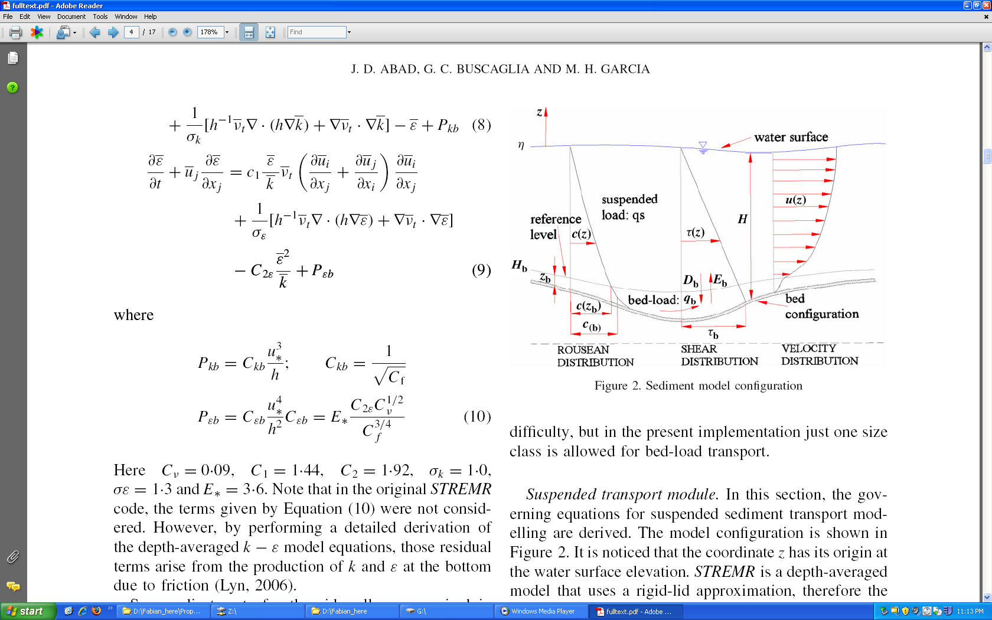

tidal advection

dissolved

constituent

Figure 2-1: Schematic of sediment/constituent transport mechanisms in the water column (adapted from Abad et al., 2008).

a) Transport of constituents in dissolved from (including sediment in suspension), considering advection due to currents and dispersion of pollutants;

b) transport of sediment as bedload, represented by empirical formulas;

c) erosion and deposition of sediment.

**2.2 General transport equations**

The processes described above are addressed in the model via the solution of a separate advection -dispersion-reaction equation (ADR) for the dissolved constituents and the suspended sediments, and the algebraic equation for the transport as bedload, as follows.

**2.2.1 Transport in suspension of sediment and of dissolved constituents**

The equations for the transport of dissolved constituents and sediment in suspension is:

(2.1)

where  is the cross-sectional wetted area (m2);  is the cross-sectional-averaged concentration of pollutant in dissolved phase or sediment in suspension, averaged over turbulence (mg/L or Volume/Volume);  is the discharge (m3/s);  denotes the dispersion coefficient (m2/s);  indicates the entrainment rate of sediment into suspension per unit width (m2/s);  represents the deposition rate of sediment per unit width (m2/s); and  (m2/s) and  (mg/L or Volume/Volume) refer to the lateral discharge (per unit width) and the concentration of pollutant or sediment in the lateral discharge, respectively. In turn, *x* and  indicate the spatial and temporal coordinates, respectively, and  denotes sources and sinks of pollutant or sediment of non-point nature. In the case of having several size classes of sediment, this equation is solved for each.

In the Equation (2.1) the first term indicates the evolution in time of the mass/length of the constituent; the second term is advective term; on the right hand side the first term is the diffusive term which denotes the dispersion of the constituent; and all the remaining are various forms of source terms. The steps followed in the derivation of the above equation can be found in Rutherford (1994).

**2.2.2 Transport of sediment as bedload**

The transport of sediment as bedload is computed via empirical relations taken from classic works. Such relations can be recast as special cases of the following relation:

(2.2)

where  is the solid discharge due to bedload per unit width (m2/s);  is the submerged specific gravity, given by , with  and  denoting the densities of sediment and water, respectively;  is the acceleration of gravity; and  is the particle diameter. These relations are said to pertain to “capacity” conditions, whereby the river can scour sediment according to the load it can actually carry. Again, this equation can be posed for each particle size class.

In the current version of the code, the bedload formula included is the Meyer-Peter and Muller (1948) modified by Wong and Parker (2006).

**2.3 Closures (entrainment and deposition)**

Entrainment formulas for non-cohesive and cohesive sediment are usually expressed in terms of either the wall-friction (shear) velocity , or the shear stress τ. For instance, the formula by García and Parker (1991) reads:

(2.3)

where  is a constant equal to 1.3 x 10-7; , with (explicit particle Reynolds number);  indicates the fall velocity; and  denotes the kinematic viscosity of water. Once  (which is a non-dimensional number) is computed, it follows that: . In turn, , where  is the local sediment concentration at a distance from the bed. (This concentration can be related to the cross-sectional concentration of sediment through empirical relations; see Appendix C.) The García and Parker formulation is one of the few which include a version for several classes of sediment size. Appendix C includes other formulations to be coded in the STM.

Numerous expressions have been presented in order to facilitate the computations of the fall velocity, . In this project, the regression proposed by Dietrich (1982) for natural particles is used, as explained in the Appendix A. We also coded the van Rijn (1984) settling velocity expression (see Appendix A).

Once the volumetric flow of sediment per unit width has been computed, it can be added to the solid discharge in suspension (=*QC/B*, where *B* is the channel width).

**CHAPTER 3**

**NUMERICAL IMPLEMENTATION**

**__________________________________**

**3.1 Basic approach**

In the discretization of Eq. (2.1) for the Sediment and Transport Module (STM), the objective was to obtain a second-order accurate scheme in both time and space. The Operator Splitting method was adopted in the numerical treatment of the equation. This means that the solution of the operators embedded in Eq. (2.1), i.e., advection, dispersion, and reaction, is accomplished in a sequential manner. The consistency with the nature of the problem and the importance of the conservation of mass strongly suggested to employ the Finite Volume Method (FVM). Here, a brief presentation of our approach for choosing the STM discretization among the existing alternatives is given. The details and more in depth information are provided in Appendix B.

**3.2 Operator splitting**

In the classic operator splitting (Godunov splitting), sometimes called fractal step method, one operator is employed on the previous step's solution (known values), and then the result is fed into the next operator. It was proven by Valocchi and Malmstead (1992) that this method of operator splitting does not conserve mass in the presence of a reaction (source) term. To overcome this limitation, it is possible to reduce the order of errors associated with the Godunov method by using a time centered method referred to as Strang splitting (Strang, 1968). This method involves centering the reaction step between two transport steps. The scheme can also be used with multiple reaction and transport steps, but in each case the reaction step will be centered. When only a single reaction step is used, the method takes the form:

(3.1)

where *L(* ***.*** *)* refers to transport operator, followed by the reaction step:

(3.2)

which is in turn followed by another ½ transport step:

(3.3)

For the time being, the different operators of the STM code are combined using the Godunov splitting. The authors will investigate alternating (Strang splitting) in the near future.

**3.3 Discretization of the hyperbolic term (advection)**

Because of the great interest in numerically simulating high-Peclet-number[2] flows (advection dominated) a large number of methods have been proposed in the last decades. These methods include the method of characteristics (MOC) or modified versions of it (Konikow and Bredehoeft, 1978; Chilakapati, 1993; Roache, 1992) and adjoint Eulerian-Lagrangian methods (Celia et al., 1990). Both MOC and Eulerian-Lagrangian approaches are based on the treatment of the advection part of the transport equation using a Lagrangian[3] scheme. The approach reduces the numerical diffusion[4] by reducing the effective grid Peclet number for the fixed Eulerian grid. Although there are some implementing restrictions, the method of characteristics and its related approaches are still widely used when it is critical that numerical diffusion be avoided. Another method is the TVD or *total variation diminishing* scheme, which gives an almost oscillation-free behavior (Yee, 1987; Gupta et al., 1991). The TVD is one of a class of methods which uses limiters to ensure *monotonicity[5]* of solution (van Leer, 1977; Hundsdorrfer and Verwer, 2003). TVD methods with flux limiter sometimes perform better than the same order *flux–corrected transport* (FCT) counterpart on the reactive transport in case of oscillations (Steefel and MacQuarrie, 1996). Another class of high resolution Eulerian methods uses higher-order approximations for the first derivatives, but hybridizes these with low-order schemes in an attempt to obtain monotone solutions. The solutions have the higher-order approximations in smooth regions and the low-order accuracy near discontinuities (e.g., near plume fronts). The price to be paid for these schemes is that they are *non-linear*, even when applied to initially linear problem such as the ADR equation. In this class are the FCT methods (Boris and Book, 1973; Zalesak 1987; Hills et al., 1994) which usually gives excellent results when applied to non-reactive solute transport (Hills et al., 1994). However, as in some of the other methods discussed above, very low levels of oscillation still appears in the solution. Here, an Eulerian (fixed) reference frame is then used to simulate the dispersive/diffusive transport. We chose to employ the FCT methods for discretization of the advective term of STM. Advection was coded with a modified[6] Richtmyer two-step Lax-Wendroff method (Leveque, 1992). For overcoming the cases of shock, the van Leer flux limiter (slope limiter) was employed in the step of flux calculation (Saltzman, 1994).

**3.4 Parabolic term (dispersion)**

The conventional Crank-Nicolson discretization in a FVM framework was used for the dispersion operator. The method is second-order accurate in time and space. The Crank-Nicolson method is fully implicit and unconditionally stable, which allows the user to select larger time steps (Crank and Nicolson, 1947). In the solution process, the Crank-Nicolson scheme yields a tri-diagonal matrix. The tri-diagonal matrix algorithm (TDMA), also known as the Thomas algorithm, is used to solve the system (Press et al., 1992). TDMA is a very cost effective solver and it inverts a *n* by *n* matrix with only *O(n)* number of operations. Owing to the modular nature of the STM solver, it would be relatively easy to replace the TDMA solver with a more efficient tri-diagonal matrix solver library in the future. Further, since the extension to a network of channels will produce values different from zero outside of the main three diagonals, a sparse matrix solver will be needed. This can be easily done given the carefully crafted structure of STM.

**3.5 Ordinary differential equation integrator**

The Heun's second-order ordinary differential equation (ODE) integrator was coded. The solver was combined within the predictor and corrector step of the Richtmyer two-step Lax-Wendroff advection solver (see Appendix B). This numerical trick was utilized by Colella (for example see: Chombo Design Documents, 2009) for increasing the accuracy of the predictor step in the advection solver.

The Heun solver pertains to the family of second-order explicit Runge-Kutta solvers. For the probable cases of stiff source terms, also a third-order explicit Runge-Kutta solver, as a separate operator, was coded. A time step adaptive Runge-Kutta solver (RK 4-5) is coded for the case of stiff source term (Reference here 19XX).

**3.6 Limitations**

The advection solver is coded in an Eulerian framework and the Courant-Friedrichs-Lewy number (CFL) must be less than one. The CFL number can be interpreted as the fractional distance relative to the grid spacing traveled due to advection in a single time step.

(3.4)

The second issue to consider for the advection solver is the grid Peclet number. The grid Peclet number compares the characteristic time for diffusion (dispersion) given a length scale, with the characteristic time for advection. The wiggles start at a mesh Peclet number above 2 (Unger and Forsyth, 1995) and the problem becomes more severe when the grid Peclet number increases. In the lower grid Peclet number range, the flux limiter is not triggered to work; hence the global order of accuracy is not reduced due to flux limiter's side effect.

The diffusion solver is unconditionally stable. However, instabilities can occur if the ratio of time step to the square of space step is large. A similar expression may be derived for systems characterized by purely diffusion transport, giving rise to the diffusion number (Fletcher, 1991):

(3.5)

**3.7 Summary of the schemes included in the STM**

The hyperbolic (advective) term was discretized with the Richtmyer two-step Lax-Wendroff method in a FVM framework. The parabolic (dispersion) term of transport equation discretized with time centered Crank-Nicolson method individually. Reactive term was treated by Heun ODE solver which is incorporated inside the advection solver. Finally above three operators assembled together employing operator splitting.

**CHAPTER 4**

**FRAMEWORK FOR CODE TESTING**

**__________________________________**

**4.1 Generalities. Types of tests**

In this chapter we describe a framework for software verification of the STM. Some of the ideas discussed below are taken from a recent paper published as: "Using Software Quality and Algorithm Testing to Verify a One-dimensional Transport Model" in the 2011 ASCE World Environmental & Water Resources Congress, in Palm Springs, California.

The framework was crafted according to principles from both the software testing (sometimes known as Software Quality Engineering or SQE) and numerical testing fields. Herein, we describe the components and implementation of the test suite, which includes unit tests, regression tests and algorithm tests of error convergence and accuracy. We make use of some analytical solutions obtained from the literature and others developed/modified by ourselves. Applying this rigorous testing framework to our transport code provides assurance to the developers and end users that the code performs as expected.

Flow and transport codes inherently comprise both numerical algorithms and pieces of software. Limited testing literature exists for both, but not exhaustively developed. Oberkampf and Trucano (2002) described some elements of SQE in the context of numerical verification, and noted some cultural reasons why it is seldom implemented. Figure 4.1 is adapted from this work and depicts the relationship between software testing components and algorithmic testing such as convergence tests.

**4.2 Basic concepts in STM software testing**

**4.2.1 Static versus dynamic testing**

The testing of codes can be categorized as *static* or *dynamic*. In the first class, the code is checked once when it is developed. Thus, the static testing approach could be employed in the testing process of legacy codes or if the final product is going to be used without any further change. On the other hand, in the dynamic testing, a program is repeatedly checked versus a predefined criteria. Hence, dynamic testing is utilized in cases of ongoing development of a code or modification of it for new reasons. Dynamic testing may begin before the code is complete and develop as a the main code is building up. Since the STM was developed anew, it was decided to code its accompanying dynamic test suite.

**4.2.2 Black box testing versus glass box testing**

In the black box testing the functionality of a code is tested without access to the internal structure of the code. Therefore, black box testing is the only option when the source code is not available. Opposing black box testing, glass box testing is a procedure in which functionality of each part and the path of data inside a code is checked. Glass box testing could be performed at the level of units or whole system. Given that in the STM project source code is under development, glass box testing verification approach was chosen.

**4.2.3 Unit tests versus system tests**

Unit testing is a procedure in which each individual unit of a code is checked if it arrives out the task it is supposed to carry out. Unit is the smallest testable part of a code. The mission of unit testing is to isolate each individual part of a code and prove it works correctly, whereas, in algorithm testing or system testing a larger subtask or portion or even a whole code is checked. The unit testing point of view is that the code must be exercised over a range of inputs that covers every line. For instance, to test a gradient routine with a slope limiter, a developer would want to cover:

1. smooth cases in the middle of the mesh;
2. behavior near the edges of the mesh, where one-sided differences may be used instead of central differences;
3. cases that test the limiters with steep or zero gradients in both directions.

The STM test package includes both unit tests (280 tests) and system tests (70 tests).

**4.2.4 Fail/pass criteria**

In the project the testing procedure is automated. A consequence of automation is that verification tests must be phrased in terms of binary assertions, true and false statements that can be tested without human intervention, and that reveal whether the aspect of the code under consideration is correct. Convergence criteria are a rigorous basis for assertions, either by requiring strict convergence criteria (“the algorithm is second order accurate in time and space”) or a regression criterion (“convergence will not get any worse than last time the code was tested”).

**4.2.5 Regression tests**

Regression test is a software testing approach in which a system is checked for newly introduced errors. In the regression test a system is checked versus its previous step condition by re-running previously run tests and checking if code behavior has changed or not and whether previously fixed faults emerge again. In the STM project regression testing will be employed in the extension of the code. The test suite will be run automatically on a regular basis, and in case the previous results are not obtained, developers will receive a warning message.

**4.3 STM testing package**

In this project a comprehensive test package was put together for the full verification of the STM solver. The test package was developed having certain features in mind: dynamic testing; automatic and continued testing, step by step increase in complexity; the test approach should foster exact specification of every unit of code, and finally testing should provide assurance of whether a set of specifications is met or not.

One goal of tests is that they be a continuous assessment of the code. The entire testing system is a *regression* testsuite that establishes a gauntlet through which future code changes must be passed.

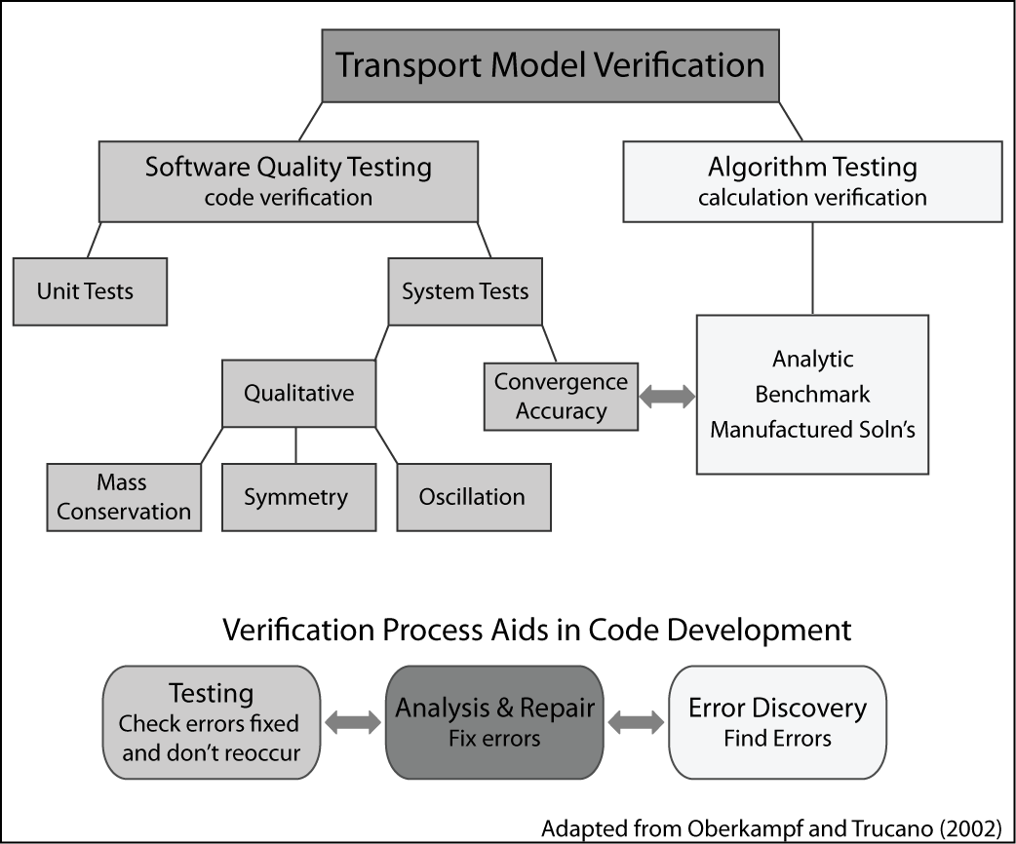

Figure 4-1: Relationship between software testing components and algorithmic testing.

Software testing principles.

For example, the evaluation of a gradient might be a unit of code and it would have a unit test. Convergence tests and other algorithm tests are examples of system tests.

Any system test will certainly exercise the gradient code in the middle of the mesh, which in any event can seldom be wrong without being obvious. However, system-level tests might miss the more unusual cases. For example, a convergence test may miss a bug in the limiter for the case of steep decreasing slope for several reasons. First, convergence is often assessed with limiters turned off, as they are locally order reducing. Second, it is hard to fiddle with the problem in just the right way to make sure the left, right, and center cases of the gradient limiter are all triggered. This is particularly true when trying to exercise other units of code at the same time – parameter choices made to fully exercise gradient limiter the may lessen the coverage of another unit.

**4.4 Framework of algorithmic tests**

Faced with the need for verification of our transport code, we immediately noticed a lack of a comprehensive suite of tests in the literature, able to check all aspects of the ADR solver. Thus, we devised what we consider a novel framework to achieve such a step-by-step verification. In that framework, we have three degrees of freedom: the flow field, the boundary conditions, and the number of involving operators, as depicted in Figure 4-2.

* Operators: The key processes tested are the operators of advection, dispersion and reaction (e.g. growth or decay). These are tested individually, then in combinations of two and at the end all three together. Complexity increases with including more operators in a test.
* Flow field complexity and physical setup: Our framework included the following cases:

* + No flow: The test suite started with testing of dispersion and reaction operators in quiescent flow conditions.
  + Uniform flow: These tests involved uniform steady flow on a channel, sometimes with a reverse in direction halfway through the simulation. The mass transported is Gaussian. The suite includes advection, dispersion and reaction alone and in the combinations indicated in Figure 4.2.
  + Tidal flow: This test used a tidal flow field from Wang et al. (2009), adapted to be 1D and modified to be mass conservative, to test advection and reaction. The test itself has no analytical solution, but it is periodic in a way that the initial mass distribution moves forward and returns to its initial position in each tidal cycle.

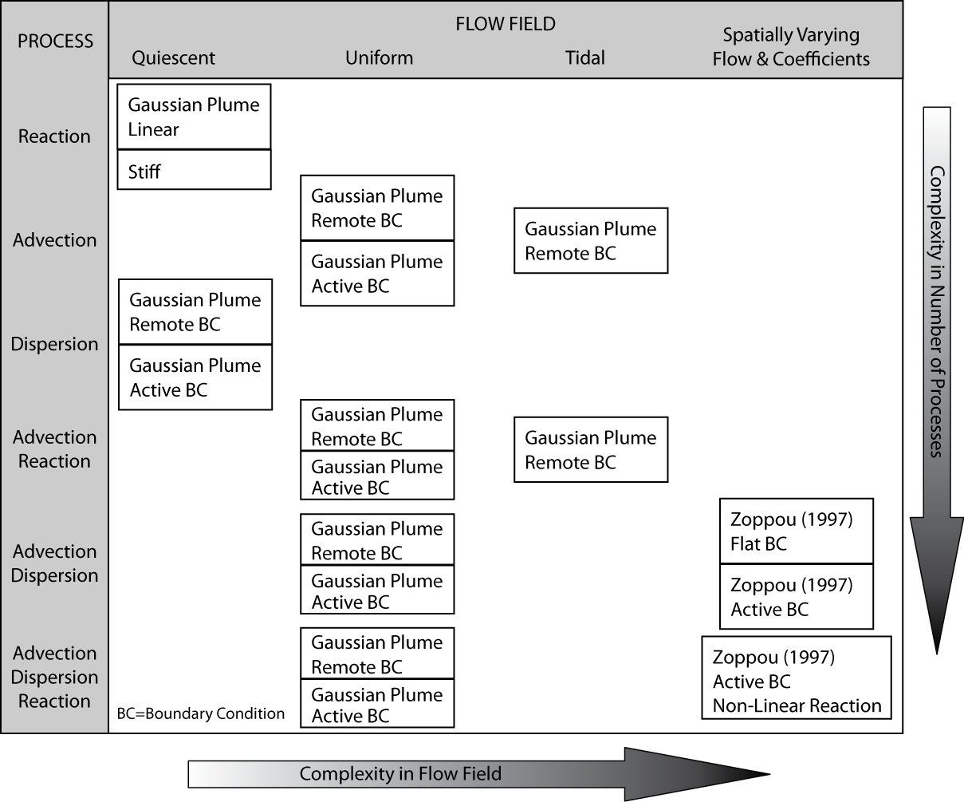

Figure 4-2: Transport algorithm testing incremental complexity.

* + Spatial variation in flow field and dispersion coefficient (Zoppou): This test is basically due to Zoppou and Knight (1997) and includes velocity proportional to distance and diffusion coefficients proportional to distance squared. This test had to be modified for a conservative fluid flow.
* Boundary complexity: For the uniform flow and Zoppou tests, we included cases where the boundary is far away from the transported mass and cases where the boundary is actively part of the problem. This allowed us to determine the extent to which convergence rates are affected by boundaries.

In what follows, we describe with some details all tests involved in the framework of algorithmic tests.

**4.4.1 Single operator tests**

## 1) ODE solver tests

This test represents physically the simple case of a mass of constituent being reduced by a decay of mass which could be attributed to processes such as settling of sediment particles, death of cells, etc. Mathematically, this leads to a linear decay equation, presented in Appendix C. This is an ordinary differential equation (ODE). The linear decay equation was solved by the second order Heun method. Results are compared with the analytical solution in Figure 4-3. It is worth mentioning that the remote boundary condition is meaningless in the context of an ODE solver. Test passed the defined criteria with 2nd order convergence ratio and the results were within in the acceptable range of accuracy (error was smaller than 10-6).

Also, a third order accurate Runge-Kutta solver for cases of stiff reaction problem was coded. The solver was checked versus the linear decay analytical solution. Test passed the defined criteria with 2nd order convergence ratio and the results were within the desirable range of accuracy (Figure 4-4).

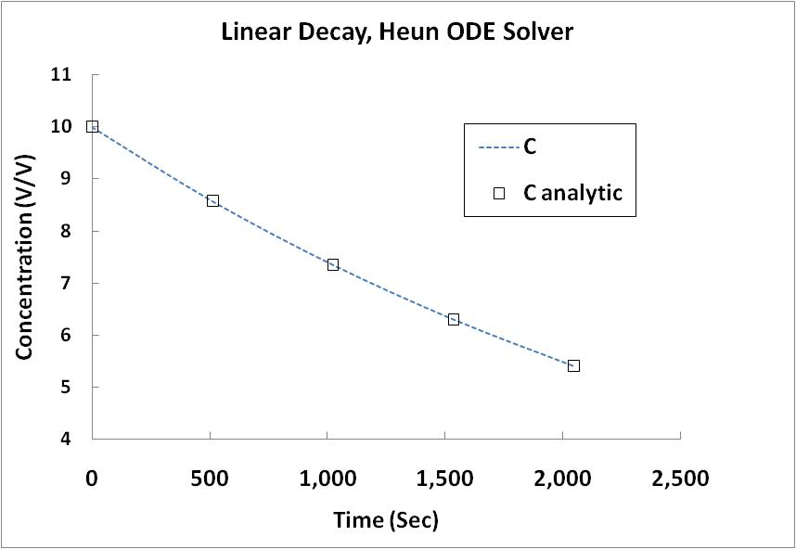

Figure 4-3: Heun ODE (reaction) solver convergence test

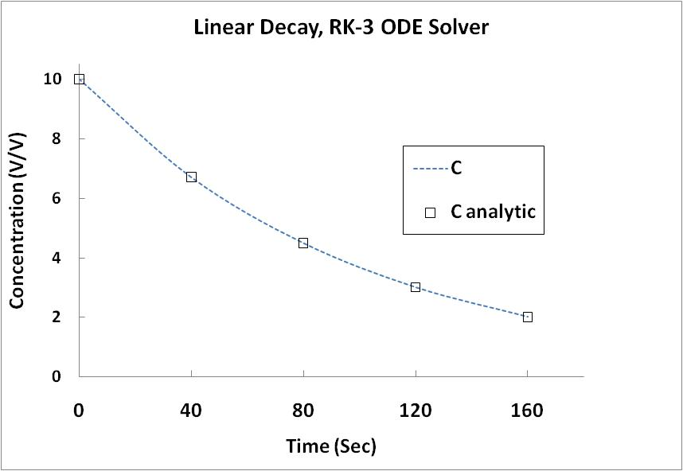

Figure 4-4: 3rd order accurate Runge-Kutta ODE solver convergence test

## 2) Quiescent flow- diffusion test

In this test, diffusion of a initial smooth distribution of mass between 0.1 and 1 is considered. Concentration value is fixed at the right end of the domain and it is changing with time at the left end. Since the analytical solution of concentration is known, both Dirichlet (value) and Neumann (flux) boundary conditions can be tested.

Diffusion solver was verified versus analytical solution (second and third exact solutions, equation C2 , and C3). First, for the second analytical solution, boundaries were set far in a way that the boundary values became smaller than the machine's precision (remote boundary condition). Then, boundaries placed closer in a way the boundary values were taking a value greater than zero. Test was performed with both flux and value boundary condition. The test passes the defined criteria with 2nd order convergence ratio and the results are restrained in the acceptable range of accuracy.

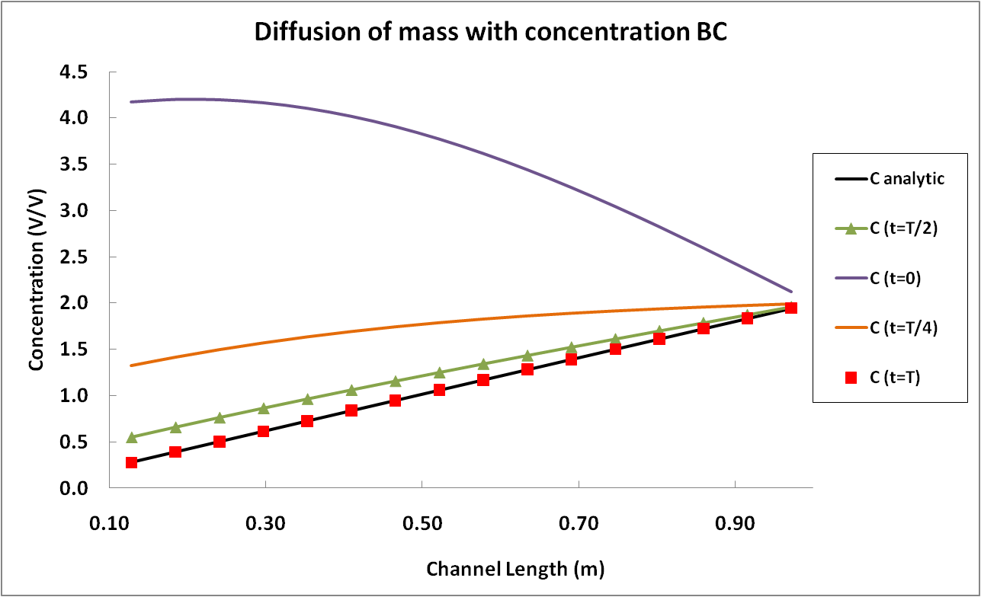

Figure 4-5: Diffusion single operator test, Dirichlet boundary condition

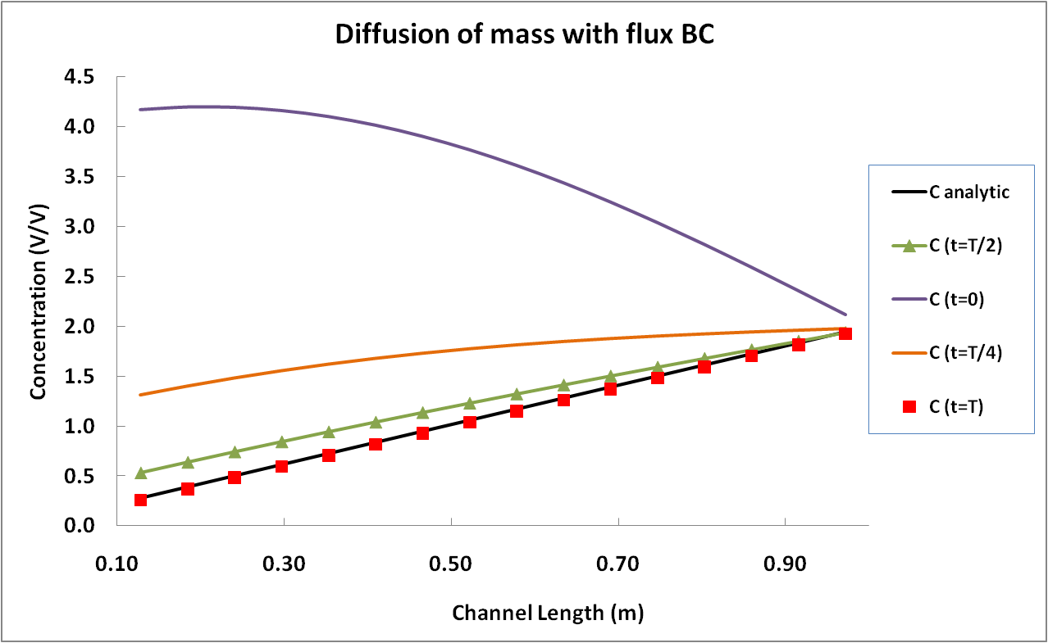

Figure 4-6: Diffusion single operator test, Neumann boundary condition

## 4.4.2 Uniform Flow Tests

* **Advection subjected to uniform flow:**

In this test analytical solution C4 is used. Initial Gaussian plume of mass is shifted forward (and backward) with constant velocity. The analytical solution is derived with changing the Lagrangian coordination to Eulerian (see de Marsily, 1986).

Advection solver was initially tested with remote boundary condition, where boundary values were defined far field where the machine precision dominates the boundary values. After passing these tests in both unidirectional and bidirectional flow setup the same tests repeated with domain boundaries set close to the Gaussian plume of mass. The detail of test where provided in the case two of analytical solutions (appendix C2). For unidirectional test, numerical results checked versus the exact solution and in the bidirectional flow field, numerical results checked versus the initial mass distribution. All of the above mentioned tests pass the predefined 2nd order accuracy in grid convergence study.

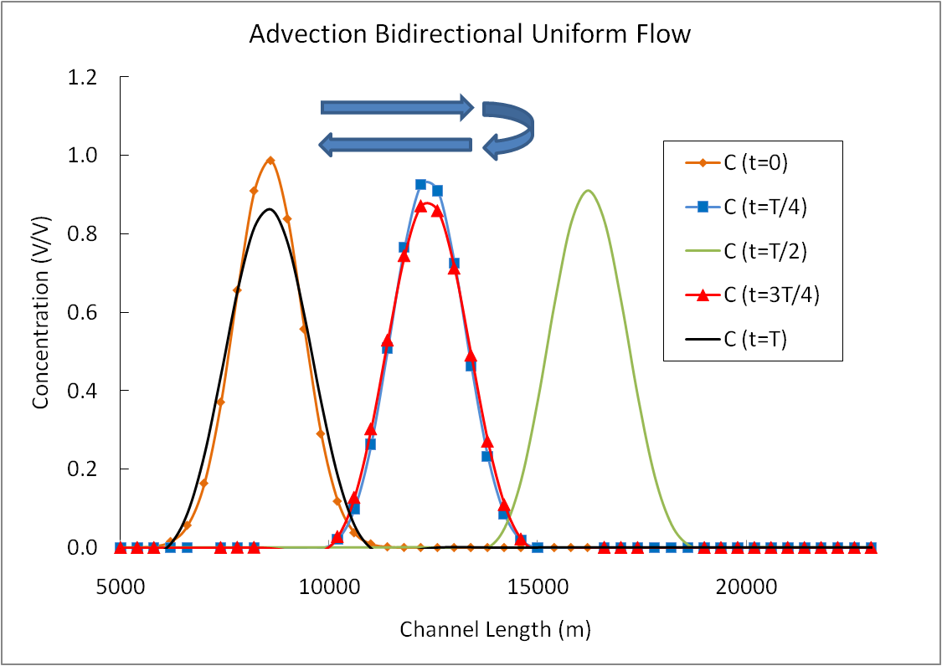

Figure 4-7: Advection solver, test bi-directional flow, Gaussian Plume of mass, remote boundary condition

* **Advection Reaction subjected to uniform flow:**

Advection solver and the ODE solver are integrated in one single routine. For details of numerical discritization see appendix BXXX. Using the exact solution case II, the Advection-Reaction solver was tested initially with remote boundary setup and then with active boundary. In both cases test was performed once in unidirectional flow and another time with bidirectional back and forth constant flow field. All of the above mentioned tests pass the predefined 2nd order accuracy in grid convergence study.

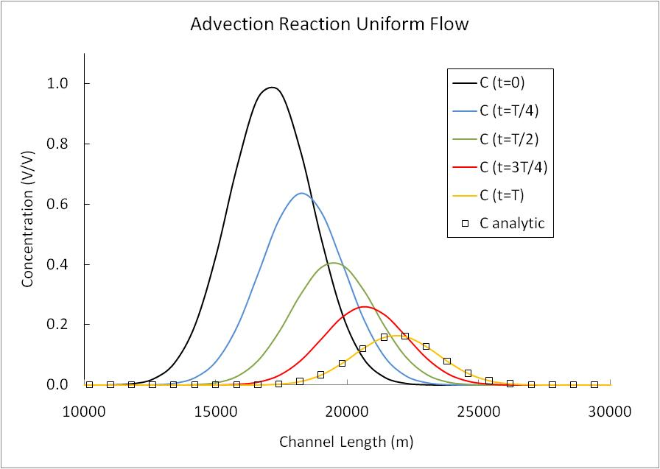

Figure 4-8: Advection-decay solver test, uniform flow

* **Advection dispersion**

Advection and the diffusion solvers are combined with operator splitting to run this test. For details of numerical implementation see appendix BX. The Advection-Dispersion solver was initial tested with remote boundary setup and then with the active boundary. Test was performed with unidirectional constant flow field. Both active and remote boundary tests pass the predefined 2nd order accuracy in the grid convergence study.

* **Advection dispersion reaction**

Three solvers together are tested in this test. The test problem was the Gaussian mass distribution which was pushed forwarded by uniform flow and also it was subjected to linear decay (second exact solution). Similar to the previous cases test was performed in two steps. First, boundaries were far from the plume and practically their values were zero (remote boundary), and then close to the plume (active boundary). For the remote boundary set up test passed the predefined 2nd order accuracy and for the case with active boundary order of accuracy in the grid convergence study was close to 1st order.

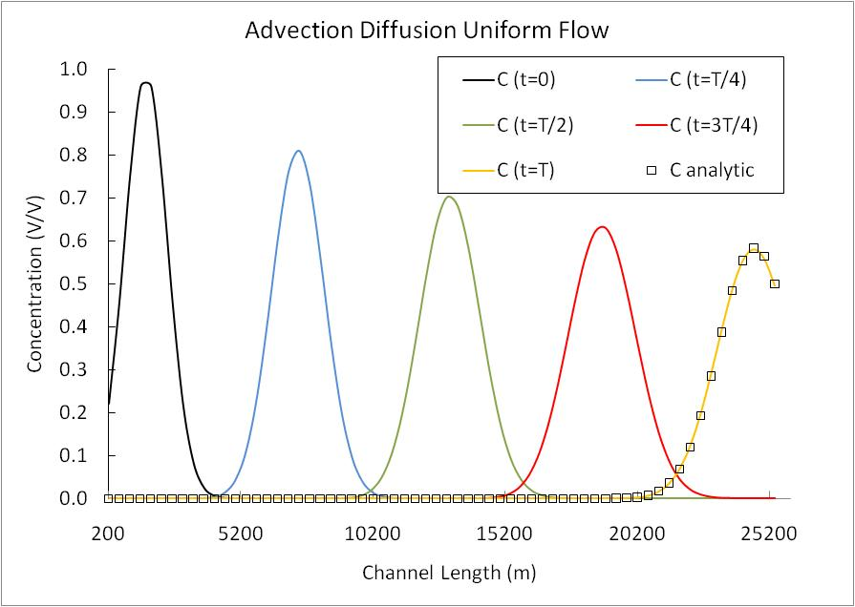

Figure 4-9: Coupling advection diffusion and reaction with zero order implementation of intermediate boundary condition, L1 error norm convergence ratio drops from 2 to 1.02

## 4.4.3 Test with tidal flow field

* **Advection**

Advection solver is checked in this test. Since only the analytical solution of tidal flow field is available, the test is performed with remote boundary condition. The initial mass distribution must be at the same location after one tidal cycle (12.41 hr). Test is conducted with both sinusoidal and Gaussian initial mass distribution. The grid convergence test passes predefined second order error in both Gaussian and sinusoidal plume. Detail of the solution is given under the fifth exact solution.

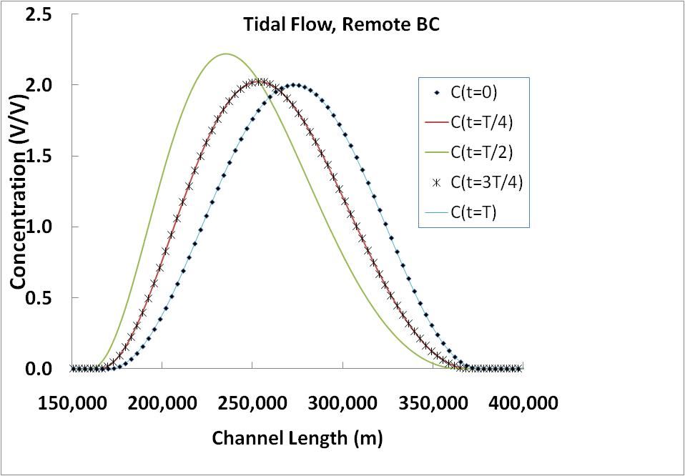

Figure 4-10: Tidal flow field, advection solver with Gaussian initial mass distribution

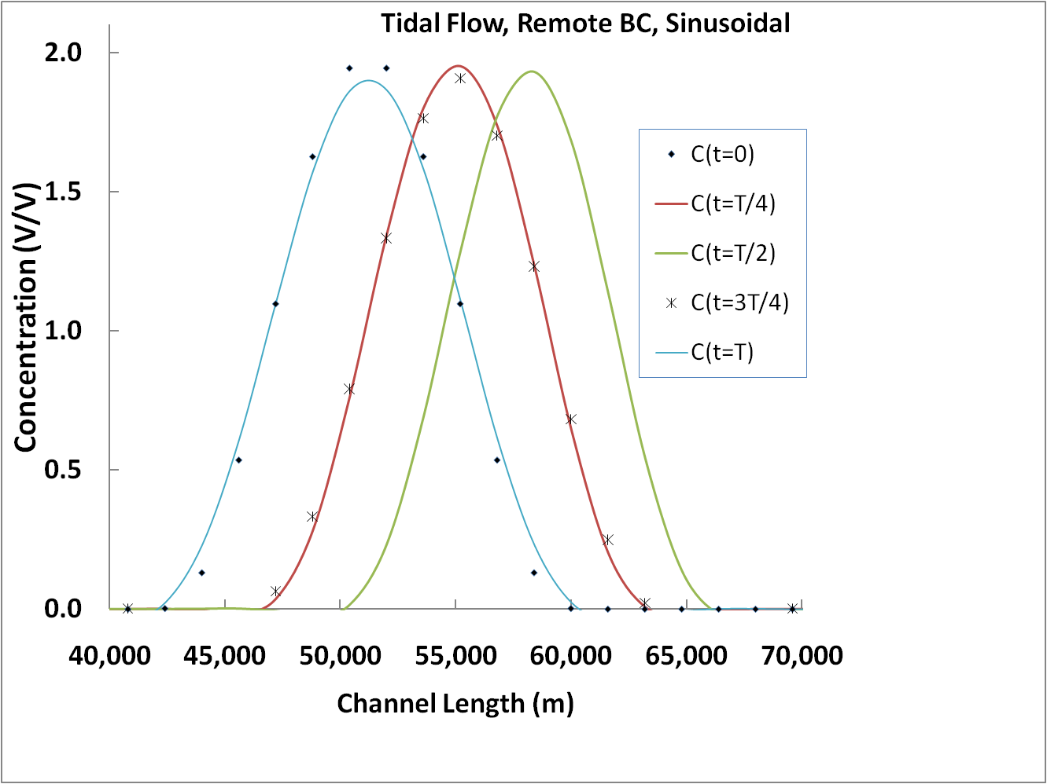

Figure 4-11:Tidal flow field, advection solver with sinusoidal initial mass distribution

* **Advection reaction**

Combination of Reaction and Advection solvers are checked in this test. Since only the analytical solution of tidal flow field is available, the test is performed with remote boundary condition. The initial mass distribution must be at the same location after one tidal cycle (12.41 hr). Test is conducted with both sinusoidal and Gaussian initial mass distribution. The grid convergence test passes predefined second order error in both Gaussian and sinusoidal cases. That is to mention integrating of two solvers (advection and reaction) is not extendable to the diffusion solver due to the lack of boundary conditional and also non-linearity of diffusion operator in a tidal flow field.

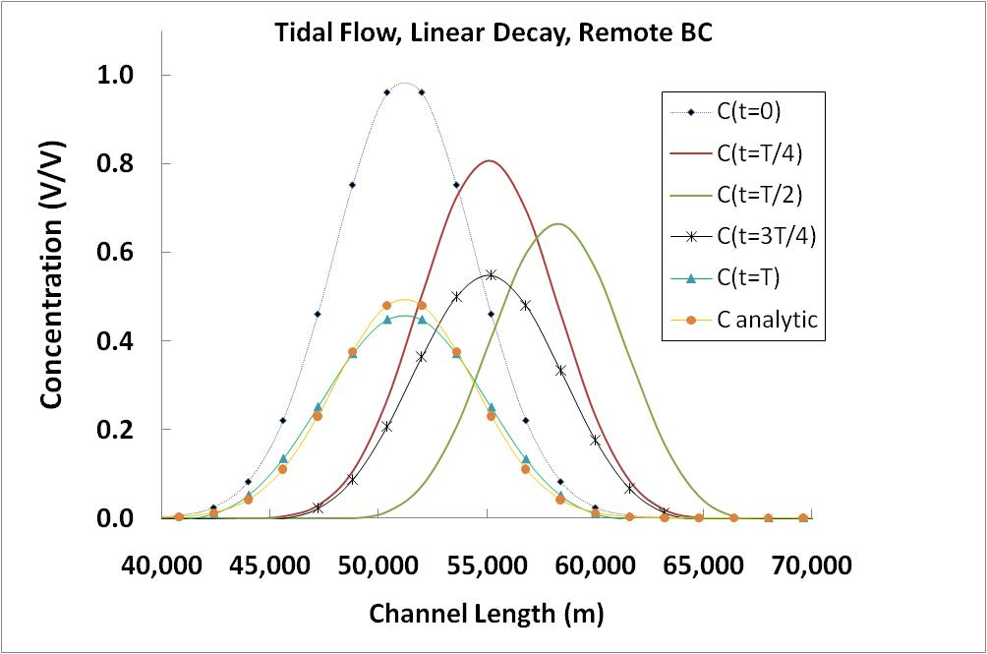

Figure 4-12: Tidal flow field, advection and reaction solvers with Gaussian initial mass distribution

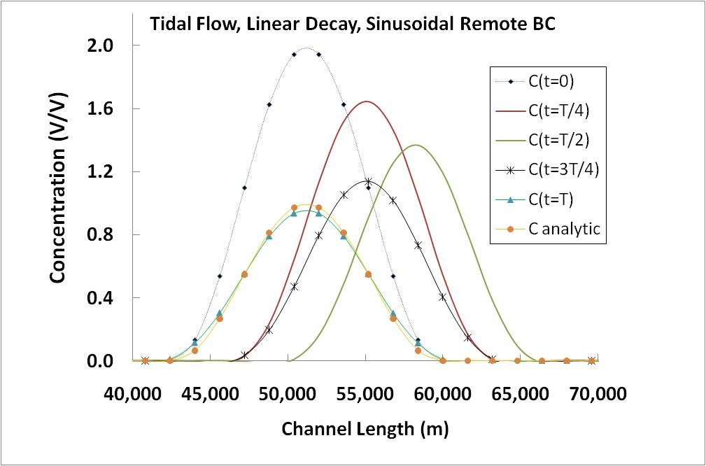

Figure 4-13: Tidal flow field, advection and reaction solvers with sinusoidal initial mass distribution

## 4.4.4 Test with spatially varying coefficient and flow field

Advection and dispersion solvers are tested versus an analytical solution which was by Zoppou and Knight (1997). Both dispersion coefficient and velocity are function of space in that analytical solution (case four in the exact solutions). The exact solution was modified to satisfy continuity equation. The test was performed in both remote boundary and active boundary setups. Although the numerical results are in very good agreement with analytical solution, mesh convergence study for Godunov splitting of operators could not pass second order convergence rate.

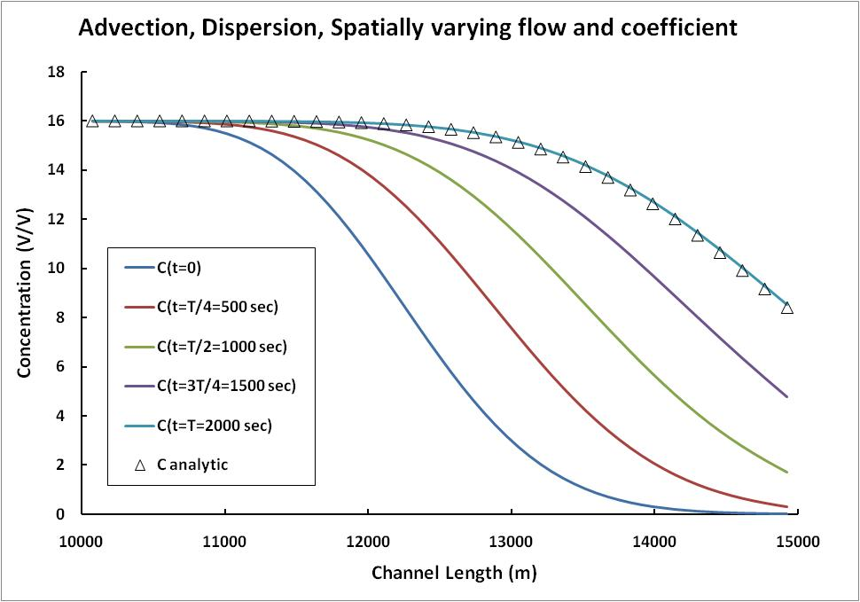

Figure 4-14: Spatially varying flow field and dispersion coefficient, advection and dispersion (Zoppou)

These tests were conducted for a range of parameter values that it usually occurs in an estuary. Typically the Courant number (a measure of numerical stability of the algorithm), domain length, and dispersion and decay coefficients were fixed, and the grid spacing and time steps were adjusted to maintain the same Courant number.

## 4.5 Examples of detected errors

In the STM verification process, many initial programming errors were found and fixed thanks to the unit testing. Then, in the next level of testing (algorithm and system testing) two additional errors were detected. One of the errors was a programming error and the other was an inconsistency in the introduction of the source term. This shows the importance of the test suite developed.

## 4.5.1 Algorithmic error in advection

The problem was originated in the feeding of the source term, which was coded in primitive variable (concentration) in the extrapolate subroutine of advection routine:

conc_lo(:,i)=conc(:,i)+half*(-grad(:,i)-dtbydx*grad(:,i)*vel+dt*source(:,i))

But latter in the update the conservative variables using divergence of fluxes the source term was introduced in the primitive values (mass):

mass(:,i)= ... +dt*half*source_prev(:,i)*area_prev+ dt*half*source(:,i)*area

At the beginning, the unidirectional advection grid convergence test was crafted for the advection routine. The test could not detect the error, because it employed unit area which is an idempotent operation of multiplication. In the transport suite test, the test latter was improved to bidirectional flow to be a enhanced simulation of tidal environment and the unidirectional advection test was eliminated. While we thought every component works correct, there was a serious pitfall. The error in the foreword push of the mass plume was canceled out by the same amount of error in the backward move (Figure 4-15). The symmetric nature of bidirectional flow concealed the algorithmic error in the advection solver. For that reason, the bug was not detectable with a grid convergence study. After visual investigation of results evolution in time, the defect was noticed and then resolved.

Figure 4-15: Schematic of the algorithmic error in introduction of the source to advection solver

## 4.5.2 Bug in imposing the boundary condition of diffusion

The transport test suite was able to detect incorrect array index in implementing boundary cells.

The erroneous line was:

... right_hand_side(ncell-1,:)- theta_stm*(dt/dx)*flux_end

and it was corrected to:

... right_hand_side(ncell,:)- theta_stm*(dt/dx)*flux_end

The buggy line above is underlined. We did not expect the mesh convergence test to detect this bug. Although the above bug reduced the accuracy in the numerical results by several order of magnitude, it did not impact the order of convergence. The bug was found by assigning a very large number to the concentration values which are not using in the boundary value. The reason was as follows: As a general rule we intuitively think that an *O(hP)* local truncation error (LTE) leads to and *O(hP)* and an scheme with the convergence order of "p". In some cases the LTE can be lower in order at limited points without affecting the global order of error convergence. In the standard three point finite volume discretization of an elliptic differential equation, local reduction of order of accuracy in the interior cells up to 1 order hides in global error convergence ratio. Furthermore, the local reduction of order of error in boundary cells up to 2 order does not affect global order of convergence. Hence the classic grid convergence test could not detect the above indexing error. There are two ways to find the error: First implement point-wise error grid convergence study instead of global assessment of error. Second, perturbation of a point in domain up to the order of error buffer can cause reduction in the order of accuracy in case of existence of any bug.

if we are dealing with the elliptic system:

The relation between local error τ and global error ε is:

Since the infinity error norm is the most restrictive band the proof for automatically concludes proof for the other error norms.

so if is from order of O(hp), then on the boundary and interior nodes consider the global order of error. It is proven that is in the interior cells and on the boundary nodes (for example see Leveque, 2007) therefore with of in interior cells and . of on the boundary the whole system still yields of

**CHAPTER 5**

**DEVELOPMENT OF A WEBSITE**

**WITH DATA ON SEDIMENT**

**TRANSPORT**

**__________________________________**

**5.1 Overview**

In last decades, several state and federal agencies have contributed to a better understanding of the sedimentation processes and mechanisms leading to morphological changes in the Sacramento-San Joaquin Delta through the collection of in situ data. These measured data have been published in different formats, and stored electronically in diverse webpages. The UC Davis Department of Civil and Environmental Engineering, in cooperation with DWR personnel, created an unprecedented website with links to that available information. This website thus provides a sediment data inventory for the Delta. The website was published in May 2010, and can be found in the following URL:

*http://baydeltaoffice.water.ca.gov/modeling/deltamodeling/models/stm/STPversion1.2/STPwebsite.html#top*

linked to the website of the DWR.

The website is organized in three parts: the first part offers a list of pertinent data sites with sediment-related data for the Delta, including company/project contacts to have access to the data. Each section lists the frequency, method, period, and location of each collected parameter, as well as the data format. The second part of the site lists known reports and publications related to sediment transport and monitoring. This section also includes a brief description of each document and an address to an on-line copy of the reports and publication. Finally, a section containing useful links is given. Fig. 5-1 shows the first page of the website, where the aforementioned sections are apparent.

**5.2 Data sites**

This section contains the data categorized by organization, by type, and collection frequency. Within organization, it is possible to mention agencies such as DWR, the United States Geological Survey (USGS), the Sacramento Regional County Sanitation District (SRCSD), DWR, and the Central Valley Monitoring Directory among others.

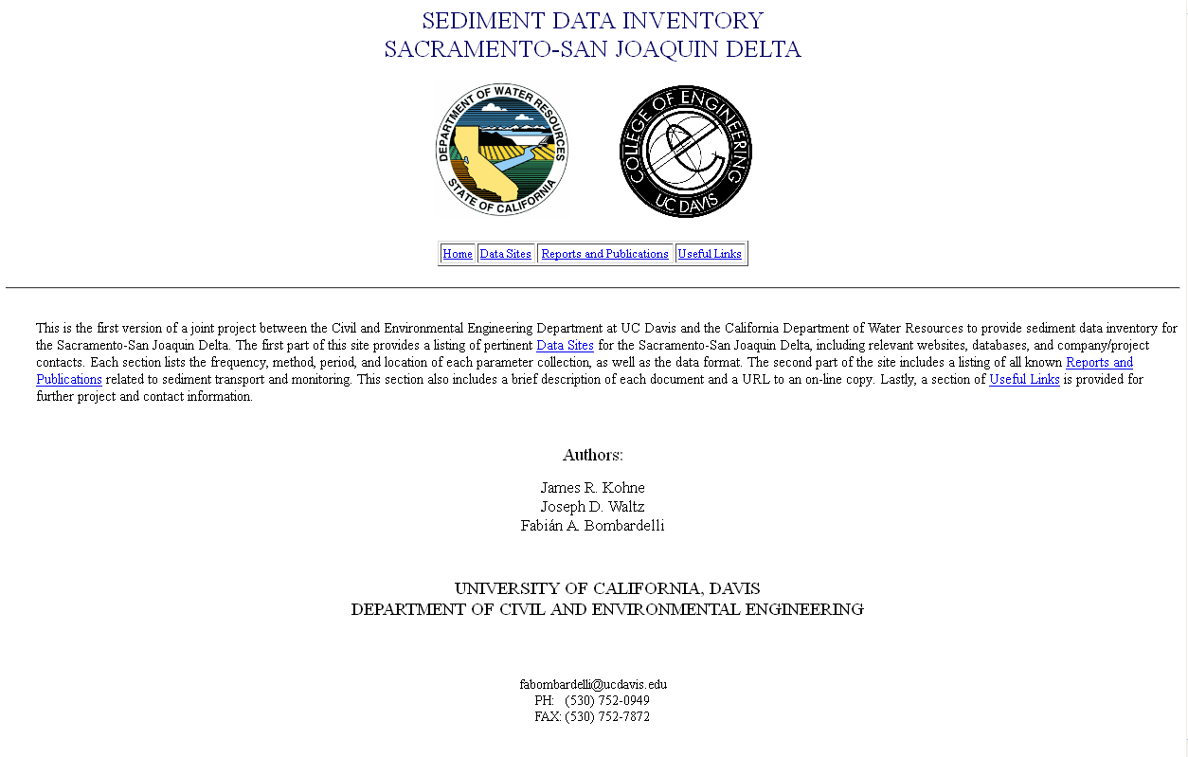

Figure 5‑1: The first page of Sacramento- San Joaquin Delta, sediment-transport data webpage.

Regarding the type of data, the different ways in which sediment concentrations can be inferred, and associated variables are reported: turbidity, total suspended solids; dredging data; electrical conductivity; particle size distribution; etc. Finally, the data were organized based on the sampling frequency. The detail of this method of category is given in the Figure 5-2.

**5.3 Delta sediment-related technical reports**

This part of the site includes a brief description of each document and a URL to an online copy of it. The reports are listed in reverse chronological order. In what follows, some examples of the kind of information summarized in the website are provided:

* “Suspended sediment and sediment-associated contaminants in the San Francisco Bay (2007). This paper uses data from the 26 locations monitored by the Regional Monitoring Program (RMP) of the San Francisco Estuary Institute to describe temporal and spatial variability of bed sediment loads and contaminant concentrations in the SF bay. They use TSS measurements from 1993-2001.”
* “Summary of SSC data, SFBay, CA, Water yr 2005. This document was prepared in cooperation with the CALFED Bay–Delta Authority and the U.S. Army Corps of Engineers, San Francisco District. Data was collected by USGS and includes suspended sediment concentrations (gathered at two depths for most sites) at 15 min intervals, from Oct. 1, 2004 – Sept. 30, 2005. Locations consist of two sites in Suisun Bay, three sites in San Pablo Bay, two sites in Central San Francisco Bay, and three sites in South San Francisco Bay.”

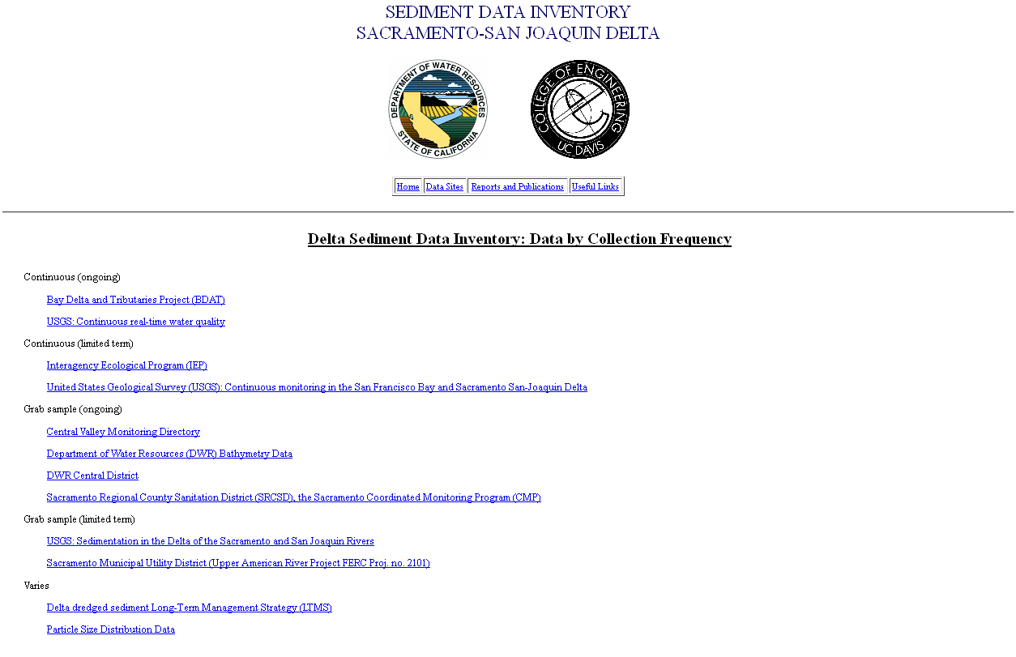

Figure 5‑2: Sediment transport data category based on collection frequency of data.

**5.4 Useful links**

This part of the website provides links to other sites related to this project, as shown in Figure 5-3.

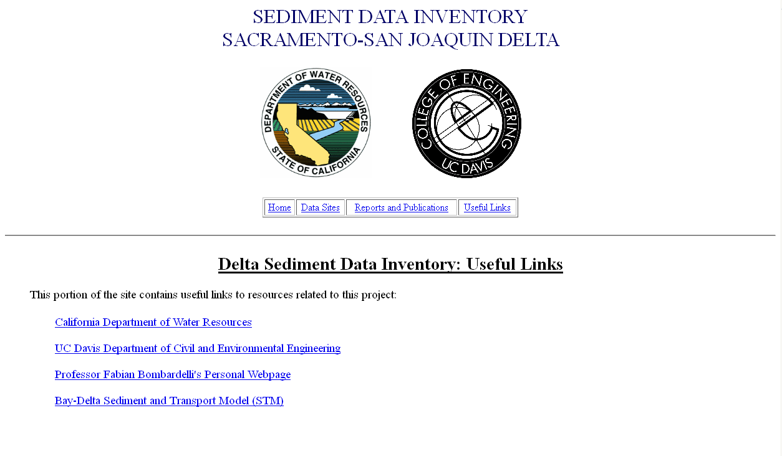

Figure 5-3: Some links included in the website.

# REFERENCES

**__________________________________**

* Abad, J.D., Buscaglia, G.C., Garcia, M.H., (2008), "2D stream hydrodynamic, sediment transport and bed morphology model for engineering applications", Hydrological Processes, Vol. 22 (10), pp. 1443-1459.
* Abbott, M. B., Price, W. A., (Eds.), (1994), “*Coastal, Estuarial, and Harbour Engineers’ Reference Book”*, Chapman & Hall.
* Abiouli, M. K., (2007), “*Sacramento- San Joaquin Delta Overview”*. Report by Bay-Delta Office, DWR, California, http://baydeltaoffice.water.ca.gov/sdb/tbp/deltaoverview/index.cfm.
* Aiyesimoju, K. O., Sobey, R. J., (1989), *“Process Splitting of the Boundary Condition for The Advection- Dispersion Equation”* Int. J. of Numerical Methods in Fluids, Vol. 9, pp. 235-244.
* Arora, M., Roe, P. L., (1997), *“A Well-Behaved TVD Limiter for High-Resolution Calculations of Unsteady Flow”*, J. of Computational Physics, Vol. 132, pp. 3-11.
* Baugh, J. V., Manning, A. J., (2007), “*An assessment of a new settling velocity parameterization for cohesive sediment transport modeling”*, Continental Shelf Research, Vol. 27, pp. 1835-1855.
* Bogacki, P., Shampine, L. F., (1989) “*A 3(2) Pair of Runge-Kutta Formulas*”, Appl. Math. Lett., Vol. 2(4), pp. 321-325.
* Boris, J.P., Book, D.L., (1973) "Flux corrected transport I: SHASTA, Afluid transport algorithm that works", J Computational Physics, Vol. 11, pp. 38-69.
* Celia , M.A., Russell, T.F., Herrera,I., Ewing, R.E., (1990), "An Eulerian-Lagrangian localized adjoint method for the advection-dispersion equation", Advance in Water Resource, Vol. 13, pp. 187-206.
* Chen, Y., Falconer, R. A., (1992), *“Advection Diffusion Modeling Using the Modified Quick Scheme”,* International J. for Numerical Methods in Fluids, Vol. 15(10), pp. 1171-1196.
* Cheng, H. P., Yeh, G. T., Cheng, J. R., (2000), *"A numerical model simulating reactive transport in shallow water domains: model development and demonstrative applications"*, Advances in Environmental Research, Vol. 4, pp. 187-209.
* Chilakapati, A., (1993), "Numerical Simulation of Reactive Flow and Transport through the Subsorface" PhD dissertation, Rice University, Houston, TX.
* Chung, T. J., (2002), *“Computational Fluid Dynamics”,* Cambridge University Press.
* Colella, P., et al., (2009), "Chombo Software Package for AMR Applications: Design Document", Lawrence Berkeley National Laboratory online document.
* Colella, P., Puckett, E. G., (1998), *“Modern Numerical Methods for Fluid Flow”,* UC DavisClass Note.
* Crank, J., Nicolson, P. (1947), "A practical method for numerical evaluation of solutions of partial differential equations of the heat conduction type". *Proc. Camb. Phil. Soc.* Vol. 43 (1), pp. 50–67.
* de Marsily, C., (1986), "Quantitative Hydrogeology; Groundwater Hydrology for Engineers", Academic Press.
* Dietrich, W., (1982), "Settling Velocity of Natural Particles ", Water Resources Research, Vol.18(6), pp. 1615-1626.
* Ferziger, J. H., Peric, M., (2002), “*Computational Methods for Fluid Dynamics”,* Springer.
* Fischer, B. H., List, J. E., Koh, R. C., Imberger, J., Brooks, N. H., (1979), *“Mixing in Inland and Coastal Waters”*, Academic Press, Inc.
* Fletcher, C. A. J., (1991), *“Computational Techniques for Fluid Dynamics”*, Springer.
* Garcia, M. H., (Ed.), (2008), *“Sediment Engineering, Process, Measurements, Modeling, and Practice”*, Manuals and Reports on Engineering Practice No. 110, ASCE, EWRI.
* Garcia, M. H., Parker, G., (1991), “*Entrainment of Bed Sediment into Suspension”*, Hydraulic Eng., Vol.117(4), pp. 414-435.
* Greimann, B., Lai, Y., Huang, J., (2008), “*Two-Dimensional Total Sediment Load Model Equations”*, J. Hydraulic Eng., Vol. 134(8), pp. 1142-1146.
* Gupta, A.D., Lake, L.W., Pope, G.A., Sephernoori, K., King, M.J., (1991), "High resolution monotonic schemes for reservoir fluid flow simulation", In Situ, Vol. 15 (3), pp. 289-317.
* Hanak, E., Lund, J., Dinar, A., , Gray, B., Howitt, R., Mount, J., Moyle, P., Thompson, B., (2011), "Managing California’s Water: From Conflict to Reconciliation", Public Policy Institute of California, San Francisco, CA.
* Hills, R.G., Fisher, K.A., Kirkland, M.R., Wierenga, P.J., (1994), "Application of flux-corrected transport to the Las Cruces Trench site", WATER RESOUR. RES., vol. 30(8), pp. 2377-2386.
* Holly, F. M., Yang, J. C., Schwartz, P., Schaefer, J., Hsu, S. H., Einhellig, R., (1990), “*CHARIMA: Numerical Simulation of Unsteady Water and Sediment Movement in Multiply Connected Networks of Mobile-Bed Channels”*, Iowa Institute of Research, IIHR Report No. 343.
* Hundsdorfer, W., Verwer, J. G., (2003), "*Numerical Solution of Time-Dependent Advection-Diffusion-Reaction Equation*", Springer.
* IEEE Standards Board, (1993), “*IEEE Standard for Software Unit Testing”*, ANSI/IEEE Std, No. 1008-1987.
* Julien, P. Y., (1994), “*Erosion and Sedimentation”*, Cambridge University Press.
* Julien, P. Y., (2002), “*River Mechanics”*, Cambridge University Press.
* Kaluarachchi, J. J., Morshed, J., (1995), *“Critical Assessment of the Operator-Splitting Technique in Solving the Advection-Dispersion-Reaction: 1. First-Order Reaction”*, Advances in Water Resources, Vol. 18(2), pp. 89-100.
* Khan, L. A., Liu, P. L., (1994), “*An operator splitting algorithm for coupled one dimensional advection-diffusion –reaction equations”*, Computational Methods in Applied Mechanics and Eng., Vol. 127, pp. 181-201.
* Khan, L. A., Liu, P. L., (1995), “*Intermediate Dirichlet Boundary Conditions for Operator Splitting Algorithms for Advection-Diffusion Equation”*, Computers and Fluids. Vol. 24(4), pp. 447-458.
* Kollmann, W., (2009), “*UC Davis, Lecture Notes ME-210B: Stability, Insatiability and Transition to Turbulence*”, University Readers.
* Konikow, L.F., Bredehoeft, J.D., (1978), "Computer Model of two-dimensional solute transport and dispersion in groundwater" Chapter C2 in: Techniques of Water-Resources Investigation, Reston, VA.
* Lanser, D., Verwer, J. G., (1999), *“Analysis of operator splitting for Advection-Diffusion-Reaction Problems from Air Pollution Modelling”*, J. of Computational and Applied Mathematics, Vol. 111, pp. 201-216.
* Leveque, J. R., (1986), *“Intermediate Boundary Conditions for Time-Split Methods Applied to Hyperbolic Partial Differential Equations”*, Mathematics of Computation, Vol. 47 (175), pp. 37-54.
* Leveque, J. R., (1992), *"Numerical Methods for Conservation Laws"*, 2nd ed, Birkhauser Verlag.
* Leveque, J. R., (2002), *“Finite Volume Methods for Hyperbolic Problems”*, Cambridge University Press.
* Leveque, J. R., (2007), *"Finite Difference Methods for Ordinary and Partial Differential Equations: Steady State and Time-Dependent Problems"*, SIAM.
* Leveque, J. R., Oliger, J., (1983), *“Numerical Methods Based on Additive Splitting for Hyperbolic Partial Differential Equations”*, Mathematics of Computation, Vol. 40 (162) , pp. 469-497.
* Lund, J., Hanak, E., Fleenor, W., Bennett, W., Howitt, R., Mount, J., Moyle, P., (2008), "Comparing Futures for the Sacramento-San Joaquin Delta", Public Policy Institute of California, San Francisco, CA.
* Lund, J., E. Hanak, W. Fleenor, R. Howitt, J. Mount, and P. Moyle, (2007), "[Envisioning Futures for the Sacramento-San Joaquin Delta](http://cee.engr.ucdavis.edu/faculty/lund/www.ppic.org)", Public Policy Institute of California, San Francisco, CA.
* Lyn, D. A., Goodwin, P., (1987), “Stability of a General Preissmann Scheme”, J. Hydraulic Eng., Vol. 113(1), pp. 16-28.
* Maa, J. P. Y., Sanford, L. P., Schoellhamer, D. H., (2007), “*Estuarine and Coastal Fine Sediment Dynamics”*, INTERCOH 2003 (Proceedings in Marine Science), Elsevier.
* Mehta, A. J., McAnally, W. H., (2007), “*Fine-Grained Sediment Transport*”, Chapter 4 in “*Sediment Engineering*”, Garcia, M. H., (Ed.), Manuals and Reports on Engineering Practice No. 110, ASCE, EWRI.
* Oberkampf, W. L., Trucano T. G., (2002), *“Verification and Validation in Computational Fluid Dynamics”*, SANDIA REPORT, No. SAND2002-0529.
* Oberkampf, W. L., Trucano T. G., (2007), *“Verification and Validation Benchmarks”*, SANDIA REPORT, No. SAND2007-0853.
* Press, W. H., Teukolsky, S. A., Vetterling, T. W., Flannery B. P., (1992), *"Numerical Recipes in FORTRAN"*, 2nd edition, CAMBRIDGE.
* Remesikova, M., (2004), *"Solution of convection–diffusion problems with nonequilibrium adsorption"*, J. of Computational and Applied Mathematics, Vol. 169, pp. 101-116.
* Roache, P. J., (1992), *“A Flux-Based Modified Method of Characteristics”*, International J. of Numerical Methods in Fluids, Vol. 15, pp.1259-1275.
* Roache, P. J., (2002), *“Code Verification by the Method of Manufactured Solutions”*, J. of Fluid Eng., Vol. 124, pp. 4-10.
* Roache, P. J., (2009), *“Fundamentals of Verification and Validation”*, Hermosa Publishers.
* Roache, P. J., Knupp, P. M., (1993), *“Complete Richardson Extrapolation”*, Communication in Numerical Method in Eng. Vol. 9, pp. 365-374.
* Rutherford, J.C., (1994), "River Mixing", Wiley.
* Saltzman, J., (1994), *“An Unsplit 3D Upwind Method for Hyperbolic Conservation Laws”*, J. of Computational Physics, Vol. 115, pp. 153-168.
* Sommeijer, B. P., van Der Houwen, P. J., Verwer, J. G., (1981), *“On the Treatment of Time-Dependent Boundary Condition in Splitting Methods for Parabolic Differential Equations”*, International J. for Numerical Methods in Eng., Vol. 17(3), pp. 335-346.
* Steefel, C. I., MacQuarrie, K. T. B., (1996), “*Approaches to Modeling of Reactive Transport in Porous Media”*, Chapter 2 in “*Reactive Transport in Porous Media*”, Lichtner, P. C., Steefel, C. I., Oelkers, E. H., (Eds.), Mineralogy Society of America, Washington, DC.
* Strang, G., (1968), “*On the construction and comparison of difference schemes”*, SIAM J. Numerical Analysis, Vol. 5, pp. 506-517.
* Sussman, B. C., Fitzpatrick, B. W., Pilato, C. P., (2004), “*Version Control with Subversion*” online book.
* Twizell, E. H., Gumel, A. B., Arigu, M. A., (1996), “*Second-order, L0-stable methods for the heat equation with time-dependent boundary conditions*”, Advances in Computational Mathematics, Vol. 6, pp. 333-352.
* Unger, A.J.A., Forsyth, P.A., Sudicky, E.A., (1995) "Variable spatial and temporal weighting schemes for use in multi phase compositional problems", Advances in Water Resources, Vol.19(1), pp. 1-27.
* Valocchi, A. J., Malmstead, M., (1992), “*Accuracy of operator splitting for advection-dispersion-reaction problems”*, Water Resource Research, Vol. 28(5), pp. 1471-1476.
* van Genuchten, M. Th., (1981), *“Analytical solutions for chemical transport with simultaneous adsorption, zero-order production and first-order decay”*, J. Hydrology, Vol. 49, pp. 213-233.
* van Leer, B., (1977), *"Towards the Ultimate Conservative Difference Scheme, IV. A New Approach to Numerical Convection*", J. Computational Physics, Vol. 23, pp. 276–299.
* van Rijn, L. C., (1984), “*Sediment Transport Part I. Bed-Load Transport”*, J. Hydraulic Eng., Vol. 110(10), pp. 1431-1456.
* van Rijn, L. C., (1984), “*Sediment Transport Part II. Suspended Load Transport”*, J. Hydraulic Eng., Vol. 110(11), pp. 1613-1641.
* van Rijn, L. C., (1984), “*Sediment Transport Part III. Bed-Forms and Alluvial Roughness”*, J. Hydraulic Eng., Vol. 110(12), pp. 1733-1754.
* van Rijn, L. C., (1993), “*Principle of Sediment Transport in Rivers, Estuaries, and Coastal Seas”*, AQUA Publications.
* Vanoni, V. A., (Ed.), (1977), *“Sediment Engineering”*, Manuals and Reports on Engineering Practice No. 54, ASCE.
* Wang, S. Y., Roache. P. J., Schmalz, R. A., Jia, Y., Smith, P. E., (2009), *“Verification and Validation of 3D Free-Surface Flow Models”*, ASCE, EWRI.
* Wong, M., Parker, G., (2006), "Reanalysis and correction of bed-load relation of Meyer-Peter and Muller using their own database", J. Hydraulic Eng., Vol. 132(11), pp. 1159-1168
* Wu, W., (2008), “*Computational River Dynamics*”, Taylor & Francis.
* Wu, W., Vieira, D. A., (2002), *“One-Dimensional Channel Network Model CCHE1D Version 3.0 – Technical Manual”*, National Center for Computational Hydroscience and Eng., Report No. NCCHE-TR-2002-1.
* Yeh, G. T., Tripathi, V. S., (1989), *"A Critical Evaluation of Recent Developments in Hydrogeochemical Transport Models of Reactive Multichemical Components"*, Water Resources Research, Vol. 25(1), pp. 93-108.
* Yeh, H.C., (1987), "Construction of explicit and implicit symmetric TVD schemes and their applications", J. Computational Physics, Vol. 68, pp. 151-179.
* Zalesak, S.T., (1987), "A preliminary comparison of modern shock-capturing schemes: Linear advection" . In: R. Vichnevetsky and R.S. Stepleman, Editors, *Advances in Computer Methods for Partial Differential Equations* **VI**, IMACS, New Brunswick, N.J.
* Zoppou, C., Knight, J. H., (1997), “*Analytical Solution for Advection and Advection-Diffusion Equation with Spatially Variable Coefficients*”, J. Hydraulic Eng., Vol. 123(2), pp. 144-148.

# APPENDIX A

# EQUATIONS OF THE THEORETICAL MODEL

**________________________________**

**A1. Sediment entrainment and deposition functions**

There are many formulas for sediment entrainment. The following formulas are widely recommended in the literature.

1. Garcia and Parker

In 1991, Garcia and Parker suggest the following formula:

 (A1.1)

where Es is sediment entrainment coefficient



 (A1.1.2)

Zu is a measure of the shear stress strength but it also takes into account the particle size. Here reference level is taken to be 5% of the depth.

 (A1.1.3)

*u\** : shear velocity

*v*s= sediment fall velocity (will discuss later in this Appendix)

 (A1.1.4)

Rep is particle Reynolds number

(A1.1.5)



*R* is specific submerged gravity (*1.65* for quartz particle), *g* = Gravitational acceleration, *D = D50*.

In Garcia and Parker (1991) a comparison of many of other entrainment formula could be found. They have found that the relation (A1.1) works well for fine-grained non-cohesive sediments.

1. van Rijn

## Another formula that has been found to perform well is that of van Rijn (1984b).

 (A1.2)

where:

 (A1.2.1)

 (A1.2.2)

*ks=3D* for uniform material (is effective roughness height),  is a bed forms height and *b=ks* when bed forms height is unknown, *H*: Total depth of flow, d*= is dimensionless particle parameter, : Reference concentration for equilibrium case (near bed value of mean volumetric sediment concentration),, *Ds= D50*, g = Gravitational acceleration, Note: here denotes the dimensionless Shields stress due to skin friction (mobility parameter)

 (A1.2.3)

 (A1.2.4)

 is the shear stress caused by skin friction

 (A1.2.5)

In which, *Cfs* is the resistant coefficient, *k*s is the effective roughness height, = von Karman constant (0.41), this formula has been used extensively in numerical treatment of suspended sediment transport (Duan et al., 2001; Zeng et al., 2006).

1. Smith and McLean

Third equation which performs well is by Smith and McLean (1977). This equation is based on Yalin early works (1963).

 (A1.3)

where, : reference concentration for equilibrium case,, and the value of *b* (height in which the is to be evaluated) is given by the following:

 (A1.3.1)

*k*s= is the equivalent roughness height for fixed bed

 (A1.3.2)

is the dimensionless stress due to skin friction

 (A1.3.3)

 is the shear stress caused by skin friction

 (A1.3.4)

Here *Hs* is the depth in absence of bed forms (*Hs+Hf=H*) and *H*s it could be expressed as:

 (A1.3.5)

= von Karman constant (0.41), *K*s is the effective roughness height, *S:* energy slope, is dimensionless critical Shields shear stress for incipient motion (Appendix A2).

The Smith and McLean formula is used extensively in benthic boundary layer flows and oceanic sedimentation (McCave, 2004).

1. Zyserman and Fredsoe

After the comparative analysis of different entrainment formulations, in 1994 Zyserman and Fredsoe proposed an empirical relation (A1.4) using the Fort Collins experimental data.

 (A1.4)

 here is referred to concentration at *b=2D50*,

, is the shields stress due to skin friction

 (A1.4.1)

 (A1.4.2)

Here *Hs* is the depth in absence of bed forms, (*Hs+Hf=H*) and *H*s could be expressed as:

 (A1.4.3)

= von Karman constant (0.41), S=energy slope, *k*s is the effective roughness height,is dimensionless critical Shields shear stress for incipient motion.

This formula is based on laboratory data, but it has been used widely in costal engineering practice (Soulsby, 1997).

**A2. Fitted Formula to the Shields Diagram**

**A2-1: Brownlie (1981)**

 (A2.1)

where; , *D=D50*, *g*: gravitational acceleration, ν: kinematic viscosity of water, is dimensionless critical Shields shear stress for incipient motion.

### A2-2: Mantz (1977)

For fine-grained sediments Shields diagram does not provide realistic results. Mantz conducted a series of experiments and observed that for fine grained non-cohesive sediments the critical shear stresses can be estimated with the following relation

 (A2.2)

The Mantz equation merges Brownlie equation for *Rep=4.22*

**A3. Fall Velocity**

Fall velocity or settling velocity is a fundamental property of a sediment particle. Falling under the gravity action a particle will reach a constant, terminal velocity once the drag is equal to the submerged weight of the particle. The range of particle sizes can be categorized in three following sizes:

* 1. Medium and coarse sand, gravel, cobble, and boulder; *ds>0.1 mm* which must be calculated with Rubey’s approximation of fall velocity (Stokes’ law is not valid for them)

b) Very fine Sand and Silt; *0.1 mm >ds > 0.004 mm* which can calculate by Stokes’ law.

c) Clay; which is also calculated by Stokes’ law but flocculation is possible.

### Stokes’ law:

### It is valid for small particle size (*ds<0.1 mm*) falling in viscous fluid (*Rep<0.1*)

 (A3.1)

*G* is specific gravity and, for quartz particle.

### Rubey’s Formula:

Rubey’s approximation formula (A3.2) of fall velocity in clear water is based on drag coefficient of sand particle equation (A3. 3):

 (A3.2)

 (A3.3)

 (A3.4)

 (A3.5)

 is the kinematic viscosity of water-sediment mixture, d* is the dimensionless particle diameter, both Rubey’s and Stokes’ formula yield practically same results for the cases of Reynolds numbers less than one, so all the settling velocities will be calculated base on Rubey’s approximation

**A4. Cohesive Sediment**

**A4-1 Generalities**

Fine grained sediment transport is generally characterized by size composition, and plasticity (van Rijn, 1993). Cohesion is due to electrochemical forces acting on the particle surface. Hence the degree of cohesion depends on the ratio of particle surface area to particle weight, that is, specific surface area. Migniot (1968) showed that the ratio of particle settling velocity to particle size increases due to floc and cohesion.

A characteristic gauge of clay mineral cohesion is cation exchange capacity (CEC). The higher the CEC, the greater the cohesion, which causes micro-meter-sized individual clay particles to coagulate or flocculate in water, to form much larger aggregates, or flocs when water salinity exceeds a critical value which depends on the clay mineral.

Kaolinite, illite, chlorite, and montmorillonite are the most commonly found clays, in the San Francisco Bay estuary (Krone, 1962). As salinity increases above the critical value, floc size density, and strength vary. However, above a salinity of about 10 ppt, its effect on the floc properties is comparatively minor (Krone, 1962; 1986) and there is no need to take it into calculation.

|  |  |  |  |
| --- | --- | --- | --- |
| Table C1: Clay Minerals. CEC, and Critical Salinity for Flocculation | | | |
| Clay mineral | Nominal  Diameter (μm) | CEC  (meq/100 g) | Critical Salinity  (ppt) |
| Kaolinite | 0.36 | 3-15 | 0.6 |
| Illite | 0.062 | 10-40 | 1.1 |
| Chlorite | 0.062 | 24-35 | Not reported |
| Montmorillonite | 0.011 | 80-150 | 2.4 |

To make assessing of transport related data possible, the basic parameters of floc in cohesive sediment should be defined. Regarding the fact that the cost of evaluation of a large number of parameters is not feasible in most technical studies, finally six parameters have been chosen to be representative of characterization of sediment in the situation in which the transport is not overwhelmingly influenced by biochemical factors;

* Particle size: use the standard procedure of (ASTM 1993d), settling column bottom withdrawal test. If the organic content is greater than 10%, this test shouldn’t perform
* Fall or settling velocity.
* Mineral decomposition: obtain types of relative quantities of the principle clay and non-clay minerals using standard X-ray diffraction tests.
* Organic content: Loss of sample mass on ignition standard test (ASTM 1993d) An alternative is to measure total organic carbon.
* Cation exchange capacity: follows standard procedure for clay minerals (ASTM 1993c, SCS 1992)
* Salinity: report salinity if less than about *10 ppt*, At higher salinity the effect of salinity on floc structure is comparatively minor.

**A4-2 Settling velocity of cohesive sediment**

For hindered settling of mud flocs, Mehta (1986) suggested a modification of the well known Richardson and Zaki formula:

 (A4.1)

where *v*s is the effective settling velocity, *vs,0* the settling velocity of a single particle in still water, *k* is an empirical parameter, *φp* is the volumetric concentration of primary particle, *φp= C/ρs* in which *C* is the mass concentration and *ρ*s is the density of the sediment.

Winterwerp (2002) reasoned that the rational embedded in (A4.1) can be applied to cohesive sediments as well. He suggested that, as each individual floc within a suspension is considered to settle in the rest of the suspension, this would result in three hindering effects:

1. Return flow and wake formation. A settling particle generates a return flow and a wake. Other neighboring particles will be influenced by this and their effective settling velocity will be decreased by a factor (1- φ), where φ is the volumetric concentration of flocs.
2. Viscosity. Each individual particle within a suspension is considered to fall in the remainder of that suspension which has an increased viscosity.
3. Buoyancy or reduced gravity. For the same argument, an individual particle settles in a suspension with an increased bulk density. The effective settling velocity is decreased by a factor of (1-φp).

This led to a new theoretically-derived formula for the hindered settling of mud flocs:

 (A4.2)

where *v*s is the effective settling velocity, *vs,0* the settling velocity of a single particle in still water. The volumetric concentration is herein related to the gelling concentration (≡ C/Cgel), in which Cgel is the concentration at which flocs become space-filling and form a network structure, called a gel, and a measurable strength build up. The volumetric concentration of primary particles is also related to the gelling concentration, . Here the accounts for the return-flow effect, accounts for the buoyancy effect and accounts for augmented viscosity. The exponent “m” is an empirical parameter to account for possible non-linear effects. When the return flow effect is linear (m=1) only the volume effect of a suspension settling in a liquid is taken into account. The downward flux of sediment is thus expected to create an equal upward flux of water with sediment. When nonlinearity is taken into account, all the effects generated by a settling particle in a suspension are incorporated. Winterwerp (2002) compared Eq. (A4.2) to data by fitting the model parameter and not actually using parameter values derived from data. A reasonable fit was obtained.

**APPENDIX B**

# NUMERICAL DISCRETIZATION USED IN STM

**__________________________________**

**B1. Advection, Modified Richtmyer two-step Lax-Wendroff method**

From the equation (2.1), the advection portion is given by:

 (B1.1)

*where A,Q,* are known from HYDRO

1- First half step:

 (B1.2)

where







 (B1.3)



 (B1.4)

2- Second half step:

 (B1.5-a,b)

*x*

*t*

*n*

*n+½*

*n+1*

*i-1*

*i+1*

*i*

Figure B1: schematic of Modified Richtmyer two-step Lax-Wendroff method

**B1-1. Flux limiter:**

Flux limiters (slope limiters) are used in high resolution schemes, to avoid the spurious oscillations (wiggles) that would otherwise occur with high order spatial discretization schemes due to shocks, discontinuities or sharp changes in the solution domain.

van Leer (1977) flux limiter is one of the widely used limiters, which guarantees no new maximum/ minimum formed, and it could be formulated as follows for coding proposes: (Saltzman 1994).

1- Second order van Leer flux limiter:

 (B1.6)

Where:





And the limited flux will be:



2- Fourth order van Leer flux limiter:

 (B1.7)

where:



Note:  and  are the u which are already *2*nd order flux limiter applied on them

And the limited flux will be: 

**B1-2. Embedded Heun ODE integrator:**

Heun method of ODE integration is from the family of the Runge-Kutta methods and it is as follows:

(B1.8)

(B1.9-a,b)

It had been proven that in the operator splitting, presence of reaction term will lead to over/under estimation of mass (for example see Valocchi and Malmstead, 1992). There is an inherent error in mass balance in boundary value problem ADR with continuous mass in put regardless of the accuracy of schemes using for each part. The error is presents even in absence of discritization errors than may be emerge from each part of Operator splitting. The accuracy could be increase with alternating or Starng method, and also it is depends on *kdt* (k is the linear decay coefficient) , small *kdt* reduce error. In this method *dt* in reaction part restricts the accuracy. Alternating enhance convergence and the range of error drops about one order. The other probable way to reduce the above mentioned error is combining the ODE integrator and the advection solver in each of the steps of advection solver. In Eqs. (B1.5-a,b) the Heun method steps (B1.9-a,b) is integrated into the advection algorithm.

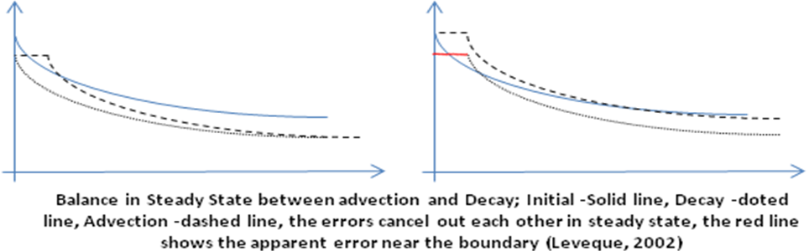Figure B2: Balance in Steady State between advection and decay; initial values -solid line, decay - dotted line, advection -dashed line, the errors cancel out each other in steady state, the red line shows the apparent error near the boundary (after Leveque, 2002)

**B1-3. Modification in the corrector value of the concentration:**

We employed a method which has been used by Colella et al. (2009) in Chombo. The *C* value in the half time step (predictor) of the advection solver Eq.(B1.3), is modified by the two other operators. We expect this modification increases the accuracy of the numerical solution. Our preliminary results denotes this modification improves the accuracy and order of convergence of the numerical scheme.

**B2: Diffusion, Crank-Nicolson Method**



(B2.1)

 (B2.2)





is unknown in (A2.2) and other terms are known from measurements or previous step.



(B2.3)

In which *F* is diffusive flux re-writing (A3.2) yields:

 (B2.4)

**B2.1 Neumann boundary condition implementation**



Just by replacing F in the first and last diffusive flux Neumann Boundary condition will be implemented

* Middle row will be:



* First row: *i=1*



* Last row*: i=m*



**B2.2 Dirichlet boundary condition implementation**

We assume the C is known on the face of first/last cells (edges of channel)

*x*

*t*

*n*

*n+1*

*C1*

*C3*

*C2*

*C\**

Figure B3: Schematic of boundary condition implementation

**2.1- c(x) = a + bx+dx2 (quadratic)**

what we need is  (B2.8)

1-at x=0 🡪 c(0) = a+ b(0)+d(0) =a=c*

2-at x=Δx /2 🡪 c(1/2) = c* +bΔx /2+ dΔx /4

3-at x=3Δx /2 🡪 c(3/2) = c*+3bΔx /2+ 9dΔx /4

where b, d, c(1/2) and c(3/2) are unknowns.

If we eliminate d between equations 2, and 3 above, regardless of time.

 (B2.9)

The only known value in the above is c* = c at the boundary, by replacing in (B2.6-7) we may compute the changes in coefficient and right hand side matrices.

**2.2- c(x) = a + bx (linear)**

what we need is  (B2.10)

1. at x=0 🡪 c(0) = a + b(0) = c*
2. at x=Δx/2 🡪 c(1/2) = a +bΔx /2 =c* + bΔx /2

* b = (2c(1/2) – 2c* )/ Δx

where b and c(1/2) are unknowns and C* is the known value of the boundary

Finally, Dirichlet boundary condition will be:

For the left boundary,  (B2.11)

The right boundary,  (B2.12)

* Middle row: is the same as previous case
* First row : *i=1*

 (B2.13)

* Last row: *i=m*

 (B2.14)

**APPENDIX C**

# Analytical solutions

**__________________________________**

## C1. Linear decay

The (C1) first order ordinary differential equation (ODE) has the analytical solution (C2)

## C2. Diffusion analytical solution

Convergence tests were performed for a case taken from Fletcher (1991), which uses both Neumann and Dirichlet boundary conditions that varies in time. In this particular case, advection and reactions are not present, meaning that only the pure dispersion term is needed from the A-D-R equation. Recalling the dispersion equation (C3) from before:

will be solved in the spatial interval *0.1 ≤ x ≤ 1.* The analytical solution (C4):

Both Neumann and Dirichlet boundary conditions could be retrieved from the above exact solution.

## C3.Advection-Diffusion-Reaction with constant flow and linear decay

The equation (C5) has an analytical solution of (C6):

The initial and boundary condition could be derived from Analytical solution (Sobey, 1989; Khan and Liu, 1995). The deriving procedure of the (C6) could be found in the classic literature (see: de Marsily, 1986).

## C4. Analytical solution of tidal forcing in a rectangular 2D basin

Governing equation in 2D (X-Z):

1-Continuity

Assumptions:

* u, is not function of z but vertical velocity w is a function of z
* H (depth) is constant
* Ζ << H

2- Momentum

Assumptions:

* Inviscid fluid (interfacial and bottom friction are neglected)
* ρ=constant
* Non-rotating reference frame (f=0)

Analytical solution for velocity field is (C7):

Integration on *x* to get cell average value

Where

a: is amplitude (0.25-0.5 m)

L: basin length 100,000 m

Width: width (we assume unit width)

H: Depth (16 m)

A = width× =

Q =A × u

Retrieving Area from discharge for sake of mass continuity:

Area cell average

This analytical solution of tidal flow field is from the book: Principles of Physical Oceanography Neumann, G., and Pierson W. J., 1966.

## C5. Advection diffusion solution by Zoppou and Knight (1997)

This is subjected to:

The solution is (C16):

**APPENDIX D**

**QUESTIONS FOR THE TECHNICAL ADVISORY COMMITTEE (TAC)**

# __________________________________

**D1-Questionnaire for DSM2 Sediment Transport Model Technical Advisory Committee**

**January 13, 2010**

1-What features are important to you for the Sediment Transport Model and its application to the Delta?

2-Do you know of any data sets or Delta sediment transport studies that you think that the model development team should investigate?

3-Is there anything else that you would like us to know and/or consider when developing STM?

Name and contact info (optional):

In your opinion, which of the following best depicts sediment distributions in the Delta?

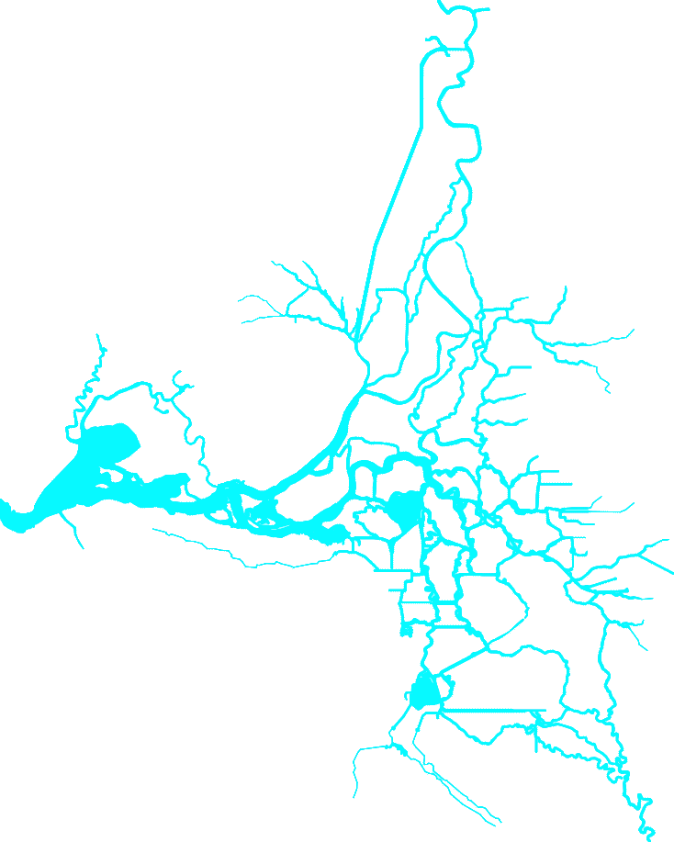 

a)

b)

c)

 

f) Other

draw your own

e)

d)

What is the basis for your answer above?

❑ Field experience in the Delta

❑ Field experience in another system __________________________________

❑ Educated guess

❑ Gut feeling

❑ Wild guess

❑ Doodling fun

❑ Other___________________________________________________________

## D2 -Questions for TAC (January 2010)

We have prepared a list of questions for the TAC members. We would be very pleased in having insights from members regarding the following points; we have classified the questions according to three main categories:

Questions of physical nature

Questions of numerical modeling nature

Questions of user point of view.

## Physical - Effective Bed Roughness

There are two main types of flow resistance, skin friction and form drag (Ks = Ks’+ Ks”). Ks’ denotes the roughness height which is associated with skin friction forces, Ks” is the equivalent form roughness height which is generated by pressure forces acting on the bed-forms. Skin friction is given by the shear stress that the bed particle experiences as the reaction to the shear stress exerted to the flow by the boundary. Form drag is the flow resistance from the separation of flow due to bed-forms. A calibrated Manning’s n value in the Delta accounts for both types of friction, as well as other effects like bathymetry representation, three dimensional effects which are not included in the 1D approach, etc. However, sediment particles only move due to skin friction. How should this be characterized in the STM model? Basically, two approaches can be found in the literature to estimate the bed roughness height:

1. Methods based on bed-forms and grain-related parameters such as bed-form length, height, steepness and bed-material size; these methods are more universal and can also be used to determine the roughness of a movable bed in non-steady condition, provided that the bed-form characteristics are known. van Rijn (1993) method is:

K’s min= 0.01 m

K’s = 3 d90 for θ <1 (lower regime)

K’s = 3 θ d90 for θ >1 (upper regime)

 = mobility parameter

b = bed shear stress

Lower regime is the condition of the river with dunes in it and upper regime is the situation in which anti-dunes are appeared (See García 1999). If this method is adopted, estimations of d­50 and d90 in the entire Delta are needed. Is this information available?

1. Methods based on integral parameters such as mean depth, mean velocity and bed material size, namely the methods by, Einstein (1950), Nelson and Smith etc., As an example Smith and McLean method is as follows:



In which:

Ks,c = effective current-related bed roughness

 = mobility parameter

θcr = critical mobility parameter

d50=median particle diameter of bed material

The above equation is valid in the lower regime (θ <0.7) with dunes; yields ks,c=d50 for θ ≤θcr. Is there any information on location and size of dunes in the Delta? (We know that there are some data in the USGS website).

## Physical – Distribution of Sediment in Junctions

* Do you know of any studies of sediment transport at junctions in the Delta or in other systems? Do you have any experience on how sediment behaves in the Delta at junctions?

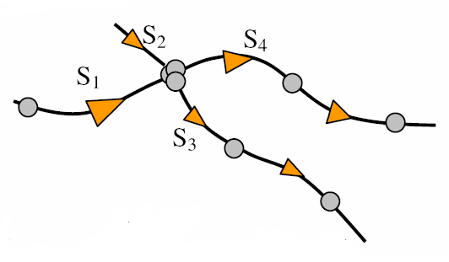

Figure D1: Source: Mike11, DHI

Option: by definition a 1D sediment transport model cannot predict the split of sediment transport in a junction; therefore various models for split of sediment load as a function of discharge have been proposed. One of the available methods is as follows (taken from Mike11 ):



where K3, K4, n3, and n4 are calibration coefficients; Si  is the sediment load and Q is discharge.

## Physical – Treatment of Bed-load

* There are two methods to implement the computation of the bed-load transport. First, to solve an advection-diffusion-reaction equation for suspended load, and use empirical formula for computing bed-load.

Second, to solve an advection-diffusion-reaction equation for both the bed-load and the suspended load, following the proposal by Greimann et al. (2008); the proposed formulation is as follows, for a 2D case:



Where:

Se= Erosion source term

f = Transport load parameter, fraction of suspended load to total load

h = Flow depth

 = Angle of sediment transport

 = Ratio of sediment velocity to flow velocity

Vt = Total flow velocity

C = Sediment concentration.

## Physical - Entrainment and Deposition of Sediments in the Delta

* In the Delta, is there any tested method for representation of settling velocity (or deposition instead) for cohesive sediment particles beyond Krone’s (1962) work?

Options:

There are many cases in which a constant settling velocity for cohesive sediment has been used in the literature; for example 0.5 mms-1 in diverse systems. One step further, a power-law relation has been used as a function of concentration, such as 1) Ws,m= Ws(1- ac)b 2) Ws,m= Kcm  where a, b, and m involve calibration parameters. The relations could be calibrated base, on existing data to be more precise. Krone has reported data from the Delta which may be useful.

* In the Delta, is there any tested expression for entrainment of cohesive sediment particles beyond the work by Krone (1962)? We propose to use where   denote calibration parameters.

## Physical - Description of Cohesive Sediment

* Many parameters need to be determined in order to fully describe cohesive sediment. To reduce the number of variables, which are the most important variables for the Delta?

Options:

Ws = Ws (Salinity, Concentration, ...)

Water depth, maximum current velocity, maximum wave height

Dry sediment density, critical shear stress for erosion of bed

Water column temperature, pH chemical composition

Percentage of clay, silt and sand; percentage organic content, specific area, cation exchange capacity(CEC)

Including more variables will mean that a spatial and temporal description for them is needed.

## User Needs/Requests

* Is it desirable for STM to have a feature that allows the user to select the numerical scheme to be used to solve the advection part? e.g. higher order vs second order (initial implementation is second order), various versions of second order, etc.
* Initial non-cohesive implementation has four options for entrainment functions which are: 1) Garcia and Parker (1991); their relation works well for fine-grained non-cohesive sediments. 2) van Rijn (1984), whose formula has been used extensively in the numerical treatment of suspended sediment transport. 3) Smith and McLean (1977); this equation is based on Yalin early works (1963). 4) Zyserman and Fredsoe (1994) analyzed different entrainment formulations; they proposed an empirical relation using the Fort Collins experimental data. Is there any other formulation you prefer to have in DSM2-STM?
* What kinds of analytical tests and comparisons to data (field and laboratory) would you like to see in the STM code? We have included and plan to include:

1- Error convergence test on L∞ (absolute value of largest error in the domain).

2- Comparison with analytical solutions of advection-diffusion-reaction PDE including: a) diffusion of a spike of a mass at center of coordinate system. b) Diffusion of a symmetric triangle; c) diffusion of harmonic distribution of concentration with a Diritchlet boundary condition on one side, and a Neumann boundary condition on the other; d) Advection of a Gaussian curve; e) Advection of a square of concentration

3- Comparison with flume data from the literature (not yet done). Test to include:

Newton (1951), Soni (1981), Cui (1996).

* What units for sediment/constituent concentration you would like to see in DSM2-STM? Volume per volume or mass per volume?

## Numerical

* Do you know of any reliable second order methods for updating boundary conditions for advection-diffusion-reaction equations with operator splitting?
* What order, in the splitting procedure, should we solve the advection-diffusion-reaction equations? Our initial thought is to solve advection first, then reaction and finally diffusion. Advection is always the dominant term and it should come first.

1. http://baydeltaoffice.water.ca.gov/modeling/deltamodeling/dsm2usersgroup.cfm
2. Peclet number
3. XXXXXXXXXXXXXXXX
4. Numerical diffusion: in numerical discretization of continuum fluid a challenge usually emerges is that, solution shows more deffusivity compared to the physical value.
5. Monotonicity: a numerical method is monotonic or monotonicity preserving if no new local extrema is created within the solution domain and the value of exciting minimum/maximum are not decreased/increased (Hundsdorfer and Verwer, 2003).
6. The word "modified" is discussed briefly in the Appendix B.