* **2nd order Heun method**:



Where



* **2nd order Cauchy –Euler**:



* **Classic Runge-Kutta Third Order:**

This method is a third order Runge-Kutta method for approximating the solution of the initial value problem.



which evaluates the integrand, *f(x,y),* three times per step. For step *i+1*,

This method is a third order procedure for which Richardson extrapolation can be used.



* Nystrom Method 3rd order

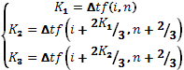

* Optimum method 3rd order

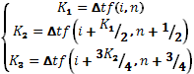

* Heun 3rd order

