# Analytical solution of tidal forcing in a rectangular 2D basin

Governing equation in 2D (X-Z):

1-Continuity

Assumptions:

* u, is not function of z but vertical velocity w is a function of z
* H is constant
* Ζ << H

2- Momentum

Assumptions:

* Inviscid fluid ( interfacial and bottom friction are neglected)
* ρ=constant
* Non-rotating reference frame (f=0)

a: is amplitude (0.25-0.5 m)

L: basin length 100,000 m

Width: width (we assume unit width)

H: Depth (16 m)

A=width× =

Q=A × u

retrieving A from discharge for the sake of mass continuity

diff((H+a*(cos(B*(L-x))/cos(B*L))*coa(o*t)*A*sin(B*(L-x))*sin(o*t), x)

=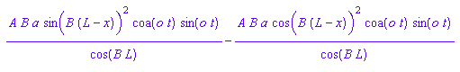

int(-diff(H+a*(cos(B*(L-x))/cos(B*L))*coa(o*t)*A*sin(B*(L-x))*sin(o*t), x), t)

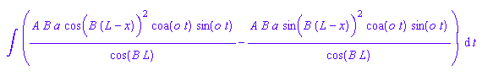

A = int (-diff(Q,x),t)

Reference:

Neumann, G., and W. J. Pierson, 1966, Principles of Physical Oceanography. Prentice-Hall, Englewood Cliffs, N.J.