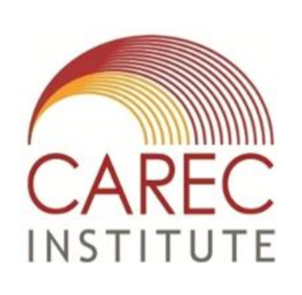

**Central Asian Regional Modeling Analysis Workshop**

Naxoz University

Almaty, Kazakhstan

12-15 December 2016

Jointly Organized by:

Asian Development Bank and the CAREC Institute

**Revised Program**

**Day 1: Overview of Scenario Analysis [Monday, December 12]**

Introduction to scenario tools for simple policy analysis and results communication.

9:00 – Opening Session: Welcoming remarks – ADB/CI/NU representatives

9:30 – Introduction to History and Methods of Input-output and Multipliers

Mr. Malik Mehdiyev

**Day 2: Structural Models and Methods [Tuesday, December 13]**

A new economic assessment package for the CAREC regional economies.

**13:00 – 14:30 –** *Lecture 1: Structural Economic Assessment*

**14:30 – 14:45** – *Coffee Break*

**14:45 – 17:00** – *Workshop 1: Practical Methods of Structural Assessment*

**17:00** *– End of Day 2*

**Day 3: Computable General Equilibrium Modeling [Wednesday, December 14]**

**9:00 – 10:15 -** *Lecture 2: Overview of Structural Policy Modeling*

**10:15 – 10:30** – *Coffee Break*

**10:30 – 12:00** *– Lecture 3: Analytics of a Research Grade CGE Model*

**12:00 – 13:00** - *Lunch*

**13:00-14:45** – *Workshop 2: Introduction to GAMS Programming I*

**14:45-15:00** *– Coffee Break*

**15:00 – 18:00** – *Workshop 3: Introduction to GAMS Programming II*

**18:00 -** *End of Day 3*

**Day 4: National Modeling [December 15]**

**9:00 – 10:30 -** *Lecture 4: Overview of CGE Applications*

**10:30 – 10:45** – *Coffee Break*

**10:45 – 12:00** *– Lecture 5: CAREC Regional CGE Modeling*

**12:00 – 13:00** - *Lunch*

**13:00-14:45** – *Workshop 4: Calibrating a National CGE Model*

**14:45-15:00** *– Coffee Break*

**15:00 – 17:30** – *Workshop 5: Working with CAREC National Data*

**17:30 – 17:45** - **Concluding remarks by ADB/CI/NU representatives**

**17:45 – Certificate Presentation and Group Photo**

*End of Workshop*