The Linkage Model: A Quick Start
Dominique van der Mensbrugghe
Development Prospects Group
The World Bank

Table of Contents
Introduction 2
Directory structure and file installation 2
Preparing the data 6
Aggregation 7
Comparative static simulations 8
Dynamic simulations 9
Annex 1—Pivot tables 12
Saving GAMS Results in Database Format 12
Excel Pivot Tables 13
Adding drivers for Microsoft Query 24
Custom lists and sorting in Excel 27

Introduction
This document provides a quick introduction to running the World Bank’s global dynamic computable general equilibrium model, known as the Linkage Model. There are four sections. The first describes directory structure and file installation. The second describes how to prepare data files and aggregate the GTAP dataset. The third describes how to run comparative static simulations. The final section describes how to run dynamic simulations.

Directory structure and file installation
This section describes how data and files are organized for the standard installation of the Linkage Model. There is no best way to organize data and files, but the structure described below has proven over time to be useful. There are two basic folders. One contains the raw GTAP data set, the aggregation facility and files needed for the aggregation facility. The second basic folder contains the “generic” model code. This is the code that all simulations use. Each particular application of the model is stored in its own folder.

Each new application starts with an aggregation. The output from the aggregation routine is copied into a “new” application folder. The user then prepares the experiment files in the application folder and runs the model simulation. Results are stored in ‘CSV’ format and typically loaded into Excel worksheets.

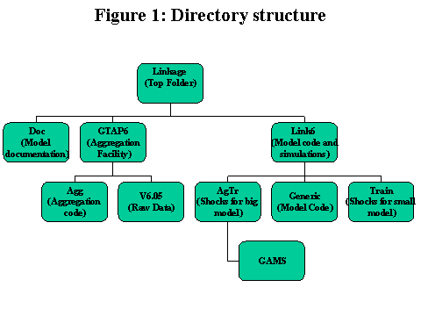
The following diagram shows the “default” directory structure:

The top folder is designated as ‘Linkage’ (and we will assume it is on drive V, so that the path is V:\Linkage). There are three sub-folders. The first is ‘Doc’ and contains all relevant model documentation, including the technical reference document and this user’s guide. The second is ‘GTAP6’ and contains the GTAP data set and the aggregation facility. The third is called ‘Link6’ and contains the generic model code (in GAMS) and two simulation scenarios. The first scenario is called ‘Train’ and contains an aggregated version of the GTAP data set. This is useful for training purposes and for debugging of model code. The second—called ‘AgTr’—is a normal user application using a relatively disaggregated version of the GTAP dataset. It contains several dynamic experiments, including a baseline (or reference) scenario, a policy shock where all tariffs are removed, and several other simulations.

The following tables provide the file contents of each of the folders (at the time of distribution).
Table 1: Files in the ‘Linkage\GTAP6\V6.05’ folder
Name | Description
***.zip | Compressed GTAP data
convert.cmd | DOS command file for converting HAR data to GAMS format
gsddat.txt | Input file for convert.cmd. Contains instructions for converting gsddat.har to gsddat.gms
gsdpar.txt | Input file for convert.cmd. Contains instructions for converting gsdpar.har to gsdpar.gms
tstrade0.txt | Input file for convert.cmd. Contains instructions for converting tstrade0.har to tstrade0.gms
tstrade1.txt | Input file for convert.cmd. Contains instructions for converting tstrade1.har to tstrade1.gms

Table 2: Files in the ‘Linkage\GTAP6\Agg’ folder
Name | Description
AggGTAP6.gms | Main aggregation file (in GAMS)
AggGTAP.cmd | DOS command file for running the aggregation routine
AggScen.gms | File for aggregating GDP and population projections (used in dynamic scenarios)
agtr.br | Bridge file for the large data aggregation
convert6.gms | File for converting *.DAT files to *.GDX format
tstrade1.txt | Input file for convert.cmd. Contains instructions for converting tstrade1.har to tstrade1.gms
GEP05_16.DAT | Population, GDP, and consumption projections for dynamic scenarios
GTAP6set.gms | Set definitions for the aggregation code. Normally only changed with a new release of the GTAP data.
MACRO60.GMS | Base year population and GDP data
train.br | Bridge file for the small data aggregation

The generic code for the model is contained in the folder called ‘Generic’ (see table 3). This code is invariant for all model applications. Some of the code is not used when running comparative static simulations. The code is arranged by order of execution. The controlling code—called the shock or experiment file—determines the order of execution. The experiment file first reads the data and parameter files. This is followed by the initialization code—essentially variable and parameter declarations. The calibration code comes next. Each model variable has two or three incarnations. The first incarnation is the name of the variable with a 0 appended, for example, initial output has the variable name xp0. The second incarnation is the model variable itself, for example xp. There is subtle difference between the two. The first incarnation is declared as a parameter and the second as a variable. Thus the first has only a single attribute, its level, and cannot be “endogenously” determined by the model. The second has all of the GAMS attributes of a variable such as a level, a lower bound, an upper bound, etc. Some variables also have a third incarnation—this is the variable name with a ‘T’ appended, for example xpT. These variables, unlike the others are indexed by time. This is one way to store variables across the model’s time dimension. Time-dimensioned variables are initialized after each time period. The model itself has no explicit time dimension. The calibration routine initializes or calibrates the 0-appended variables, for example xp0. The code in ‘init.gms’ initializes the model variables (for example xp.l = xp0). The model equations are provided in the model.gms file.

Each experiment file has a ‘time’ dimension. In the case of comparative static experiments the ‘time’ dimension simply determines the number of different shocks to be simulated. (N.B. The model is never simulated for the first ‘time’ period, which is assumed to contain the model’s base variable levels. In the case of dynamic experiments the ‘time’ dimension corresponds to an explicit time horizon, for example 2001 through 2015.)

There is code included at the beginning of each ‘time’ period, for example initializing lag variables, and code included at the end of each time period, for example calculating model statistics and saving intermediate output.

The final code is included after having simulated each ‘time’ period. For example, dynamically calibrated parameters are saved to an external file after a baseline scenario.

Table 3: Files in the ‘Linkage\Link6\generic’ folder
Name | Description
Declarations
decl.gms | Declaration of model variables and parameters and initial model values.
stats.gms | Declaration of model results.
Initialization
cal.gms | Initialization of base year model variables and calibration of parameters.
init.gms | Initialization of model variables (from their base year values).
model.gms | Definition of model equations.
zero.gms | Counting of zero activities. (This part of the code is not up-to-date).
Iteration initialization
iterloop.gms | Contains code which is executed at the beginning of each iteration (in dynamic version)—for example to update lagged variables, update stock variables, etc.
recal.gms | Contains code also executed at the beginning of each iteration (in dynamic version). Used to re-calibrate ‘dynamic’ parameters such as production share and ELES parameters.
Iteration termination
postsim.gms | Calculates post-simulation statistics.
report.gms | Saves intermediate results to CSV file.
wtf.gms | Saves intermediate bilateral trade variables to CSV file.
sam.gms | Saves intermediate SAMs to CSV file
yelas.gms | Saves intermediate consumer demand variables to a CSV file.
Simulation termination
tables.gms | Specialized output for decomposing dynamic results (saved in CSV format).
savtrn.gms | Code to save calibrated baseline results. This code is only used when running a new baseline. Among other results it saves are the calibrated productivity trends. These are assumed exogenous in policy shock scenarios.
Data management
gdxDecl.gms | Declares variables and sets for the GDX files
gdxRead.gms | Reads in variable levels
GDXRW.gms | Loads or saves a GDX file
gdxSave.gms | Saves variable levels
Link5Data.gms | Re-writes the initial dataset in GMS format
mkcsv.gms | Writes model output to a CSV file
mkrslt.gms | Calculates output parameters for the mkcsv.gms file
parms.gms | Outputs model parameters (elasticities, etc) to a TXT file
SAVBAU.GMS | Currently not used (under development)
savebau.GMS | Saves baseline results for calculating changes (under development)
scalmod.gms | Scales model variables and equations (when necessary)
Shocks.gms | Dynamic calibration for the global reform scenario
STATS.GMS | Declares time-subscripted variables for the report facility
statsdecl.gms | Declares output parameters for the mkcsv.gms file

The ‘Train’ folder has four data files, a comparative static experiment file, and two dynamic experiment files (see table 4). The data files are created by the aggregation routine—three of which, the parameter file, the scenario file, and the flags file, require special attention from the user. The parameter file should be modified by the user to make sure the parameter values and the specification options correspond to the user’s preferences. The scenario data file contains exogenous information needed for creating a baseline scenario. The flags file determines which model variables will be written to CSV files by one of the output routines. This is further described below.

The ‘AgTrade’ folder is similar to the ‘Train’ folder. It contains five data files, the consistency check comparative static file, and three dynamic scenario files. The new data file is a shock file, which contains changes in protection that are part of the baseline, such as full phase-in of the Uruguay Round commitments and full implementation of the enlarged European Union. The new dynamic scenarios include a ‘BaUGBL’ file that runs both the business-as-usual and trade reform scenarios, and a ‘GblAll’ file that only runs the reform simulations. The trade reform scenarios contain some useful code. The code shows how policy reforms can be limited to certain regions and sectors. It also shows how to phase in reforms over a given time horizon. And finally, it shows how to break shocks (within a time period) into small shocks so as to minimize convergence problems.

Table 4: Files in the ‘Linkage\Link6\train’ folder
Name | Description
Data files
train.dat | Base data file—an output from the aggregation facility.
trainprm.dat | Parameter file, also an output from the aggregation facility, but needs user editing.
trainscn.dat | Scenario file needed for creating a dynamic baseline—an output from the aggregation facility.
flags1.dat | Identifies model variables that will be output in the CSV file.
Comparative static files
comp.gms | Basic file to check model consistency.
Dynamic experiments
BaU.gms | Dynamic experiment file for creating a baseline
GBL1.gms | Dynamic experiment file with a phaseout of tariffs. Uses calibrated parameters from BaU file.
Output files
Annex.gms | Creates customized output CSV files using inputs from the pivot2.gms file
pivot2.gms | Main output routine
GBL1.xls | Sample output from the ‘GBL1’ simulation in Excel pivot table format

Table 5: Files in the ‘Linkage\Link6\AgTr\GAMS’ folder
Name | Description
Data files
agtr.dat | Base data file—an output from the aggregation facility.
agtrprm.dat | Parameter file, also an output from the aggregation facility, but needs user editing.
agtrscn.dat | Scenario file needed for creating a dynamic baseline—an output from the aggregation facility.
agtrshk.dat | Baseline shock file that serves as an input to the scenario file.
flags1.dat | Identifies model variables that will be output in the CSV file.
Comparative static files
comp.gms | Basic file to check model consistency.
Dynamic experiments
BaU.gms | Dynamic experiment file for creating a baseline
BaUGBL.gms | Dynamic experiment file that runs both the baseline and the trade reform shocks
GblAll.gms | Dynamic experiment file that only runs the trade reform scenarios
Output files
Annex.gms | Creates customized output CSV files using inputs from the pivot2.gms file
pivot2.gms | Main output routine

Preparing the data

The GTAP data is distributed in GEMPACK’s HAR format. Before running the LINKAGE model, the user must convert the data to GAMS format. The following steps are performed for each new release of GTAP:

- Unpack the compressed GTAP data into a new directory.
- Convert the HAR files to GAMS format
- Convert GMS files to GDX format

Each new release of GTAP data should be placed in a new folder inside the ‘Linkage\GTAP6’ directory (the current version of GTAP is 6.05, so we will assume the data are saved in the ‘Linkage\GTAP6\V6.05’ folder). The new folder should include the zipped GTAP data as well as all other files specified in Table 1.

The first task is to extract the relevant files from the compressed GTAP dataset. The following files should be unzipped into the ‘Linkage\GTAP6\V6.05’ folder (note that extracting the tstrade0 and tstrade1 files is optional since these files are not used by the model):

Table 6: Files to be extracted into the ‘Linkage\GTAP6\V6.05’ folder
Name | Description
seehar.exe | Utility program for converting HAR data to other formats
gsddat.har | Data file containing basic GTAP data, including SAMs
gsdpar.har | Data file containing GTAP parameters
tstrade0.har | Optional: data file containing detailed trade flows
tstrade1.har | Optional: data file containing detailed trade flows

After the necessary data files have been extracted, the user should run the ‘convert.cmd’ program by either double-clicking on its icon or typing ‘convert’ in a DOS command window from the ‘Linkage\GTAP6\V6.05’ directory. The program will call the ‘seehar’ utility for each of the HAR data files in table 6 and generate new GAMS files with the same name and a ‘.gms’ extension. After all files have been converted to GAMS format, the HAR files may be deleted from the directory to conserve space.

The next step is to switch to the ‘GTAP6\Agg’ directory and open the ‘convert6.gms’ file in GAMS IDE or a text editor of user’s choice. Here, the user must make sure that the ‘$include "..\V6.05\gsddat.gms" ‘ line contains the correct directory for the ‘gsddat’ data file (recall that the directory name should correspond with the GTAP version; in our case, it is V6.05). It is also prudent to make sure that the ‘$include "GTAP6set.gms" ‘ line points to the set definition file that is consistent with the most recent release of GTAP.

The ‘convert6.gms’ file will transform the data in the ‘gsddat.gms’ file to a GDX format, which facilitates reading of the data by GAMS. The user can run this file from GAMS IDE or use the following command from a DOS window:

gams convert6

The program will save a new GDX file in the current directory (here ‘GTAP6\Agg’ ). After the program run is complete, the user needs to move the ‘gsdpar.gms’ file from the ‘GTAP6\V6.05’ directory into the ‘GTAP6\Agg’ directory and may also delete the ‘gsddat.gms’ file from the ‘GTAP6\V6.05’ directory to preserve space (it is no longer needed since it contents are now stored in the ‘gsddat.gdx’ file in the ‘Agg’ directory).

Aggregation

Before the LINKAGE model is run, the user needs to decide on a suitable level of aggregation. The following steps are performed for each application:

- Edit or create a bridge file
- Run the aggregation facility

Each new application requires the user to prepare a separate bridge file (of which there are two samples in the distribution package—‘train.br’ and ‘agtr.br’). This file contains the aggregation codes for the specific application, including both comparative static and dynamic scenarios. Typically, one would start with an existing bridge file. After making the edits, save the file (perhaps with a new name).The sample bridge files distributed with the LINKAGE model are extensively commented, but several points are worth emphasizing:

- The SAM accounts must include both sectors and regions.
- The user can modify the names of the following accounts: sectors, regions, and labor. All other account labels are hard-coded in the model and should not be changed.
- Aggregate sectors and regions are only relevant for the LINKAGE output routine—they are not used during the model solution procedure.
- The user can choose which labor types are complements to capital, and which are substitutes.
- The model can handle multiple households, although the current GTAP release includes only a single household account.
- The model’s regions are aggregated in a four-level Armington nest. This approach creates the potential for a quite rich import demand structure, but the nesting can be specified in a way that simplifies the model to a two-level Armington nest (see the sample bridge files in the distribution package).

Once the user has made the necessary edits to the bridge file and saved the changes, it is necessary to run the aggregation facility. The aggregation program can be invoked by typing the following in a DOS window:

agggtap bridge

where ‘bridge’ is the name of the relevant bridge file without the ‘.br’ extension. Assuming the bridge file used for aggregation is ‘train.br’, the program will save the following files to the ‘GTAP6\Agg’ directory:

Table 7: Files created by the aggregation routine
Name | Description
train.csv | Optional: base year SAM and auxiliary matrices in CSV format.
train.dat | Base year SAM and auxiliary matrices in DAT format. This data file is used by both the comparative static and dynamic versions of the model.
trainprm.dat | Base year parameter values in DAT format. This data file is used by both the comparative static and dynamic versions of the model.
trainscn.dat | Parameter values for the solution horizon in DAT format. This data file is used by the dynamic version of the model.

After the program run is complete, the user should check the parameter and aggregation files. The aggregation facility outputs default values for most parameters. These may need to be edited for each application. Once satisfied with the aggregation, the user should transfer the files listed in table 3 to a new application directory.

Comparative static simulations
A comparative static simulation is relatively easy to undertake. Each of the application folders included with the distribution has a comparative static experiment file called comp.gms. This file contains two experiments. (This means the ‘time’ dimension has three elements since the first ‘time’ dimension is simply the calibrated initial levels.) The first experiment is a so-called residual check. This experiment is intended to verify model consistency in two-ways. The first is to verify variable initialization and model calibration. This is done by looking at the listing file and verifying that the LHS values are zero or at least smaller than the residual error of the base SAM. (N.B. It may be the case that the LHS value evaluates to a constant different from zero because an exogenous variable appears linearly in an equation. In this case, the LHS value should be equal to the exogenous variable, which will also be displayed in the equation listing.) The second consistency check is to make sure the model is able to reproduce the base level values, i.e. in the absence of any shock, the model solution is the same as the input data set. This can be verified in the output CSV files which will save both the initial and post-simulation values.

The second experiment is a test of the model’s price homogeneity. In this case the model numéraire is shocked by a percentage amount. All prices of the model should increase by the same amount, volume variables should be unchanged, and value variables should also increase by the same percentage. This can also be verified in the output files.

The following steps are required to run comparative static experiments:

- Edit a comparative static experiment file. This normally involves changing the simulation name, input and output filenames, the ‘time’ dimension, and defining the experiment.
- Run the simulation by invoking GAMS. In a DOS window, the following command could be used:
gams comp –pw=115 –idir=v:\linkage\link6\generic

The pw option will change the width of the listing file. The second option, ‘idir’, tells GAMS to look for the include files in the folder ‘V:\Linkage\link6\generic’.
- Load the results into Excel. The results are stored as CSV files. The best way of loading these files is with Excel’s pivot tables (see Annex 1).

Dynamic simulations
Dynamic simulations are more complicated than comparative static simulations. First, the time dimension corresponds to real time. Second, a baseline scenario is needed to calibrate some key dynamic parameters. In essence, the baseline file (BaU.gms), assumes a given path for output growth and calculates a productivity parameter consistent with the exogenous growth path (and all of the other variables in the model). The key output from the BaU file is a data file with the default name of ‘reftrn.gdx’. The latter contains all calibrated parameters (and other dynamic variables which may be needed for policy scenarios). A policy scenario reads in the ‘reftrn.gdx’ file, makes the productivity parameters exogenous, and has endogenous GDP growth.

In a nutshell, the following steps are needed to create a baseline:

- Edit a scenario file (if necessary).
- Prepare and/or edit the BaU file. This involves setting simulation code, input and output file names, including the filename containing the output reference trends, and setting the time dimension. For the baseline scenario it is important to set the ‘CalFlag’ to 1. This will indicate that productivity trends are to be calibrated. It is also important to check the ‘if’ flags in the beginning of the file. If these flags are set to 1, the relevant CSV and DAT files containing model output will be generated. If the flags are set to 0, model output will be saved in GDX files (conserving space) for further processing by the output routine. Save the file.
- Run the baseline simulation by invoking GAMS, for example:

gams bau –pw=115 –idir=v:\linkage\link6\generic

Note that in the ‘AgTr’ folder, the business-as-usual scenario can be generated in two ways: the user can use the code specified above to run the BaU simulation only, or it can be created as a part of a larger simulation file that also includes trade liberalization scenarios. This file, ‘BaUGBL’, runs the BaU scenario together with trade reform scenarios specified in ‘GblAll’, and can be invoked using the following GAMS code:

gams BaUGbl –pw=115 –idir=v:\linkage\link6\generic

- Prepare the output routine. The main output facility ‘pivot2.gms’ will produce an output file ‘Annex.csv’. This file will contain the customized output created by the ‘Annex.gms’ file in addition to any output generated by the ‘mkcsv.gms’ file. The user can determine the contents of the output file by editing the ‘flags1.dat’ file (which will be read by the ‘mkcsv.gms’ file) and the ‘Annex.gms’ rows of the table at the end of the ‘pivot2.gms’ file. Editing the flag file involves un-commenting the lines of code that contain variables of interest. In order to make changes to the customized output, the user simply needs to add/remove a 1 to/from the appropriate row in the above table. It is also necessary to make sure that the table at the end of the ‘pivot2.gms’ file does not contain references to simulations that have not been run (e.g. gbl1). Such lines need to be commented out.
- Run the output routine by invoking GAMS. In a DOS window, the following command could be used:
gams pivot2 –pw=115 –idir=v:\linkage\link6\generic

- After the simulation it is possible to load results into Excel. Typically, one will first run one or more policy shocks and then load the combined results simultaneously.

Running policy scenarios is similar, though there are a few subtle changes. The scenario file (e.g. trainscn.dat) should be the same in both cases. With a new model, it is often times good practice to run a policy scenario with no shocks (at least no shocks different from those included in the baseline). This is a consistency check of the reference scenario. A no-shock policy scenario should reproduce the exact same dynamic results as the reference scenario.

The remaining steps are as follows:

- Prepare and/or edit the policy shock file. This involves setting simulation code, input and output file names, including the filename containing the input reference trends, and setting the time dimension. For the shock scenario it is important to set the ‘CalFlag’ to 0. This will indicate that productivity trends have been pre-calibrated. If the user plans on concatenate the shock scenario results with previously generated simulation output, the header flags for the CSV files should all be set to 0. Only the first file in the concatenation should contain the header line. Save the file.
- Run the shock scenario by invoking GAMS, for example:

gams gbl1 –pw=115 –idir=v:\linkage\link6\generic

- Prepare and run the output facility, making sure that the table at the end of the ‘pivot2.gms’ file makes references to all the scenarios for which the model was solved (including the baseline scenario). The included scenarios need not have been generated with the most recent model run—the output facility will write all scenario results to a single CSV file as long as the GDX files for each simulation exist in the application directory.
- Alternatively, the user can run the output facility only for the most recent simulations and concatenate the results from the policy shocks with those from the reference scenario. Before invoking ‘pivot2.gms’ in GAMS, the user needs to provide a unique file name in the ‘file csv / ‘..’ /’ line, for example ‘Annex_gbl1.csv’. Then, if there is a reference scenario with output ‘Annex.csv’ and a policy scenario with output ‘Annex_gbl1.csv’, the two files can be concatenated in a DOS window with the following command:

copy Annex.csv+Annex_gbl1.csv results.csv

- The final step would be to load the resulting combined file, ‘Annex.csv’ if the first method is used or ‘results.csv’ for the second method, into an Excel pivot table. Given the size of the file, it is often best to filter the data request to ask for specific variables and or time periods

Annex 1—Pivot tables

Saving GAMS Results in Database Format

The GAMS “put” facility enables virtually unlimited possibilities for saving GAMS results to text (i.e. ASCII) files. Later versions of Excel (and perhaps other spreadsheet programs) include a very powerful feature for structuring database type data in tabular format—these are known as pivot tables. Pivot tables are particularly useful for analyzing data of greater than two dimensions. Examples of these abound in GAMS programs. For example, macro data might have three dimensions if it is defined by variable name and has an index for time and scenario. Sectoral data may have three dimensions or more. Sectoral data will be defined by variable name, and indexed by sector, time, and scenario. Multi-regional models add an extra dimension. The best way to transfer this from GAMS is in database format. A database in text format has one record (i.e. line) per data item. The first line in a data base file contains the name of the fields of the record. For example, to save the macro results from a dynamic scenario would require GAMS code such as:

* Define the output file
file report / 'BaU.csv' / ;
put report ;
* Define the reporting years
set tr(t) reporting years ;
tr(t) = yes ;
*----- Write the header
put "Title,Variable,Sector,Year,Value" / ;
*----- Loop over the reporting years
loop(tr,
*----- Output the macro data
put system.title, ",rgdp,," , tr.tl:4",",rgdpT(tr) / ;
put system.title, ",TCons,," , tr.tl:4",",TConsT(tr) / ;
put system.title, ",TInv,," , tr.tl:4",",TInvT(tr) / ;
put system.title, ",TGov,," , tr.tl:4",",TGovT(tr) / ;
put system.title, ",TExp,," , tr.tl:4",",TExpT(tr) / ;
put system.title, ",TImp,," , tr.tl:4",",TImpT(tr) / ;
) ;

After opening the file, the first put statement writes the data base fields. In the example above, there are five fields: the scenario title, the name of the output variable, and the corresponding sector, year, and value. The output routine loops over the number of reporting years. In this case, it is all years of the simulation, but the subset tr can be defined to be less than the full number of years. (N.B. This structure can also be used for a sequence of comparative static experiments where the index time is replaced by simple ordinal indices rather than by defining calendar years.) Macro variables have no sector definitions, so in the output of each record, the sector definition is blank, and the consecutive commas indicate this. The reason why the sector field may be included is that often the output will mix both sectoral data and macro data. These could be separated into different files, but it is also possible to filter the data when being read into Excel which makes this unnecessary (see below). Sectoral data can be saved into the same file by GAMS code such as:

* Output the sectoral data

loop(i, put system.title,",rent,", i.tl:10,",",tr.tl,",", rentT(i,tr) / ; ) ;
loop(i, put system.title,",wage,", i.tl:10,",",tr.tl,",", wageT(i,tr) / ; ) ;
loop(i, put system.title,",xp,", i.tl:10,",",tr.tl,",", XPT(i,tr) / ; ) ;
loop(i, put system.title,",ES,", i.tl:10,",",tr.tl,",", EST(i,tr) / ; ) ;
loop(i, put system.title,",XD,", i.tl:10,",",tr.tl,",", XDT(i,tr) / ; ) ;
loop(i, put system.title,",XM,", i.tl:10,",",tr.tl,",", XMT(i,tr) / ; ) ;

The inner loops ranging over the sectoral indices i, are contained in the outer loop over the reporting years tr.

In many cases it is desirable to compare the results of different simulations. In this case, all one has to do is to concatenate the different output files into a single file. Only the first file should contain the field descriptors. All subsequent files should only contain data records. There are a variety of ways to concatenate files. The DOS copy command works well, as does cutting and pasting from any editor or word processor (remembering to save the file as text only if that is necessary). (N.B. Some of the result files may have spurious blank lines which will show up as blank records in the pivot table. These can either be deleted in an editor, or else the blank records can be hidden from within the pivot table.)

Excel Pivot Tables

To create a pivot table from a text (or CSV) file, start Excel. Typically one initiates the process from a blank work sheet, but this is not strictly necessary. Under the Data Menu, choose the item PivotTable and PivotChat Report..., which starts the PivotTable Wizard and brings up the following screen:

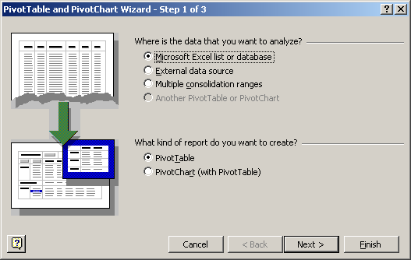

Since the data is located in an external text file click on the button indicated by External data source and then click on the Next > button. This will bring up Step 2 of the PivotTable Wizard, which is indicated by the following screen:

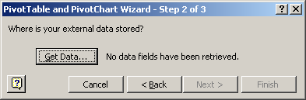

This step proceeds to retrieve the data from the external data source, it actually builds a link between the Excel pivot table and the data in the text file. To retrieve the data, click on the button Get Data... This action will start a new procedure known as Microsoft Query, which is built into MS Office, and starts with the following screen:

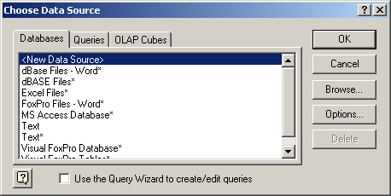

Click once on Text and then on the OK button, or double click on the text choice. Microsoft Query will then bring up the standard open file dialogue box, for example:

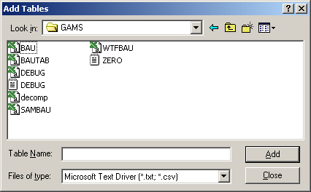

It may be necessary to navigate to the correct sub-directory. By default, only files ending in ‘.csv’ and ‘.txt’ will appear in the open file dialogue box. Once the correct directory has been located, choose the name of the file containing the GAMS results in database format. The file extension should be either txt or csv. Click (once) on the appropriate file name, and then click once on the Add, followed by clicking once on the Close button.

Assuming a link has been made with the external file (called BaU in this case), Microsoft Query will parse the first line of the database into the different fields. The next window will look something like the following:

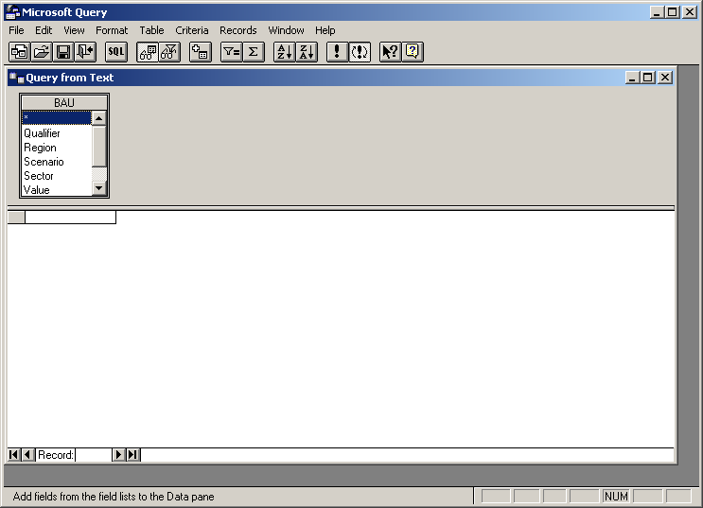

Drag the highlighted rectangle containing the asterisk into the blank rectangle in the bottom half of the screen. This indicates to Microsoft Query that all fields will be passed forward to the pivot table. Upon successful completion of this step, the main Microsoft Query window will have an appearance similar to the following:

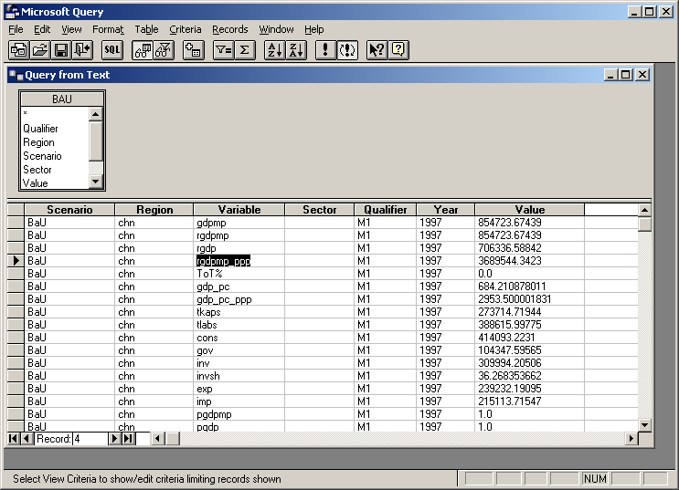

where each field is already laid out in tabular format, with the field headers at the top of the data matrix, and each data record on a corresponding line of the data matrix. One of the more powerful features of Microsoft Query is the ability to filter the data before transferring it to Excel. Filtering is done by using the Add Criteria... item under the Criteria Menu. This document is only meant to be an introduction to the use of pivot tables, so it will not go into all the many different uses of the add criteria function. Some examples may help in providing some initial insights into its usefulness.

The Add Criteria... menu item brings up the following window:

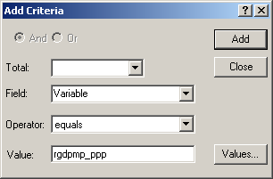

The criteria can be defined over any field and can be filtered in many ways. For example, to select only macro data, i.e. records with no data in the Sector field simply choose the field Sector in the text box designated by Field and choose the filter “is Null” in the text box designated by Operator. When finished with the first criteria, click on the Add button. You can add additional qualifiers (using both the Add and Or operators). In the example shown below, all macro variables for select years will be returned to Excel. When finished, click on the close button. This will return the user back to the main Microsoft Query window:

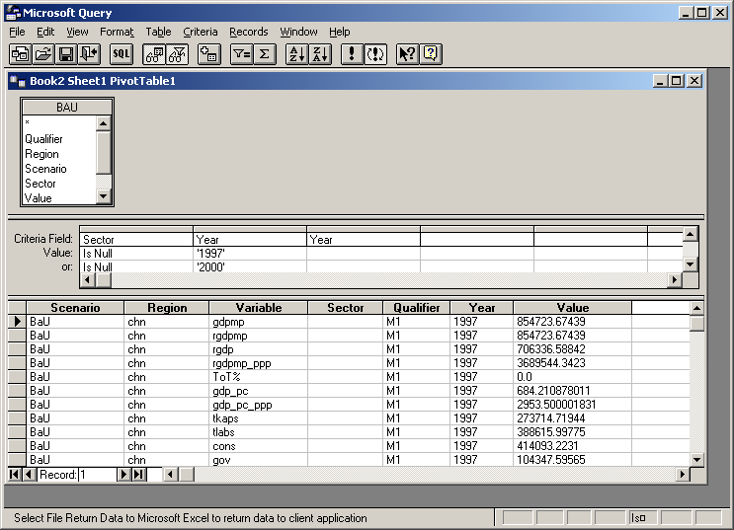

After selecting the data and optionally adding any filtering criteria, the next step is to send the data back to the Excel PivotTable Wizard. From the Microsoft Query File Menu, click on the item Return Data to Microsoft Excel. This sends the user back to step 2 of the Pivot Table Wizard. Click on the Next > button to start step 3 of the PivotTable Wizard, which presents the following screen:

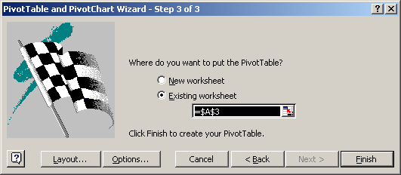

This step allows the user to designate the structure of the pivot table and options. Note that the structure is very easy to modify later once the initial pivot table is constructed. Click first on the Layout… button. The following screen appears:

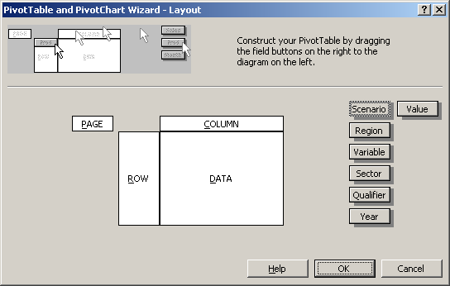

Pivot tables have four dimensions, though in this example, there are seven fields. Therefore, one or more dimensions of the pivot table will have multiple fields. The ‘Value’ field virtually always goes in the Data section of the pivot table. The other six fields can be arranged in a variety of ways. If the file contains data from only one scenario (i.e. the ‘Scenario’ field is uniform), and the data only contains macro results, than it is traditional to put the ‘Scenario’ and ‘Sector’ fields in the Page dimension, let ‘Year’ represent the Columns, and put the ‘Region’ in the Rows. (The qualifier field has been used to segment results by theme. For example M1 has the standard macro aggregates. We shall put this in the Page dimension. If it is set to (All), then all macro variables will be displayed.) The Variable field can either be put in the Row dimension with the regions, or else in the Page field for selection. For results from more than one scenario, it might be practical to have the ‘Scenario’ and ‘Year’ side by side in the Columns. The former structure is depicted by the next window:

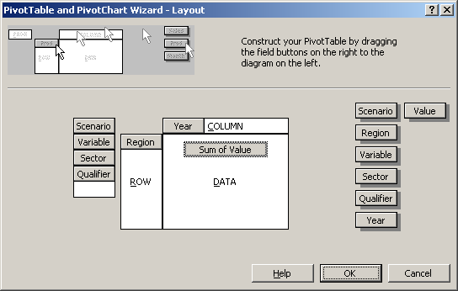

There are still a variety of options which can be set from the window above (i.e. in Step 3), though some can also be done at anytime once the pivot table is finished. One option is to define the format for the data. Doubling clicking on the Sum of Value button brings up the following window:

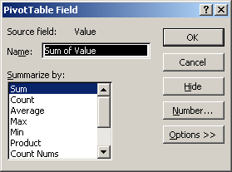

Double clicking on the Number... button brings up the usual Format Cells Excel dialogue. Choose any appropriate format and then click on the OK button twice to return to the PivotTable Wizard Step 3 window. After having finished the layout under step 3 , click on the Options… button. The following window appears:

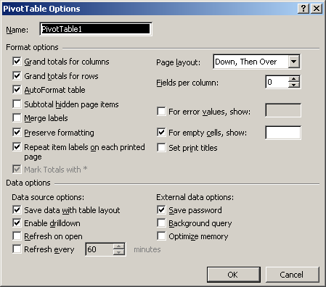

Typically, given the nature of the data in the pivot table, it does not make sense to add the data in the columns or in the rows. The fields Grand totals for columns and Grand totals for rows should be unchecked in this case. There are clearly times when the totals make sense and can be useful. For example, adding up GDP across regions. It is normal usage to uncheck the AutoFormat table option. It is possible to have Pivot tables calculate percent differences automatically (see the Options >> button from the previous dialogue box). This can be useful in providing tables of growth rates or percent difference across simulations. If there are any divisions by zero, these can be excluded from the pivot table by checking the For error values, show: option above and leaving the text box blank. Similarly, blank cells can be filled with alternative text, such as “..” for example. After clicking on the OK button, the final step is click on the Finish button from the Step 3 window of the PivotWizard.

The appearance of the final pivot table will have a form similar to the following window:

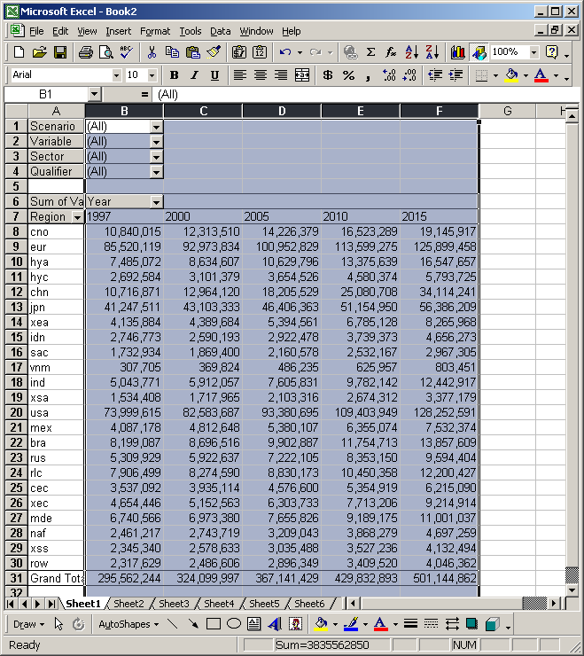

The table is not meaningful because all macro variables are aggregated together due to the value of ‘(All)’ in the variable list. To simply see GDP for example, choose the variable ‘rgdpmp’ from the drop down list to see the following:

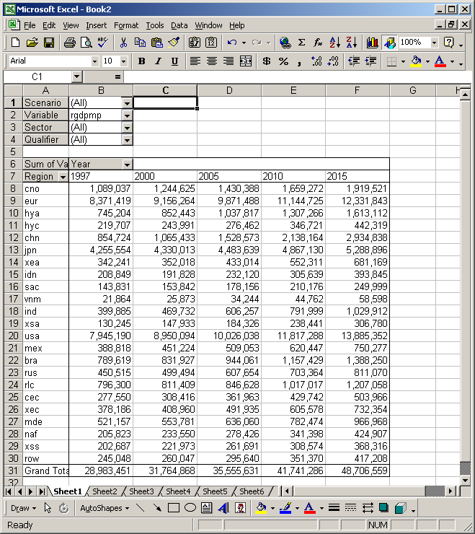

Once the pivot table is finished, it is possible to re-structure the pivot tables in different ways. For example, it is possible to move fields from one location to another. The variable field can be moved into the row field with regions, etc. It is also possible to change some options for specific fields. For example, it is possible to hide certain variables or years, or to have sums calculated or suppressed for specific fields. Double clicking on any one of the field names will bring up the following screen:

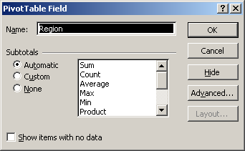

From within the pivot table it is possible to re-arrange the ordering of rows and columns by dragging and moving specific records.

It is also possible for the same Excel file to contain more than one pivot table. For example, one worksheet may contain macro data only. A second worksheet may be loaded with a pivot table, which contains all of the sectoral data, etc. Creating a second pivot table simply requires going through all of the same steps as defined above, but using different criteria to provide a different lens for analyzing the output. (The PivotTable Wizard will at some point bring up the following dialogue when creating multiple pivot tables in the same Excel file:

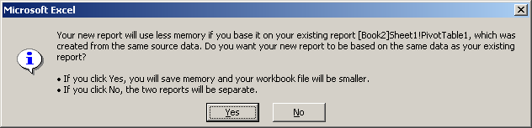

It is best to answer no since it relies on the criteria specified in Microsoft Query. Unless you desire to see the same data (with the same criteria) with a different view, the correct answer is no. Alternatively, the initial pivot table can contain all data from the external file and subsequent pivot tables can be linked to the original pivot table. The distinct advantage of this is that hitting the refresh key to update one pivot table, will refresh all linked pivot tables.

Adding drivers for Microsoft Query

The pivot tables created by the GAMS package are all text-based CSV files. Windows comes packaged with a number of database drivers, but not all are installed by default, and typically the text driver is not installed. The following instructions show how to install the text driver if it is not already available. This needs to be done only once. First, enter the control panel and open the folder called ‘Administrative Tools’. Click on the file called ‘Data Sources (ODBC)’. This will open the application to load a database driver. A screen similar to the following will appear:

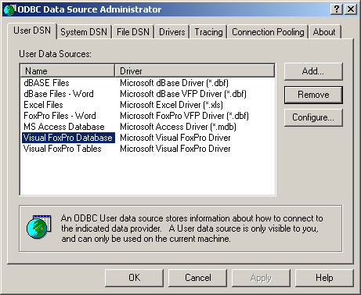

Click on Add… to see the following:

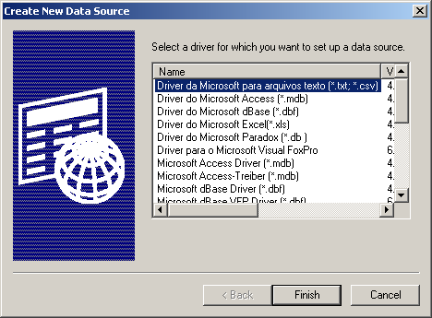

This provides a list of all drivers available with the current operating system. Scroll down to the Microsoft text driver:

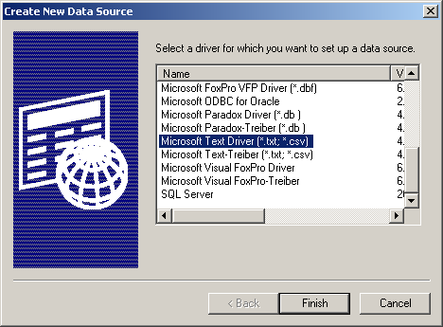

Then click on finish. The following screen appears:

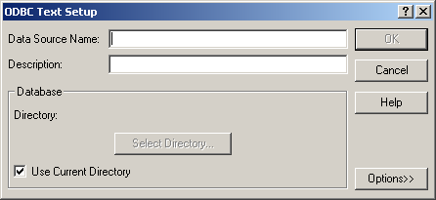

Fill in the text boxes with the following information:

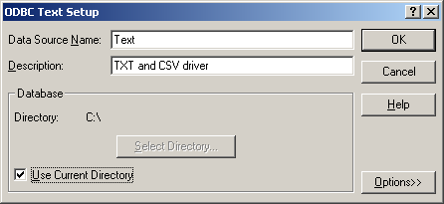
Then click on OK. This will return control back to the main dialogue box:

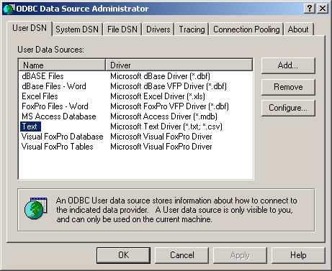

The text driver has been added. Click on OK once more to complete the installation.

Custom lists and sorting in Excel

It is easy to sort data in pivot tables, particularly if you have created a custom list. The following shows an unordered Pivot table:

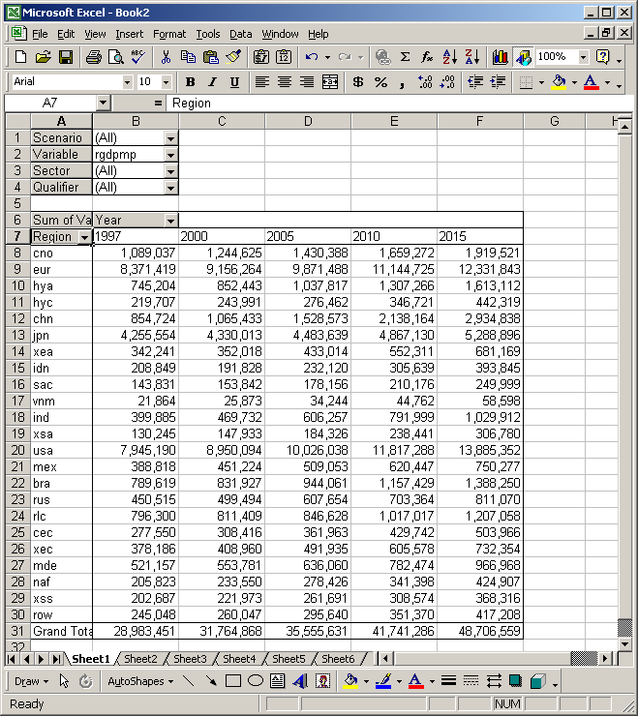

Say the desired order is the following:

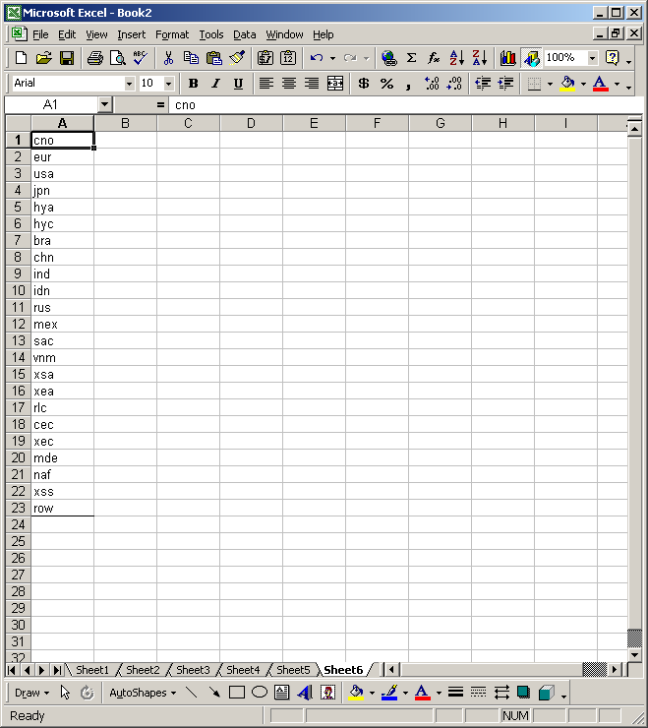

The labels are entered in the right order and as values. (This procedure cannot be used on text formulas.) From the Tools menu, choose, Options, and then Custom lists. Click on the Import box and select the labels. The dialogue box should look like the following:

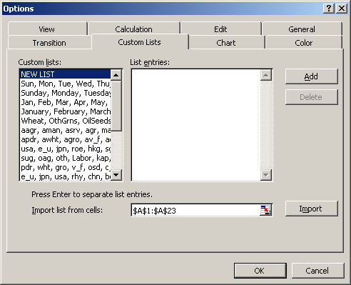

Click on the OK button.

To sort the data table by region, click once near the top of the region tab, until the cursor turns into a downward pointing arrow. This should highlight the region labels. From the Data menu, select the Sort option. To bring up the following screen:

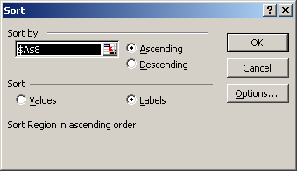

Click on Options, which brings up the following:

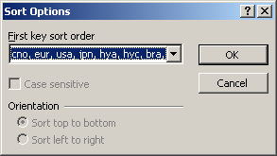

It may be necessary to click on the tab to select the right sort key. Then click on OK. Click on OK once more in the main Sort dialogue. This will implement the sort. The final pivot table will look like:

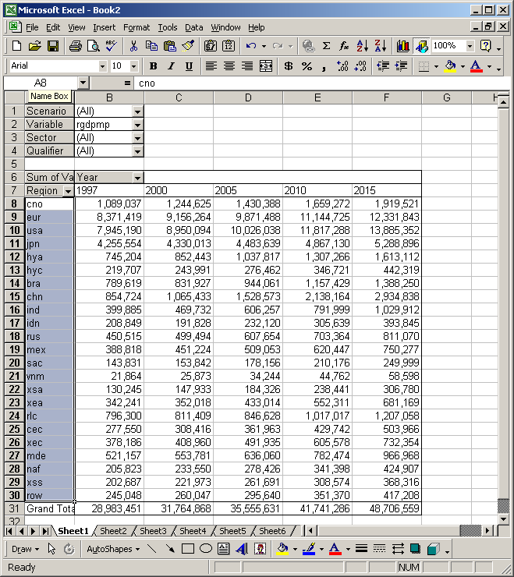

To be purchased from GTAP at Purdue University.
Note that the LINKAGE model uses the “flexible aggregation” version of GTAP data, distributed for the 6.05 release as ‘flexagg6p5.zip’. The user should ignore the ‘gtapagg6p5.zip’ version of the data.
Sets that end with ‘ra’ or ‘ia’ designations.
The limrow option of GAMS must be set to some positive number, the default is 3.
There are some versions of the model specification that are not necessarily homogeneous in prices. For example, fixing nominal wages will void the homogeneity properties.
If using the GAMS IDE, the directory option can be specified in the File|Options menu. Click on the Execute tab. Check the box labeled ‘Use following additional parameters’. In the text box below, enter ‘-idir= V:\Linkage\link6\generic’.
See the Linkage Technical Reference Manual, Part IV, for more on the model’s dynamics.
Baseline scenarios can contain policy changes, particularly those having occurred over an historic period. For example, China’s accession to the WTO could be incorporated into the baseline. The shocks file in the ‘AgTr’ folder is an example of policy changes in the baseline.
This assumes that the pivot table function, with all of its options have been fully installed during the installation of Microsoft Office. In particular, reading pivot tables from external databases requires the installation of Microsoft Query, plus the pre-defined data base types available with Microsoft Query. For our purposes, these pre-defined databases include text and csv files. While the windows and examples in this document have been prepared with Office 97 and Windows NT Version 4, the functions should be similar using other versions of Excel (starting with Version 5 and other operating systems).
It might be necessary to add the correct driver for reading text files. See the end of this appendix for how to add drivers for the MS Query package.
Uncheck the Use the Query Wizard to create/edit queries at the bottom of the dialogue box if it is checked.

