**Part 1**

The J. Paul Getty Museum

Bust Of Madame Recamier – Joseph Chinard (French, 1756 – 1813)

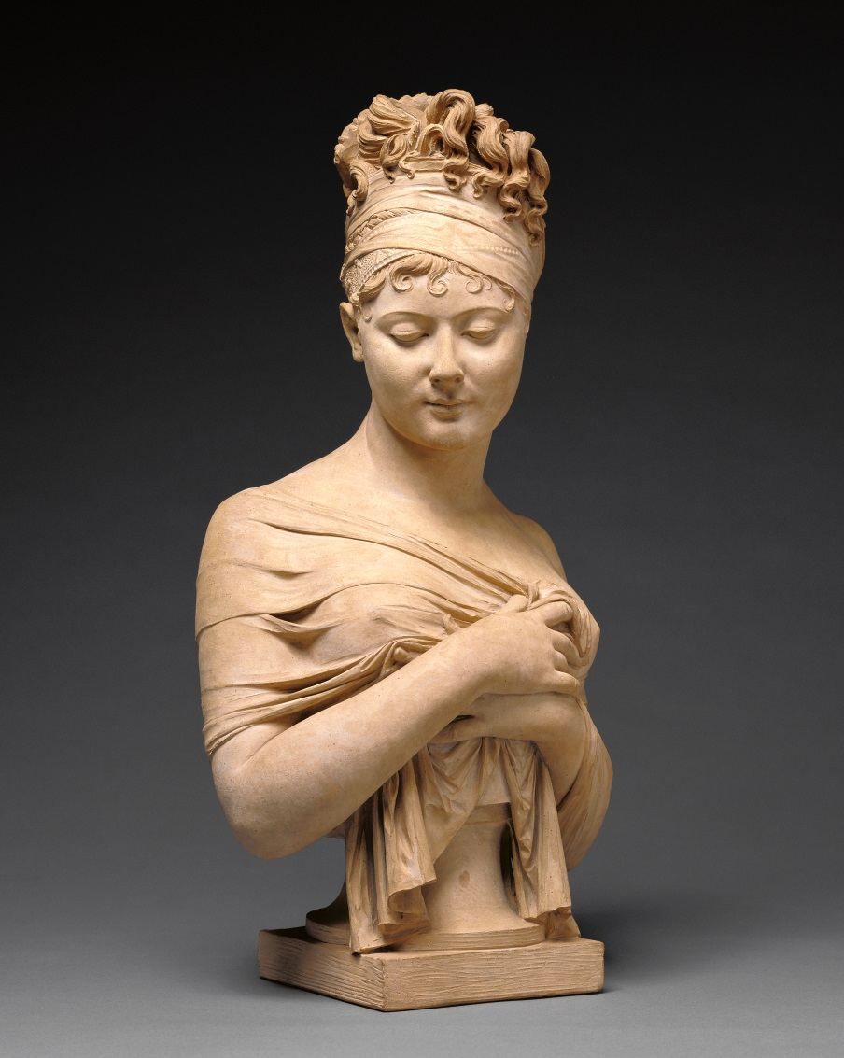

* Made out of terracotta
* The color has the tone of fair skin
* The fabric across the chest and her hair are very life like.
* Although this is a static pose, the downward gaze of the subject feels like the movement just occurred.
* The piece felt sad. Almost like her beauty was a burden.

Irises – Vincent van Gogh (Dutch, 1853 – 1890)

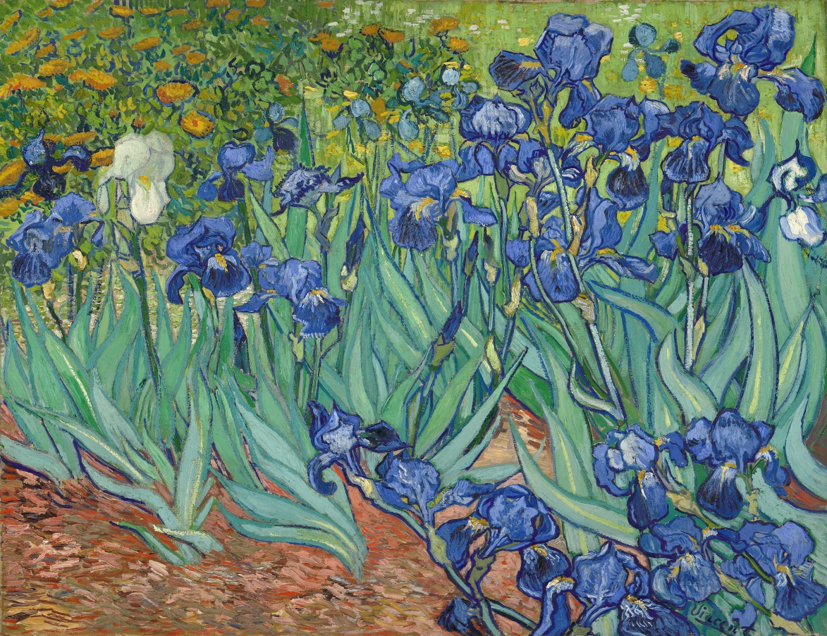

* Oil on canvas
* It looks like there is just a few colors used but the even so the painting feels vibrant.
* The flowers in the foreground feel almost alive even given their simplistic look.
* The green leaves look as if they are moving in the wind
* Even knowing van Gogh tortured life the scene felt hopeful. As if the blooming of the flowers signified an new beginning.

**Part 2**

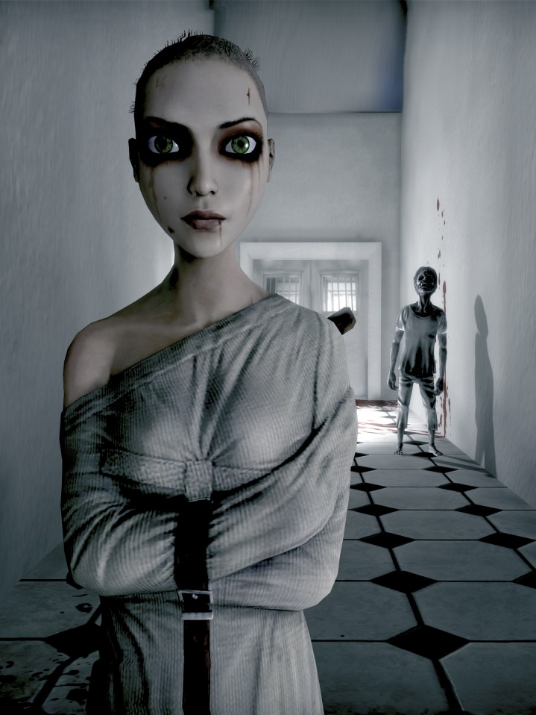

This CG image is a screenshot from the 2013 video game Alice: Madness Returns It was created by <http://deadendthrills.com/> and is titled "Frame Of Mind".

It was created by re-mapping Unreal Engine debug commands along with a static camera and a custom FOV. It uses a color palette that has a lot of grey in it. The aspect ratio is about 1:2 and has a nice perspective view. The shot follows the rules of thirds as can be seen by the placement of the figures. The most obvious texture is that of the straight jacket. This texture is slightly muddy due to the close up. This is understandable given that the texture was never meant to be statically viewed up close. The lighting on the figure in the background is one of my favorite parts of the image. I also like her crazy hair that looks like it’s been cut off with kitchen scissors.

An interesting article detailing the creation and art style of this game can be found at: <http://deadendthrills.com/little-china-doll-alice/>