CS148: Reading Guide, Tuesday 1 July
Shirley Ch. 2 pp. 13-29, Ch. 4: Ray Tracing
You’ll be needing your basic trig and linear algebra for the second assignment. You
should find this reading extremely helpful! The chapter on ray tracing provides a foundation for understanding what you’ll be asked to do in HW2, along with many useful derivations.
The figure at left shows the unit circle in the x,y plane. A vector lies on the unit circle at an angle θ to the x-axis as shown.
1) What is the value of the vector projected onto the x-axis? y-axis? (see dashed lines.)
x-axis: ________________________
y-axis: ________________________
2) Prove the Pythagorean identity, sin2 (θ) + cos2 (θ) = 1. (Feel free to continue on the back of this sheet.)
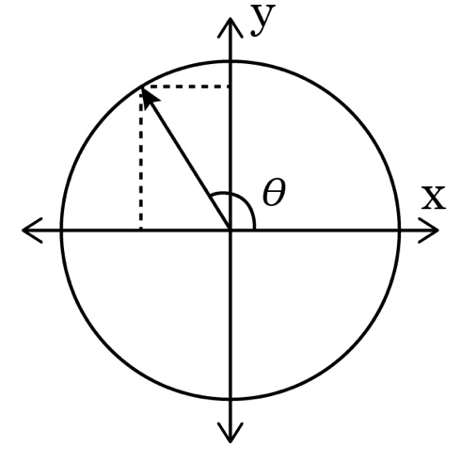
3) If you took the dot product of the given vector with (1, 0)T , would the sign be positive or negative? (Visualize projecting the vector onto the x-axis.)
4) What kind of material might you visualize with Lambertian shading? Blinn/Phong shading?

