Folder 1.0

v. 1.0 November 2015Contents

I Introduction 3

II Workspace overview 3

III Pre-processing 5

Computational domain 5

Interface 5

Interface parameters 5

Interface selection 5

Perturbation 5

Sine 5

Step 6

Triangle 6

Bell 6

Gaussian autocorrelation function 6

New perturbation 6

Region 7

Region parameters 7

Region selection 7

Material table 7

Quick model setup 8

Passive markers and finite strain 9

Deformation 10

Solvers 10

IV Post-processing 11

Time step 11

Scalar field 12

Vector field 12

Tensor field 13

V Plotting options 13

VI Saving data 14

VII Mesh info 15

VIII Numerical run summary 15

IX Growth rate 16

Analytical solutions 16

Numerical solutions 17

X List of platforms and matlab versions, where the code was testes 18

Windows 18

Linux 18

XI Bibliography 18

# I Introduction

Folder is a tool to simulate deformation in the layered viscous media. When FOLDER is executed (**folder.m** file), it loads a square domain divided by two interfaces (perturbed with a sine function) into three regions with specified material parameters. The model can be modified according to the user. FOLDER features include various functionalities that allow in the pre-processing stage:

1. Defining model geometry (model size, number and shape of interfaces)
2. Defining materials parameters
3. Specifying passive markers pattern and points where finite strain is calculated
4. Defining numerical parameters (mesh size in each region, ODE solver, number of time steps)
5. Selecting deformation mode (shortening or extension)
6. Defining amount of deformation

and in the post-processing stage :

1. Visualizing various physical fields (scalars, vectors, and tensors)
2. Analysing deformation of passive markers of finite strain distribution

# II Workspace overview

The workspace contains the following components:

1. Title bar – indicates the folder path where the current data is saved
2. Menu bar – provides access to the basic commends and functionality,
3. Toolbars - provides a quick access to selected items,
4. Figure window – displays your model,
5. Control panel – displays options and parameters. Control panel is divided into A) pre-processing panel:

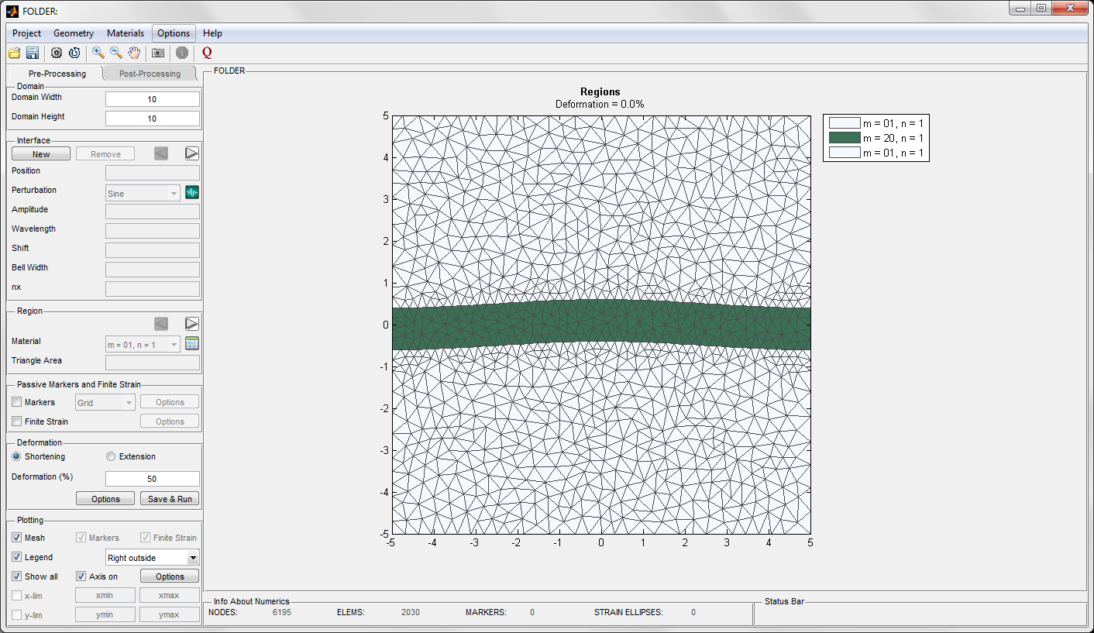

and B) post-processing panel:

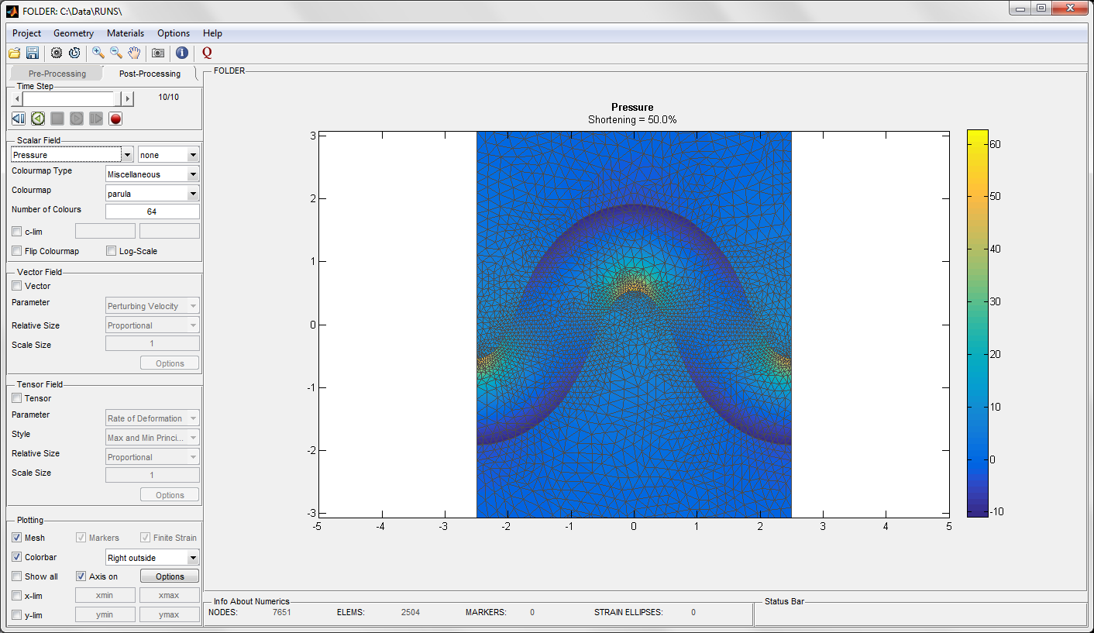

The pre-processing and post-processing panels can be selected at any time, however not all functions can be available. When selecting the pre-processing panel, the initial setup is automatically displayed.

# III Pre-processing

## Computational domain

The computational domain has a rectangular shape. The user can define the domain width and the domain height.

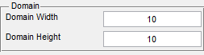

## Interface

### Interface parameters

The domain must contain at least one interface. The interface is defined through set of parameters: position, perturbation type, amplitude of perturbation, and number of points on the interface. In case of some perturbations some additional parameters have to be indicated such as: wavelength, shift, bell width (see Perturbation). In order to modify the parameters, the interface must be selected.

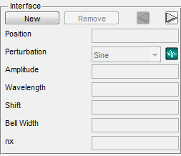

**Remark**: Two interfaces cannot intersect. In order to avoid any interference between interfaces, the minimum distance between them must be larger than the sum of their perturbation amplitudes.

### Interface selection

The interface can be selected using the arrow buttons in the Interface control panel or by clicking on the interface in the plot. Selected interface is highlighted. To unselect the interface, we can click in the margins of the plot in the plotting window or use the arrow buttons. The interface selection colour, marker colour, and marker size can be modified through **Option/Selection options** in the menu bar or through the **Options** in the Plotting control panel.

### Perturbation

Quick access to seven perturbation types: sine, step, triangle, and bell functions and red noise, white noise, Gaussian noise.

#### Sine



where  is the amplitude,  is the wavelength,  is the phase shift, and  is the domain length

#### Step



#### Triangle



#### Bell



where  is a parameters that controls the width of the bell shape function. The perturbation is rescaled to fit the desired amplitude

#### Gaussian autocorrelation function



where  is the variance and in Folder it is set to 1,  is the correlation length scale,  is the Hurst exponent.  acts as a cut-off length for self-affinity, above which the correlation disappears.  corresponds to regular surface with Gaussian correlations, whereas  the surface is self-affine.

### New perturbation

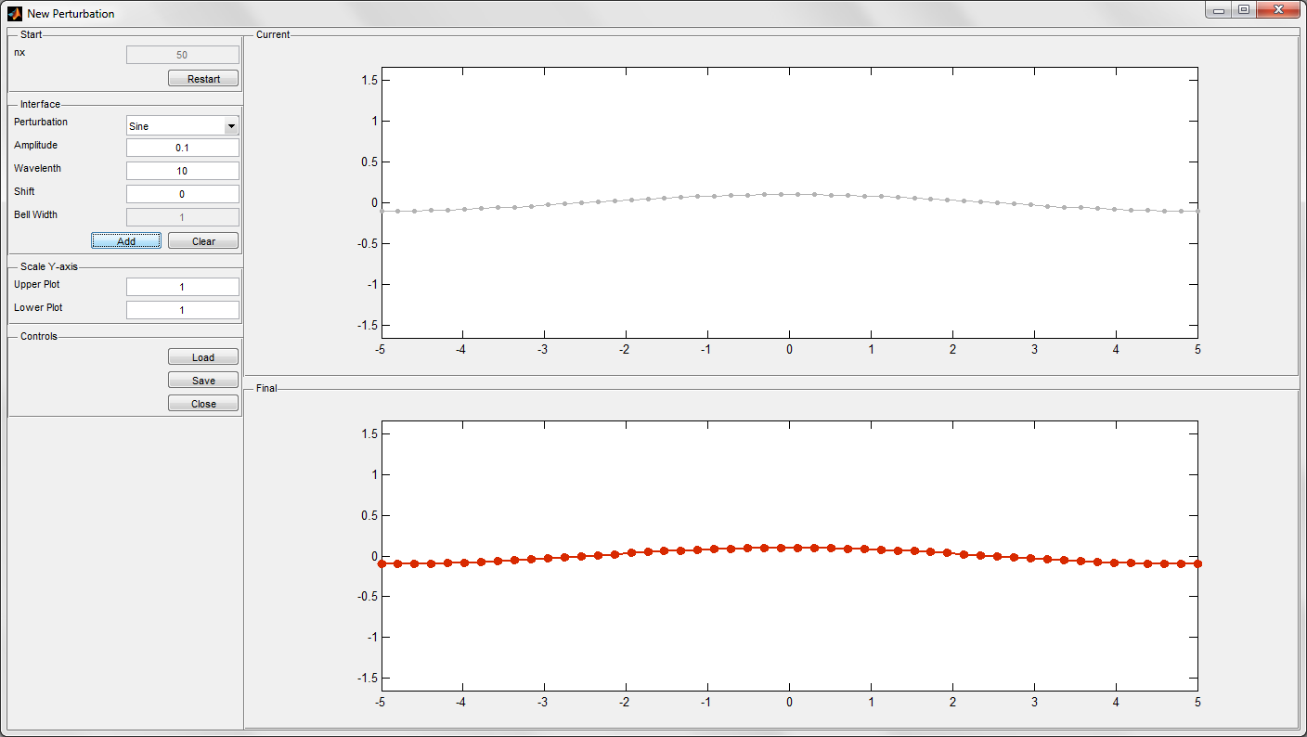

We can define new perturbation by selecting the icon  in the interface panel or **Geometry/New perturbation** from the menu bar. The horizontal span is inherited from the domain width (perturbation span automatically adjusts if the domain width changes). The user has access to the basic perturbation functions: sine, step, hat, and bell functions, red and white noises, Gaussian autocorrelation function or an arbitrarily defined (hand-drawn) curve. The user can also load and work on a picture or a previously saved perturbation. Various perturbations can be superposed. The upper plot shows the current perturbation, whereas the lower plot shows the final (superposition) perturbation.

When the perturbation is saved, it is automatically loaded into the perturbation list in the main GUI and it can be assign to any interface. Once defined number of points on the interface, they cannot be changed later.

**Note:** the amplitude of the perturbation is adjusted to the amplitude defined in the main GUI.

## Region

### Region parameters

Each region needs to have material and maximum triangle area defined. We can assign the parameters to a particular region only it is selected. The material parameters can be selected form the Material dropdown menu, which is compatible with the current material database. The database is accessible through the table icon next to the dropdown menu , **Material/Material table** in the Menu bar, or using a shortcut **Ctrl+M**. The table with data is editable, where each material can be modified or removed, or a new material can be added. When you right click on a region in the figure, it provides detailed information about the material properties.

**Note:** parameters in the table can be modified only before the simulations.

**Remember:** The material parameters are assigned to the regions based on the material list provided in the table. Changing the position of the material in the table can affect your model!

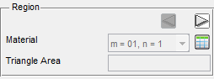

Triangle area defines the maximum area of the triangular element in the numerical mesh. In each region, we can assign different mesh size. Refining the mesh often improves the results accuracy; however, it also requires more computational memory and time.

### Region selection

The region is selected either by clicking on the region in the figure or by using the arrow buttons in the Region control panel. To unselect the interface, we can click in the margins of the plot in the plotting window or use the arrow buttons. The region selection colour can be modified through **Option/Selection options** in the menu bar or through the **Options** in the Plotting control panel.

### Material table

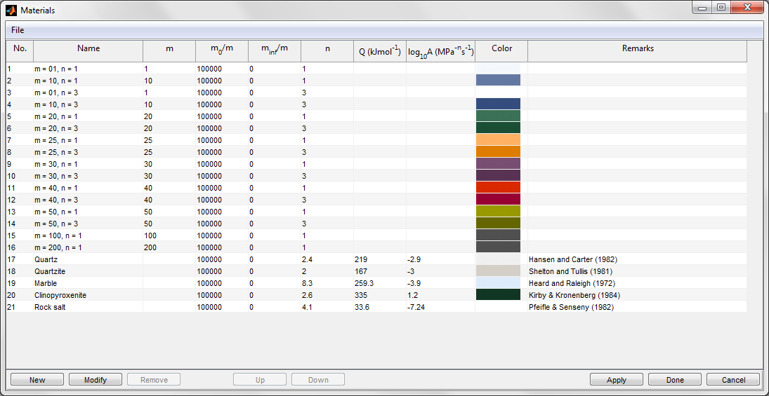

Folder includes a list of predefined materials. The list is editable, and material parameters can be modified, reordered, added, or deleted.

There are two ways of defining the material parameters:

1) providing background apparent viscosity (m), normalized viscosity at zero shear rate (m0/m), normalized viscosity at infinite shear rate (minf/m), and stress exponent (n)

2) providing parameters used in the power-law constitutive models: activation energy (Q), pre-exponential factor (A), normalized viscosity at zero shear rate (m0/m), normalized viscosity at infinite shear rate (minf/m), and stress exponent (n). Activation energy, pre-exponential factor and stress exponent are used to calculate the reference viscosity

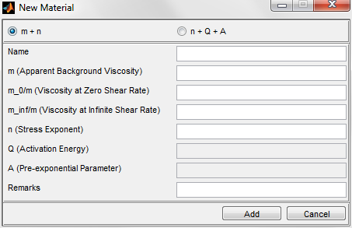

**Remember:** The material parameters are assigned to the regions based on the material list provided in the table. Changing the position of the material in the table can affect your model!

## Quick model setup

This GUI enables for a quick design of a multilayer model with interfaces having the same geometrical parameters: (amplitude, wavelength, shift, bell width, and nx). The multilayer package cannot exceed the model height. The package is located centrally in the model but it can be shifted using **Shift Interfaces** option. The user can assign different material properties to the multilayer package by defining the one or more material number (material numbers are specified in the table). In the case of larger number of regions then defined materials, the list of materials assigned to the regions a repeating sequence e.g. in order to define bilaminate only two material numbers need to be defined. The material numbers can be checked in the Material table.

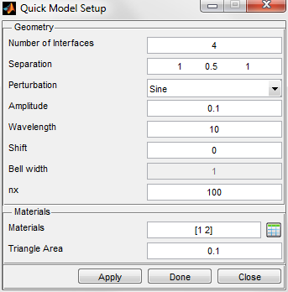

## Passive markers and finite strain

We can add passive markers or finite strain ellipses to the model by selecting appropriate option in the **Passive Markers and Finite Strain** panel. The passive markers patterns can be chosen from the dropdown list and include: layers, bars, grid, circles, and polygrain pattern.

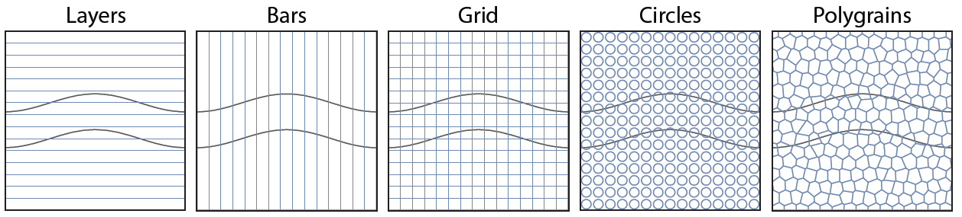

Additional parameters can be specified through the **Options** windows.

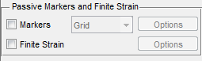

The user can set number of cells in horizontal direction (cell number), number of points per cell (resolution), and their horizontal and vertical span.

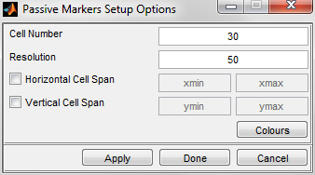

Regarding the strain ellipse, the following options are accessible: number strain ellipses in horizontal direction (cell number), number of points that define the ellipse (resolution), and their horizontal and vertical span.

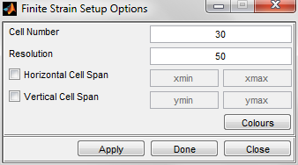

Passive markers and finite strain ellipses are automatically plotted in the figure after selecting. At the same time, the **Markers** and **Finite Strain** dialog boxed in the Plotting control panel become active. Selecting or deselecting these boxes displays or hides the feature, accordingly.

The passive marker and finite strain colours can be modified through *Option/Selection options* in the menu bar or through the Options in the Plotting control panel.

## Deformation

Here, the user can specify the deformation type either shortening or extension and amount of deformation in %.

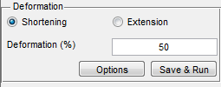

Selecting **Options** in the Deformation control panel provides access to:

1) numerical parameters (selecting ODE solver and number of time steps),

2) deformation dependent parameters (temperature and rate of deformation) (active only when material parameters used in the model are specified according to the full form of the power-law equation)

3) iterations for non-linear materials (active only when non-linear materials are used in the model)

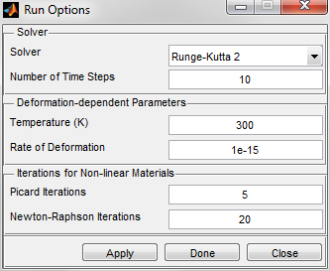

## Solvers

Evaluation of the model deformation in time requires solving the ordinary differential equation of the form:



We employ various numerical methods, which find numeric approximation to the above solution. The choice of the method is the user-defined parameter. In Folder, we incorporate only explicit integration schemas with fixed time step. This includes Euler method, Heun method (improved Euler), Runge-Kutta family methods, and Adams-Bashforth family methods.

Euler scheme follows the formula:



whereas the improved Euler (Heun) method is:



Runge-Kutta methods belong to the group of algorithms that incorporate mid-steps to calculate the next time step. These methods are usually the most computationally demanding. From this family of methods, we incorporate only second, third- and fourth-order Runge-Kutta schemas. The first order is equivalent to the Euler method, whereas the second-order method (also called a mid-point method) is given by:



The formula for the third-order Runge-Kutta method is:



where:



whereas, for the forth-order, the formula follows:



where:



The last family of methods are Adams-Bashforth methods, which belong to the multistep algotithms. These methods incorporate several previous time steps to calculate next step. One-step Adams-Bashforth method is equivalent to the Euler method. Two-step Adams-Bashforth method follows:



three-step Adams-Bashforth method is given by



whereas four-step Adams-Bashforth method is



# IV Post-processing

## Time step

Time-step panel includes: 1) slide bar, where the user using arrows can choose to visualise next or previous deformation step 2) information about the current timestep, 3) buttons: go to the first step, play backward, stop, play forward, go to the last step, and record.

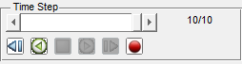

**Remark:** Information about the current amount of shortening/extension is provided in the figure title.

## Scalar field

The user can choose to plot:

1) pressure

2) total velocity (x- and y- components and magnitude)

3) perturbing velocity (x- and y- components and magnitude)

4) rate of deformation (xx-, yy-, and xy- components and second invariant)

5) total stress (xx-, yy-, and xy- components and second invariant

5) deviatoric stress (xx-, yy-, and xy- components and second invariant

6) apparent viscosity

All the values can be plotted using the logarythimic scale.

We provide over 30 different colourmaps, which are classified into four categories: monochromatic, bichromatic, diverging, and miscellaneous. By default each colourmap is defined by 64 colours. The number of colorurs can be modified in a range between 2 and 256. The colourmap scale can be also flipped. Additionally, the user can choose to set limits on the c-axis, flip colourmaps, or set the logarithmic scale.

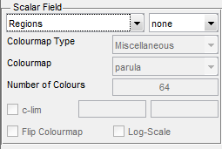

## Vector field

Total velocity or perturbing velocity can be illustrated using vector field. The relative length of the arrows can be modified using the options: proportional, logarithmic, and equal. Additionally, the arrow length can be rescaled.

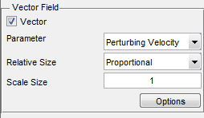

The user can set number of vectors in the horizontal direction (x-grid points) and vertical direction (y-grid points) and their span in the horizontal (x-grid span) and vertical direction (y-grid span). If the **Irregular Grid** option is not selected, the spacing in horizontal and vertical directions is equal and number of number of vectors in the vertical direction adjust accordingly to the current size of the domain or the defined by the user y-grid span.

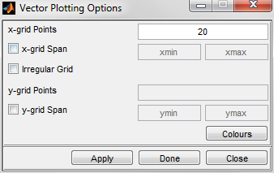

## Tensor field

Rate of deformation, total stress and deviatoric stress can be illustrated using crosshair or ellipse glyphs. In the case of crosshair glyph, the user can choose to visualize only minimum or maximum principle axes, or both. Two colours used in the glyph are employed to distinguish between the positive and negative magnitude values. The relative length of the glyphs can be modified using the options: proportional, logarithmic, and equal. Additionally, the glyph size can be rescaled.

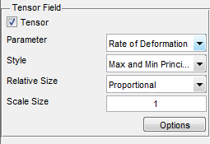

Similarly as for the vectors options, the user can set number of glyphs in the horizontal direction (x-grid points) and vertical direction (y-grid points) and their span in the horizontal (x-grid span) and vertical direction (y-grid span).

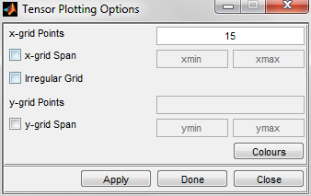

# V Plotting options

This control panel is active during pre- and post-processing stage. It allows:

1) showing or hiding mesh, passive markers, finite strain, legend, or colourbar.

2) positioning legend or colourbar

3) showing all (Show all)

4) showing or hiding axis (Axis on)

5) setting the x- and y-limits on the axis

**Remark**: If you select the figure region using zoom options( ) from the **Toolbar**, you can freeze these axis limits by clicking on the **x-lim** and **y-lim** in the panel. The axis limits (**xmin**, **xmax**, **ymin**,and **ymax**) are read from the figure, fixed, and displayed in the panel.

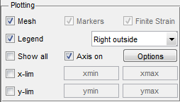

This window incudes options to set vertical exaggeration of the plot and define thickness and colours of 1) lines that outlines the layer, 2) lines that defines the mesh edges, 3) lines that define contours of passive markers and finite strain ellipses, 4) vectors and tensors lines, and 5) filling in tensor ellipse.

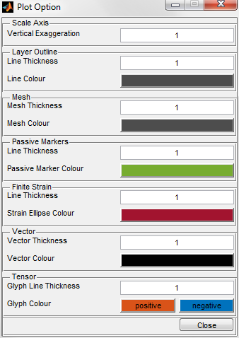

# VI Saving data

The user is asked to select the folder where the data is saved each time before the calculation starts (after pressing button **Save&Run**). The user can also save the model setup at any time by selecting the icon in the toolbar or **Project/Save Project**. The access to the previously saved data is provided through icon in the toolbar or **Project/Open Project**.

# VII Mesh info

This control panel provides information about numeric: 1) number of nodes (NODES), 2) number of elements (ELEMS), 3) number of marker points (MARKERS), number of strain ellipses (STRAIN ELLIPSES).



Remark: If the number of elements exceeds 1’000’000, the number is highlighted in red

# VIII Numerical run summary

During each simulation, Folder generates a report file that documents main information about the numerical run i.e. number of nodes, number of elements, and time of each time step. For the case of non-linear materials, number of iterations, mean iteration time, and the relative residual is also provided. The data can be visualized using a separate GUI by selecting a Run Information icon from the Toolbar. The icon is active only after the run simulation is completed.

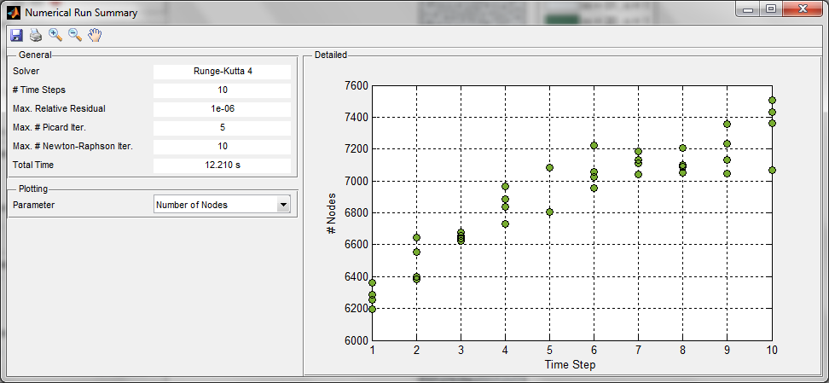

# IX Growth rate

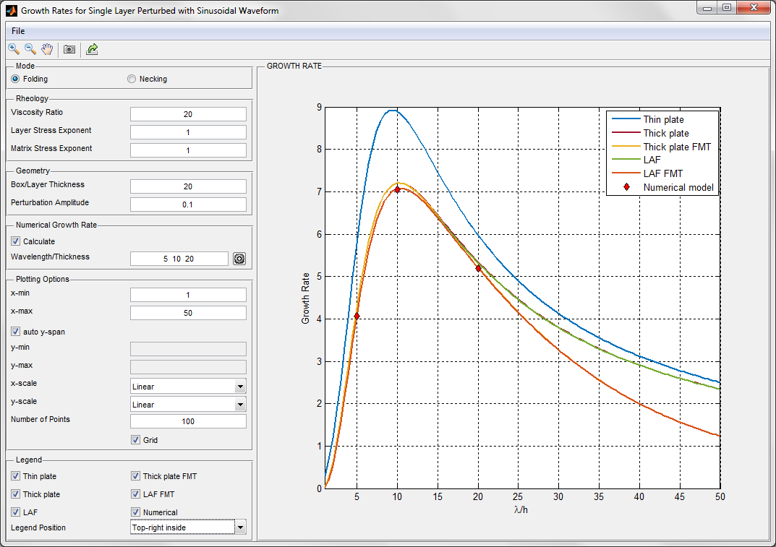

## Analytical solutions

This GUI provides growth rate solutions for various analytical models for the case of folding and necking.

**- Layer parallel shortening of linear viscous materials:**

1. thin plate solution **Error! Bookmark not defined.**
2. thick plate solution (Fletcher, 1977; Smith, 1977)
3. thick plate solution for finite matrix thickness (thick plate FMT)
4. large amplitude folding solution (LAF) (Adamuszek et al., 2013)
5. large amplitude folding solution for finite matrix thickness (LAF FMT)

**- Layer parallel shortening of non-linear viscous materials**

1. thin plate solution (Fletcher, 1974)
2. thick plate solution (Fletcher, 1974)
3. thick plate solution for finite matrix thickness

**- Layer parallel extension of linear viscous materials**

1. thick plate solution (Fletcher, 1974)
2. thick plate solution for finite matrix thickness

**- Layer parallel extension of non-linear viscous materials**

1. thick plate solution (Fletcher, 1974)
2. thick plate solution for finite matrix thickness

The table below shows parameters that are taken into account in the growth rates calculation in various analytical solutions.

|  |  |  |  |  |
| --- | --- | --- | --- | --- |
|  | Apparent Background Viscosity Ratio | Layer and Matrix Stress Exponents | Box/Layer Thickness | Perturbation Amplitude |
| Thin plate | ✓ | ✓ |  |  |
| Thick plate | ✓ | ✓ |  |  |
| Thick plate FMT | ✓ | ✓ | ✓ |  |
| LAF | ✓ | ✓ |  | ✓ |
| LAF FMT | ✓ | ✓ | ✓ | ✓ |

## Numerical solutions

The user can provide a list of wavelength to thickness ratios, for which numerical models are generated and the numerical growth rates are calculated. The values of the numerical growth rates are presented on the figure together with the analytical solutions.

Range of parameters required to control the numerical run include spatial resolution, maximum triangle area, maximum number of Picard and Newton-Raphson iterations and relative residual. The parameters are accessible through the icon  in the Numerical Growth Rate control panel.

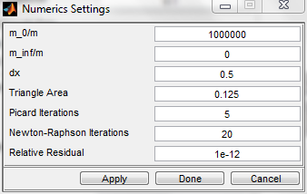

## Export data

The analytical and numerical solutions can be exported to the workspace using the  button. First, the user is asked to provide the name of the variable, which includes the data and by default is it GR

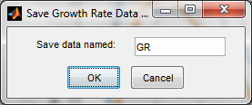

After pressing OK, the data is saved in the workspace and this information is also displayed in the Matlab Command Window. The data is stored in the structure array with fields following the five anaytical solution labels used in the Folder and Numerics.

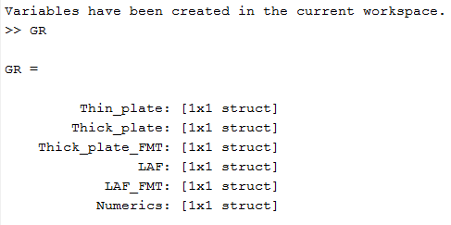

Each of the field includes x and y coordinates of the data, e.g.,

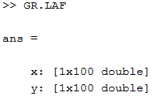

# X List of platforms and matlab versions, for which the code was testeD

## Windows

1. Windows 7

Matlab 2012a

Matlab 2013a

Matlab 2015a

1. Windows 10

Matlab 2015a

## Linux

Matlab 2013a

Matlab 2013b

Matlab 2014a

Matlab 2014b

Matlab 2015a

# XI Bibliography

Adamuszek, M., Schmid, D., and Dabrowski, M., 2013, Theoretical analysis of large amplitude folding of a single viscous layer: Journal of Structural Geology, v. 48, p. 137–152.

Biot, M. A., 1961, Theory of Folding of Stratified Viscoelastic Media and Its Implications in Tectonics and Orogenesis: Geological Society of America Bulletin, v. 72, no. 11, p. 1595-1620.

Fletcher, R. C., 1974, Wavelength Selection in Folding of a Single Layer with Power-Law Rheology: American Journal of Science, v. 274, no. 9, p. 1029-1043.

-, 1977, Folding of a single viscous layer: exact infinitesimal-amplitude solution: Tectonophysics, v. 39, p. 593–606.

Smith, R. B., 1977, Formation of folds, boudinage and mullions in non-Newtonian materials: Geological Society of America Bulletin, v. 88, p. 312-320.