Advanced AI Software and Toolkits

Table of Contents
System Configuration 2
Operating System 2
Hardware Platform 2
Software (installed in the indicated order) 3
Cuda SDK 3
OpenCV 4
cuDNN 4
Caffe 5
DIGITS 6
Image Processing 9
Classification (determine the subject class of an image) 9
Image Classification using DIGITS 9
Generate a Model Classifier using DIGITS 9
Classify an image from the command line using a model created in DIGITS 9
Using DIGITS scripts 9
Using Caffe Script 11
Use a pre-trained model for image classification in DIGITS 13
Use a pre-trained model to improve test accuracy and training speed 17
Object Detection (Identify objects in an image and draw bounding boxes around them) 23
Fast R-CNN: Fast Region-based Convolutional Networks for object detection 23
DIGITS with fast-rcnn support ? 26
Faster R-CNN 30
Faster-RCNN - Beyond The Demo 35
Train & test a custom dataset (INRIA-Person) 40
Plot the training log (from faster r-cnn end2end caffe output) 45
Modify test output to combine all boxes and classes into a single image 46
Process the images from the INRIA Test directory 47
Modify INRIA test to work with ZF (end2end) network (vs VGG16) 48
Train and Test Faster R-CNN on 2-class “Tote-Ball” data set 49
Object detection using YOLO (You Only Look Once) (darknet) 53
Demo Tests 55
Plot the Training Log 57
Train YOLO on Pascal VOC data 57
Train/validate VOC data using “tiny” YOLO network 61
Run a video through YOLO 61
Train YOLO on a custom 2 class dataset 63
Train 2-class dataset on “Tiny” YOLO 67
Train tiny YOLO on Tote-Ball data set 69
SSD (single-shot multibox-detector) 73
Installation 73
Test a set of images using a trained network 75
Test a video (mp4) file using a trained network 76
Train one of the provided datasets (VOC) 78
Train and test SSD on a custom dataset 2
Object Detection using DIGITS (detectnet) 3
Installation 3
Train and test a model dataset 4
Notes 6
Segmentation (identify objects at the pixel level) 7
Image Segmentation using DIGITS 5 7
Segment images in PASCAL VOC 2012 dataset using FCN-ALEXNET 7
Segment images in SYNTHIA dataset using FCN-ALEXNET 8
Improve segmentation resolution using fcn-8s 11
Image segmentation using DeepMask and SharpMask 17
Image segmentation using Conditional Random Fields (CRF-RNN) 23
Image Segmentation using Mask Regional Convolutional Neural Networks (Mask R-CNN) 26
Computing Topics 27
Compile and run the Nvidia CUDA examples 27
NSIGHT - NVidia Eclipse based IDE 29
Linking g++ code with CUDA libraries 31

System Configuration

Operating System
  - Ubuntu 14.04

Hardware Platform
  - AMD Phenom II 1055t CPU (6 cores)
  - Nvidia GTX 980 GPU (2048 cores)
    - Maxwell series
    - note: cuDNN requires Maxwell level or better graphics card
  - Nvidia driver version: 352.68
  - 8 GB RAM
  - 466 GB Hard Drive (dual partitioned with Windows 10)

Software (installed in the indicated order)

Cuda SDK
    - Register as an Nvidia developer
  - To sign up, go to the Nvidia developer home page and create an account
  - Note: It takes 2-3 days to get an acknowledgment back from NVidia and obtain download and other privileges
    - Download latest Cuda toolkit (8.0 as of 4/2017)
download site: https://developer.nvidia.com/accelerated-computing-toolkit
  - Press Cuda Toolkit Download
  - Press “Linux” in target platform panel
  - Press x86_64 in “Architecture” options
  - Press Ubuntu in distribution options
  - Press 14.04 in version options
  - Press “deb (network)” in installer type options
  - Press “Download (2.1 KB)” in “Target Download Installer .. Panel
    - Choose a download directory (e.g. ~/Downloads)
  - $ cd ~/Downloads
    - downloads latest deb installer <installer.deb>
      - 7.5: cuda-repo-ubuntu1404_7.5-18_amd64.deb
      - 8.0: cuda-repo-ubuntu1404_8.0.61-1_amd64.deb
    - installation
  - $ sudo dpkg -i <installer.deb>
  - $ sudo apt-get update
  - $ sudo apt-get install cuda
    - Setup environment
- make soft link
  - cd /usr/local/
  - sudo ln -s cuda-8.0 cuda
- Add to ~/.bashrc
export CUDA_HOME=/usr/local/cuda
export LD_LIBRARY_PATH=${CUDA_HOME}/lib64
PATH=${CUDA_HOME}/bin:${PATH}
export PATH

OpenCV
    - Obtain source code
- $ git clone https://github.com/Itseez/opencv
- cd opencv
- git checkout tags/3.1.0 -b 3.1.0
  - note: master branch is actually at 2.4 which produces compile errors unless CUDA is disabled
    - configure
- mkdir build && cd build
- ccmake ..
  - select options
    - YES: WITH_CUDA, WITH_OPENGL, WITH_MP ..
  - press c (configure)
  - press g (generate)
    - build
- make -j6 (takes ~ 1hr to build)
    - install
- sudo make install

cuDNN
- Download and Install latest version from NVIDIA developers site
  - membership required
- versions <cudnn-version>.tar
  - Version 3.0: cudnn-7.0-linux-x64-v3.0-prod.tgz, cudnn-sample-v3.tgz
  - Version 6.0 <for cuda 8.0>: cudnn-8.0-linux-x64-v6.0.tgz
- Install
  - https://developer.nvidia.com/rdp/cudnn-download
  - accept licence agreement (check box) and select cuDNN for Linux ,guides, code examples and download into some directory (e.g. ~/Downloads)
  - untar libraries and header files to global location
  - sudo tar -xf cudnn-8.0-linux-x64-v6.0.tgz -C /usr/local
  - installs the following files
cuda/include/cudnn.h
cuda/lib64/libcudnn.so
cuda/lib64/libcudnn.so.6
cuda/lib64/libcudnn.so.6.0.20
cuda/lib64/libcudnn_static.a
    - note : /usr/local/cuda was soft-linked to /usr/local/cuda-8.0 in cuda install procedure described above

Caffe
- Version (compatible with cuDNN 5.1 and OpenCV 3.1)
- references
  - http://caffe.berkeleyvision.org/installation.html
- Obtain source code
$ cd
$ git clone https://github.com/BVLC/caffe
$ cd ~/caffe
- Get dependencies
$ for req in $(cat requirements.txt); do pip install $req; done
- Set up for Build
$ cp Makefile.config.example Makefile.config
  - Edit Makefile.config
  - Uncomment: USE_CUDNN := 1
  - Uncomment: WITH_PYTHON_LAYER := 1
  - Uncomment: OPENCV_VERSION := 3
- Build
$ make all
$ make pycaffe
$ make test
$ make runtest

DIGITS
- Version 3.0
  - Installation
    - follow install instructions for 3.0: https://github.com/NVIDIA/DIGITS/blob/digits-3.0/docs/UbuntuInstall.md#repository-access
  - Running
    - start server: sudo start nvidia-digits-server
    - stop server: sudo start nvidia-digits-server
    - In browser change port from 5000 to 80
      - http://localhost:80
- Version 4.0 (released Aug. 2016)
  - Installation
    - Log in as NVIDIA developer
    - Go to downloads tab
    - follow instructions for installing DIGITS 4.0:
https://github.com/NVIDIA/DIGITS/blob/digits-4.0/docs/UbuntuInstall.md#repository-access
  - Running
    - See “Getting Started” page at: https://github.com/NVIDIA/DIGITS/blob/digits-4.0/docs/GettingStarted.md
- Version 5.0 (released April 2017)
Adds support for Image Segmentation using fcn-alexnet
  - Installation
    - Log into NVIDIA developer page and follow instructions for downloading and installation of version 5.0
      - installs into ~/digits
    - Installed and built caffe version 1.0.0-rc5
      - includes support for fcn-alexnet caffe layers
      - installs into ~/caffe
      - to start digits with this caffe:
        - export CAFFE_ROOT=~/caffe;~/digits/digits-devserver
    - Installed and built NVIDIA-caffe
      - includes support for fcn-alexnet caffe layers
      - provides support for NVIDIA “Detectnet” demo (bounding boxes)
      - follow install and build instructions on this page: https://github.com/NVIDIA/DIGITS/blob/digits-5.0/docs/BuildCaffe.md
      - note: for Detectnet support use cmake as described in reference (not Makefile.config as is normally used to build caffe)
        - using ccmake first need to build opencv and then set OPENCV_DIR to ~/opencv/release and OPENCV_FOUND to ON to avoid errors
        - then configure (press c), exit (q) and run cmake
        - once Makefile is createsd run “make -j6”, “make pycaffe” to build
      - to start digits with this caffe enter:
export CAFFE_ROOT=~/NVIDIA-caffe; ~/digits/digits-devserver
    - Disable auto-launch of DIGITS server on startup
      - following the NVIDIA install instructions causes a default web server to be launched at system startup (which sets DIGITS_JOBS_DIR to /var/lib/digits/jobs). This is inconvenient because the directory is owned by root and the version of digits launched is slightly older than the one in ~/digits (5.1-dev)
      - needed to delete several files in /etc/init to prevent the server from starting up on boot (remove anything with “digits” in the name)
  - Running
    - > ~/digits/digits-server
    - You can change the port digits uses by adding a port number in the dialog box that pops up by running: sudo dpkg-reconfigure digits
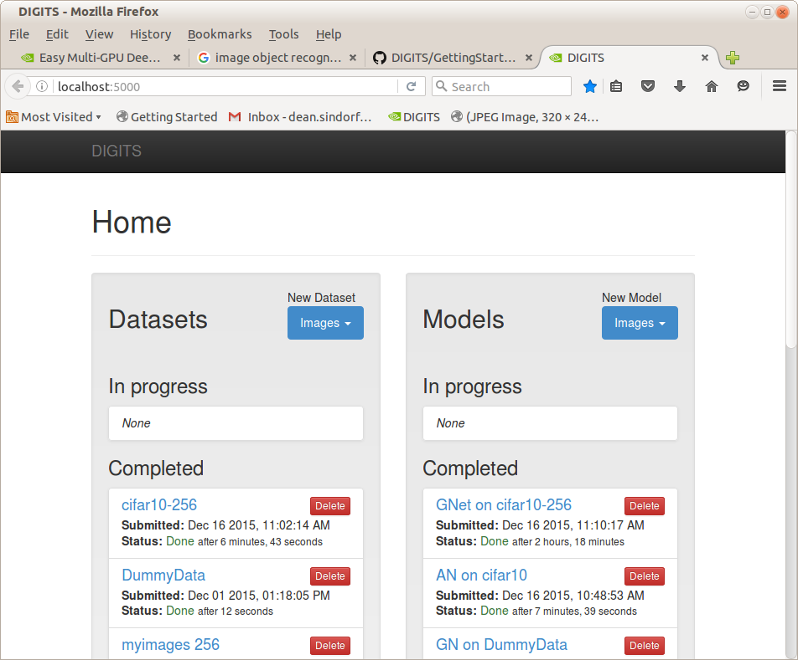

Image Processing

Classification (determine the subject class of an image)

Image Classification using DIGITS

Generate a Model Classifier using DIGITS
Follow the examples in the “Getting Started” link at: https://github.com/NVIDIA/DIGITS/blob/digits-4.0/docs/GettingStarted.md
- Create a Classifier to recognize hand-written numbers
- mnist
- Create a Classifier to recognize common objects (e.g. dogs,cats,boats) in small images
- cifar10

Classify an image from the command line using a model created in DIGITS
The Dataset and model used in this test was obtained from a set of images of a “ball” or “no ball” generated from a camera sensor in Gazebo while driving a simulated robot around in “teleop” mode (see ImageProcessing.odt:page-76 located in the same Team159 github/MentorRepository directory as this document for further details)
Goals:
- After training a model using DIGITS use command line instructions or a shell script to identify objects in single images (rather than using the Browser interface)
- Determine what tools are needed to export and use a DIGITS Classifier on external hardware (e.g. a Jetson TK1 board)

Using DIGITS scripts
- References
- https://github.com/NVIDIA/DIGITS/tree/master/examples/classification
- DIGITS locations
- python script to classify a test image is at:
  - $HOME/DIGITS/examples/classification/example.py
- DIGITS trained models and data sets are stored at: /usr/share/digits/digits/jobs/
  - e.g 20160816-144923-ad9f (name appears to contain date-stamp)
- Model classifier “jobs” contain the following files needed for object identification
  - deploy.prototxt
  - snapshot_iter_<some number>.caffemodel
- Also needed is the “mean” and “labels” files generated by the Dataset
  - grep mean.binaryproto caffe_output.log
Loading mean file from: /usr/share/digits/digits/jobs/20160816-143420-d01a/mean.binaryproto
  - dataset directory=/usr/share/digits/digits/jobs/20160816-143420-d01a
    - contains mean.binaryproto and labels.txt
- Create a model test directory
- $ mkdir -p ~/data/models/ball-only-LE
- $ pushd /usr/share/digits/digits/jobs/20160818-093555-89d5 (ball only model)
- $ cp snapshot_iter_60.solverstate deploy.prototxt ~/data/models/ball-only-LE
- $ grep mean.binaryproto caffe_output.log
Loading mean file from: /usr/share/digits/digits/jobs/20160818-093431-a67d/mean.binaryproto
- $ cp /usr/share/digits/digits/jobs/20160818-093431-a67d/mean.binaryproto ~/data/models/ball-only-LE
- $ cp /usr/share/digits/digits/jobs/20160818-093431-a67d/labels.txt ~/data/models/ball-only-LE
- Test script (test.sh)
#!/bin/sh

TESTEXE=/home/dean/DIGITS/examples/classification/example.py
BASEDIR=/home/dean/data/models/ball-only-LE
MODEL=$BASEDIR/snapshot_iter_60.caffemodel
PROTO=$BASEDIR/deploy.prototxt
MEAN=$BASEDIR/mean.binaryproto
TDIR=/home/dean/data/ball-only
TEST1=$TDIR/field/"default_ShooterCamera(1)-0312.jpg"
TESTALL=$TDIR/ball/"*.jpg"
LABELS=$BASEDIR/labels.txt
$TESTEXE $MODEL $PROTO $TEST1 --mean $MEAN --labels $LABELS
#$TESTEXE $MODEL $PROTO $TESTALL --mean $MEAN --labels $LABELS
- Results
- Single image file
  - $TESTEXE $MODEL $PROTO $TEST1 --mean $MEAN --labels $LABELS
$ ./test.sh
Processed 1/1 images in 0.051673 seconds ...
Prediction for /home/dean/data/ball-tote-2/ball/default_ShooterCamera(1)-0252.jpg
99.8915% - "ball"
0.0738% - "tote"
0.0347% - "none"
Script took 4.985445 seconds.
- Multiple files (batch-size=1)
  - $TESTEXE $MODEL $PROTO $TESTALL --mean $MEAN --labels $LABELS
Processed 1/85 images in 0.007678 seconds ...
Processed 2/85 images in 0.021934 seconds ...
...
  - Average ~400 us/image
  - Worst case: 0.02 s (2nd image)
- Multiple files (batch-size=85)
  - Processed 85/85 images in 0.006281 seconds …
  - average: 73 us/image

Using Caffe Script
Note: Jetson TK1 supports Caffe but not DIGITS
- Test script (pytest.sh)
#!/bin/sh

TESTEXE=/home/dean/caffe/python/classify.py
BASEDIR=/home/dean/data/models/ball-only-LE
MODEL=$BASEDIR/snapshot_iter_60.caffemodel
PROTO=$BASEDIR/deploy.prototxt

python convert_mean.py
MEAN=$BASEDIR/mean.npy
TDIR=/home/dean/data/ball-only
#TEST=$TDIR/field/"default_ShooterCamera(1)-0312.jpg"
TEST=$TDIR/ball
LABELS=$BASEDIR/labels.txt
$TESTEXE --pretrained_model $MODEL --model_def $PROTO –-gpu --images_dim 32,32 --mean_file $MEAN $TEST result

python print_array.py

- python convert_mean.py
The "mean.binaryproto" file generated by DIGITS "Datasets" needs to be converted to a ".npy" file for use by the Caffe script. Found the following phython script to do the conversion:
import caffe
import numpy as np
import sys

blob = caffe.proto.caffe_pb2.BlobProto()
data = open( 'mean.binaryproto' , 'rb' ).read()
blob.ParseFromString(data)
arr = np.array( caffe.io.blobproto_to_array(blob) )
print arr.shape
arr = np.reshape(arr, (3,32,32))
print arr.shape
np.save('mean.npy', arr)

- python print_array.py
This scripts prints out the classifier probability results as a list of fractions.
import numpy as np
m = np.load("result.npy")
np.set_printoptions(formatter={'float': '{: 0.3f}'.format})
print(m)

- Results
- Single Image
  - TEST=$TDIR/field/"default_ShooterCamera(1)-0312.jpg"
Classifying 1 inputs.
Done in 0.01 s.
- Multiple Images
  - TEST=$TDIR/ball
Classifying 85 inputs.
Done in 0.48 s.
  - average: 5.6 ms/image (0.48/85)
- CPU only
  - removed –gpu from script
  - took 1.68 s to process 85 images
    - GPU only provided ~ x3 speedup over CPU (expected more)
- Comments
  - Total batch performance MUCH worse than using DIGITS script (why ??)

Use a pre-trained model for image classification in DIGITS
Neural Networks with parameters that have been trained on the huge ImageNet dataset with expensive gpu server arrays and many hours of compute time can be downloaded and used to categorize arbitrary images via caffe and it's browser based front-end “DIGITS”. Unfortunately, since DIGITS was designed as a “training” rather than an “evaluation” system the procedure to do this seems to be unnecessarily complex (but is described in the following reference)
reference: https://github.com/NVIDIA/DIGITS/issues/49
  - Obtain a pretrained caffe model
$ cd ~/caffe
$ scripts/download_model_binary.py models/bvlc_alexnet
$ scripts/download_model_binary.py models/bvlc_googlenet
  - Set up a “dummy” data set
  - Create a “dummy” data directory
$ mkdir ~/data/dummy
  - Save some (arbitrary) image file here
e.g. $ cp ~/caffe/examples/images/cat.jpg ~/data/dummy/image.jpg
  - Create a textfile “train.txt” using the same image once for each category 0-999 e.g.:
/home/username/data/dummy/image.jpg 0
/home/username/data/dummy/image.jpg 1
...
/home/username/data/dummy/image.jpg 999
    - e.g. shell script to do this:
$ for((i=0;i<1000;i+=1)); do echo "$HOME/data/dummy/image.jpeg $i ">>train.txt; done
  - Get synset_words.txt using this script
mkdir ~/data/synset
cd ~/data/synset
wget http://dl.caffe.berkeleyvision.org/caffe_ilsvrc12.tar.gz
tar -xf caffe_ilsvrc12.tar.gz && rm -f caffe_ilsvrc12.tar.gz
  - Configure Digits “dummy” data image
- In Browser panel: DIGITS->New Dataset->Images->Classification->Upload Text Files
Training set: Browse to ~/data/dummy/train.txt
Validation set: none (uncheck)
Labels: Browse to ~/data/synset/synset_words.txt
- Dataset Name: DummyData
- Press “Create”
  - Configure Digits classification model
    - DIGITS-> Models-> New Model → classification
    - Select model in Standard networks tab (e.g. choose 1)
Alexnet
GoogleNet
    - Press “customize”
    - In Pretrained model box enter full path to the “.caffemodel” file in one of the directories created in 1.1 above e.g.:
/home/dean/caffe/models/bvlc_googlenet/bvlc_googlenet.caffemodel
    - Select Dataset → DummyData
    - Set the following “Solver Options”
Training Epochs: 1
Base learning rate: 0.0
Batch Size : 1 (single image) note: not described in reference
    - Set an appropriate Model Name (e.g. “GN on DummyData”)
    - Press “Create”
  - If successful a new “Completed” Model will be created in the Digits home page
  - Test classify an images
- Obtain an image or images from some source
e.g. download URLs from http://image-net.org/download
- In the Digits home page select the relevant “Completed” model
e.g. “GN on DummyData”
- At the bottom of the “Image Classification Model” page press “Browse” in the “Upload Image” tab
Browse to one of the test images and select it
- Press “Classify One Image”
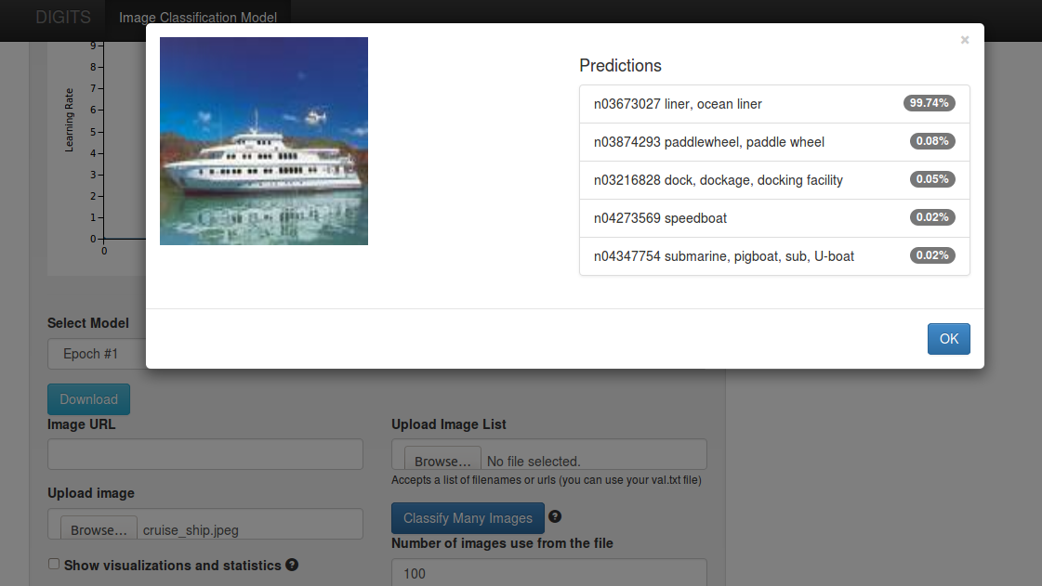
  - When trying to duplicate this procedure after uploading Digits 3 classification results were much worse than with digits-2 (a ship wasn't even in the top 5 list)
  - Retested Digits-2 “test 1” (ocean liner) using previously created “GN on DummyData” and accuracy was still good
  - Created a new GN classification in Digits 2 with old DummyData dataset based with prebuilt /home/dean/caffe/models/bvlc_googlenet/bvlc_googlenet.caffemodel parameters and accuracy for correctly identified “ocean liner” was still >99%
  - Same accuracy problem with digits-3 using Alexnet
  - Selecting “none” for “subtract mean” in digits 3.0 image classification interface greatly improves accuracy over default “image” option (e.g. “ocean liner” now found with >99 % accuracy). However, some searches were still not as good as with digits -2 (e.g. “weimeraner” found with 65% in digits 3 but 89% with digits 2)
    - In digits 3 the options are “none”, “image” or “pixel”
      - using “pixel” results in good accuracy for some tests (weimeraner=97%) but inferior accuracy for others (“ocean liner” = 37%)
    - In digits 2 “subtract mean” pulldown has 2 options “yes” and “no”
      - rebuilding image classifier with “no” option reduced accuracy of “weimeraner” prediction from 89% to 77%
      - “yes” option in digits-2 and “pixel” option in digits-3 both result in identical train_val.prototxt files that include the following section:
transform_param {
mirror: true
crop_size: 227
mean_value: 110.687591553
mean_value: 110.9559021
mean_value: 102.489151001
}
      - in digits 3 selecting “image” results in:
transform_param {
mirror: true
crop_size: 227
mean_file: "/usr/share/digits/digits/jobs/20160714-092012-ed46/mean.binaryproto"
}

Use a pre-trained model to improve test accuracy and training speed
References
- https://www.learnopencv.com/deep-learning-example-using-nvidia-digits-3-on-ec2/
Create a DIGITS Dataset
- Obtain some images
- For this test a set of images of 17 flower varieties with 80 examples for each were down-loaded from :
http://www.robots.ox.ac.uk/~vgg/data/flowers/17/index.html
- After untarring the images are located in a sub-directory called “jpg” and have generic names like : image_0190.jpg etc.
- To import into DIGITS the images first either need to be sorted into 17 different sub-directories or a set of text files need to be created that identify the flower category of the images in the common directory (the later approach was followed here)
- Create a labels mapping file
- DIGITS needs a special file (e.g. labels.txt) that's used to associate a label with a numerical index used iadditional image mapping files
- Unfortunately, I couldn't find anything on the Oxford download site which identified which images corresponded to which flower types so had to guess the mapping based on the samples shown on the reference link. The final presumed mapping order was:
Daffodil Snowdrop LilyValley Bluebell Crocus Iris Tigerlily Tulip Fritillary Sunflower Daisy Colt'sFoot Dandelion Cowslip Buttercup Windflower Pansy
- With one entry per line in the labels file with “Daffodil” associated with image_0001.jpg to image_0080.jpg etc.
- Create the train and test mapping files needed by Digits
- the classifier files need to consist of a set of lines with the following syntax:
  - <full-path-to-image-directory>/<imag-name> <zero-based-classification-index>
- The indexes are mapped from the labels file using (0 based) ids that correspond to the associated line number
  - e.g /home/dean/data/17flowers/jpg/image_0060.jpg 0 maps into “Daffodil” if labels.txt looks like:
Daffodil
Snowdrop
... <15 more lines>
- Used a bash shell script to create a training (train.txt) and test (test.txt) file to map the images to flower classification types:
#!/bin/bash
rm -f train.txt;
rm -f test.txt;
txt_file="train.txt"
for((i=0,k=1;i<17;i+=1)) do
for((j=0;j<80;j+=1,k+=1)) do
if [ $(($k % 10)) -eq 0 ]
then
txt_file="test.txt"
else
txt_file="train.txt"
fi;
if [ $k -lt 10 ]
then
echo "/home/dean/data/17flowers/jpg/image_000$k.jpg $i">>$txt_file
elif [ $k -lt 100 ]
then
echo "/home/dean/data/17flowers/jpg/image_00$k.jpg $i">>$txt_file
elif [ $k -lt 1000 ]
then
echo "/home/dean/data/17flowers/jpg/image_0$k.jpg $i">>$txt_file
else
echo "/home/dean/data/17flowers/jpg/image_$k.jpg $i">>$txt_file
fi
done
done
  - text.txt contains mapping information for every 10th image which will be used for validation but not training
  - train.txt contains mapping information for the remaining images 9whicj will be used in training)
- Create a DIGITS Dataset for the 17 flowers image set
- Open DIGITS in a file browser
- Select Datasets → Images → classification
- Use 256x256 (Color) for image size and type
- Can use Squash or Crop for Resize transformation (I used squash)
- Choose “use Text files” and enter fields as shown:
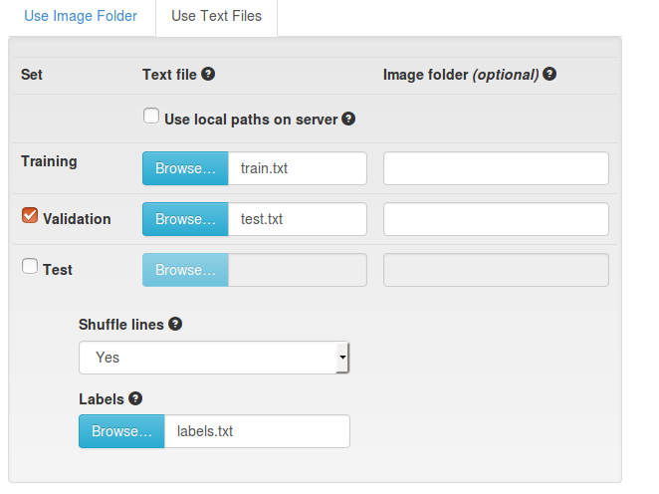
- Also used jpg for image encoding and set the “dataset Name” to “Flowers 17”
- Press Create to build the data set
Train and validate the Dataset using the Alexnet network
- Use an new (not pre-trained) set of network parameters
- In DIGITS Select Models → Images → Classification
- Select “Flowers17” as the Dataset and “Alexnet” from the standard networks list
- keep “Solver Options” defaults except:
  - reduce base learning rate from 0.01 to 0.002 (otherwise get divergence)
  - Set Batch size to 16 (otherwise got “out of memory” error)
- Choose a model name (e.g. “Flowers17 – AN”)
- press “Create” to start training
- Results:
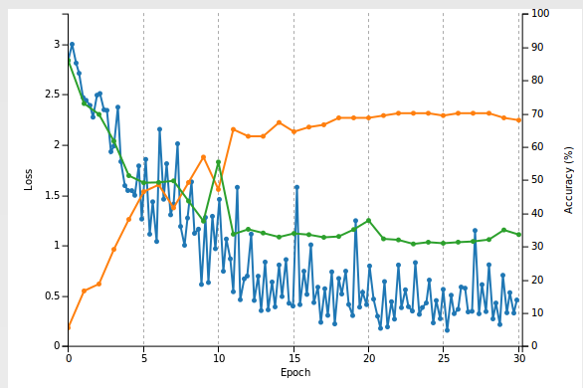
- Training took ~5 minutes with a final accuracy of ~ 70 %
- Start with a set of pre-trained network parameters
- Follow the image classification procedure as before but in this case press “customize” after selecting Alexnet from the standard networks list
- In the “pre-trained model” entry field enter the full path to a previously down-loaded set of network parameters
  - e.g. from the downloaded file described in Topc 1 above /home/dean/models/bvlc_alexnet/bvlc_alexnet.caffemodel
- In the “Custom network” text window change all instances of “fc8” to “fc9” (should be 5 of them)
  - Not sure what this does ? (just blindly followed directions in the reference)
- Reduce the “Base Learning rate” to 0.001
- Choose a Model name (e.g. Flowers17- AN – Pretrained)
- Press “Create”
- Results:
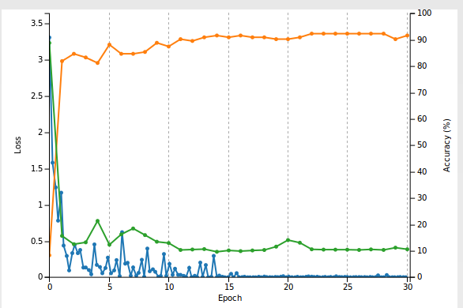
- Conclusions:
  - Network converged on solution much faster than when using untrained parameters
  - All training images were correctly identified (with >98% probability)
  - For test data final accuracy was 92 % (vs. 68%)
  - Reference video said something about it “being beyond the scope of this tutorial” as to why a trained network trained on a totally different set of images performed much better when used as a starting point for a new set of image classifiers
    - need to look into this further

Object Detection (Identify objects in an image and draw bounding boxes around them)

Fast R-CNN: Fast Region-based Convolutional Networks for object detection
Created by Ross Girshick at Microsoft Research, Redmond.
- Goals
- Run the stock demo
- Modify the demo software so that it will identify a different object in an image other than the categories provided
- References
  - https://github.com/rbgirshick/fast-rcnn (primary reference)
  - http://arxiv.org/pdf/1504.08083v2.pdf (Original research paper by Ross Girshick)
  - https://indico.cern.ch/event/395374/session/8/contribution/22/attachments/1186808/1721069/Getting_started_with_caffe_v2.pdf (page 17)
  - https://suryatejacheedella.wordpress.com/2015/03/22/install-caffe-on-ubuntu-14-04/ (details on how to set up Python in Caffe)
- Obtain the fast-rcnn source code
- $ cd
- $ git clone --recursive https://github.com/rbgirshick/fast-rcnn.git
  - Creates a directory called fast-rcnn in $HOME
  - In ~/.bashrc create an export to this directory
    - export FRCN_ROOT=$HOME/fast-rcnn
- get pre-computed Fast R-CNN models
  - $ ./data/scripts/fetch_fast_rcnn_models.sh
  - note: this requires about 1GB of storage and took a couple of hours since the server doesn't have very high bandwidth for downloads
- Build the Python modules
- cd $FRCN_ROOT/lib
- $ make
- Build a local (special) version of caffe in ~/fast-rcnn/caffe-fast-rcnn
- In Makefile.config uncomment: WITH_PYTHON_LAYER := 1
- $ make -j8 && make pycaffe
  - Apparently, you can't use a standard caffe build because fast-rcnn has added a couple of new layers (roi_pooling_layer etc.)
- Build Problems
- Could not run the demo because of various Python “import” errors (_caffe, google.protobuf,cv2)
  - Tried various combinations of setting for PYTHONPATH and PYTHON_INCLUDE environment variables but to no avail
  - Fix was to add the following to $FRCN_ROOT/lib/test.py and $FRCN_ROOT/lib/fast_rcnn/config.py
import sys
sys.path.append('/usr/local/lib/python2.7/dist-packages/')
- Stock Demo Output (monitor, sofa,cars)
- Run the demo
  - $ cd ~/fast-rcnn
  - tools/demo.py
Loaded network /home/dean/fast-rcnn/data/fast_rcnn_models/vgg16_fast_rcnn_iter_40000.caffemodel
~~~~~~~~~~~~~~~~~~~~~~~~~~~~~~~~~~~
Demo for data/demo/000004.jpg
Detection took 0.572s for 2888 object proposals
All car detections with p(car | box) >= 0.6

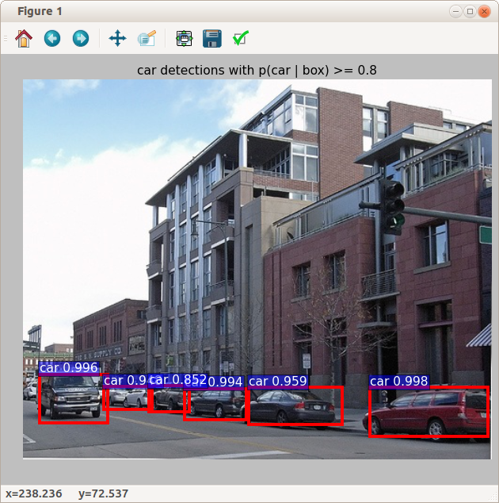
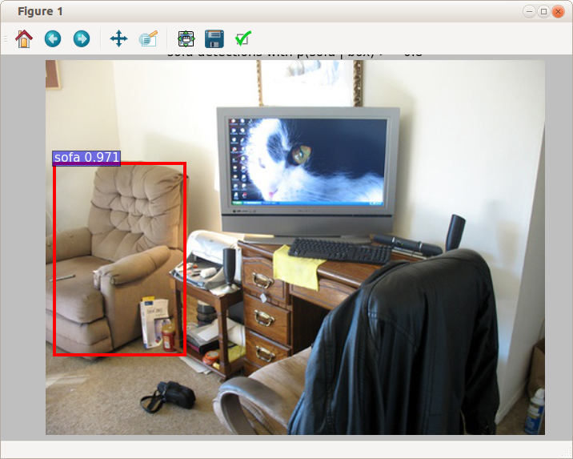
- Goal 2: Add a dog to the stock room image containing the sofa and tvmonitor
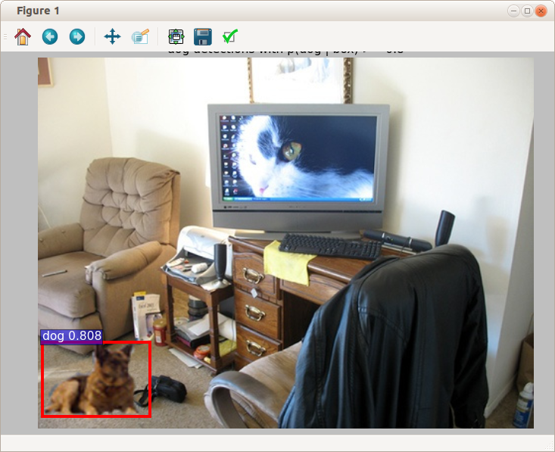
- Comment: needed to create an “image.mat” file by cloning the one associated with the “cars” image (000004). Using the mat file for the sofa/tvmonitor image didn't work (dog not found)

DIGITS with fast-rcnn support ?
It would be nice to be able to use the web-based UI in DIGITS to train and test networks from fast-rcnn. Unfortunately, this isn't directly possible because the caffe component of those two github projects have diverged from each other (and both are also different from the latest BVLC caffe version). An attempt to obtain a common code base that would allow fast-rcnn models to imported into DIGITS is briefly described in this section
Component versions (as of 9/1/2016)
- BVLC caffe (rc3,master)
- git clone https://github.com/BVLC/caffe
- py-faster-rcnn
- git clone https://github.com/rbgirshick/py-faster-rcnn
- note: incompatible with latest BVLC caffe and cuDNN
- NVIDIA-caffe (0.15)
- git clone https://github.com/NVIDIA/caffe NVIDIA-caffe
- note: incompatible with py-faster-rcnn
- DIGITS (4.0)
- git clone https://github.com/NVIDIA/DIGITS
- cuDNN (5.1)
- download from NVIDIA developer site
- CUDA SDK (7.5)
- download from NVIDIA developer site
Merge Strategy
- Create initial directory for caffe merge (caffe-fast-rcnn)
- Start with py-faster-rcnn
  - git clone git clone https://github.com/rbgirshick/caffe-fast-rcnn/tree/4115385deb3b907fcd428ac0ab53b694d741a3c4~/caffe-fast-rcnn
- Merge in latest version of BVLC caffe
  - cd caffe-fast-rcnn
  - Then follow the procedure described in section py-faster-rcnn (7) above
- Since I already did all this when fixing the compatibility issues with py-faster-rcnn described previously I just did the following:
  - git clone ~/py-faster-rcnn/caffe-fast-rcnn ~/caffe-fast-rcnn
  - downside to this is that I can only pull in changes from my local git repo
- note: this caffe is now compatible with py-faster-rcnn, CUDA SDK-7.5 and cuDNN-5.1
- Merge in code from NVIDIA-caffe (0.15)
- Add NVIDIA-caffe as a new remote repo
  - Again to save time used the local repo already present in ~/NVIDIA-caffe
  - git remote add nvidia-caffe ../NVIDIA-caffe
  - git fetch nvidia-caffe
- Try a merge
  - git merge remotes/nvidia-caffe
  - most files merged ok but got conflicts in ~10 or so
- Try to fix merge conflicts
  - git mergetool (configured for kdiff3)
  - In kdiff3 choose remote file (NVIDIA-caffe) for most (should be all?) conflicts
    - save and quit kdiff3 after each file is merged (git will then reopen kdiff3 with the next file that has conflicts)
- Attempt a caffe build
  - make -j8 -k
    - -k=keep going
  - got only 1 build error:
...
CXX src/caffe/layer_factory.cpp
NVCC src/caffe/solvers/adagrad_solver.cu
src/caffe/layers/cudnn_relu_layer.cpp: In member function ‘virtual void caffe::CuDNNReLULayer<Dtype>::LayerSetUp(const std::vector<caffe::Blob<Dtype>*>&, const std::vector<caffe::Blob<Dtype>*>&)’:
src/caffe/layers/cudnn_relu_layer.cpp:15:3: error: ‘createActivationDescriptor’ is not a member of ‘caffe::cudnn’
cudnn::createActivationDescriptor<Dtype>(&activ_desc_, CUDNN_ACTIVATION_RELU);
  - fix was to just comment out the offending line (15)
    - //cudnn::createActivationDescriptor<Dtype>(&activ_desc_, CUDNN_ACTIVATION_RELU);
    - since there was another similar line immediately below in the file the problem was probably caused by a bad git merge attempt (it happens!)
  - $ make -j8
    - build now completes
- Attempt a pycaffe build
  - make pycaffe
CXX/LD -o python/caffe/_caffe.so python/caffe/_caffe.cpp
python/caffe/_caffe.cpp: In instantiation of ‘void caffe::Solver_add_callback
error: invalid new-expression of abstract class type ‘caffe::PythonCallback<float>’
...
  - looks like I kept the wrong version in the kdiff3 merge (try fetching the file from the NVIDIA repo)
    - git checkout remotes/nvidia-caffe – python/caffe/_caffe.cpp
  - $ make pycaffe
    - build now completes
- Attempt to run DIGITS using this version caffe
  - Using a text editor, changed “caffe_root” in ~/DIGITS/digits/digits.cfg to:
    - caffe_root = /home/dean/caffe-fast-rcnn
    - could have also used python -m digits.config.edit -v from ~/DIGITS
  - $ ~/DIGITS/digits-server -b localhost:5000
Error: 'gunicorn_config.py' doesn't exist
  - gunicorn_config.py (and other python files) are in ~/DIGITS and need to be copied over to the python directory in caffe-fast-rcnn
- Add in directories and files from DIGITS
  - cd ~/DIGITS
  - cp -R *.py tools digits ~/caffe-fast-rcnn/python
  - Q: could I have avoided having to do this this by modifying PYHONPATH to include DIGITS directories and files?
- Try another DIGITS launch
  - ~/DIGITS/digits-server -b localhost:5000
2016-09-02 08:28:56 [21429] [INFO] Starting gunicorn 17.5
…
File "/home/dean/caffe-fast-rcnn/python/caffe/__init__.py", line 2, in <module>
from ._caffe import set_mode_cpu, set_mode_gpu, than last set_device, Layer, get_solver, layer_type_list, set_random_seed
ImportError: cannot import name set_random_seed
  - Fix (?) was to remove ”,set_random_seed” from line 2 of __init__.py
    - will probably be a problem if some check box in DIGITS requires this and will need to figure out later where “set_random_seed” is supported in the code.
  - ~/DIGITS/digits-server -b localhost:5000
    - DIGITS now comes up and seems to work for basic functionality but will need to do more testing to see how well it supports fast-rcnn (or if anything in the normal UI is now broken)
Results
- Can import a fast-rcnn network into DIGITS and use “visualize” to get a flow diagram
- Can still train or test previous DIGITS networks
- But get errors when trying to train even similar models and datasets using fast-rcnn networks

Faster R-CNN
According to recent comments in reference 1 by the author the active code base for “fast r-cnn” has been moved to a new github site (py-faster-rcnn) and the original site is now only maintained for “historical reasons”
Obtain source and build
- References
- https://github.com/rbgirshick/py-faster-rcnn
- Obtain source code
- git clone --recursive https://github.com/rbgirshick/py-faster-rcnn.git
- export FRCN_ROOT=$HOME/py-faster-rcnn
- Build Cython modules
- cd $FRCN_ROOT/lib
- make
- Obtain pre-trained network
- cd $FRCN_ROOT
- ./data/scripts/fetch_faster_rcnn_models.sh
- build the “special” caffe version (following instructions from reference)
- cd caffe-fast-rcnn
- cp Makefile.config.example Makefile.config
- edit Makefile.config
  - uncomment USE_CUDNN := 1, WITH_PYTHON_LAYER := 1
- make
  - Got multiple errors (function prototype mismatches etc.)
- Try to fix build problems and build again
It looks like the code base is incompatible with CUDA 7.5, cuDNN 5.1 (or both)
- needed to obtain an older version of cuDNN (3.0) from the NVIDIA archive and copy the libraries and include files from it to a older CUDA SDK installation directory (in /usr/local/cuda-6.5)
- Additionally, modified Makefile.config as follows:
  - CUDA_DIR := /usr/local/cuda-6.5
  - CUSTOM_CXX := /usr/bin/g++-4.8
    - when using g++4.9 got errors about incompatibility with g++ 4.9 or later
- rebuild
  - make -j8 (now completes)
  - make pycaffe
run the demo
- tools/demo.py
  - get dynamic library link errors
  - export LD_LIBRARY_PATH=/usr/local/cuda-6.5/lib64
  - tools/demo.py
    - demo now runs
~~~~~~~~~~~~~~~~~~~~~~~~~~~~~~~~~~~
Demo for data/demo/000456.jpg
Detection took 0.171s for 300 object proposals
~~~~~~~~~~~~~~~~~~~~~~~~~~~~~~~~~~~
...
- Found a hint on the following website: https://github.com/rbgirshick/py-faster-rcnn/issues/237 that first merges in changes from the upstream caffe website (which is compatible with later CUDA tools)
- reverted to original Makefile.config
  - cp Makefile.config.example Makefile.config
  - uncomment USE_CUDNN := 1, WITH_PYTHON_LAYER := 1
  - uncomment OPENCV_VERSION := 3
    - Otherwise, got opencv linker errors at end of build
- Merge in latest code from caffe
git remote add caffe https://github.com/BVLC/caffe.git
git fetch caffe
git merge caffe/master
- Fix code problem as described in issues report cited above
Remove self_.attr("phase") = static_cast<int>(this->phase_); from include/caffe/layers/python_layer.hpp after merging.
- make pycaffe
  - Note: without this demo.py fails with :
Traceback (most recent call last):
File "tools/demo.py", line 135, in <module>
net = caffe.Net(prototxt, caffemodel, caffe.TEST)
AttributeError: can't set attribute
- build
  - make -j8; make pycaffe
  - build now finishes !
- run demo
  - cd ../
  - tools/demo.py
  - demo now runs ! (also slightly faster than before with cudnn 3.0)
Loaded network /home/dean/py-faster-rcnn/data/faster_rcnn_models/VGG16_faster_rcnn_final.caffemodel
~~~~~~~~~~~~~~~~~~~~~~~~~~~~~~~~~~~
Demo for data/demo/000456.jpg
Detection took 0.151s for 300 object proposals
~~~~~~~~~~~~~~~~~~~~~~~~~~~~~~~~~~~
…
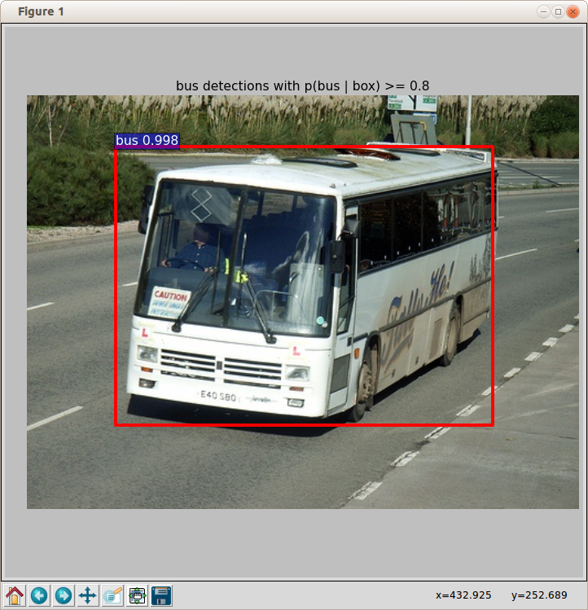
- run demo (cpu only)
  - tools/demo.py –cpu
~~~~~~~~~~~~~~~~~~~~~~~~~~~~~~~~~~~
Demo for data/demo/000456.jpg
Detection took 26.677s for 300 object proposals
~~~~~~~~~~~~~~~~~~~~~~~~~~~~~~~~~~~
  - GTX 980 provides 178x speedup over CPU
- run demo (zf net)
  - ./tools/demo.py --net zf
Loaded network /home/dean/py-faster-rcnn/data/faster_rcnn_models/ZF_faster_rcnn_final.caffemodel
~~~~~~~~~~~~~~~~~~~~~~~~~~~~~~~~~~~
Demo for data/demo/000456.jpg
Detection took 0.071s for 300 object proposals
~~~~~~~~~~~~~~~~~~~~~~~~~~~~~~~~~~~
  - “zf net” 2x faster than default (vgg16)
  - some differences in objects that got detected
- Comments
  - The “faster” version seems to use fewer “object proposals” (bounding box candidates) than the original version (300 vs ~3000) which probably explains most of the speedup (0.15 vs 0.5 s typical)
  - With cudnn 5.1 get a ~13% speed improvement over cudnn 3.0 (0.151 vs 0.171 on same image)
  - Probably would still need significant improvements to be viable as a real-time target detection system on less capable hardware (e.g. Jetson TK1) but is worth exploring Possible speedup approaches:
    - analyze smaller images (320x240)
    - reduce classification set (only 1 or 2 object types)
    - use fewer object proposals (50-100 enough?)
    - limit target size range (e.g. 0.1-0.5 full image scale)

Faster-RCNN - Beyond The Demo
References:
  - https://github.com/rbgirshick/fast-rcnn
  - https://github.com/rbgirshick/py-faster-rcnn
  - http://sunshineatnoon.github.io/Train-fast-rcnn-model-on-imagenet-without-matlab/
Projects
- Use command line tools to test one of the datasets mentioned in the reference
- Create a directory to the hold test and training data
  - mkdir -p ~/data/VOCdevkit && cd VOCdevkit
- Download the VOCdevkit image data as described in reference 1
wget http://host.robots.ox.ac.uk/pascal/VOC/voc2007/VOCtrainval_06-Nov-2007.tar
wget http://host.robots.ox.ac.uk/pascal/VOC/voc2007/VOCtest_06-Nov-2007.tar
wget http://host.robots.ox.ac.uk/pascal/VOC/voc2007/VOCdevkit_08-Jun-2007.tar
- Create a soft link to the data in ~/py-faster-rcnn/data
  - cd ~/py-faster-rcnn/data
  - ln -s ~/data/VOCdevkit VOCdevkit2007
- Download the pre-computed Selective Search object proposals for VOC2007 and VOC2012
  - cd ~/py-faster-rcnn
- Test the VOC2007 data with the trained VGG16 network using the following command:
  - $ ./tools/test_net.py --gpu 0 --def models/pascal_voc/VGG16/fast_rcnn/test.prototxt --net data/faster_rcnn_models/VGG16_faster_rcnn_final.caffemodel
  - Output:
...
AP for aeroplane = 0.7477
AP for bicycle = 0.7813
AP for bird = 0.7223
…
Mean AP = 0.6804
  - Add “–vis” to the above command to see the results of testing each or the 4092 images (need to close each figure to see the next result)COCO_val2014_000000
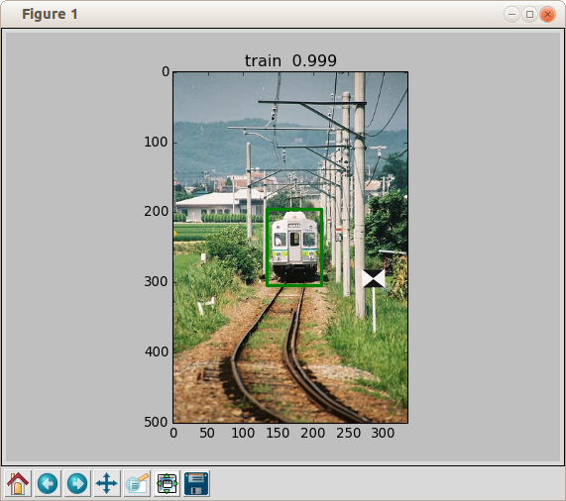
- Also tried testing using the smaller “zf” network
  - tools/test_net.py --gpu 0 --def models/pascal_voc/ZF/fast_rcnn/test.prototxt --net data/faster_rcnn_models/ZF_faster_rcnn_final.caffemodel
AP for aeroplane = 0.6495
AP for bicycle = 0.6969
AP for bird = 0.5924
...
AP for tvmonitor = 0.5693
Mean AP = 0.5874
  - ave ~3 ms/image but mean AP quite a bit worse than VGG16 (0.68)
- Train one of the referenced datasets using command syntax
- ./tools/train_net.py --gpu 0 --solver models/pascal_voc/VGG16/fast_rcnn/solver.prototxt --weights data/faster_rcnn_models/VGG16_faster_rcnn_final.caffemodel
...
I0830 19:13:15.138401 25313 solver.cpp:228] Iteration 39980, loss = 0.161604
I0830 19:13:15.138479 25313 solver.cpp:244] Train net output #0: loss_bbox = 0.0734029 (* 1 = 0.0734029 loss)
I0830 19:13:15.138496 25313 solver.cpp:244] Train net output #1: loss_cls = 0.0882007 (* 1 = 0.0882007 loss)
I0830 19:13:15.138514 25313 sgd_solver.cpp:106] Iteration 39980, lr = 0.0001
speed: 0.479s / iter
(5.3 hours to train)
- Test the newly trained model
  - ./tools/test_net.py --gpu 0 --def models/pascal_voc/VGG16/fast_rcnn/test.prototxt --net output/default/voc_2007_trainval/vgg16_fast_rcnn_iter_40000.caffemodel
AP for aeroplane = 0.6899
AP for bicycle = 0.7933
...
Mean AP = 0.6746
- Train a dataset using the faster-rcnn method (endtoend)
The original fast-rcnn requires a Matlab structure that is created from the training data using the “Selective Search” process to generate a matrix of bounding box proposals. The newer “faster” rcnn instead optimizes both the classification and bounding box assignments directly using a single (endtoend) or multiple network passes
- Download pretrained Imagenet models
  - ./data/scripts/fetch_imagenet_models.sh
- Use one of the installed scripts to train and test a model
  - ./experiments/scripts/faster_rcnn_end2end.sh 0 VGG_CNN_M_1024 pascal_voc
...
I0906 15:38:02.364949 5111 solver.cpp:228] Iteration 69980, loss = 0.535902
I0906 15:38:02.365006 5111 solver.cpp:244] Train net output #0: loss_bbox = 0.190156 (* 1 = 0.190156 loss)
I0906 15:38:02.365015 5111 solver.cpp:244] Train net output #1: loss_cls = 0.232242 (* 1 = 0.232242 loss)
I0906 15:38:02.365025 5111 solver.cpp:244] Train net output #2: rpn_cls_loss = 0.0928219 (* 1 = 0.0928219 loss)
I0906 15:38:02.365032 5111 solver.cpp:244] Train net output #3: rpn_loss_bbox = 0.0206826 (* 1 = 0.0206826 loss)
I0906 15:38:02.365041 5111 sgd_solver.cpp:106] Iteration 69980, lr = 0.0001
  - training time: 2.7 hours
  - in the script training is followed by testing
...
im_detect: 4951/4952 0.074s 0.001s
im_detect: 4952/4952 0.074s 0.001s
...
VOC07 metric? Yes
AP for aeroplane = 0.6646
AP for bicycle = 0.6842
...
AP for tvmonitor = 0.6294
Mean AP = 0.6054
- Test the newly trained model using the standard command line tools
./tools/test_net.py --gpu 0 --def models/pascal_voc/VGG_CNN_M_1024/faster_rcnn_end2end/test.prototxt --net /home/dean/py-faster-rcnn/output/faster_rcnn_end2end/voc_2007_trainval/vgg_cnn_m_1024_faster_rcnn_iter_70000.caffemodel --imdb voc_2007_test --cfg experiments/cfgs/faster_rcnn_end2end.yml --vis
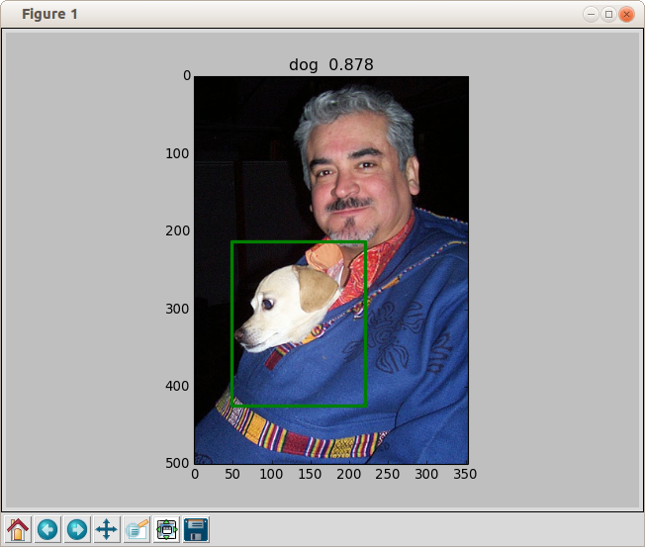

Train & test a custom dataset (INRIA-Person)
The objective is to see how well the py-faster-rcnn endtoend method works on a much smaller set of annotated images with a restricted number of classifiers as well as get an understanding of what needs to be done in general to process a custom data set
References
- https://github.com/deboc/py-faster-rcnn/blob/master/help/Readme.md
- https://github.com/zeyuanxy/fast-rcnn/blob/master/help/train/README.md
- http://sgsai.blogspot.com/2016/02/training-faster-r-cnn-on-custom-dataset.html
- https://huangying-zhan.github.io/2016/09/22/detection-faster-rcnn.html
Dataset creation (IMDB)
Will use the INRIA Person data set which contains only a single class of objects (persons) following the procedure described in reference 2 above
- Obtain the raw Image and Annotation data
- download site: http://pascal.inrialpes.fr/data/human/
- download file: INRIAPerson.tar (970MB)
- expanded file structure:
|-- INRIAPerson/
|-- 70X134H96/
|-- 96X160H96/
|-- Test/
|-- test_64x128_H96/
|-- Train/
|-- train_64x128_H96/
- untar to ~/data
  - tar -xf INRIAPerson.tar -C ~/data
- Insert the INRIAPerson data into the py-faster-rcnn data directory tree
- $ cd ~/py-faster-rcnn
  - $ mkdir -p data/INRIA_Person_devkit/data
  - $ ln -s ~/data/INRIAPerson/Train/annotations/ INRIA_Person_devkit/data/Annotations
  - $ ln -s ~/data/INRIAPerson/Train/pos/INRIA_Person_devkit/data/Images

- Resultant directory structure in ~/py-faster-rcnn/data
INRIA_Person_devkit/
|-- data/
|-- Annotations/
|-- *.txt (Annotation files)
|-- Images/
|-- *.png (Image files)

- Generate py-faster-rcnn dataset text files
- $ cd INRIA_Person_devkit/data
- $ mkdir ImageSets
- $ ls Annotations/ -m | sed s/\\s/\\n/g | sed s/.txt//g | sed s/,//g > ImageSets/train.txt
  - generates a file called “train.txt” in ImageSets that contains a list of filenames (one per line) from the files in “Annotations” after stripping off the “.txt” extension
- Final directory structure in ~/py-faster-rcnn/data
INRIA_Person_devkit/
|-- data/
|-- Annotations/
|-- *.txt (Annotation files)
|-- Images/
|-- *.png (Image files)
|-- ImageSets/
|-- train.txt
Modify the ~/py-faster-rcnn python environment
- add python files in lib/datasets for the custom dataset
- added inria.py and inria_eval.py downloaded from reference 1 github site
- add a section in lib/datasets/factory.py that adds the custom dataset to a the set list
- as per reference 1:
inria_devkit_path = '~/py-faster-rcnn/data/INRIA_Person_devkit'
for split in ['train', 'test']:
name = '{}_{}'.format('inria', split)
__sets[name] = (lambda split=split: inria(split,inria_devkit_path))
- note: may need absolute path (vs ~/py-faster-rcnn ..)
- to access dataset from other python scripts use hashname “inria_train” or “inria_test”

- Modify end2end net prototxt files
- Create a new directory called INRIAperson in ~/py-faster-rcnn/models
  - $ mkdir -p models/INRIAperson
- Copy prototxt files from pascal end2end directory
  - $ cp -R models/pascal_voc/VGG_CNN_M_1024/faster_rcnn_end2end models/INRIAperson
- Modify the prototxt files to use 2 vs 21 classes
  - Images$ cd models/INRIAperson/ faster_rcnn_end2end
  - In train.prototxt and test.prototxt change all instances of 21 to 2, and 84 to 8
- modify solver.prototxt
  - set train net: to "models/INRIA_Person/faster_rcnn_end2end/train.prototxt"
  - set snapshot_prefix: to “inria”
  - reduce learning rate to: 0.001 (since we will be starting from a pre-trained network)
Train the INRIA_Person dataset
- create a shell script for training in ~/py-faster-rcnn
- file: train_INRIA_Person.sh
LOG="experiments/logs/inria.txt.`date +'%Y-%m-%d_%H-%M-%S'`"
exec &> >(tee -a "$LOG")
echo Logging output to "$LOG"
time ./tools/train_net.py \
--gpu 0 \
--solver models/INRIA_Person/faster_rcnn_end2end/solver.prototxt \
--weights data/imagenet_models/VGG_CNN_M_1024.v2.caffemodel \
--imdb inria_train \
--iters 40000 \
--cfg experiments/cfgs/faster_rcnn_end2end.yml
- $ chmod +x train_INRIA_Person.sh
- use a py-faster-rcnn supplied pre-trained network to train initially
- e.g. set: –weights=data/imagenet_models/VGG_CNN_M_1024.v2.caffemodel
- in train.prototxt and test.prototxt change the names of the layers “cls_score” and “bbox_pred” to something else (e.g. cls_score2, box_pred2) so that the weights of those layers will not be taken from the pretrained model which has a different number of classes
- run the training script
  - $ ~/train_INRIA_Person.sh
- after the first snapshot is created stop training and use it for continued training using snapshot model
- move the snapshot from output to somewhere else
  - $ mv output/faster_rcnn_end2end/train/inria_iter_10000.caffemodel output
- In the train script now set: --weights=output/inria_iter_10000.caffemodel
- restore the original names of “cls_score” and “bbox_pred”
  - so we can use the standard testing scripts
    - culprit is /fast-rcnn/test.py (fetches blobs by fixed names)
- re-run the training script
  - note: layers cls_score and bbox_pred will again be different so they will again be retrained
- allow training to complete (e.g. after 40000 iterations)
- save the last generated snapshot for testing
  - $ mv output/faster_rcnn_end2end/train/inria_iter_40000.caffemodel output
  - note: the final .caffemode was trained using the expected layer names for the faster-rcnn end2end network and so can be used with the standard scripts for testing
Test the model
- create a shell script for testing in ~/py-faster-rcnn
- test_INRIA_Person.sh
time ./tools/test_net.py \
--gpu 0 \
--imdb inria_train \
--def models/INRIA_Person/faster_rcnn_end2end/test.prototxt \
--net output/faster_rcnn_end2end/train/inria_iter_40000.caffemodel \
--cfg experiments/cfgs/faster_rcnn_end2end.yml \
--vis
- chmod +x test_INRIA_Person.sh
- run the test script
- ~/test_INRIA_Person.sh
- example results (with –vis)
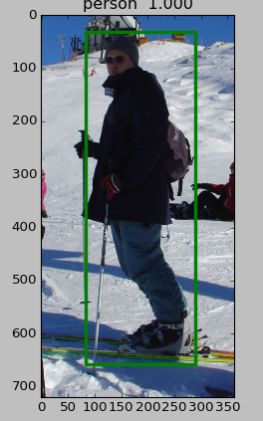
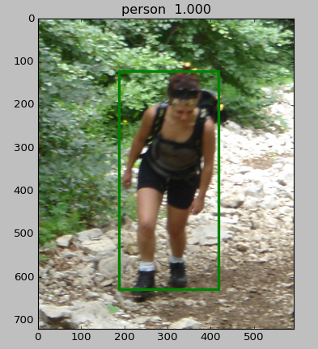
- without –vis
  - mean AP=0.994
    - note though that testing was done on the training data
  - 600 images processed in ~/0.08 sec per image

Plot the training log (from faster r-cnn end2end caffe output)
wrote a python script to a parse a training log file and save data into a csv file or plot data directly (with or without cvs save)
sample plot
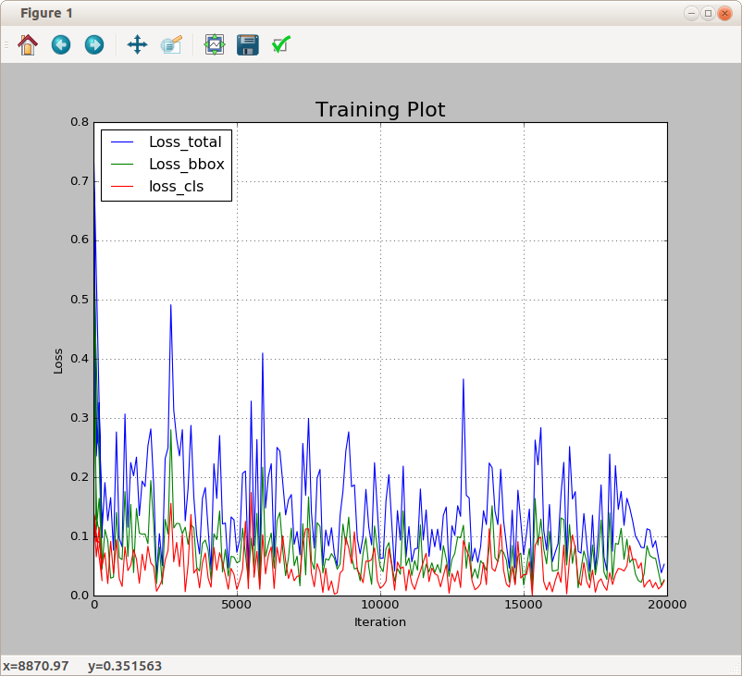

Modify test output to combine all boxes and classes into a single image
Modified py-faster-rcnn/tools/test.py
- added a new function called “plot_all”
- removed function calls to vis_detections
- added calls to plot_all in test.py “test_net” and (new) “test_one” functions
sample output:
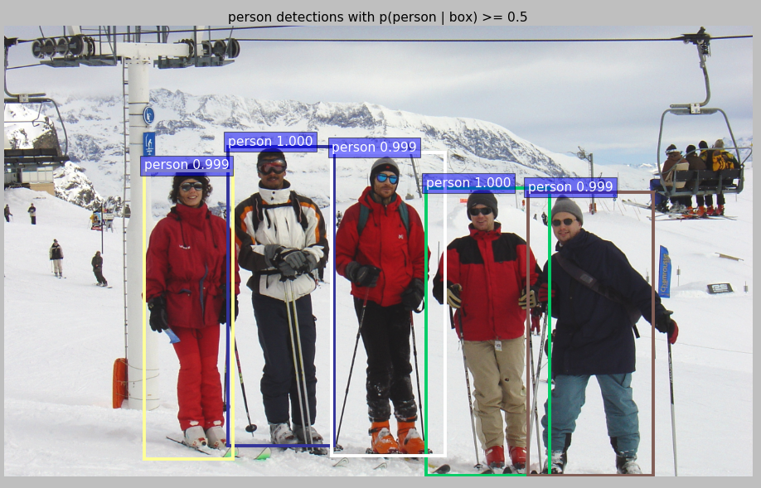

Process the images from the INRIA Test directory
- Redo the INRIA dataset creation procedure to include both test and train images
  - Remove the “Annotations” and “Images” soft links in INRIA_Person_devkit
  - make hard directories instead
    - mkdir Annotations Images
  - Copy or move all INRIAPerson annotation files into Annotations
    - $ cp ~/data/INRIAPerson/Train/annotations/*.txt ~/py-faster-rcnn/data/INRIA_Person_devkit/data/Annotations
    - cp ~/data/INRIAPerson/Test/annotations/*.txt ~/py-faster-rcnn/data/INRIA_Person_devkit/data/Annotations
  - Copy or move all INRIAPerson image files into Images
    - $ cp ~/data/INRIAPerson/Train/pos/*.png ~/py-faster-rcnn/data/INRIA_Person_devkit/data/Images
    - $ cp ~/data/INRIAPerson/Test/pos/*.png ~/py-faster-rcnn/data/INRIA_Person_devkit/data/Images
  - Create a test.txt file in ImageSets
    - $ cd ~/data/INRIAPerson/Test
    - ls annotations/ -m | sed s/\\s/\\n/g | sed s/.txt//g | sed s/,//g > ~/py-faster-rcnn/data/INRIA_Person_devkit/data/ImagesSets/test.txt
- modify the test_INRIA_Person.sh script
  - change --imdb inria_train to --imdb inria_test
- remove annots.pkl from ~/py-faster-rcnn/data/INRIA_Person_devkit/annotations_cache
  - otherwise will get failure without --vis
- re-run test_INRIA_Person.sh script
  - $ ./test_INRIA_Person.sh
- results
  - with –vis: similar to before but with a different set of images (from Test)
  - without –vis: Mean AP = 0.9005
    - as expected, accuracy is lower than that seen when testing the training images (0.994)
  - results for all images logged into ~/py-faster-rcnn/data/INRIA_Person_devkit/results

Modify INRIA test to work with ZF (end2end) network (vs VGG16)
- followed similar training procedure as before
  - added ZF directory to models/INRIA
    - copied prototxt files from models/pascal_voc/ZF/faster_rcnn_end2end
  - modifed train and test prototxt files
    - 2 classes vs 21
    - change name of bbox_pred and cls_score
  - trained initially using INRIA dataset and supplied ZF_faster_rcnn_final.caffemodel
  - stopped training after first snapshot (INRIA_ZF_1000.caffemodel)
  - restored original names in test and train prototxt files
  - continued training using INRIA_ZF_1000.caffemodel (to 20000 iterations)
- tested INRIA test dataset using trained ZF model
- results
  - similar to VGG16 in accuracy (0.8-0.9)
  - no appreciable speedup seen (still ~0.08 s per image)

Train and Test Faster R-CNN on 2-class “Tote-Ball” data set
Will use a set of images obtained from a Gazebo simulation of “totes” in the 2016 “FRC” competition field
Data files
- see the document “ImageProcessing.odt” in the Software/Docs subdirectory of the Team 159's github site: https://github.com/FRCTeam159/MentorRepository for details on how this data was collected
  - very small training data set (only 16 annotated images)
  - small images (320x240)
- File organization of the py-faster-cnn/data directory
TOTE_devkit/
|-- data/
|-- Annotations/
|-- *.xml (Annotation files)
|-- Images/
|-- *.jpg (Image files)
| ImageSets
train.txt

Python files
- py-faster-rcnn/lib/datasets/tote_eval.py
  - The annotation files generated for the simulation dataset are xml based and similar to those used in the pascal_voc test
  - voc_eval parses an xml based annotation file
    - extracts bounding boxes and other attributes (e.g. class name)
  - inria_eval parses a custom text file format with entries like:
    - parser only captures coordinates of bounding boxes (e.g. 262,109,512,705)
- py-faster-rcnn/lib/datasets/ttote.py
  - similar to inria.py except for the annotation file parser section
Training
- used Inria prototxt files and training scripts with modifications to access the TOTE_devkit data files
- Trained to 10000 iterations (accuracy ~1.0)
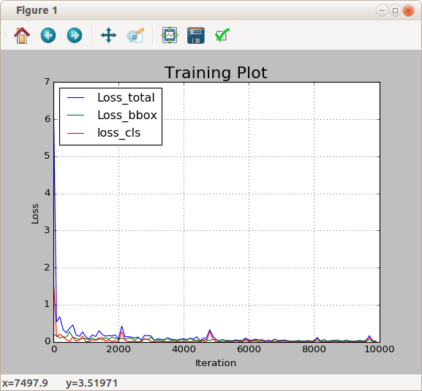

Test
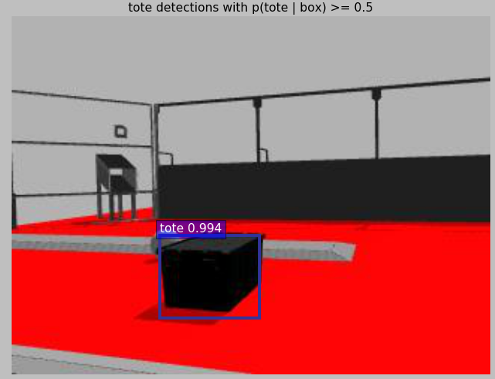

Notes
- ran into many difficulties when accidentally included a few training examples that had a different detection object (ball vs tote)
- faster-rcnn always scales images so that the smallest dimension is 600 pixels so no big advantage is seen in test and rain times when smaller images are used
- Train and Test a user generated data set with two classes
Followed a similar procedure as in the previous test with the following differences
- copied tote.py in lib/datasets to a new python file balltote.py that expected expect 2 classes
- modified model train.prototxt and test.Prototxt for 3 object classes
  - num_classes=2->3, 8->12
- changed cls_score and bbox_pred names to cause retraining of those layers
  - started training from last snapshot (.caffefmodel) of TOTE training
  - stopped training after 5000 iterations
- restored original names for cls_score and bbox_pred
  - restarted training using .caffemodel snapshot generated in the previous step
  - finished training after 10000 iterations
- copied final snapshot to faster-rcnn_models/BALLTOTE_ZF_final.caffemodel for use in testing
Test results (2 classes)
AP for tote = 1.0000
AP for ball = 0.9615
Mean AP = 0.9808
sample images
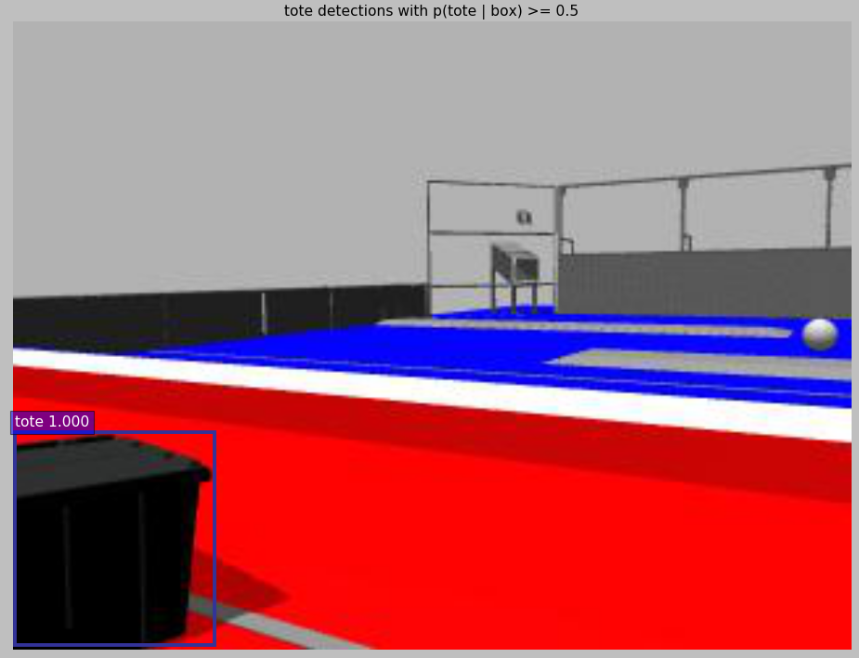
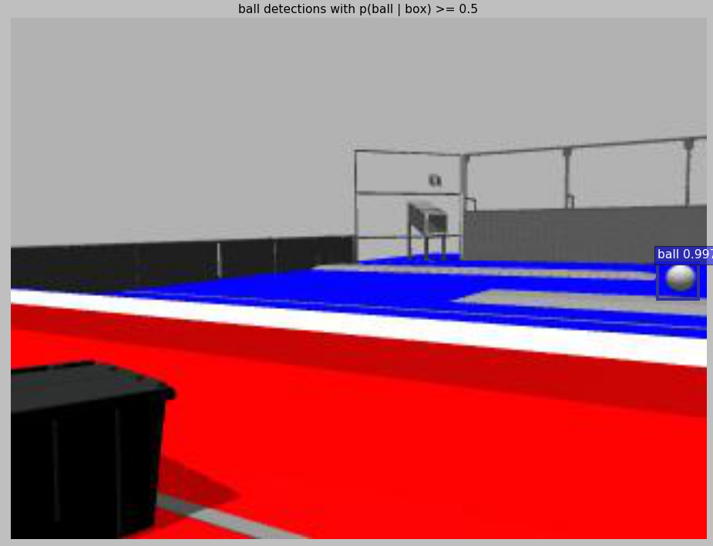

Object detection using YOLO (You Only Look Once) (darknet)
An open-source “c” based neural network object detection method
main developers :Joseph Redmon, Ali Farhadi
Features
- Has a fully contained code base to develop neural networks
- doesn't require 3rd party frameworks like Torch or Caffe
- could be compiled natively on an ARM co-processor ?
- Could be much faster than other methods such as faster-rcnn
- up to 200 FPS on good single GPU hardware
- demo video shows realtime performance on Jetson TX1
- the main Yolo application (darknet) can be extended beyond object-detection
- a demo is provided to play “Go” at the DAN-1 level
- another called “nightmare” adds interesting distortions to images
References
- home page: https://pjreddie.com/darknet/yolo/
- papers
- https://arxiv.org/pdf/1506.02640.pdf
- https://arxiv.org/pdf/1612.08242.pdf
- adaptation to custom data sets: http://guanghan.info/blog/en/my-works/train-yolo/
Installation
- git clone https://github.com/pjreddie/darknet.git
- wget https://pjreddie.com/media/files/yolo.weights
- wget https://pjreddie.com/media/files/tiny-yolo-voc.weights
Build
- Makefile Options:
- GPU=1
- CUDNN=1
- OPENCV=1
- Build
make -j6
  - with GPU=0
- no errors
  - with OPENCV=1
- error: link error (-lippicv not found)
- fix: download and install libippicv from 3rd party
  - with CUDNN=1
  - error: insufficient number or argument in cudnnSetConvolution2dDescriptor
  - fix: add CUDNN_DATA_FLOAT as addition last argument on line 133 of darknet/src/convolutional_layer.c
    - cudnnSetConvolution2dDescriptor(l->convDesc, l->pad, l->pad, l->stride, l->stride, 1, 1, CUDNN_CROSS_CORRELATION,CUDNN_DATA_FLOAT);

Demo Tests

Performance
darknet detect cfg/yolo.cfg yolo.weights data/dog.jpg or darknet detect cfg/yolo.cfg yolo.weights data/person.jpg
  - with GPU=0
- data/dog.jpg: Predicted in 10.941975 seconds
- to see result run : $ eog predictions.png
  - with GPU=1
- data/person.jpg: Predicted in 0.244977 seconds.
  - With OPENCV=1
- data/person.jpg: Predicted in 0.257358 seconds
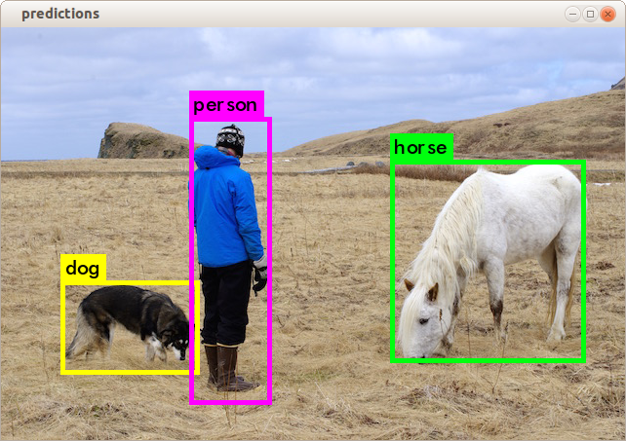
- now figure pops up automatically
  - with CUDNN=1
- data/person.jpg: Predicted in 0.019908 seconds
  - Using “tiny” version (all make options enabled)
- darknet detector test cfg/voc.data cfg/tiny-yolo-voc.cfg tiny-yolo-voc.weights /home/dean/data/voc-data/small/train/images/2007_000256.jpg
- aeroplane: 76% in 0.006783 seconds (150 FPS)
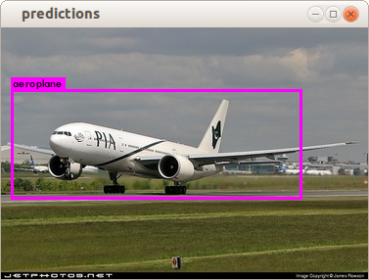

Plot the Training Log
wrote a python script (scripts/plot_log.py) to parse and plot a training log file
- parses output from region_layer.c and detector.c
sample plot
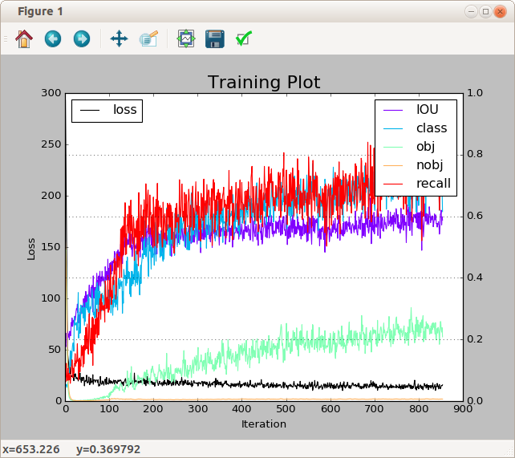
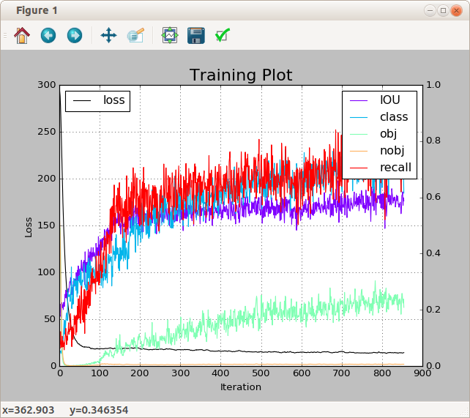

Train YOLO on Pascal VOC data
Setup
following instructions in reference 1
- Obtain VOC data
- Instructions are given for downloading VOV 2007 and 2012 Image and annotation files
- Will just use 2007 data already present in ~/data/VOCdevkit
  - in darknet director create a soft link to ~/data/VOCdevkit
  - ln -s ~/data/VOCdevkit VOCdevkit
- Modify the labels to YOLO format
- copy voc_label.py from scripts to darknet root directory
- remove 2012 references in file (keep refs to 2017)
- run the script
  - chmod +x voc_label.py
  - $ python voc_label.py
    - generates: 2007_train.txt, 2007_val.txt and 2007_test.x
    - also creates a labels directory with (YOLO style) text files in VOCdevkit/2007/labels
- A more general way to create a list containing absolute paths to a set of images
  - e.g. with images (.jpg or .JPEG) in a directory called “images” run:
  - $ find `pwd`/images -name \*.jpg -o -name \*.JPEG > train.list
- modify files in cfg directory
- need to create a new cfg for training based on yolo-voc.2.0.cfg (originally configured for testing)
- save yolo-voc.2.0.cfg as yolo-voc.2.0.test.cfg
- change batch from 1 to 64
  - batch=32 seems to run longer without crashing the os
    - note: but still got crash after 10000 itrs
- change subdivisions from 1 to 8 or 16
  - must be multiplier of batch
  - larger values require less gpu memory (and may reduce crashes)
- change steps to: 100,1000,5000
  - with “scales” specifies regime where learning rate muliplier is applied to previous value
- change scales to: scales=1,0.1,0.1
  - learning rate schedule (with steps)
- change learning_rate to 0.001
  - initial learning rate
- change max_batches to 10000
- save file as yolo-voc.2.0.train.cfg
- train
- get pretrained voc weights
  - download darknet19_448.conv.23 from YOLO site
- run a training script
  - $ ./darknet detector train cfg/voc.data cfg/yolo-voc.2.0.train.cfg darknet19_448.conv.23
- during training got occasional failure which freezes Ubuntu (can't even ping remotely)
  - can sometimes recover by pressing power button lightly
  - but usually need to reboot
- can resume training by replacing darknet19_448.conv.23 with a snapshot in outputs directory (assuming a new one has been generated)
  - by default snapshots are created every 100 iterations up to 1000 then, every 1000 (saved as yolo-voc.backup)
  - snapshots “remember” the last iteration that was reached so will continue with learning rate schedule as defined in cfg file
- tests
- test a single image
  - $ darknet detector test cfg/voc.data ${CFG} ${WEIGHTS} ${IMAGE}
    - where: CFG=cfg/yolo-voc.2.0.test.cfg
    - WEIGHTS = output/yolo-voc.backup (or last snapshot)
    - image=data/dog.jpg
- validate a set of test images (using detector function)
  - fix path in validate_detector_recall in dectector.c to point the the list of names extracted from test dataset (e.g. 2007_test.txt generated as part of the voc demo)
    - original path is hard-coded to “data/voc.2007.test)
      - could also use a soft link to map 2007_test.txt to data/ voc.2007.test
    - function assumes a “labels” director containing single line extracted bounding data alongside a directory containing jpg images (e.g. JPGImages directory as in VOC devkit)
  - run a darknet detector command
    - $ darknet detector recall cfg/voc.data cfg/yolo-voc.2.0.test.cfg weights/yolo-voc_final.weights
  - sample output:
...
10 23 28 RPs/Img: 111.55 IOU: 62.17% Recall:82.14%
11 24 29 RPs/Img: 107.42 IOU: 62.37% Recall:82.76%
12 26 31 RPs/Img: 103.92 IOU: 63.39% Recall:83.87%
...
  - first 3 numbers are: image id, good boxes so far (boxes with overlap>thresh), total boxes tested
  - Rps/Img may be the average number of region proposals tested per image so far (?)
  - “IOU” is “intersection over union” which is a measure of bounding box fitting accuracy
  - “Recall” is related to “mAP” (mean average precision) metric that is usually given
  - output comes from validate_detector_recall in detector.c

Train/validate VOC data using “tiny” YOLO network
- Run a training command:
- darknet detector train cfg/voc.data cfg/tiny-yolo-voc.cfg weights/tiny-yolo-voc.weights
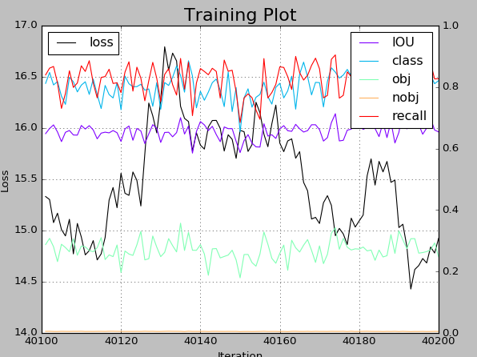
- stopped training after verifying that weight were correct (no real improvement observed)

- validate
- darknet detector recall cfg/voc.data cfg/tiny-yolo-voc.cfg weights/tiny-yolo-voc.weights
...
10 22 28 RPs/Img: 97.91 IOU: 63.88% Recall:78.57%
11 23 29 RPs/Img: 92.08 IOU: 64.33% Recall:79.31%
12 25 31 RPs/Img: 88.38 IOU: 65.49% Recall:80.65%
13 30 41 RPs/Img: 90.64 IOU: 63.55% Recall:73.17%

Run a video through YOLO
- References:
- https://github.com/pjreddie/darknet/wiki/YOLO:-Real-Time-Object-Detection
- https://github.com/Guanghan/darknet (darknet fork for “yield” and “stop” signs)
- get a u-tube video for demo
- On Ubuntu first needed to install “DownloadHelper” plugin for Firefox and converter libs
  - http://www.downloadhelper.net/welcome.php?version=6.3.1
  - http://www.downloadhelper.net/install-converter3.php
- A short video with 2 cars:
  - https://github.com/udacity/CarND-Vehicle-Detection/blob/master/test_video.mp4
  - download directly or copy url to browser
  - in Firefox when video is showing select download helper icon and choose convert to mp4
    - video saved as test_video.mp4
- run demo
- $ darknet yolo demo -thresh 0.3 cfg/yolo-voc.2.0.cfg weights/yolo-voc_final.weights data/test_video.mp4
- note: “yolo demo” is hard-coded to work only with the voc object classes (person, cars etc.) need to use the more flexible “detector demo” for other datasets
- results
- 10 FPS
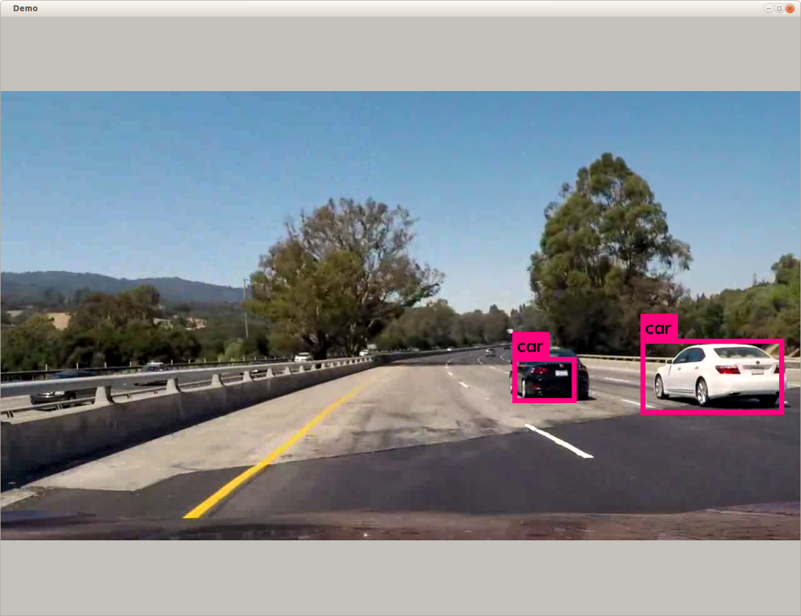
- Notes
- smaller fps than expected
  - didn't see a change in FPS when using tiny-yolo
  - frame rate set in VideoCapture (from file)was 30

Train YOLO on a custom 2 class dataset
Will use “signs” data from reference 1 but will train using YOLO v2 (ref 2)
- References
  - https://github.com/Guanghan/darknet (darknet fork for “yield” and “stop” signs)
  - https://pjreddie.com/darknet/yolo/
- Setup Notes
- to convert yolo.cfg to a different number of classes ,need to modify last “convolution” layer and “region” layer at bottom of file
- filters = (classes + coords + 1)*num
  - from region params
[convolutional]
size=1
stride=1
pad=1
filters=425
activation=linear

[region]
anchors = 0.57273, 0.677385, 1.87446, 2.06253, 3.33843, 5.47434, 7.88282, 3.52778, 9.77052, 9.16828
bias_match=1
classes=80
coords=4
num=5
softmax=1
jitter=.3
rescore=1

- filters for classes:
  - 80 425
  - 20 125
  - 2 35
- other cfg changes (from yolo.cfg)
  - changed height and width from 416 to 448
  - changed decay from 0.005 to 0.001
- Training Notes
- Set up data folders and image lists as described in reference 2
  - downloaded images and labels data from reference
  - needed to remove some images (stopsign_xxx.jpg) that had no corresponding labels
- first tried training from scratch (no weights) but even though got good results for IOU, recall and class the following properties were worse than expected:
  - both Obj and No Obj started out with values of at least a few per-cent but ended up around 0.
  - Loss never got smaller than ~10
  - validate using weights from training returned very low predictions (1-2%)
  - for single image tests, In order to see any boxes at all needed to set threshold very low (<~0.01) and the match with the target objects even in that case was very poor
- Retrained using weights from darknet19_448.conv.23
  - training now curve looked much more promising:
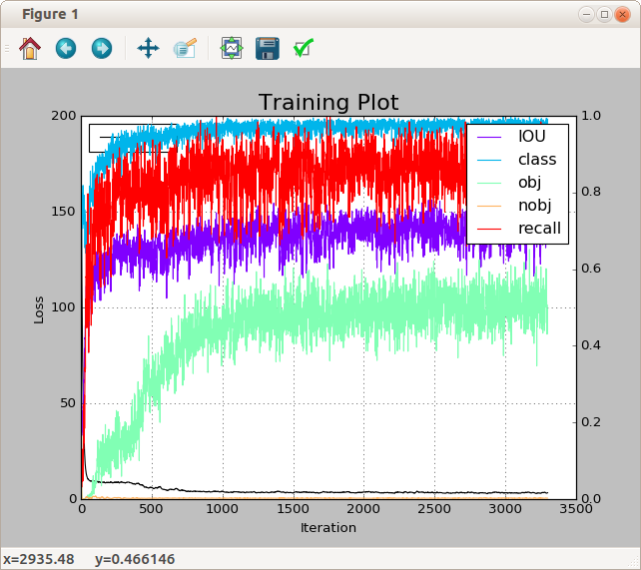
  - Loss ended up at 3.322325 after 3299 iterations (211136 images) but training was interrupted after a system crash (see above)
  - Test on a single image(stopsign_00001.jpg) now good (stopsign: 81%)
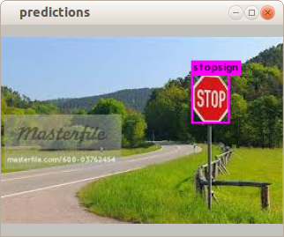
- Test on demo video
  - darknet detector demo data/signs.data cfg/yolo-2class.cfg $weights/yolo-2class.3000.weights videos/yieldsigns1.mp4
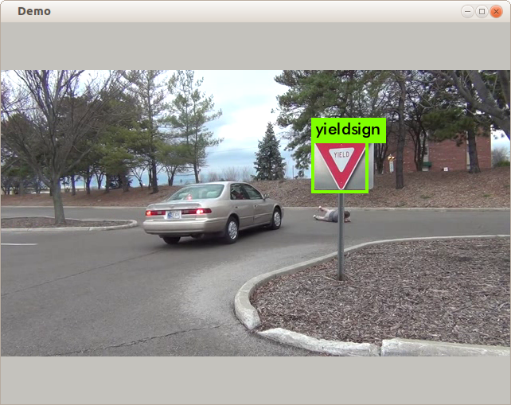
  - ~20 FPS (yieldsign 77%)

Train 2-class dataset on “Tiny” YOLO
- Clone a 2-class cfg file from yolo-tiny.cfg
- structure of last 2 layers is similar to standard yolo.cfg
- changed classes=2 in region layer and filter=35 in convolution layer
- use “darknet partial” to clone a set of staring weights
- $ darknet statistics cfg/tiny-yolo.cfg
yolo-tiny.cfg
layer filters size input output
0 conv 16 3 x 3 / 1 416 x 416 x 3 -> 416 x 416 x 16
1 max 2 x 2 / 2 416 x 416 x 16 -> 208 x 208 x 16
2 conv 32 3 x 3 / 1 208 x 208 x 16 -> 208 x 208 x 32
3 max 2 x 2 / 2 208 x 208 x 32 -> 104 x 104 x 32
4 conv 64 3 x 3 / 1 104 x 104 x 32 -> 104 x 104 x 64
5 max 2 x 2 / 2 104 x 104 x 64 -> 52 x 52 x 64
6 conv 128 3 x 3 / 1 52 x 52 x 64 -> 52 x 52 x 128
7 max 2 x 2 / 2 52 x 52 x 128 -> 26 x 26 x 128
8 conv 256 3 x 3 / 1 26 x 26 x 128 -> 26 x 26 x 256
9 max 2 x 2 / 2 26 x 26 x 256 -> 13 x 13 x 256
10 conv 512 3 x 3 / 1 13 x 13 x 256 -> 13 x 13 x 512
11 max 2 x 2 / 1 13 x 13 x 512 -> 13 x 13 x 512
12 conv 1024 3 x 3 / 1 13 x 13 x 512 -> 13 x 13 x1024
13 conv 1024 3 x 3 / 1 13 x 13 x1024 -> 13 x 13 x1024
14 conv 125 1 x 1 / 1 13 x 13 x1024 -> 13 x 13 x 125
15 detection
- looks like last convolution layer is 14
  - could probably use a set of “tiny” weights trained on the 20 class voc data set truncated at layer 12 or 13 (will try 12 just to be safe)
- darknet partial function
  - partial(char *cfgfile, char *weightfile, char *outfile, int max)
- $ darknet partial cfg/tiny-yolo.cfg weights/tiny-yolo-voc.weights weights/tiny-yolo-12.weights 12
- Training
- stopped after 1000 iterations
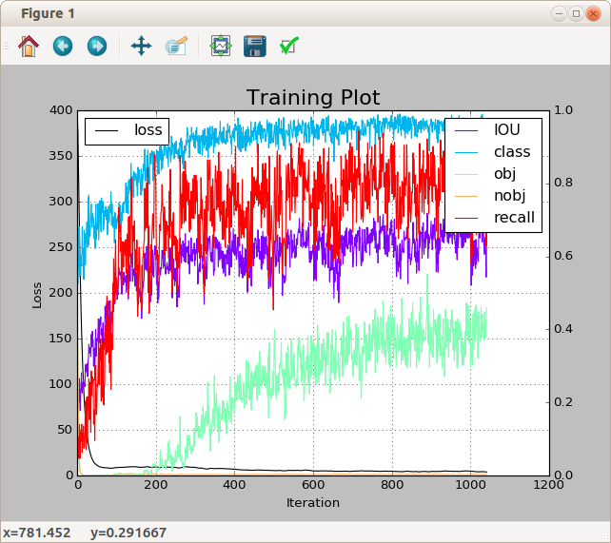
- Tests
- results from single image and video tests were similar to those observed for standard yolo
  - fps ~20 (no change – would have hoped it would increase ?)
  - demo for yieldsigns2.mpg only found one sign (vs 2 in the standard yolo test)
    - but might have done better if training had gone on to 3000 iterations
    - also, box overlap was not as good
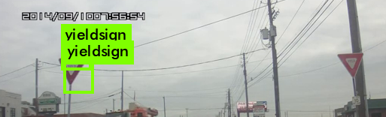
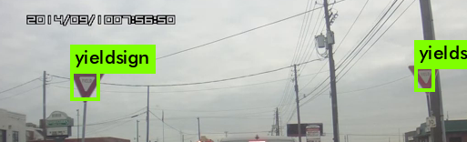

Train tiny YOLO on Tote-Ball data set
- Generate labels from annotations
- generated a conversion file called 'balltote_label.py' based on voc-label.py
- $ python balltote_label.py
- generates a labels directory alongside Images directory in balltote data path
  - contains a set of text files (e.g. '0163.txt') each of which is a conversion of the data from Annotations/ 0163.xml etc.
- generates a file “balltote_train.txt” in ~/AI/darknet that contains a list of absolute paths to the image data
/home/dean/data/frc-robotics/ball_tote_devkit/data/Images/0163.jpg
/home/dean/data/frc-robotics/ball_tote_devkit/data/Images/0164.jpg
...
- used the 2-class cfg file from “signs” detection test described in the previous section
- mods to tiny
  - line 115: filters=35
  - line 120: classes = 2
- train
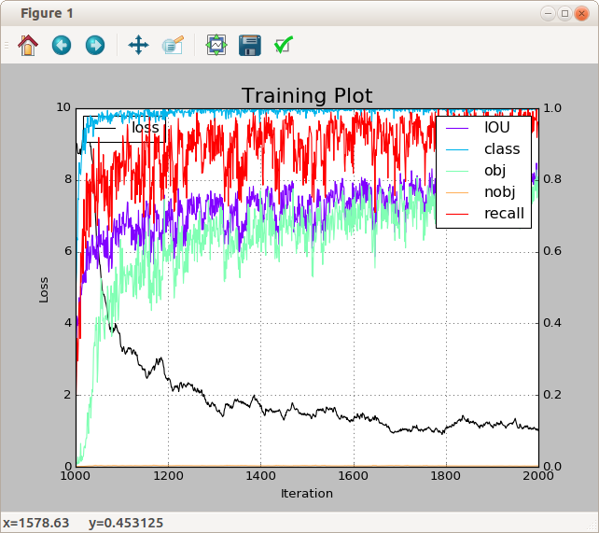
- used starting weights from the “signs” 1000 iteration backup save
- note: only 16 “tote” or “ball” annotated images were used in training
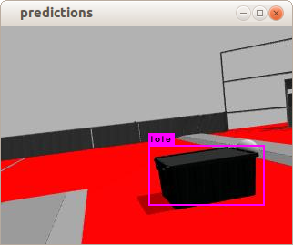
- single image test (tote: 89% Predicted in 0.006774 seconds.)
- image file was not in training set

- video demo test (from mp4 file)

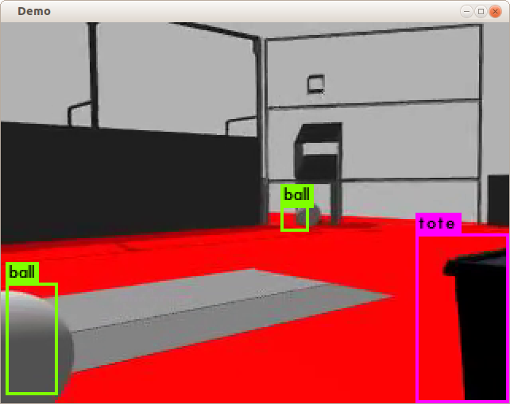
- Created an mp5 video from images captured while driving around in a simulated FRC 2015 field in Gazebo
  - modified Gazebo “world” file
    - added a camera sensor section with:
<sensor name='Sim' type='camera'>
<visualize>1</visualize>
<always_on>1</always_on>
<update_rate>30</update_rate>
<camera name='Cam'>
<save enabled='1'>
<path>/tmp/sim-camera</path>
</save>
</camera>
</sensor>
  - modified VisionTest startup scripts to generate a set of files from gazebo simulation
    - modified mjpg-streamer startup script:
      - old: mjpg_streamer -i "input_file.so -f /tmp/sim-camera -r " -o "output_http.so -w www -p 5002"
      - new: mjpg_streamer -i "input_file.so -f /tmp/sim-camera " -o -d 0.1 "output_http.so -w www -p 5002"
      - -r causes mjpg -streamer to remove files once they have been sent
      - -d 0.1 forces a 0.1 second delay (10 Hz) between saved images (to reduce mp4 file size)
  - After simulation was finished, generated a mp4 file from images using ffmpeg
    - ffmpeg -r 20 -f image2 -s 320x240 -start_number 2630 -i "default_2016-Robot_Shooter_Sim(1)-"%d.jpg -vcodec libx264 -crf 25 -pix_fmt yuv420p ~/data/frc-robotics/test.mp4
  - started darknet demo with filename set to generated mp4 file
WEIGHTS=weights/tiny-yolo-balltote_2000.weights
CFG=cfg/tiny-yolo-2class.cfg

FILE="test.mp4"

darknet detector demo cfg/balltote.data ${CFG} ${WEIGHTS} ${FILE} -thresh 0.2

  - reported FPS: ~20
- video demo test (from live mjpg stream)
- setup identical to above except:
  - used original mjpg-streamer startup script (see above)
  - passed a URL stream line as “filename” in darknet demo start up script
FILE="http://192.168.1.107:5002/?action=stream?dummy=param.mjpg"

- notes:
  - reported FPS: ~20
  - takes a while for demo window to open (20-30 s?)
  - also observed a latency of around a second for images in demo window to catch up with movements of the camera in gazebo

SSD (single-shot multibox-detector)
A new caffe-based object detection method that is reportedly faster and more accurate than both YOLO and faster r-cnn.

Installation
- Obtain source
- git clone https://github.com/weiliu89/caffe.git ssd-caffe
- Obtain models
- Downloaded “models_VGGNet_VOC0712_SSD_300x300.tar.gz” by following “here” link on the github site:
“If you don't have time to train your model, you can download a pre-trained model at here.”
- Expanded tar file into models/VGGNet/VOC0712/SSD_300x300
  - contains prototxt files and caffemodel
- Build ssd caffe
- First attempted to build following installation instructions in Readme.md but got compilation errors like the following:
src/caffe/layer.cpp
src/caffe/layer.cpp:7:30: error: no ‘void caffe::Layer<Dtype>::InitMutex()’ member function declared in class ‘caffe::Layer<Dtype>’
void Layer<Dtype>::InitMutex() {
…
  - options originally selected in Makefile.config
    - USE_CUDNN := 1
    - OPENCV_VERSION := 3
    - ANACONDA_HOME := $(HOME)/anaconda2
    - PYTHON_INCLUDE := $(ANACONDA_HOME)/include ..
    - PYTHON_LIB := $(ANACONDA_HOME)/lib
    - WITH_PYTHON_LAYER := 1
  - was able to fix build (at least it finished) by making more modification to Makefile.config
    - INCLUDE_DIRS := -I$(CAFFE_ROOT)/include -I$(PYTHON_INCLUDE) -I/usr/local/include
      - note: can't believe Makefile.config.example didn't add include files from caffe build directory $(CAFFE_ROOT)/include
      - also, example syntax is wrong (need to add -I in front of all include dirs)
    - USE_PKG_CONFIG := 1
      - otherwise get link error for opencv
  - to build:
    - make -j6
    - make py
- next tried using cmake & ccmake and that also worked
  - mkdir release && cd release
  - cmake ..
    - usual error related to OPENCV_DIR
  - ccmake ..
    - fix path to OPENCV_DIR
      - OpenCV_DIR /home/dean/opencv/release
    - set OpenCV_Found ON
  - cmake ..
    - now succeeds
  - make -j6
    - completes
  - make pycaffe
    - completes
  - make runtest -j6
    - completes

Test a set of images using a trained network
- The pretrained network (caffemodel and prototxt file) will be from a ssd trained model on the VOC data set 92017,2012)
- Wrote a bash script to display bounding boxes around an image set using the voc classes
- the script inputs one or more images from a file containing a list of paths
  - e.g. make a list of the first 100 images in VOCdevkit/2007/JPEGImages
find `pwd`/JPEGImages -name \*.jpeg | sort > voc_images.list
  - then open in a text editor and delete all but the first 100 lines
  - save as voc_100.list
- Uses “build/examples/ssd/ssd_detect.bin” to apply a pretrained caffe model (VGG_VOC0712_SSD_300x300) to detect objects and boxes in the image
- Uses plot_detections.py to generate an annotated image from the test image
- Uses “eog” to display the images (use left and right arrow keys to scroll)

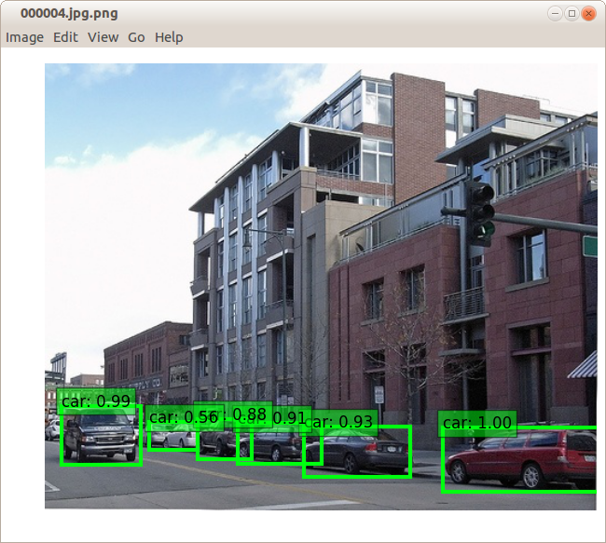
Test a video (mp4) file using a trained network
- Again the trained model and weights will be the packages provided for the VOC dataset
- the video file to be tested is the one provided in examples/videos:
ILSVRC2015_train_00755001.mp4
- First tried to use “ssd_detect.bin” by passing in a video file (mp4) but always got a “could not open” error
- from a web search there seems to be an issue with ffmpeg support in opencv that might be responsible for this (although didn't have a problem with video in YOLO which uses the same opencv libraries)
- Next tried the built in pyhon-based demo (and that worked)
- $ python examples/ssd/ssd_pascal_video.py
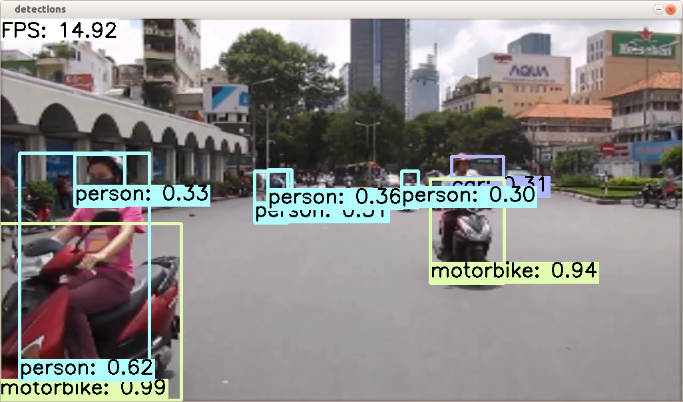
- FPS displayed during short video: ~15-20
- in looking at the ssd_pascal_video.py python script it appears to do the following:
  - the mpg file and voc trained caffemodel (from 300x300) are hard-coded
    - weights: VGG_VOC0712_SSD_300x300_iter_120000.caffemodel
    - video_file = "examples/videos/ILSVRC2015_train_00755001.mp4"
  - other properties specific to the VOC data set are also specified
    - num_classes=21
    - label_map_file = "data/VOC0712/labelmap_voc.prototxt"
      - a list of class names
    - snapshot_dir = "models/VGGNet/VOC0712/{}".format(job_name)
      - used to lookup *.caffemodel file and where to save test.prototxt
  - from the fixed parameters the script generates a “prototxt” file which it saves in: models/VGGNet/VOC0712/SSD_300x300_video/test.prototxt
    - also saved (in examples/jobs/..) is a shell script than can be used to launch the demo from the command line:
./build/tools/caffe test --model="models/VGGNet/VOC0712/SSD_300x300_video/test.prototxt"\
--weights=\
"models/VGGNet/VOC0712/SSD_300x300/VGG_VOC0712_SSD_300x300_iter_120000.caffemodel" \
--iterations="536870911" \
--gpu 0
  - so the video input is encoded into a custom built prototxt file that is passed to “caffe test” for processing
- changed video_file line to test another video and that worked
- To test a different data set it looks like a good approach would be to clone a version of ssd_pascal_video.py and configure it appropriately (e.g. change num_classes etc0

Train one of the provided datasets (VOC)
Will follow the github site instructions for the VOC data but will only use the 2007 images since these have been previously downloaded (the 2012 image set is much larger and takes several hours to download)
- Prepare the dataset
Instructions:
# Create the trainval.txt, test.txt, and test_name_size.txt in data/VOC0712/
./data/VOC0712/create_list.sh
# You can modify the parameters in create_data.sh if needed.
# It will create lmdb files for trainval and test with encoded original image:
# - $HOME/data/VOCdevkit/VOC0712/lmdb/VOC0712_trainval_lmdb
# - $HOME/data/VOCdevkit/VOC0712/lmdb/VOC0712_test_lmdb
# and make soft links at examples/VOC0712/
./data/VOC0712/create_data.sh
- $ ./data/VOC0712/create_list.sh
  - ran to completion even though it skipped the 2012 data
  - created 3 new files in project directory data/VOC0712
    - trainval.txt and testval.txt
      - lists of paired paths (relative to ~/data/VOCdevkit) of image and annotation files
VOC2007/JPEGImages/006844.jpg VOC2007/Annotations/006844.xml
VOC2007/JPEGImages/000001.jpg VOC2007/Annotations/000001.xml

    - test_name_size.txt
      - a list of image file size values
000001 500 353
000002 500 335
- $ ./data/VOC0712/create_list.sh
  - originally failed with an error (couldn't find module caffe)
  - fixed by adding export PYTHONPATH=python to the create_list.sh script
  - after running the script new “.mdb” files were found in ~/data/VOCdevkit/..
- Train the model
  - Instructions for training from scratch:
# It will create model definition files and save snapshot models in:
# - $CAFFE_ROOT/models/VGGNet/VOC0712/SSD_300x300/
# and job file, log file, and the python script in:
# - $CAFFE_ROOT/jobs/VGGNet/VOC0712/SSD_300x300/
# and save temporary evaluation results in:
# - $HOME/data/VOCdevkit/results/VOC2007/SSD_300x300/
# It should reach 77.* mAP at 120k iterations.
# run python examples/ssd/ssd_pascal.py
- $ python examples/ssd/ssd_pascal.py
  - needed to change the following lines to get script to run on my system
  - line 333: gpus = "0" (from: gpus = "0,1,2,3")
    - otherwise got “unknown device” error
  - line 339: batch_size = 8 (from batch_size=32)
    - otherwise got “Out of Memory” error
  - Output once script was running:
...
I0608 10:52:30.927119 19222 solver.cpp:243] Iteration 330, loss = 7.29032
I0608 10:52:30.927280 19222 solver.cpp:259] Train net output #0: mbox_loss = 6.79195 (* 1 = 6.79195 loss)
I0608 10:52:30.927317 19222 sgd_solver.cpp:138] Iteration 330, lr = 0.001
...
- As in the video test case it looks like the python file is customized to generate a set of voc-specific files saved in models/VGGNet/VOC0712/SSD_300x300:
test.prototxt
train.prototxt
- These 2 files contain entries like the following:
name: "VGG_VOC0712_SSD_300x300_test"
source: "examples/VOC0712/VOC0712_test_lmdb"
label_map_file: "data/VOC0712/labelmap_voc.prototxt"
num_classes: 21
dim: 21
VGG_VOC0712_SSD_300x300_iter_500.caffemodel
VGG_VOC0712_SSD_300x300_iter_500.solverstate
  - plot the training log
- wrote a python file and shell script to plot the training log (see below)
  - run crashed (out of memory) after 10000 iterations (first test cycle) without saving a snapshot (oh well..)
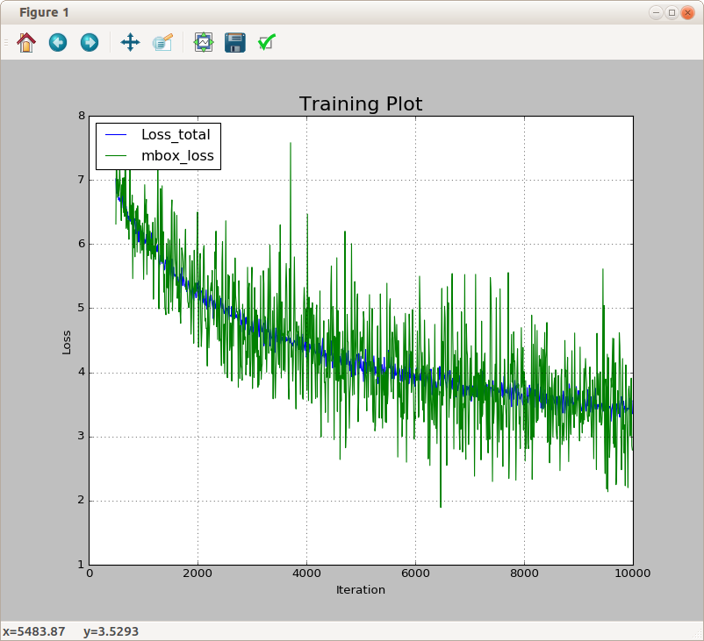
  - training VOC from a different pre-trained model
  - the original training script (plot shown above) used VGG_ILSVRC_16_layers_fc_reduced.caffemodel for starting weights. To continue training from the more fully trained (120000 iterations) model need to modify ssd_pascal.py to set the following:
  - pretrain_model = "models/VGGNet/VOC0712/SSD_300x300/VGG_VOC0712_SSD_300x300_iter_120000.caffemodel
  - max_iter': 130000
    - otherwise training never starts (thinks it has already reached the max value)
- other useful changes:
  - 'base_lr': 0.0001
    - reduced from 0.001 since model is already trained
  - test_batch_size = 1
    - otherwise lead to a crash on test cycle (out of memory)
  - 'snapshot': 2000,
    - crash insurance
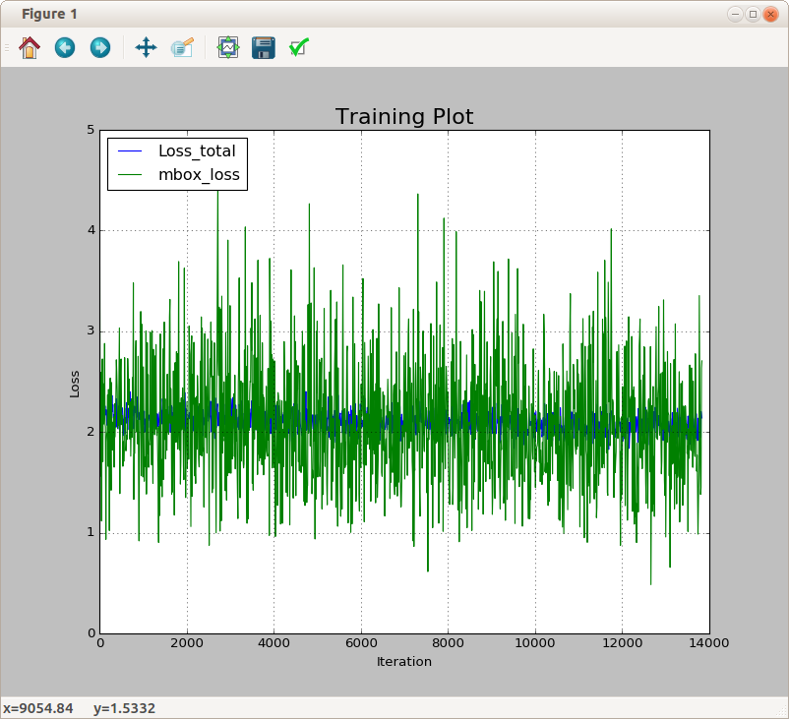
  - notes:
    - Not unexpected, hardly any improvement after an additional 14000 iterations (~10% more)
    - starts off with a loss of ~2 (vs final loss of ~3.5 for previous training test)

Train and test SSD on a custom dataset (TOTEBALL)
Will first try the small 2-class “ball-tote” dataset for this test
- references
- https://www.bountysource.com/issues/39786385-training-and-testing-ssd-via-new-dataset
- Create a new sub-directory in “data” to contain custom scripts etc for this dataset
- $ mkdir data/TOTEBALL
- Prepare the data directories
- data files and directories in ~/data/frc_robotics:
|-- BallToteData/
|-- Annotations/
|-- *.xml (Annotation files)
|-- Images/
|-- *.jpg (Image files)
|-- ImageSets
trainval.txt
test.txt

  - Annotations files are in the VOC xml format
  - ImageSet .txt files contain simple lists of names that correspond to the image files in the images directory (sans extension and path)
    - e.g. 0167
    - moved 8 names from the original trainval.txt and added them in test.txt (trainval.txt now contains only 29 entries)
    - note: can't have any emtpy lines in these files 9even at the bottom)
- Generate SSD style labels files
- copied create_list.sh from data/VOC0712 to data/TOTEBALL
- modified create_list.sh as follows:
  - changed root_dir to $HOME/data/frc-robotics/BallToteData
  - removed for loop for VOC2007 and VOC2012
  - removed references to “name” in sed lines
    - sed -i "s/^/$name\/Annotations\//g" $label_file →
    - sed -i "s/^/Annotations\//g" $label_file
  - changed “JPEGImages” to “Images”
- ran the modified scripts and found new files in data/TOTEBALL
  - test.txt, trainval.txt
Images/0167.jpg Annotations/0167.xml
Images/0170.jpg Annotations/0170.xml
...
  - test_name_size.txt
0167 240 320
0170 240 320
...
- Create lmdb files for the dataset
- copied labelmap_vocl.prototxt from data/VOC0712 to data/TOTEBALL
  - renamed to labelmap_toteball.prototxt
  - reduced number of entries to 3
    - added tote(0) and ball(1)
    - added background (2)
- copied create_data.sh from data/VOC0712 to data/TOTEBALL/
- modified create_data.sh as follows:
  - data_root_dir="$HOME/data/frc-robotics/BallToteData"
  - mapfile="$root_dir/data/$dataset_name/labelmap_toteball.prototxt"

- ran the create_data.sh script
  - generated new files and directories in ToteBallData
|-- BallToteData/
|-- TOTEBALL
|-- lmdb/
|-- TOTEBALL_test_lmdb
data.mdb (77824)
lock.mdb
|-- TOTEBALL_trainval_lmdb
data.mdb (249856)
lock.mdb
- Create a training script
- cloned examples/ssd/ssd_pascal.py to examples/ssd/ssd_toteball.py
- make the following changes to sd_toteball.py
  - replaced VOC0712 everywhere it occurred in the file with TOTEBALL
  - label_map_file = "data/TOTEBALL/labelmap_toteball.prototxt"
  - num_test_image = 8
  - num_classes = 3
  - background_label_id=2

- Train
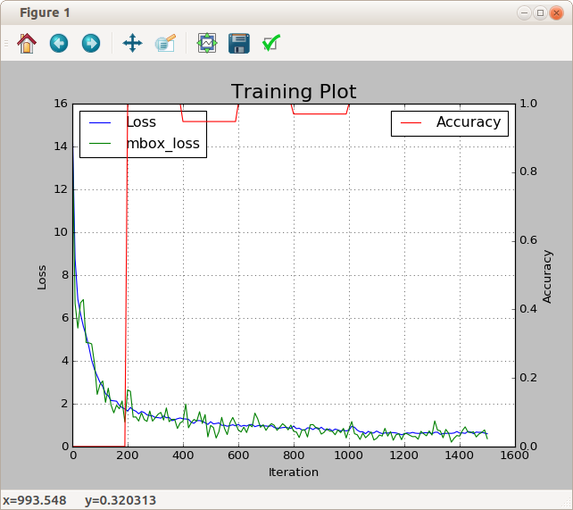
- stopped training after 1500 iterations
- loss = 0.598579, mbox_loss = 0.366453, accuracy=1.0
- Test single images
- example image
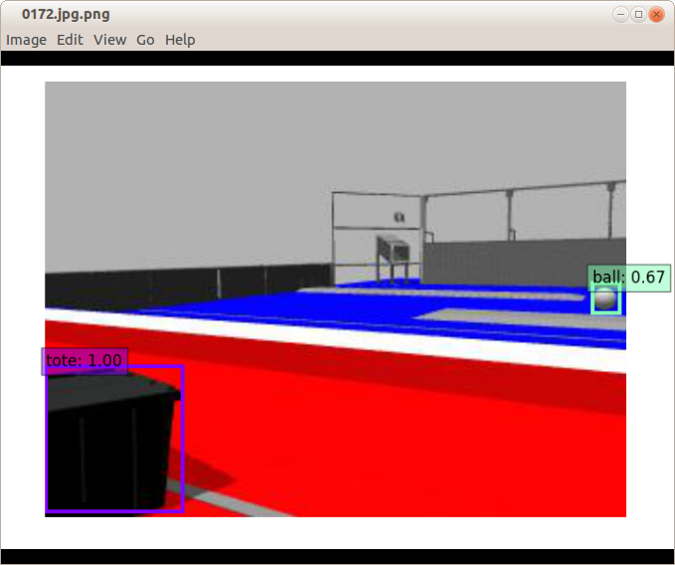
- mpg file test
- copied examples/ssd/ssd_pascal_video.py to examples/ssd/ssd_toteball_video.py
- modified ssd_toteball_video.py similarly to ssd_toteball.py (see above)
  - video_file = "/home/dean/data/videos/balltote3.mp4"
  - num_classes = 3
  - background_label_id=2
  - replaced all occurances of “VOC0712” with “TOTEBALL”
  - video_width = 640, video_height = 480, scale=1
- results (played all 3 toteball.mp4 files)
  - most balls and totes correctly labeled with good boxes
  - occasionally, mislabeled loading box as a tote
  - missed some objects, particularly if far away or partially occluded
  - FPS reported (scale=0.5,1.0,2.0)
    - ~30 for 320x240 image display
    - ~25 for 640x480 image display
    - ~20 for 1280x960 image display
- real time video test (Gazebo simulation)
- ssd (or caffe) apparently doesn't provide direct support for web based cameras (only video files and USB camera) so had to do a little hacking thanks to this reference:
  - https://stackoverflow.com/questions/43344255/how-to-use-remote-camera-when-using-caffe-ssd
To minimize changes in caffe code you can keep the web address in video_file and set device_id to something other than 0. To add this support edit src/caffe/layers/video_data_layer.cpp file by replacing line 45-47 with:
// suppose 101 is the code for remote webcam
if(device_id == 101){
CHECK(video_data_param.has_video_file()) << "Must provide webcam address";
const string& video_file = video_data_param.video_file();
if (!cap_.open(video_file)) {
LOG(FATAL) << "Failed to open remote webcam: " << video_file;
}
}else {
if (!cap_.open(device_id)) {
LOG(FATAL) << "Failed to open webcam: " << device_id;
}
}
Now rebuild caffe. Edit your https://github.com/weiliu89/caffe/blob/ssd/examples/ssd/ssd_pascal_webcam.py file line 117 like:
video_data_param = {
'video_type': P.VideoData.WEBCAM,
'device_id': 101,
'skip_frames': skip_frames,
'video_file': "remote webcam address"
}

- modified video_data_layer.cpp as indicated above and rebuilt caffe
  - make (ssd project directory)
- copied examples/ssd/ssd_pascal_webcam.py to examples/ssd/ssd_toteball_gazebo.py
- modified similarly to ssd_toteball_video.py plus added:
  - video_file = "http://192.168.1.107:5002/?action=stream?dummy=param.mjpg"
  - modified video_data_param as shown above except:
    - 'video_file': video_file
- Run test
  - started gazebo as described above (YOLO section)
  - then ran examples/ssd/ssd_toteball_gazebo.py from ssd project root
- Results
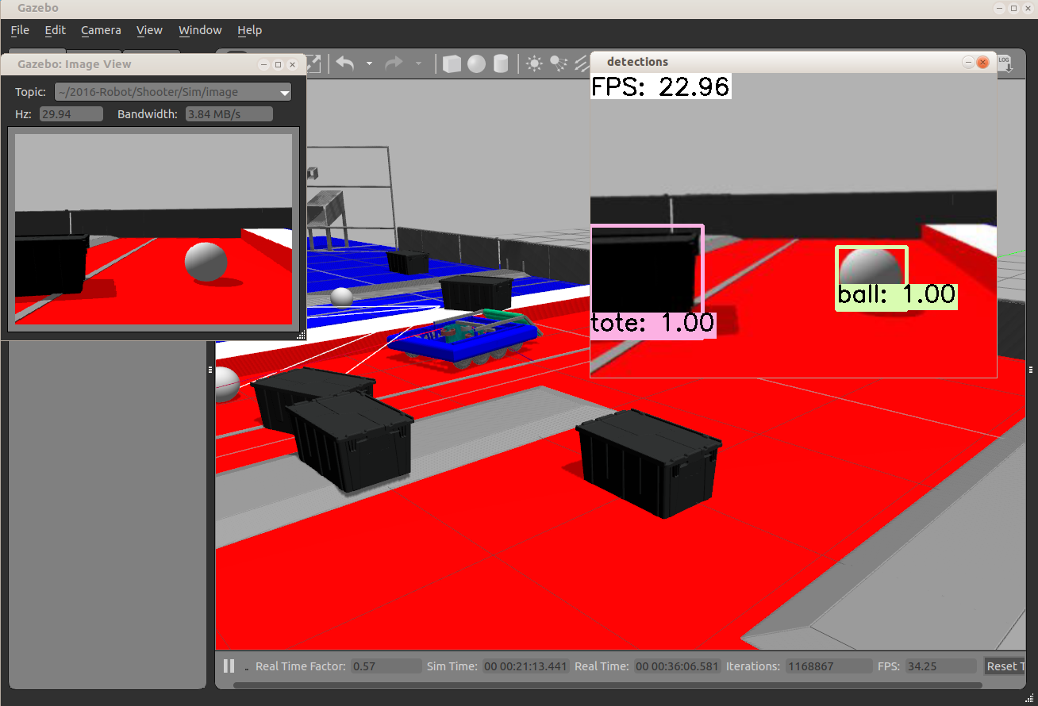
  - observed a lag of a few seconds before motion in gazebo was reelected in the images (but it seemed to track better after that)

Object Detection using DIGITS (detectnet)

Installation
- References
  - https://github.com/NVIDIA/DIGITS/tree/master/examples/object-detection
  - https://devblogs.nvidia.com/parallelforall/detectnet-deep-neural-network-object-detection-digits/
- Requirements
- DIGITS 4.0 or later
- NVCaffe 0.15.1 or later
  - includes “detectnet_network.prototxt file and other files
- Obtain Pretrained Googlenet.caffenet model
  - http://dl.caffe.berkeleyvision.org/bvlc_googlenet.caffemodel
- Setup
- Obtain KITTI Image Data
  - KITTI website: http://www.cvlibs.net/datasets/kitti/eval_object.php
  - follow instructions in reference 1
  - need to obtain special email link download (12GB)
- Refactor KITTI Data to be compatible with DIGITS
  - $DIGITS_HOME/examples/object-detection/prepare_kitti_data.py -i <source-dir> -o <dest-dir>
- Create Test DIGITS Dataset (KITTI)
- Create Dataset as described in reference 1

Train and test a model dataset
- Setup model classifier as described in reference 1
- Give model a name (e.g. KITTI GN)
- Press Create
- Wait for completion (?)
  - On my system with a GTX 980 a single epoch took >1.5 hours
  - After 1.2 epochs (2 hours) got this failure:
I0827 20:01:29.032479 2725 sgd_solver.cpp:106] Iteration 4378, lr = 0.0001
libpng error: IDAT: CRC error
E0827 20:05:49.394631 2754 io.cpp:173] Could not decode datum
*** SIGFPE (@0x7f1e5d320320) received by PID 2725 ...
  - problem may be image corruption in Dataset (png CRC error followed by Floating point error ?) or buggy code
  - Will go ahead and test results from epoch #1
- Results (epoch #1 ):
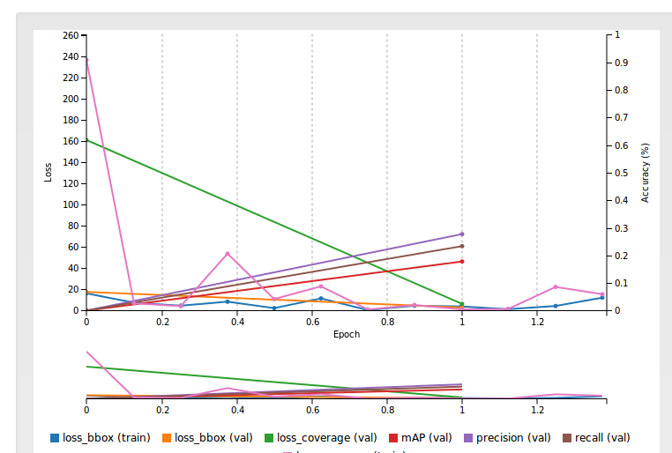
- Test 1 image:
  - took 7 seconds

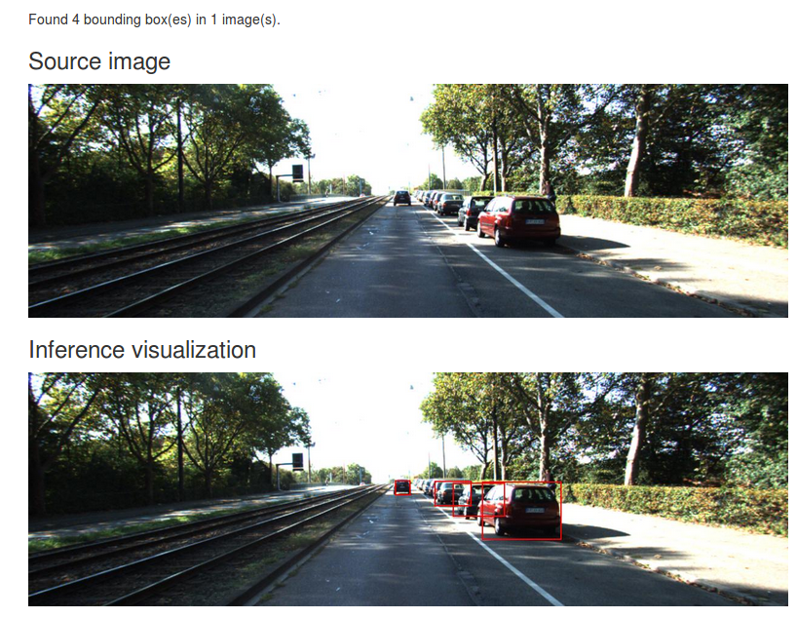

Notes
- Buggy and very slow (both train and classify)
- 4/12/17 update
  - Retested with more recent NVIDIA toolchains (digits-5,cuda-8,cuDNN-6) and training was much faster (~8 minutes/epoch) without crashes.
  - Needed to start digits from a shell after “CAFFE_ROOT=~/NVIDIA-caffe” otherwise get error “ImportError: No module named layers.detectnet.clustering”
- A web search indicates that out-of-the-box “DetectNet” only works for a single type of object (e.g. cars) so seems less useful than other methods (e.g. faster r-cnn)

Segmentation (identify objects at the pixel level)

Image Segmentation using DIGITS 5

Image segmentation refers to a technique where instead of classifying a single image as a “cat image”, (for example) the network attempts to make a classification at the pixel level. This allows images to contain multiple objects that can be isolated and classified in the image, similarly to the “bounding box” method described above.
References
- https://devblogs.nvidia.com/parallelforall/image-segmentation-using-digits-5/
- https://github.com/NVIDIA/DIGITS/tree/master/examples/semantic-segmentation
- https://github.com/NVIDIA/DIGITS/tree/master/examples/medical-imaging
- https://people.eecs.berkeley.edu/~jonlong/long_shelhamer_fcn.pdf
Tests

Segment images in PASCAL VOC 2012 dataset using FCN-ALEXNET
- Test images are variable size and shapes of real photos with human-annotated corresponding ground truth images
- Followed procedure in reference 2 for obtaining data and pre-trained fcn-alexnet model
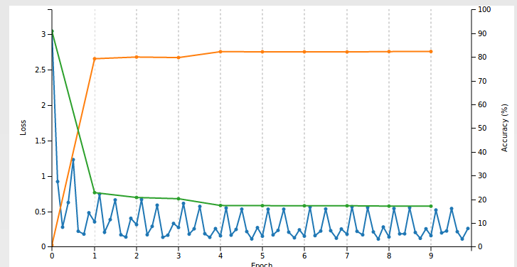
- similar 32 bit resolution result shown in reference 1
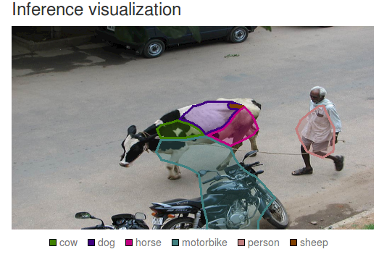

Segment images in SYNTHIA dataset using FCN-ALEXNET
- SYNTHIA contains automatically generated scenes and ground truth images for a simulated city
- Need to register on SYNTHIA site in order to download datasets
  - lots of choices automatically checked on website, selected only the first (same as the examples shown in reference 1)
  - 13+ GB data took 4 hours to download (slow server connection ?)
- Used pretrained fcn-alexnet model with “net-surgury” as described in references 1&2 to get reasonable results (accuracy=91%) after training for 5 epochs
- Results for fcn-alexnet (32 pixel resolution)
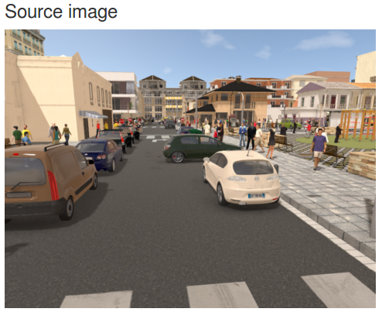
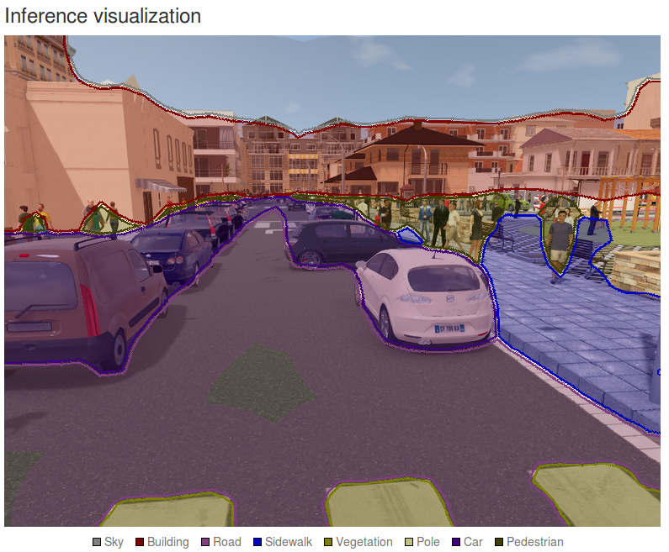

Improve segmentation resolution using fcn-8s
fcn-8s is based on VGG16 and is a much larger network than Alexnet (uses “skip layers” to improve segmentation resolution: 8x8, vs 32x32 patches).
- Tried to train fcn-8s on VOC or SYNYHIA datasets but got “OUT of Memory” errors
  - fails with or without pre-trained data file
  - always corresponds to start of first “TEST” phase using NVIDIA-caffe (0.14)
    - also fails on startup with same error when using berkley caffe (1.04)
  - fails for voc-fcn16, voc-fcn32 (i.e any fcn network based on voc-net)
  - fails with same “data and score” nodes that are used in fcn-alexnet
  - from a web search it looks like other folks have had same problem using graphics cards with 4G or less of memory
- possible ways to get around “Out of Memory” error :
- buy a GPU card with more memory
  - not gonna do this except as a last resort
- Train and test using a “random crop” to reduce image size
  - managed to get past the “out of memory” error by adding the following line to all “data” layers in train_val.prototxt file:
transform_param { crop_size: 416 }
  - tested after one epoch and it looked like segmentation didn't work at all (just random patches)
    - maybe GT and RGB images pairs are given different random crops ?
- Modify fcn-alexnet to add skip layers like in fcn-8s or fcn-16s
- tried to mimic fcn-16s net but couldn't get past caffe errors (may not even be possible, or justs reflects my lack of expertise in doing this
- Retrain fcn-alexnet net using smaller images
  - Shrink images before building lmdb file
    - web search indicated that this worked for some people so will try this approach first
  - used imagemagic (mogrify) to reduce the size of all images in the SYNTHIA data set
  - copied RGB and GT to 'small' directory tree
    - in each small directory ran the following shell command:
> mogrify -resize 50% *.png
      - reduces image size to ¼ (½ width, ½ height) original (takes quite a while to complete)
  - In DIGITS, rebuilt SYNTHIA dataset using the resized (smaller) images
    - partially through, val or train phases got failures like the following in GT directory:
“Labels are expected to be RGB images <filename> mode is 'P'. If your label s are palette or grayscale images then set the 'Color Map Specification' field to 'from label image'”
    - noticed that GT images were already reduced to correct size prior running “mogrify” command (so may have accidentally run “convert” in original GT directory ?)
    - In any case, proceeded to delete files that produced the error in both the GT and RGB directories until the DIGITS “create database” succeeded
    - Once database containing smaller images was created, used pretrained model fcn_alexnet.caffemodel, to initialize weights and trained for one epoch
  - Results using fcn-alexnet trained using small images
    - test accuracy: 81% on small or large images
    - note: segmentation is considerably worse than that seen for net trained with larger images (see above) but might be improved if fcn-8s will now run without memory errors
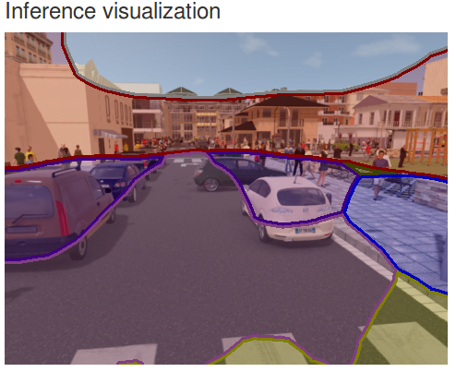
- Train fcn-8s using SYNTHIA dataset with smaller images in hope of avoiding “Out of Memory” error
  - used fcn-8s net (VGG16-based) with pretrained weights available from berkley.org github site
  - Got past initial validate and test phases without errors
  - ran for 2+ epochs then stopped (after 4 ½ hours)
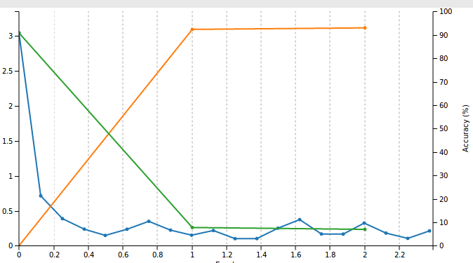
    - performance leveled off at 93% accuracy
      - no improvement when continued training an additional 5 epochs
    - training was slower than for fcn-alexnet (about twice as slow)
  - result for fcn-8s trained on reduced sized SYNTHIA dataset
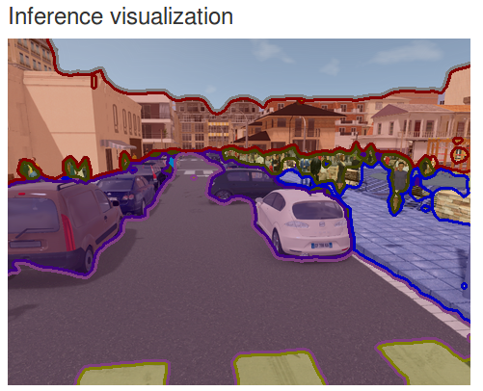
  - observations
    - about the same resolution (or slightly better) as seen for fcn-alexnet trained with larger images
    - much better resolution than fcn-alexnet trained on small images
    - lines surrounding object classes seem to be thicker
- Problem with mogrify “resize” command for indexed label images (e.g. voc segmentation data)
  - indexes label images do not keep original color map but are converted to RGB (with blending)


    - leads to error when generating a dataset since colormap (rgb table) isn't defined
    - may also be the reason for the wider object separation lines seen using rescaled SYNTHIA data since blended regions dont correspond to expected label colors
  - can preserve colormap when scaling label images by using the following command
> mogrify -define png:preserve-colormap -sample 75% *.png
- Train fcn-8s using reduced image size PASCAL VOC 2012 dataset
  - reduced the size of all images to 75% using mogrify command given above
  - now trains to 90.6% accuracy without “out of memory” error (~1hr to train)
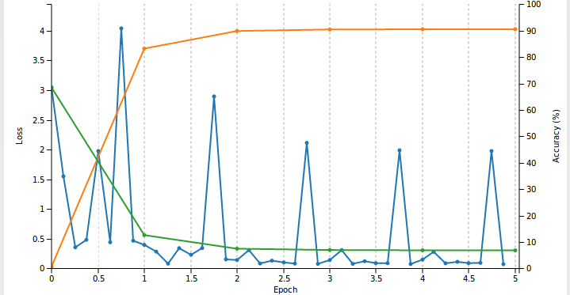
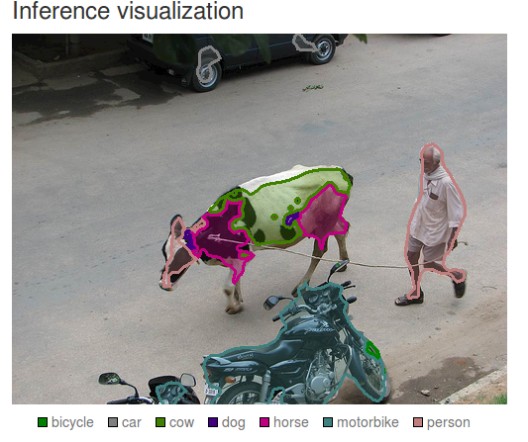
  - some confusion on the cow (horse-cow?) but still significantly better than the result obtained using fcn-alexnet (see above)
  - note: tried training using weight from from a fcn-8s network pretrained on SYNTHIA dataset but got essentially the same results

Image segmentation using DeepMask and SharpMask
A different approach to object segmentation that uses Torch and LUA instead of CAFFE
The authors state that a significant advantage of using this method (vs the segmentation strategy described in the previous section) is that it is capable of separating instances as well as classes of objects
References
- https://code.facebook.com/posts/561187904071636/segmenting-and-refining-images-with-sharpmask/
- https://arxiv.org/abs/1405.0312
- http://torch.ch/docs/getting-started.html#_
Installation
- Torch
instructions from reference 3
- get source code
> git clone https://github.com/torch/distro.git ~/torch –recursive
- install Torch and dependencies
> cd ~/torch;
> bash install-deps;
  - got one error about inability to find lib gfortran
    - fixed by adding a soft link in /usr/lib/x86_64-linux-gnu
> sudo ln -s libgfortran.so.3.0.0 libgfortran.so
- Install LuaJIT and LuaRocks
> ./install.sh

- Install Torch LUA packages
install required Torch packages specified in reference 1
- install torch packages COCO API, image, tds, cjson, nnx, optim, inn, cutorch, cunn, cudnn sudo luarocks install <package> [scm-1]
  - sudo luarocks install image : succeeds
  - sudo luarocks install tds : succeeds
  - sudo luarocks install cjson : succeeds
  - sudo luarocks install nnx: succeeds
  - sudo luarocks install optim: succeeds
  - sudo luarocks install cutorch : fails
- identifier "TH_INDEX_BASE" is undefined
  - sudo luarocks install cunn: fails
- THC/THCGenerateFloatTypes.h: No such file or directory
  - sudo luarocks install cudnn: succeeds
- install COCO API
  - git clone https://github.com/pdollar/coco
  - cd coco
  - sudo luarocks make LuaAPI/rocks/coco-scm-1.rockspec
- list packages currently installed:
> luarocks list
- Fix package installation errors
  - sudo rm -fr ~/.cache/luarocks
  - reinstall torch
    - cd ~/torch
    - ./clean.sh
    - TORCH_LUA_VERSION=LUA52 ./install.sh
  - reinstall torch and cuda packages
    - sudo luarocks install torch scm-1 [missed first time ?]
    - sudo luarocks install cutorch [now no errors ..]
    - sudo luarocks install nn scm-1
    - sudo luarocks install cunn scm-1
    - sudo luarocks install cudnn scm-1
- install deepmask/sharpmask
instructions from reference 1
- get source code
> export DEEPMASK=~/deepmask
> git clone git@github.com:facebookresearch/deepmask.git $DEEPMASK
- get deepmask and sharpmask models
> mkdir -p $DEEPMASK/pretrained/deepmask
> cd $DEEPMASK/pretrained/deepmask
> wget https://s3.amazonaws.com/deepmask/models/deepmask/model.t7
> mkdir -p $DEEPMASK/pretrained/sharpmask
> cd $DEEPMASK/pretrained/sharpmask
> wget https://s3.amazonaws.com/deepmask/models/sharpmask/model.t7
- get COCO images (optional)
> mkdir -p $DEEPMASK/data; cd $DEEPMASK/data
>wget http://msvocds.blob.core.windows.net/annotations-1-0-3/instances_train-val2014.zip
> wget http://msvocds.blob.core.windows.net/coco2014/train2014.zip
- 6.5 GB
> wget http://msvocds.blob.core.windows.net/coco2014/val2014.zip
- 13.5 GB
Tests
- test one image:
- unzipped COCO val images and copied last in val2014 directory to $DEEPMASK/data/last_val.jpg
- ran sharpmask segmentation test on image
> th $DEEPMASK/deepmask/computeProposals.lua $DEEPMASK/pretrained/sharpmask -img $DEEPMASK/data/last_val.jpg
- generates res.jpg in working directory

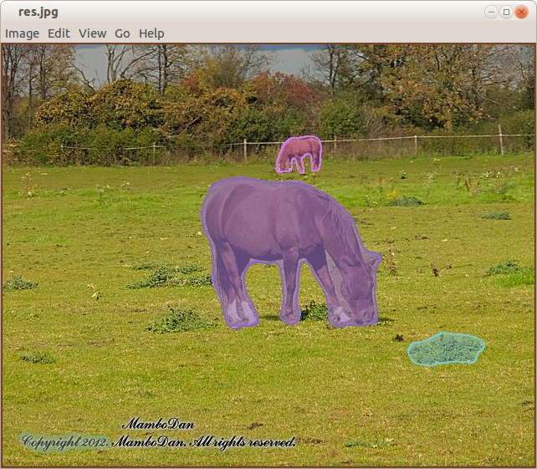

Comparison with segmentation using DIGITS with fcn-8s (trained on VOC dataset)

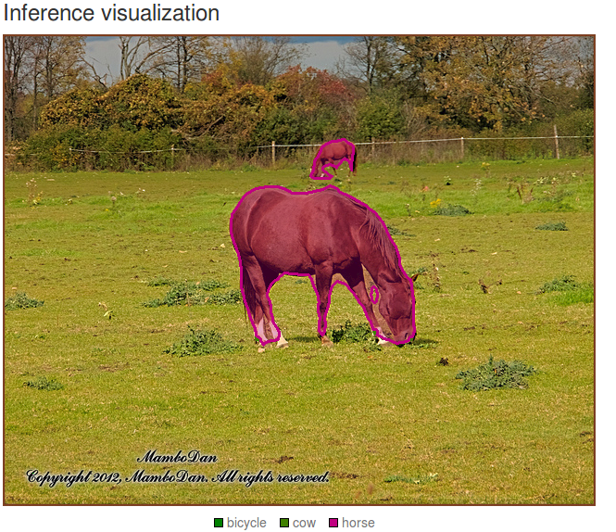
- Running the “pycoco” demo (Displays annotated images from the coco web database)
- references:
- https://github.com/pdollar/coco/blob/master/PythonAPI/pycocoDemo.ipynb
- https://github.com/pdollar/coco/tree/master/PythonAPI
- install the python coco and json modules
  - follow instructions in reference 2 (setup.sh) for installation into anaconda
- displaying annotations
  - > cd $DEEPMASK/data
  - > mkdir demos && cd demos
  - > python
  - open reference 1 in a web browser
  - copy and paste python segments from the browser page (or create a python file that packages everything together)
- example result (selects a random image from coco database)
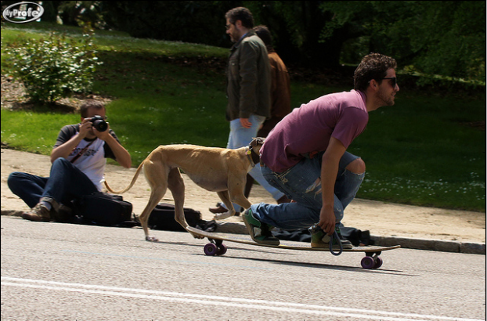
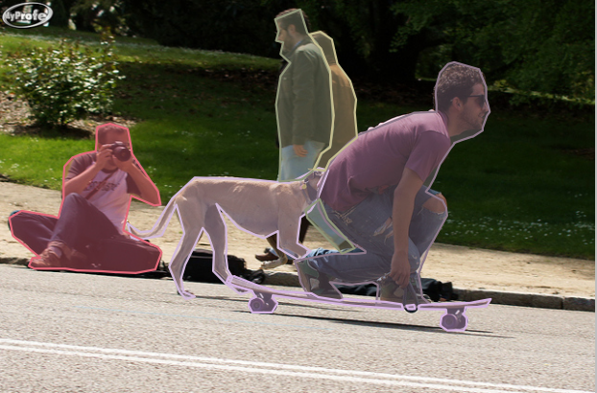
NEW DIGITS ERROR: HDF5 library version mismatched
after installing DeepMask as described above got the following error when running or starting digits:

Warning! ***HDF5 library version mismatched error***
The HDF5 header files used to compile this application do not match
the version used by the HDF5 library to which this application is linked
…
You can, at your own risk, disable this warning by setting the environment
variable 'HDF5_DISABLE_VERSION_CHECK' to a value of '1'.
Setting it to 2 or higher will suppress the warning messages totally.
Headers are 1.8.15, library is 1.8.17
…
Workaround:
Was able to run digits again by setting HDF5_DISABLE_VERSION_CHECK to 2 as suggested in the error message

> export HDF5_DISABLE_VERSION_CHECK=2
> ~/digits/digits-devserver
Better Fix?
Following a net search clue (https://github.com/h5py/h5py/issues/853) I was able to run digits again (without setting HDF5_DISABLE_VERSION_CHECK) by issuing the following commands:
> conda install -c anaconda hdf5=1.8.15
- downgrade hdf5
- side-effect is that this also downgrades many other libraries to older versions
> conda install -c anaconda hdf5
- upgrades hdf5 back to 1.8.17
- upgrades other libraries to latest versions
note: the search hint said that issuing: “conda install -c anaconda hdf5=1.8.17” fixed the problem for them but that didn't work for me

Image segmentation using Conditional Random Fields (CRF-RNN)
Uses “Conditional Random Fields”
References
- https://github.com/torrvision/crfasrnn
- https://arxiv.org/abs/1502.03240
Installation
- clone the directory from reference 1
- fix caffe build (fixes problems with cuda version 8.0)
- in the crfasmn directory delete or move aside the directory named “caffe”
- clone a version that has support for this method
  - git clone https://github.com/torrvision/caffe.git
- build new caffe
  - cd caffe
  - cp Makefile.config.example Makefile.config
  - edit Makefile.config
    - uncomment: USE_CUDNN := 1
    - add: OPENCV_VERSION := 3
      - otherwise get “undefined symbol:_ZN2cv6imreadERKNS_6StringEi
    - uncomment ANACONDA defines
      - set: ANACONDA_HOME := $(HOME)/anaconda2
    - uncomment: WITH_PYTHON_LAYER := 1
  - make [-j6]
  - make pycaffe
- download trained caffe model
- fix compatibility problems with newer caffe
  - cd to python-scripts
  - fix unknown field problems
    - in TVG_CRFRNN_new_deploy.prototxt and TVG_CRFRNN_COCO_VOC.prototxt remove spatial_filter_weight and bilateral_filter_weight lines from multi_stage_meanfield_param section
Tests
- run the demo
- python crfasrnn_demo.py
  - defaults to CPU (takes ~15s for test to run)
  - gpu test (with -g 0) results in a core dump (gpu out of memory error)
- compare results
- expected (from ref 1) vs observed
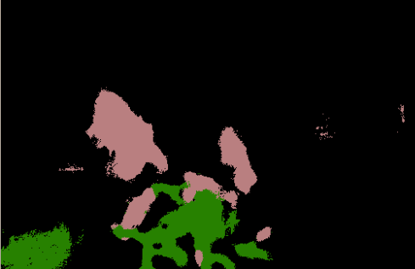
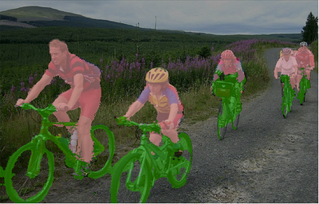

Image Segmentation using Mask Regional Convolutional Neural Networks (Mask R-CNN)
An exciting and very recent (as of 5/2017) extension of the “faster R-CNN” method by some of the same authors that adds a binary mask in parallel with the region proposal network
References
- https://blog.athelas.com/a-brief-history-of-cnns-in-image-segmentation-from-r-cnn-to-mask-r-cnn-34ea83205de4
- https://arxiv.org/abs/1703.06870
- https://arxiv.org/pdf/1703.06870.pdf
Installation
Because this method is so new there isn't a complete public build and test environment established for it yet. However, a couple of preliminary github sites have been started:
- https://github.com/CharlesShang/FastMaskRCNN
- https://github.com/felixgwu/mask_rcnn_pytorch
Tests
- Results published in ref 2
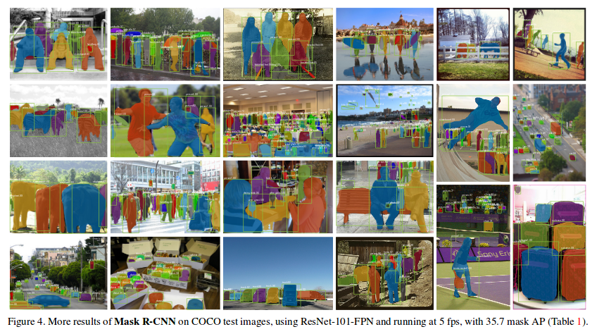

Computing Topics

Compile and run the Nvidia CUDA examples
It is assumed that the CUDA toolbox has been downloaded and installed in /usr/local/cuda-7.5, the environment variable have been configured etc.
e.g see section 3.1 in “System Configuration” above
- Copy the source code into a build directory
- $ cd $CUDA_HOME/bin
- $ ./cuda-install-samples-7.5.sh ~
  - creates a directory called NVIDIA_CUDA-7.5_Samples in $HOME
- Compile the sample code
- $ cd ~/ NVIDIA_CUDA-7.5_Samples
- $ make -j6
- goto the build directory
- $ cd ~/ NVIDIA_CUDA-7.5_Samples/bin/x86_64/linux/release
- Run the example (e.g. mandelbrot)
- $ ./mandelbrot
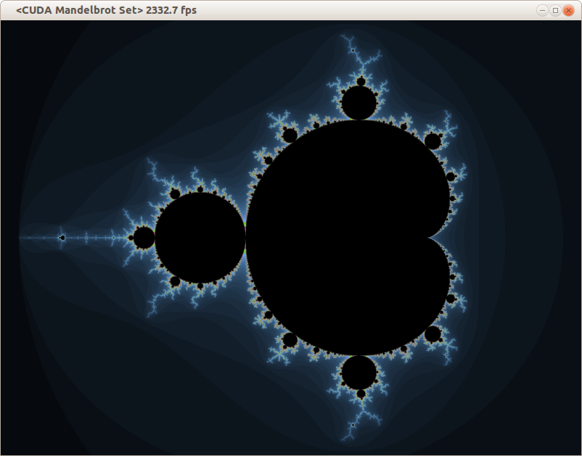
- Examine the source code for the examples
- Sample code is located in subdirectories of the following directories in NVIDIA_CUDA-7.5_Samples
0_Simple
1_Utilities
2_Graphics
3_Imaging
4_Finance
5_Simulations
6_Advanced
7_CUDALibraries
- Build and run individual samples in the sample directories
- cd to one of the sample directories (e.g. cd ~/NVIDIA_CUDA-7.5_Samples/5_Simulations/oceanFFT)
- There should already be an executable here that was built as part of step 3 above so just enter its name in the command line to run it (e.g. ./oceanFFT)
- If you want to change the code and rebuilt the sample just run make
  - Probably should make a backup first of the original source code in this case

NSIGHT - NVidia Eclipse based IDE
Nsight is included as part of the CUDA 7.5 Toolkit and provides an Eclipse based development and debugging environment for pure CUDA applications targeted to local and remote NVidia GPUs
- Setup
- Install CUDA 7.5 toolkit (see system installation 3.1 above)
- Launching
- Applications->programming->Nsight Eclipse Edition
- or nsight from a command prompt
- Problems
  - nsight Eclipse interface had FRC plugin decorations and symbols
  - but path at first launch was set to non-frc eclipse (i.e. /opt/eclipse/eclipse vs. /opt/eclipse-frc) ?
  - Perhaps frc environment was set when CUDA 7.5 toolkit was installed (?)
  - work-around
    - press “already installed” link in Help->Install new software … panel
    - manually “uninstall” FRC plugins and references in “Installed Software” tab
  - Can't change default workspace directory
  - The first time nsight launches it creates a directory called cuda_workspace in $HOME
    - But wanted something different (e.g. a directory called cuda_workspace in ~/CUDA)
  - There doesn't seem to be any way to change the default directory from the Eclipse interface or to have a workspace selection dialog show up on launch
    - Eclipse always starts up without a prompt and creates a ~/cuda_workspace directory if one doesn't exist
    - launch appears to ignore “prompt for workspaces on startup” checkbox in windows->preferences->startup and shutdown->workspaces panel
  - work-around
    - moved cuda_workspace to ~/CUDA
    - launched nsight (this creates a new cuda_workspace in ~)
    - In Eclipse, selected “switch workspace..” in file menu (then browsed to CUDA/cuda_workspace)
    - set “prompt for workspaces on startup” checkbox in windows->preferences->startup and shutdown->workspaces panel
    - exit nsight
    - sudo gedit /usr/local/cuda/libnsight/configuration/config.ini
      - changed: osgi.instance.area.default=@user.home/cuda-workspace
      - to: osgi.instance.area.default=@user.home/CUDA/cuda-workspace
    - relaunch nsight
      - now workspace selection dialog appears and can select ~/CUDA/cuda-workspace
    - deleted ~/cuda-workspace
- Compiling and running samples
Note: Assumes samples are already in /usr/local/cuda-7.5/samples as part of 7.5 toolkit installation
  - creating a new c++ sample code project
  - File → new CUDA C/C++ Project
  - enter a project name (e.g. “bandwidthTest”)
  - select “Import CUDA Sample” from “project type”
  - Select sample project from list (e.g. bandwidthTest)
  - Press “Finish”
  - Compiling the sample code
    - Debug configuration
- select sample project in C/C++ projects window
- press build (hammer) select “Debug”
    - Release Configuration
- select sample project in C/C++ projects window
- press build (hammer) select “Release”
  - Debug the sample
- select sample project in C/C++ projects window
- Press Debug (bug symbol) >”Local C/C++ Application” in Toolbar Panel
- answer “yes” to “Open Debug Perspective ?” question
- Set breakpoints etc.
- press > icon to start debugging
  - Run the optimized sample code (release)
- select sample project in C/C++ projects window
- Press Run as (green button with right chevron symbol) >Local C/C++ Application in Toolbar Panel
  - Screenshot of nsight eclipse IDE

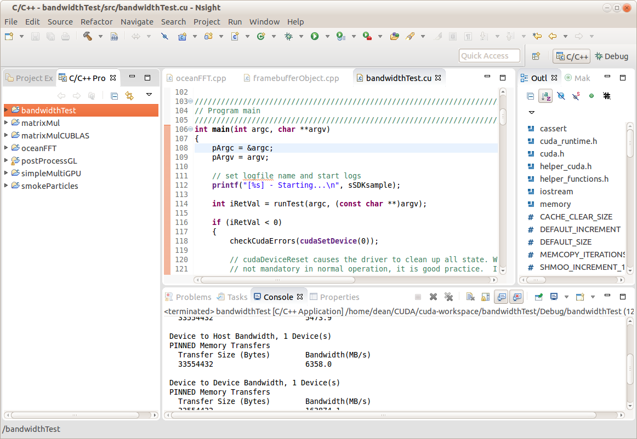

Linking g++ code with CUDA libraries
How to build a c++ application using g++ /Eclipse and link it with a static or dynamic project built using nvcc/Nsight
- Build CUDA library project
- In nsight, create a new (managed) library project (e.g. cuda_process)
- Import or create library source code
  - May involve a combination of .cu and .cpp files
  - For easier export good idea is to only add cuda specfic #includes to source files (not the library .h file)
- Set project properties to build static or dynamic library
  - Select project ->properties->build->settings->build artifact (select static or dynamic)
- Build g++/Eclipse project
- In Eclise create a new c++ project (managed or Makefile based)
- Import or create source code which may have references to CUDA user library functions
    - Add #include to g++ source (e.g. #include “cuda_process.h”)
  - In project build properties add include path to library project
  - e.g. ~/CUDA/cuda_workspace/cuda_process

- Set linker paths
  - Add link path (-L) to CUDA user library (e.g. ~/CUDA/cuda-workspace/cuda_process/Release)
  - If linking to a static user library only Add path to CUDA system libraries (/usr/local/cuda/targets/x86_64-linux/lib)

- Add user library to link libraries (-l)
  - e.g. cuda_process

- For static user library only also need to include the following libs to avoid a link error on build
  - cudart_static, cudadevrt, rt …
  - order may be important and may need other libraries as wel

- Run g++ project
  - For link with dynamic library only need to add LD_LIBRARY_PATH to the run configuration and set it to the path of the library build object (i.e. the .so file)
  - e.g. LD_LIBRARY_PATH=~/CUDA/cuda-workspace/cuda_process/Release
  - Can also avoid this issue by copying the library “.so” file to an automatically included path (e.g. /usr/x86_64-linux-gnu)

