ASTAR ERP
Technical Design Document
Product | Astar ERP ("AASTAR Logs")
Document | Technical design: architecture, system processes (L0–L2), data model (ERD and data dictionary), interfaces, 3-server deployment
Version | 1.0
Date | 2026-10-29
Status | Draft for technical review
Based on | PRD.md v1.0, CODE-REVIEW.md, DWS-HUB-INTEGRATION.md, and the source code as of 2026-10-29
Companion artefact | backend/db/migrations/0001_target_schema.sql, the target PostgreSQL 18 schema, applied with npm run db:migrate (tested on PostgreSQL 18.6)

Contents
1. Introduction 4
1.1 Purpose 4
1.2 Audience 4
1.3 Conventions 4
2. System overview 5
2.1 Context 5
2.2 Technology stack 5
2.3 Logical components 5
3. Architecture 7
3.1 Current runtime (single host) 7
3.2 Target runtime (three servers) 8
3.3 Request paths 9
4. Deployment architecture (3 servers) 10
4.1 Server specification (recommended starting size) 10
4.2 Network and security 10
4.3 Frontend server: Nginx configuration (reference) 10
4.4 Backend server: process configuration (reference) 11
4.5 Environment configuration by server 11
4.6 Code changes required for the target platform 12
4.7 Deployment procedure 12
5. System process model (L0 → L1 → L2) 14
5.1 L0 system process map 14
5.2 SP-01 Authentication and session management 15
5.3 SP-02 Authorization and access administration 17
5.4 SP-03 Data ingestion (Google Sheets → mirror) 18
5.5 SP-04 Query and presentation 19
5.6 SP-05 Write-back transactions 21
5.7 SP-06 Realtime notification 23
5.8 SP-07 Audit and security reporting 23
5.9 SP-08 Observability and support · SP-09 Build, deploy and operate 23
5.10 Mapping: business processes (PRD) ↔ system processes 24
6. Data architecture 25
6.1 Data stores: today and target 25
6.2 ERD 1: application, security and audit 26
6.3 ERD 2: business read model (mirror and links) 28
6.4 Data dictionary: schema app 29
6.5 Data dictionary: schema security 30
6.6 Data dictionary: schema audit 31
6.7 Data dictionary: schema mirror 31
6.8 Data dictionary: schema links 34
6.9 Database roles and access 34
7. Interface specifications 35
7.1 REST API catalogue (base /api) 35
7.2 WebSocket protocol (/api/ws) 36
7.3 External integrations 37
8. Security architecture 38
9. Concurrency, performance and capacity 39
10. Observability and operations runbook (summary) 40
11. Migration plan: SQLite single host → 3 servers with PostgreSQL 41
12. Testing strategy 42
Appendix A. Glossary 43
Appendix B. Reference files 44

1. Introduction

1.1 Purpose
This document describes how Astar ERP is built and how it will run in production. It covers three areas:
- What exists today. A single host runs Node.js, SQLite files and Nginx. All statements about the current system are taken from the code.
- The target platform. There are three servers:
  - a frontend server (Nginx serving the React SPA and proxying the API);
  - a backend server (Node.js API, WebSocket and Google Sheets sync);
  - ApsaraDB RDS for PostgreSQL 18 (all persistent data).
- The system processes, L0 to L2. These are the technical counterpart of the business processes in the PRD. Each L2 step names the component and source file that performs it.

1.2 Audience
Developers, DevOps / infrastructure, DBAs, security reviewers and IT support (DWS Hub / Sentinel).

1.3 Conventions
- SP-nn is a system process (L0). L1-nn.m is a sub-process. L2 steps are numbered inside each L1 table.
- "Today" means the code as deployed now (SQLite). "Target" means the 3-server design with PostgreSQL. Where they differ, both are stated.
- File references are relative to the repository root, e.g. backend/services/hubSso.js.
- PRD process IDs (L0-01 … L0-08) are business processes. This document's SP-01 … SP-09 are system processes. §5.10 maps one set to the other.

2. System overview

2.1 Context
Astar ERP joins data held in six Google Spreadsheets:
- contracts (AASTAR, KIMARA, GR);
- the Vessel DB;
- stock;
- TPG/GLM operations.
It presents that data as role-specific dashboards, and lets authorised users make a few rule-checked edits that are written back to the sheets. Google Sheets remain the system of record. The ERP keeps a mirror (read model) of the sheets, refreshed every 15 s, plus its own application, security and audit data.

2.2 Technology stack
Layer | Technology | Version (lockfile) | Notes
Frontend | React, react-router-dom, Vite (Rolldown) | 18.x, 7.18, 8.2 | Lazy-loaded routes; BrowserRouter (web) or HashRouter (desktop shell)
Charts and maps | recharts, react-simple-maps, leaflet / react-leaflet | 3.10, 3.0, 1.9.4 / 4.2.1 | VesselFinder iframe for live positions
HTTP client | axios | 1.20 | withCredentials, 15 s timeout, CSRF header on writes
Backend runtime | Node.js | 22 LTS | single process
Web framework | Express | 4.x | helmet, compression, cors, express-rate-limit
Realtime | ws | 8.21 | path /api/ws
Auth | jose (OIDC/JWKS), jsonwebtoken (session), google-auth-library (legacy) | 6.2, 9.x, 9.x | DWS Hub strict OIDC + PKCE
Google APIs | googleapis (Sheets v4) | 176 | 5 service accounts
Database (today) | better-sqlite3 (SQLite, WAL) | 12.4 | erp.db, login_security.db, user_activity.db, DB1..DB17.db, vessel_links.db
Database (target) | ApsaraDB RDS for PostgreSQL 18, driver pg | 18 | schemas app, security, audit, mirror, links
Reports | nodemailer, exceljs, geoip-lite | 9.x, 4.4, 1.4 | shift audit e-mails
Observability | DWS Hub SDK + Sentinel, /api/health, /api/ready | — | see SP-08
Tests | node:test | — | 93 backend tests, 22 frontend unit tests

2.3 Logical components
Component | Location | Responsibility
SPA shell | frontend/src/App.jsx, components/Sidebar.jsx, TopBar.jsx, ProtectedRoute.jsx, PageErrorBoundary.jsx | Routing, navigation by permission, page-level error isolation
Auth context | frontend/src/context/AuthContext.jsx, services/api.js, services/hubSdk.js | Session restore, CSRF token, sign-out, DWS Hub SDK identify/reset
Pages | frontend/src/pages/** | 22 business pages (PRD §5) plus admin and test tools
Realtime client | frontend/src/services/realtime.js, useDataRefresh.js | WebSocket subscription, debounced refetch, polling fallback
HTTP pipeline | backend/server.js | Security headers, CORS, body limit, IP gate, rate limits, routing, error handler, readiness, shutdown
Auth and identity | routes/auth.js, services/hubSso.js, sessionAuth.js, sessionCookie.js, googleAccountAccess.js, loginSecurity.js, loginPresentation.js, middleware/auth.js | SP-01, SP-02
User administration | routes/users.js | Approval, access, admin role
Read API | routes/sheets.js (GET), routes/vesselSlots.js, routes/data.js | SP-04
Dashboard builders | services/contractDashboard.js, vesselContract.js, exportSummary.js, vesselStatus.js, weeklyOpsMeeting.js, stockSummary.js, exportPlanning.js, liveVessels.js, vesselUpdate.js, abvOptions.js | Business rules over the mirror
Write API | routes/sheets.js (POST), services/sheetMutations.js, vesselMatching.js, vesselLinkStore.js, contractUnlink.js | SP-05
Ingestion | services/bulkDataSync.js, config/dataSources.js, services/vesselLinks.js | SP-03
Realtime server | services/realtime.js | SP-06
Audit | services/userActivity.js, securityAuditWorkbook.js | SP-07
Preload | services/dashboardPreload.js | Cache warm-up
Apps Script bridge (test) | routes/appsScriptTest.js, services/appsScriptSheetSync.js | Admin proof of concept

3. Architecture

3.1 Current runtime (single host)
On the current host, Nginx serves the built SPA and proxies /api to Express on 127.0.0.1:3001. The comment at routes/auth.js /gate shows that Nginx also uses auth_request against /api/auth/gate. The one Node process runs:
- the HTTP API;
- the WebSocket server;
- the Sheets sync timer (every 15 s);
- the Apps Script outbox (every 2 s);
- the activity flush (every 60 s) and report scheduler;
- the dashboard preload.
All data lives in SQLite files under backend/data/.

3.2 Target runtime (three servers)
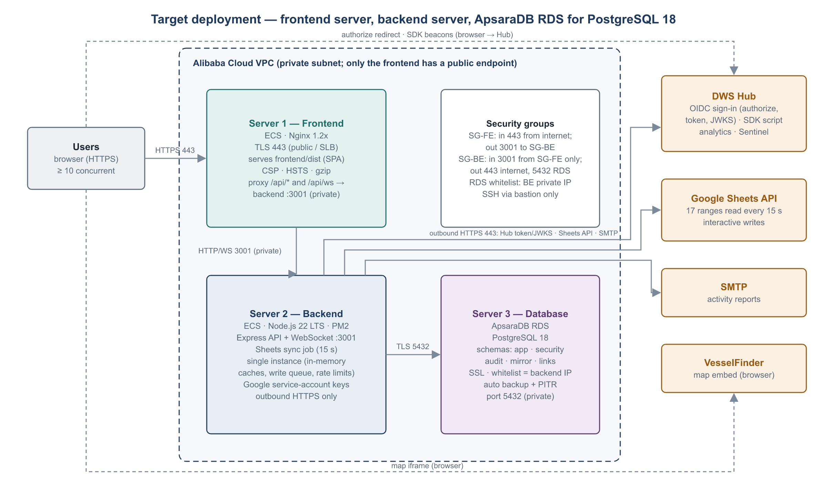
Figure: Target deployment on three servers
Design decisions:
# | Decision | Rationale
D1 | Frontend and API share one origin. The frontend Nginx proxies /api/* and /api/ws to the backend's private IP. | Keeps the __Host- session cookie, CSRF header model, SameSite behaviour and DWS Hub redirect URI unchanged. No CORS is needed for the web app, and the backend gets no public IP.
D2 | Exactly one backend instance. | Caches, rate-limit counters, the sheet-mutation queue and the sync timer are in-process. A second instance would double Google polling and break write serialisation (CODE-REVIEW §4). Availability comes from PM2 auto-restart plus graceful shutdown.
D3 | All persistent data moves to PostgreSQL. This includes the Sheets mirror. | Survives backend rebuilds; gives managed backup and point-in-time recovery; lets reporting connect read-only. Mirror swaps are transactional, so readers never see a half-built table.
D4 | The mirror stays text-typed, one table per sheet range. | Matches the code's current behaviour (all sheet values are strings) and keeps sheet-structure changes from breaking ingestion. Typed access belongs in views, such as mirror.v_port_calls.
D5 | Audit tables are partitioned by month. | Retention (90 days) is done by dropping partitions instead of large DELETEs.
D6 | Secrets stay on the backend server only. | Google service-account keys, JWT_SECRET, DB credentials and SMTP credentials never reach the frontend server.

3.3 Request paths
Path | Hops
Page load | Browser → FE Nginx (static dist/, cached assets)
API read | Browser → FE Nginx /api/... → BE Express → PostgreSQL mirror / links (or in-process cache)
API write | Browser → FE Nginx → BE Express → mutation queue → Google Sheets API → PostgreSQL mirror → WebSocket broadcast
Realtime | Browser ⇄ FE Nginx /api/ws (upgrade) ⇄ BE ws
Sign-in | Browser → FE → BE /api/auth/sso/login → 302 DWS Hub → Browser → FE → BE /api/auth/sso/callback → Hub token + JWKS (BE outbound) → PostgreSQL app.users
Sync | BE timer → Google Sheets API → PostgreSQL mirror / links
Telemetry | Browser → DWS Hub SDK endpoint (direct, not through the ERP)

4. Deployment architecture (3 servers)

4.1 Server specification (recommended starting size)
Server | Service | Size (start) | OS / software | Inbound | Outbound
1. Frontend | Alibaba Cloud ECS (optionally behind SLB/ALB) | 2 vCPU, 4 GB RAM, 40 GB ESSD | Ubuntu 24.04 LTS or Alibaba Cloud Linux 3; Nginx; certbot or SLB certificate | 443 from internet (80 → 301); 22 from bastion | 3001 to backend (private)
2. Backend | ECS, private subnet, no public IP | 4 vCPU, 8 GB RAM, 60 GB ESSD | Node.js 22 LTS, PM2 | 3001 from frontend security group only; 22 from bastion | 443 to internet (Google APIs, DWS Hub, SMTP, via NAT gateway); 5432 to RDS
3. Database | ApsaraDB RDS for PostgreSQL 18, High-availability edition (primary + standby) | 2 vCPU, 8 GB RAM, 100 GB ESSD PL1, storage auto-scale on | — | 5432 from the backend private IP (RDS whitelist) | —

Sizes assume 50 concurrent users (PRD NFR-01) and should be checked against the staging load test (backend/scripts/load-test.js). Before provisioning, confirm that PostgreSQL 18 is offered in the target region and instance family. The schema uses no PostgreSQL 18-only features, so PostgreSQL 17 is a drop-in fallback.

4.2 Network and security
Control | Setting
VPC | One VPC, two vSwitches: public (frontend / SLB) and private (backend). RDS sits in the private vSwitch zone.
SG-FE | In: 443 (and 80) from 0.0.0.0/0; 22 from the bastion SG. Out: 3001 to SG-BE; 443 for OS updates.
SG-BE | In: 3001 from SG-FE only; 22 from the bastion SG. Out: 443 (via NAT gateway); 5432 to the RDS endpoint.
RDS whitelist | Backend private IP only, plus the bastion for DBA access. No public endpoint.
TLS | Public: TLS 1.2+ on Nginx or SLB, HSTS. Database: sslmode=verify-full with the RDS CA certificate.
DWS Hub | Register redirect URI https://<erp-host>/api/auth/sso/callback and Target URL https://<erp-host>/api/auth/sso/login. SDK allowed origin: https://<erp-host>.
Google | Service-account JSON files only on the backend, chmod 600, in SERVICE_ACCOUNTS_DIR.

4.3 Frontend server: Nginx configuration (reference)
upstream erp_backend { server 10.0.2.10:3001; keepalive 32; } # backend private IP

server {
listen 443 ssl http2;
server_name erp.example.com;
ssl_certificate /etc/nginx/tls/erp.crt;
ssl_certificate_key /etc/nginx/tls/erp.key;

root /var/www/astar-erp/dist;
index index.html;

add_header Strict-Transport-Security "max-age=31536000; includeSubDomains" always;
add_header X-Content-Type-Options nosniff always;
add_header Referrer-Policy strict-origin-when-cross-origin always;
add_header Content-Security-Policy "default-src 'self'; script-src 'self' https://dwshub.kpndomain.com https://accounts.google.com; connect-src 'self' wss://erp.example.com https://dwshub.kpndomain.com; frame-src https://www.vesselfinder.com https://accounts.google.com; img-src 'self' data: https:; style-src 'self' 'unsafe-inline' https://accounts.google.com" always;

gzip on; gzip_types application/json application/javascript text/css image/svg+xml;

location /assets/ { expires 1y; add_header Cache-Control "public, immutable"; try_files $uri =404; }

location = /api/ws {
proxy_pass http://erp_backend;
proxy_http_version 1.1;
proxy_set_header Upgrade $http_upgrade;
proxy_set_header Connection "upgrade";
proxy_set_header Host $host;
proxy_set_header X-Forwarded-For $remote_addr;
proxy_set_header X-Forwarded-Proto https;
proxy_read_timeout 1h;
}

location /api/ {
proxy_pass http://erp_backend;
proxy_http_version 1.1;
proxy_set_header Connection "";
proxy_set_header Host $host;
proxy_set_header X-Forwarded-For $remote_addr; # one trusted hop -> app.set('trust proxy', 1)
proxy_set_header X-Forwarded-Proto https;
proxy_read_timeout 90s; # Google write timeout is 60 s
client_max_body_size 200k;
}

location / { try_files $uri /index.html; add_header Cache-Control "no-cache"; }
}
If an SLB/ALB terminates TLS in front of Nginx, enable real_ip from the SLB address range. That keeps X-Forwarded-For as one hop to the backend and keeps IP-based rate limits and lockout accurate (CODE-REVIEW H8).

4.4 Backend server: process configuration (reference)
// /opt/astar-erp/backend/ecosystem.config.js
module.exports = {
apps: [{
name: 'astar-erp-api',
script: 'server.js',
cwd: '/opt/astar-erp/backend',
instances: 1, // D2: never cluster
exec_mode: 'fork',
kill_timeout: 12000, // graceful shutdown completes within 10 s
max_memory_restart: '1500M',
env: { NODE_ENV: 'production' },
}],
};

4.5 Environment configuration by server
Variable | Server | Example / rule
VITE_HUB_SDK_KEY, VITE_HUB_SDK_URL, VITE_GIT_SHA | build of the frontend | Production Hub key and URL; release = git commit
PORT, HOST, TRUST_PROXY_HOPS | backend | 3001; the backend private IP (default 127.0.0.1); 1 with Nginx only, 2 if an SLB sits in front without real_ip
JWT_SECRET | backend | ≥ 32 random characters; rotation logs everyone out
FRONTEND_URL, CORS_ORIGINS | backend | https://erp.example.com
DATABASE_URL, PG_POOL_MAX | backend | postgres://erp_app_login:<pw>@<rds-host>:5432/erp?sslmode=verify-full&sslrootcert=/opt/astar-erp/secrets/rds-ca.pem; pool max 20
MIGRATION_DATABASE_URL | backend (deploy only) | Same form, owner account erp_owner; used only by npm run db:migrate
DWS_HUB_URL, DWS_HUB_CLIENT_ID, DWS_HUB_REDIRECT_URI, DWS_HUB_ALLOWED_EMAIL_DOMAINS | backend | see DWS-HUB-INTEGRATION §3
SERVICE_ACCOUNTS_DIR | backend | /opt/astar-erp/secrets/service-accounts
GOOGLE_CLIENT_ID, GOOGLE_ALLOWED_DOMAIN | backend | Legacy Google sign-in; unset to disable
SMTP_URL or SMTP_HOST / SMTP_USER / SMTP_PASS, USER_ACTIVITY_REPORT_TO | backend | Activity reports
MATTHEW_EMAIL | backend | Owner / recovery admin (to be replaced, PRD Q7)
SESSION_AUDIT_HMAC_KEY, PASSWORD_AUDIT_HMAC_KEY | backend | Audit fingerprints
READY_MAX_SYNC_AGE_MS, SHEET_MUTATION_MAX_WAIT_MS | backend | Defaults 300000 and 10000

4.6 Code changes required for the target platform
ID | Change | Files | Effort
C-1 | Bind to process.env.HOST (default 127.0.0.1) instead of the hard-coded loopback, so the frontend server can reach the API; TRUST_PROXY_HOPS configurable. Done (Phase 0). | backend/server.js | XS
C-2 | Add a PostgreSQL data-access layer (pg Pool, async) and move app / security / audit tables to it | db/database.js, services/sessionAuth.js, googleAccountAccess.js, hubSso.js, loginSecurity.js, userActivity.js, routes/users.js, routes/auth.js, appsScriptSheetSync.js | L
C-3 | Write the mirror to mirror.* with staging tables and a transactional swap; maintain mirror.database_meta.version | services/bulkDataSync.js | M
C-4 | Replace the SQLite file-signature cache keys with mirror.database_meta.version | all dashboard builders (databaseFileSignature users), routes/data.js | M
C-5 | Build links.* in PostgreSQL | services/vesselLinks.js, vesselLinkStore.js, vesselMatching.js, contractUnlink.js | M
C-6 | Use one Postgres-backed audit.ensure_month_partitions job, and retention by DROP TABLE of old partitions | services/userActivity.js | S
C-7 | Run SQL migrations at deploy time, replacing the inline ALTER TABLE try/catch; numbered files in backend/db/migrations/. Runner done (Phase 0): backend/db/postgres/migrate.js, npm run db:migrate / db:status; checksums, advisory lock, one transaction per file. | backend/db/postgres/migrate.js, scripts/db-migrate.js | S
C-8 | A data migration script (SQLite → PostgreSQL) for erp.db, login_security.db and user_activity.db. The mirror is rebuilt from Sheets, so it is not migrated. | new backend/scripts/migrate-sqlite-to-postgres.js | S
C-9 | Readiness probe checks PostgreSQL (SELECT 1) and pool saturation | backend/server.js | XS

Sizes: XS < ½ day, S ≈ 1 day, M 2–3 days, L 4–6 days. The total, including testing, is about 3 weeks for one developer. §11 gives the phasing.

4.7 Deployment procedure
- Database. Create the RDS instance, database erp and the login users. On the backend server run MIGRATION_DATABASE_URL=… npm run db:migrate as the owner account; it applies every pending file in backend/db/migrations/ and is safe to re-run. npm run db:status shows what is applied.
- Backend.
  - git pull or copy the release.
  - npm ci --omit=dev.
  - Place .env and the service-account keys.
  - pm2 start ecosystem.config.js (or pm2 reload for an update; SIGTERM is handled gracefully).
  - Check curl http://<be-ip>:3001/api/ready on the private network. It returns 200 once the first sync succeeds.
- Frontend.
  - Build with VITE_HUB_SDK_KEY and VITE_GIT_SHA set: npm ci && npm run build.
  - Upload dist/ atomically: copy to releases/<sha>, then switch the current symlink.
  - nginx -t && systemctl reload nginx.
- Smoke test.
  - /api/auth/access-status shows hubSso.enabled: true.
  - Sign in through the Hub.
  - Open one page per department.
  - The Hub SDK screen shows "Receiving data".
- Rollback.
  - Frontend: switch the symlink back.
  - Backend: pm2 deploy the previous release.
  - Database: migrations are additive and backward-compatible for one release; use RDS point-in-time restore only for data corruption.

5. System process model (L0 → L1 → L2)

5.1 L0 system process map
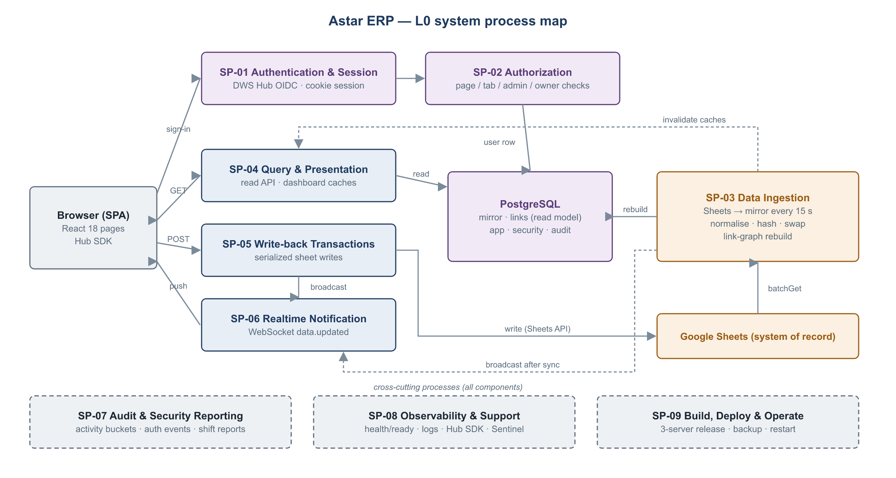
Figure: L0 system process map
L0 | System process | Trigger | Main components | Supports PRD L0
SP-01 | Authentication and session management | User sign-in; every API request | hubSso.js, routes/auth.js, sessionAuth.js, sessionCookie.js | L0-01
SP-02 | Authorization and access administration | Every API request and WS message; admin edits | middleware/auth.js, routes/users.js, ProtectedRoute.jsx | L0-01
SP-03 | Data ingestion (Google Sheets → mirror) | Timer (15 s); manual refresh; after writes | bulkDataSync.js, dataSources.js, vesselLinks.js | L0-07 (feeds L0-02 … L0-06)
SP-04 | Query and presentation | Page load; realtime refresh | routes/sheets.js (GET), dashboard builders, React pages | L0-02 … L0-06
SP-05 | Write-back transactions | User edits | routes/sheets.js (POST), sheetMutations.js, vesselMatching.js, contractUnlink.js | L0-02, L0-03
SP-06 | Realtime notification | Data change | services/realtime.js, useDataRefresh.js | L0-02 … L0-07
SP-07 | Audit and security reporting | Every request; schedule (07:00 / 19:00 SGT) | userActivity.js, loginSecurity.js, securityAuditWorkbook.js | L0-08
SP-08 | Observability and support | Continuous | /api/health, /api/ready, Hub SDK, PageErrorBoundary.jsx, Sentinel | L0-08
SP-09 | Build, deploy and operate | Release; incident | Vite build, PM2, Nginx, RDS backup | L0-08

5.2 SP-01 Authentication and session management
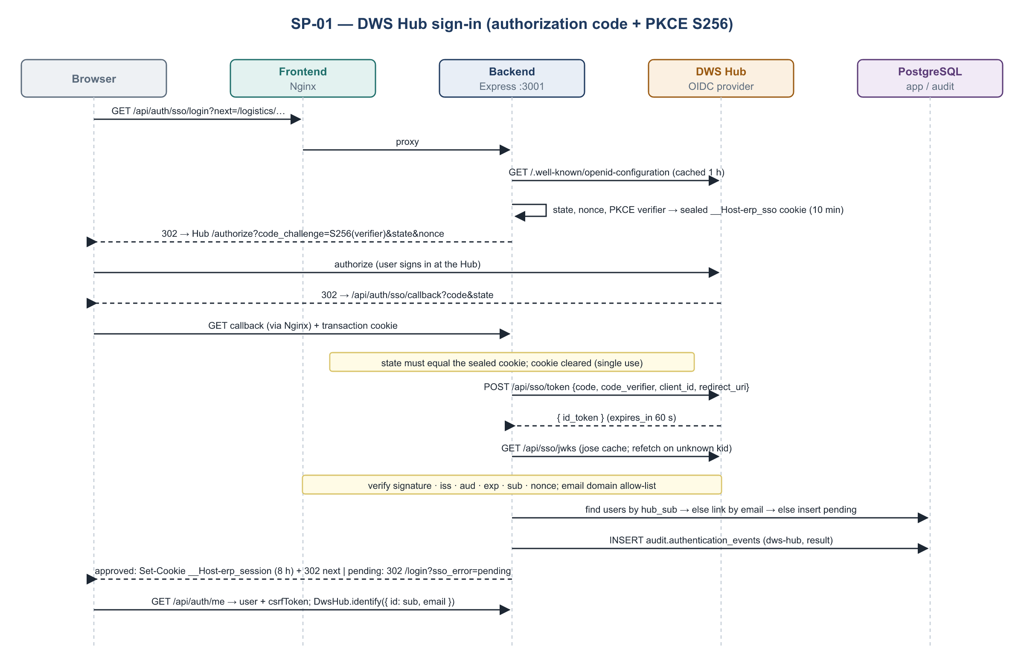
Figure: DWS Hub sign-in sequence
L1-01.1 DWS Hub OIDC sign-in
L2 | Step | Component | Behaviour | Errors / edge cases
1 | Start | GET /api/auth/sso/login?next= (routes/auth.js) | Checks Hub SSO is enabled and the IP is not blocked; rate limit 300 per 15 min per IP | Disabled → /login?sso_error=sso_disabled; blocked → login error, or decoy outside TW/ID
2 | Discovery | hubSso.getDiscovery() | Fetches <DWS_HUB_URL>/api/sso/.well-known/openid-configuration, cached 1 h, 10 s timeout | Unreachable → hub_unavailable
3 | Transaction | hubSso.startTransaction() | Random state (32 B), nonce (32 B), PKCE verifier (48 B); S256 challenge. Sealed as HS256 JWT in the __Host-erp_sso cookie (HttpOnly, Secure, SameSite=Lax, 10 min). next is restricted to same-site ERP paths (safeNextPath). | Open-redirect attempts fall back to /dashboard
4 | Authorize redirect | hubSso.authorizationUrl() | 302 to Hub /authorize with response_type=code, client_id, redirect_uri, scope, state, nonce, code_challenge, code_challenge_method=S256 | —
5 | Callback | GET /api/auth/sso/callback | Reads and clears the transaction cookie; constant-time state comparison | Hub error= → hub_denied; no cookie or mismatch → session_expired
6 | Token exchange | hubSso.exchangeCode() | POST /api/sso/token JSON {grant_type, code, redirect_uri, client_id, code_verifier} | invalid_grant or non-200 → token_invalid
7 | ID token verification | hubSso.verifyIdToken() (jose) | JWKS via createRemoteJWKSet (refetch on unknown kid, 30 s cooldown). Checks issuer from discovery, aud = client_id, asymmetric algorithms only, exp (15 s tolerance), sub present, nonce equal if echoed | Any failure → token_invalid
8 | Email policy | isAllowedHubEmail() | Optional DWS_HUB_ALLOWED_EMAIL_DOMAINS | Refused → identity_not_allowed (no account created)
9 | Identity mapping | provisionHubUser() | Find by hub_sub; else link the existing account by case-insensitive email; else insert a pending user | hub_sub mismatch → review_required
10 | Approval gate | routes/auth.js | is_approved must be true | Pending → /login?sso_error=pending
11 | Session issue | startSession() | JWT HS256 {id, auth_version, jti, csrf, …} in the __Host-erp_session cookie: 8 h, or 30 days with DWS_HUB_SESSION_REMEMBER. Audit events recorded; dashboard preload triggered; 302 to next | —
12 | Client bootstrap | AuthContext.jsx | GET /api/auth/me → user + CSRF token (sessionStorage); WebSocket connect; DwsHub.identify({ id: hub_sub, email }) | 401 → /login

L1-01.2 Corporate Google sign-in (legacy)
L2 | Step | Component | Behaviour
1 | Button | Login.jsx (Google Identity Services) | Shown when GOOGLE_CLIENT_ID is set; hidden in the desktop shell only for Hub SSO
2 | Verify | POST /api/auth/google → OAuth2Client.verifyIdToken | Audience = GOOGLE_CLIENT_ID
3 | Domain policy | isAllowedGoogleIdentity() | email_verified, hd = GOOGLE_ALLOWED_DOMAIN, email suffix
4 | Provision and gate | provisionGoogleUser() | Same pending / approval rules as Hub
5 | Session | issueSession() | JSON {user, csrfToken} + cookie; "remember" gives 30 days

L1-01.3 Per-request session validation
L2 | Step | Component | Behaviour
1 | Extract | sessionTokenFromRequest() | Cookie __Host-erp_session (≤ 8 KB), else Authorization: Bearer
2 | Verify | verifySessionToken() | jwt.verify HS256 with JWT_SECRET; reloads the user row; auth_version must match; is_approved must be 1
3 | CSRF | csrfValidForRequest() | Cookie transport + POST/PUT/PATCH/DELETE → header X-ERP-CSRF must equal the csrf claim (constant-time)
4 | Context | requireAuth | Sets req.user; records request activity (SP-07)
5 | Reject | requireAuth | 401 (cookie cleared) or 403 ACCOUNT_PENDING / CSRF_INVALID; the client redirects to /login

L1-01.4 Restore and sign-out
L2 | Step | Behaviour
1 | Restore | On SPA start: GET /auth/access-status (decoy check, sign-in options), then GET /auth/me
2 | Sign-out | DwsHub.reset(), then POST /auth/logout (audit "cleared"); cookie cleared; WebSocket closed

L1-01.5 Sign-in protection
L2 | Step | Component | Behaviour
1 | IP gate | server.js middleware | A blocked IP gets 403 or the decoy on /api/*, except health, access-status, sign-in endpoints and page-visit
2 | Rate limits | express-rate-limit | Per 15 min per IP: password 30, Google 200, DWS Hub 300, page-visit 120, Apps Script events 900, global 15,000. Allow-listed IPs skip the sign-in limits.
3 | Lockout | loginSecurity.js | 4 failed password or Google sign-ins → blocked until unlocked. DWS Hub failures are audit-only.
4 | Presentation | loginPresentation.js | Real login and errors only for GeoIP TW/ID; others get the decoy page (PRD Q2)
5 | Nginx gate | GET /api/auth/gate | 204 or 403 for Nginx auth_request before serving documents

5.3 SP-02 Authorization and access administration
L1-02.1 Page-level authorization
L2 | Step | Component | Behaviour
1 | Resolve the grant | hasPageAccess(user, path) | Admin → allow. permissions contains the department (path segment 1) → allow. tab_permissions contains the exact path → allow.
2 | Enforce on API | canAccessAnyPage() in routes/sheets.js; requireAnyPage | Each endpoint lists the page paths that may read it (§7.1). Failure → 403 "Access denied".
3 | Enforce in UI | ProtectedRoute, AuthContext.hasPermission / hasTabAccess, Sidebar | Hidden menu entries; direct URL → /dashboard

L1-02.2 Administrative roles
L2 | Step | Component | Behaviour
1 | Admin | requireAdmin | is_admin → user list and approval, sheet config, refresh, data browser, test tools
2 | Owner | requireMatthew | Email = MATTHEW_EMAIL → manage admins, change linked emails, delete users, IP rules, activity report
3 | Invariants | db/database.js start-up and routes/users.js | The owner always stays an approved admin; admin cannot be granted through permissions; an admin needs a linked identity (Hub or Google)

L1-02.3 Approve or modify a user (PUT /api/users/:id)
L2 | Validation / action
1 | Target exists (404). The email is normalised; an unchanged Hub email from another domain is accepted.
2 | Non-owner cannot edit admins, the owner, themself, or grant admin (403). Non-owner cannot change the email (403).
3 | Admin requires a linked identity and approval (400). admin in permissions is rejected (400). A linked email cannot change (400).
4 | Approval requires at least one page (400). Cannot remove own admin role or approval (400). The owner must stay an approved admin (400).
5 | UPDATE with auth_version = auth_version + 1, which revokes the user's sessions on their next request.

L1-02.4 Realtime authorization: realtime.js canReceive delivers data.updated only to sockets whose user can open at least one page affected by the resource.

5.4 SP-03 Data ingestion (Google Sheets → mirror)
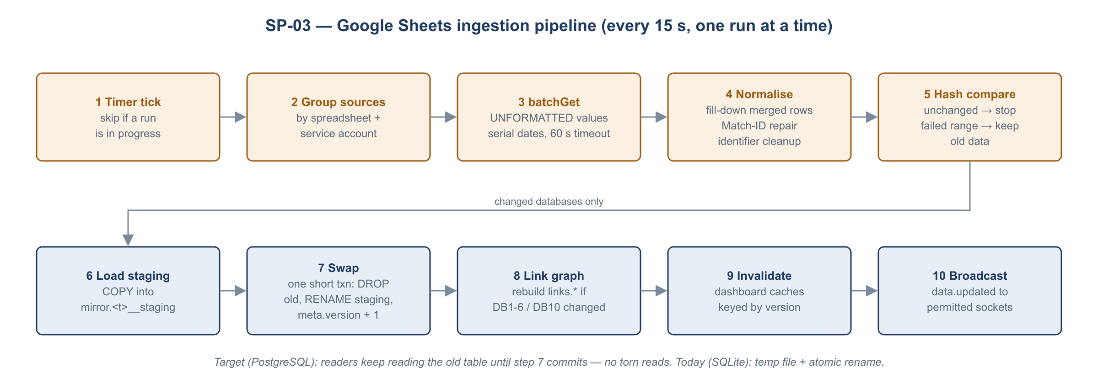
Figure: Ingestion pipeline
L1-03.1 Scheduled pull
L2 | Step | Component | Behaviour | Errors
1 | Tick | startBulkDataSync() | Every 15 s (BULK_SYNC_INTERVAL_MS); a run is skipped while another runs | —
2 | Group | refreshBulkDatabases() | One group per (spreadsheet, service account): 6 groups for 17 databases | —
3 | Fetch | values.batchGet | UNFORMATTED_VALUE, serial dates, 60 s timeout | A failed group marks its databases unavailable; old data is kept
4 | Normalise | bulkDataSync.js | Fill-down for merged child rows (DB1–DB5); identifier normalisation; numeric date formatting | —
5 | Match-ID repair | bulkDataSync.js | A duplicate ERP Match ID gets a new UUID on the later copy, which is written back to the sheet and its legacy VSL cell cleared. If the write fails, the row is quarantined with a blank ID. | Logged
6 | Change detection | SHA hash of the normalised payload | Unchanged → stop for that database | —
7 | Rebuild | writeDatabase() | Today: temp SQLite file → renameSync (atomic on Linux). Target: load mirror.<t>__staging, then in one transaction drop the old table, rename staging, and upsert mirror.database_meta (version + 1) and mirror.column_map. | A failure leaves the previous table intact
8 | Link graph | rebuildVesselLinks() | If any of DB1–DB6 or DB10 changed: rebuild parent nodes (DB6 slots), child nodes (contract rows), links | Skipped if any link source is unavailable
9 | Notify | broadcastDataUpdated({resource: 'bulk-databases', databases}) | SP-06 | —
10 | Status | bulkSyncStatus() | lastSuccessAt feeds /api/ready (stale after 5 min → 503) | —

L1-03.2 Mirror table layouts (config/dataSources.js)
Layout | Used by | Shape
separate | DB6–DB8, DB10–DB17 | One table per range; _sheet_row + one text column per header
side-by-side | DB1–DB5 | Contract tab and its Shadow tab combined row by row: _<prefix>_row, <prefix>_<header>…, _shadow_row, shadow_<header>…
raw-grid | DB9 | Unparsed grid (c1…cN); the Stock Summary parser finds port headers and date rows

Header-to-column naming: lower snake_case; duplicates get _2, _3…; empty headers become col_<n>. The mapping is kept in _columns today and mirror.column_map in the target.
L1-03.3 Manual and post-write refresh: POST /api/sheets/refresh (admin) runs the pull immediately. Writes schedule a refresh 500 ms after success.

5.5 SP-04 Query and presentation
L1-04.1 API request pipeline (order in server.js)
L2 | Middleware | Purpose
1 | helmet | X-Frame-Options: SAMEORIGIN, nosniff, referrer policy (CSP and HSTS are set by Nginx)
2 | compression | gzip / brotli JSON
3 | cors | Allow-list FRONTEND_URL, CORS_ORIGINS, DESKTOP_CLIENT_ORIGIN
4 | express.json | 100 KB limit, strict
5 | IP gate | SP-01 L1-01.5
6 | Rate limits | SP-01 L1-01.5
7 | Router | /api/auth, /api/users, /api/sheets, /api/data, /api/vessel-slots, /api/test/apps-script-sheet
8 | requireAuth + page check | SP-01, SP-02
9 | Error handler | 403 origin, 413 body, 400 JSON, 500 generic (logged with method, path and stack)

L1-04.2 Dashboard build and cache
L2 | Step | Behaviour
1 | Cache key | Today: file signature (size + mtime) of each DB file read. Target: mirror.database_meta.version of each table read.
2 | Hit | Return the cached JSON object (contract dashboard, vessel contract, export summary, vessel status, vessel update, KPN export, live vessels)
3 | Miss | Read the mirror tables, apply the business rules (PRD §4), store the result under the new key
4 | Paging | Contract Dashboard (limit 20–200, offset), Pending Matching, Contract Unlink, data browser
5 | Preload | dashboardPreload.js at start-up (+8 s) and after each sign-in, at most once per 60 s

L1-04.3 Client data lifecycle (useDataRefresh.js)
L2 | Behaviour
1 | Initial fetch on page mount
2 | Subscribe to data.updated for the page's resources
3 | Debounce refetches by 500 ms; defer while the tab is hidden
4 | Polling fallback every 60 s (Stock Summary 7 s)
5 | Keep cells the user is editing (Vessel Update)

5.6 SP-05 Write-back transactions
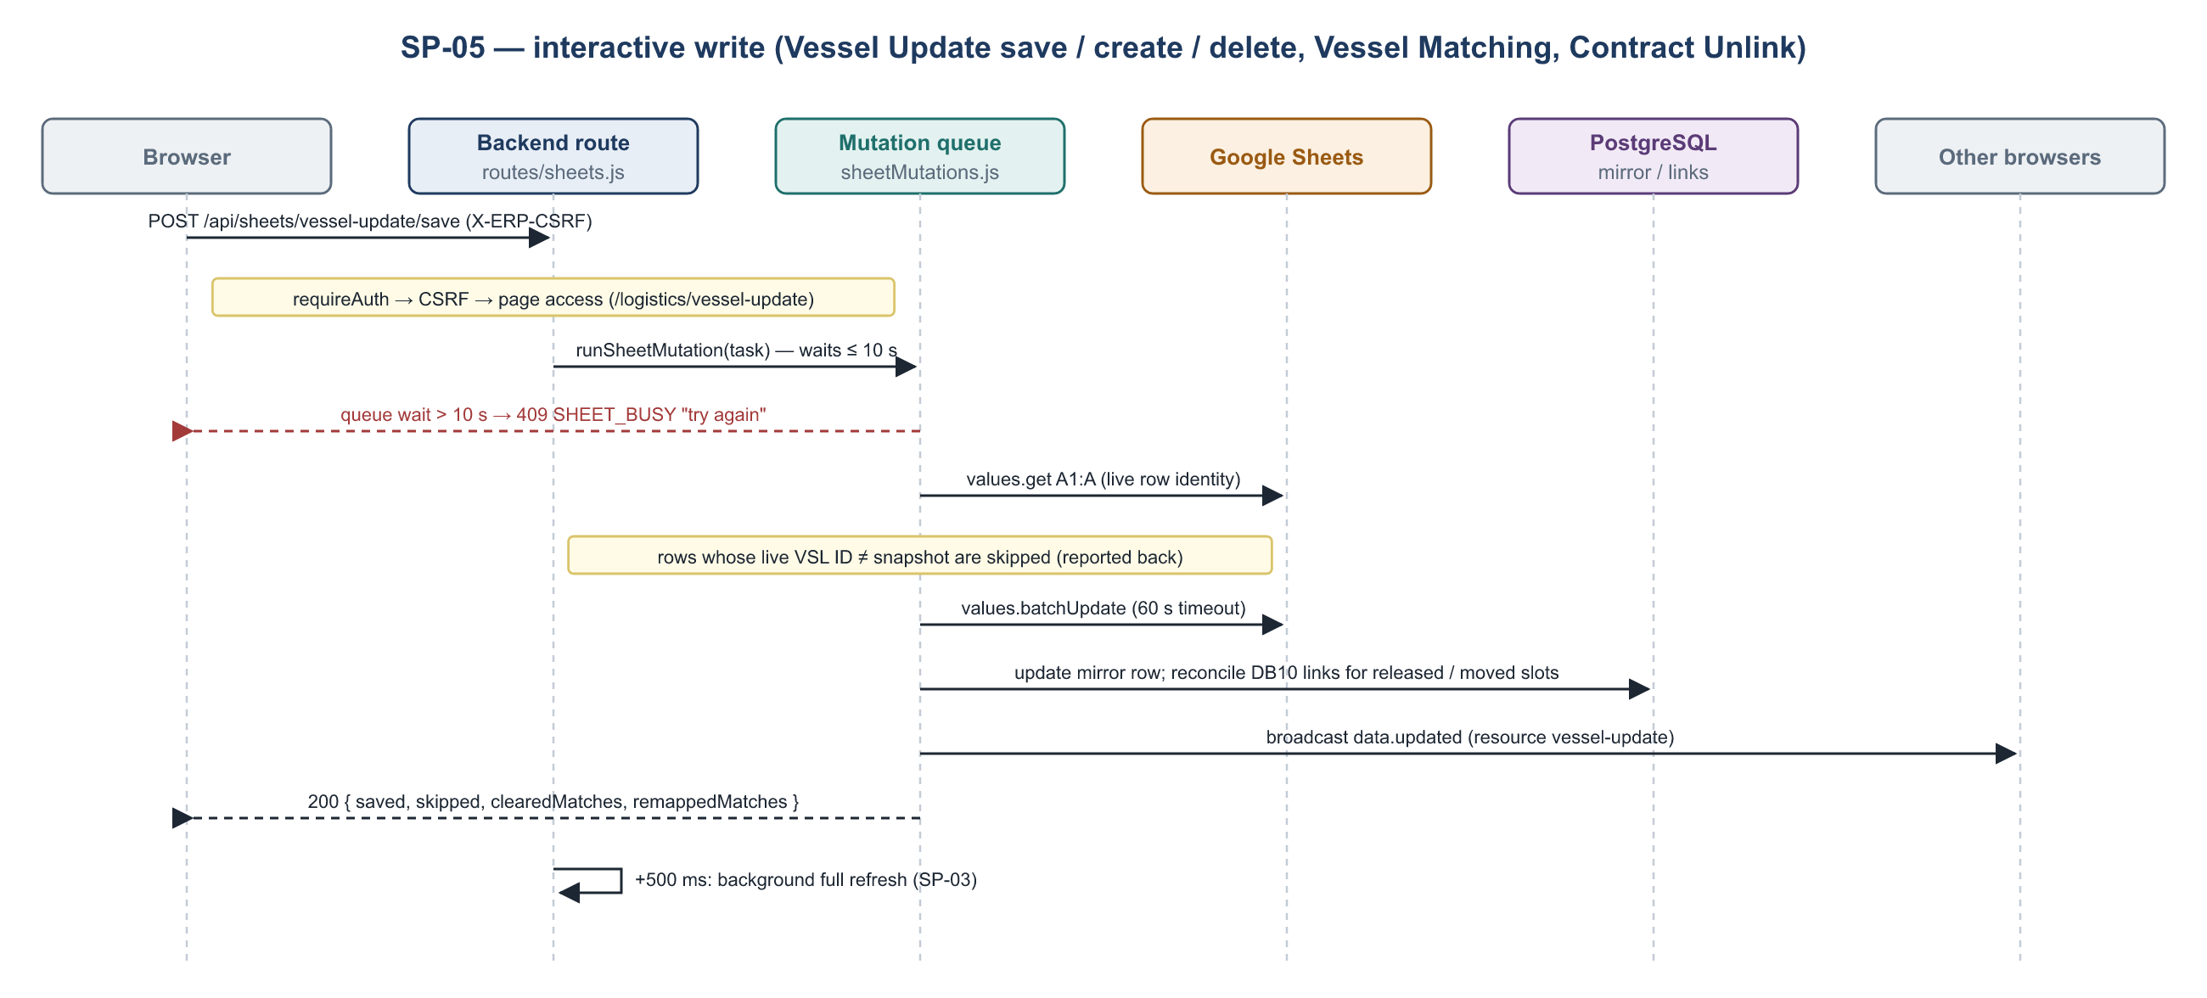
Figure: Write path sequence
L1-05.0 Common write envelope (all writes)
L2 | Step | Component | Behaviour
1 | Authenticate | requireAuth | Cookie + CSRF header
2 | Serialize | serialized() → runSheetMutation() | Single in-process FIFO. Waiting more than 10 s → 409 SHEET_BUSY. One failure never blocks the next write.
3 | Authorize | handler | Page check (§7.1)
4 | Live re-check | readSourceRange() | Row identity is read from the live sheet inside the queue
5 | Write | writeSourceCells / writeSourceRange / appendSourceRows / deleteSourceRow | Google Sheets API, 60 s timeout, USER_ENTERED (formula-injection risk, CODE-REVIEW M1)
6 | Mirror update | updateVesselDatabase, vesselLinkStore | Local mirror updated immediately so the next read is consistent
7 | Notify | broadcastDataUpdated | SP-06
8 | Respond | — | JSON result; 4xx with a user-readable reason; 5xx generic

L1-05.1 Vessel Update save (POST /api/sheets/vessel-update/save)
L2 | Step
1 | Validate updates[] (integer row ≥ 2, col ≥ 0); optional expected_ids{row: vsl_id}
2 | Compare against the snapshot (expected_ids), then against the live column A. Mismatches go to skipped[].
3 | Convert YYYY-MM-DD to D Mon YYYY; demurrage rate (col O) to a number
4 | Per row: compute the final port blocks. Slots that become empty or non-load are released; valid slot_remaps move links
5 | batchUpdate the cells, then update the DB6 mirror, then reconcileVesselMatchingSlots (DB10)
6 | Broadcast vessel-update (and vessel-matching if links changed); refresh 500 ms later

L1-05.2 Vessel create: read A:E live → nextVslId = vsl_<YY>_<max+1> for the current year → target row = last row with a vessel name + 1 → write the sparse row (vessel fields, 10 × 15 port fields; slot VSL-ID formula columns untouched) → refresh and broadcast.
L1-05.3 Vessel delete: snapshot check (vsl_id) → live check of A and E for the row → deleteDimension → refresh and broadcast. A mismatch → 409.
L1-05.4 Vessel Matching assign / unmatch (services/vesselMatching.js)
L2 | Step
1 | Validate the tab and row; the row's ref and match_id must equal expectedRef / expectedMatchId (409 "row shifted or was copied")
2 | The Match ID must be unique and present (409 / 503 "waiting for a unique ERP Match ID")
3 | The target slot must exist and be a valid load slot (409 "loadport no longer available")
4 | The current assignment must equal expectedAssignedVslId (409 "assignment changed")
5 | Upsert the DB10 ledger row (Active TRUE / FALSE, Updated At, Updated By) → append or update in the sheet + local mirror
6 | Mirror the legacy VSL column on the source tab (best effort; legacyVslSynced)

L1-05.5 Partials:
- add-partial: insert a child row after the group, with a new Match ID, PARTIAL flag and qty 0. Re-merge the group's cells (GR keeps its merge topology).
- remove-partial: child rows only.
- save-partial-qty: a number ≥ 0 on PARTIAL rows only. The parent quantity is recalculated as contract qty − Σ children.
L1-05.6 Contract Unlink: a link is active when its latest DB10 row is Active and its VSL ID equals the contract's VSL. Unlink calls the matching save with an empty value, guarded by expectedVslId (409 when reassigned).

5.7 SP-06 Realtime notification
L1 | L2 steps
L1-06.1 Connect | 1. Browser opens wss://<host>/api/ws. 2. Server upgrade handler accepts only this path and allow-listed origins. 3. Session cookie verified as in SP-01 (pending or revoked → close). 4. Socket registered with its user's permissions.
L1-06.2 Broadcast | 1. broadcastDataUpdated({department, resource, action, …}). 2. For each socket, canReceive(user, message). 3. Send JSON. Payloads ≤ 16 KB.
L1-06.3 Liveness | Heartbeat every 30 s; dead sockets terminated. Graceful shutdown closes all sockets.
L1-06.4 Client | Reconnect with backoff; debounce and refetch (SP-04 L1-04.3). Edit-presence messages (edit.start / change / end) are implemented on the server but not used by any page.

5.8 SP-07 Audit and security reporting
L1 | L2 steps
L1-07.1 Request activity | 1. recordAuthenticatedRequest per request: user, IP, GeoIP country / region / city, device, path. 2. Aggregated in memory per (15-min bucket, session) and per (day, session). 3. Writes and admin actions are also recorded as user_action_events (method, path, status, duration, changed fields).
L1-07.2 Authentication events | Every sign-in outcome (auth_method password / google / dws-hub; result success / failure / pending / blocked / rate-limited / review-required / decoy) and every session-cookie event (issued / validated / rejected / cleared)
L1-07.3 Persistence and retention | Flush every 60 s and on shutdown; purge after USER_ACTIVITY_RETENTION_DAYS (default 90, minimum 7). Target: monthly partitions, dropped by the retention job.
L1-07.4 Shift reports | Scheduler checks every 60 s; at 07:00 and 19:00 Asia/Singapore it sends the previous 12 h. HTML summary plus aastar-security-audit-<date>-<shift>.xlsx. Idempotent per window (periodic_report_runs). Manual send by the owner (409 if already running, 502 on SMTP failure).
L1-07.5 IP security administration | Owner lists blocked IPs, unlocks, adds or removes allow-list entries (validated IPv4 / IPv6)

5.9 SP-08 Observability and support · SP-09 Build, deploy and operate
L1 | L2 steps
L1-08.1 Health | GET /api/health: liveness, always 200 while the process serves. GET /api/ready: 200 only if the DB answers, the last successful sync is ≤ 5 min old, and the process is not shutting down. Reports sync age and pending sheet writes.
L1-08.2 Logging | stdout / stderr captured by PM2 (pm2 logs, rotate with pm2-logrotate). Errors include method, path and stack. Sign-in failures log the reason code, never tokens.
L1-08.3 Client telemetry | Hub SDK script injected at build (vite.config.js). Page views (path only), time in app, JS errors and breadcrumbs, bug-report button. identify after sign-in, reset on sign-out. 8 tracked business actions (counts or flags only).
L1-08.4 Error isolation | PageErrorBoundary keeps the shell usable. window.reportError forwards the error to the SDK; "Report a bug" opens the SDK dialog.
L1-08.5 AI support | Sentinel (in the Hub) analyses each new error fingerprint and bug report, reading the code at data-release once the repository is connected
L1-09.1 Build | Frontend: npm ci && npm run build with VITE_HUB_SDK_KEY and VITE_GIT_SHA; names kept for readable stacks. Backend: npm ci --omit=dev. CI runs npm test in both packages.
L1-09.2 Release | DB migration → backend pm2 reload → frontend symlink switch (§4.7)
L1-09.3 Start and stop | Start: migrations check → init → realtime → sync → preload (+8 s). Stop (SIGTERM / SIGINT): stop sync → close WS → drain HTTP → flush audit → close DB → exit 0 (hard exit after 10 s).
L1-09.4 Backup and restore | RDS automatic full backup daily plus log backup (PITR), 14-day retention minimum. Monthly restore drill to a temporary instance. The mirror needs no backup (rebuilt from Sheets in under 1 minute). Service-account keys and .env are held in the secrets vault.
L1-09.5 Monitoring | Alerts: /api/ready ≠ 200 for 5 min; backend CPU > 80 % for 10 min; RDS connections > 80 %; RDS storage > 80 %; audit default partition not empty; certificate expiry < 21 days

5.10 Mapping: business processes (PRD) ↔ system processes
PRD L0 | SP-01 | SP-02 | SP-03 | SP-04 | SP-05 | SP-06 | SP-07 | SP-08 / 09
L0-01 Identity & access | ● | ● |  |  |  |  | ●
L0-02 Contract allocation |  | ○ | ● | ● | ● | ● | ○
L0-03 Vessel scheduling |  | ○ | ● | ● | ● | ● | ○
L0-04 Export reporting |  | ○ | ● | ● |  | ●
L0-05 Stock monitoring |  | ○ | ● | ● |  | ●
L0-06 Laytime & demurrage |  | ○ | ● | ●
L0-07 Master data sync |  |  | ● |  | ○ | ● |  | ○
L0-08 Platform ops & audit | ○ | ○ |  |  |  |  | ● | ●

● primary · ○ supporting

6. Data architecture

6.1 Data stores: today and target
Today (SQLite file) | Contents | Target (PostgreSQL schema) | Migration
data/erp.db | users, app_migrations, sheets_config, apps_script_*, sheet_cache (legacy) | app | Copied by script C-8; sheet_cache dropped
data/login_security.db | login_ip_security, login_ip_allowlist | security | Copied
data/user_activity.db | 9 audit tables | audit (partitioned) | Copy the last 90 days; credential-structure columns are not migrated (CODE-REVIEW M11)
data/databases/DB1.db … DB17.db | Sheets mirror, _database_meta, _columns | mirror | Not migrated; rebuilt by the first sync
data/databases/vessel_links.db | Link graph | links | Rebuilt by the first sync
Orphaned (shpt_file.db, master_matching.db, sheets_mirror.db) | Unused prototypes | — | Not migrated

6.2 ERD 1: application, security and audit
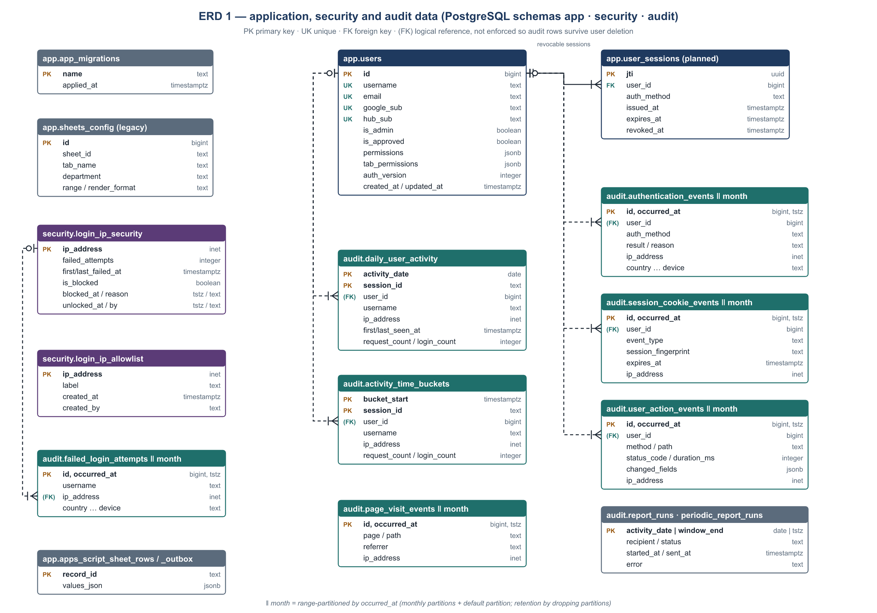
Figure: ERD 1
Relationship notes:
- app.users 1 — N app.user_sessions is enforced (ON DELETE CASCADE). The table is planned for server-side session revocation.
- app.users 1 — N audit.*.user_id is logical (no FK), so audit history survives user deletion. username and email are copied into each event for the same reason.
- security.login_ip_security.ip_address — audit.failed_login_attempts.ip_address is logical. Historical failures are imported into the lockout table on first start.

6.3 ERD 2: business read model (mirror and links)
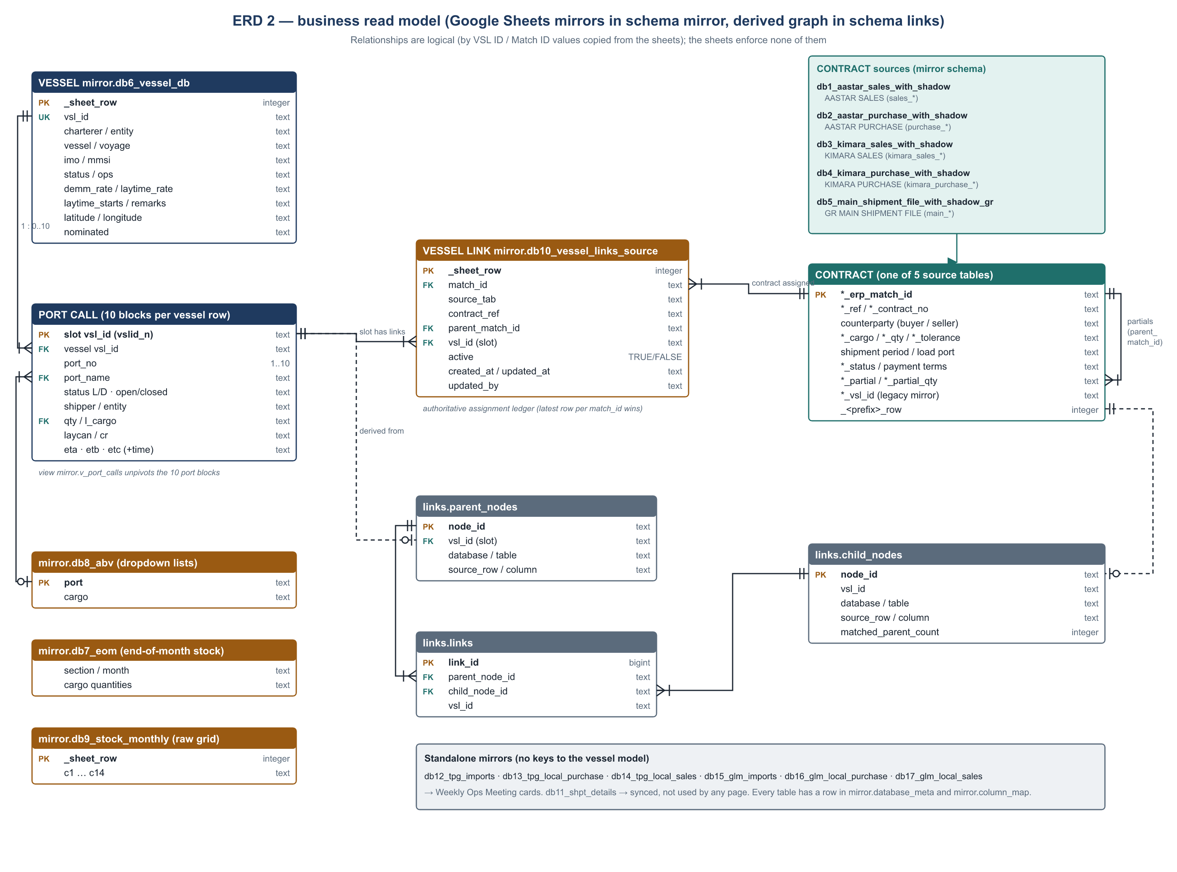
Figure: ERD 2
Entity (logical) | Physical table | Key | Notes
VESSEL | mirror.db6_vessel_db | _sheet_row; business key vsl_id (vsl_YY_NNNN) | One row per voyage, from VESSEL DB A:FX
PORT CALL | Columns of db6_vessel_db (10 blocks × 16) → view mirror.v_port_calls | Slot vslid_n | Block n starts at column 20 + 16 (n − 1). Fields: VSL ID (formula), port, L/D, shipper, entity, qty, cargo, open/closed, laycan, CR, ETA (+time), ETB (+time), ETC (+time)
VESSEL LINK | mirror.db10_vessel_links_source | match_id (latest row wins) | Authoritative assignment ledger (contract → slot), written by Vessel Matching and Unlink
CONTRACT | mirror.db1…db5_*_with_shadow* | <prefix>_erp_match_id | Five source tabs with different column prefixes; parent → partial children via parent_match_id in DB10 and the PARTIAL flag
Link graph | links.parent_nodes, links.child_nodes, links.links | node_id, link_id | Derived index of slot ↔ contract-row matches, used by the dashboards
Reference | mirror.db8_abv (ports, cargoes), db7_eom, db9_stock_monthly | — | Dropdowns, month-end stock, daily stock
Standalone | mirror.db11…db17 | _sheet_row | TPG / GLM operations (Weekly Ops); DB11 unused

6.4 Data dictionary: schema app
app.users: ERP accounts and their access grants.
Column | Type | Null | Key | Description
id | bigint identity | N | PK | Internal user ID (session JWT id claim)
username | text | N | UK | Display / reference name. New users get their email.
email | text | Y | UK (lower) | Sign-in email; immutable once a Hub or Google identity is linked
google_sub | text | Y | UK | Google subject (legacy sign-in)
hub_sub | text | Y | UK | DWS Hub OIDC sub; canonical identity for Hub sign-in and SDK identify
is_admin | boolean | N |  | Administrator role (CHECK: an admin must be approved)
is_approved | boolean | N |  | Access approved; false = pending
permissions | jsonb (array) | N |  | Whole-department grants: commercial, chartering, finance
tab_permissions | jsonb (array) | N |  | Exact page paths, e.g. /logistics/vessel-update
auth_version | integer | N |  | Incremented on every access change; sessions carrying an older value are rejected
created_at, updated_at | timestamptz | N |  | Audit timestamps

app.user_sessions (planned, CODE-REVIEW M2)
Column | Type | Null | Key | Description
jti | uuid | N | PK | Session ID (JWT jti)
user_id | bigint | N | FK → users.id (cascade) | Owner
auth_method | text | N |  | dws-hub / google
issued_at, expires_at | timestamptz | N |  | Validity window
revoked_at, revoked_by | timestamptz, text | Y |  | Logout or admin revocation

app.app_migrations
Column | Type | Null | Key | Description
name | text | N | PK | Migration identifier, e.g. 2026-09-delegated-administrators
applied_at | timestamptz | N |  | When it ran

app.sheets_config (legacy; not used by the live sync)
Column | Type | Null | Key | Description
id | bigint identity | N | PK
sheet_id | text | N |  | Google spreadsheet ID
sheet_name, tab_name | text | N |  | Display name, tab
department | text | N |  | Owning department
service_account_index | integer | N |  | Index into the legacy key list
range | text | Y |  | A1 range
render_format | text | N |  | unformatted or formatted

app.apps_script_sheet_rows / _meta / _events / _outbox (admin proof of concept)
Table | Columns | Purpose
apps_script_sheet_rows | record_id (PK, text), row_number (int), values_json (jsonb), pending_append (bool), source_updated_at, updated_at (tstz) | Local copy of Sheet1 rows with stable IDs
apps_script_sheet_meta | key (PK), value, updated_at | Sync cursor and settings
apps_script_sheet_events | event_id (PK), event_type, payload_json (jsonb), received_at | Idempotent inbound edit events
apps_script_sheet_outbox | id (PK), dedupe_key (UK), operation, record_id, column_number, values_json, attempts, next_attempt_at, last_error, created_at, updated_at | Durable outbound writes with retry

6.5 Data dictionary: schema security
security.login_ip_security
Column | Type | Null | Key | Description
ip_address | inet | N | PK | Client IP (after the trusted proxy)
failed_attempts | integer | N |  | Counted failures (password or Google)
first_failed_at, last_failed_at | timestamptz | Y |  | Window
last_username | text | Y |  | Last attempted name
is_blocked | boolean | N | IX | Blocked from all APIs
blocked_at, blocked_reason | timestamptz, text | Y |  | e.g. historical-login-failures
unlocked_at, unlocked_by | timestamptz, text | Y |  | Owner unlock

security.login_ip_allowlist
Column | Type | Null | Key | Description
ip_address | inet | N | PK | Trusted IP (skips sign-in rate limits and lockout)
label | text | Y |  | e.g. "Jakarta office"
created_at | timestamptz | N
created_by | text | N |  | Owner username

6.6 Data dictionary: schema audit
Client context columns. Most audit tables repeat the same client context. They are described once here:
Column | Type | Description
ip_address | inet | Client IP
country_code, country, region, city | text | geoip-lite lookup of the IP
user_agent | text | Raw User-Agent (truncated)
device | text | Parsed device / browser summary

Table | Key | Specific columns | Partitioned | Written by
daily_user_activity | (activity_date, session_id) | user_id, username, first_seen_at, last_seen_at, last_path, request_count, login_count | no | L1-07.1
activity_time_buckets | (bucket_start [15 min], session_id) | same as daily | no | L1-07.1
failed_login_attempts | (id, occurred_at) | activity_date, username | monthly | L1-01.5
authentication_events | (id, occurred_at) | activity_date, user_id, username, email, auth_method, result, reason, credential_supplied | monthly | L1-01.x
page_visit_events | (id, occurred_at) | activity_date, page (login / dummy), path, referrer | monthly | /auth/page-visit
user_action_events | (id, occurred_at) | completed_at, activity_date, user_id, username, email, session_id, method, path, status_code, duration_ms, changed_fields (jsonb), target_reference | monthly | L1-07.1
session_cookie_events | (id, occurred_at) | activity_date, user_id, username, email, event_type, session_fingerprint (HMAC), expires_at, auth_method, transport, cookie_name, secure, http_only, same_site | monthly | L1-01.x
report_runs | activity_date | recipient, status, started_at, sent_at, error | no | daily report (legacy)
periodic_report_runs | window_end | window_start, recipient, status, started_at, sent_at, error | no | L1-07.4

Function audit.ensure_month_partitions(month date) creates the five monthly partitions for that month. The backend calls it at start-up and daily for the current and next month. Each partitioned table also has a _default partition as a safety net; monitoring alerts when it is not empty.

6.7 Data dictionary: schema mirror
mirror.database_meta: one row per mirrored table.
Column | Type | Description
database_name, table_name | text (PK) | e.g. DB6, db6_vessel_db
layout | text | separate, side-by-side, raw-grid
source_sheet_id, service_account_email, source_tab, source_range | text | Provenance
row_count, column_count | integer | Size of this build
source_hash | text | Hash of the normalised payload (change detection)
version | bigint | +1 on every rebuild; the cache key for dashboards
pulled_at | timestamptz | Build time

mirror.column_map: (database_name, table_name, ordinal) PK → column_name, source_label (original sheet header).
Mirror table catalogue
DB | Target table | Spreadsheet → tab!range | Service account | Layout | Consumed by
DB1 | db1_aastar_sales_with_shadow | AASTAR Sales → AASTAR SALES!A:AU + Shadow!A:C | aastar-sales@ | side-by-side | Vessel Matching, Vessel Contract, Contract Dashboard, Open Shipments, Export Planning, links
DB2 | db2_aastar_purchase_with_shadow | AASTAR Sales → AASTAR PURCHASE!A:AK + Shadow!D:F | aastar-sales@ | side-by-side | same
DB3 | db3_kimara_sales_with_shadow | AASTAR Sales → KIMARA SALES!A:AQ + Shadow!G:I | aastar-sales@ | side-by-side | same
DB4 | db4_kimara_purchase_with_shadow | AASTAR Sales → KIMARA PURCHASE!A:AK + Shadow!J:L | aastar-sales@ | side-by-side | same
DB5 | db5_main_shipment_file_with_shadow_gr | GR → MAIN SHIPMENT FILE!A:BN + Shadow GR!A:E | grsalesandpurchase@ | side-by-side | same + Weekly Ops (GR exports)
DB6 | db6_vessel_db | Vessel → VESSEL DB!A:FX | vessel-vs-contract-2-0@ | separate | All logistics pages, links
DB7 | db7_eom | Vessel → EOM!A:R | vessel-vs-contract-2-0@ | separate | Export Summary (EOM stock)
DB8 | db8_abv | Vessel → ABV!A:C | vessel-vs-contract-2-0@ | separate | Vessel Update dropdowns
DB9 | db9_stock_monthly | Stock → Monthly!A:N | kpn-stock@ | raw-grid | Stock Summary
DB10 | db10_vessel_links_source | AASTAR Sales → Vessel Links!A:J | aastar-sales@ | separate | Assignment ledger
DB11 | db11_shpt_details | Shipment Details → Shpt Details!A:BC | tpgsalesandpurchase@ | separate | none (PRD Q5)
DB12 | db12_tpg_imports | TPG Operations → TPG IMPORTS!A:V | palmshptfile@ | separate | Weekly Ops
DB13 | db13_tpg_local_purchase | → TPG LOCAL PURCHASE!A:AM | palmshptfile@ | separate | Weekly Ops
DB14 | db14_tpg_local_sales | → TPG LOCAL SALES!A:AD | palmshptfile@ | separate | Weekly Ops
DB15 | db15_glm_imports | → GLM IMPORTS!A:L | palmshptfile@ | separate | Weekly Ops
DB16 | db16_glm_local_purchase | → GLM LOCAL PURCHASE!A:AM | palmshptfile@ | separate | Weekly Ops
DB17 | db17_glm_local_sales | → GLM LOCAL SALES!A:AD | palmshptfile@ | separate | Weekly Ops

mirror.db6_vessel_db: vessel-level columns (A–T). Every column is text except _sheet_row (integer).
Column | Sheet column | Header | Used for
_sheet_row | — | (row number) | Row identity for writes
vsl_id | A | vsl_id | Vessel business key vsl_YY_NNNN
charterer | B | Charterer | Export Planning filter (default AlphaStar)
entity | C | Entity | A*, A*JV, GR, JPN, 3P
mth | D | Mth | Month fallback for Export Summary
vessel | E | Vessel | Name; "last real row" for creates
voyage | F | Voyage
contractual_lc | G | Contractual LC | Read as est_demmurage by vesselUpdate.js
imo | H | IMO | VesselFinder lookup (7 digits)
mmsi | I | MMSI | VesselFinder lookup (9 digits)
status | J | Status | OPEN / CLOSED
ops | K | Ops | "pending" → planning status Pending
allocation | L | Allocation
latitude, longitude | M, N | latitude, longitude | Map fallback
demm_rate | O | Demm Rate | USD per day (PDPR)
laytime_rate (load_rate) | P | Load Rate | MT per hour
laytime_starts | Q | Laytime Starts | NOR +6, All Fast, Laycan NOR+6, Laycan All Fast
remarks | R | Remarks | Free text
nominated | S | Nominated | TRUE / FALSE
vslid_1 … port blocks | T onwards | see PORT CALL | 10 × 16 columns

mirror.db1_aastar_sales_with_shadow (example of a contract table; 52 columns). The DB2–DB5 tables follow the same pattern with prefixes purchase_, kimara_sales_, kimara_purchase_ and main_.
Column | Header | Column | Header
_sales_row | (row) | sales_ref | REF
sales_shpt_year | SHPT YEAR | sales_lexagle | LEXAGLE
sales_ctr | CTR | sales_bp | BP
sales_cfm | CFM | sales_performed | PERFORMED
sales_washout | WASHOUT | sales_balance | BALANCE
sales_status | STATUS | sales_trader | TRADER
sales_trade_date | TRADE DATE | sales_cargo | CARGO
sales_buyer | BUYER | sales_contract_no | CONTRACT NO
sales_broker | BROKER | sales_broker_buyer_ref_no | BROKER/BUYER REF NO
sales_brokerage_mt | BROKERAGE/MT | sales_qty | QTY
sales_tolerance | TOLERANCE | sales_inco_term | INCO TERM
sales_basis | BASIS | sales_prov_price | PROV PRICE
sales_final_price | FINAL PRICE | sales_sales_value | SALES VALUE
sales_currency | CURRENCY | sales_contract_start | CONTRACT START
sales_contract_end | CONTRACT END | sales_due_date | DUE DATE
sales_shpt_mth | SHPT MTH | sales_cargo_origin | CARGO ORIGIN
sales_intention_load_port | INTENTION LOAD PORT | sales_discharge_port | DISCHARGE PORT
sales_discharge_country | DISCHARGE COUNTRY | sales_payment_terms | PAYMENT TERMS
sales_remarks_outstanding | REMARKS / OUTSTANDING | sales_intention_vessel | INTENTION VESSEL
sales_freight | FREIGHT | sales_fob_sale_price | FOB sale Price
sales_spot_fwd | Spot/FWD | sales_mtm_price | MTM PRICE
sales_trade_margin | Trade Margin | sales_vsl_id | VSL_ID (legacy assignment mirror)
sales_partial | Partial | sales_partial_qty | Partial Qty
sales_erp_match_id | ERP Match ID (contract key) | _shadow_row | (row)
shadow_as_id | AS ID | shadow_as_contract | AS Contract
shadow_as_parent_child | AS Parent/Child

mirror.db10_vessel_links_source: _sheet_row, match_id, source_tab (AASTAR SALES / AASTAR PURCHASE / KIMARA SALES / KIMARA PURCHASE / MAIN SHIPMENT FILE), contract_ref, parent_match_id, source_row, vsl_id (slot), active (TRUE / FALSE), created_at, updated_at, updated_by.

6.8 Data dictionary: schema links
Table | Columns | Description
graph_meta | database_name (PK), parent_database, child_database_count, parent_node_count, child_node_count, link_count, built_at | Build statistics
parent_nodes | node_id (PK), database_name, table_name, source_row, source_column, vsl_id (IX) | One vessel load slot (DB6 vslid_n)
child_nodes | node_id (PK), database_name, table_name, source_row, source_column, vsl_id (IX), matched_parent_count | One contract row (DB1–DB5) carrying a VSL ID
links | link_id (PK), vsl_id (IX), parent_node_id (FK), child_node_id (FK, IX), parent_database / table / row / column, child_database / table / row / column | Slot ↔ contract match

6.9 Database roles and access
Role | Login user | Privileges
owner (RDS privileged account) | erp_owner | DDL and migrations only; not used by the application
erp_app | erp_app_login (backend) | DML on app, security, audit; full control of mirror and links (staging and swap)
erp_read | erp_read_login (reporting, support) | SELECT on all schemas

Recommended role settings: ALTER ROLE erp_app_login SET statement_timeout = '30s' and SET idle_in_transaction_session_timeout = '60s'. Recommended instance parameters: log_min_duration_statement = 1000, pg_stat_statements enabled, timezone = 'UTC'.

7. Interface specifications

7.1 REST API catalogue (base /api)
Auth column: — public · S session · A admin · O owner. Unsafe methods with a cookie session need the X-ERP-CSRF header.
Method | Path | Auth | Page permission (any of) | Purpose
GET | /health | — |  | Liveness
GET | /ready | — |  | Readiness (DB, sync age)
GET | /auth/access-status | — |  | Decoy check; Google and Hub sign-in options
GET | /auth/gate | — |  | Nginx auth_request (204 / 403)
POST | /auth/page-visit | — |  | Login or decoy page visit audit
POST | /auth/login | — |  | Disabled password sign-in (always 401; audited)
POST | /auth/google | — |  | Legacy Google sign-in
GET | /auth/sso/login | — |  | Start DWS Hub sign-in (302)
GET | /auth/sso/callback | — |  | Hub callback (302)
GET | /auth/me | S |  | Current user + CSRF token
POST | /auth/logout | S |  | Sign out
GET | /auth/security/blocked-ips, /auth/security/ip-rules | O |  | IP security view
POST | /auth/security/allowlist, /allowlist/remove, /unlock | O |  | IP security changes
POST | /auth/activity-report | O |  | Send the activity report now
GET | /users | A |  | List users
PUT | /users/:id | A |  | Approve or modify a user (§5.3)
DELETE | /users/:id | O |  | Delete a user
POST | /users | O |  | 405 (users come from sign-in)
GET | /sheets/contract-dashboard | S | /operations/contract-dashboard | Paged vessel cards; ?details=1&vslId=
GET | /sheets/vessel-contract | S | /operations/vessel-contract, /logistics/vessel-contract, /logistics/vessel-status | Vessel → loadport → contracts
GET | /sheets/vessel-contract/pending | S | /operations/vessel-contract, /logistics/vessel-contract | Pending matching (paged)
GET | /sheets/open-shipments | S | /commercial/open-shipments | Voyage view
GET | /sheets/kpn-export | S | /commercial/kpn-export | KPN export schedule
GET | /sheets/weekly-ops-meeting | S | /operations/tpg-gr-weekly-ops | Weekly ops cards
GET | /sheets/export-summary | S | /logistics/export-summary | 3-month breakdown
GET | /sheets/export-summary-total | S | /logistics/export-summary-total | All months
GET | /sheets/export-planning | S | /chartering/export-planning, /logistics/export-planning | Planning rows
GET | /sheets/stock-summary | S | /logistics/stock-summary | Stock series + ETA overlay
GET | /sheets/vessel-status | S | /logistics/vessel-status | Daily ETA table
GET | /sheets/vessel-map | S | /logistics/vessel-map | Map list
GET | /sheets/live-vessels | S | /logistics/live-vessels | Trackable open fleet
GET | /sheets/vessel-update | S | /logistics/vessel-update, /logistics/demurrage | Editable vessel list + dropdowns
POST | /sheets/vessel-update/save | S | /logistics/vessel-update | L1-05.1
POST | /sheets/vessel-update/create | S | /logistics/vessel-update | L1-05.2
POST | /sheets/vessel-update/delete | S | /logistics/vessel-update | L1-05.3
GET | /sheets/vessel-matching | S | /logistics/vessel-matching | Contracts and slots
POST | /sheets/vessel-matching/save, /add-partial, /remove-partial, /save-partial-qty | S | /logistics/vessel-matching | L1-05.4, L1-05.5
GET | /sheets/contract-unlink | S | /logistics/contract-unlink | Active links (paged)
POST | /sheets/contract-unlink | S | /logistics/contract-unlink | L1-05.6
GET | /vessel-slots | S | vessel matching pages | Valid load slots
GET | /sheets/config · POST /sheets/config · DELETE /sheets/config/:id | A |  | Legacy sheet config
POST | /sheets/refresh | A |  | Force sync
GET | /sheets/queue/stats, /sheets/data/:department, /sheets/matching-sales | A / S | department / vessel matching | Legacy reads (empty cache)
PUT/POST | /sheets/data/:id, /append, /queue/flush, /matching-sales/* | S / A |  | 410 Gone (retired)
GET | /data/databases, /data/:db/tables, /data/:db/table/:t | A |  | Mirror data browser
* | /test/apps-script-sheet/* | A (events: shared secret) |  | Apps Script proof of concept

Standard error body: { "error": "<message>", "code"?: "<CODE>" }. Codes used:
- ACCOUNT_PENDING
- ACCOUNT_REVIEW_REQUIRED
- CSRF_INVALID
- LOGIN_RATE_LIMITED
- LOGIN_ACCESS_DENIED
- GOOGLE_IDENTITY_NOT_ALLOWED
- SHEET_BUSY

7.2 WebSocket protocol (/api/ws)
Direction | Message | Fields
server → client | data.updated | department, resource (bulk-databases, vessel-update, vessel-matching, contract-unlink…), action, optional databases[], rows[], vslId
client → server | edit.start / edit.change / edit.end | Edit presence (implemented on the server, unused by the UI)
server → client | edit.updated / edit.ended / edit.snapshot | Presence fan-out

Limits: 16 KB per message; origin allow-list; session required; 30 s heartbeat.

7.3 External integrations
System | Protocol | Direction | Credentials | Timeouts / limits
DWS Hub OIDC | HTTPS JSON: discovery, /authorize (browser), /token, /jwks | Backend → Hub; Browser → Hub | Public client + PKCE (no secret) | 10 s; discovery cached 1 h; JWKS cached by jose
DWS Hub SDK | HTTPS script + beacons | Browser → Hub | Publishable key dwsk_… + origin allow-list | —
Google Sheets API v4 | HTTPS (googleapis) | Backend → Google | 5 service-account JSON keys | 60 s; quota about 60 writes/min per account
Google Identity (legacy) | GIS button + ID token verify | Browser / Backend | GOOGLE_CLIENT_ID | —
SMTP | SMTPS 465 | Backend → mail | SMTP_URL / user + password | —
VesselFinder / MarineTraffic | iframe / links | Browser | none | —

8. Security architecture
Area | Control
Identity | DWS Hub strict OIDC (code + PKCE S256, JWKS-verified asymmetric ID token, iss/aud/exp/sub/nonce); local approval gate
Session | HttpOnly, Secure __Host- cookie; HS256 JWT with jti, csrf, auth_version; 8 h default; revoked on any access change
CSRF | Double-submit header X-ERP-CSRF on unsafe methods; CORS allow-list
Authorization | Server-side page / tab checks on every endpoint and WS broadcast; owner-only operations
Transport | TLS 1.2+ public; private HTTP between FE and BE inside the VPC; TLS (verify-full) to RDS
Network | Backend and RDS have no public endpoints; security groups as in §4.2
Secrets | Backend only; files chmod 600; rotate JWT_SECRET and service-account keys yearly or on staff change
Input | 100 KB body limit; parameterised SQL; identifier sanitisation; open-redirect protection on next
Abuse | Per-IP rate limits; IP lockout for password and Google sign-ins; write queue bound (10 s)
Audit | All sign-in outcomes, session events, requests, actions; 90-day retention; twice-daily report
Privacy | Analytics without query strings or form data; Sentinel pseudonymises emails
Known gaps (backlog) | Formula injection on free text (M1); server-side revocation (M2); SameSite=None (M3); password-structure audit (M11); hard-coded owner (M12)

9. Concurrency, performance and capacity
Aspect | Design | Capacity (single backend)
Reads | Served from mirror + in-process caches keyed by data version; Google reads independent of user count | 50–100 concurrent users after CODE-REVIEW H5 (sync off the main thread); ≥ 10 today
Writes | FIFO mutation queue + live row checks; 10 s wait bound | ~20–40 writes/min (Google quota bound)
Sync | One run at a time; unchanged data skipped by hash | 17 ranges per 15 s
DB connections (target) | pg pool max 20; short transactions; statement timeout 30 s | RDS 2 vCPU / 8 GB comfortably serves this
Realtime | One broadcast per change, filtered per user | Hundreds of sockets
Front-end | Lazy routes; immutable asset caching | —

Verification is the staging load test (backend/scripts/load-test.js): 25 virtual users for 10 minutes with p95 < 2 s and errors < 1 %, plus 5 concurrent creates producing 5 distinct VSL IDs.

10. Observability and operations runbook (summary)
Situation | Signal | Action
Sheets mirror stale | /api/ready 503, sheetsSyncAgeSeconds rising; log "Bulk fetch failed" | Check Google API reachability or quota and the service-account key; admin "Refresh"
Users cannot sign in | authentication_events with dws-hub failures; login page sso_error | See DWS-HUB-INTEGRATION §7
"Another change is being saved" | 409 SHEET_BUSY; pendingSheetWrites > 5 | Look for slow Google writes (timeouts); retry
Office locked out | Many 403 LOGIN_ACCESS_DENIED | Owner unlocks the IP or adds the office IP to the allow-list
JS errors after a release | Hub Analytic → errors; Sentinel analysis | Roll back the frontend symlink; apply the reviewed fix
DB full or slow | RDS monitoring; pg_stat_statements | Check audit partitions and retention; scale storage

11. Migration plan: SQLite single host → 3 servers with PostgreSQL
Phase | Scope | Exit criteria
0. Foundations (week 1) | Code into git + CI; C-1 (HOST); C-7 migration runner; provision the 3 servers and RDS; npm run db:migrate | Staging reachable; schema applied. Code part done 2026-10-30; provisioning open
1. Data layer (weeks 1–2) | C-2, C-6: async pg repositories for app / security / audit; port tests to a PostgreSQL test container | All backend tests green against PostgreSQL
2. Mirror and links (weeks 2–3) | C-3, C-4, C-5: staging + swap ingestion; version-keyed caches | Dashboards identical to SQLite output for the same sheet snapshot (compare JSON)
3. Data migration and staging (week 3) | C-8 script; load test; DWS Hub staging registration | Load test passes; SSO checks pass
4. Cut-over (1 evening) | Freeze writes (maintenance page) → final SQLite export → import → start backend on PostgreSQL → first sync → smoke test → DNS / SLB switch | /api/ready 200; users sign in; first edits written to Sheets
5. Hypercare (2 weeks) | Monitor; keep the old host read-only for fallback | No P1 incidents; old host decommissioned

Rollback during cut-over: point DNS back to the old host. No sheet data is at risk because Google Sheets remain the system of record.

12. Testing strategy
Level | Scope | Tooling
Unit | Business rules (export summary, weekly ops, demurrage, vessel status, open-shipments basis, live vessels), mutation queue, session cookie, login security | node:test (backend 93, frontend 22)
Integration | DWS Hub OIDC against a mock Hub with real RS256 keys (15 cases); account approval; delegated admin; page authorisation; websocket security | node:test + in-process Express
Database (target) | Schema migrations and repositories on postgres:18 | Docker container in CI
Performance | 25–50 virtual users, read endpoints; concurrent creates | backend/scripts/load-test.js
Security | Dependency audit, header check, SSO negative paths, IP lockout | npm audit, tests
UAT | PRD user stories (positive and negative) per department | PRD §5 IDs

Appendix A. Glossary
Term | Meaning
Mirror | Read-only copy of a Google Sheets range inside the ERP database
Slot | One port block of a vessel row, identified by its slot VSL ID
Match ID | ERP-generated stable key of a contract row
PKCE | Proof Key for Code Exchange (RFC 7636); S256 = SHA-256 challenge
JWKS | JSON Web Key Set, the Hub's public signing keys
PITR | Point-in-time recovery (RDS log backup)
SG | Security group (Alibaba Cloud firewall)

Appendix B. Reference files
File | Content
backend/db/migrations/0001_target_schema.sql | Full target DDL: schemas, tables, indexes, partitions, roles
backend/db/postgres/migrate.js, backend/scripts/db-migrate.js | Migration runner and CLI
.github/workflows/ci.yml | CI: backend tests with PostgreSQL 18, migrations, frontend tests and build
docs/images/*.svg / *.png | Diagrams in this document (SVG is editable)
backend/.env.example, frontend/.env.example | Configuration templates
backend/scripts/load-test.js | Concurrency gate

