EXPORT CHARGES REGISTRY (ECR)
Product Requirements Document
Indonesia export duty (Bea Keluar) and export levy (Pungutan Ekspor) on palm oil products — updated to release v1.2.0

Version: 2.0 (release v1.2.0)
Date: 10 November 2026
Owner: Jerry Hakim
Status: Updated to the built system — pending sign-off
Classification: Internal

Document control
Field | Value
Product | Export Charges Registry (ECR)
Document | Product Requirements Document (PRD)
Document version | 2.0 — describes ECR as built in release v1.2.0 (git tag v1.2.0, commit 818f3b6)
Date | 10 November 2026
Document owner | Jerry Hakim
Status | Updated to the built system — pending sign-off by Business Owner, Tax/Customs, IT Security
Repository | github.com/dwsitproject-hub/Export-Charges (branches main and SIT)
Related documents | ECR Technical Documentation v1.2 (docs/ECR-Technical-Documentation-v1.2.docx); docs/DEPLOY-STAGING.md; docs/DEPLOY-PROD.md; repository README
Predecessor artefact | assets/Indo HS code and tarif.html (prototype, 14 Aug 2026) and its review docs/01-Review-of-Current-HTML.md
Marking of changes | Requirements and functionalities added in this version are marked (v1.2). Requirement IDs of earlier versions are kept.

Version history
Version | Date | Author | Change
1.0 | 27 Oct 2026 | Jerry Hakim | First draft from the prototype review
1.2 | 28 Oct 2026 | Jerry Hakim | DWS Hub OIDC contract; duty and levy rules checked against PMK 214/2008 and PMK 69/2025
1.3 | 30 Oct 2026 | Jerry Hakim | Aligned with the build: DWS Hub owns access, ECR authenticator step-up, change-set and calculator decisions
2.0 | 10 Nov 2026 | Jerry Hakim | Aligned with release v1.2.0: automatic and semi-automatic updates, Home and palm spotlight, Find a product, official documents, app tour, add/edit/delete users, Synology NAS storage, staging and production deployment; change log (§20) and limitations (§21)

Review and approval
Role | Name | Decision | Date
Business Owner (Commercial / Export)
Tax & Customs Lead
IT Security
IT Delivery Lead

Contents
Document control 2
Version history 2
Review and approval 2
1. Executive summary 5
2. Background & problem statement 5
2.1 Current state 5
2.2 Problems 6
2.3 Opportunity 6
3. Goals, non-goals & success metrics 6
3.1 Goals 6
3.2 Non-goals (v1) 6
3.3 Success metrics (KPIs) 6
4. Users, personas & roles 7
4.1 Personas 7
4.2 System roles (summary — full matrix in §8) 7
5. Scope & release phasing 8
6. Business processes — L0, L1, L2 9
6.1 L0 — End-to-end value chain 9
6.2 L1 — Sub-processes per L0 11
6.3 L2 — Detailed process flows 17
7. Functional requirements 24
7.1 Identity & Access Management (IAM) 24
7.2 Regulation & master data (REG / PRD / TRF / REF) 25
7.3 Inquiry & calculation (CAT / CAL) 27
7.4 Governance (AUD / DQ / CFG) 27
8. User access control (RBAC) — permission matrix 28
9. Data model & calculation rules 30
9.1 Core entities 30
9.2 Calculation rules 31
9.3 Other business rules (referenced above) 32
10. Non-functional requirements 33
11. User stories — positive & negative (per functionality) 34
Functionality index 34
Module A — Identity & Access Management 35
Module B — Regulation & master data administration 41
Module C — Inquiry & calculation 45
Module D — Governance 48
12. Screen inventory 50
13. Integrations & API 51
13.1 Official sources for verification 51
13.2 Hosting and deployment (as built, v1.2) 52
14. Data migration from the prototype 52
15. Release plan (indicative) 53
15.1 Releases 53
15.2 Build status (10 Nov 2026, release v1.2.0) 54
16. Risks & mitigations 55
17. Assumptions, dependencies & open questions 55
Assumptions 55
Dependencies 55
Open questions 56
18. Glossary 57
19. Appendix — Traceability from prototype critique to requirements 58
20. Change log — releases v1.0 to v1.2 59
21. Not in scope and known limitations (v1.2) 59

1. Executive summary
Indonesian exporters must apply two independent government charges at the time of export:
- Export Duty — Bea Keluar (BK) — collected by Customs (DJBC) under the PMK on export-duty goods and tariffs. Palm products use a stepped USD/MT table driven by the monthly CPO reference price; other goods use ad-valorem percentages of an export base price; cocoa steps with the cocoa reference price.
- Export Levy — Pungutan Ekspor (PE) — collected for the plantation fund agency (BPDP / formerly BPDPKS) under the PMK on levy tariffs, as a percentage of the reference price or a fixed USD/MT.
Both depend on product identity (official classification + technical parameters), HS code (BTKI), the applicable regulation version and a periodic reference price. Rules change frequently (several PMK amendments per year; reference prices monthly), and a wrong classification is the most common cause of re-assessment.
The prototype HTML proves the data model for palm derivatives but is a static file with no governance. ECR turns it into a production, multi-commodity, effective-dated system of record with:
- A Regulation Register and a product/tariff master covering every palm oil product (CPO and derivatives) in the duty and levy schedules, modelled so other commodities can be added later.
- Effective-dated rates, reference prices and FX, so any shipment date can be priced.
- A charge calculator (per MT and per shipment, USD and IDR) with shared-HS risk warnings.
- Maker-checker publishing, version history, diff and rollback.
- Single sign-on through DWS Hub (DWS Hub decides who may use ECR), role-based access control (RBAC) with an authenticator code for privileged roles, office-network and VPN-only access and an immutable audit trail.
- (v1.2) Automatic updates of the monthly CPO reference price (Kepmendag) and the weekly KMK USD/IDR rate, read from the official decrees, checked and published by ECR itself, with every user notified.
- (v1.2) Semi-automatic drafts for Checkers: what ECR should not publish by itself — unusual values, corrected decrees, and new regulations that amend or revoke one ECR holds or change the palm duty or levy tables — is drafted as a change set and sent to the Checkers, who approve it.
- (v1.2) A "Check a product" home page with today's reference prices and every palm oil product in a spotlight list (duty, levy with its % of the CPO reference price, total, key specification), a first-sign-in app tour, and user administration in which administrators add, edit and delete users.
- (v1.2) Every stored file (official PDFs, imports, exports, evidence packs, review reports) lives in ECR's own folder on the company Synology NAS; ECR runs on the company's staging and production servers on Alibaba Cloud with ApsaraDB RDS for PostgreSQL 18.
This version of the PRD (2.0) describes ECR as built in release v1.2.0 (10 November 2026). Items added since PRD 1.3 are marked (v1.2); §20 lists the changes per release and §21 what is out of scope or a known limitation.

2. Background & problem statement

2.1 Current state
- Charges are researched manually from PDFs (PMK, Permenperin, Kepmendag) and kept in personal spreadsheets or the prototype HTML.
- The prototype covers 143 products (122 palm, 21 non-palm), one reference price at a time, no history, no access control (see review doc §3).

2.2 Problems
# | Problem | Consequence
P1 | No single, authoritative, versioned source for BK/PE rates across all commodities | Inconsistent figures across Commercial, Finance, Tax, Logistics
P2 | No effective dating | Cannot verify historical shipments, reconcile accruals or defend audits
P3 | Classification relies on HS code alone in practice | Shared tariff posts lead to mis-declaration and re-assessment
P4 | Data updates are manual edits with no review | High risk of undetected rate errors
P5 | No access control or audit | Data can be altered and redistributed without accountability

2.3 Opportunity
A governed registry reduces mis-declaration risk, speeds up pricing and export-cost estimation, and gives Tax/Customs an auditable trail of which rule applied to which shipment date.

3. Goals, non-goals & success metrics

3.1 Goals
ID | Goal
G1 | Provide a structured, searchable list of all palm oil products (CPO and derivatives) subject to BK and/or PE, with legal basis for each charge.
G2 | Calculate BK and PE correctly for any product, quantity and as-of date.
G3 | Make every published figure traceable to a regulation, annex, item number and approver.
G4 | Ensure only authorised, authenticated, MFA-verified staff can change data; all changes are reviewed (four-eyes).
G5 | Publish regulation changes within 2 business days of promulgation.

3.2 Non-goals (v1)
- Filing export declarations (PEB) or paying BK/PE — ECR is a reference & calculation tool, not a customs/payment channel.
- Legal advice. ECR displays a disclaimer; the regulation text prevails.
- Non-tariff export requirements (bans, export approvals, surveyor reports, export-proceeds retention, DMO) — captured as an informational "Other obligations" note per product only; a full module is Phase 3.
- Import duties.
- Non-palm commodities (cocoa, hides and skins, wood, metal minerals, pine resin): out of scope by decision (OQ-01); the data model can take them later.

3.3 Success metrics (KPIs)
KPI | Target (6 months after go-live)
Schedule coverage — % of palm products in current BK & PE annexes loaded and published | 100 %
Calculation accuracy vs. Tax-team sample (≥ 50 historical shipments) | 100 % match
Median time from regulation promulgation to publication | ≤ 2 business days
Rate changes published without checker approval | 0
Active monthly users (Viewer and above) | ≥ 80 % of target user base
Critical/High security findings open at go-live (pen-test) | 0
Search p95 response time | ≤ 500 ms

4. Users, personas & roles

4.1 Personas
Persona | Typical job | Needs
Export Commercial Officer | Prices export contracts | Quick per-MT charge at current reference price; compare products
Tax / Customs Specialist | Validates PEB, handles audits | Legal basis, historical as-of calculation, shared-HS warnings, export to evidence pack
Finance / Accounting | Accrues export charges | Shipment-level totals in USD & IDR, period exports
Logistics / Shipping | Prepares shipping documents | HS code and spec parameters per product
Regulatory Analyst (Maker) | Monitors regulation, maintains data | Efficient data entry, bulk import, validation
Regulatory Approver (Checker) | Senior tax/legal | Clear diff of changes, approve/reject with comments
User Administrator | IT / business admin | Assign roles, deactivate users, reset authenticators (access to ECR itself is granted in DWS Hub)
Super Administrator | IT platform owner | System configuration, admin management, break-glass
Internal Auditor | Internal audit / compliance | Read-only access to audit trail and all versions

4.2 System roles (summary — full matrix in §8)
Role code | Role | Privileged? | MFA
GUEST | Not used — no public or guest access (OQ-04) | No | n/a
VIEWER | Read, search, calculate, export | No | Per DWS Hub policy
MAKER | Create/edit drafts, import | Yes | Mandatory
CHECKER | Review, approve/reject, publish, rollback | Yes | Mandatory
USER_ADMIN | Manage users & role assignment (not data) | Yes | Mandatory
AUDITOR | Read-only access to audit log and versions | Yes | Mandatory
SUPER_ADMIN | Full system administration | Yes | Mandatory unless exempted (v1.2: TOTP_EXEMPT_ROLES, default SUPER_ADMIN)

Segregation-of-duties (SoD) rules:
- SoD-1 A user cannot approve a change set they created or edited.
- SoD-2 USER_ADMIN cannot hold MAKER or CHECKER simultaneously (configurable warning → block).
- SoD-3 A user cannot change their own roles or account status.
- SoD-4 At least two active SUPER_ADMIN accounts must exist (after bootstrap); any deactivation or demotion that would leave fewer than two is blocked.
(v1.2) Changes ECR makes by itself (automatic updates, drafts for Checkers) are recorded under the system account ECR automatic update. It is deactivated, has no DWS Hub identity and cannot sign in; because it is the creator of those change sets, any Checker may review them (SoD-1).

5. Scope & release phasing
Area | MVP (Release 1) | Release 2 | Release 3
Identity & access | DWS Hub SSO (access to ECR granted in DWS Hub), account created at first sign-in with a default role, bootstrap of the first Super Admins, ECR authenticator (TOTP) for privileged roles with step-up, local break-glass login with TOTP and password reset, session mgmt, user & role management, access review, office/VPN-only network access | Passkeys for break-glass accounts | —
Regulation & master data | Regulation register, official source registry and document links, commodities, products, HS (BTKI), BK & PE schedules, reference prices, FX, Excel import, maker-checker, versioning, rollback | Automated monitoring alerts of official sources | AI-assisted extraction from PMK PDFs (human-approved)
Consumption | Catalogue, search, filters, sort, detail, calculator (per MT & shipment, USD/IDR), as-of date, shared-HS view, CSV/XLSX export, PDF evidence pack, permalink, KPI tiles | Change subscriptions/notifications, period comparison | Non-tariff obligations module
Governance | Audit trail, data-quality checks, system configuration | Scheduled DQ reports | —
Integration | — | Read-only REST API with API keys | ERP (SAP) / logistics platform integration for shipment costing
Languages | English + Bahasa Indonesia UI labels; legal text as published | Full bilingual content fields | —
Commodities | Palm oil, CPO and all derivatives, including mixtures | — | Other commodities, if required

Status at release v1.2.0. Brought forward from Release 2 and built: change notifications and subscriptions (F-48), the automated watch of official sources (F-32). Built beyond the original plan: automatic CPO reference price and KMK rate updates (F-33) and semi-automatic drafting of new regulations' palm duty and levy tables for Checkers (F-34) — rule-based reading of the official PDFs with checks and human approval, rather than the Release 3 "AI-assisted extraction". Not yet built from the MVP list: local break-glass login and password reset (F-05, F-07), the own-profile page (F-08), custom roles (F-11), the language switch (F-49); see §15.1 and §21.

6. Business processes — L0, L1, L2

6.1 L0 — End-to-end value chain
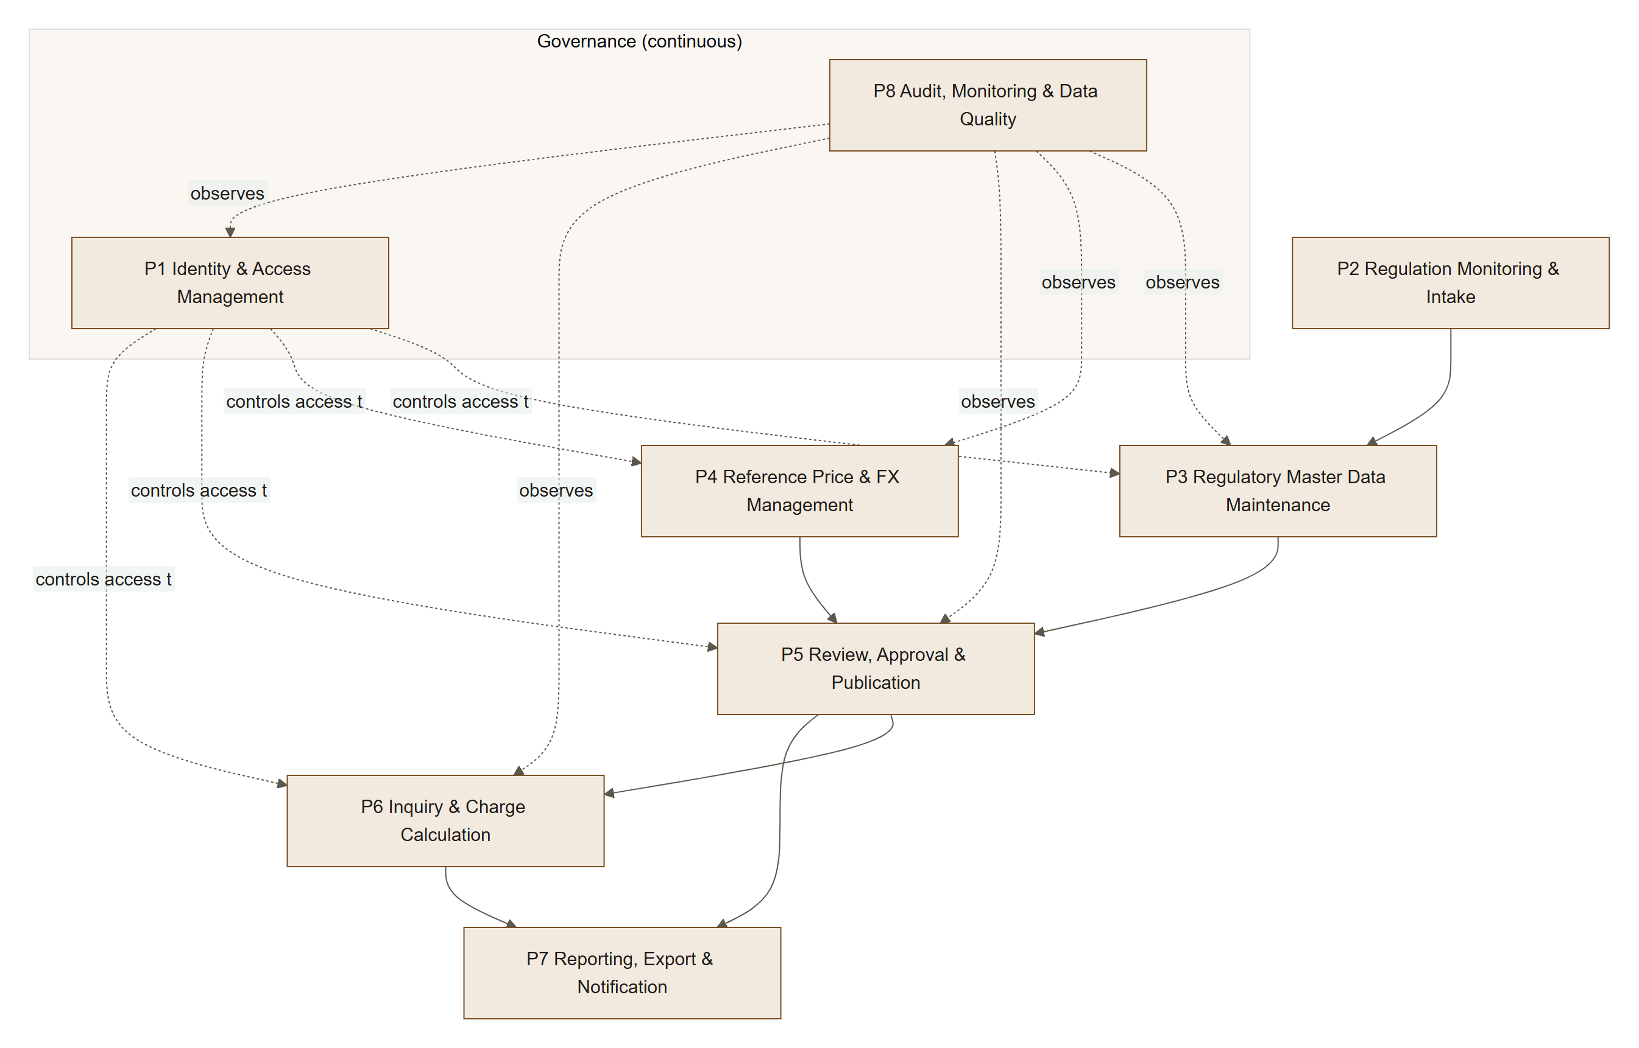

L0 ID | Process | Purpose | Primary actors | Key outputs
P1 | Identity & Access Management | Ensure only verified, authorised users access functions matching their role | Super Admin, User Admin, all users | Active accounts, role assignments, sessions
P2 | Regulation Monitoring & Intake | Detect and register new/amended regulations and reference-price decrees | Maker | Regulation records (draft), source documents, impact list
P3 | Regulatory Master Data Maintenance | Maintain commodities, products, HS mappings, BK and PE schedules | Maker | Draft change sets
P4 | Reference Price & FX Management | Record periodic reference prices (CPO, cocoa, export base prices) and FX rates | Maker | Draft price/FX records
P5 | Review, Approval & Publication | Four-eyes validation and effective-dated publishing | Checker | Published versions, rejections, rollbacks
P6 | Inquiry & Charge Calculation | Let users find products and compute BK/PE for a date & quantity | Viewer (and above) | Search results, calculations
P7 | Reporting, Export & Notification | Distribute data and changes | Viewer, Checker, System | Exports, permalinks, change bulletins
P8 | Audit, Monitoring & Data Quality | Evidence, security monitoring and data integrity | Auditor, Super Admin, System | Audit log, DQ findings, security alerts

6.2 L1 — Sub-processes per L0

P1 Identity & Access Management
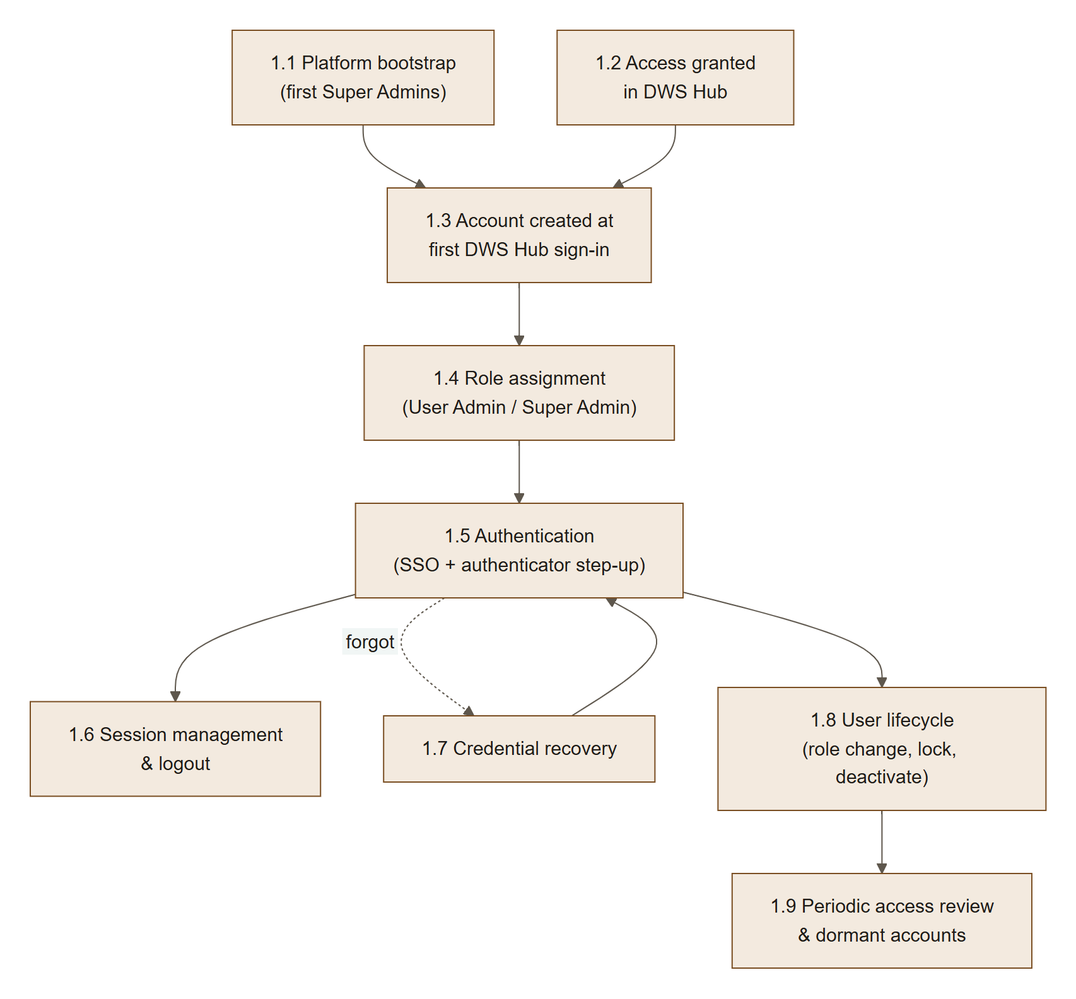
L1 | Name | Trigger | Actor | Output
1.1 | Platform bootstrap | First deployment | Operator + nominated Super Admins | Two Super Admins granted by command after their first sign-in
1.2 | Access granted in DWS Hub | Staff need ECR | DWS Hub administrator (outside ECR) | ECR assigned to the person in DWS Hub
1.3 | Account created at first sign-in | First DWS Hub sign-in to ECR | User, System | ECR account ACTIVE with the default role (Viewer)
1.4 | Role assignment | Job needs a privileged role | User Admin / Super Admin | Roles changed; the person's sessions end
1.5 | Authentication | User signs in | User, System | Authenticated session
1.6 | Session management | Idle/absolute timeout, logout | User, System | Terminated sessions
1.7 | Credential recovery | Forgotten password / lost MFA device on a local account (SSO users recover at DWS Hub) | User, User Admin | Password reset, MFA reset
1.8 | User lifecycle | Role change, leaver, lockout | User Admin | Updated roles/status
1.9 | Periodic access review | Quarterly / 90-day dormancy | User Admin, System | Review attestation, auto-disabled dormant accounts

P2 Regulation Monitoring & Intake
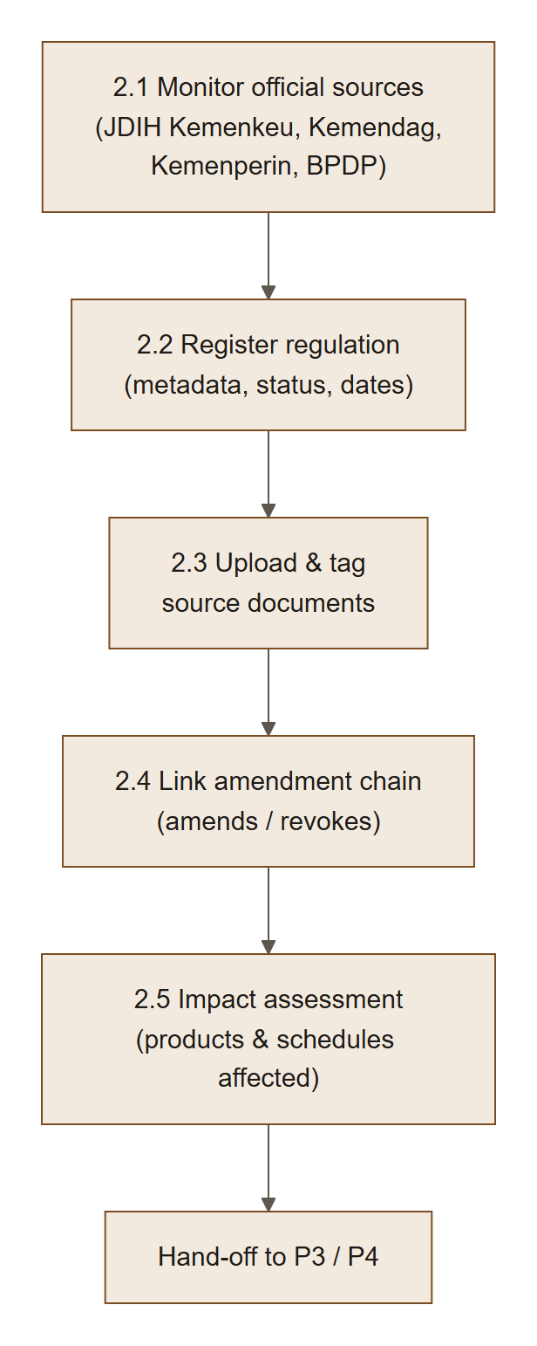

P3 Regulatory Master Data Maintenance
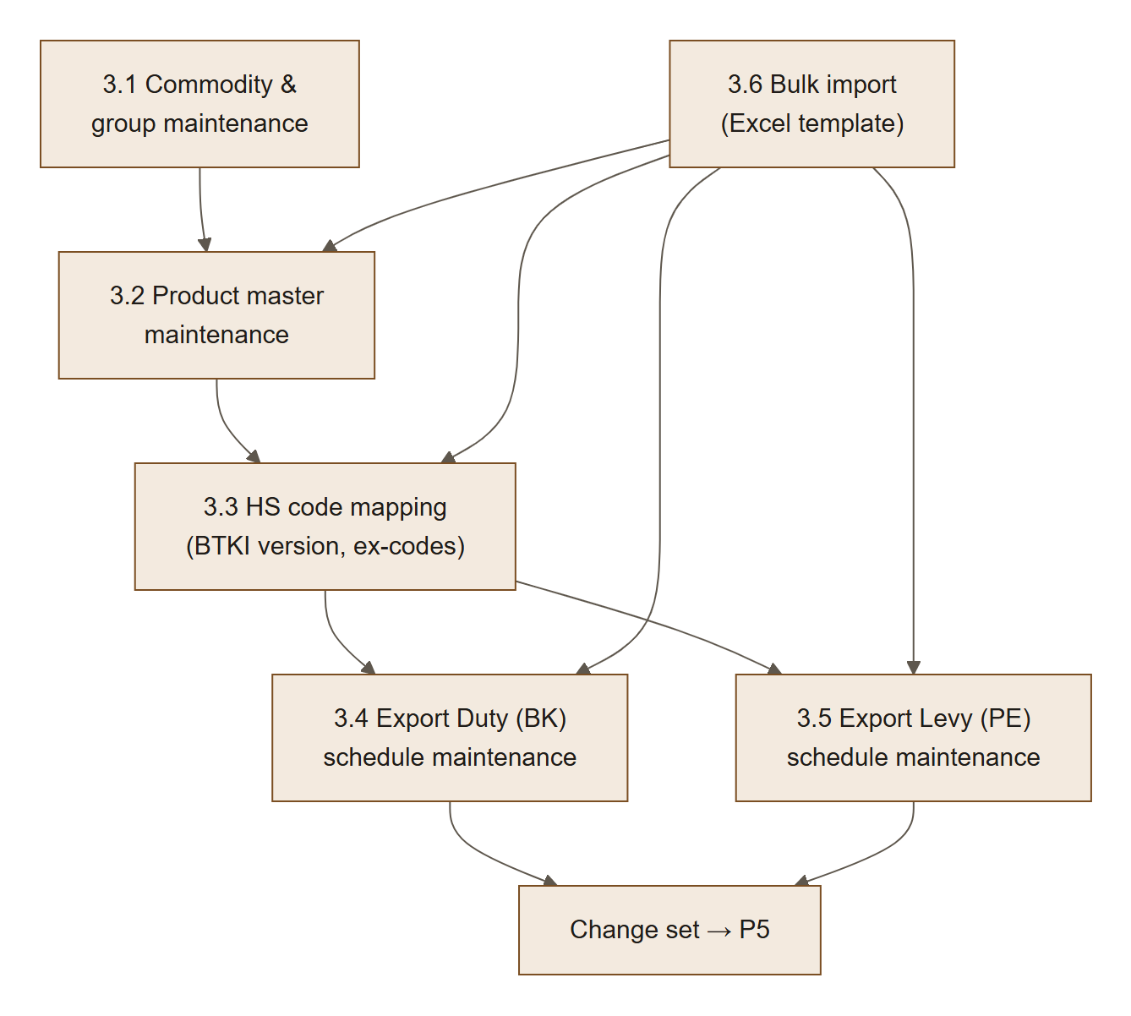

P4 Reference Price & FX Management
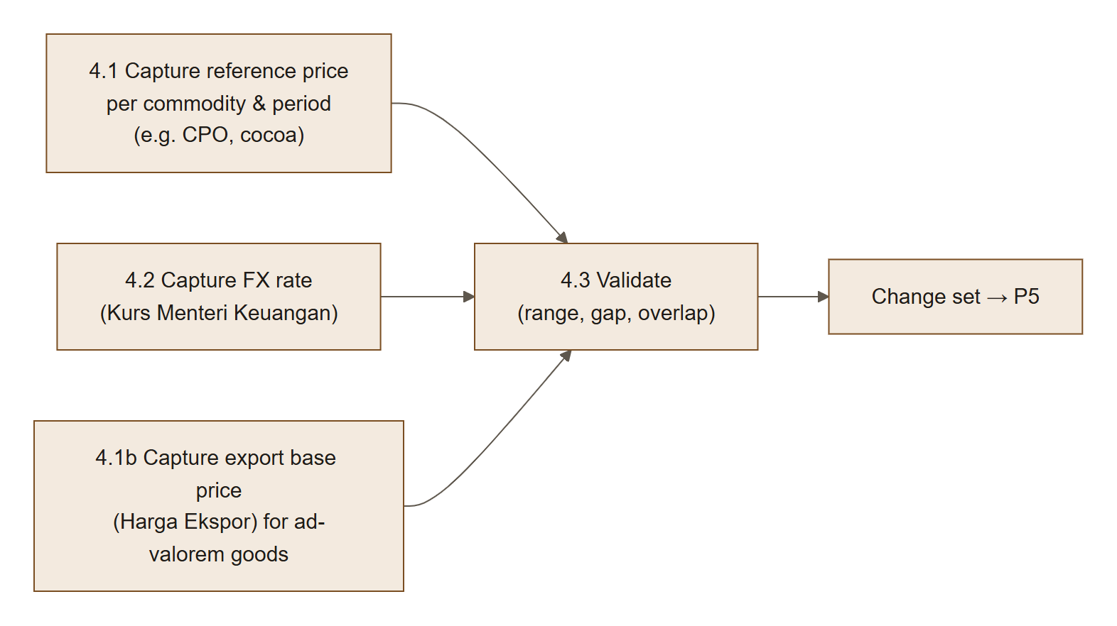

P5 Review, Approval & Publication
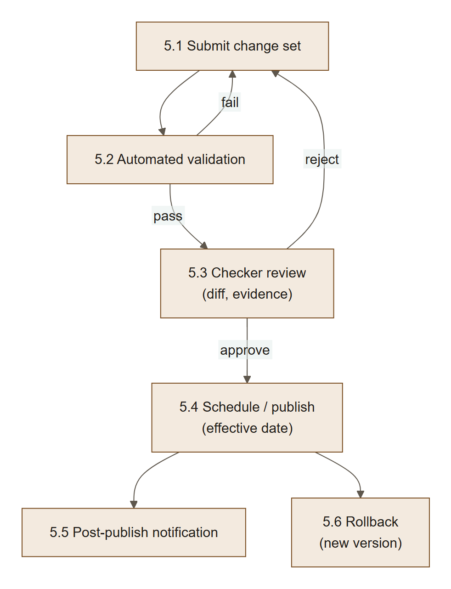

P6 Inquiry & Charge Calculation
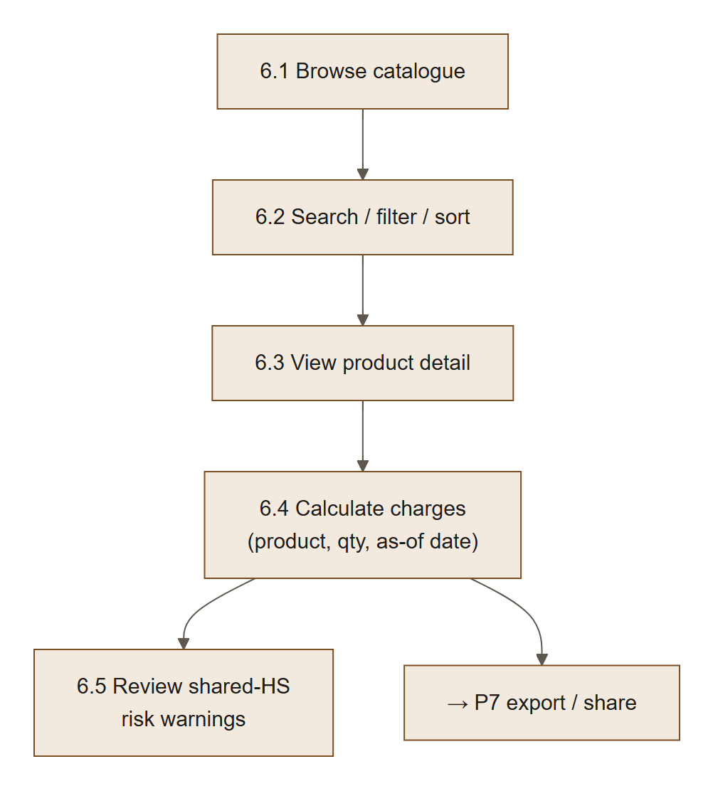

P7 Reporting, Export & Notification
L1 | Name | Description
7.1 | Export list / calculation | CSV, XLSX (MVP); PDF evidence pack (R2)
7.2 | Permalink | Shareable URL encoding filters, as-of date and calculator inputs (no personal data)
7.3 | Change subscription | Users subscribe to commodities/products; notified on publish (R2)
7.4 | Change bulletin | Automatically generated summary of each published version

P8 Audit, Monitoring & Data Quality
L1 | Name | Description
8.1 | Audit capture | Every create/update/delete/approve/login/role change written to append-only log
8.2 | Audit review | Auditor searches and exports audit log
8.3 | Data-quality checks | Rule engine runs on every change set and nightly on published data
8.4 | Security monitoring | Failed-login spikes, lockouts, MFA resets, privilege changes alert Super Admin

6.3 L2 — Detailed process flows
Notation: Actor = who acts; System = ECR behaviour; BR = business rule reference.

L2-1.1 Platform bootstrap (first Super Admins)
Step | Actor | Action | System response / rule
1 | Nominated Super Admins | Each signs in to ECR once through DWS Hub | Account created with the default role (L2-1.2)
2 | Operator | Runs grant:role --email … --role SUPER_ADMIN --reason … on the BE server for each | Refuses unknown or inactive accounts; audit ROLE_GRANTED_CLI with the OS user; the person's sessions end
3 | Super Admin | Signs in again and sets up the ECR authenticator | Required before any privileged function (BR-IAM-13)
4 | Super Admins | Manage all further roles in Users | Two active Super Admins required from then on (SoD-4)

L2-1.2 Account creation at first DWS Hub sign-in
DWS Hub decides who may use ECR: its administrators assign ECR to people, and DWS Hub handles invitations and access requests. ECR creates the account the first time a person signs in and owns roles, account status, sessions and the audit trail.
Step | Actor | Action | System response / rule
1 | User | Opens ECR or its tile in DWS Hub | Sign-in through DWS Hub (F-13)
2 | System | Verifies the ID token and looks up the Hub sub | Known sub: signs in, refreshes name and email
3 | System | Unknown sub and no ECR account with that email | Creates the account ACTIVE with the default role(s), Viewer by default (BR-IAM-12); audit USER_PROVISIONED
4 | System | Unknown sub but the email belongs to another ECR account | Refused, "This email already belongs to another ECR account" (LOGIN_IDENTITY_CONFLICT); a User Admin resolves it
5 | System | Hub token without an email | Refused (LOGIN_NO_EMAIL)

L2-1.3 Role assignment
Step | Actor | Action | System response / rule
1 | User Admin | Opens Users, selects a person, ticks roles, enters a reason | BR-IAM-02: User Admin grants Viewer, Maker, Checker, Auditor; only a Super Admin manages User Admin and Super Admin roles or accounts
2 | System | Asks for an authenticator code if the last one is older than 5 minutes | Step-up (BR-IAM-13)
3 | System | Checks segregation of duties | SoD-2 (User Admin with Maker or Checker), SoD-3 (own account), SoD-4 (two Super Admins)
4 | System | Saves the roles and ends the person's sessions | New roles apply at the next sign-in; audit ROLES_CHANGED with before, after and reason
5 | Person | Signs in again; a privileged role requires setting up the authenticator first | BR-IAM-13

L2-1.5 Authentication (login + MFA)
All users sign in through DWS Hub SSO; ECR receives the verified identity and applies its own roles, sessions and audit. Users in privileged roles also set up an authenticator app in ECR and enter a code before sensitive actions (BR-IAM-13). The password steps below apply only to local break-glass Super Admin accounts (not built yet, §15.1).
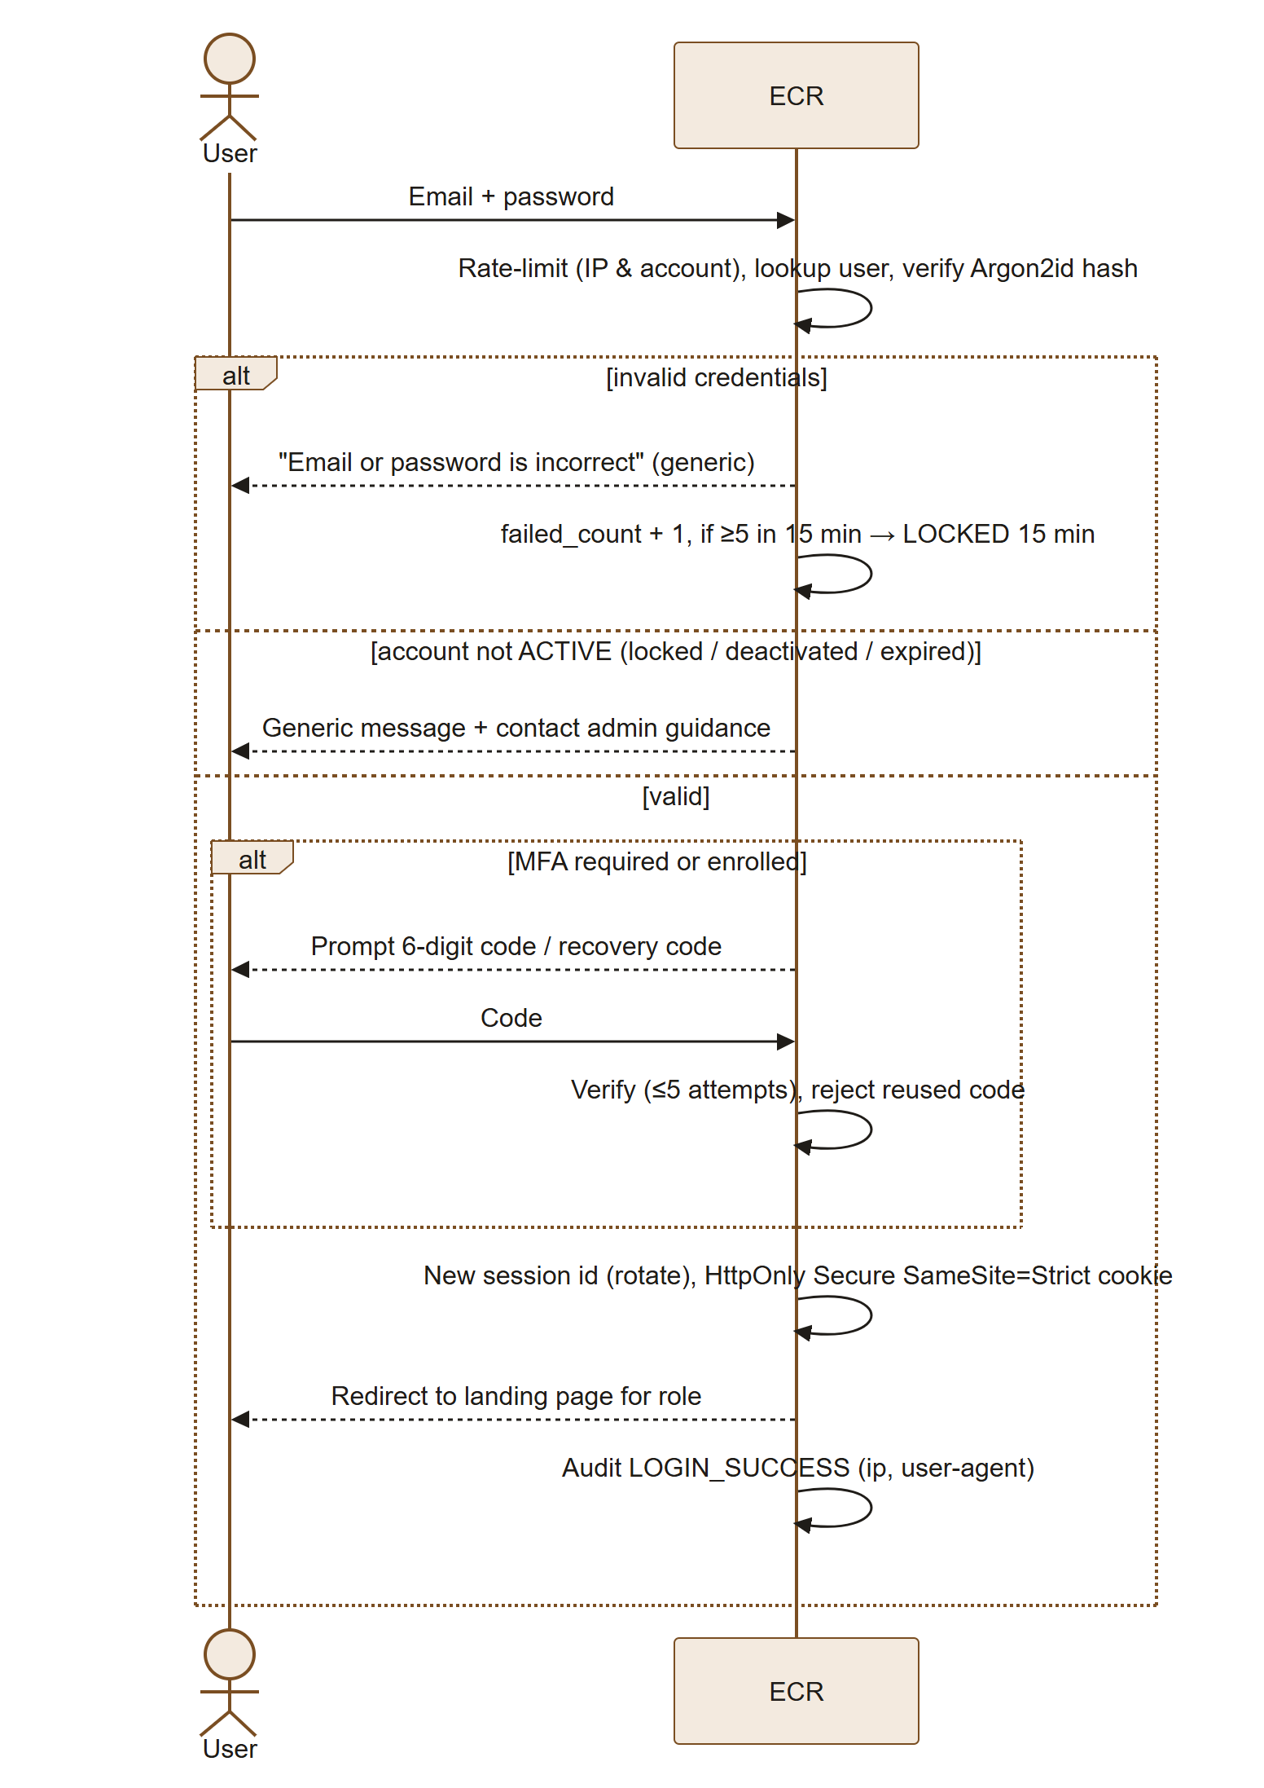
Step | Actor | Action | System response / rule
1 | User | Enters email + password | TLS only; no credentials in URL
2 | System | Verifies; generic error on any failure | BR-IAM-09
3 | System | Lockout after 5 failures / 15 min, auto-unlock after 15 min, or User Admin unlock | BR-IAM-06
4 | User | Enters MFA code | Privileged roles always; Viewer if enrolled or policy-enforced
5 | System | Creates session; forces password change if flagged (admin reset) | BR-IAM-07
6 | System | If password expired by policy or breached-list hit at login → force change | —

L2-1.6 Session management & logout
Step | Actor | Action | System response / rule
1 | System | Tracks activity | Idle timeout 30 min (privileged 15 min); absolute 8 h (BR-IAM-08)
2 | System | 2 min before idle timeout shows countdown dialog | "Stay signed in" extends idle only
3 | User | Clicks Sign out | Server-side session destroyed; cookie cleared; audit LOGOUT
4 | System | Step-up with an ECR authenticator or recovery code before: approve, reject or cancel a schedule, rollback, role change, deactivate or reactivate, authenticator reset, system config | Valid 5 min
5 | User / Admin | "Sign out all other sessions" / User Admin "Revoke sessions" | All other sessions invalidated

L2-1.7 Credential recovery
SSO users reset passwords and MFA at DWS Hub; the steps below apply to local break-glass accounts.
Step | Actor | Action | System response / rule
1 | User | Forgot password → enters email | Always "If an account exists, we have sent a link" (BR-IAM-09)
2 | System | Sends reset link (single use, 30 min) only to ACTIVE/LOCKED accounts | Rate-limit 3 / hour / account
3 | User | Sets new password; must pass MFA if enrolled | Previous 5 passwords disallowed
4 | System | Invalidates all sessions; emails confirmation "password changed" | Audit PASSWORD_RESET
5 | User | Lost MFA device → uses recovery code or requests MFA reset | MFA reset only by USER_ADMIN (or SUPER_ADMIN for admins) after identity verification; user must re-enrol at next login

L2-1.8 User lifecycle
Step | Actor | Action | System response / rule
1 | User Admin | Searches user; opens profile | Shows roles, status, last login, MFA status, sessions
2 | User Admin | Changes roles | BR-IAM-02, SoD-2/3/4; step-up auth; user notified by email
3 | User Admin | Deactivates (leaver) | Sessions revoked immediately; pending change sets of a Maker are reassigned or returned to Draft
4 | User Admin | Reactivates | Reason required; the person signs in again through DWS Hub
5 | User Admin | Unlocks / forces password reset / resets MFA | Audit with reason
6 | System | Access expiry date reached | Status EXPIRED; user & admin notified 7 days before

L2-1.9 Periodic access review & dormant accounts
Step | Actor | Action | System response / rule
1 | System | Nightly: accounts with no login for 90 days → DORMANT_DISABLED (BR-IAM-11) | Email notice at day 80
2 | System | Quarterly: generates access-review campaign (all users & roles) | Assigned to User Admins; Super Admin reviews admins
3 | Reviewer | Confirms or revokes each assignment | Unreviewed after 14 days → escalation to Super Admin
4 | System | Stores signed review report | Retained per BR-AUD-02

L2-2.2 Register a regulation
Step | Actor | Action | System response / rule
1 | Maker | Regulations → New; selects type (PMK, Permenperin, Permendag, Kepmendag, Perpres, other) | —
2 | Maker | Enters number/year, title (ID & EN), issuer, status (DRAFT_RANCANGAN, PROMULGATED, IN_FORCE, AMENDED, REVOKED), promulgation date, effective date, end date | Number + year + type unique (BR-REG-01)
3 | Maker | Links "amends / revokes / implements" relations | No circular amendment chain (BR-REG-02)
4 | Maker | Uploads source documents (PDF, ≤ 25 MB, virus-scanned) and official URL | SHA-256 stored for integrity
5 | Maker | Lists affected annexes (e.g., Lampiran C) and impacted products | Impact list auto-suggested from previous version
6 | Maker | Saves as Draft → adds to change set | Not visible to Viewers until published

L2-3.2 / 3.3 Product master & HS mapping
Step | Actor | Action | System response / rule
1 | Maker | Creates/edits product: commodity, classification group, item no. as printed, names (ID/EN), synonyms, definition, technical parameters (name, operator, value, unit), notes | Surrogate key generated; "as printed" number may duplicate (BR-PRD-02)
2 | Maker | Adds HS mapping(s): BTKI version, 8-digit code, ex flag + qualifying description | Code must exist in selected BTKI version (BR-PRD-03); ex-code requires description
3 | System | Detects other products on same HS code | Flags shared tariff post; shown to Maker and later to users (BR-PRD-04)
4 | Maker | Sets validity (effective from/to) and links classification regulation | Required (BR-PRD-01)
5 | Maker | Adds to change set | —

L2-3.4 / 3.5 Duty & levy schedule maintenance
Step | Actor | Action | System response / rule
1 | Maker | Selects regulation version and schedule (BK Lampiran X / PE Lampiran Y) | Schedule belongs to exactly one regulation
2 | Maker | Creates schedule line: Kelompok, item no., uraian (verbatim), linked product(s), basis type | Basis type: BAND_USD_PER_MT, AD_VALOREM_PCT, PCT_OF_REF_PRICE, FIXED_USD_PER_MT, BAND_PCT (e.g. cocoa), ZERO_LISTED
3 | Maker | Enters rate data per basis (e.g. 17 band amounts against band table; or %) | Bands contiguous, non-overlapping, cover 0→∞ (BR-TRF-02); amounts ≥ 0 (BR-TRF-03); monotonic warning
4 | Maker | Selects reference-price series used (CPO, cocoa, Harga Ekspor for product) | Required for band/%-of-ref bases (BR-TRF-04)
5 | System | Shows impact preview: old vs new charge at current reference price for each linked product | —
6 | Maker | Adds to change set | —

L2-3.6 Bulk import
Step | Actor | Action | System response / rule
1 | Maker | Downloads versioned Excel template | Template version checked on upload
2 | Maker | Uploads file (≤ 10 MB, .xlsx) | Virus scan; formula cells rejected (CSV/formula injection protection)
3 | System | Parses & validates all rows (dry run) | Row-level errors/warnings report; nothing saved on error
4 | Maker | Fixes and re-uploads, or accepts warnings | Errors block; warnings require acknowledgement
5 | System | Creates one change set with all rows as Draft | Import id linked to every record (lineage)

L2-4.1 / 4.2 Reference price & FX
Step | Actor | Action | System response / rule
1 | Maker | Selects series (CPO reference price, cocoa reference price, Harga Ekspor per product from MK/BC decisions, monthly or half-monthly; FX USD/IDR KMK) | —
2 | Maker | Enters period start/end, value, currency/unit, source regulation (e.g. Kepmendag no.) and document | Periods for a series may not overlap (BR-REF-01); gaps flagged
3 | System | Validates value vs. previous period (±30 % → warning) | BR-REF-02
4 | Maker | Adds to change set | Reference price publish is typically monthly; FX weekly

L2-5 Maker-checker approval & publication
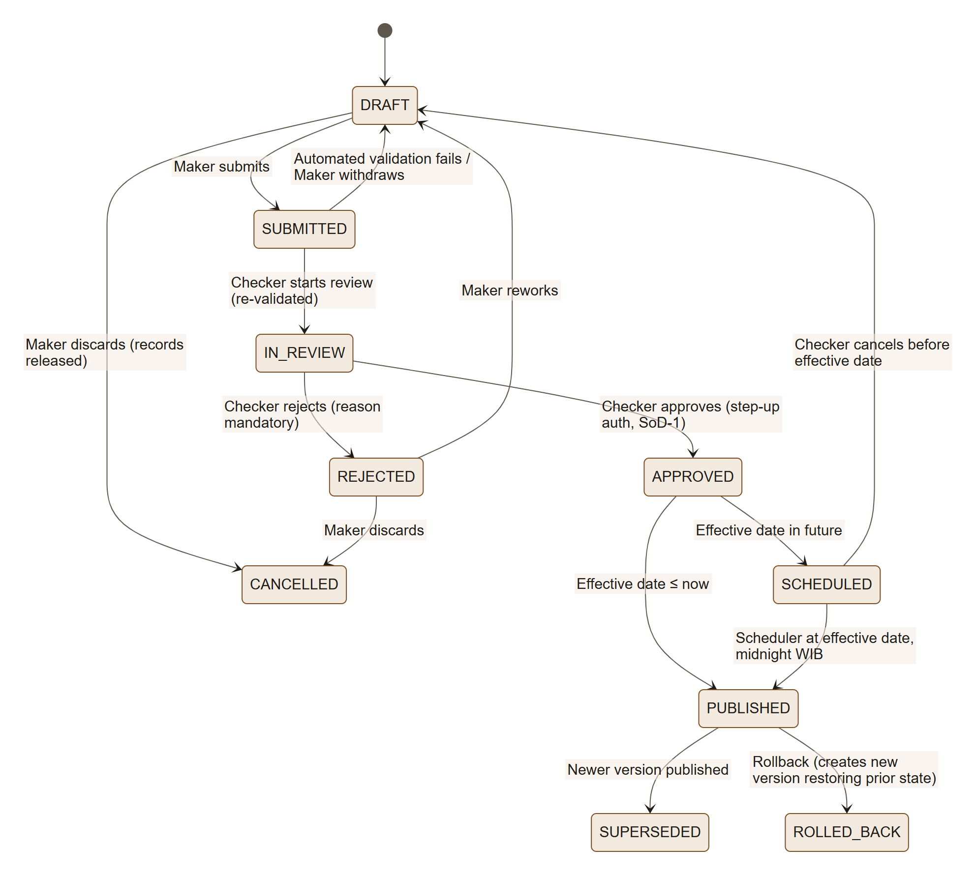
Step | Actor | Action | System response / rule
1 | Maker | Reviews change set summary, adds justification, submits | Automated validation (all BR-* and DQ rules): errors block; warnings must be acknowledged; a record can be open in only one change set at a time
2 | System | Notifies Checkers | —
3 | Checker | Starts the review (validation runs again against today's published data), reads the field-level diff, impact preview and source documents | Cannot review a set they created or edited (SoD-1); failing validation returns the set to the Maker
4 | Checker | Approves (step-up auth) or rejects with comment per item or whole set | Partial approval not allowed in MVP (all-or-nothing)
5 | System | Publishes at effective date (WIB, UTC+7); creates immutable version number | Version = monotonically increasing; bulletin generated
6 | Checker | Rollback: selects published version → creates new change set restoring previous state → standard approval by a different Checker | Rollback is never a hard delete

L2-6.4 Charge calculation
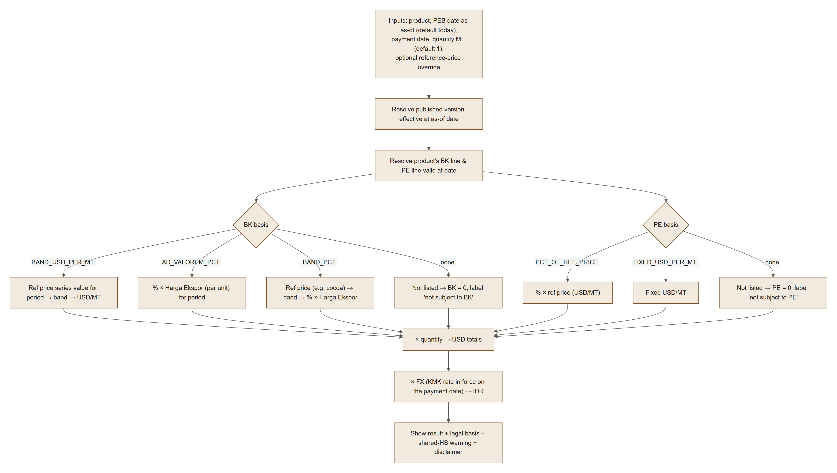

Step | Actor | Action | System response / rule
1 | User | Selects products (up to 50 lines), PEB date (as-of), payment date, quantities | Payment date at most 30 days before the PEB date (BR-CAL-11); a future date uses published data plus approved changes scheduled by then, and such a result cannot be saved (BR-CAT-02)
2 | System | Resolves rules & prices for the date | A missing reference price or FX rate is named and the affected total stays empty; a missing next-period Harga Ekspor falls back to the previous period (BR-CAL-03)
3 | User | (optional) Overrides reference price for "what-if" | Result clearly labelled SIMULATION, never exported as official
4 | System | Displays per-MT and total in USD and IDR, the band used, the regulation/annex/item, and warnings | Rounding BR-CAL-05
5 | User | Saves the calculation (inputs, data version and result, replayable) or copies the permalink | → P7

L2-8.3 Data-quality checks
Rule | Check | Severity
DQ-01 | Product without HS mapping | Error
DQ-02 | HS code not in BTKI version | Error
DQ-03 | Shared HS code between charged and uncharged products | Warning (shown to users)
DQ-04 | Duplicate "as printed" item number within group | Info (allowed, flagged)
DQ-05 | Missing definition or technical parameters for palm product | Warning
DQ-06 | Band table gap/overlap; band amounts decreasing | Error / Warning
DQ-07 | Reference-price period gap for an active series | Error (for current month)
DQ-08 | Schedule line not linked to any product, or product in schedule not in classification | Warning
DQ-09 | Regulation IN_FORCE past its end date | Warning
DQ-10 | Classification regulation still DRAFT_RANCANGAN | Info badge on all affected products

7. Functional requirements
Priority: M = Must (MVP), S = Should (MVP if capacity, else R2), C = Could (R2+).

7.1 Identity & Access Management (IAM)
ID | Requirement | Priority
FR-IAM-01 | System shall let an operator grant the first Super Admins by command after their first sign-in, audited; two are required (SoD-4). | M
FR-IAM-02 | System shall create an ECR account at a person's first DWS Hub sign-in with the configured default role(s) (default Viewer); DWS Hub decides who may use ECR. (v1.2) A person an administrator added beforehand (FR-IAM-17) gets that account and its roles instead. | M
FR-IAM-03 | System shall refuse a new Hub identity whose email already belongs to another ECR account, and a Hub token without an email, with a clear message. | M
FR-IAM-04 | System shall authenticate local break-glass Super Admin accounts with email + password; passwords hashed with Argon2id (or bcrypt cost ≥ 12). | M
FR-IAM-05 | Privileged roles shall use ECR TOTP with 10 single-use recovery codes, enrolled at first privileged sign-in and used for step-up, until DWS Hub reports MFA (OQ-12, T-01); break-glass accounts use password + TOTP. (v1.2) Roles listed in TOTP_EXEMPT_ROLES (default SUPER_ADMIN) need no ECR authenticator; an empty list makes every privileged role use it. | M
FR-IAM-06 | For local accounts, system shall provide forgot-password via single-use, 30-minute reset links, without revealing account existence. | M
FR-IAM-07 | System shall lock accounts after 5 failed attempts in 15 minutes for 15 minutes, and allow admin unlock. | M
FR-IAM-08 | System shall manage server-side sessions with idle and absolute timeouts and step-up re-authentication for sensitive actions. | M
FR-IAM-09 | System shall let User Admins list, search, filter, view, edit roles, deactivate, reactivate, unlock, force password reset and reset MFA for users, subject to SoD rules. (v1.2) Also add, edit and delete users (FR-IAM-17 to 19); every change needs a reason and a fresh authenticator code where required, and is audited. | M
FR-IAM-10 | System shall provide role and permission management (Super Admin); built-in roles are non-deletable. | M
FR-IAM-11 | System shall auto-disable dormant accounts (90 days) and run quarterly access reviews. | S
FR-IAM-12 | Users shall be able to view their profile, change password, manage MFA, view and revoke their active sessions. | M
FR-IAM-13 | System shall use DWS Hub single sign-on for all users; DWS Hub grants access to ECR, ECR keeps roles, account status, sessions and audit; local break-glass Super Admins remain for when DWS Hub is down. | M
FR-IAM-14 | Network restriction: ECR is reachable only from the office network and corporate VPN; no public or guest access. | M
FR-IAM-15 | (v1.2) A launch from the DWS Hub dashboard (the Hub starts the authorization itself) completes sign-in without an error page: ECR never redeems a code it did not request, and restarts its own sign-in once; with the Hub session open the person lands signed in. | M
FR-IAM-16 | (v1.2) Opening any ECR page without a session starts DWS Hub sign-in automatically and returns to that page (at most once per 30 seconds per browser tab, so a blocked cookie cannot loop). | M
FR-IAM-17 | (v1.2) Administrators add a person before their first sign-in (email, name, department, roles); the account is INVITED until the person's first DWS Hub sign-in with that email, which links the Hub identity and activates it with those roles. | M
FR-IAM-18 | (v1.2) Administrators edit a person's name and department; the email only while the account is INVITED (afterwards DWS Hub supplies it). | M
FR-IAM-19 | (v1.2) Administrators delete a user: an unused INVITED account is removed; an account with history is anonymised (roles, sessions, authenticator, follows and Hub link removed, name and email erased, deactivated and hidden) so the audit trail stays intact and the person can be added again. Never on oneself; two Super Admins always remain. | M

7.2 Regulation & master data (REG / PRD / TRF / REF)
ID | Requirement | Priority
FR-REG-01 | Maintain a Regulation Register with type, number, year, title (ID/EN), issuer, status, promulgation/effective/end dates, amendment relations and source documents. | M
FR-REG-02 | Store source documents with SHA-256 checksum, virus scan, and immutable versions. | M
FR-STO-01 | (v1.2) Every stored file is kept in ECR's own folder on the shared Synology NAS (staging APPs/dev/ECR, production APPs/ECR); only that folder is bound into the application, ECR never creates or changes folders, and it refuses to start or deploy when the folder is not the right network mount or not writable. | M
FR-PRD-01 | Maintain commodities (palm oil in scope; the model accepts other commodities later) and classification groups. | M
FR-PRD-02 | Maintain products with names (ID/EN), synonyms, definition, technical identification parameters, notes, "as printed" item no., annex page and validity dates. | M
FR-PRD-03 | Maintain HS mappings per BTKI version, including ex codes with qualifying description; normalise HS input (dots/spaces optional). | M
FR-PRD-04 | Automatically compute shared-tariff-post relations between products. | M
FR-TRF-01 | Maintain BK schedules supporting bases: banded USD/MT, ad valorem %, banded %, listed-at-zero. | M
FR-TRF-02 | Maintain PE schedules supporting bases: % of reference price, fixed USD/MT, listed-at-zero. | M
FR-TRF-03 | Maintain band tables (edges, labels) per regulation version and reference series. | M
FR-REF-01 | Maintain effective-dated reference-price series (CPO, cocoa, Harga Ekspor per product) and FX (USD/IDR KMK). | M
FR-IMP-01 | Provide Excel template import with dry-run validation and row-level error report. | M
FR-WF-01 | All data changes go through change sets with maker-checker approval, SoD-1, and effective-dated scheduled publishing. | M
FR-WF-02 | Provide field-level diff, impact preview, rollback via new version, and version history per record. | M
FR-WF-03 | (v1.2) Direct publication without a Checker exists only for (a) the first load of an empty registry by operator command and (b) automatic updates that pass every check (FR-SRC-06); both are audited as CHANGESET_PUBLISHED_DIRECT with the reason. | M
FR-SRC-01 | Official source registry: the authoritative publisher and domain for each data type (regulations, reference prices, Harga Ekspor, FX, BTKI), as listed in 13.1. | M
FR-SRC-02 | Every published value links to an official source document stored with SHA-256; a change set with an unsourced value cannot be submitted. | M
FR-SRC-03 | Scheduled status check of registered regulations against the BPK regulation database (in force, amended, revoked); a change creates an intake task for Makers. | S — built (daily 06:00 WIB)
FR-SRC-04 | Scheduled watch of official listings for new PMK, MK/BC, Kepmendag and KMK documents matching configured keywords; creates draft intake items, never publishes. | Built (brought forward)
FR-SRC-06 | (v1.2) Automatic update: each new CPO reference price decree (JDIH Kemendag) and KMK USD/IDR rate (BKF Kurs Pajak) is downloaded and read from its PDF; when the wording is found, BKF's page and the decree agree, the value is within range (CPO US$ 300–3,000/MT and ≤ 30 % from the previous month; USD/IDR Rp 5,000–50,000 and ≤ 5 % from the previous week) and the period does not overlap a published one, ECR stores the PDF, publishes the value directly and tells every user. | M
FR-SRC-07 | (v1.2) Semi-automatic drafting: a value that fails a check, a corrected decree, and a new regulation the source watch finds on BPK that amends or revokes a registered regulation or carries a changed palm duty (17 CPO bands) or levy table are drafted as a change set (regulation, start date from its own text, relations, new schedule and lines linked to their products, old ones ended) and submitted to the Checkers; nothing is published before a Checker approves. | M
FR-SRC-08 | (v1.2) Every PDF read automatically must name its own regulation or decree (number and year) or it is refused; for a PMK the Ministry of Finance's copy on JDIH Kemenkeu is read before BPK's. What ECR cannot read or draft is left to the Makers, alerted once. | M
FR-SRC-09 | (v1.2) An Official documents page lists every source PDF the published data relies on, with what cites it, to open in the browser or download. | M
FR-SRC-05 | Cross-check published monthly CPO duty and levy against a secondary source (e.g. DDTCNews) and flag differences; never a source of record. | C (R2)

7.3 Inquiry & calculation (CAT / CAL)
ID | Requirement | Priority
FR-CAT-01 | Display a structured, paginated list of all published products with: product, commodity/group, HS code(s), key spec, BK, PE, total, legal-basis badges, status badges (draft classification, shared HS). | M
FR-CAT-07 | (v1.2) Home leads with Check a product (search by name or HS code, frequent shortcuts, today's CPO reference price with its band and the KMK rate) followed by every palm oil product with today's duty, levy (with its % of the CPO reference price where applicable), total per tonne and key specification, filterable by group and text; other tasks are smaller supporting links. | M
FR-CAT-08 | (v1.2) Find a product gives one plain answer for the product picked: duty, levy and total per tonne for a shipping date, and how each was worked out (reference price, band or rate, regulation line, official PDF). | M
FR-CAT-02 | Full-text search over names (ID/EN), synonyms, HS (normalised), definitions, parameters, notes and schedule uraian; tolerant to diacritics and HS formatting. | M
FR-CAT-03 | Filters: commodity, group, charge status (both / BK only / PE only / listed-at-zero / not listed), shared HS, regulation, BK basis type; multi-select; counts per facet. | M
FR-CAT-04 | Sort by any column; units-aware (USD/MT values separated from % values). | M
FR-CAT-05 | Product detail page with definition, parameters, notes, HS mappings, BK & PE lines with legal references (regulation, annex, Kelompok, item, verbatim uraian), band strip, shared-HS warning, version history. | M
FR-CAL-01 | Calculator: product, PEB date (as-of), payment date, quantity (MT), returns per-MT and total in USD and IDR with the band, reference values and their source links. | M
FR-CAL-02 | What-if mode with reference-price override, clearly labelled simulation. | S
FR-CAL-03 | Multi-line shipment calculation (several products in one calculation). | S
FR-CAT-06 | KPI tiles that reconcile to the total shown (both, BK only, PE only, none, shared HS). | M
FR-EXP-01 | Export current list or calculation to CSV and XLSX including as-of date, version number, timestamp and disclaimer. | M
FR-EXP-02 | PDF/A evidence pack per calculation: inputs, outputs, legal references, version, source-document links with SHA-256, evidence ID, content hash and an internal verification link. | M
FR-EXP-03 | Permalink encoding filters/as-of date/calculator inputs. | M
FR-NTF-01 | Subscriptions to commodities/products; email/in-app notification on publication. | Built (brought forward)
FR-NTF-02 | (v1.2) Every active user is told (in ECR and by email) of each automatic update and of each ECR draft a Checker approved; people following affected products receive their follower notice instead of a second one. | M
FR-NTF-03 | (v1.2) Checkers are told when ECR has drafted a change for them (Change set waiting for review … ECR drafted this change by itself from the official source). | M
FR-UI-01 | UI in English and Bahasa Indonesia; legal text shown in original language. | M — not yet built
FR-UI-02 | (v1.2) A guided app tour at a person's first sign-in (each step highlights one part of Home with a short explanation; steps for their role only), remembered per account and replayable from the Tour button or the account menu. | M

7.4 Governance (AUD / DQ / CFG)
ID | Requirement | Priority
FR-AUD-01 | Append-only audit log of security and data events with actor, timestamp (UTC + WIB display), IP, user agent, entity, before/after values, reason. | M
FR-AUD-02 | Auditor UI to search/filter/export audit log; no edit/delete capability for anyone. | M
FR-DQ-01 | Data-quality rule engine (DQ-01…DQ-10) on change-set validation and nightly. | M
FR-CFG-01 | Super Admin configuration: session timeouts, default role at first sign-in, office and VPN IP allow-list, DWS Hub SSO settings, disclaimer text, email templates. | M
FR-API-01 | Read-only REST API with API keys (scoped, rate-limited) for published data and calculation. | C (R2)
FR-JOB-01 | (v1.2) Scheduled jobs run inside the API under a database lock, each run recorded; a failed run alerts Super Admins. Daily (WIB): dq-nightly 01:00, dormancy 01:30, audit-chain-verify 03:30, source-watch 06:00, ref-gap-check 07:00, access-review 08:00; every 3 h auto-update; every 6 h jwks-refresh; every 15 min session-sweep; plus publish-due, email outbox and export runner on short intervals. | M

8. User access control (RBAC) — permission matrix
✔ = allowed · ✖ = denied · ◐ = allowed with restriction (see note)
Permission | GUEST¹ | VIEWER | MAKER | CHECKER | USER_ADMIN | AUDITOR | SUPER_ADMIN
View published catalogue & detail | ✖ | ✔ | ✔ | ✔ | ✔ | ✔ | ✔
Use calculator | ✖ | ✔ | ✔ | ✔ | ✔ | ✔ | ✔
Export CSV/XLSX, permalink | ✖ | ✔ | ✔ | ✔ | ✔ | ✔ | ✔
View drafts / change sets | ✖ | ✖ | ✔ | ✔ | ✖ | ✔ (read) | ✔
Create/edit drafts, import | ✖ | ✖ | ✔ | ✖ | ✖ | ✖ | ◐²
Submit change set | ✖ | ✖ | ✔ | ✖ | ✖ | ✖ | ◐²
Approve / reject / publish | ✖ | ✖ | ✖ | ◐³ | ✖ | ✖ | ◐²³
Rollback | ✖ | ✖ | ✖ | ◐³ | ✖ | ✖ | ◐²³
Assign roles VIEWER/MAKER/CHECKER/AUDITOR | ✖ | ✖ | ✖ | ✖ | ✔ | ✖ | ✔
Assign USER_ADMIN or SUPER_ADMIN | ✖ | ✖ | ✖ | ✖ | ✖ | ✖ | ✔
Edit roles / deactivate / unlock / reset MFA | ✖ | ✖ | ✖ | ✖ | ◐⁴ | ✖ | ✔
(v1.2) Add, edit and delete users | ✖ | ✖ | ✖ | ✖ | ◐⁴ | ✖ | ✔
(v1.2) Review ECR's drafted change sets | ✖ | ✖ | ✖ | ✔ | ✖ | ✖ | ✖
Manage role definitions & permissions | ✖ | ✖ | ✖ | ✖ | ✖ | ✖ | ✔
View audit log | ✖ | ✖ | ◐⁵ | ◐⁵ | ◐⁶ | ✔ | ✔
Export audit log | ✖ | ✖ | ✖ | ✖ | ✖ | ✔ | ✔
System configuration | ✖ | ✖ | ✖ | ✖ | ✖ | ✖ | ✔
Manage own profile, password, MFA, sessions | ✖ | ✔ | ✔ | ✔ | ✔ | ✔ | ✔

Notes:
- GUEST is not used: ECR is reachable only from the office network and VPN, and every user signs in (OQ-04).
- Super Admin data permissions are disabled by default and must be explicitly granted (break-glass), each use alerting other Super Admins.
- SoD-1: never on a change set the user created or edited.
- Not on USER_ADMIN/SUPER_ADMIN accounts and never on self (SoD-3).
- Only events on data entities they can see.
- Only IAM/security events.
Granting someone access to ECR at all happens in DWS Hub, not in ECR. Authorisation is enforced server-side on every request (deny by default); UI hiding is cosmetic only, and refused attempts are audited (AUTHZ_DENIED).

9. Data model & calculation rules

9.1 Core entities
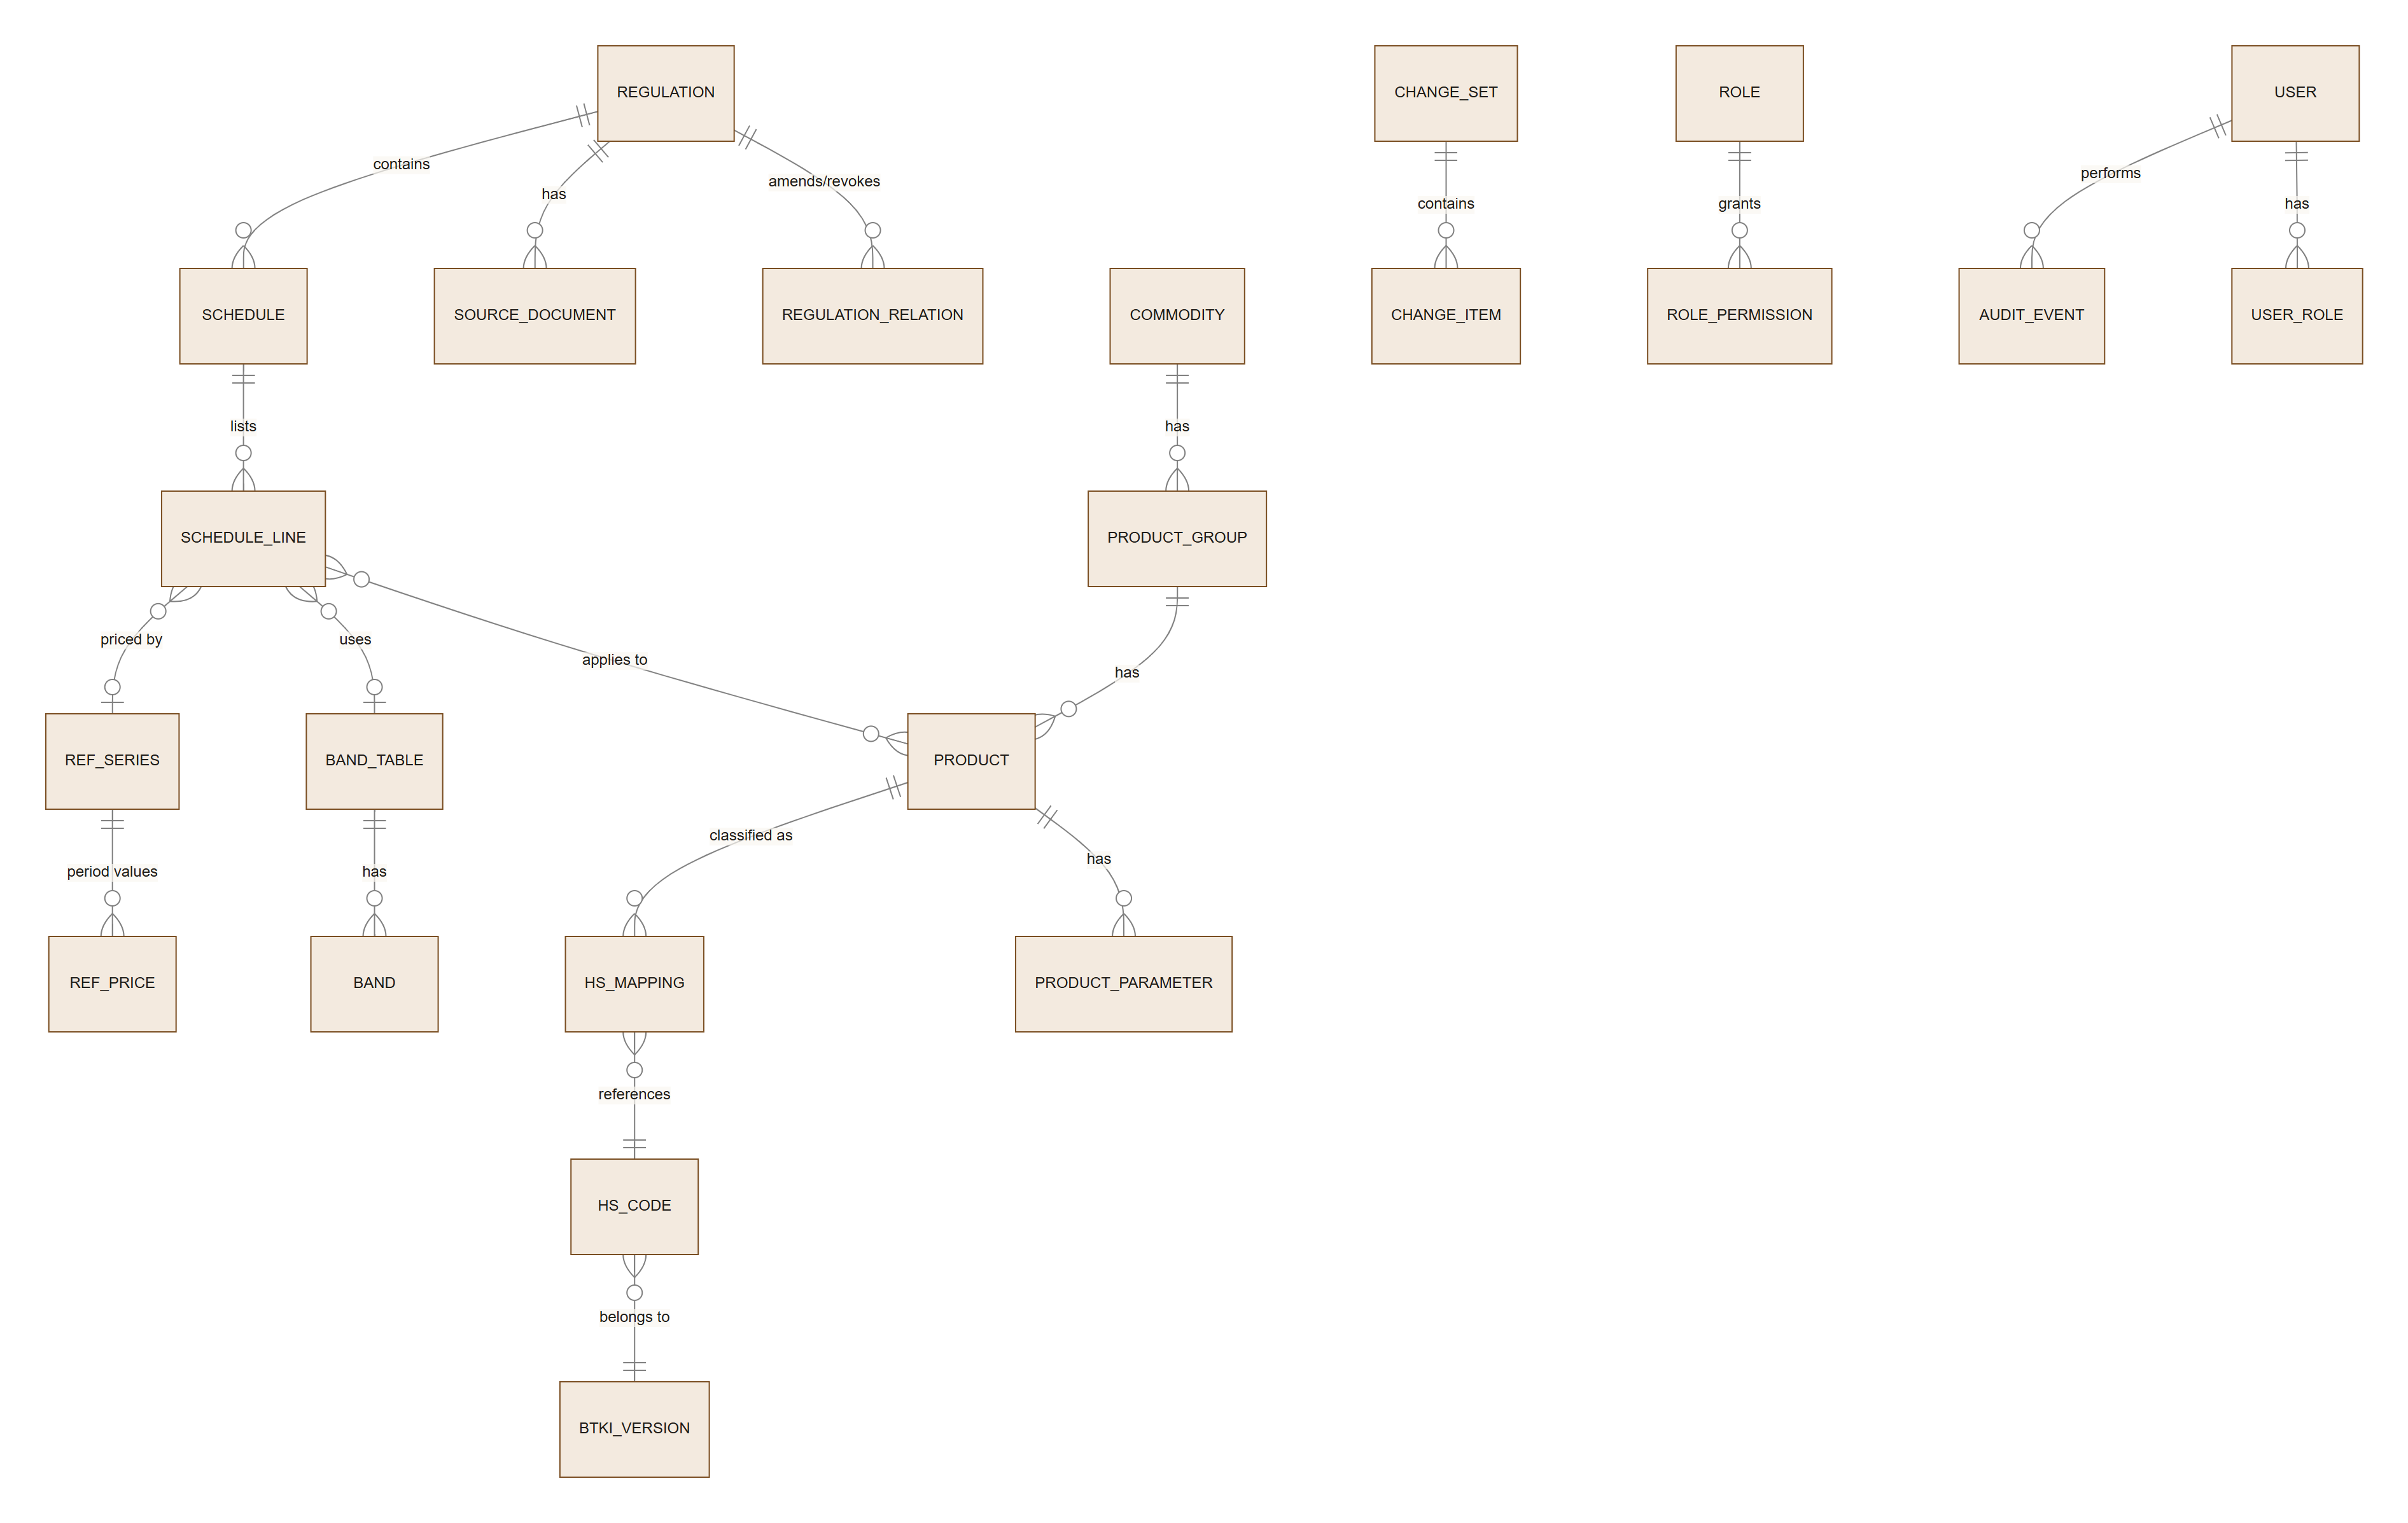

Entity | Key fields
REGULATION | id, type, number, year, title_id, title_en, issuer, status, promulgated_on, effective_from, effective_to, official_url
SCHEDULE | id, regulation_id, charge_type (BK/PE), annex (Lampiran), commodity_id
SCHEDULE_LINE | id, schedule_id, kelompok, item_no, uraian (verbatim), basis_type, pct, usd_per_mt, band_table_id, band_values[], ref_series_id, effective_from/to
BAND_TABLE / BAND | id, ref_series_id, ordinal, lower_exclusive, upper_inclusive, label
PRODUCT | id (surrogate), commodity_id, group_id, item_no_as_printed, name_id, name_en, synonyms[], definition, notes[], annex_page, classification_regulation_id, effective_from/to, other_obligations_note
PRODUCT_PARAMETER | product_id, name, operator, value_text, unit, is_primary
HS_MAPPING | product_id, hs_code_id, is_ex, ex_description, effective_from/to
REF_SERIES / REF_PRICE | series code (CPO, COCOA, HE-<product>, FX-USDIDR), unit; period_from, period_to, value, source_regulation_id, source_document_id
CHANGE_SET | id, status, created_by, submitted_at, reviewed_by, decision, comment, effective_at, version_no
USER | id, email (unique, lower-case), full_name, department, status, mfa_enabled, failed_count, locked_until, last_login_at, access_expires_at
AUDIT_EVENT | id, ts_utc, actor_id, action, entity, entity_id, before, after, ip, user_agent, reason, hash_prev (hash chain)

All business tables are bitemporal-lite: effective_from/to (legal validity) + immutable version rows (system history).

9.2 Calculation rules
The charge formulas per shipment come from PMK 214/2008 Article 4 (duty) and PMK 69/2025 Articles 4 and 8 (levy):
\begin{aligned}
BK_{specific} &= \text{USD/MT}_{band(ref)} \times Q \\
BK_{ad\,valorem} &= r_{BK} \times HE \times Q \\
PE_{palm} &= r_{PE} \times ref_{CPO} \times Q \\
PE_{fixed} &= \text{USD/MT} \times Q \\
PE_{cocoa} &= r_{PE}(ref_{cocoa}) \times HE \times Q \\
IDR &= USD \times KMK_{payment\ date}
\end{aligned}

ID | Rule
BR-CAL-01 | Duty: the rate, band and Harga Ekspor in force on the date the export declaration (PEB) is registered at the customs office apply (PMK 214/2008 Art. 5(1)). The calculator's as-of date is that PEB date, default today (WIB). Levy: the rate follows the CPO reference price for the period; PMK 69/2025 does not state which date sets it, so the PEB date is used until BPDP confirms (OQ-03).
BR-CAL-02 | Band selection: first band where ref_price ≤ upper_inclusive; above the last edge → top band. Prototype edges: ≤680, 681–730 … 1,381–1,430, >1,430 (17 bands).
BR-CAL-03 | If the next period's Harga Ekspor is not yet set, the previous period's applies, labelled as such (PMK 214/2008 Art. 5(2)). A missing reference price or FX rate blocks the calculation with "value for <series> <period> not yet published".
BR-CAL-04 | Formulas above: Q = quantity in MT, ref = reference price, r = rate. HE = Harga Ekspor set per period by MK/BC decision (Customs for the Finance Minister, from the Trade Ministry's export price decree), never the invoice or FOB value. The cocoa levy uses the same HE (PMK 69/2025 Art. 8(4)).
BR-CAL-05 | Rounding: display 2 decimals for USD and 0 decimals for IDR; no intermediate rounding.
BR-CAL-06 | Distinguish "Not listed" (no schedule line) from "Listed at 0" (e.g. FFB levy USD 0).
BR-CAL-07 | If the product shares an HS code with a product carrying a different charge, show a warning naming the other product(s) and charge.
BR-CAL-08 | Every result displays: version number, regulation references, PEB date, payment date, and the disclaimer.
BR-CAL-09 | IDR uses the weekly KMK rate in force on the payment date, for duty (PMK 214/2008 Art. 5(3)) and levy (PMK 69/2025 Art. 9). Payment date is its own input, default the PEB date; the result names the KMK decree used. Exception: export goods with special characteristics use the PEB date (PMK 214/2008 Art. 5(4)).
BR-CAL-10 | Every rate, reference price, Harga Ekspor and FX value in a result links to its official source document (BR-SRC-01).
BR-CAL-11 | The payment date may be at most 30 days before the PEB date. Goods marked special-characteristic use the PEB date for FX (BR-CAL-09).
BR-CAL-12 | A what-if reference price replaces every reference price in force on the PEB date; the result is labelled SIMULATION and can never become evidence. A value that is not a positive number is ignored with a notice.
BR-CAT-01 | Catalogue categories, each product in exactly one: duty and levy, duty only, levy only, listed at 0, not listed. A charge that is listed but not computable for the date (e.g. reference price missing) counts as charged. The tiles always sum to the products shown.
BR-CAT-02 | Reads take a business date and a data version (default the latest). For a date after today, approved change sets scheduled to take effect by that date are applied on top of the published data; a calculation that relies on them cannot be saved.

9.3 Other business rules (referenced above)
ID | Rule
BR-IAM-01 | The first Super Admins are granted by an operator command after their first DWS Hub sign-in; the command is audited and ends the person's sessions.
BR-IAM-02 | Role-granting authority: User Admin → VIEWER/MAKER/CHECKER/AUDITOR; Super Admin → all.
BR-IAM-03 | Who may use ECR is decided in DWS Hub (application assignment); ECR keeps no email-domain allow-list.
BR-IAM-04 | Email is the unique login id, case-insensitive.
BR-IAM-05 | Local break-glass accounts only. Password: min 12 chars, max ≥ 64, all printable/Unicode allowed, checked against breached/common list, not containing email local part, last 5 not reusable. No forced periodic rotation (NIST SP 800-63B).
BR-IAM-06 | Lockout: 5 failures / 15 min → 15 min lock; 3 consecutive locks within 24 h → lock until admin unlock.
BR-IAM-07 | Admin-reset password is temporary and must be changed at next login.
BR-IAM-08 | Idle timeout 30 min (privileged 15 min); absolute 8 h; max 3 concurrent sessions per user.
BR-IAM-09 | Authentication and recovery responses never reveal whether an account exists or its status beyond "contact your administrator".
BR-IAM-10 | Rate limits: break-glass login 10/min/IP; reset 3/hour/account.
BR-IAM-12 | First DWS Hub sign-in creates the ECR account with the configured default role(s) (Viewer by default; empty means no access until a role is granted). A Hub identity whose email belongs to another ECR account is refused.
BR-IAM-13 | Privileged roles set up an ECR authenticator (TOTP, RFC 6238, ±1 step, each code used once) before any privileged function, and enter a code before sensitive actions (valid 5 min). Ten single-use recovery codes; 5 wrong codes in 15 min lock it for 15 min. Applies until DWS Hub reports MFA (OQ-12, T-01).
BR-IAM-11 | Dormancy 90 days → disabled; reactivation by User Admin.
BR-REG-01 | (type, number, year) unique.
BR-REG-02 | Amendment graph must be acyclic.
BR-PRD-01 | Every product must reference its classification regulation and have validity dates.
BR-PRD-02 | "As printed" item numbers may duplicate; surrogate key is the identity.
BR-PRD-03 | HS codes validated against the selected BTKI version; non-code text (e.g. "ex 4407 (all subheadings…)") must be expanded to explicit codes.
BR-PRD-04 | Shared tariff posts are computed, not manually entered.
BR-TRF-01 | A product may have at most one active BK line and one active PE line per date.
BR-TRF-02 | Band tables contiguous, non-overlapping, covering 0→∞.
BR-TRF-03 | Rates ≥ 0; % ≤ 100.
BR-TRF-04 | Band and %-of-reference bases must name their reference series.
BR-REF-01 | Reference-price periods within a series must not overlap.
BR-REF-02 | Change > ±30 % vs. previous period → warning requiring Maker acknowledgement.
BR-REF-03 | Harga Ekspor periods may be monthly or half-monthly (e.g. 15–30 Sep 2026); the previous period's value stays in force until a new decision is published.
BR-SRC-01 | Every published regulation, rate, reference price, Harga Ekspor and FX value has a source document from an allow-listed official domain (13.1), stored with SHA-256. News and consultancy pages may be attached only as secondary references.
BR-AUD-01 | Audit log is append-only and hash-chained; tampering detectable.
BR-AUD-02 | Retain audit log and published versions 10 years (aligned with Indonesian tax-record retention; decided 28 Oct 2026 — OQ-06).

10. Non-functional requirements
Category | ID | Requirement
Security | NFR-SEC-01 | Conform to OWASP ASVS 4.0 Level 2; OWASP Top 10 mitigated; independent pen-test before go-live with no open Critical/High.
 | NFR-SEC-02 | TLS 1.2+ (HSTS); cookies Secure; HttpOnly; SameSite=Strict; CSRF tokens on state-changing requests; strict CSP; no inline scripts.
 | NFR-SEC-03 | Secrets in a vault/KMS; DB encryption at rest (AES-256); backups encrypted.
 | NFR-SEC-04 | All tokens (session, CSRF, reset, recovery codes) ≥ 128-bit entropy, stored hashed; reset and recovery codes single-use.
 | NFR-SEC-05 | File uploads virus-scanned, type-verified by content, stored outside web root.
 | NFR-SEC-06 | Security events forwarded to SIEM (if available) within 5 min.
Privacy | NFR-PRV-01 | Comply with UU 27/2022 (Perlindungan Data Pribadi): minimal personal data (name, email, department, IP logs), privacy notice at first sign-in, data-subject requests handled by Super Admin.
Performance | NFR-PRF-01 | Catalogue search & filter p95 ≤ 500 ms for 10,000 products; calculation p95 ≤ 300 ms; page LCP ≤ 2.5 s on 4G.
Availability | NFR-AVL-01 | 99.5 % monthly during 06:00–22:00 WIB business window; planned maintenance announced 48 h ahead.
Recoverability | NFR-REC-01 | RPO ≤ 24 h, RTO ≤ 4 h; ApsaraDB automated backups with point-in-time recovery; quarterly restore test.
Scalability | NFR-SCL-01 | 500 concurrent users; 50 k products; 10 years of versions.
Accessibility | NFR-ACC-01 | WCAG 2.1 AA: keyboard operable rows/sorting (aria-sort, aria-expanded), focus visible, contrast ≥ 4.5:1.
Responsiveness | NFR-RSP-01 | Usable from 360 px width; table switches to card list or horizontal scroll with sticky first column; sticky header must work.
Localisation | NFR-L10N-01 | EN/ID UI; dates DD MMM YYYY; numbers locale-aware; time zone WIB displayed, UTC stored.
Auditability | NFR-AUD-01 | Every published figure reproducible from version number + inputs.
Maintainability | NFR-MNT-01 | Automated tests ≥ 80 % on calculation & authorisation modules; calculation golden-file tests from Tax-team samples.
Observability | NFR-OBS-01 | Structured logs, health endpoint, metrics (latency, errors, login failures), alerting.
Browser support | NFR-BRW-01 | Latest 2 versions of Chrome, Edge, Firefox, Safari.
Security | NFR-SEC-07 | Reachable only from office IP ranges and the corporate VPN, enforced by Alibaba Cloud security groups and WAF; database in a private subnet with no public endpoint.
Hosting | NFR-HST-01 | Alibaba Cloud: FE server, BE server, ApsaraDB RDS for PostgreSQL 18; separate development, UAT and production environments; region chosen for data residency (OQ-13).

11. User stories — positive & negative (per functionality)
Format: P = positive (happy path), N = negative (error, abuse or boundary path). Acceptance criteria (AC) use Given / When / Then. Each functionality maps to the FR IDs in §7.

Functionality index
Module | ID | Functionality | FR
IAM | F-01 | Super Admin bootstrap | FR-IAM-01
IAM | F-02 | Account creation at first DWS Hub sign-in | FR-IAM-02
IAM | F-03 | Identity conflicts at first sign-in | FR-IAM-03
IAM | F-04 | Withdrawn — DWS Hub handles invitations and activation | —
IAM | F-05 | Login | FR-IAM-04, 07
IAM | F-06 | MFA enrolment & challenge | FR-IAM-05
IAM | F-07 | Forgot / reset password & MFA reset | FR-IAM-06
IAM | F-08 | Profile, change password, own sessions | FR-IAM-12
IAM | F-09 | Session timeout, step-up & logout | FR-IAM-08
IAM | F-10 | User management (v1.2: add, edit, delete) | FR-IAM-09, 17–19
IAM | F-11 | Role & permission management (RBAC) | FR-IAM-10
IAM | F-12 | Access review & dormant accounts | FR-IAM-11
IAM | F-13 | Single sign-on through DWS Hub | FR-IAM-13
IAM | F-14 | Network access restriction (office and VPN only) | FR-IAM-14
IAM | F-15 | (v1.2) App tour | FR-UI-02
IAM | F-16 | (v1.2) Automatic sign-in and DWS Hub launch | FR-IAM-15/16
Data | F-20 | Regulation register | FR-REG-01
Data | F-21 | Source document repository | FR-REG-02
Data | F-22 | Commodity & group management | FR-PRD-01
Data | F-23 | Product master maintenance | FR-PRD-02
Data | F-24 | HS code mapping (BTKI) & shared-HS detection | FR-PRD-03/04
Data | F-25 | Export Duty (BK) schedule maintenance | FR-TRF-01/03
Data | F-26 | Export Levy (PE) schedule maintenance | FR-TRF-02
Data | F-27 | Reference price & FX management | FR-REF-01
Data | F-28 | Bulk import (Excel) | FR-IMP-01
Data | F-29 | Maker-checker approval & publishing | FR-WF-01
Data | F-30 | Version history, diff & rollback | FR-WF-02
Data | F-31 | Official source verification | FR-SRC-01…05
Data | F-32 | (v1.2) Source watch | FR-SRC-03/04
Data | F-33 | (v1.2) Automatic reference price and KMK rate updates | FR-SRC-06/08, FR-WF-03
Data | F-34 | (v1.2) Semi-automatic drafts for Checkers | FR-SRC-07/08, FR-NTF-03
Data | F-35 | (v1.2) Official documents page | FR-SRC-09
Use | F-40 | Product catalogue (structured list); v1.2: Home and palm spotlight | FR-CAT-01, 07
Use | F-41a | (v1.2) Find a product | FR-CAT-08
Use | F-41 | Search | FR-CAT-02
Use | F-42 | Filter & sort | FR-CAT-03/04
Use | F-43 | Product detail | FR-CAT-05
Use | F-44 | Charge calculator | FR-CAL-01/02/03
Use | F-45 | As-of date (historical) lookup | FR-CAL-01
Use | F-46 | KPI tiles | FR-CAT-06
Use | F-47 | Export & permalink | FR-EXP-01/03
Use | F-48 | Change notifications (built; v1.2: everyone on automatic updates) | FR-NTF-01/02
Use | F-49 | Language switch | FR-UI-01
Gov | F-50 | Audit trail | FR-AUD-01/02
Gov | F-51 | Data-quality checks | FR-DQ-01
Gov | F-52 | System configuration | FR-CFG-01
Gov | F-53 | Read-only API (R2) | FR-API-01
Gov | F-54 | (v1.2) File storage on the Synology NAS | FR-STO-01
Gov | F-55 | (v1.2) Scheduled jobs | FR-JOB-01

Module A — Identity & Access Management
Authentication mode: every user signs in through DWS Hub SSO (F-13), and ECR is reachable only from the office network and VPN (F-14). DWS Hub decides who may use ECR; ECR creates the account at first sign-in (F-02) and owns roles, sessions and audit. The password and reset criteria in F-05 and F-07 apply to local break-glass Super Admin accounts; the ECR authenticator (F-06) applies to everyone in a privileged role.

F-01 Super Admin bootstrap
US-01-P1 (Positive) — As the nominated platform owner, I want an operator to make me Super Admin after my first sign-in, so that the platform has an accountable administrator from day one.
- AC1 Given I have signed in once through DWS Hub (account with the default role), when the operator runs grant:role with my email, role SUPER_ADMIN and a reason, then I hold the role, my sessions end and ROLE_GRANTED_CLI is audited with the operator's OS user.
- AC2 At my next sign-in I must set up the ECR authenticator before any privileged function.
- AC3 Two Super Admins are granted this way; from then on roles are managed in Users (SoD-4).
US-01-N1 (Negative) — As the security owner, I want the command to be unable to create accounts or touch inactive ones.
- AC1 Given no ECR account exists for the email, the command exits with "The person must sign in through DWS Hub once first" and changes nothing.
- AC2 Given the account is not ACTIVE, the command refuses; given the person already holds the role, it reports that and changes nothing.

F-02 Account creation at first DWS Hub sign-in
US-02-P1 (Positive) — As an employee given ECR in DWS Hub, I want my ECR account created when I first sign in, so that I can start without waiting for an ECR administrator.
- AC1 Given my Hub identity is new to ECR, when I sign in, then an ACTIVE account is created with my Hub name and email and the default role (Viewer), and USER_PROVISIONED is audited.
- AC2 Given I sign in again later, my name and email are refreshed from DWS Hub; my roles stay as set in ECR.
US-02-P2 (Positive) — As a User Admin, I want people to appear in Users after their first sign-in, so that I can give them the roles their job needs.
- AC1 The users list shows the new account with role Viewer; role changes follow L2-1.3.
US-02-N1 (Negative) — As the security owner, I want the default role to be configurable, so that ECR grants nothing if DWS Hub lets anyone in.
- AC1 Given the default role list is empty, a new account gets no roles and sees "You don't have access" until a role is granted (OQ-14).

F-03 Identity conflicts at first sign-in
US-03-N1 (Negative) — As the security owner, I don't want a new Hub identity to take over an existing ECR account.
- AC1 Given a new Hub sub whose email already belongs to another ECR account, sign-in is refused with "This email already belongs to another ECR account. Contact your administrator." and LOGIN_IDENTITY_CONFLICT is audited.
- AC2 Given a Hub token without an email, sign-in is refused with "DWS Hub did not share an email for your account".
- AC3 Given a deactivated ECR account, sign-in is refused even with a valid Hub sign-in.

F-04 Withdrawn
Invitations, access requests and account activation are handled by DWS Hub; ECR has no invitation or access-request flow (decided 29 Oct 2026). Activation is replaced by F-02.

F-05 Login
US-05-P1 (Positive) — As an active user, I want to sign in with my email and password (plus MFA when required), so that I can access the functions for my role.
- AC1 Given valid credentials and MFA code, I am signed in, a new session id is issued, and I am redirected to the page I originally requested (same-origin only) or my home page.
- AC2 LOGIN_SUCCESS is audited with IP and user agent; last login is shown on my profile.
US-05-N1 (Negative) — As the security owner, I want wrong credentials to give no hints.
- AC1 Given a wrong password or an unknown email, the message is "Email or password is incorrect" with an indistinguishable response time.
- AC2 LOGIN_FAILED is audited (never the password).
US-05-N2 (Negative) — As the security owner, I want brute-force attempts stopped.
- AC1 Given 5 failed attempts within 15 minutes, the account is LOCKED for 15 minutes and the user receives an email "Your account was temporarily locked".
- AC2 Given 3 locks within 24 h, the account stays locked until a User Admin unlocks it.
- AC3 Given more than 10 login attempts per minute from one IP, further attempts get HTTP 429.
US-05-N3 (Negative) — As the security owner, I want deactivated, expired or dormant users to be unable to sign in.
- AC1 When such a user submits correct credentials, they see "Your account is not active. Contact your administrator." and no session is created.
US-05-N4 (Negative) — As the security owner, I want to prevent open redirects after login.
- AC1 Given a returnUrl pointing to another domain, the user is redirected to their home page instead.

F-06 MFA enrolment & challenge
US-06-P1 (Positive) — As a Maker, I want to protect my account with an authenticator app, so that a stolen password is not enough to change regulatory data.
- AC1 When enrolling, I scan a QR code (secret also shown as text), enter a valid 6-digit code, and receive 10 one-time recovery codes that I must confirm I've saved.
- AC2 At my first privileged sign-in I must set it up before any privileged function; before a sensitive action older than 5 minutes I'm asked for a code, and a valid code within ±30 s lets the action through.
US-06-P2 (Positive) — As a user who lost my phone, I want to sign in with a recovery code, so that I'm not locked out.
- AC1 A valid unused recovery code confirms the action, is marked used, and the remaining code count is shown; a User Admin can reset my authenticator so I set it up again.
US-06-N1 (Negative) — As the security owner, I want MFA codes to resist guessing and replay.
- AC1 Given 5 wrong codes within 15 minutes, the authenticator is locked for 15 minutes; failed attempts are counted even when the request fails.
- AC2 Given a code already used within its time window, it is rejected.
US-06-N2 (Negative) — As the security owner, I want privileged users to be unable to disable MFA.
- AC1 Given a privileged role, the Disable MFA option is not available and the API returns 403; only Re-enrol is offered.

F-07 Forgot / reset password & MFA reset
US-07-P1 (Positive) — As a user who forgot my password, I want to reset it by email, so that I can regain access without calling IT.
- AC1 When I enter my email, I see "If an account exists, we've sent a reset link."
- AC2 The link works once within 30 minutes; after setting a new compliant password (and passing MFA if enrolled) all my sessions are revoked and I receive a "password changed" email.
US-07-P2 (Positive) — As a User Admin, I want to reset a user's MFA after verifying their identity, so that they can re-enrol.
- AC1 With step-up authentication and a mandatory reason, MFA is cleared; at next login the user must re-enrol; MFA_RESET is audited and the user is emailed.
US-07-N1 (Negative) — As the security owner, I want password reset not to reveal accounts or be abusable.
- AC1 Given an unknown email, the UI message is identical and no email is sent.
- AC2 Given more than 3 reset requests per hour for an account, further requests are silently dropped (same UI message).
- AC3 Given an expired or used reset link, the page says "link invalid or expired" and offers to request a new one.
US-07-N2 (Negative) — As the security owner, I don't want password reset to bypass MFA.
- AC1 Given MFA is enrolled, the reset flow requires a valid MFA or recovery code before the new password is accepted.
US-07-N3 (Negative) — As the security owner, I want a User Admin to be unable to reset MFA for a Super Admin or for themselves.
- AC1 The action is hidden and the API returns 403; only another Super Admin can reset a Super Admin's MFA.

F-08 Profile, change password & own sessions
US-08-P1 (Positive) — As any signed-in user, I want to see my profile, change my password and see my active sessions, so that I can manage my own security.
- AC1 Profile shows name, email, department, roles, MFA status, last login and active sessions (device, IP, last activity).
- AC2 Changing password requires the current password; all other sessions are revoked.
- AC3 Sign out other sessions revokes all sessions except the current one.
US-08-N1 (Negative) — As the security owner, I want users unable to change their own roles, email or status.
- AC1 These fields are read-only in the UI and the API rejects such changes with 403.
- AC2 Given a wrong current password on change, I see "Current password is incorrect" and the attempt counts toward lockout.

F-09 Session timeout, step-up & logout
US-09-P1 (Positive) — As a Checker, I want to be warned before my session times out, so that I don't lose an approval in progress.
- AC1 2 minutes before idle timeout, a dialog with countdown offers Stay signed in; clicking it extends the idle timer (not the absolute limit).
US-09-P2 (Positive) — As a user, I want Sign out to end my session completely, so that shared computers are safe.
- AC1 On sign-out the server session is destroyed, the cookie cleared, and the back button cannot show protected pages (no-store cache headers).
US-09-N1 (Negative) — As the security owner, I want expired sessions to be unusable.
- AC1 Given idle 15 min (privileged) / 30 min (Viewer) or absolute 8 h has elapsed, any request returns 401 and the UI redirects to login preserving the target URL; unsaved draft form data is kept locally in the browser and offered for restore.
US-09-N2 (Negative) — As the security owner, I want sensitive actions protected even in a live session.
- AC1 Given my last code was more than 5 minutes ago, when I click Approve, Reject, Cancel schedule, Rollback, Save roles, Deactivate, Reset authenticator or Save configuration, then I must enter a code from my ECR authenticator (or a recovery code); after it is accepted the action runs; cancelling aborts it.

F-10 User management
US-10-P1 (Positive) — As a User Admin, I want to find users and change their roles, status and access expiry, so that access matches current job needs.
- AC1 The users list supports search (name/email), filters (role, status, MFA, last-login range), sorting and CSV export.
- AC2 Role changes require step-up auth, take effect on the user's next request, are emailed to the user and audited with before/after values.
US-10-P2 (Positive) — As a User Admin, I want to deactivate a leaver immediately, so that they lose access the same day.
- AC1 On Deactivate (reason required) all sessions are revoked instantly; any of their Draft/Submitted change sets are flagged for reassignment.
US-10-N1 (Negative) — As the security owner, I want SoD enforced in user management.
- AC1 A User Admin cannot edit their own roles/status (SoD-3) — controls disabled and API returns 403.
- AC2 A User Admin cannot modify USER_ADMIN or SUPER_ADMIN accounts.
- AC3 Deactivating or demoting a Super Admin when only two active Super Admins exist is blocked with "At least two active Super Admins are required" (SoD-4).
US-10-N2 (Negative) — As a User Admin, I don't want to lose evidence by deleting users.
- AC1 There is no hard delete for users with any audit history — only deactivate. Personal-data erasure requests are handled by a Super Admin via pseudonymisation that keeps audit integrity.

F-11 Role & permission management (RBAC)
US-11-P1 (Positive) — As a Super Admin, I want to view the permission matrix and create a custom role (e.g. "Finance Viewer – export only"), so that access fits the organisation.
- AC1 Built-in roles are shown read-only; custom roles are composed from permissions; changes require step-up auth and are audited.
- AC2 The UI shows how many users hold each role.
US-11-N1 (Negative) — As the security owner, I want role configuration to be safe.
- AC1 Built-in roles cannot be deleted, and SoD-conflicting permissions (e.g. change_set.create + change_set.approve) cannot be combined in one custom role — save is blocked with an explanation.
- AC2 A role assigned to users cannot be deleted until those users are reassigned.
- AC3 Any non-Super-Admin calling role APIs receives 403.
US-11-N2 (Negative) — As the security owner, I want a Viewer to be unable to reach admin functions by URL.
- AC1 Given a Viewer navigates to /admin/users or calls admin APIs, they get 403 (UI: "You don't have access to this page") and the attempt is logged.

F-12 Access review & dormant accounts
US-12-P1 (Positive) — As a User Admin, I want a quarterly access-review campaign, so that I can attest who should keep which role.
- AC1 The campaign lists each user/role with last login; I can Keep or Revoke; completion produces a signed report downloadable by the Auditor.
US-12-N1 (Negative) — As the security owner, I want inactive accounts disabled automatically and reviews not ignored.
- AC1 Given no login for 90 days, the account becomes DORMANT_DISABLED; at day 80 the user is warned by email.
- AC2 Given a review item not actioned in 14 days, it escalates to Super Admins; Super Admin accounts are reviewed by another Super Admin.

F-13 Single sign-on through DWS Hub
US-13-P1 (Positive) — As an employee, I want to sign in to ECR with my DWS Hub account, so that I use one corporate identity and don't manage another password.
- AC1 Sign in with DWS Hub redirects to DWS Hub, returns a verified identity, and selects the ECR account linked to the Hub sub; on a first sign-in the account is created (F-02). Roles always come from ECR.
- AC2 DWS Hub does not yet report MFA, so users in privileged roles also enter a one-time code from an authenticator app enrolled in ECR at their first privileged sign-in and for step-up; once the Hub sends auth_time and amr claims, ECR relies on them instead (OQ-12, T-01).
- AC3 Signing out of ECR ends the ECR session; DWS Hub has no logout endpoint yet (T-05), so the page says the Hub session is still active and links to DWS Hub.
US-13-N1 (Negative) — As the security owner, I don't want SSO alone to grant access.
- AC1 DWS Hub decides who may sign in to ECR; ECR gives a new account only the default role, and privileged roles only through L2-1.3.
- AC2 A deactivated, expired or dormant ECR account is refused even with a valid DWS Hub sign-in.
- AC3 Tampered, expired or wrong-audience SSO responses are rejected and logged.
- AC4 While DWS Hub is unavailable, only local break-glass Super Admins can sign in, and each use alerts the other Super Admins.

F-14 Network access restriction (office and VPN only)
US-14-P1 (Positive) — As IT Security, I want ECR reachable only from the office network and the corporate VPN, so that regulatory data and admin functions are never exposed to the internet.
- AC1 Requests from configured office IP ranges and the VPN address pool reach the sign-in page; the allow-list lives in Alibaba Cloud security groups and WAF and is mirrored in ECR configuration (F-52).
US-14-N1 (Negative) — As the security owner, I want any other origin blocked before it reaches the application.
- AC1 Requests from outside the allow-list are refused at the network edge and never reach the FE or BE servers; if one gets through, ECR rejects it and logs the source IP.
- AC2 The only pages without sign-in are sign-in, sign-in errors and signed-out, all reachable only inside the allow-list.

F-10 addendum (v1.2) — Add, edit and delete users
US-10-P5 (P) As a Super Admin, I add a colleague before they first sign in, so they arrive with the right role.
- AC1 Given the Users page, when I enter their DWS Hub email, name, department, roles and a reason, then the account appears as Invited · not signed in yet with those roles, and USER_CREATED is audited.
- AC2 Given an invited account, when the person signs in with DWS Hub using that email, then the Hub identity is linked, the account becomes Active with the chosen roles, and USER_INVITE_ACCEPTED is audited.
US-10-N5 (N) An email that already has an ECR account is refused (EMAIL_TAKEN); an account without a role cannot be added; a User Admin cannot add administrators (FORBIDDEN).
US-10-P6 (P) As an administrator, I edit a person's name and department; while they are still invited, also their email. After the first sign-in the email is refused (EMAIL_FROM_HUB).
US-10-P7 (P) As an administrator, I delete a user. An unused invited account is removed; an account with history is anonymised (access removed, name and email erased, shown as "Deleted user" in history) and can be added again. US-10-N7 (N) Deleting myself, or a Super Admin when only two remain, is refused.

F-15 App tour (v1.2)
US-15-P1 (P) As a new user, at my first sign-in Home shows a short guided tour (Check a product, today's prices, the palm list and its filters, opening a product, the menu, notifications, my role's reviews, how to replay it).
- AC1 Given I finish or skip the tour, then it is not shown again on any browser (tourSeenAt on my account).
- AC2 Given I press Tour (header) or Take the app tour again (account menu) on any page, then Home opens and the tour starts at step 1.
- AC3 Steps whose part is not on my page (e.g. the calculator for a role without it) are left out; Esc closes the tour, arrow keys move between steps; it fits phone screens.

F-16 Automatic sign-in and DWS Hub launch (v1.2)
US-16-P1 (P) As a user, clicking the ECR tile in DWS Hub signs me in directly (no "Your sign-in expired" page). US-16-P2 (P) Opening any ECR page without a session takes me through DWS Hub and back to that page.
- AC1 A callback ECR did not start (Hub launch, replayed or expired link, another browser) is never redeemed; ECR restarts its own sign-in once and audits LOGIN_RELAUNCHED with the reason.
- AC2 A restarted sign-in is never restarted again; if it fails too, the sign-in error page is shown.

Module B — Regulation & master data administration

F-20 Regulation register
US-20-P1 (Positive) — As a Maker, I want to register a new PMK amending the levy schedule, so that users can see which law governs each levy.
- AC1 I can enter type, number, year, titles (ID/EN), issuer, status, promulgation/effective/end dates, official URL, and link "amends PMK 69/2025".
- AC2 The register list shows each regulation's status badge and amendment chain (timeline view).
US-20-N1 (Negative) — As a Maker, I want the system to block inconsistent regulation records.
- AC1 Given (type, number, year) already exists, save is blocked: "Regulation already registered" with a link.
- AC2 Given an effective date earlier than the promulgation date, a warning requires confirmation; given an end date earlier than the effective date, save is blocked.
- AC3 Given an amendment link that would create a cycle, save is blocked.
US-20-N2 (Negative) — As a Viewer, I must not see unpublished regulations.
- AC1 Draft regulations are excluded from all Viewer lists, searches and APIs.

F-21 Source document repository
US-21-P1 (Positive) — As a Maker, I want to attach the official PDF of a regulation and its annexes, so that Checkers and users can verify the source.
- AC1 Upload PDF ≤ 25 MB; the system stores SHA-256, uploader and timestamp; Viewers can download published documents.
US-21-N1 (Negative) — As the security owner, I want uploads to be safe and immutable once published.
- AC1 Given a file that fails virus scan, is not a real PDF (content sniffing) or exceeds 25 MB, upload is rejected with the reason.
- AC2 Published documents cannot be replaced; a new version must be uploaded and linked, preserving the old one.

F-22 Commodity & group management
US-22-P1 (Positive) — As a Maker, I want to add a new commodity (e.g. coconut) and its classification groups, so that new levy scopes can be modelled.
- AC1 A commodity has code, names (ID/EN), default reference series and unit; groups have an ordinal for display order.
US-22-N1 (Negative) — As a Maker, I must not orphan products.
- AC1 Given a commodity/group has products, delete is blocked; only Deactivate (end-date) is allowed.
- AC2 Given a duplicate commodity code, save is blocked.

F-23 Product master maintenance
US-23-P1 (Positive) — As a Maker, I want to create a product with its definition and technical identification parameters, so that users can identify it correctly at export.
- AC1 I can enter names (ID/EN), synonyms, "as printed" item no., annex page, definition, parameters (name, operator, value, unit, primary flag), notes, other-obligations note, classification regulation and validity.
- AC2 The primary parameter is shown as "Key spec" in the catalogue.
US-23-P2 (Positive) — As a Maker, I want to record a product whose source item number is duplicated, so that I mirror the regulation exactly.
- AC1 Given another product in the same group already has item no. "10", I can save with a DQ-04 info flag; both remain distinct by surrogate id.
US-23-N1 (Negative) — As a Checker, I want incomplete products blocked from submission.
- AC1 Given no classification regulation, no validity start or no HS mapping, Submit is blocked with the list of missing fields.
- AC2 Given a palm product without definition or parameters, submit shows a DQ-05 warning that must be acknowledged.
US-23-N2 (Negative) — As a Maker, I must not edit published data directly or overwrite a colleague's draft.
- AC1 Editing a published product creates a draft copy in a change set; the published record stays unchanged until approval.
- AC2 Given another Maker has the same product in an open change set, I'm warned "Product is being edited in change set #123 by <name>" and can only view.

F-24 HS code mapping & shared-HS detection
US-24-P1 (Positive) — As a Maker, I want to map a product to 8-digit HS codes, including partial "ex" codes, so that tariff positions are precise.
- AC1 Input 15111000, 1511 10 00 or 1511.10.00 normalises to 1511.10.00 and is validated against the selected BTKI version.
- AC2 Marking a code as ex requires a qualifying description.
- AC3 The system shows other products sharing that code and their charges.
US-24-N1 (Negative) — As a Checker, I want invalid HS input rejected.
- AC1 Given a code not in the BTKI version, wrong length, or free text (e.g. "ex 4407 (all subheadings…)"), save is blocked with "Enter explicit 8-digit HS codes".
- AC2 Given the same HS code added twice to one product, the duplicate is rejected.

F-25 Export Duty (BK) schedule maintenance
US-25-P1 (Positive) — As a Maker, I want to enter a palm BK line as 17 USD/MT amounts against the CPO band table, so that duty can be calculated for any reference price.
- AC1 I pick the regulation, annex (Lampiran), Kelompok, item no., paste the verbatim uraian, select basis BAND_USD_PER_MT and the band table, and enter one amount per band.
- AC2 An impact preview shows old vs. new duty for each linked product at the current CPO reference price.
US-25-P2 (Positive) — As a Maker, I want to enter ad-valorem lines (e.g. wood 5 %, hides 25 %) and cocoa banded-% lines, so that non-palm goods are covered.
- AC1 AD_VALOREM_PCT requires a % and the Harga Ekspor series; BAND_PCT requires the cocoa band table and a % per band.
US-25-N1 (Negative) — As a Checker, I want rate errors caught before review.
- AC1 Given a band table with gaps/overlaps or not ending at ∞, submission is blocked (BR-TRF-02).
- AC2 Given a negative amount, a % > 100, or fewer amounts than bands, save is blocked.
- AC3 Given amounts that decrease as the reference price rises, a warning must be acknowledged.
US-25-N2 (Negative) — As a Checker, I want a product never to have two active BK lines on the same date.
- AC1 Given a product already linked to an active BK line overlapping the validity period, save is blocked and the conflicting line is shown.

F-26 Export Levy (PE) schedule maintenance
US-26-P1 (Positive) — As a Maker, I want to enter levy lines as a % of the CPO reference price or as fixed USD/MT, so that the levy matches the PMK.
- AC1 PCT_OF_REF_PRICE requires a % and reference series; FIXED_USD_PER_MT requires an amount; ZERO_LISTED records an explicit USD 0 line (e.g. Fresh Fruit Bunch).
US-26-N1 (Negative) — As a Checker, I want invalid levy lines blocked.
- AC1 Given % ≤ 0 or > 100 for PCT_OF_REF_PRICE, or no reference series, save is blocked.
- AC2 Given overlapping active PE lines for a product, save is blocked.
- AC3 Given a levy line not linked to any product, a DQ-08 warning appears on submit.

F-27 Reference price & FX management
US-27-P1 (Positive) — As a Maker, I want to record the monthly CPO reference price from the Minister of Trade decree, so that duty and levy for that month are correct.
- AC1 I enter series CPO, period (e.g. 1–30 Nov 2026), value (USD/MT), source regulation and document; once published, calculations for dates in that period use it.
- AC2 The catalogue header shows "CPO reference price: USD x (period, source)".
US-27-P2 (Positive) — As a Maker, I want to record the weekly KMK USD/IDR rate, so that IDR amounts are correct.
- AC1 Series FX-USDIDR accepts a weekly period, rate and KMK reference; the calculator uses the rate in force on the payment date.
US-27-N1 (Negative) — As a Checker, I want price errors caught.
- AC1 Given a period overlapping an existing published period for the same series, save is blocked.
- AC2 Given a value deviating more than ±30 % from the previous period, a warning must be acknowledged with a comment.
- AC3 Given a value ≤ 0, save is blocked.
US-27-N2 (Negative) — As a Viewer, I want to be told when the current month's reference price is missing rather than see a wrong number.
- AC1 Given no published CPO price covers today, the catalogue shows a warning banner "Reference price for <month> not yet published — showing last available (<month>)", and the calculator for today's date is blocked (BR-CAL-03) unless a what-if override is used.

F-28 Bulk import (Excel)
US-28-P1 (Positive) — As a Maker, I want to import a full annex from an Excel template, so that a new PMK with 100+ lines can be loaded in minutes.
- AC1 Upload → dry-run report (rows OK / warnings / errors) → Create change set creates all rows as Draft with an import id.
- AC2 The initial migration of the prototype's 122 palm rows uses this same function.
US-28-N1 (Negative) — As a Maker, I want the import to be all-or-nothing on errors and safe against malicious files.
- AC1 Given any row with an error (missing mandatory field, invalid HS, wrong band count), no data is saved and the error report lists row, column and message, downloadable as Excel.
- AC2 Given an outdated template version, the upload is rejected with a link to the current template.
- AC3 Given a text cell starting with =, +, - or @, it is rejected (formula injection).
- AC4 Given a file > 10 MB or not .xlsx, the upload is rejected.

F-29 Maker-checker approval & publishing
US-29-P1 (Positive) — As a Maker, I want to bundle related changes (new regulation + changed lines + new reference price) into one change set and submit it, so that they publish together consistently.
- AC1 Submit runs validation; on pass, status becomes SUBMITTED and Checkers are notified.
- AC2 I can withdraw a submitted change set before review starts, and discard a draft or rejected one (status CANCELLED; its records are released, nothing is deleted).
US-29-P2 (Positive) — As a Checker, I want to review a field-level diff with impact preview and approve with an effective date, so that changes go live exactly when the law takes effect.
- AC1 The diff highlights old/new values; the impact table shows the charge change per product at the current reference price.
- AC2 On approve (step-up auth), if the effective date ≤ now the status becomes PUBLISHED; otherwise SCHEDULED and it auto-publishes at 00:00 WIB on that date.
- AC3 A change bulletin listing all changes is generated.
US-29-N1 (Negative) — As the security owner, I want four-eyes enforced.
- AC1 Given I created or edited any item in the change set, Approve is disabled and the API returns 403 (SoD-1).
- AC2 Given a change set fails validation, it cannot move to IN_REVIEW.
US-29-N2 (Negative) — As a Checker, I want to reject with reasons, so that the Maker can fix it.
- AC1 Reject requires a comment (overall and/or per item); status becomes REJECTED; the Maker is notified and can rework it into Draft.
US-29-N3 (Negative) — As a Checker, I want to stop a scheduled change if the regulation is postponed.
- AC1 Given status SCHEDULED and the effective date not reached, Cancel schedule (reason required) returns it to Draft. After publishing, only rollback is possible.
US-29-N4 (Negative) — As a Checker, I want conflicting concurrent changes detected.
- AC1 Given another change set touching the same records was published after this one was created, approval is blocked with "Change set is stale — rebase required", and the Maker must refresh it.

F-30 Version history, diff & rollback
US-30-P1 (Positive) — As a Tax Specialist, I want to see the history of a product's charges, so that I can explain differences between shipments.
- AC1 Product detail → History lists versions with effective dates, change set, approver and diff.
US-30-P2 (Positive) — As a Checker, I want to roll back an erroneous publication, so that wrong rates stop being used quickly.
- AC1 Rollback to version N creates a change set restoring version N's values that must be approved by a different Checker; after publishing, the erroneous version stays visible in history marked ROLLED_BACK.
US-30-N1 (Negative) — As an Auditor, I want history to be immutable.
- AC1 No role (including Super Admin) can edit or delete a published version or its audit records; API attempts return 403/405 and are logged.
- AC2 A rollback cannot be approved by the Checker who initiated it.

F-31 Official source verification
US-31-P1 (Positive) — As a Checker, I want every value in a change set linked to its official source document, so that I can verify it against the gazette before approving.
- AC1 Each regulation, schedule line, reference price, Harga Ekspor and FX value shows its source (publisher, number, date, URL) and SHA-256, and the diff view opens the document beside the value.
- AC2 A scheduled check against the BPK regulation database marks a registered regulation amended or revoked and creates an intake task for Makers.
US-31-N1 (Negative) — As the security owner, I want unsourced or altered sources impossible to publish.
- AC1 A change set with any value lacking an official source document cannot be submitted; the error lists those values.
- AC2 A URL outside the allow-listed official domains (e.g. a news site) is rejected as a source of record and may only be attached as a secondary reference.
- AC3 If a re-downloaded source file's SHA-256 differs from the stored one, the record is flagged for review and Checkers are alerted.

F-32 Source watch (v1.2 status: built)
US-32-P1 (P) As a Maker, every morning (06:00 WIB) ECR reports new documents on the official listings (BPK searches for "bea keluar", "dana perkebunan", "kelapa sawit"; JDIH Kemendag "harga referensi"), BPK status changes and amendments of registered regulations, new files on their JDIH pages, and official PDFs that changed. US-32-N1 (N) The first read of a listing only records what is there; a page that cannot be read is listed in the run; when none can be read the run fails and Super Admins are alerted.

F-33 Automatic reference price and KMK rate updates (v1.2)
US-33-P1 (P) As any user, when Kemendag publishes next month's CPO reference price or the Ministry of Finance the next week's KMK rate, ECR publishes it within 3 hours and tells me: "CPO reference price for December 2026: US$ 1,012.50/MT" with the previous value and a link to the bulletin.
- AC1 The value is published only when the decree's wording is found, the KMK PDF agrees with BKF's page, the value is within range and close to the previous period, and the period does not overlap a published one.
- AC2 The PDF is stored as the value's source; the change set is created and published under ECR automatic update; CHANGESET_PUBLISHED_DIRECT records the decree, PDF SHA-256 and quoted text.
- AC3 The same value already published, or a period already over, is recorded and nothing is published.

F-34 Semi-automatic drafts for Checkers (v1.2)
US-34-P1 (P) As a Checker, when ECR finds a change it should not publish by itself, I receive "Change set waiting for review … ECR drafted this change by itself from the official source", compare it with the PDF, and approve or reject it. On approval every user is told ("Updated: …").
- AC1 Drafted: a price or rate that fails a check (with the reason), a corrected decree (update of the published value), a new regulation that amends or revokes a registered one (regulation, start date, relations; a revoked one set to REVOKED), and a changed palm duty or levy table (new schedule and lines linked to the products of the lines they replace; the old schedule and lines ended the day before).
- AC2 The start date is read from the regulation's own text ("mulai berlaku setelah N hari terhitung sejak tanggal diundangkan") with BPK's promulgation date.
- AC3 A regulation that changes nothing ECR holds is dismissed from the source watch with a note.
US-34-N1 (N) A PDF whose own text names another regulation is refused (BPK's page for PMK 9/2026 serves PMK 8/2026's file); for a PMK the Ministry of Finance's copy is read first. A document ECR cannot read, a period overlapping a published one, or a draft failing the change-set checks is left to the Makers, alerted once.

F-35 Official documents page (v1.2)
US-35-P1 (P) As a Viewer, I open the official PDFs the figures come from (regulations, reference-price and KMK decrees), see which regulations and values cite each, and open it in the browser or download it.

Module C — Inquiry & calculation

F-40 Product catalogue (structured list)
US-40-P1 (Positive) — As an Export Commercial Officer, I want a structured list of all export products subject to duty and/or levy, so that I can see charges at a glance.
- AC1 The list shows product, commodity/group (+ item no. as printed), HS code(s), key spec, BK, PE, total (per MT, USD), and badges (draft classification, shared HS, listed-at-zero vs. not listed).
- AC2 Default order: commodity (Palm first, then others alphabetically), group, item no.
- AC3 The header shows data version, as-of date and the reference price(s) used.
- AC4 Pagination or virtual scrolling handles ≥ 10,000 rows; the sticky header works; the page is usable at 360 px width.
US-40-N1 (Negative) — As a user, I want values of different units never mixed.
- AC1 Ad-valorem duties are shown as "% of HE" in the BK column and converted to USD/MT only when Harga Ekspor for the period is available (labelled); otherwise the total shows "n/a – needs HE" instead of a misleading number.
US-40-N2 (Negative) — As a user, I want a clear empty state.
- AC1 Given no results, the list shows "No products match these filters" with a Clear filters button.

F-41 Search
US-41-P1 (Positive) — As a Logistics Officer, I want to search by product name (English or Bahasa), synonym, HS code in any format, or spec keyword, so that I quickly find the right product.
- AC1 glycerine, gliserin, 15200010, 1520.00.10, RBD and split all return relevant products; matched text is highlighted.
- AC2 Search is case- and diacritic-insensitive and also covers schedule uraian text.
US-41-N1 (Negative) — As the security owner, I want search to be safe and resilient.
- AC1 Given input with HTML/script or SQL meta-characters, it is treated as literal text and rendered escaped.
- AC2 Given input longer than 200 characters, it is truncated with a notice.
- AC3 Given no match, "Did you mean…" suggestions are shown when a close match exists.

F-42 Filter & sort
US-42-P1 (Positive) — As a Tax Specialist, I want to filter by commodity, group, charge status (both / BK only / PE only / listed-at-zero / not listed), shared HS and regulation, so that I can focus on risk positions.
- AC1 Filters are multi-select with result counts; active filters appear as removable chips; Clear all resets.
- AC2 Sorting by any column toggles asc/desc, exposes aria-sort, and is keyboard operable.
US-42-N1 (Negative) — As a user, I want sorting by charge to be meaningful.
- AC1 Given a mix of % ad-valorem and USD/MT rows, sorting by BK orders USD/MT rows numerically and groups % rows separately (labelled), never treating them as zero or -1.

F-43 Product detail
US-43-P1 (Positive) — As a Tax Specialist, I want a product page with definition, technical parameters, HS mappings, legal references and band strip, so that I can justify the classification and charges.
- AC1 BK & PE lines show regulation number, Lampiran, Kelompok, item no. and the full verbatim uraian (never truncated mid-text; "Show more" for long text).
- AC2 The band strip highlights the band for the current reference price.
- AC3 The shared-HS box lists other products on the same code with their charges in plain words (e.g. "levy 10 % of CPO reference price"), not internal codes.
- AC4 Links to source documents and version history are shown.
US-43-N1 (Negative) — As a user, I want to know when a classification is unofficial or a product does not exist.
- AC1 Given the classification regulation status is DRAFT_RANCANGAN, a prominent badge says "Classification based on a draft regulation — subject to change".
- AC2 Given a URL for a non-existent or unpublished product, a 404 page with a search box is shown.

F-44 Charge calculator
US-44-P1 (Positive) — As a Finance Officer, I want to calculate BK and PE for a product, quantity and date in USD and IDR, so that I can accrue export charges accurately.
- AC1 Inputs: product (searchable), PEB date as the as-of date (default today WIB), payment date for the FX rate (default the PEB date), quantity in MT (default 1, up to 3 decimals).
- AC2 Output: reference price & period, band, BK per MT & total, PE per MT & total, grand total USD, FX rate & date, IDR total, regulation references, version number.
- AC3 Results match the Tax-team golden test set 100 %.
US-44-P2 (Positive) — As a Commercial Officer, I want a what-if with my own reference price, so that I can price forward contracts.
- AC1 The override field shows a SIMULATION banner; results cannot be exported as official evidence.
US-44-P3 (Positive) — As a Finance Officer, I want to calculate a multi-product shipment in one go.
- AC1 I can add up to 50 lines; each line shows a subtotal, plus a grand total; the result is exportable.
US-44-N1 (Negative) — As a user, I want invalid inputs rejected clearly.
- AC1 Given quantity ≤ 0, non-numeric or > 1,000,000 MT, the field shows an inline error and no calculation runs.
- AC2 Given a reference-price override < 0 or empty, it is ignored with a message.
US-44-N2 (Negative) — As a user, I want no silent wrong answers.
- AC1 Given the reference price or FX rate is missing, the result area names the missing value and shows no total; a missing next-period Harga Ekspor falls back to the previous period, labelled as such (BR-CAL-03).
- AC2 Given the product is not listed in a schedule, the line reads "Not subject to BK" / "Not subject to PE", distinct from "Listed at USD 0".

F-45 As-of date (historical) lookup
US-45-P1 (Positive) — As a Tax Specialist under audit, I want to view the catalogue and calculate charges as of a past PEB date, so that I can prove which rates applied.
- AC1 Setting the as-of date re-renders catalogue, detail and calculator using the version, rates and reference prices in effect on that date; a banner shows "Viewing as of DD MMM YYYY (version N)".
- AC2 Permalinks and exports include the as-of date.
US-45-N1 (Negative) — As a user, I want clear limits on historical and future data.
- AC1 Given a date before the earliest loaded data, the message "No data loaded before <date>" is shown.
- AC2 Given a future date, only SCHEDULED versions are considered and the banner says "Future date — scheduled changes applied; reference price not yet known" where applicable.

F-46 KPI tiles
US-46-P1 (Positive) — As a manager, I want summary tiles that add up to the total, so that I trust the numbers.
- AC1 Tiles: products shown = BK+PE + BK only + PE only + listed-at-zero + not listed; plus shared-HS count, reference price and band. Clicking a tile applies the matching filter.
US-46-N1 (Negative) — As a manager, I want tiles never to contradict the list.
- AC1 An automated test asserts that the category tiles sum to the products-shown tile for every filter combination in the test suite.

F-47 Export & permalink
US-47-P1 (Positive) — As a Tax Specialist, I want to export the filtered list or a calculation to Excel, so that I can attach it to my working papers.
- AC1 XLSX/CSV, and the PDF/A evidence pack for calculations, include all visible columns plus HS codes, legal references, version number, as-of date, reference prices, export timestamp, exporting user and disclaimer.
- AC2 Copy link produces a URL reproducing filters, sort, as-of date and calculator inputs.
US-47-N1 (Negative) — As the security owner, I want exports controlled and safe.
- AC1 Roles without the export permission see no export button; the API returns 403.
- AC2 Text cells beginning with =, +, - or @ are prefixed with ' to prevent formula injection.
- AC3 Exports > 50,000 rows are generated asynchronously and emailed as a link valid 24 h to the requesting user only.
- AC4 Permalinks never contain personal data or session tokens.

F-48 Change notifications (Release 2)
US-48-P1 (Positive) — As a Commercial Officer, I want to subscribe to "Palm – Group IV" changes, so that I'm told when rates change.
- AC1 When a publication affects my subscribed scope, I receive an in-app and email notice with the change-bulletin link.
US-48-N1 (Negative) — As a user, I don't want notification spam or leaks.
- AC1 Multiple changes in one change set produce one notification; users can unsubscribe in one click; deactivated users receive nothing.
- AC2 Notification emails contain no draft data — only published changes.

F-49 Language switch
US-49-P1 (Positive) — As a user, I want the interface in English or Bahasa Indonesia, so that I work in my preferred language.
- AC1 A header toggle switches language and is remembered in my profile; product names show both languages where available; legal uraian is always shown in the original Bahasa.
US-49-N1 (Negative) — As a user, I want a sensible fallback.
- AC1 Given a translation is missing for a label or product name, the other language is shown rather than a blank or a key.

F-40 / F-41a addendum (v1.2) — Home and Find a product
US-40-P5 (P) As a user, Home opens on Check a product with today's CPO reference price (and its band) and KMK rate, then every palm oil product with today's duty, levy (and its % of the CPO reference price), total per tonne and key specification; I filter by group or by part of a name, HS code or specification, and open any product.
US-41a-P1 (P) As a user, Find a product shows one plain answer for the product I pick — "If you ship 1 tonne on 10 November 2026, you pay USD … in total" — with duty, levy, total and How we got this number (reference price, band or rate, regulation line, official PDF).

Module D — Governance

F-50 Audit trail
US-50-P1 (Positive) — As an Auditor, I want to search the audit log by user, action, entity and date, so that I can investigate any change or access event.
- AC1 Each event shows timestamp (WIB), actor, action, entity, before/after values, IP, user agent and reason; the log is exportable to CSV with a hash-chain verification status.
US-50-N1 (Negative) — As the security owner, I want the audit log tamper-evident and complete.
- AC1 No UI or API exists to edit/delete audit events; the application's DB role has insert-only rights on the audit table.
- AC2 A nightly job verifies the hash chain; a break raises a critical alert to Super Admins.
- AC3 Passwords, MFA secrets, tokens and recovery codes are never written to logs.
- AC4 If the audit write fails, the originating business transaction is rolled back (fail-closed).

F-51 Data-quality checks
US-51-P1 (Positive) — As a Checker, I want automated DQ findings on each change set and a nightly DQ dashboard, so that data issues are visible before users see them.
- AC1 Findings list rule id, severity, entity, message and link; errors block submission; warnings require acknowledgement.
US-51-N1 (Negative) — As a Checker, I want DQ rules impossible to bypass.
- AC1 Given an Error-level finding, no role can approve the change set; API approval returns 422 with the findings.

F-52 System configuration
US-52-P1 (Positive) — As a Super Admin, I want to configure timeouts, the default role at first sign-in, the office and VPN IP allow-list, and disclaimer text, so that the platform fits company policy.
- AC1 Each change requires step-up auth, records before/after in the audit log, and takes effect immediately (sessions re-evaluated on next request).
US-52-N1 (Negative) — As the security owner, I want configuration bounded by safe limits.
- AC1 Given idle timeout > 60 min, absolute > 12 h, password minimum < 12, or MFA disabled for privileged roles, save is blocked with the allowed range.
- AC2 Given a privileged role as the default role at first sign-in, save is blocked.

F-53 Read-only API (Release 2)
US-53-P1 (Positive) — As an integration developer, I want a REST API for published products, charges and calculation, so that ERP shipment costing can use ECR data.
- AC1 Endpoints /products, /products/{id}, /calculate, /regulations, /reference-prices all accept asOf; an OpenAPI spec is published.
US-53-N1 (Negative) — As the security owner, I want the API scoped and throttled.
- AC1 Requests without a valid API key, or with a revoked/expired key, get 401; more than 600 requests/min get 429.
- AC2 API keys are created only by a Super Admin, shown once, stored hashed, scoped read-only, and expire within 12 months.

F-54 File storage on the Synology NAS (v1.2)
US-54-P1 (P) As IT, every file ECR stores goes to ECR's own NAS folder, and nothing else on the shared NAS is visible to or changed by ECR. US-54-N1 (N) If the folder is missing, not a network mount, another application's folder, read-only or not writable by the API's user, the deploy stops with a clear message and the API does not start.

F-55 Scheduled jobs (v1.2)
US-55-P1 (P) As a Super Admin, the Background jobs page lists every job with its schedule, last run and history; I can Run now. A failed run alerts Super Admins once a day.

12. Screen inventory
# | Screen | Roles | Key elements
S-01 | Sign in | All | Sign in with DWS Hub; local sign-in for break-glass accounts; sign-in error and signed-out pages
S-02 | Authenticator setup and code prompt | Privileged roles | QR code, key as text, recovery codes shown once, “Confirm it's you” prompt before sensitive actions
S-03 | Withdrawn — access requests are in DWS Hub | — | —
S-04 | Withdrawn — activation happens at first DWS Hub sign-in | — | —
S-05 | Forgot / reset password | Public | Email, new password
S-06 | Home (v1.2) | Viewer+ | Check a product search, today's CPO reference price and KMK rate, palm spotlight list (group buttons, filter, key spec, duty, levy with %, total), supporting task links, waiting-for-you counts, recent updates, glossary
S-06a | Full product table (catalogue) | Viewer+ | Search, filters, KPI tiles, table, as-of date, export
S-07 | Product detail | Viewer+ | Definition, parameters, HS, BK/PE lines, band strip, shared HS, history
S-08 | Calculator | Viewer+ | Single & multi-line, what-if, results, export
S-09 | Regulations | Viewer+ (read), Maker (edit) | List, timeline, detail, documents
S-10 | Data admin workspace | Maker | Products, HS, schedules, band tables, reference prices, FX, import
S-11 | Change sets | Maker, Checker, Auditor | Inbox, diff, impact, approve/reject, schedule, rollback
S-12 | DQ dashboard | Maker, Checker | Findings by rule & severity
S-13 | Users | User Admin, Super Admin | List, search, add user (v1.2), edit details (v1.2), roles with reason, deactivate/reactivate, end sessions, reset authenticator, delete (v1.2)
S-14 | Roles & permissions | Super Admin | Matrix, custom roles
S-15 | Access reviews | User Admin, Super Admin, Auditor | Campaigns, attestation
S-16 | Audit log | Auditor, Super Admin | Search, export, chain status
S-17 | System configuration | Super Admin | Security, default role, office and VPN allow-list, DWS Hub SSO, templates
S-18 | My profile | All signed-in | Profile, password, MFA, sessions, language, subscriptions (not yet built; authenticator and notifications pages exist)
S-19 | Find a product (v1.2) | Viewer+ | Search, shipping date, plain answer, how the number was worked out, other matches
S-20 | Official documents (v1.2) | Viewer+ | Source PDFs with what cites them; open or download
S-21 | New regulation watch (v1.2) | Maker, Checker, Auditor, Super Admin | Source-watch findings, mark done or dismissed
S-22 | Background jobs (v1.2) | Super Admin, Auditor | Jobs, schedule, last run, history, run now
S-23 | App tour (v1.2) | All signed-in | Highlighted steps over Home; Tour button in the header

13. Integrations & API
Integration | Direction | Release | Notes
Corporate SMTP / email service | Out | MVP | Checker, publication, automatic-update and security notifications via the email outbox; MAIL_TRANSPORT=log writes them to the API log until a relay is configured; no invitation mail (DWS Hub handles access)
Antivirus scanning | Internal | MVP | ClamAV daemon scans every uploaded PDF; required wherever HTTPS is on
Breached-password list | Internal | MVP | Local list or k-anonymity range API (no full hashes sent)
DWS Hub SSO | In | MVP | Authentication for all users: OIDC authorization code + PKCE (S256), JWKS-verified ID token, claims sub, email, name; no MFA, logout or email_verified signal yet (OQ-12). (v1.2) Hub-tile launches complete by a one-time sign-in restart (FR-IAM-15). DWS Hub SDK (page views, errors, bug button, identify with the Hub sub) and Sentinel are configured per environment
SIEM | Out | R2 | Security events
Read-only REST API | Out | R2 | For ERP / logistics platforms
ERP (e.g. SAP) shipment costing | Out | R3 | Push calculated BK/PE per shipment; to be scoped separately
Official sources (JDIH Kemenkeu, JDIH Kemendag, BKF, BPK) | In (automatic) | MVP | (v1.2) Daily source watch; automatic CPO and KMK updates every 3 h; semi-automatic drafts of new regulations for Checkers. Read over HTTPS from peraturan.bpk.go.id, jdih.kemenkeu.go.id, jdih.kemendag.go.id, fiskal.kemenkeu.go.id
Synology NAS (SMB/CIFS) | Internal | MVP | (v1.2) All stored files, in ECR's own folder (FR-STO-01)

13.1 Official sources for verification
Every value ECR publishes must trace to one of these publishers. No public API was found for any of them (28 Oct 2026), so ingestion is scheduled fetching plus human entry and Checker approval (FR-SRC-01 to 05, OQ-11).
Data | Authoritative source | Published as | Used for
Duty and levy regulations (PMK) | JDIH Kemenkeu | Document pages with amendment links; PDF downloads | Source document of record, e.g. PMK 214/2008
Regulation status | BPK regulation database | In force / amended / revoked, effective date, amendment links, e.g. PMK 69/2025 | Status check (FR-SRC-03)
Gazette copy | peraturan.go.id and the national JDIHN portal | PDFs | Fallback copy
CPO and cocoa reference prices | Ministry of Trade decree (Kepmendag) and its monthly press release | Monthly decree | Series CPO, COCOA
Harga Ekspor | MK/BC decisions on JDIH Kemenkeu, signed by Customs for the Finance Minister | Monthly or half-monthly decision, annex per tariff post | Series HE per product
FX USD/IDR | Weekly KMK exchange rate from the Fiscal Policy Agency (fiskal.kemenkeu.go.id) | Weekly decree | Series FX-USDIDR
HS codes | BTKI 2022 (PMK 26/2022); INSW trade repository | Tariff book; web lookup | HS codes, BTKI version
Palm classification | JDIH Kemenperin | Permenperin | Classification regulation
Cross-check only | DDTCNews monthly duty and levy reports | News | FR-SRC-05; golden test data

13.2 Hosting and deployment (as built, v1.2)
ECR runs on the company's Alibaba Cloud servers (region Jakarta, ap-southeast-5): a front-end (FE) server, a back-end (BE) server, ApsaraDB RDS for PostgreSQL 18 and the company Synology NAS. Users reach it only from the office network and VPN; the API accepts only the allow-listed networks (NFR-SEC-07).
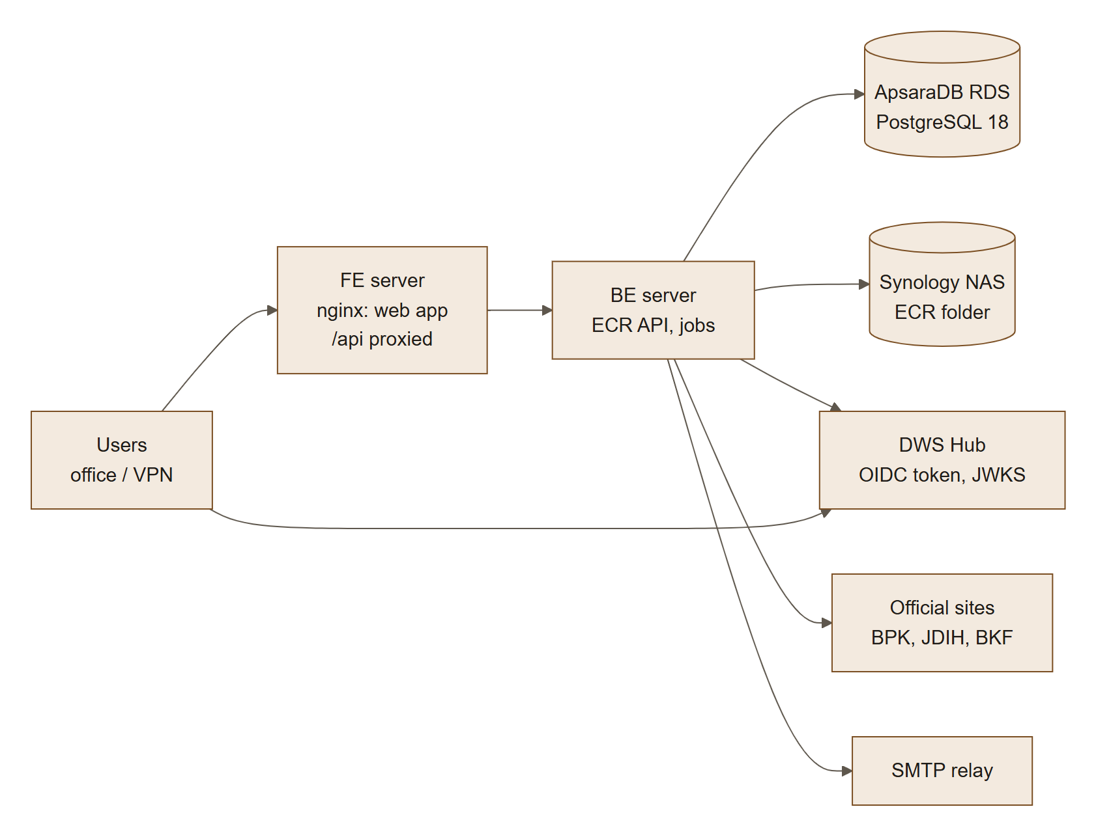
Environment | FE server | BE server | Database | NAS folder
Staging | 172.28.92.56, port 3160 (ecr-web-staging) | 172.28.92.57, port 4160 (ecr-api-staging) | pgm-d9jx9o06qae8gf3h.pgsql.ap-southeast-5.rds.aliyuncs.com | APPs/dev/ECR mounted at /mnt/synology-ecr
Production | 172.28.80.50, port 3160 (ecr-web-prod) | 172.28.80.51, port 4160 (ecr-api-prod) | pgm-d9jn3khh0b3907w4.pgsql.ap-southeast-5.rds.aliyuncs.com | APPs/ECR mounted at /mnt/synology/ECR (systemd mount unit)

Both environments are served over HTTP on the private network (COOKIE_SECURE=false); HTTPS with a DNS name is the recommended next step (§21). Production runs tagged releases (latest v1.2.0); staging follows the SIT branch. The deployment steps are in docs/DEPLOY-STAGING.md, docs/DEPLOY-PROD.md and the Technical Documentation.

14. Data migration from the prototype
Step | Activity | Owner | Exit criterion
M1 | Extract the 122 palm rows (the 21 non-palm rows are out of scope), band table (17 bands) and schedule metadata from the prototype JSON | Dev | Machine-readable staging file
M2 | Create Regulation records: Permenperin draft (status DRAFT_RANCANGAN), PP 55/2008 and PMK 214/2008 (duty collection), PMK 38/2024, PMK 68/2025, PMK 69/2025, PMK 9/2026 — verify each number, date and annex against JDIH Kemenkeu and the BPK database (13.1) | Maker | Source PDFs attached, Checker approved
M3 | Expand non-code HS text (e.g. ex 4407 (all subheadings listed in Annex A)) into explicit codes; assign BTKI version | Maker | DQ-02 clean
M4 | Map duty rates[17] → BAND_USD_PER_MT; pctFlat → AD_VALOREM_PCT; cocoa → BAND_PCT; levy pct → PCT_OF_REF_PRICE; usd → FIXED_USD_PER_MT (USD 0 → ZERO_LISTED) | Dev | Import dry-run passes
M5 | Fill gaps found in the review: missing definitions (4), missing parameters (13), mixture rules (PMK 69/2025 Lampiran B) | Maker | DQ warnings triaged
M6 | Load reference prices, Harga Ekspor (MK/BC) and KMK FX rates for at least the last 24 months, each with its source document | Maker | DQ-07 clean
M7 | Reconcile: calculated values at a USD 900 reference equal prototype outputs for all palm rows (except intentional fixes) | QA + Tax | Signed reconciliation report
M8 | Checker approval and publication of the initial version (v1) | Checker | Version 1 published

(v1.2) As done. The first load of staging and production was made from the official PDFs (Permenperin 32/2024, PMK 68/2025, PMK 69/2025, PMK 9/2026, Kepmendag 2064/2026, KMK 53/MK/EF.2/2026, each checked against its SHA-256) by the operator command seed-official-data, which publishes data version 1 directly on an empty registry (FR-WF-03): the PALM commodity, groups I–V, 4 regulations, 122 products, BK (26 lines × 17 bands) and PE (34 lines) schedules, the CPO band table, the November 2026 CPO reference price and the 4–10 November KMK rate. The 21 non-palm prototype items were not loaded (out of scope).

15. Release plan (indicative)
Phase | Duration | Content | Exit
Discovery & design | 3 weeks | Close open questions, UX prototypes, architecture & security design, Alibaba Cloud environments, DWS Hub SSO registration, golden test set from Tax | Design sign-off
MVP build — Sprints 1–2 | 4 weeks | DWS Hub SSO (F-13), IAM (F-01…F-12), network restriction (F-14), audit (F-50), configuration (F-52) | Security tests pass
MVP build — Sprints 3–4 | 4 weeks | Data admin (F-20…F-28), DQ (F-51) | Prototype data imported
MVP build — Sprints 5–6 | 4 weeks | Workflow (F-29, F-30), source verification (F-31), catalogue, calculator & PDF evidence pack (F-40…F-47, F-49) | Golden tests 100 %
Hardening | 3 weeks | Pen-test, performance, accessibility audit, migration M1–M8, UAT | No Critical/High; UAT sign-off
Go-live & hypercare | 2 weeks | Production launch, support | KPIs tracked
Release 2 | +8 weeks | Notifications, API, SIEM, automated source watch | —

15.1 Releases
Release | Date | Content
v1.0.0 | 9 Nov 2026 | First production release: everything in §15.2 up to the production deployment files
v1.0.1 | 9 Nov 2026 | Production NAS folder APPs/ECR (not APPs/prod/ECR)
v1.1.0 | 9 Nov 2026 | Automatic CPO and KMK updates; semi-automatic drafts for Checkers; PDF identity check, JDIH Kemenkeu before BPK
v1.1.1 | 9 Nov 2026 | Home: key specification and levy % in the palm spotlight
v1.2.0 | 10 Nov 2026 | App tour; add, edit and delete users

15.2 Build status (10 Nov 2026, release v1.2.0)
The system is built in vertical slices; 170 automated tests (22 files) run against PostgreSQL 18. Details per slice are in the repository README.
Area | Functionalities | Status
Sign-in, sessions, logout, network allow-list | F-09, F-13, F-14 | Built
Hub-tile launch and automatic sign-in | F-16 | Built (v1.2)
Accounts at first sign-in, identity conflicts | F-02, F-03 | Built
ECR authenticator, step-up, recovery codes, exempt roles | F-06 | Built (Super Admin exempt by default)
User administration with SoD-2/3/4, Super Admin bootstrap command; add, edit, delete users | F-01, F-10 | Built (add/edit/delete in v1.2)
App tour | F-15 | Built (v1.2)
Audit trail, hash chain, nightly chain check, audit log page with search and CSV/XLSX export | F-50 | Built; narrower views for Makers, Checkers and User Admins not yet
Scheduled jobs and their page | F-55, F-51, F-12 | Built
Quarterly access reviews | F-12, L2-1.9 | Built
Configuration screen | F-52, FR-CFG-01 | Built; DWS Hub SSO settings read-only (deployment), email templates not yet
Regulation register, official source documents, virus scan | F-20, F-21, F-31 | Built (virus scan required when HTTPS is on)
Official documents page | F-35 | Built
Commodities, products, HS codes, shared HS | F-22, F-23, F-24 | Built; full BTKI 2022 load pending (loader ready)
BK and PE schedules, band tables, reference prices, Harga Ekspor, FX | F-25, F-26, F-27 | Built
Maker-checker change sets, versions, history, impact preview, rollback | F-29, F-30 | Built
Source watch | F-32 | Built (daily)
Automatic CPO and KMK updates | F-33 | Built (every 3 h; checked live against the real decrees)
Semi-automatic drafts for Checkers | F-34 | Built (PMK 68/2025 and PMK 9/2026 tables reproduced exactly)
Notifications in ECR and by email, subscriptions, bulletins | F-48 | Built (everyone notified of automatic updates in v1.2)
Excel bulk import with dry run and row-level report | F-28 | Built
Home with Check a product and palm spotlight, Find a product, catalogue, filters, KPI tiles, detail, as-of date | F-40 to F-43, F-45, F-46 | Built
Calculator with what-if, saved calculations with replay check | F-44 | Built; golden test set pending (A3)
Permalinks, CSV/XLSX export, PDF/A evidence pack with verification page | F-47 | Built; veraPDF validation in CI not yet
File storage on the Synology NAS | F-54 | Built
Staging and production deployment, deploy scripts with safety checks | §13.2 | Built; production go-live in progress
Break-glass login and reset, own profile page, custom roles, language switch | F-05, F-07, F-08, F-11, F-49 | Not yet

16. Risks & mitigations
# | Risk | Likelihood | Impact | Mitigation
R1 | Rates or reference prices entered wrongly | Medium | High | Maker-checker, DQ rules, ±30 % warnings, golden tests, rollback
R2 | Classification regulation stays a draft or changes (incl. possible removal of HS codes from the Permenperin) | High | Medium | Status badges, effective dating, product identity decoupled from HS
R3 | Users treat ECR as legal advice | Medium | High | Disclaimer on all outputs; legal references always shown
R4 | Account takeover of a Maker/Checker | Low | High | Mandatory MFA, lockout, step-up, SoD, alerts
R5 | Slow regulation intake (Maker capacity) | Medium | Medium | Bulk import, R2 source monitoring, time-to-publish KPI
R6 | Scope creep into non-tariff obligations | Medium | Medium | Explicit non-goal; Release 3 module
R7 | Ambiguity in calculation base (Harga Ekspor vs. invoice; PEB date) | Medium | High | Duty base and date confirmed from PMK 214/2008; Tax/Customs to confirm the levy date and later amendments before build (OQ-02/03)
R8 | Personal-data non-compliance | Low | Medium | Data minimisation, privacy notice, PDP-compliant retention; deleted users anonymised (FR-IAM-19)
R9 | (v1.2) An official site changes its layout and automatic reading stops | Medium | Medium | Readers return nothing rather than guess; the run reports unreadable pages, Makers are alerted, ref-gap-check warns when no value covers today
R10 | (v1.2) An automatically published value is wrong | Low | High | Identity check of every PDF, page/PDF agreement for KMK, range and change limits, overlap check; anything unusual goes to a Checker; rollback of the data version
R11 | (v1.2) An official portal links the wrong document (seen: BPK's page for PMK 9/2026) | Medium | High | The PDF's own text must name the regulation; the issuing ministry's copy is read first

17. Assumptions, dependencies & open questions

Assumptions
- A1 ECR is an internal web application reachable only from the office network and VPN.
- A2 DWS Hub assigns ECR to the right people and refuses sign-in for people not assigned (to be confirmed, OQ-14); a corporate email service exists for notifications.
- A3 Tax/Customs will provide a golden test set of ≥ 50 historical shipments.
- A4 Regulatory content in the prototype is a starting point only and will be re-verified against official sources.

Dependencies
- D1 Availability of official regulation PDFs and monthly reference-price decrees.
- D2 BTKI (Indonesian tariff book) code list in machine-readable form.
- D3 Hosting platform, vault/KMS, backup and email services provided by IT.

Open questions
# | Question | Owner | Needed by | Status (30 Oct 2026)
OQ-01 | Which commodities are in MVP scope? | Business Owner | Discovery | Answered: palm oil, CPO and all derivatives, including mixtures. Non-palm commodities are out of scope; the model stays commodity-agnostic.
OQ-02 | What is the base for percentage-based duty and the cocoa levy? | Tax/Customs | Discovery | Mostly answered: the Harga Ekspor set per period by MK/BC decision, not invoice or FOB (PMK 214/2008 Art. 4(2), 5(2); PMK 69/2025 Art. 8(4)). Remaining: confirm the 2014 and 2016 amendments to PMK 214/2008 left Articles 4–5 unchanged. Palm duty itself is a fixed USD/MT amount, so this matters only if other commodities return.
OQ-03 | Which date sets the rate, and which FX rate applies? | Tax/Customs | Discovery | Partly answered: duty uses the PEB registration date (PMK 214/2008 Art. 5(1)); FX for duty and levy is the KMK rate on the payment date (PMK 214/2008 Art. 5(3); PMK 69/2025 Art. 9). Remaining: which date sets the levy rate — not stated in PMK 69/2025; the build uses the PEB date until BPDP confirms.
OQ-04 | Is public access needed? | Business Owner | Sprint 1 | Answered: no. Office network and VPN only (F-14, NFR-SEC-07).
OQ-05 | How and when is SSO delivered? | IT Security | Discovery | Answered: DWS Hub SSO, in the MVP (F-13). Integration details in OQ-12.
OQ-06 | Retention period for audit log and versions (proposed 10 years)? | Legal | Sprint 1 | Answered: 10 years, aligned with tax-record retention (BR-AUD-02).
OQ-07 | Who are the initial named Makers and Checkers, SoD-compliant? | Business Owner | Before UAT | Deferred: to be assigned per role later.
OQ-08 | What evidence format is needed? | Tax | Sprint 5 | Recommended, awaiting confirmation: XLSX/CSV for working data plus a PDF/A evidence pack per calculation with an evidence ID, content hash, source-document SHA-256 and an internal verification link (FR-EXP-02, now MVP). Add a certified e-signature only if Tax or external auditors require it.
OQ-09 | Target hosting stack? | IT | Discovery | Answered: Alibaba Cloud with FE server, BE server and ApsaraDB RDS for PostgreSQL 18 (13.2).
OQ-10 | Do the PMK 9/2026 levy rates in the prototype (e.g. 12.5 % for CPO) match its Lampiran A? So far only news reports confirm them. | Tax/Customs | Sprint 3 | Answered (v1.2): the official PDF's Lampiran A, read line by line, gives all 34 rates (12.5 %, 12 %, 10 %, 7.25 % of the CPO reference price; fixed US$ 25/30/15/5; TBS listed at zero), as loaded.
OQ-11 | Do JDIH Kemenkeu and the BPK database permit scheduled fetching, or can an official data feed be requested? No public API was found. | IT, Legal | Sprint 3 | Open for Legal; built with a low request rate (source watch daily, automatic updates every 3 h, a few pages each) and an identifying user agent.
OQ-12 | DWS Hub SSO details: protocol (OIDC or SAML), claims (verified email, employee ID), whether it reports MFA, single logout, group-to-role mapping. | IT, DWS Hub team | Sprint 1 | Mostly answered by the DWS Hub strict OIDC contract: authorization code + PKCE (S256), ID token verified via JWKS, sub as user key, email and name as profile only, 60-second ID token, no refresh token. Gaps: no MFA or sign-in-time claim (T-01), no logout endpoint (T-05), no email_verified (T-06), no group claims (roles stay in ECR), no leaver signal (T-10) — see the Technical Design.
OQ-13 | Alibaba Cloud region (Jakarta recommended for data residency under UU 27/2022), PostgreSQL 18 availability on ApsaraDB there, and OSS for source documents. | IT | Discovery | Answered: Jakarta (ap-southeast-5), ApsaraDB RDS for PostgreSQL 18; citext and btree_gist created with the high-privilege account; files on the company Synology NAS instead of OSS.
OQ-14 | Does DWS Hub refuse sign-in to ECR for people who are not assigned the application? If not, the default role at first sign-in must be empty (BR-IAM-12). | DWS Hub team | Before UAT | Open
OQ-15 | Real PMK 38/2024 band amounts, reference prices and decrees for the initial load (the walkthrough data so far is test data). | Tax/Customs, Maker | Migration M2–M6 | Mostly answered: the initial load uses PMK 68/2025 Lampiran C (which replaces PMK 38/2024's palm table), PMK 9/2026, the November 2026 CPO price and KMK 53; PMK 38/2024 itself is not loaded.

18. Glossary
Term | Meaning
BK — Bea Keluar | Export duty collected by Customs (DJBC)
PE — Pungutan Ekspor | Export levy collected for the plantation fund agency (BPDP, formerly BPDPKS)
PMK | Peraturan Menteri Keuangan — Minister of Finance Regulation
KMK rate | Weekly USD/IDR exchange rate set by Keputusan Menteri Keuangan, published by BKF (Kurs Pajak), valid Wednesday–Tuesday
Kepmendag | Keputusan Menteri Perdagangan — the monthly decree setting the CPO reference price (Harga Referensi)
ECR automatic update | The deactivated system account under which ECR records its own updates and drafts (v1.2)
Source watch | The daily check of the official sites for new or changed documents (v1.2)
Permenperin | Peraturan Menteri Perindustrian — Minister of Industry Regulation (palm-derivative classification)
Kepmendag | Keputusan Menteri Perdagangan — Minister of Trade Decree (reference prices, Harga Ekspor)
Lampiran / Kelompok | Annex / group within an annex
Uraian | Official description text of a tariff line
HS / BTKI | Harmonized System code / Buku Tarif Kepabeanan Indonesia (8-digit national tariff book)
ex code | Only part of an HS subheading, qualified by a description
Reference price (Harga Referensi) | Periodic price (e.g. CPO, cocoa) used to determine the duty band and levy
Harga Ekspor (HE) | Export base price for ad-valorem BK and the cocoa levy, set per period by MK/BC decision (Customs, for the Finance Minister) from the Trade Ministry's export price decree
KMK rate | Kurs Menteri Keuangan — official FX rate for customs/tax
PEB | Pemberitahuan Ekspor Barang — export declaration
Shared tariff post | One HS code used by several products that may carry different charges
Maker / Checker | Person who prepares a change / independent person who approves it
SoD | Segregation of duties
MFA / TOTP | Multi-factor authentication / time-based one-time password
WIB | Western Indonesia Time (UTC+7)

19. Appendix — Traceability from prototype critique to requirements
Review finding (doc 01) | Addressed by
S1 Palm-only scope | FR-PRD-01, FR-TRF-01/02, F-22, M5, OQ-01
S2 Non-palm levy missing | FR-TRF-02, F-26, M5
S3 No regulation register | FR-REG-01/02, F-20, F-21
S4 No time dimension | Effective dating (§9.1), F-27, F-45, BR-CAL-01
S5 Non-tariff obligations | Non-goal v1; other_obligations_note; Release 3 module
S6 Unverified/draft content | DQ-10, US-43-N1, M2
F1 Default sort | US-40-P1 AC2
F2/F3 Tiles don't reconcile | F-46
F4 Mixed units | US-40-N1, US-42-N1, BR-CAL-04
F5 Cocoa not calculable | BAND_PCT basis, US-25-P2
F6 No quantity/IDR | F-44, BR-CAL-04/05
F7 Truncated uraian | US-43-P1 AC1
F8 Confusing shared-HS text | US-43-P1 AC3
F9 HS search format | US-41-P1, FR-PRD-03
F10 Non-code HS cell | BR-PRD-03, US-24-N1, M3
F11 "No charge" ambiguity | BR-CAL-06, US-44-N2 AC2
U1–U3 Sticky header / mobile / accessibility | NFR-ACC-01, NFR-RSP-01, US-40-P1 AC4, US-42-P1 AC2
U4 Scale | NFR-PRF-01, NFR-SCL-01
U5 Language | F-49, NFR-L10N-01
U6 Export / permalink | F-47
G1–G4 Governance & security | F-01…F-12, F-29, F-30, F-50
G5 Effective dating | §9.1, F-27, F-45
G6 Numbering defects | BR-PRD-02, DQ-04, US-23-P2
G7 BTKI version | FR-PRD-03, DQ-02

Disclaimer: This PRD describes a reference and calculation tool. Regulation numbers, rates and calculation bases cited from the prototype must be verified against the official published regulations before the system is used for customs declarations or financial reporting.

20. Change log — releases v1.0 to v1.2
Release | Date | Area | Change | Requirements
v1.0.0 | 9 Nov 2026 | Sign-in | DWS Hub strict OIDC sign-in; Hub-tile launches complete without "Try again" (one-time restart); automatic sign-in from any page | FR-IAM-13, 15, 16
v1.0.0 | 9 Nov 2026 | Access | ECR authenticator with Super Admin exemption (TOTP_EXEMPT_ROLES); health checks exempt from the network allow-list | FR-IAM-05, 14
v1.0.0 | 9 Nov 2026 | Data | First load from the official PDFs by operator command, published directly on an empty registry | FR-WF-03
v1.0.0 | 9 Nov 2026 | Storage | All files in ECR's own Synology NAS folder; deploy and start-up checks | FR-STO-01
v1.0.0 | 9 Nov 2026 | Home | Check a product first; every palm product with today's duty, levy and total in a spotlight list | FR-CAT-07
v1.0.0 | 9 Nov 2026 | Sources | Official documents page; daily source watch | FR-SRC-03/04/09
v1.0.0 | 9 Nov 2026 | Deployment | Staging and production compose files, shared deploy script (staging/prod), production guide, release tags | §13.2
v1.0.1 | 9 Nov 2026 | Deployment | Production NAS folder APPs/ECR | FR-STO-01
v1.1.0 | 9 Nov 2026 | Updates | Automatic CPO reference price and KMK rate updates with checks; every user notified | FR-SRC-06, FR-NTF-02
v1.1.0 | 9 Nov 2026 | Updates | Semi-automatic drafts for Checkers: failed checks, corrected decrees, new regulations, palm duty and levy tables | FR-SRC-07, FR-NTF-03
v1.1.0 | 9 Nov 2026 | Updates | PDF identity check; Ministry of Finance copy before BPK's | FR-SRC-08
v1.1.1 | 9 Nov 2026 | Home | Key specification column; levy shown with its % of the CPO reference price | FR-CAT-07
v1.2.0 | 10 Nov 2026 | Users | Add users before their first sign-in (linked at first Hub sign-in), edit details, delete (remove or anonymise) | FR-IAM-17–19
v1.2.0 | 10 Nov 2026 | Help | First-sign-in app tour, replayable from the Tour button | FR-UI-02

21. Not in scope and known limitations (v1.2)
# | Item | Status / reason
L-01 | Product classifications (Permenperin) are not read or drafted automatically | Product definitions and specifications cannot be matched reliably; the source watch reports a new Permenperin and Makers enter it
L-02 | BPK status changes without a named amending or revoking regulation are reported, not drafted | No reliable end date to draft from
L-03 | HTTP on the private network (staging and production); no DNS name or certificate yet | HTTPS needs a certificate, an SMTP relay and a virus scanner (COOKIE_SECURE=true enforces them)
L-04 | Uploaded files are not virus-scanned while MALWARE_SCAN_REQUIRED=false (HTTP mode) | A ClamAV daemon is required with HTTPS
L-05 | Notifications are written to the API log, not emailed, while MAIL_TRANSPORT=log | Configure the corporate SMTP relay
L-06 | High-severity advisories in two existing dependencies, nodemailer (email) and multer (file uploads) | Pre-existing; upgrade proposed as a separate change
L-07 | Break-glass local login and password reset, own-profile page, custom roles, Bahasa Indonesia UI | Not yet built (F-05, F-07, F-08, F-11, F-49)
L-08 | 21 non-palm prototype items | Out of scope (OQ-01)
L-09 | Read-only API, SIEM, ERP integration | Release 2/3
L-10 | The levy-rate date (PEB date) awaits BPDP confirmation (OQ-03) | Built on the PEB date
L-11 | The automatic updates depend on the official sites' current page layouts | A changed layout stops automatic reading safely and alerts Makers (R9)
L-12 | Official portals can link wrong documents (e.g. BPK's PMK 9/2026 page) | Identity check and issuer-first sourcing (R11); report such errors to the portal

