EXPORT CHARGES REGISTRY (ECR)
Technical Documentation
Architecture, process flows, data model, API, security, deployment and operations — release v1.2.0

Version: 1.2 (release v1.2.0)
Date: 10 November 2026
Owner: Jerry Hakim
Status: Issued for review
Classification: Internal

Document control
Field | Value
System | Export Charges Registry (ECR)
Document | Technical Documentation
Document version | 1.2 — describes release v1.2.0 (git tag v1.2.0, commit 818f3b6)
Date | 10 November 2026
Document owner | Jerry Hakim
Based on | Product Requirements Document 2.0 (docs/ECR-PRD-v1.2.docx)
Repository | github.com/dwsitproject-hub/Export-Charges
Generated parts | §6.4 table reference from backend/migrations 0001–0018; §7.2 endpoint list from the API controllers
Related documents | docs/DEPLOY-STAGING.md, docs/DEPLOY-PROD.md, repository README, functional and penetration test reports

Version history
Version | Date | Author | Change
1.0 | 28 Oct 2026 | Jerry Hakim | Technical design (Claude Doc): flows, API, ERD, tables, DWS Hub OIDC
1.2 | 10 Nov 2026 | Jerry Hakim | Full technical documentation of release v1.2.0, aligned with PRD 2.0

Review and approval
Role | Name | Decision | Date
IT Delivery Lead
IT Security
IT Infrastructure

Contents
Document control 2
Version history 2
Review and approval 2
1. Introduction 5
1.1 Purpose and scope 5
1.2 Audience 5
1.3 Sources of truth 5
1.4 Conventions 5
2. System overview 5
3. Architecture 7
3.1 System context 7
3.2 Deployment architecture 9
3.3 Containers 10
3.4 Technology stack 10
4. Process flows 11
4.1 L0 — system flow 11
4.2 L1 — sign-in, including a DWS Hub launch 12
4.3 L1 — maker-checker publication 13
4.4 L1 — charge calculation 14
4.5 L1 — automatic and semi-automatic updates 15
4.6 L1 — source watch, notifications and file storage 16
4.7 L2 — detailed steps 16
5. Code structure 18
5.1 Repository layout 18
5.2 Back-end modules (backend/src) 18
5.3 Web app (frontend/src) 19
6. Data model 20
6.1 Principles 20
6.2 Entity-relationship diagrams 20
6.3 Tables by domain 27
6.4 Table reference 27
7. API reference 45
7.1 Conventions 45
7.2 Endpoints 45
8. Security design 51
8.1 Authentication 51
8.2 Sessions and cookies 51
8.3 Authorisation and segregation of duties 51
8.4 Network and HTTP 52
8.5 Files and uploads 52
8.6 Audit trail 52
8.7 Secrets 52
9. Scheduled jobs 52
10. Configuration 53
10.1 Settings (backend/.env.<env>, read at start-up) 53
10.2 Runtime configuration (Configuration screen, system_config) 54
11. Deployment 54
11.1 Repository, branches and releases 54
11.2 The deploy scripts 54
11.3 Servers, database and NAS (one-time) 55
11.4 Order of a release 55
12. Operations 55
12.1 Health and monitoring 55
12.2 Logs 56
12.3 Backup and recovery 56
12.4 Routine data upkeep 56
12.5 Troubleshooting 56
12.6 Known technical debt 56
13. Testing approach 57
13.1 Automated tests 57
13.2 Other verification 57

1. Introduction

1.1 Purpose and scope
This document describes how the Export Charges Registry (ECR) is built and run, as of release v1.2.0 (git tag v1.2.0, commit 818f3b6, 10 November 2026). It is the technical counterpart of the Product Requirements Document 2.0 (docs/ECR-PRD-v1.2.docx): every requirement ID quoted here (FR-…, F-…, BR-…, NFR-…) refers to that PRD.
It covers the system context and architecture, the process flows at three levels (L0, L1, L2), the code structure, the data model with entity-relationship diagrams and a table-by-table reference, the API, the security design, the scheduled jobs, configuration, deployment, operations and the testing approach.

1.2 Audience
Reader | Sections of most use
Developers maintaining ECR | 3, 4, 5, 6, 7, 8, 13
IT operations and infrastructure | 3, 9, 10, 11, 12
IT security and auditors | 3, 8, 6 (audit trail), 12
Business owners and testers | 2, 4, 13

1.3 Sources of truth
The facts in this document come from the repository github.com/dwsitproject-hub/Export-Charges at tag v1.2.0: the source code (backend/src, frontend/src), the SQL migrations backend/migrations/0001 to 0018, the compose files and deploy scripts, the README and the deployment guides docs/DEPLOY-STAGING.md and docs/DEPLOY-PROD.md. The table reference (§6.4) and the API reference (§7) are generated from the migrations and controllers.

1.4 Conventions
- WIB is Western Indonesia Time (UTC+7). Business dates (PEB date, payment date, schedules, job times) are WIB days.
- BK is the export duty (Bea Keluar), PE the export levy (Pungutan Ekspor).
- Amounts are decimals (never floating point): numeric in PostgreSQL, decimal.js in TypeScript.
- Code identifiers are written like_this.

2. System overview
ECR is the single source of the Indonesian export duty and export levy on palm oil products, with the regulation behind every figure. People use it to check a product (duty, levy and total per tonne for a shipping date), to calculate a shipment in USD and Rupiah with a verifiable PDF/A evidence pack, and to follow changes. Makers and Checkers maintain the data under four-eyes control; since v1.1 ECR also updates the monthly CPO reference price and the weekly KMK exchange rate by itself, and drafts new regulations' palm duty and levy tables for Checkers.
Quality | How ECR achieves it
Correctness | Effective-dated, versioned data; every value tied to an official source document (SHA-256); maker-checker with automated validation; charges computed from one engine; replayable calculations
Traceability | Append-only, hash-chained audit trail; data versions with bulletins; change sets with justification; evidence packs with content hashes
Security | DWS Hub OIDC with PKCE; server-side sessions; CSRF tokens; role-based permissions checked on every request; TOTP step-up for privileged actions; office/VPN network allow-list; segregation-of-duties rules
Availability | Stateless API and web containers restarted automatically; managed PostgreSQL with backups; files on the company NAS
Maintainability | NestJS modules per domain; plain SQL migrations; 170 automated tests against PostgreSQL 18

3. Architecture

3.1 System context
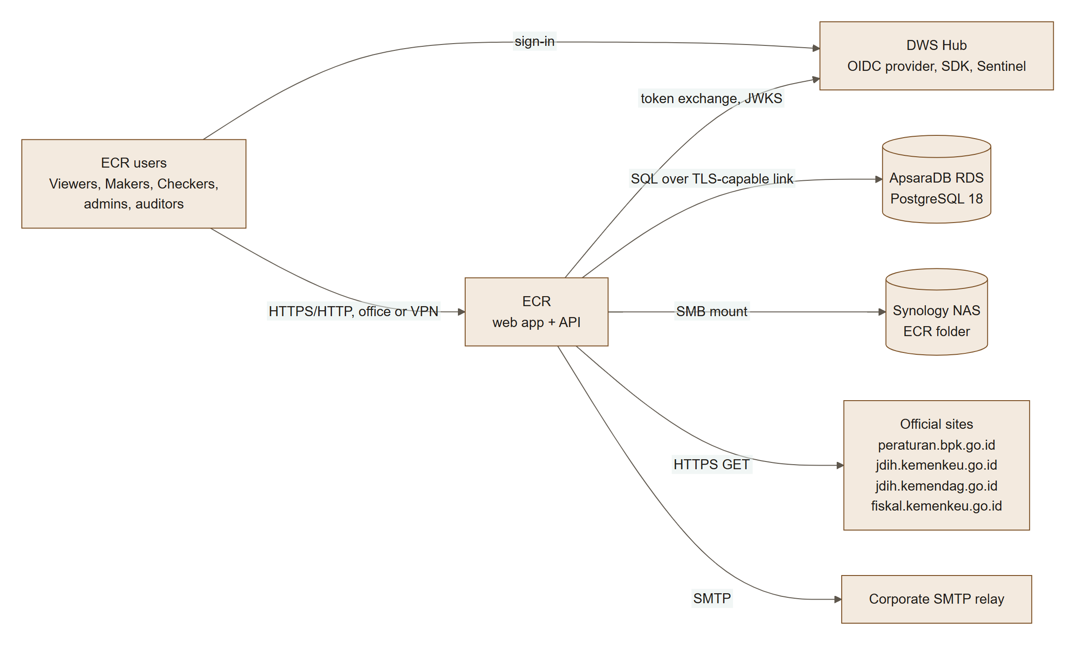

External system | Direction | Purpose | Protocol / detail
DWS Hub | In and out | Single sign-on for every user; the Hub decides who may use ECR. Hub SDK (page views, errors, bug button) and Sentinel analysis | OIDC authorization code + PKCE (S256); ID token RS256/ES256 verified with the Hub JWKS; discovery document cached and refreshed every 6 h
ApsaraDB RDS for PostgreSQL 18 | Out | All business data, sessions, audit trail, job state | pg driver; schema ecr; extensions citext, btree_gist; uuidv7()
Synology NAS | Out | Every stored file: official PDFs, imports, exports, evidence packs, access-review reports | SMB/CIFS mount of ECR's own folder, bound into the API container
Official sites | Out | Source watch, automatic CPO and KMK updates, regulation drafting | HTTPS GET with user agent ECR-source-watch/1.0, 45 s timeout, 40 MB limit
SMTP relay | Out | Notification emails from the email outbox | nodemailer; STARTTLS required unless configured otherwise; MAIL_TRANSPORT=log writes emails to the log instead

3.2 Deployment architecture
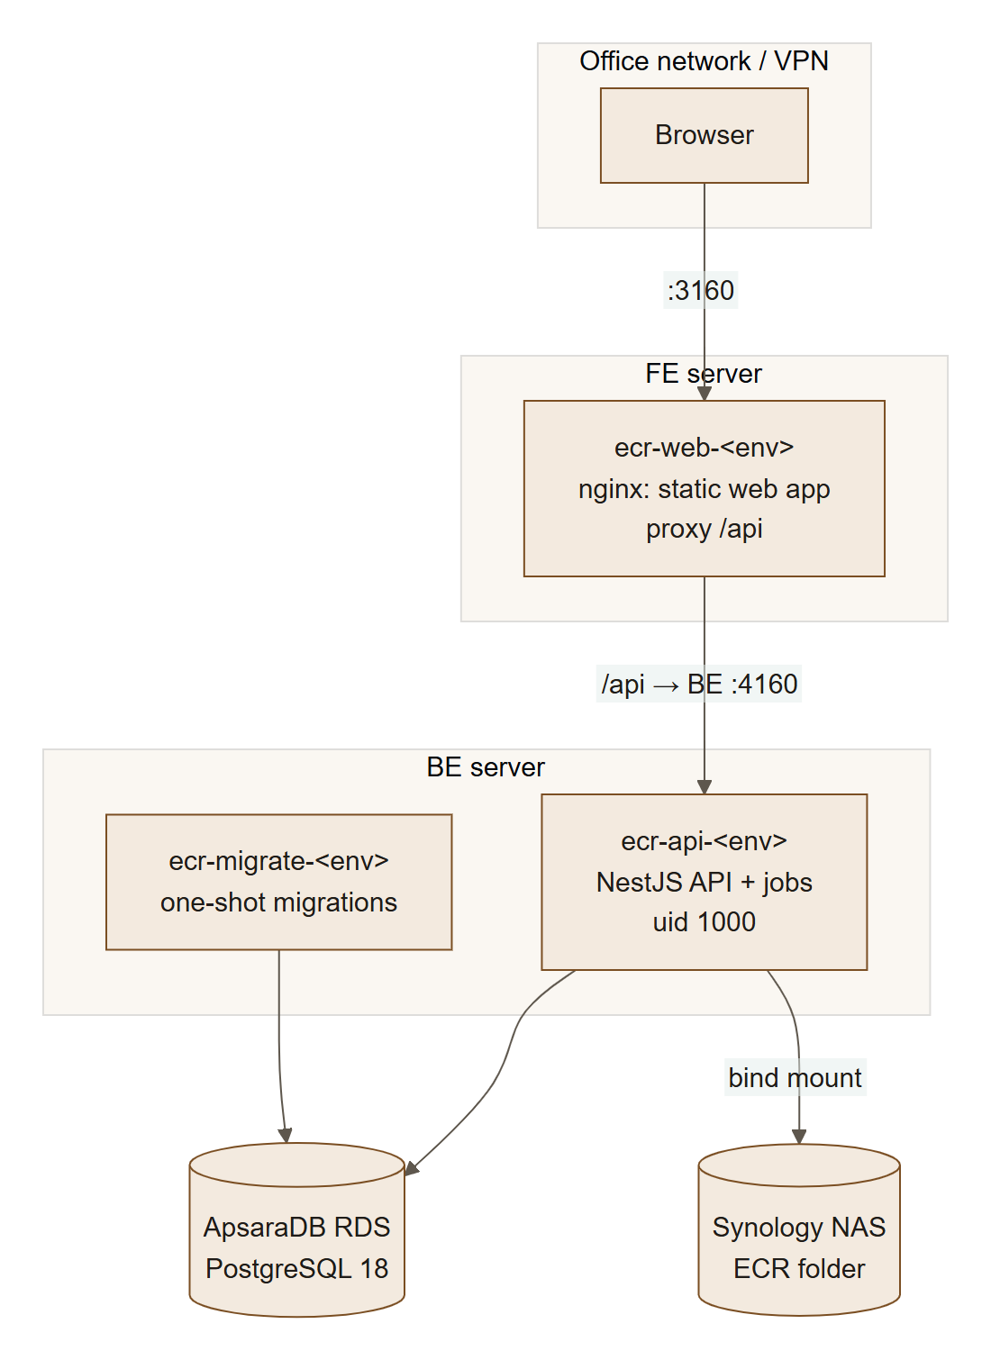
Environment | FE server (container, port) | BE server (container, port) | Database host | NAS folder → mount point | Code
Local development | ecr-web-1 on 127.0.0.1:8095 | ecr-api-1 (+ ecr-db-1, ecr-hub-1 stand-in) | Docker volume ecr_ecr-db | var/storage (local folder) | working tree
Staging | 172.28.92.56, ecr-web-staging, 3160 | 172.28.92.57, ecr-api-staging, 4160 (bound to the private address only) | pgm-d9jx9o06qae8gf3h.pgsql.ap-southeast-5.rds.aliyuncs.com | APPs/dev/ECR → /mnt/synology-ecr (fstab) | branch SIT
Production | 172.28.80.50, ecr-web-prod, 3160 | 172.28.80.51, ecr-api-prod, 4160 (private address only) | pgm-d9jn3khh0b3907w4.pgsql.ap-southeast-5.rds.aliyuncs.com | APPs/ECR → /mnt/synology/ECR (systemd mount unit) | release tag (v1.2.0)

Ports 3160 and 4160 were chosen after checking the ports already used by the other applications on the shared servers; the deploy scripts refuse to start when another program holds them.

3.3 Containers
Container | Image (build target) | Runs | Notes
ecr-web-<env> | frontend/Dockerfile, target web (nginx) | The built React app; /api proxied to ECR_API_UPSTREAM | Build arguments VITE_HUB_SDK_URL, VITE_HUB_SDK_KEY, VITE_GIT_SHA (release reported to the Hub SDK); nginx configuration from nginx.conf.template
ecr-migrate-<env> | backend/Dockerfile, target build (tools) | npx tsx src/scripts/migrate-cli.ts, then exits | One-shot: applies pending migrations at each deploy; the API starts only after it exits with 0 (service_completed_successfully). A stopped ecr-migrate container is expected
ecr-api-<env> | backend/Dockerfile, target api | node dist/main.js on port 3100, as user node (uid 1000) | Health check GET /api/ready; restart unless-stopped; log rotation 5 × 20 MB; NAS folder bound at /mnt/synology/<deployment>/ECR

3.4 Technology stack
Layer | Technology | Version (pinned in package files)
Web app | React, Vite, TypeScript | React 19, Vite 6, TypeScript 5.7
Web server | nginx (container) | nginx 1.27 (Alpine)
API | NestJS on Node.js, TypeScript | NestJS 11, Node 22.20 (Debian bookworm-slim images)
Database | PostgreSQL (ApsaraDB RDS) | 18
Database access | pg, plain SQL, own migration runner | —
Authentication | jose (JWT/JWKS), own OIDC client, own TOTP | —
Decimal maths | decimal.js | —
PDF reading | Mozilla pdf.js (pdfjs-dist) | 4.10.38
PDF writing | Own PDF/A writer with embedded DejaVu fonts (evidence/pdfa.ts) | —
Email | nodemailer | 7 (see §12.6)
Tests | Vitest, Supertest, PostgreSQL 18 in Docker | Vitest 3
Packaging | Docker, Docker Compose | —

4. Process flows

4.1 L0 — system flow
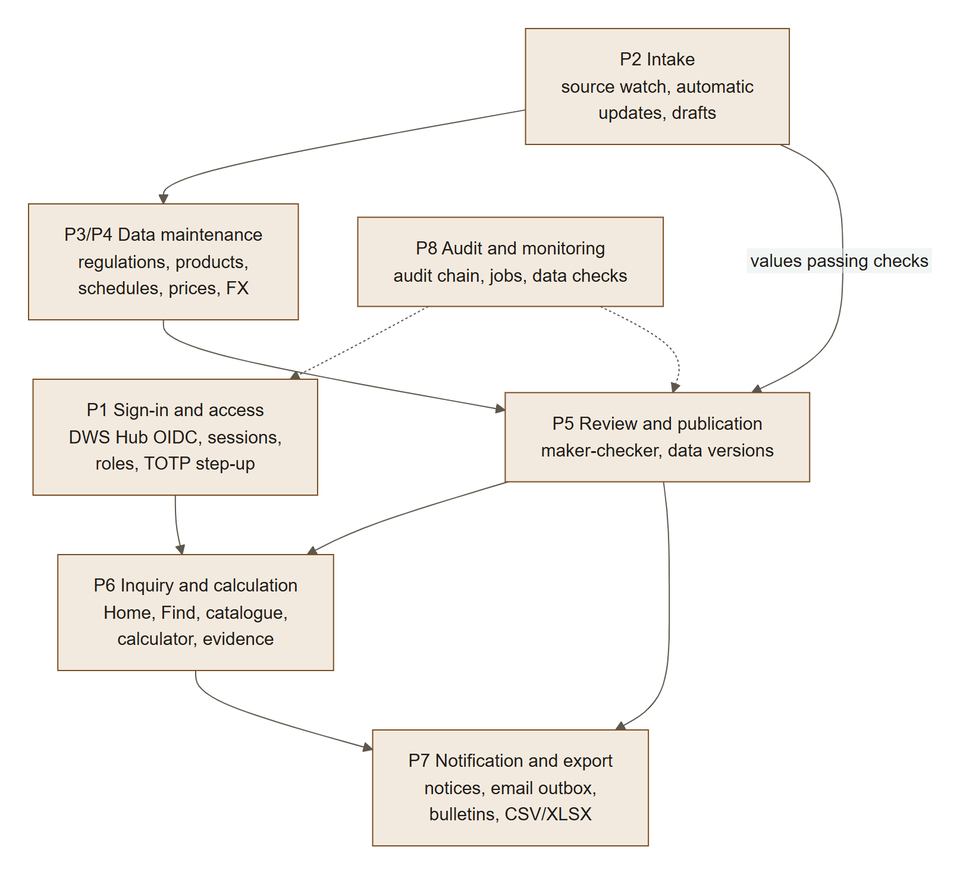
L0 | Process | What the system does | Main modules
P1 | Sign-in and access | Authenticates through DWS Hub, binds the Hub identity to an ECR account, keeps server-side sessions, checks permissions and step-up | auth, admin, access-reviews, settings
P2 | Intake | Watches the official sites daily; reads new CPO and KMK decrees every 3 h; drafts what needs a person | source-watch, auto-update, jobs
P3/P4 | Data maintenance | Change sets with items for every registry entity; Excel import | registry, tariffs, imports
P5 | Review and publication | Validation, review, approval, scheduled or immediate publication as a data version, rollback | registry (change sets), jobs (publish-due)
P6 | Inquiry and calculation | Catalogue, Find, Home spotlight, calculator, evidence packs | catalogue, tariffs, evidence
P7 | Notification and export | In-app notifications, email outbox, subscriptions, bulletins, exports | notifications, exports
P8 | Audit and monitoring | Audit trail with hash chain, data-quality checks, scheduled jobs, health checks | audit, jobs, health

4.2 L1 — sign-in, including a DWS Hub launch
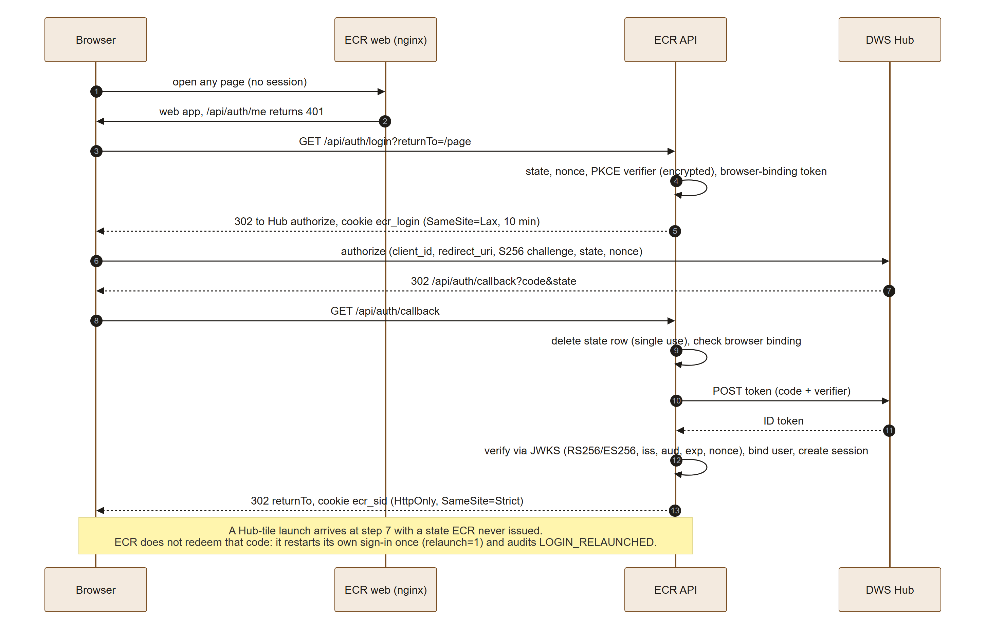

4.3 L1 — maker-checker publication
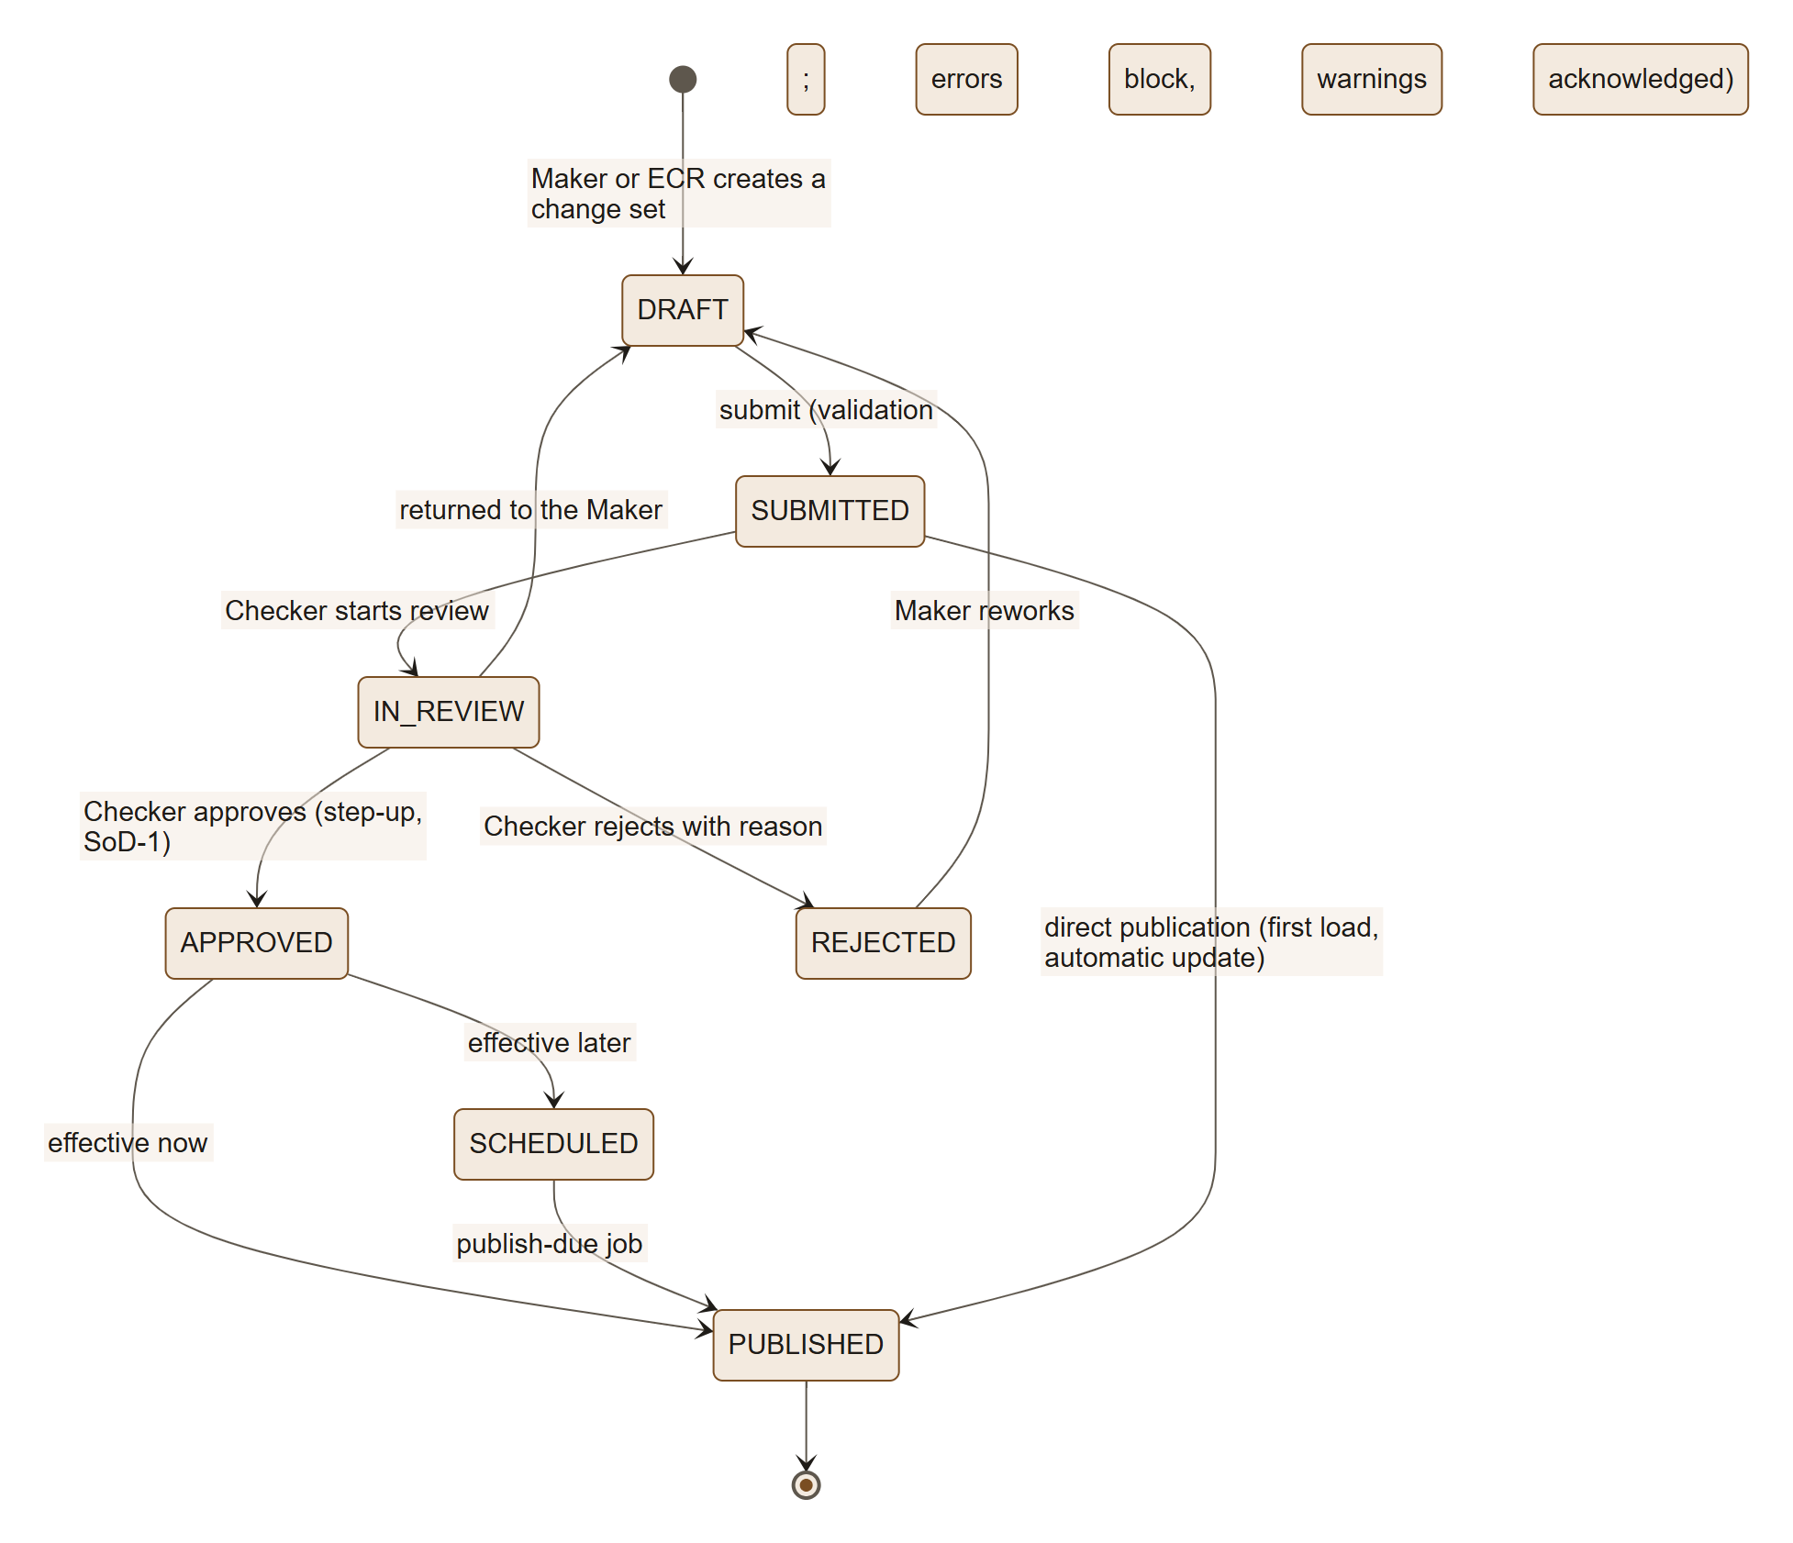
Publication (ChangeSetsService.publish) runs in one transaction under an advisory lock: the set is validated again, a new data_version number is taken, each item closes the current version row of its entity (version_to = v) and inserts the new row (version_from = v), a bulletin is stored, the audit event is written, and the notifications are created — so the notices exist exactly when the version does.

4.4 L1 — charge calculation
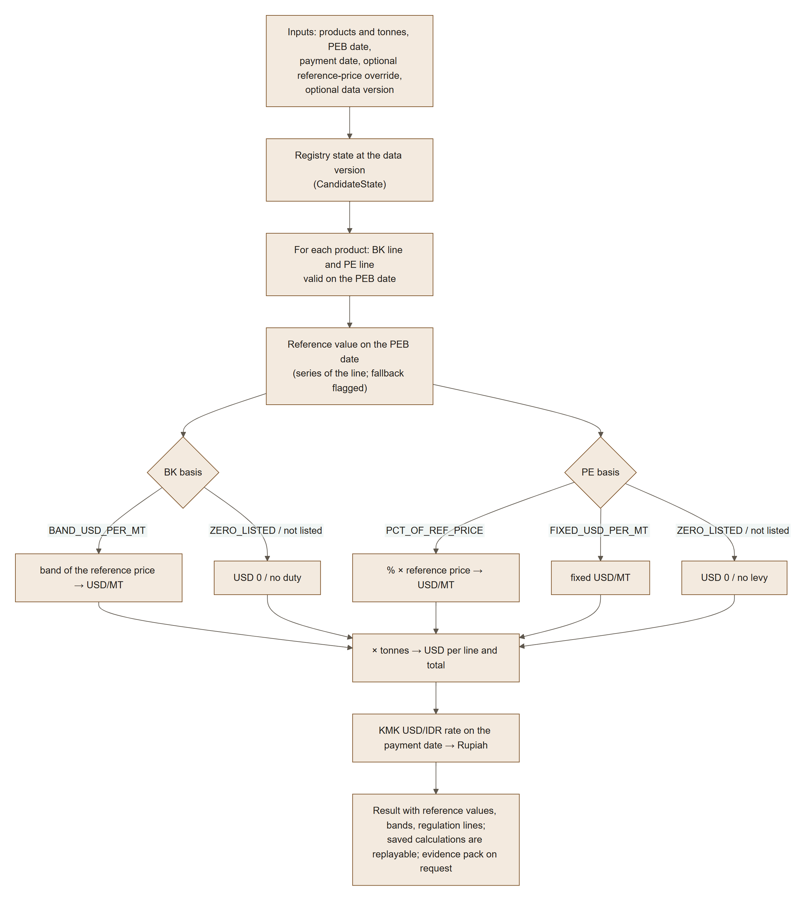
The engine is backend/src/tariffs/charge-engine.ts; the catalogue, Find, Home, the calculator and the evidence pack all use it. Other bases supported by the data model (AD_VALOREM_PCT, BAND_PCT with Harga Ekspor) are computed the same way when such lines exist.

4.5 L1 — automatic and semi-automatic updates
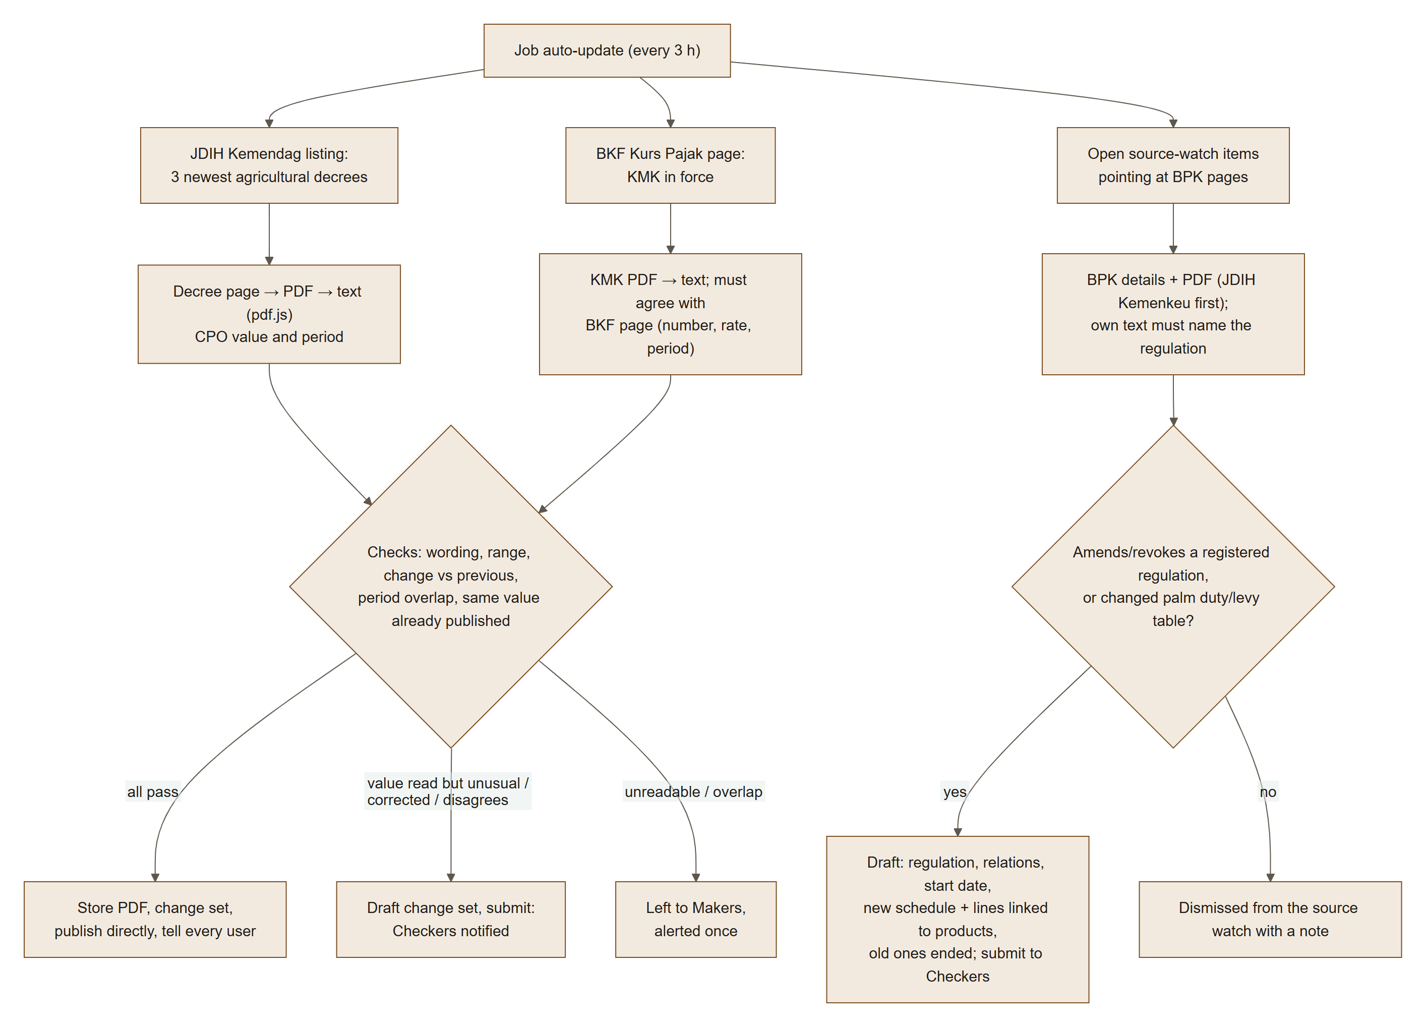

4.6 L1 — source watch, notifications and file storage
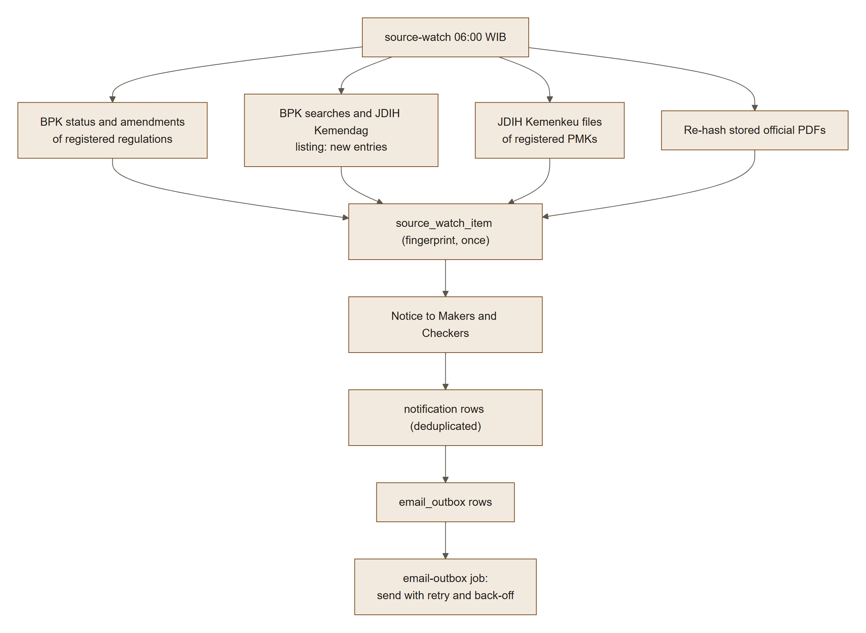
Every file ECR stores goes through DirectoryObjectStore (registry/file-handling.ts): keys are restricted to [a-z0-9/_.-] without .., the root is ECR's NAS folder, and at start-up the API writes and removes a probe file (assertWritable) — it does not start without a writable folder.

4.7 L2 — detailed steps

L2 sign-in (auth/auth.controller.ts, oidc.service.ts, user-binding.service.ts, session.service.ts)
Step | Actor | Action | Rule / data
1 | Browser | Opens a page without a session; the web app calls /api/auth/me (401) and redirects to /api/auth/login?returnTo= | At most once per 30 s per tab (sessionStorage guard) — FR-IAM-16
2 | API | Creates oidc_login_state: SHA-256 of the state, browser-binding hash, nonce, PKCE verifier encrypted with ECR_ENCRYPTION_KEY, sanitised returnTo, expiry 10 min | returnTo must be a relative path (open-redirect protection)
3 | API → Hub | 302 to the Hub's authorization_endpoint with S256 challenge | Discovery from HUB_DISCOVERY_URL or HUB_ISSUER
4 | API | Callback: deletes the state row (single use); checks expiry and browser binding | Unusable callback → relaunch once (relaunch flag + ecr_relaunch cookie, 60 s) — FR-IAM-15
5 | API → Hub | Token request with code and verifier | HUB_TIMEOUT_MS (5 s)
6 | API | Verifies the ID token with the Hub JWKS: algorithm RS256/ES256 only, issuer, audience, expiry (60 s tolerance), nonce when present | HS256 and none refused
7 | API | Binds the user: existing Hub sub → account (refused if not ACTIVE); else an INVITED account with that email → linked and activated; else a new account with the default roles; an email used by another account → LOGIN_IDENTITY_CONFLICT | FR-IAM-02/03/17
8 | API | Creates the session: random token (only its SHA-256 stored), CSRF token, idle limit 30 min (15 for privileged roles), absolute 8 h, at most 3 sessions per person | Configurable within limits (§10.2)
9 | Browser | GET /api/auth/me returns profile, permissions, TOTP state, tourSeenAt, CSRF token | The web app sends the CSRF token in X-CSRF-Token on every change

L2 publication of a change set (registry/change-sets.service.ts)
Step | Actor | Action | Rule
1 | Maker (or ECR) | Creates a change set with title and justification | changeset.create
2 | Maker | Adds items: CREATE, UPDATE, END_DATE (or WITHDRAW) per entity | An entity can be open in one change set only
3 | Maker | Submits; validation runs over the candidate state (registry + items) | Errors block; warnings must be acknowledged; unsourced values block (FR-SRC-02)
4 | Checker | Starts the review; approves or rejects with a reason | Step-up; SoD-1: never a set one created or edited (database CHECK as well)
5 | System | Publishes now, or at the effective date via publish-due | One transaction, advisory lock, data version, bulletin, audit, notifications
6 | Checker | Rollback of a data version creates a ROLLBACK change set restoring the prior state | Reviewed by another Checker

L2 automatic update of a reference value (auto-update/auto-update.service.ts)
Step | Action | Rule
1 | Skip decrees already in auto_update_source | One outcome per decree
2 | Read the listing/page, the PDF and its text | Unreadable now → tried again next run
3 | Parse the decree (official-values.ts): number, year, value, period | Nothing guessed: no wording → NEEDS_REVIEW
4 | Compare with the series in the registry | Same value same period → ALREADY_PUBLISHED; period over → OLDER_PERIOD; different value same period → draft UPDATE for a Checker; overlap → Makers
5 | Limits: CPO US$ 300–3,000/MT and ≤ 30 % change; USD/IDR Rp 5,000–50,000 and ≤ 5 % | Outside → draft for a Checker
6 | Store the PDF (SourceDocumentsService.upload), create the change set under the system account, submit, publish directly | CHANGESET_PUBLISHED_DIRECT, justification with PDF URL, SHA-256 and quoted text
7 | Notify every active user; close the matching source-watch item | Dedupe key published:<version>

L2 drafting a new regulation (auto-update/regulation-drafts.ts, regulation-text.ts)
Step | Action | Rule
1 | Pick open source-watch items whose URL is a BPK Details page not yet handled | At most 10 per run
2 | Read BPK's fields: type, number, year, title, issuer, enactment and promulgation dates, status, PDF link | Already registered → NOT_RELEVANT
3 | Find the PDF: for a PMK the copies on JDIH Kemenkeu first, then BPK's; the first whose own heading names this regulation | Wrong document refused and noted
4 | Read the text: what it amends/revokes, start rule ("mulai berlaku setelah N hari … diundangkan"), palm duty table (17 bands) and levy table | Merged levy cells carried down
5 | Compare with the schedules in force | Unchanged tables are not redrafted
6 | Draft: REGULATION create (+ relations, PDF), REVOKED update for revoked ones, new band table if bands changed, new SCHEDULE and SCHEDULE_LINEs linked to the products of the lines they replace (same number and HS codes), END_DATE of the old schedule and lines the day before | Lines without products are listed in the justification
7 | Submit to the Checkers; close the source-watch item | A draft failing validation stays a draft for a Maker (alerted once)

5. Code structure

5.1 Repository layout
Path | Content
backend/ | NestJS API (@ecr/api): src/, migrations/, test/, seed/, deploy/, Dockerfile, compose files per environment, settings templates
frontend/ | React web app (@ecr/web): src/, index.html, nginx.conf.template, deploy/, Dockerfile, compose files
docs/ | PRD, technical documentation, review of the prototype, deployment guides
assets/ | The original prototype HTML
docker-compose.yml | Local development stack (name: ecr)
package.json | npm workspaces backend and frontend

5.2 Back-end modules (backend/src)
Module | Responsibility | Key files
main.ts, app.ts, app.module.ts, config.ts | Start-up: settings, Nest application, HTTP middleware, storage check | config.ts validates every setting at start
common | Errors with stable codes, crypto helpers, field validation, HTTP middleware (trace id, security headers, network allow-list), storage location | http.ts, crypto.ts, storage-path.ts
db | Connection pool, transactions, migration runner, DATABASE_URL or DB_* settings | db.service.ts, migrate.ts, database-url.ts
auth | OIDC client, callback and relaunch, sessions, CSRF, permission decorator @Authorize, TOTP enrolment and step-up, user binding | auth.controller.ts, oidc.service.ts, session.service.ts, authorize.ts, totp.service.ts, user-binding.service.ts
admin | User administration: list, add, edit, delete, roles, deactivate/reactivate, sessions, authenticator reset | users-admin.service.ts
access-reviews | Quarterly access reviews and their signed PDF/A report | access-reviews.service.ts, review-report.ts
audit | Writing and reading the audit trail, chain verification, export | audit.service.ts
settings | Runtime configuration (sessions, step-up window, default roles, networks, disclaimer) | settings.service.ts
registry | Entity definitions, versioning, candidate state, validation, change sets, publication, source documents, read services | entities.ts, versioning.ts, candidate.ts, validation.ts, change-sets.service.ts, source-documents.service.ts, file-handling.ts
tariffs | Tariff entities (reference series and values, band tables, schedules, lines), charge engine, impact preview | charge-engine.ts, tariff-entities.ts, impact.ts
catalogue | Catalogue rows, filters, KPIs; calculator and saved calculations | catalogue.service.ts, calculator.ts, calculations.service.ts
evidence | PDF/A evidence packs and their verification | evidence.service.ts, pdfa.ts
exports | CSV/XLSX exports, background export jobs | exports.service.ts, export-jobs.service.ts
imports | Excel template, reader, dry run and import into a change set | imports.service.ts, xlsx-reader.ts
notifications | In-app notifications, email outbox and sending, subscriptions, bulletins | notifications.service.ts, mail.ts
jobs | Scheduler and the daily/interval jobs | jobs.service.ts
source-watch | Daily watch of the official sites | source-watch.service.ts
auto-update | Automatic CPO/KMK updates, regulation drafting, PDF text, decree and table readers, system account | auto-update.service.ts, regulation-drafts.ts, official-values.ts, regulation-text.ts, pdf-text.ts, system-account.ts
scripts | Operator commands: migrations, Super Admin grant, official first load, BTKI loader | migrate-cli.ts, grant-role.ts, seed-official-data.ts, official-seed.ts, load-btki.ts
health.controller.ts | GET /api/health (process up) and GET /api/ready (database reachable) | exempt from the network allow-list

5.3 Web app (frontend/src)
File | Content
main.tsx, App.tsx | Start-up, routing by path, signed-in area with automatic sign-in, Home, What changed
ui.tsx | Page shell: header, tabs, More tools menu by permission, notifications bell, Tour button, account menu, step-up dialog, shared components
tour.tsx | The app tour (first sign-in and replay)
api.ts, api-catalogue.ts | API client: CSRF header, error codes, typed calls
hubSdk.ts | DWS Hub SDK: identify with the Hub sub, reset on sign-out, tracked actions
styles.css | Design tokens (light and dark), layout, components
pages/PalmSpotlight.tsx | Home's palm oil list and reference prices
pages/Find.tsx | Find a product
pages/Catalogue.tsx | Full product table with filters and export
pages/Calculator.tsx | Calculator, saved calculations, evidence verification
pages/Registry.tsx, Tariffs.tsx, Editors.tsx, TariffEditors.tsx | Regulations, products, schedules, prices; their editors
pages/ChangeSets.tsx, Imports.tsx | Change sets (draft, review, publish, rollback); Excel import
pages/Sources.tsx, SourceWatch.tsx | Official documents; new regulation watch
pages/Notifications.tsx, Exports.tsx | Notifications and following; downloads
pages/AdminUsers.tsx, AccessReviews.tsx, AuditLog.tsx, Jobs.tsx, Configuration.tsx, Authenticator.tsx | Administration

6. Data model

6.1 Principles
- Schema ecr in one PostgreSQL 18 database; keys are uuid generated with uuidv7() (time-ordered); case-insensitive emails with citext; overlapping validity prevented with exclusion constraints (btree_gist).
- Entities and versions. Every registry record (regulation, commodity, product group, product, reference series and value, band table, schedule, schedule line) has one row in entity_key and one row per version in its table. A version row carries version_from and version_to (data version numbers; version_to IS NULL = current) and, where it applies, the business validity valid_from/valid_to. References between registry records point at entity_key, so they survive new versions.
- Change sets. All registry changes are change_item rows of a change_set; publication creates a data_version and applies the items. Any past answer can be reproduced from the rows current in that version (loadAtVersion).
- Audit. audit_event is append-only (triggers refuse UPDATE, DELETE and TRUNCATE) and hash-chained: each row's hash is SHA-256 of the previous hash and the row's canonical text; audit_chain_head keeps the last link.

6.2 Entity-relationship diagrams
The diagrams show primary keys (PK), the references that matter in each domain (FK) and a few descriptive columns. References to app_user (created by, decided by…) and the versioning columns are left out outside their own diagrams; §6.4 lists every column.

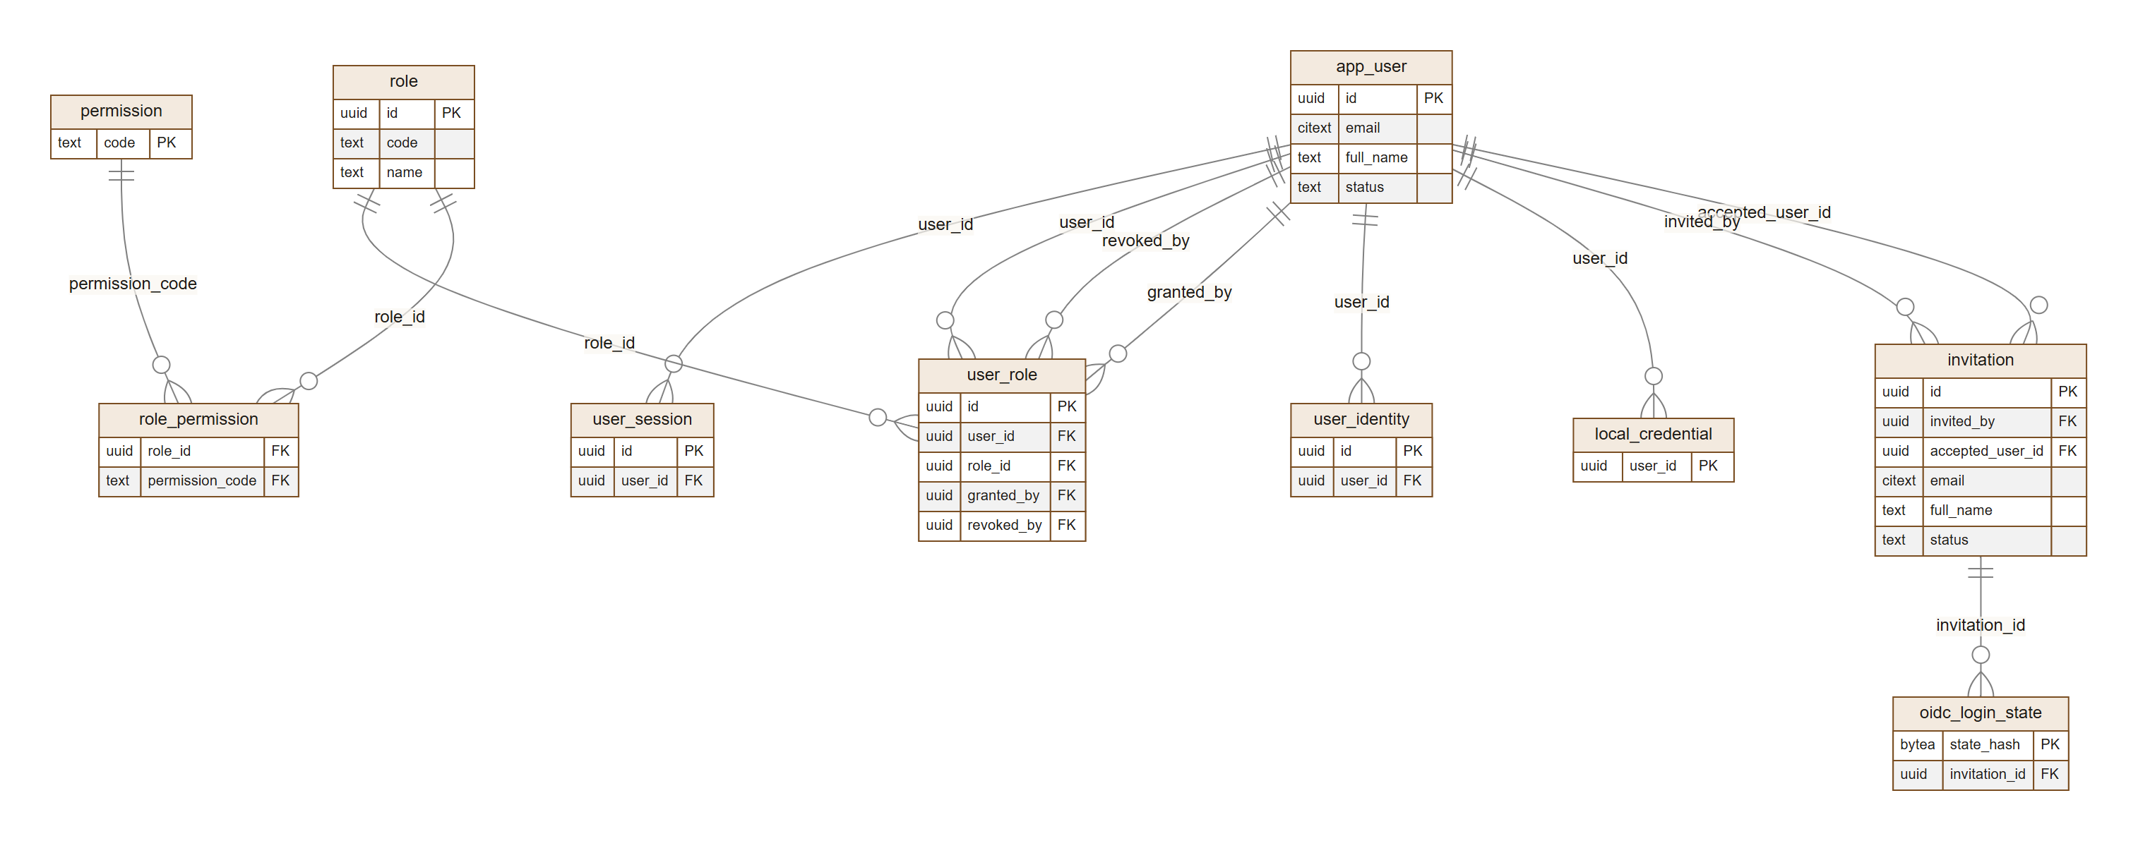
Figure 6-1 — Identity, roles, sessions and sign-in state

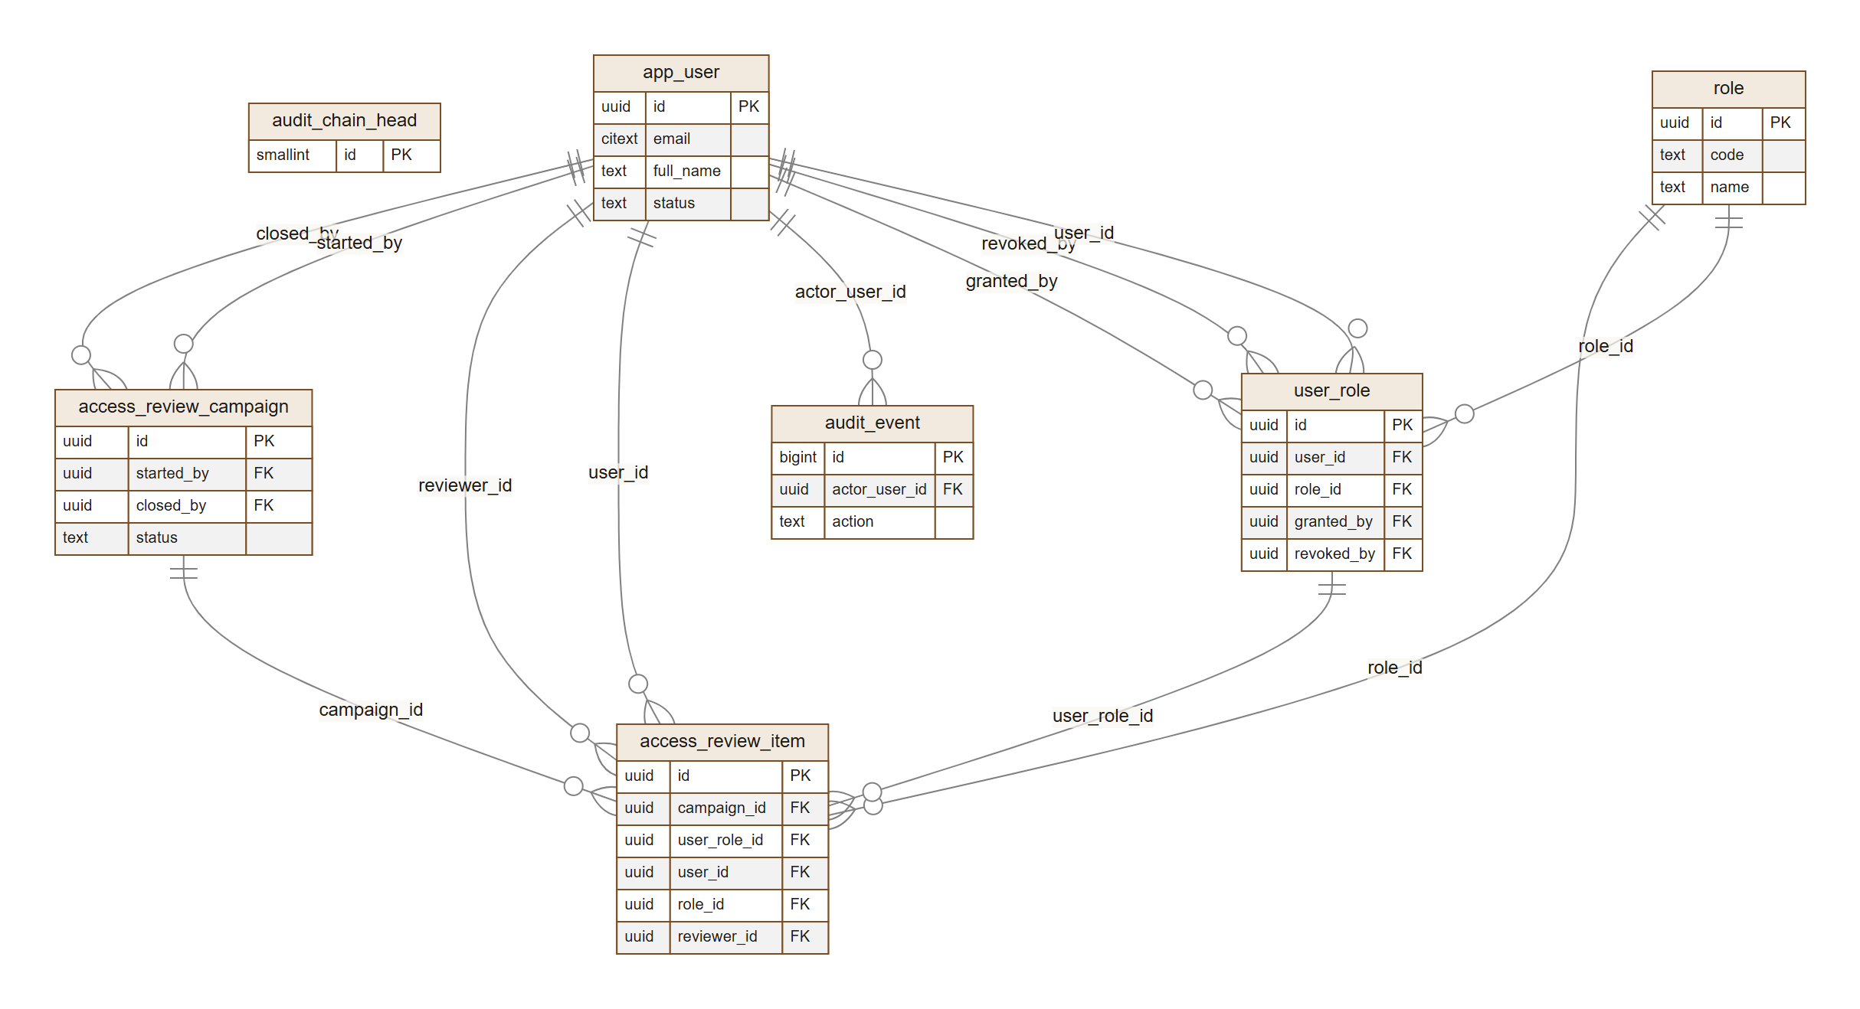
Figure 6-2 — Audit trail and access reviews

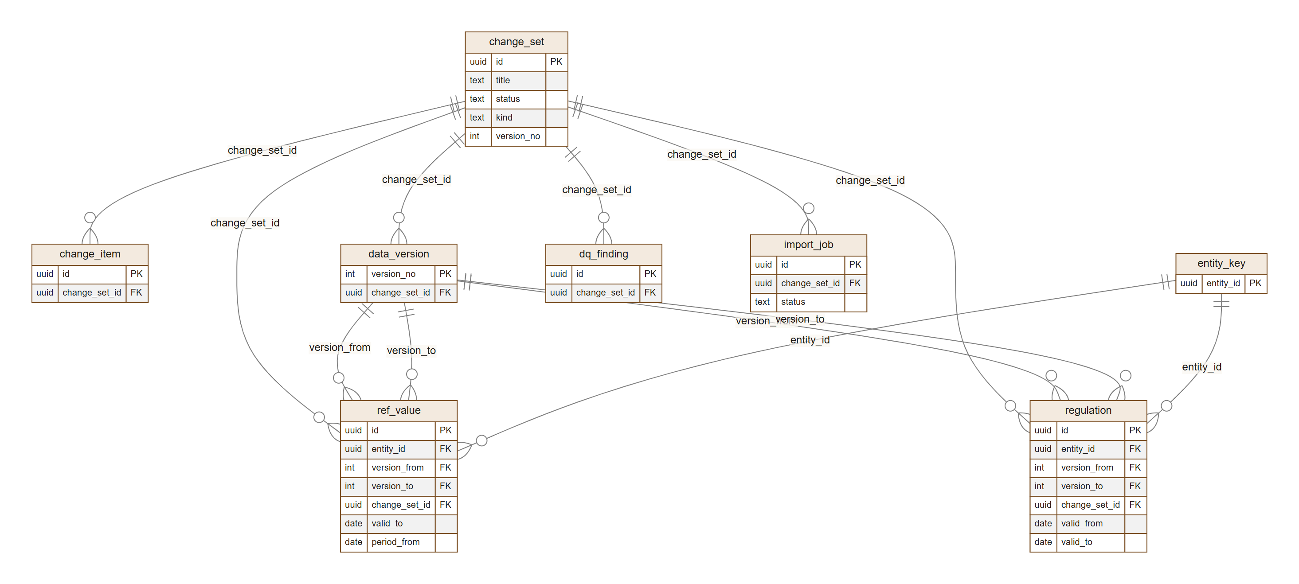
Figure 6-3 — Versioning: change sets, items, data versions, entity keys, data-quality findings, imports

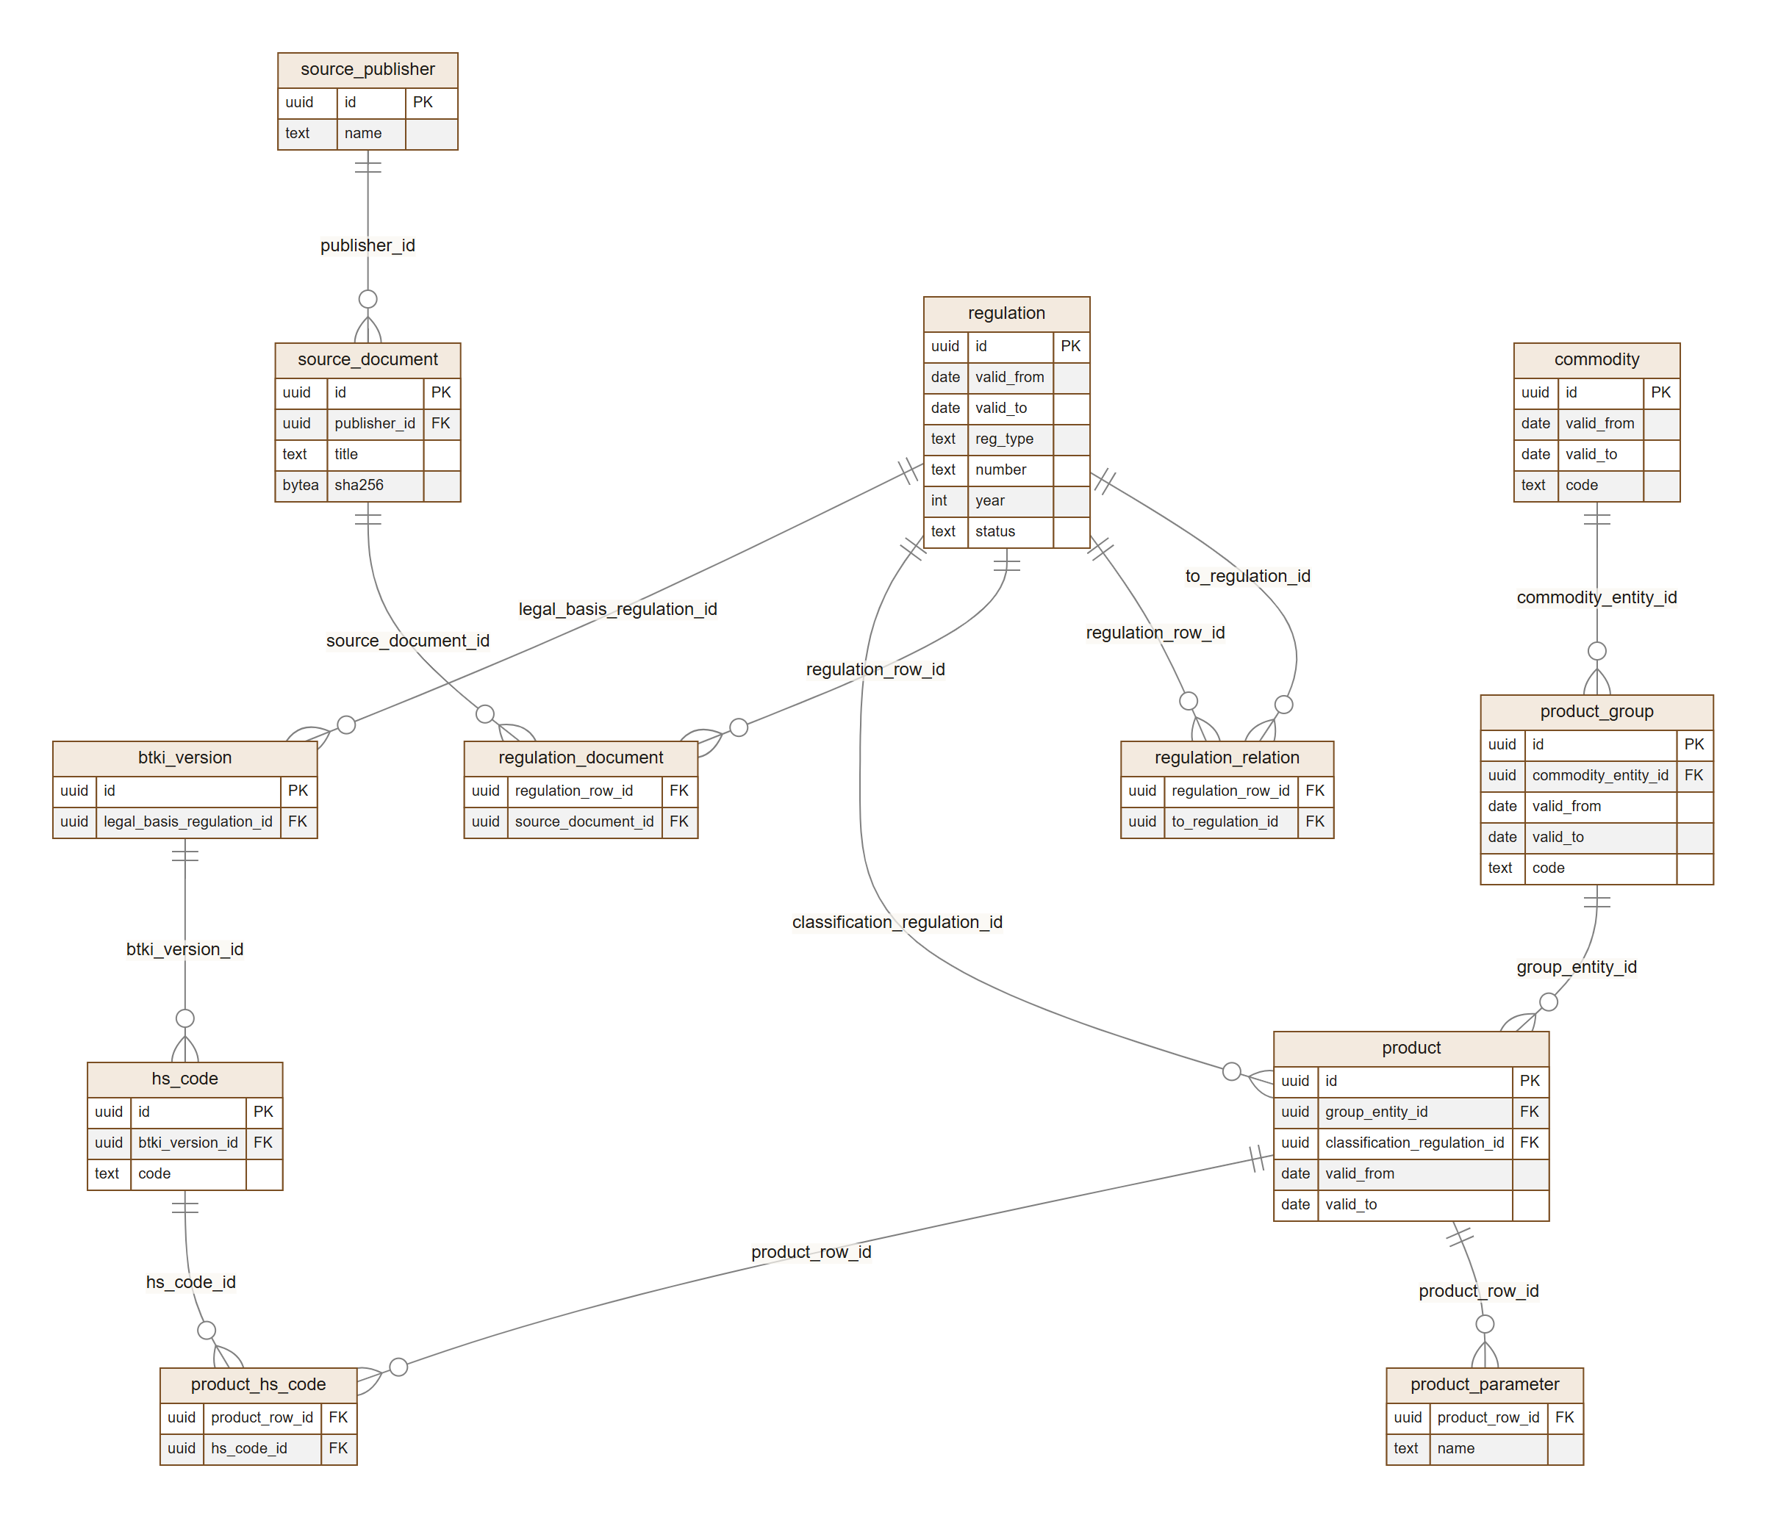
Figure 6-4 — Registry: regulations, source documents, commodities, groups, products, HS codes
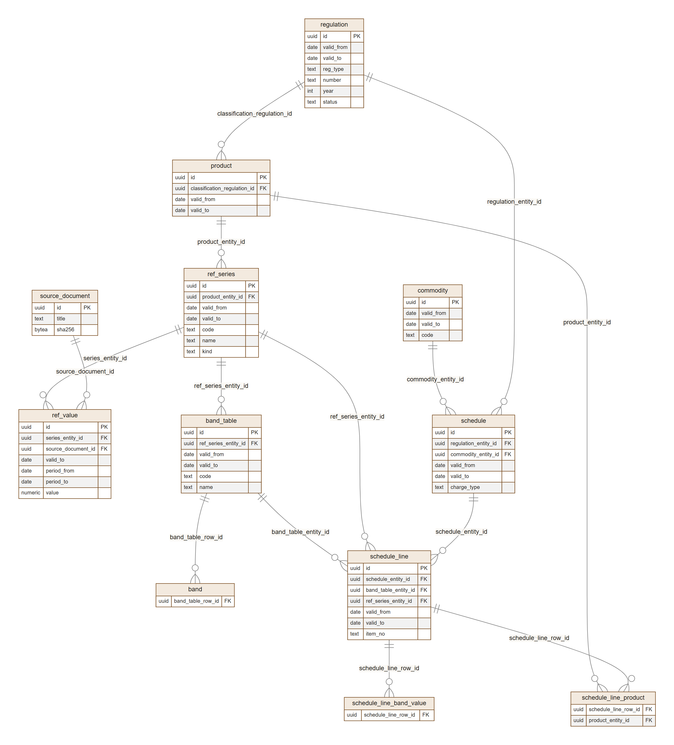
Figure 6-5 — Tariffs: reference series and values, band tables, schedules and lines

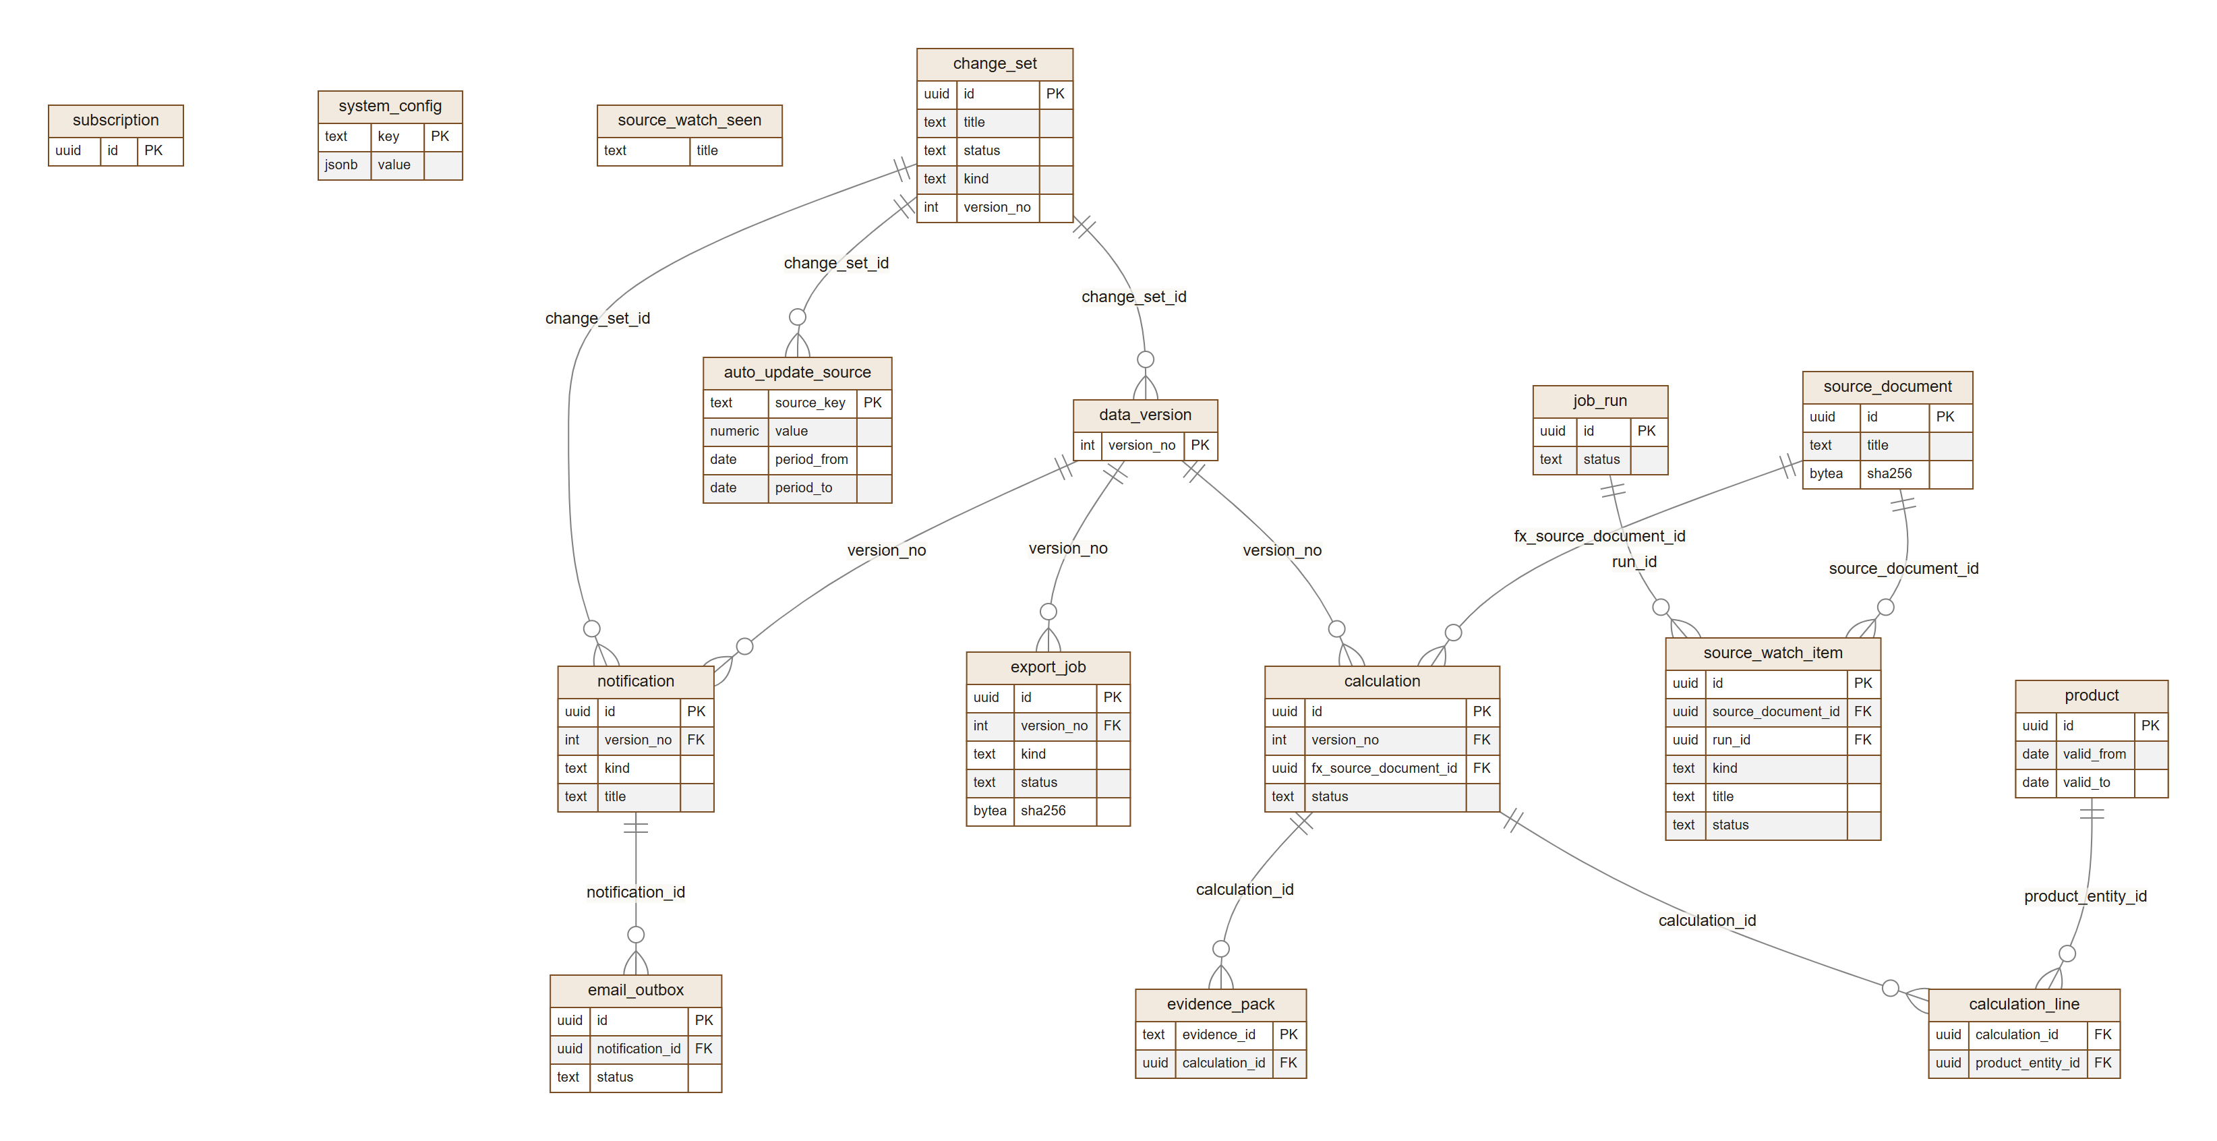
Figure 6-6 — Operations: calculations, evidence, exports, notifications, jobs, configuration, source watch, automatic updates

6.3 Tables by domain
Domain | Tables | Migration
Identity and access | app_user, user_identity, role, permission, role_permission, user_role, invitation (unused since DWS Hub handles invitations), oidc_login_state, user_session, local_credential | 0001, 0003, 0016, 0018
Audit | audit_event, audit_chain_head | 0001
Change sets and versions | change_set, change_item, data_version, entity_key, dq_finding, import_job | 0004, 0009
Sources | source_publisher (allow-listed official publishers), source_document | 0004
Registry | regulation, regulation_relation, regulation_document, commodity, product_group, btki_version, hs_code, product, product_parameter, product_hs_code | 0004, 0005
Tariffs | ref_series, ref_value, band_table, band, schedule, schedule_line, schedule_line_product, schedule_line_band_value | 0006
Calculation and evidence | calculation, calculation_line, evidence_pack | 0007, 0008
Notifications and exports | notification, email_outbox, subscription, export_job | 0010, 0011
Operations | job_run, access_review_campaign, access_review_item, system_config, source_watch_item, source_watch_seen, auto_update_source | 0012–0015, 0017

Migrations 0016 (oidc_login_state.relaunch), 0017 (system account ECR automatic update, auto_update_source) and 0018 (app_user.tour_seen_at) are the v1.x additions. Migration 0005 loads the BTKI 2022 palm HS codes.

6.4 Table reference
The reference below is generated from the migrations: each table's comment, columns, types, keys (PK, unique, references →) and allowed values.
Migration 0001_identity_and_audit.sql

Table app_user
Column | Type | Notes
id | uuid | PK
email | citext | required, unique
full_name | text | required
department | text
status | text | required, one of INVITED,ACTIVE,LOCKED,DEACTIVATED,EXPIRED,DORMANT_DISABLED
access_expires_at | timestamptz
last_login_at | timestamptz
is_break_glass | boolean | required
deactivated_reason | text
pseudonymised_at | timestamptz
created_at | timestamptz | required
updated_at | timestamptz | required
dormancy_warned_at | timestamptz | added in 0012_scheduled_jobs.sql
tour_seen_at | timestamptz | added in 0018_app_tour.sql

Table user_identity
Column | Type | Notes
id | uuid | PK
user_id | uuid | required, → app_user
provider | text | required, one of DWS_HUB,LOCAL
subject | text | required
issuer | text | required
email_at_link | citext | required
last_seen_at | timestamptz
created_at | timestamptz | required

Table role
Column | Type | Notes
id | uuid | PK
code | text | required, unique
name | text | required
description | text
is_builtin | boolean | required
is_privileged | boolean | required
created_at | timestamptz | required
updated_at | timestamptz | required

Table permission
Column | Type | Notes
code | text | PK
description | text | required
sod_group | text

Table role_permission
Column | Type | Notes
role_id | uuid | required, → role
permission_code | text | required, → permission

Table user_role
Column | Type | Notes
id | uuid | PK
user_id | uuid | required, → app_user
role_id | uuid | required, → role
granted_by | uuid | → app_user
granted_at | timestamptz | required — NULL = granted by the system (bootstrap or seed)
expires_at | timestamptz
revoked_at | timestamptz
revoked_by | uuid | → app_user

Table invitation
Column | Type | Notes
id | uuid | PK
email | citext | required
full_name | text | required
department | text
role_ids | uuid[] | required
access_expires_at | timestamptz
token_hash | bytea | required, unique
status | text | required, one of INVITED,ACCEPTED,EXPIRED,REVOKED
expires_at | timestamptz | required
invited_by | uuid | → app_user
accepted_user_id | uuid | → app_user — NULL = system seed
created_at | timestamptz | required
updated_at | timestamptz | required

Table oidc_login_state
Column | Type | Notes
state_hash | bytea | PK
browser_binding_hash | bytea | required
nonce | text | required
code_verifier_enc | bytea | required
return_to | text | required
invitation_id | uuid | → invitation
purpose | text | required, one of LOGIN,STEP_UP
expires_at | timestamptz | required
created_at | timestamptz | required
relaunch | boolean | added in 0016_login_relaunch.sql

Table user_session
Column | Type | Notes
id | uuid | PK
token_hash | bytea | required, unique
user_id | uuid | required, → app_user
auth_method | text | required, one of DWS_HUB,LOCAL
id_token_hash | bytea
csrf_token | text | required
idle_timeout_minutes | int | required
created_at | timestamptz | required
last_seen_at | timestamptz | required
absolute_expires_at | timestamptz | required
stepped_up_at | timestamptz
ip | inet
user_agent | text
revoked_at | timestamptz
revoke_reason | text | one of LOGOUT,LOGOUT_ALL,EXPIRED,SESSION_LIMIT,ADMIN_REVOKE,USER_INACTIVE

Table audit_chain_head
Column | Type | Notes
id | smallint | PK
last_seq | bigint | required
last_hash | bytea | required

Table audit_event
Column | Type | Notes
id | bigint | PK
chain_seq | bigint | required, unique
occurred_at | timestamptz | required
actor_kind | text | required, one of USER,SYSTEM,ANONYMOUS
actor_user_id | uuid | → app_user
session_id | uuid
ip | inet
user_agent | text
action | text | required
entity_type | text
entity_id | text
before | jsonb
after | jsonb
reason | text
prev_hash | bytea | required
hash | bytea | required

Migration 0003_jit_provisioning_and_totp.sql

Table local_credential
Technical Design §7.1 local_credential. Password columns stay for break-glass accounts (later slice).
Column | Type | Notes
user_id | uuid | PK, → app_user
password_hash | text
password_history | text[] | required
must_change_password | boolean | required
totp_secret_enc | bytea
totp_confirmed_at | timestamptz
totp_last_step | bigint
recovery_codes_hash | text[] | required
failed_count | int | required
locked_until | timestamptz
created_at | timestamptz | required
updated_at | timestamptz | required

Migration 0004_registry_and_change_sets.sql

Table change_set
Column | Type | Notes
id | uuid | PK
title | text | required
justification | text | required
status | text | required, one of DRAFT,SUBMITTED,IN_REVIEW,REJECTED,APPROVED,SCHEDULED,PUBLISHED,CANCELLED
kind | text | required, one of NORMAL,IMPORT,ROLLBACK
created_by | uuid | required, → app_user
submitted_at | timestamptz
reviewed_by | uuid | → app_user
review_started_at | timestamptz
decision_comment | text
approved_at | timestamptz
effective_at | timestamptz
version_no | int
rollback_of_version | int
created_at | timestamptz | required
updated_at | timestamptz | required

Table data_version
Column | Type | Notes
version_no | int | PK
change_set_id | uuid | required, unique, → change_set
published_at | timestamptz | required
published_by | uuid | → app_user
bulletin | jsonb | required
rolled_back_by_version | int | → data_version

Table entity_key
Column | Type | Notes
entity_id | uuid | PK
entity_type | text | required, one of REGULATION,COMMODITY,PRODUCT_GROUP,PRODUCT
natural_key | text
created_at | timestamptz | required

Table change_item
Column | Type | Notes
id | uuid | PK
change_set_id | uuid | required, → change_set
entity_type | text | required, one of REGULATION,COMMODITY,PRODUCT_GROUP,PRODUCT
entity_id | uuid | required — Allocated when a CREATE item is first saved so items in one set can refer to each other; the entity_key row itself is written by the publish transaction.
operation | text | required, one of CREATE,UPDATE,END_DATE
base_row_id | uuid
before | jsonb
after | jsonb | required
edited_by | uuid[] | required
is_open | boolean | required
item_comment | text
created_at | timestamptz | required
updated_at | timestamptz | required
import_row | text | added in 0009_import_and_rollback.sql

Table dq_finding
Column | Type | Notes
id | uuid | PK
change_set_id | uuid | → change_set
run_id | uuid | required
rule_code | text | required
severity | text | required, one of ERROR,WARNING,INFO
entity_type | text
entity_id | uuid
field | text
message | text | required
acknowledged_by | uuid | → app_user
acknowledged_at | timestamptz
created_at | timestamptz | required

Table source_publisher
Column | Type | Notes
id | uuid | PK
name | text | required
domain | text | required, unique
data_types | text[] | required
is_official | boolean | required
created_at | timestamptz | required

Table source_document
Column | Type | Notes
id | uuid | PK
publisher_id | uuid | → source_publisher
doc_kind | text | required, one of REGULATION,ANNEX,REF_PRICE_DECREE,HE_DECISION,FX_DECREE,OTHER
doc_number | text
doc_date | date
title | text | required
official_url | text
object_key | text | required
byte_size | bigint | required
sha256 | bytea | required, unique
content_type | text | required
original_filename | text
is_secondary | boolean | required
scan_result | text | required, one of CLEAN,NOT_SCANNED
uploaded_by | uuid | required, → app_user
last_rechecked_at | timestamptz
recheck_mismatch | boolean | required
created_at | timestamptz | required

Table regulation
Column | Type | Notes
id | uuid | PK
entity_id | uuid | required, → entity_key
valid_from | date | required
valid_to | date
version_from | int | required, → data_version
version_to | int | → data_version
change_set_id | uuid | required, → change_set
reg_type | text | required, one of UU,PP,PERPRES,PMK,KMK,PERMENDAG,KEPMENDAG,PERMENPERIN,OTHER
number | text | required
year | int | required
title_id | text | required
title_en | text
issuer | text | required
status | text | required, one of DRAFT_RANCANGAN,PROMULGATED,IN_FORCE,AMENDED,REVOKED
promulgated_on | date
effective_on | date
ends_on | date
official_url | text
bpk_status_url | text
created_at | timestamptz | required

Table regulation_relation
Column | Type | Notes
regulation_row_id | uuid | required, → regulation
relation | text | required, one of AMENDS,REVOKES,IMPLEMENTS
to_regulation_id | uuid | required, → entity_key

Table regulation_document
Column | Type | Notes
regulation_row_id | uuid | required, → regulation
source_document_id | uuid | required, → source_document
role | text | required, one of MAIN,ANNEX,CORRIGENDUM,SECONDARY

Table commodity
Column | Type | Notes
id | uuid | PK
entity_id | uuid | required, → entity_key
valid_from | date | required
valid_to | date
version_from | int | required, → data_version
version_to | int | → data_version
change_set_id | uuid | required, → change_set
code | text | required
name_id | text | required
name_en | text
is_in_scope | boolean | required
created_at | timestamptz | required

Table product_group
Column | Type | Notes
id | uuid | PK
entity_id | uuid | required, → entity_key
valid_from | date | required
valid_to | date
version_from | int | required, → data_version
version_to | int | → data_version
change_set_id | uuid | required, → change_set
commodity_entity_id | uuid | required, → entity_key
code | text | required
label | text | required
ordinal | int | required
created_at | timestamptz | required

Table btki_version
Column | Type | Notes
id | uuid | PK
label | text | required, unique
legal_basis_regulation_id | uuid | → entity_key
effective_on | date | required
is_current | boolean | required
created_at | timestamptz | required

Table hs_code
Column | Type | Notes
id | uuid | PK
btki_version_id | uuid | required, → btki_version
code_digits | char(8) | required
code | text
description | text
created_at | timestamptz | required

Table product
Column | Type | Notes
id | uuid | PK
entity_id | uuid | required, → entity_key
valid_from | date | required
valid_to | date
version_from | int | required, → data_version
version_to | int | → data_version
change_set_id | uuid | required, → change_set
group_entity_id | uuid | required, → entity_key
item_no_as_printed | text
name_id | text | required
name_en | text
synonyms | text[] | required
definition | text
notes | text[] | required
annex_page | int
classification_regulation_id | uuid | required, → entity_key
fx_on_peb_date | boolean | required
other_obligations_note | text
created_at | timestamptz | required

Table product_parameter
Column | Type | Notes
product_row_id | uuid | required, → product
ordinal | int | required
name | text | required
operator | text | required, one of <,≤,=,≥,>,RANGE,TEXT
value_text | text | required
value_min | numeric
value_max | numeric
unit | text
is_primary | boolean | required

Table product_hs_code
Column | Type | Notes
product_row_id | uuid | required, → product
hs_code_id | uuid | required, → hs_code
is_ex | boolean | required
ex_description | text

Migration 0006_tariffs_and_reference_prices.sql

Table ref_series
Column | Type | Notes
id | uuid | PK
entity_id | uuid | required, → entity_key
valid_from | date | required
valid_to | date
version_from | int | required, → data_version
version_to | int | → data_version
change_set_id | uuid | required, → change_set
code | text | required
name | text | required
kind | text | required, one of REFERENCE_PRICE,HARGA_EKSPOR,FX_RATE
unit | text | required
cadence | text | required, one of MONTHLY,HALF_MONTHLY,WEEKLY
product_entity_id | uuid | → entity_key
created_at | timestamptz | required

Table ref_value
Column | Type | Notes
id | uuid | PK
entity_id | uuid | required, → entity_key
valid_to | date | required
version_from | int | required, → data_version
version_to | int | → data_version
change_set_id | uuid | required, → change_set
series_entity_id | uuid | required, → entity_key
period_from | date | required
period_to | date | required
value | numeric(18, 6) | required
source_document_id | uuid | required, → source_document — BR-SRC-01: every published value has its official source document.
source_reference | text
created_at | timestamptz | required

Table band_table
Column | Type | Notes
id | uuid | PK
entity_id | uuid | required, → entity_key
valid_from | date | required
valid_to | date
version_from | int | required, → data_version
version_to | int | → data_version
change_set_id | uuid | required, → change_set
code | text | required
name | text | required
ref_series_entity_id | uuid | required, → entity_key
created_at | timestamptz | required

Table band
Column | Type | Notes
band_table_row_id | uuid | required, → band_table
ordinal | int | required
lower_exclusive | numeric(14, 4) | — Null lower = from 0; null upper = no ceiling. Contiguity is checked on submit (BR-TRF-02).
upper_inclusive | numeric(14, 4)
label | text | required

Table schedule
Column | Type | Notes
id | uuid | PK
entity_id | uuid | required, → entity_key
valid_from | date | required
valid_to | date
version_from | int | required, → data_version
version_to | int | → data_version
change_set_id | uuid | required, → change_set
regulation_entity_id | uuid | required, → entity_key
charge_type | text | required, one of BK,PE
annex_label | text | required
commodity_entity_id | uuid | required, → entity_key
created_at | timestamptz | required

Table schedule_line
Column | Type | Notes
id | uuid | PK
entity_id | uuid | required, → entity_key
valid_from | date | required
valid_to | date
version_from | int | required, → data_version
version_to | int | → data_version
change_set_id | uuid | required, → change_set
schedule_entity_id | uuid | required, → entity_key
kelompok | text
item_no | text
uraian | text | required
basis_type | text | required, one of BAND_USD_PER_MT,AD_VALOREM_PCT,BAND_PCT,PCT_OF_REF_PRICE,FIXED_USD_PER_MT,ZERO_LISTED
pct | numeric(7, 4)
usd_per_mt | numeric(14, 4)
band_table_entity_id | uuid | → entity_key
ref_series_entity_id | uuid | → entity_key
created_at | timestamptz | required

Table schedule_line_product
Column | Type | Notes
schedule_line_row_id | uuid | required, → schedule_line
product_entity_id | uuid | required, → entity_key

Table schedule_line_band_value
Column | Type | Notes
schedule_line_row_id | uuid | required, → schedule_line
band_ordinal | int | required

Migration 0007_calculations.sql

Table calculation
Column | Type | Notes
id | uuid | PK
created_by | uuid | required, → app_user
peb_date | date | required
payment_date | date | required
version_no | int | required, → data_version
is_simulation | boolean | required — What-if reference price (US-44-P2); a simulation can never become official evidence.
ref_price_override | numeric(18, 6)
status | text | required, one of COMPLETE,INCOMPLETE
inputs | jsonb | required
inputs_hash | bytea | required
result | jsonb | required
result_hash | bytea | required
total_usd | numeric(20, 6)
total_idr | numeric(22, 0)
fx_value | numeric(18, 6)
fx_source_document_id | uuid | → source_document
created_at | timestamptz | required

Table calculation_line
Column | Type | Notes
calculation_id | uuid | required, → calculation
ordinal | int | required
product_entity_id | uuid | required, → entity_key
quantity_mt | numeric(14, 3) | required
bk_status | text | required
bk_basis | text
bk_line_entity_id | uuid
bk_per_mt | numeric(20, 6)
bk_total_usd | numeric(20, 6)
pe_status | text | required
pe_basis | text
pe_line_entity_id | uuid
pe_per_mt | numeric(20, 6)
pe_total_usd | numeric(20, 6)
ref_value_entity_id | uuid
he_value_entity_id | uuid
band_ordinal | int
he_fallback | boolean | required
warnings | jsonb | required

Migration 0008_evidence_packs.sql

Table evidence_pack
Column | Type | Notes
evidence_id | text | PK
calculation_id | uuid | required, unique, → calculation
payload | jsonb | required
payload_sha256 | bytea | required
object_key | text | required, unique
pdf_sha256 | bytea | required
byte_size | int | required
pdfa_profile | text | required
created_by | uuid | required, → app_user
created_at | timestamptz | required
retain_until | date | required — Decision D7: evidence is kept 10 years.

Migration 0009_import_and_rollback.sql

Table import_job
Excel imports (PRD F-28, FR-IMP-01). The dry run never writes data: the job keeps the stored file, its hash and the row-level report; commit re-reads the file, validates again and creates one IMPORT change set.
Column | Type | Notes
id | uuid | PK
uploaded_by | uuid | required, → app_user
file_name | text | required
file_object_key | text | required
file_sha256 | bytea | required
byte_size | int | required
scan_result | text | required, one of CLEAN,NOT_SCANNED
template_version | text | required
status | text | required, one of VALIDATED,VALIDATED_WITH_ERRORS,COMMITTED
row_count | int | required
error_count | int | required
warning_count | int | required
change_set_id | uuid | unique, → change_set
created_at | timestamptz | required
committed_at | timestamptz

Migration 0010_notifications.sql

Table notification
Column | Type | Notes
id | uuid | PK
user_id | uuid | required, → app_user
kind | text | required
title | text | required
body | text | required
link | text | required
change_set_id | uuid | → change_set
version_no | int | → data_version
created_at | timestamptz | required
read_at | timestamptz

Table email_outbox
Column | Type | Notes
id | uuid | PK
notification_id | uuid | → notification
to_user_id | uuid | required, → app_user
to_email | text | required
subject | text | required
body_text | text | required
status | text | required, one of PENDING,SENT,FAILED,CANCELLED
attempts | int | required
next_attempt_at | timestamptz | required
last_error | text
created_at | timestamptz | required
sent_at | timestamptz

Table subscription
Change subscriptions (US-48-P1): a commodity, a product group or one product.
Column | Type | Notes
id | uuid | PK
user_id | uuid | required, → app_user
scope_type | text | required, one of COMMODITY,PRODUCT_GROUP,PRODUCT
scope_entity_id | uuid | required, → entity_key
created_at | timestamptz | required

Migration 0011_export_jobs.sql

Table export_job
Column | Type | Notes
id | uuid | PK
requested_by | uuid | required, → app_user
kind | text | required, one of CATALOGUE
format | text | required, one of csv,xlsx
query | jsonb | required — The catalogue query (search, filters, sort, date) with the data version pinned when the export was requested.
version_no | int | required, → data_version
status | text | required, one of QUEUED,RUNNING,READY,FAILED,EXPIRED
attempts | int | required
row_count | int
file_name | text
object_key | text | unique
byte_size | int
sha256 | bytea
error | text
created_at | timestamptz | required
started_at | timestamptz
finished_at | timestamptz
expires_at | timestamptz

Migration 0012_scheduled_jobs.sql

Table job_run
Column | Type | Notes
id | uuid | PK
job_name | text | required
status | text | required, one of RUNNING,OK,FAILED
triggered_by | uuid | → app_user — NULL = started by the scheduler; otherwise the Super Admin who pressed "Run now".
started_at | timestamptz | required
finished_at | timestamptz
details | jsonb
error | text

Migration 0013_access_reviews.sql

Table access_review_campaign
Column | Type | Notes
id | uuid | PK
period_label | text | required, unique
status | text | required, one of OPEN,CLOSED — e.g. 2026-Q4
started_by | uuid | → app_user — NULL = started by the quarterly job; otherwise the Super Admin who pressed "Run now".
started_at | timestamptz | required
due_at | timestamptz | required
closed_at | timestamptz | — started_at + 14 days; open items escalate after this
closed_by | uuid | → app_user
the | SHA
an | HMAC | — with the ECR server key (both printed in every page footer) and the SHA-256 of the stored PDF file.
report_content_sha256 | bytea
report_signature | bytea
report_object_key | text
report_sha256 | bytea
report_byte_size | integer

Table access_review_item
Column | Type | Notes
id | uuid | PK
campaign_id | uuid | required, → access_review_campaign
user_role_id | uuid | required, → user_role
user_id | uuid | required, → app_user
role_id | uuid | required, → role
so | the | required
last_login_at | timestamptz
granted_at | timestamptz | required
reviewer_role | text | required, one of USER_ADMIN,SUPER_ADMIN — BR-IAM-02: assignments of users who hold an administrator role are reviewed by a Super Admin.
decision | text | one of KEEP,REVOKE
reason | text
reviewer_id | uuid | → app_user
decided_at | timestamptz
escalated_at | timestamptz

Migration 0014_system_config.sql

Table system_config
Column | Type | Notes
key | text | PK
value | jsonb | required
updated_by | uuid | required, → app_user
updated_at | timestamptz | required

Migration 0015_source_watch.sql

Table source_watch_item
Column | Type | Notes
id | uuid | PK
kind | text | required, one of STATUS_CHANGE,NEW_DOCUMENT,NEW_FILE,FILE_CHANGED
fingerprint | text | required, unique
title | text | required
detail | text | required
url | text | required
source | text | required
regulation_entity_id | uuid | → entity_key
source_document_id | uuid | → source_document
detected_at | timestamptz | required
run_id | uuid | → job_run
status | text | required, one of OPEN,DONE,DISMISSED
resolved_by | uuid | → app_user
resolved_at | timestamptz
resolution_note | text

Table source_watch_seen
Entries already seen on each listing. The first read of a listing only records what is there (its baseline); later reads report what is new.
Column | Type | Notes
listing | text | required
url | text | required
title | text | required
first_seen_at | timestamptz | required

Migration 0017_auto_update.sql

Table auto_update_source
Every official decree the job has handled, so each is processed once (a failed download is retried; a decree that needs a person is reported once and then left to the Makers).
Column | Type | Notes
source_key | text | PK
decree | text | required
pdf_url | text
outcome | text | required, one of PUBLISHED,SENT_TO_CHECKER,ALREADY_PUBLISHED,OLDER_PERIOD,NOT_RELEVANT,NEEDS_REVIEW
value | numeric(18, 4)
period_from | date
period_to | date
data_version | integer
change_set_id | uuid | → change_set
detail | text
handled_at | timestamptz | required

7. API reference

7.1 Conventions
- Base path /api; JSON in and out; dates YYYY-MM-DD (WIB business days), timestamps ISO 8601.
- Authentication: the session cookie (ecr_sid, or __Host-ecr_sid over HTTPS). Every request except /api/health and /api/ready must come from ALLOWED_NETWORKS (403 NETWORK_NOT_ALLOWED).
- CSRF: every state-changing request with a session carries X-CSRF-Token with the token from /api/auth/me (403 CSRF_INVALID).
- Permissions: @Authorize({ permissions, stepUp }) checks the session's live permissions on every call (403 FORBIDDEN, audited AUTHZ_DENIED); stepUp requires an authenticator confirmation within the step-up window (403 STEP_UP_REQUIRED), except for roles in TOTP_EXEMPT_ROLES.
- Errors: { "error": { "code", "message", "details?", "traceId" } }; every response carries X-Trace-Id.

7.2 Endpoints
The table is generated from the controllers ("Access": permission(s) needed; "+ step-up": a fresh authenticator code; "signed in": any session).
Module | Method | Path | Access | Notes
access-reviews | GET | /api/admin/reviews | accessreview.read | Campaigns with their progress (User Admins, Super Admins, Auditors).
access-reviews | GET | /api/admin/reviews/:id | accessreview.read
access-reviews | POST | /api/admin/reviews/:id/items/:itemId | user.manage + step-up | Keep or revoke one assignment (fresh authenticator code). Revoking removes the role and ends the user's sessions.
access-reviews | GET | /api/admin/reviews/:id/report | accessreview.read | The signed PDF/A report of a completed review.
access-reviews | GET | /api/admin/reviews/:id/report/verify | accessreview.read
users-admin | GET | /api/admin/users | user.manage
users-admin | POST | /api/admin/users | user.manage + step-up | Adds a person before their first DWS Hub sign-in, with their roles (INVITED until they sign in).
users-admin | PATCH | /api/admin/users/:id | user.manage + step-up
users-admin | DELETE | /api/admin/users/:id | user.manage + step-up | Body { reason }. Removes a never-used account, or anonymises one with history.
users-admin | GET | /api/admin/users/:id | user.manage
users-admin | PUT | /api/admin/users/:id/roles | user.manage + step-up
users-admin | POST | /api/admin/users/:id/deactivate | user.manage + step-up
users-admin | POST | /api/admin/users/:id/reactivate | user.manage + step-up
users-admin | POST | /api/admin/users/:id/revoke-sessions | user.manage | Defensive action (e.g. suspected compromise), so no step-up is required.
users-admin | POST | /api/admin/users/:id/reset-totp | user.manage + step-up
audit | GET | /api/audit-events | audit.read | ?actor=&action=a,b&actorUserId=&entityType=&entityId=&from=&to=&before=&limit=
audit | GET | /api/audit-events/facets | audit.read | The actions and entity types present, with counts, for the filters.
audit | GET | /api/audit-events/verify | audit.read | Recomputes the whole hash chain (Technical Design §4.2.8).
audit | GET | /api/audit-events/export | audit.export | US-50-P1 AC1: the filtered events as CSV or XLSX, with the hash-chain verification status in the header block. The export itself is audited (AUDIT_EXPORTED).
auth | GET | /api/auth/login | public | SF-1.1 step 1: start DWS Hub sign-in with PKCE. Also the launch URL to register in DWS Hub (T-03).
auth | GET | /api/auth/callback | public | SF-1.1 steps 2–5: validate state, redeem the code, verify the ID token, bind the user, open a session.
auth | GET | /api/auth/me | signed in
auth | POST | /api/auth/tour-seen | signed in | The first-sign-in tour was finished or closed: it is not shown automatically again (replay stays possible).
auth | POST | /api/auth/logout | public | Ends the ECR session (Technical Design §4.1.4, US-09-P2). Idempotent: with no session it still clears cookies and returns 200. A live session requires the CSRF token; {"allSessions": true} signs the
step-up | GET | /api/auth/totp/status | signed in
step-up | POST | /api/auth/totp/enroll | signed in | Returns the secret once, for the QR code. Calling it again before confirming issues a new secret.
step-up | POST | /api/auth/totp/confirm | signed in | Confirms the first code; returns ten recovery codes that are shown only this once.
step-up | POST | /api/auth/step-up | signed in
calculations | POST | /api/calculations/preview | calc.run
calculations | POST | /api/calculations | calc.run
calculations | GET | /api/calculations | calc.run
calculations | GET | /api/calculations/products | calc.run | Products to choose from, as of a date. Declared before :id.
calculations | GET | /api/calculations/:id | calc.run
calculations | GET | /api/calculations/:id/verify | calc.run
catalogue | GET | /api/catalogue | catalogue.read
evidence | POST | /api/calculations/:id/evidence | evidence.create | 201 with the new pack, or 200 with the pack already made for this calculation.
evidence | GET | /api/evidence/:evidenceId | catalogue.read
evidence | GET | /api/evidence/:evidenceId/file | catalogue.read
evidence | GET | /api/evidence/:evidenceId/verify | catalogue.read | Any signed-in user holding a pack can check it (the URL printed in its footer opens the web page that calls this).
exports | GET | /api/exports/catalogue | export.run | Same parameters as GET /api/catalogue plus format=csv/xlsx; all matching rows, ignoring paging.
exports | GET | /api/exports/calculations/:id | export.run
exports | POST | /api/exports/jobs | export.run | US-47-N1 AC3: a catalogue export above the synchronous limit. Body: { format, query } with the catalogue's query parameters. 201 with the queued job; the requester is notified when the file is ready.
exports | GET | /api/exports/jobs | export.run
exports | GET | /api/exports/jobs/:id | export.run
exports | GET | /api/exports/jobs/:id/file | export.run | The requester only, for 24 hours (410 EXPORT_EXPIRED afterwards).
health | GET | /api/health | public
health | GET | /api/ready | public
imports | GET | /api/imports/template | import.run
imports | GET | /api/imports | import.run
imports | GET | /api/imports/:id | catalogue.read
imports | GET | /api/imports/:id/report | catalogue.read
imports | POST | /api/imports/:id/commit | import.run, changeset.create | Body: { title?, justification?, acknowledgeWarnings? }. Creates one IMPORT change set (DRAFT).
jobs | GET | /api/jobs | audit.read | Each job with its schedule and last run (Auditors and Super Admins).
jobs | GET | /api/jobs/:name/runs | audit.read
jobs | POST | /api/jobs/:name/run | config.manage + step-up | Runs a job now (Super Admin, fresh authenticator code); 409 JOB_RUNNING if it is running elsewhere.
jobs | GET | /api/dq/findings | dq.read | US-51-P1: findings of the latest nightly data-quality run.
notifications | GET | /api/notifications | signed in | Every signed-in person has their own notifications; no permission beyond a session.
notifications | GET | /api/notifications/unread-count | signed in
notifications | POST | /api/notifications/read | signed in | Body: { id } marks one notification read; no id marks all read.
notifications | GET | /api/subscriptions | catalogue.read
notifications | POST | /api/subscriptions | catalogue.read | Body: { scopeType: COMMODITY / PRODUCT_GROUP / PRODUCT, scopeEntityId }.
notifications | DELETE | /api/subscriptions/:id | catalogue.read
notifications | POST | /api/subscriptions/unsubscribe | public | One-click unsubscribe from an email link; the signed token replaces the session (US-48-N1 AC1).
notifications | GET | /api/data-versions/:versionNo/bulletin | catalogue.read
change-sets | GET | /api/change-sets | changeset.read
change-sets | POST | /api/change-sets | changeset.create
change-sets | GET | /api/change-sets/:id | changeset.read
change-sets | GET | /api/change-sets/:id/impact | changeset.read | ?date=YYYY-MM-DD (WIB), default today.
change-sets | PUT | /api/change-sets/:id/items | changeset.create
change-sets | DELETE | /api/change-sets/:id/items/:itemId | changeset.create
change-sets | POST | /api/change-sets/:id/submit | changeset.submit
change-sets | POST | /api/change-sets/:id/withdraw | changeset.submit
change-sets | POST | /api/change-sets/:id/discard | changeset.create
change-sets | POST | /api/change-sets/:id/start-review | changeset.approve
change-sets | POST | /api/change-sets/:id/approve | changeset.approve + step-up
change-sets | POST | /api/change-sets/:id/reject | changeset.approve + step-up
change-sets | POST | /api/change-sets/:id/cancel-schedule | changeset.approve + step-up
change-sets | POST | /api/change-sets/:id/cancel-rollback | changeset.approve | The initiating Checker abandons an open rollback (SUBMITTED, returned to DRAFT, or REJECTED).
change-sets | POST | /api/change-sets/:versionNo/rollback | changeset.approve + step-up | Body: { reason }. 201 with the new ROLLBACK change set (SUBMITTED).
registry | GET | /api/regulations | catalogue.read
registry | GET | /api/regulations/:entityId | catalogue.read
registry | GET | /api/commodities | catalogue.read
registry | GET | /api/products | catalogue.read
registry | GET | /api/products/:entityId | catalogue.read
registry | GET | /api/hs-codes | catalogue.read
registry | GET | /api/data-versions | changeset.read
source-documents | GET | /api/source-documents | catalogue.read
source-documents | GET | /api/source-documents/:id | catalogue.read
source-documents | GET | /api/source-documents/:id/file | catalogue.read
source-documents | GET | /api/source-publishers | catalogue.read
settings | GET | /api/admin/config | config.manage | Each setting with its value, default, allowed range and last change; deployment-only settings read-only.
settings | PUT | /api/admin/config | config.manage + step-up | {values: {key: value / null}, reason}; null restores the default. Fresh authenticator code required.
source-watch | GET | /api/source-watch | changeset.read | Items (open first) and the last run; anyone who reads change sets.
source-watch | POST | /api/source-watch/:id/resolve | changeset.create | {status: "DONE" / "DISMISSED", note}; a note is required to dismiss.
tariff | GET | /api/ref-series | catalogue.read
tariff | GET | /api/ref-series/:entityId | catalogue.read
tariff | GET | /api/band-tables | catalogue.read
tariff | GET | /api/schedules | catalogue.read
tariff | GET | /api/schedules/:entityId | catalogue.read
tariff | GET | /api/products/:entityId/charges | catalogue.read | Duty and levy per tonne for one product, as of a date (default today).

8. Security design

8.1 Authentication
- DWS Hub OIDC (strict contract): authorization code with PKCE S256, state and nonce, ID token verified against the Hub JWKS (RS256 or ES256 only; issuer, audience, expiry with 60 s tolerance, nonce when echoed). The discovery document and keys are cached and refreshed every 6 hours (jwks-refresh).
- The login state is single-use, expires after 10 minutes and is bound to the browser by a SameSite=Lax cookie; the PKCE verifier is stored encrypted (AES-256-GCM with ECR_ENCRYPTION_KEY).
- A callback ECR did not start is never redeemed; ECR restarts its own sign-in once (§4.7).
- ECR authenticator (TOTP) for privileged roles, with 10 single-use recovery codes; enrolment required at first privileged use; 5 wrong codes lock it for 15 minutes (counted outside the business transaction so the lock cannot be rolled back). Roles in TOTP_EXEMPT_ROLES (default SUPER_ADMIN) are exempt.

8.2 Sessions and cookies
Cookie | Attributes | Purpose
ecr_sid (__Host-ecr_sid with HTTPS) | HttpOnly, SameSite=Strict, Path=/, Secure with HTTPS | Session; only its SHA-256 is stored
ecr_login (__Secure-ecr_login) | HttpOnly, SameSite=Lax, Path=/api/auth, 10 min | Browser binding of the login state
ecr_relaunch (__Secure-ecr_relaunch) | HttpOnly, SameSite=Lax, Path=/api/auth, 60 s | Prevents a second sign-in restart

Sessions end after the idle limit (30 min; 15 min for privileged roles), the absolute limit (8 h), sign-out (this browser or all), an administrator action, a role change or deactivation; at most 3 per person. session-sweep removes expired ones.

8.3 Authorisation and segregation of duties
- Permissions per role (role_permission, migration 0002); the matrix is in PRD §8. Checked server-side on every request; the menu only hides what a person cannot use.
- SoD-1 a Checker never reviews a change set they created or edited (service check and database CHECK). SoD-2 USER_ADMIN never with MAKER or CHECKER. SoD-3 nobody changes their own access. SoD-4 at least two active Super Admins.
- Only Super Admins (user.invite_admin) manage administrator accounts and roles.
- ECR's own changes run under the deactivated system account; it cannot sign in, and Checkers may review its drafts.

8.4 Network and HTTP
- ALLOWED_NETWORKS (CIDR list, also editable on the Configuration screen) is enforced by the API on the client address (with TRUST_PROXY=1 behind the FE nginx); health checks are exempt so Docker can probe them.
- The API port is bound to the BE server's private address only; the FE nginx is the one way in.
- Response headers: X-Content-Type-Options: nosniff, X-Frame-Options: DENY, Referrer-Policy: same-origin, Cache-Control: no-store on authentication responses.
- Staging and production run over HTTP on the private network (COOKIE_SECURE=false). With COOKIE_SECURE=true the API requires an https PUBLIC_BASE_URL, SMTP and a virus scanner, and the cookies get the __Host-/__Secure- names.

8.5 Files and uploads
- Source documents: PDF only (magic bytes), at most 25 MB, one file per request; a source of record must come from an allow-listed official publisher (source_publisher); virus scan through ClamAV (CLAMD_HOST) when required; SHA-256 stored; identical files stored once.
- Object keys are restricted to [a-z0-9/_.-] without ..; only ECR's NAS folder is bound into the container; the API runs as uid 1000.
- Automatic downloads: HTTPS GET of known official addresses only, 45 s timeout, 40 MB limit; PDFs read with pdf.js with script evaluation disabled; every PDF must name its own regulation.

8.6 Audit trail
Every security and data event is written in the same transaction as the change it records: actor, session, IP, user agent, entity, before/after, reason. The table is append-only and hash-chained; audit-chain-verify recomputes the chain nightly and a break is a critical alert to Super Admins and Auditors. Retention: 10 years (BR-AUD-02).

8.7 Secrets
Secret | Where | Note
ECR_ENCRYPTION_KEY | backend/.env.<env> (chmod 600) and the password vault | 32 random bytes; encrypts authenticator secrets and PKCE verifiers; losing it means every authenticator is set up again
DB_PASSWORD | backend/.env.<env> | Written in single quotes; never URL-encoded
SMTP_PASSWORD | backend/.env.<env> | Optional
DWS Hub SDK key | frontend/.env.<env> | Build-time, public by nature (sent to browsers)
GitHub deploy keys | /root/.ssh/id_ed25519_exportcharges on each server | Read-only

9. Scheduled jobs
Jobs run inside the API process. Every scheduler tick (60 s) each due job runs under a PostgreSQL advisory lock (only one API instance runs it), and every run is recorded in job_run; a run still RUNNING after 2 hours is marked FAILED. A failed run alerts Super Admins once a day. Daily jobs run at the first tick after their WIB time, also after downtime. Background jobs (Super Admin, Auditor) shows each job and offers Run now.
Job | When (WIB) | What it does
dq-nightly | 01:00 | Data-quality rules over all published data; findings kept 30 days; errors alert Makers and Checkers
dormancy | 01:30 | Warns at 80 days without sign-in, disables at 90 (BR-IAM-11); never below two Super Admins
audit-chain-verify | 03:30 | Recomputes the audit hash chain; a break fails the run and alerts Super Admins and Auditors
source-watch | 06:00 | §4.6
ref-gap-check | 07:00 | Warns Makers and Checkers when no CPO reference price or KMK rate covers today
access-review | 08:00 | Opens the quarterly access review; escalates items open 14 days
auto-update | every 3 h | §4.5 (off with AUTO_UPDATE=false)
jwks-refresh | every 6 h | Reloads the DWS Hub discovery document and keys
session-sweep | every 15 min | Ends expired sessions; deletes old sessions and login states
publish-due | every PUBLISH_DUE_INTERVAL_MS (60 s) | Publishes scheduled change sets at their effective date
email outbox | every EMAIL_OUTBOX_INTERVAL_MS (60 s) | Sends due emails with retry and back-off
export runner | every EXPORT_JOB_INTERVAL_MS (15 s) | Builds large exports in the background

10. Configuration

10.1 Settings (backend/.env.<env>, read at start-up)
Setting | Default | Meaning
PORT | 3100 | API port inside the container
DATABASE_URL or DB_HOST, DB_PORT, DB_NAME, DB_USER, DB_PASSWORD, DB_SSLMODE | — | Database connection (the fields avoid URL-encoding the password)
PUBLIC_BASE_URL | required | Address users open; links in emails; must be https with COOKIE_SECURE=true
HUB_ISSUER, HUB_DISCOVERY_URL, OIDC_CLIENT_ID, HUB_DASHBOARD_URL, HUB_TIMEOUT_MS | —, issuer, required, required, 5000 | DWS Hub registration and discovery
JIT_DEFAULT_ROLES | VIEWER | Roles at first sign-in (also on the Configuration screen)
TOTP_EXEMPT_ROLES | SUPER_ADMIN | Privileged roles without the ECR authenticator
TOTP_ISSUER | ECR | Name shown in authenticator apps
COOKIE_SECURE | true | false only on HTTP (staging, production today)
ECR_ENCRYPTION_KEY | required | 32 bytes, base64
ALLOWED_NETWORKS | required | CIDR list of office and VPN networks
TRUST_PROXY | 0 | Number of proxies in front (1 behind the FE nginx)
CLAMD_HOST, CLAMD_PORT, MALWARE_SCAN_REQUIRED | —, 3310, = COOKIE_SECURE | Virus scanning of uploads
MAIL_TRANSPORT, SMTP_HOST, SMTP_PORT, SMTP_SECURE, SMTP_REQUIRE_TLS, SMTP_USER, SMTP_PASSWORD, MAIL_FROM | smtp if SMTP_HOST, else log; 587; false; true | Email delivery
STORAGE_SYNOLOGY_ROOT, STORAGE_DEPLOYMENT, STORAGE_PROJECT_SLUG | —, dev, ECR | NAS folder inside the container: {root}/{deployment}/{slug}
STORAGE_LOCAL_PATH, STORAGE_DIR | — , var/storage | Local folder (development)
AUTO_UPDATE | true | The auto-update job
PUBLISH_DUE_INTERVAL_MS, EMAIL_OUTBOX_INTERVAL_MS, EXPORT_JOB_INTERVAL_MS, SCHEDULER_TICK_MS, SETTINGS_REFRESH_MS, EXPORT_ASYNC_THRESHOLD | 60000, 60000, 15000, 60000, 5000, 50000 | Job intervals (0 disables, used in tests) and the export size handled in the background

Compose-only settings: ECR_API_BIND, ECR_API_PORT (BE), ECR_WEB_BIND, ECR_WEB_PORT, ECR_API_UPSTREAM, VITE_HUB_SDK_URL, VITE_HUB_SDK_KEY (FE), STORAGE_HOST_PROJECT_DIR (the NAS mount point on the BE server).

10.2 Runtime configuration (Configuration screen, system_config)
Key | Range | Default
Idle timeout | 5–60 min | 30
Idle timeout for privileged roles | 5–60 min, ≤ general | 15
Absolute session limit | 1–12 h | 8
Sessions per person | 1–5 | 3
Authenticator confirmation valid for (step-up window) | 1–15 min | 5
Roles at first sign-in | built-in roles | VIEWER
Office and VPN networks | 1–50 CIDR ranges | from ALLOWED_NETWORKS
Disclaimer | 20–1000 characters | built-in text

Changes take effect within SETTINGS_REFRESH_MS and are audited.

11. Deployment

11.1 Repository, branches and releases
Item | Value
Repository | git@github.com:dwsitproject-hub/Export-Charges.git (servers use read-only deploy keys, SSH alias github-exportcharges)
Branches | main (release line), SIT (staging)
Release tags | v1.0.0, v1.0.1, v1.1.0, v1.1.1, v1.2.0
Staging | follows SIT: git pull --ff-only
Production | checks out a tag: git fetch --tags && git checkout v1.2.0

11.2 The deploy scripts
backend/deploy/deploy.sh <staging|prod> (wrappers deploy-staging.sh, deploy-prod.sh):
- Reads backend/.env.<env>; refuses values still CHANGE_ME (comment lines ignored); missing settings fall back to defaults; quotes and Windows line endings ignored; any stop names the line and command.
- Production: STORAGE_DEPLOYMENT must be prod (staging dev); the code must have no local edits.
- Warns when GitHub has a newer commit; prints the release tag.
- Refuses a port held by another program.
- NAS checks: the folder exists, is a network mount (cifs/smb3/nfs/fuse), is exactly ECR's NAS folder (APPs/dev/ECR on staging, APPs/ECR in production — never another application's), and is not read-only.
- Builds the images; tests that uid 1000 can write in the folder (one temporary file).
- docker compose up -d: the migrate container runs the migrations, then the API starts; on failure the migration log is printed.
- Waits for GET /api/ready.
frontend/deploy/deploy.sh <staging|prod> checks the settings and port, checks the API answers from the FE server, builds the web app with the Hub SDK and the commit as release, starts nginx and checks / and /api/health through the proxy.

11.3 Servers, database and NAS (one-time)
Step | Staging | Production
Database | Account ecr_app, database ecr; extensions citext and btree_gist and ownership granted with the high-privilege account | Same, on the production instance; RDS whitelist only the BE server
NAS folder | APPs/dev/ECR | APPs/ECR
Mount | /etc/fstab CIFS line → /mnt/synology-ecr, uid/gid 1000 | systemd unit mnt-synology-ECR.mount → /mnt/synology/ECR, uid/gid 1000, credentials /etc/smb.creds, no nofail; mount point made immutable (chattr +i) so an unmounted NAS can never be written to locally
DWS Hub | Application registered with redirect http://172.28.92.56:3160/api/auth/callback and launch URL /api/auth/login | http://172.28.80.50:3160/api/auth/callback, launch /api/auth/login
First data | seed-official-data command (direct publication on the empty registry), first Super Admins with grant-role | Same

11.4 Order of a release
BE server first (it runs the migrations), then FE. Migrations only add to the schema, so the previous code keeps working on the newer schema; rollback is git checkout <previous tag> and the same scripts. Data is rolled back through ECR's own rollback of a data version, never by SQL.

12. Operations

12.1 Health and monitoring
Check | How
API process | GET /api/health (200)
API ready (database reachable) | GET /api/ready; Docker health check every 15 s
Web app and proxy | GET http://<FE>:3160/ and /api/health
Jobs | Background jobs page; JOB_FAILED alerts to Super Admins
Data gaps | ref-gap-check alerts; Data checks page
Audit integrity | audit-chain-verify; Audit log chain status
Usage and errors in the browser | DWS Hub Analytic and Sentinel
Cloud monitoring | Containers ecr-api-<env> (healthy) and ecr-web-<env> (running). ecr-migrate-<env> is a finished one-shot job and shows as stopped (exit code 0) — expected

12.2 Logs
docker logs -f ecr-api-<env> and ecr-web-<env>; JSON-file driver, 5 files × 20 MB. With MAIL_TRANSPORT=log emails appear in the API log.

12.3 Backup and recovery
What | Where | How
Database | ApsaraDB RDS | Automatic backups with log backup (point-in-time); restore to a new instance and point DB_HOST at it
Files | Synology NAS, ECR folder | NAS snapshot / Hyper Backup policy
Settings and keys | .env files | Copies in the password vault; ECR_ENCRYPTION_KEY essential
Code | GitHub tags | Re-clone and check out the tag

12.4 Routine data upkeep
The monthly CPO reference price and weekly KMK rate update themselves; Checkers handle ECR's drafts (Change set waiting for review); Makers handle what ECR could not read (… could not be updated / drafted automatically) and the source-watch findings that remain open.

12.5 Troubleshooting
Symptom | Cause / action
Deploy stops at the NAS check | The ECR folder is not mounted, is another folder, or is read-only (§11.3)
service "migrate" didn't complete successfully | The script prints the migration error with a hint (permission, extension, connection, password)
403 NETWORK_NOT_ALLOWED | The client address is outside ALLOWED_NETWORKS
Sign-in ends on DWS Hub is unavailable | The BE server cannot reach the issuer: set HUB_DISCOVERY_URL
Sign-in ends on could not be verified | HUB_ISSUER or OIDC_CLIENT_ID differs from the Hub registration
Value missing in the catalogue | No reference value covers the date; see ref-gap-check and the auto-update run
API does not start: storage folder | The NAS mount is missing or not writable by uid 1000

12.6 Known technical debt
- nodemailer and multer (through @nestjs/platform-express) carry high-severity advisories that predate v1.x; upgrading them is a separate change.
- HTTP on the private network; HTTPS needs a DNS name, a certificate, SMTP and ClamAV.
- Break-glass local login, own-profile page, custom roles and the Bahasa Indonesia UI are not built.

13. Testing approach

13.1 Automated tests
The back end has 170 tests in 22 files (Vitest + Supertest) run against a real PostgreSQL 18 (Docker), with a fresh schema per file and every migration applied. A DWS Hub stand-in (test/hub-stub.ts) issues real RS256 tokens through the same OIDC endpoints, so sign-in is tested end to end. No test reads the real official sites: AUTO_UPDATE=false by default and the source-watch and auto-update tests replace the fetcher with stand-in pages; the decree and table readers are tested on the real official PDFs and their extracted text (test/fixtures).
Test file | Covers
auth.test.ts | Sign-in, identity binding and conflicts, invalid tokens, replayed and cross-browser callbacks, Hub launch relaunch, sessions, logout, tour flag
admin.test.ts | Authenticator enrolment and step-up, user administration incl. add/edit/delete and invite linking, SoD rules, audit log API
totp-exempt.test.ts | Super Admin exemption
registry.test.ts, tariffs.test.ts, import-rollback.test.ts | Entities, validation, change sets, publication, schedules, reference values, imports, rollback
catalogue.test.ts, exports.test.ts, export-jobs.test.ts | Catalogue, calculator, evidence, exports
notifications.test.ts, jobs.test.ts, access-reviews.test.ts, audit-log.test.ts, settings.test.ts | Notifications, scheduled jobs, access reviews, audit, configuration
source-watch.test.ts, sources.test.ts | Source watch, official documents page
auto-update.test.ts, auto-update-regulations.test.ts | Automatic updates and drafts; the real PMK 68/2025 and PMK 9/2026 tables read exactly as entered by hand
storage.test.ts, malware-scan.test.ts, database-url.test.ts, load-btki.test.ts | Storage location and safety, virus scanning, settings, BTKI loader

Run with npm test -w @ecr/api; type checks with npx tsc --noEmit -p backend and -p frontend.

13.2 Other verification
- Live checks of the automatic updates against the real official sites (5 pages read; decrees recognised as already published).
- Browser checks of the web app on desktop and phone widths (Home, spotlight, tour, users page) in the local Docker stack.
- Functional and penetration test reports are separate documents.

