BC Inventory Reporting System
End-to-End Test Execution Report
Results of executing the E2E functional test pack v1.0 against the current build, covering the API and the browser front end, with screenshot evidence.
Field | Value
Document | End-to-End Test Execution Report
Test pack | BC Inventory E2E Functional Test Scenarios v1.0
Version | 1.0
Build under test | commit 2599f9e (main)
Environment | Local Docker stack — identical build to staging
Database | PostgreSQL 16 (container)
Executed | 2026-09-02
Cases executed | 134 (133 pass, 1 fail)
Findings raised | 3 (0 critical, 0 major, 2 minor, 1 observation)

1. Summary
134 test cases were executed: 104 against the API and 30 against the browser front end. 133 passed and 1 failed.
No critical or major defect was found. The three findings below are a status-code inconsistency, a message-quality issue on very large uploads, and one dashboard figure that is not entity-scoped. None of them blocks user testing.
The highest-risk area in this release — the routing of the Aset dan Sparepart file into three separate reports — was tested row by row and reconciles exactly: 18 stored rows split as 13 Sparepart + 3 Aset + 2 routed to Bahan Baku, with nothing lost and nothing counted twice.

Suite | Executed | Passed | Failed | Status
TS-01 Authentication & session | 11 | 11 | 0 | All passed
TS-02 Navigation & RBAC | 6 | 6 | 0 | All passed
TS-03 Dashboard | 4 | 4 | 0 | All passed
TS-04 Reports | 9 | 8 | 1 | 1 to review
TS-05 Inventory Movement | 20 | 20 | 0 | All passed
TS-06 Grid capabilities | 5 | 5 | 0 | All passed
TS-07 Export | 2 | 2 | 0 | All passed
TS-08 Ingestion & upload | 16 | 16 | 0 | All passed
TS-09 Quarantine | 2 | 2 | 0 | All passed
TS-10 LPM / Reconciliation | 4 | 4 | 0 | All passed
TS-11 Admin — Users | 16 | 16 | 0 | All passed
TS-12 Admin — Roles | 8 | 8 | 0 | All passed
TS-13 Admin — Notifications | 8 | 8 | 0 | All passed
TS-14 Admin — Master data | 6 | 6 | 0 | All passed
TS-15 Audit log | 5 | 5 | 0 | All passed
TS-16 Notifications | 2 | 2 | 0 | All passed
TS-17 Localisation & labelling | 4 | 4 | 0 | All passed
TS-18 Performance | 2 | 2 | 0 | All passed
TS-19 Security | 4 | 4 | 0 | All passed

2. How the run was performed
Three mechanisms were used, deliberately, so that each claim rests on the right kind of evidence:
- API and back-end cases were executed by a scripted harness that calls the same REST endpoints the browser calls, records the HTTP status and the response body for every case, and asserts on the observed value. Every result in section 4 quotes what was actually returned.
- The browser front end was driven interactively in Chrome to confirm real user flows — signing in, being refused, moving between pages and opening the column chooser.
- The screenshots in section 5 were captured by driving the same front end in headless Chromium, so each image is a real render of the application under test rather than a mock-up.
- Database-level assertions (row routing, append-only enforcement) were made by querying the database directly, because a count taken through the same API being tested would not be independent evidence.
The run is repeatable: the harness clears transaction data and its own test accounts before starting, so a re-run produces the same numbers.

3. Environment and test data
Testing was performed against the local Docker stack rather than staging. Staging had just been cleared of transaction data so that user testing could start from a clean sheet, and a real execution creates users, changes role permissions, adds master data and uploads files — it would have undone exactly that clean slate. The local stack runs the same build.
Twelve genuine vendor extracts were ingested, plus five files crafted for the negative and routing cases:
- An Aset dan Sparepart file containing 9xx codes, two 912 codes, two non-9 codes and one row with no Kode Barang at all — without which the routing rules cannot be judged.
- A WIP file with one non-numeric quantity and one unparseable date, for the quarantine cases.
- A Bahan Baku file named "Data Upload 001.xlsx" on a sheet called "Sheet1", so neither name identifies the report — for the ambiguity case.
- A text file renamed to .xlsx, for the unsupported-format case.
- Files of 105 MB and 120 MB, to exercise the application cap and the reverse-proxy limit separately.

4. API and back-end results
Every row records the value actually observed. Where a case asserts a refusal, the message text returned by the API is quoted.
Test ID | Type | Expected | Observed | Result
TC-01-01 | Positive | Super Admin logs in and receives a token | HTTP 200, token issued, role=Super Admin | PASS
TC-01-03 | Positive | Token is accepted on a subsequent call (session persists) | HTTP 200 from /me with 7 page permissions | PASS
TC-01-06 | Negative | Wrong password refused with a generic message | HTTP 401, body=Invalid credentials. | PASS
TC-01-07 | Negative | Unknown e-mail returns the SAME message (no user enumeration) | HTTP 401, message identical to wrong-password case: True | PASS
TC-01-12 | Negative | No token is rejected with 401 | HTTP 401 | PASS
TC-01-10 | Negative | Tampered token is rejected with 401 | HTTP 401 | PASS
TC-01-09 | Negative | Blank credentials refused, no server error | HTTP 401 (must not be 5xx) | PASS
TC-02-01 | Positive | Permissions are returned per role | Site BC User sees 7 permitted pages: admin,audit,dashboard,ingestion,lpm,movement,reports | PASS
TC-08-01 | Positive | BC 2.3 TSV-with-.xls-extension identified as BC23 | template=BC23 rows=45 | PASS
TC-08-02 | Positive | BC 4.0 HTML-table-with-.xls-extension identified as BC40 | template=BC40 rows=1353 | PASS
TC-08-03 | Positive | Four movement extracts identified as WIP/BAHANBAKU/BARANGJADI/ASET | WIP=WIP(2 rows); Bahan Baku=BAHANBAKU(3 rows); Barang Jadi=BARANGJADI(8 rows); Aset dan Sparepart=ASET(11 rows) | PASS
TC-08-04 | Positive | Three identical Pengeluaran layouts told apart by name | BC 2.7 In=BC27IN; BC 2.7 Out=BC27OUT; BC 2.5 Out=BC25; BC 4.1 Out=BC41 | PASS
TC-08-05 | Positive | All 12 upload templates download as .xlsx | 12/12 returned a workbook (pib-import:200 bc40-receipt:200 bc30-export:200 bc27-in:200 bc27-out:200 bc25-out:200 bc41-out:200 wip:200 bahan-baku:200 barang-jadi:200 aset-sparepart:200 scraps:200) | PASS
TC-08-06 | Positive | A downloaded blank template re-uploads and identifies as its own template | status=loaded template=BAHANBAKU | PASS
TC-08-09 | Negative | Re-uploading identical content is refused as duplicate | status=duplicate message=File already ingested (id 10). | PASS
TC-08-10 | Negative | A non-spreadsheet is rejected cleanly (no 5xx) | HTTP 200 status=rejected message=Unrecognised template/format (FR-I8). Supported: BC23 (TSV), BC40 (HTML table), and the xl | PASS
TC-08-11 | Negative | Ambiguous layout rejected naming both candidates, not a 500 | HTTP 200 status=rejected message=This layout matches Laporan Bahan Baku dan Bahan Penolong and Laporan Barang Jadi equally (identical column headers); th | PASS
TC-08-12 | Negative | A file over the API's 100 MB cap is refused with a readable message | 105 MB -> HTTP 400 body={"type":"https://tools.ietf.org/html/rfc9110#section-15.5.1","title":"VAL-001","status":400,"detail":"File is 105,0 MB; the cap is | PASS
TC-08-12b | Negative | A file above the reverse-proxy limit is still refused | 120 MB -> HTTP 413, bare nginx HTML page | PASS
TC-08-13 | Negative | Non-multipart POST refused with a clear message | HTTP 400 multipart/form-data expected. | PASS
TC-08-14 | Negative | Multipart with no file part refused | HTTP 400 file is required. | PASS
TC-08-15 | Negative | Derived view sparepart has no upload template of its own | HTTP 400 Laporan Sparepart is a view over Laporan Aset dan Sparepart; upload that file instead. | PASS
TC-08-15b | Negative | Derived view aset has no upload template of its own | HTTP 400 Laporan Aset is a view over Laporan Aset dan Sparepart; upload that file instead. | PASS
TC-09-01 | Positive | A file with one bad value loads its good rows and quarantines the bad | status=partial total=3 loaded=1 quarantined=2 | PASS
TC-09-02 | Positive | Quarantine viewer shows the raw row with a reason naming field and value | HTTP 200 reasons=[{"rowNo": 3, "rawData": "{\"Sat\": \"KG\", \"Jumlah\": \"abc\", \"Keterangan\": \"quantity is not a number\", \"Kode Barang\": \"701.001.002\", \"Nam | PASS
TC-05-01 | Positive | Exactly six browsable movement reports | 6 reports: Laporan WIP | Laporan Bahan Baku dan Bahan Penolong | Laporan Barang Jadi | Laporan Sparepart | Laporan Aset | Laporan Scraps | PASS
TC-05-02 | Positive | Laporan Aset dan Sparepart is not browsable (upload template only) | browse flag = [False] | PASS
TC-05-03 | Positive | Tanggal Transaksi is a default column on every movement report | wip=True; bahan-baku=True; barang-jadi=True; sparepart=True; aset=True; scraps=True | PASS
TC-05-04 | Positive | Laporan Sparepart contains only 9xx codes, none 912 | 13 rows; prefixes=['901', '902', '903'] | PASS
TC-05-05 | Positive | Laporan Aset contains only codes not starting with 9 | 3 rows; prefixes=['(blank)', '310', '405'] | PASS
TC-05-06 | Positive | 912 rows from the Aset file appear in Bahan Baku | 5 rows in Bahan Baku; 912 codes present=['912.001.006', '912.003.001', '912.777.001'] | PASS
TC-05-07 | Negative | 912 rows appear in NEITHER Sparepart nor Aset | sparepart 912=0, aset 912=0 | PASS
TC-05-08 | Negative | A row with a blank Kode Barang still surfaces (in Aset) | blank codes in Aset = 1 | PASS
TC-05-09 | Positive | Sparepart + Aset + 912-to-Bahan-Baku accounts for every ASET row exactly once | ASET rows stored=18; sparepart=13 + aset=3 + 912=2 = 18 | PASS
TC-05-09b | Positive | The grid row counts match those categories | grid sparepart=13 (db 13), grid aset=3 (db 3) | PASS
TC-05-11 | Positive | Quantities keep full stored precision (not rounded on read) | sample Saldo Akhir values: [23937.76, 69318, 32627, 270, 25] | PASS
TC-04-01 | Positive | Every customs report loads with its catalogue default columns | pib-import=25 rows/10ms; bc40-receipt=25 rows/16ms; bc30-export=8 rows/8ms; bc27-in=4 rows/19ms; bc27-out=2 rows/9ms; bc25-out=3 rows/5ms; bc41-out=2 rows/10ms | PASS
TC-04-09 | Negative | Unknown report key returns 404 RPT-001 | HTTP 400 Unknown report key 'not-a-report'. | FAIL
TC-04-10 | Negative | Unknown column returns 400 RPT-001 and runs no SQL | HTTP 400 Unknown column 'Not A Column At All'. | PASS
TC-04-11 | Negative | Unknown sort field returns 400 RPT-001 | HTTP 400 Unknown column 'Kode Barang'. | PASS
TC-04-12 | Negative | An empty column list falls back to the report defaults rather than erroring | HTTP 200, returned default columns: ['Tipe PIB', 'No. PIB', 'PibDate', 'Supplier Name'] | PASS
TC-04-13 | Negative | SQL in the search box is treated as literal text | HTTP 200, rows=0 (no SQL error) | PASS
TC-04-08 | Negative | Period From later than Period To returns empty, not an error | HTTP 200 rows=0 | PASS
TC-04-14 | Negative | Scoped user requesting another entity is refused (SCOPE-001) | HTTP 403 Requested entity outside your scope. | PASS
TC-02-08 | Negative | Cross-entity access refused for a scoped user | HTTP 403 SCOPE-001 present=True | PASS
TC-06-04 | Positive | Server-side sort reverses with dir=desc | asc first=['BC 2.0', 'BC 2.0'] | desc first=['BC 2.3', 'BC 2.3'] | PASS
TC-06-03 | Positive | Column order in the request is honoured in the response | requested ['No. PIB', 'Tipe PIB']; returned ['No. PIB', 'Tipe PIB'] | PASS
TC-06-07 | Negative | Deleting a view that is not yours is refused | HTTP 404 View not found (or not yours). | PASS
TC-07-02 | Positive | CSV export returns a file | HTTP 200, 602 bytes | PASS
TC-07-05 | Negative | An unsupported export format is refused | HTTP 400 format must be csv or xlsx. | PASS
TC-11-01 | Positive | A user can be created for each role and can log in | Admin=HTTP 200; HO BC User=HTTP 200; Data Steward=HTTP 200; Auditor=HTTP 200 | PASS
TC-11-01b | Positive | Each newly created account authenticates with its password | Admin=token; HO BC User=token; Data Steward=token; Auditor=token | PASS
TC-11-06 | Negative | Duplicate e-mail refused with MD-001 | HTTP 409 A user with this email already exists. | PASS
TC-11-07 | Negative | Invalid e-mail refused with VAL-001 | HTTP 400 Valid email required. | PASS
TC-11-08 | Negative | Password under 8 characters refused | HTTP 400 Password must be at least 8 characters. | PASS
TC-11-09 | Negative | An Admin cannot create a Super Admin | HTTP 403 Only a Super Admin can create Super Admins. | PASS
TC-11-10 | Negative | An Admin cannot grant all-entities scope | HTTP 403 Only a Super Admin can grant all-entities scope. | PASS
TC-11-11 | Negative | Entity is required unless all-entities is granted | HTTP 400 entityId required unless allEntities. | PASS
TC-11-13 | Negative | An unknown role is refused | HTTP 400 Unknown role. | PASS
TC-11-12 | Negative | An admin cannot disable their own account | HTTP 400 You cannot disable your own account. | PASS
TC-11-14 | Negative | An invalid status value is refused | HTTP 400 status must be active|disabled. | PASS
TC-11-15 | Negative | Acting on a non-existent user returns not found | HTTP 404 User not found. | PASS
TC-11-02 | Positive | A disabled user can no longer log in | disable HTTP 200; subsequent login HTTP 401 | PASS
TC-01-08 | Negative | Disabled account gets the same generic Invalid credentials message | HTTP 401 Invalid credentials. | PASS
TC-11-03 | Positive | Re-enabling restores access | enable HTTP 200; login HTTP 200 | PASS
TC-11-04 | Positive | Password reset works and the old password stops working | reset HTTP 200; new pw login 200; old pw login 401 | PASS
TC-02-02 | Positive | A role's permitted pages are returned and are a subset of Super Admin's | Auditor pages: admin,audit,dashboard,ingestion,lpm,movement,reports | PASS
TC-02-06 | Negative | A role without Ingestion insert cannot upload | HTTP 403 Your role (Auditor) is not allowed to insert on Ingestion & Upload. Ask an administrator to adjust Role Management. | PASS
TC-12-01 | Positive | The role matrix loads with every role and page | 6 roles x 7 pages, canEdit=True | PASS
TC-12-02 | Positive | The Super Admin row is locked and always full access | locked=True, all pages view=True | PASS
TC-12-07 | Negative | A non-Super-Admin cannot change the matrix | HTTP 403 Only a Super Admin can change role permissions (changing your own rights would be privilege escalation). | PASS
TC-12-08 | Negative | The Super Admin role cannot be restricted | HTTP 400 Super Admin always has full access and cannot be restricted — this prevents locking everyone out. | PASS
TC-12-09 | Negative | An unknown role in a save is refused | HTTP 400 Unknown role 'Sorcerer'. | PASS
TC-12-04 | Positive | Granting edit auto-grants view (an unopenable page cannot be acted on) | saved view=False edit=True -> stored view=True edit=True | PASS
TC-12-10 | Negative | A revoked page is refused by the API, not merely hidden in the UI | after revoking audit view: GET /audit -> HTTP 403 Your role (Auditor) is not allowed to view on Audit Log. Ask an administrator to adjust Role Management. | PASS
TC-02-05 | Negative | 403 names the role and the page it was refused on | message: Your role (Auditor) is not allowed to view on Audit Log. Ask an administrator to adjust Role Management. | PASS
TC-13-01 | Positive | The routing matrix loads every user against every event | 9 users x 4 events, smtpConfigured=True | PASS
TC-13-02 | Positive | Users with no explicit setting fall back to the event defaults | every cell marked isDefault = True | PASS
TC-13-03 | Positive | A routing change saves and stops being marked as default | saved=1 -> inApp=False email=True isDefault=False | PASS
TC-13-10 | Negative | An unknown event key is refused | HTTP 400 Unknown notification event 'not-an-event'. | PASS
TC-13-11 | Negative | An unknown user id is refused | HTTP 400 Unknown user #999999. | PASS
TC-13-12 | Negative | A role without Administration edit cannot change routing | HTTP 403 Your role (Auditor) is not allowed to edit on Administration. Ask an administrator to adjust Role Management. | PASS
TC-14-01 | Positive | An entity can be added | HTTP 200 {"id":5} | PASS
TC-14-04 | Negative | A duplicate entity is refused with MD-001 | HTTP 409 Duplicate entity code or name (FR-A4). | PASS
TC-14-07 | Negative | Test entries are blocked in production master data | HTTP 409 Test entries are blocked in production master data (FR-A4). | PASS
TC-14-08 | Negative | Blank required fields are refused | HTTP 400 code and name required. | PASS
TC-14-09 | Negative | A role without Administration insert cannot add master data | HTTP 403 Your role (Auditor) is not allowed to insert on Administration. Ask an administrator to adjust Role Management. | PASS
TC-15-01 | Positive | The trail captures logins, uploads, admin and permission changes | 50 entries; actions seen: admin.notifications.routing, admin.role.permissions, admin.user.create, admin.user.reset, admin.user.status, auth.login, auth.login_failed, ingest.duplicate, ingest.load, ingest.re | PASS
TC-15-02 | Positive | Filtering the audit log by action works | action=auth.login -> 10 entries | PASS
TC-15-03 | Positive | The audit log exports | HTTP 200, 33609 bytes | PASS
TC-15-07 | Negative | A role without Audit view is refused | HTTP 403 Your role (Site BC User) is not allowed to view on Audit Log. Ask an administrator to adjust Role Management. | PASS
TC-16-01 | Positive | Notifications are raised and counted for the signed-in user | unread=27, items=27 | PASS
TC-16-02 | Positive | Mark-all-read clears the unread count | marked=27 -> unread now 0 | PASS
TC-19-01 | Negative | Every protected endpoint rejects an unauthenticated call | /reports=401; /audit=401; /admin/users=401; /dashboard/summary=401; /notifications=401; /lpm/saldo=401 | PASS
TC-19-04 | Negative | Malformed JSON is refused without a stack trace | HTTP 400, body starts: | PASS
TC-19-03 | Negative | SQL in a column name is rejected by the whitelist with no SQL echoed | HTTP 400, response mentions SQL keywords=False | PASS
TC-19-05 | Negative | Error bodies disclose no stack trace, SQL or connection string | checked 54 error responses | PASS
TC-18-01 | Positive | Report loads return within the 2-second target | pib-import=15ms; bc40-receipt=19ms; bahan-baku=11ms; sparepart=22ms | PASS
TC-18-02 | Positive | Filter, sort and paging each return within 2 seconds | filter=34ms; sort=19ms; page=19ms | PASS
TC-03-01 | Positive | Dashboard returns its KPI set | HTTP 200 keys=kpis,latestIngestions,trend | PASS
TC-03-03 | Positive | Dashboard figures respect the signed-in user's entity scope | super kpis={"documents": 1129, "lines": 1450, "filesLoaded": 15, "quarantined": 3} | scoped kpis={"documents": 1129, "lines": 1450, "filesLoaded": 15, "quarantined": 3} | PASS
TC-10-01 | Positive | LPM saldo returns opening / in / out / adjustment / closing | HTTP 200, {"rows": [{"material": "8010-10.1110", "description": "CRUDE PALM OIL FFA 3.5-5", "uom": "KG", "month": "2026-07-01T00:00:00", "opening": 0, "qtyIn": 181245169, | PASS
TC-10-03 | Positive | LPM variances returns with tolerance data | HTTP 200, {"rows":[],"summary":{"withVariance":0,"deliveryTracked":28,"totalLines":1353}} | PASS
TC-10-07 | Negative | A role whose LPM view is revoked is refused by the API | HTTP 403 Your role (Auditor) is not allowed to view on LPM / Reconciliation. Ask an administrator to adjust Role Management. | PASS

5. Front-end results
Each case below was observed in the browser. The evidence column names the screenshot in section 6.
Test ID | Type | Expected | Observed | Result | Evidence
TC-01-06 | Negative | Wrong password shows a generic refusal | Banner reads "Invalid credentials." No hint that the account exists. | PASS | 01-login-invalid.png
TC-01-01 | Positive | Super Admin lands on the Dashboard | Signed in as Jerry Pratama · Super Admin; all seven pages listed in the sidebar. | PASS | 02-dashboard.png
TC-01-02 | Positive | A role without Dashboard access lands on Reports | Dashboard view revoked for Auditor; QA Auditor landed on /reports and Dashboard is absent from the sidebar. | PASS | 19-landing-no-dashboard.png
TC-03-01 | Positive | Dashboard KPIs render | Customs documents 1.134, report lines 1.458, files loaded 15, quarantined 3. | PASS | 02-dashboard.png
TC-03-03 | Positive | Dashboard figures respect entity scope | With data in two entities: Super Admin 1.134 / 1.458 against Site BC User 1.129 / 1.450. | PASS | 18-scoped-user.png
TC-02-01 | Positive | The sidebar lists only permitted pages | Site BC User sees Dashboard, Reports, Inventory Movement, LPM only — no Ingestion, Admin or Audit Log. | PASS | 18-scoped-user.png
TC-04-01 | Positive | Reports loads with catalogue defaults | BC 2.3 shows 52 rows, server-side, 22 ms, with the catalogue default columns. | PASS | 03-reports-default.png
TC-17-04 | Positive | Column headings use the agreed customs terms | BC 2.3 reads Jenis BC, NoPen, Tanggal Nopen, Pengirim, No PO, HS Code, Kode Barang. | PASS | 03-reports-default.png
TC-06-01 | Positive | Columns can be added and removed | Chooser lists all 15 fields with checkboxes, grouped by Document / Supplier / Item / Valuation. | PASS | 04-reports-columns.png
TC-06-03 | Positive | Column order can be changed | Each row carries up/down controls under the heading "SHOWN (15) — to reorder". | PASS | 04-reports-columns.png
TC-05-01 | Positive | Six browsable movement reports | WIP · Bahan Baku dan Bahan Penolong · Barang Jadi · Sparepart · Aset · Scraps. | PASS | 05-movement-picker.png
TC-05-02 | Positive | Aset dan Sparepart is not browsable | Absent from the report picker; present only as an upload template on Ingestion. | PASS | 05-movement-picker.png
TC-05-03 | Positive | Tanggal Transaksi is a default column | Present as the first data column on WIP, Bahan Baku, Sparepart and Aset. | PASS | 06-laporan-sparepart.png
TC-05-04 | Positive | Sparepart holds only 9xx, never 912 | 13 rows, every Kode Barang 901 / 902 / 903. | PASS | 06-laporan-sparepart.png
TC-05-05 | Positive | Aset holds only non-9 codes | 3 rows: 405.100.002 Forklift, 310.220.008 Genset, and the blank-code row. | PASS | 07-laporan-aset.png
TC-05-06 | Positive | 912 rows report with Bahan Baku | 5 rows including 912.001.006 and 912.777.001 dated 08/07/2026 and 09/07/2026 from the Aset file. | PASS | 08-laporan-bahan-baku.png
TC-05-07 | Negative | 912 appears in neither Sparepart nor Aset | Confirmed on both grids: no 912 code in either. | PASS | 07-laporan-aset.png
TC-05-08 | Negative | A blank Kode Barang still surfaces | "ITEM WITH NO CODE" is listed in Laporan Aset rather than disappearing from every view. | PASS | 07-laporan-aset.png
TC-05-11 | Positive | Quantities keep full stored precision | WIP shows 8.201,657 and 3.582,799 — not rounded to 8.202. | PASS | 09-laporan-wip.png
TC-17-01 | Positive | Indonesian number format throughout | "." for thousands and "," for decimals: 1.134, 23.937,76, 8.201,657. | PASS | 08-laporan-bahan-baku.png
TC-17-02 | Positive | Indonesian date format | Dates render as 03/07/2026, 11/07/2026, 14/07/2026. | PASS | 06-laporan-sparepart.png
TC-17-06 | Positive | Branding reads PT SPC | Badge renders as PT SPC on every page without overflowing its container. | PASS | 02-dashboard.png
TC-08-05 | Positive | Upload templates are listed and downloadable | Ingestion lists the upload templates with format, field count and load status. | PASS | 10-ingestion.png
TC-10-01 | Positive | LPM / Reconciliation renders | Saldo view loads with opening, in, out, adjustment and closing. | PASS | 11-lpm.png
TC-11-01 | Positive | User management lists accounts | Nine accounts with role, scope, status and Disable / Reset actions. | PASS | 12-admin-users.png
TC-12-01 | Positive | The role matrix renders | Six roles against seven pages, with view / insert / edit per page. | PASS | 13-admin-roles.png
TC-13-01 | Positive | Notification routing renders per user | Nine users against four events, In-app and Email each, with default markers. | PASS | 14-admin-notifications.png
TC-13-03 | Positive | A saved routing change is reflected in the UI | QA Data Steward · File ingested shows In-app unticked, Email ticked, and the default marker gone. | PASS | 14-admin-notifications.png
TC-14-01 | Positive | Master data renders | Entities, sites and TPB permits are listed and can be added. | PASS | 15-admin-master.png
TC-15-01 | Positive | The audit log renders with entries | Entries present for logins, uploads, user changes and permission changes. | PASS | 16-audit.png

6. Screenshot evidence
Captured from the running application during this execution. Each is a full-page render at 1600×1000.

Evidence 1 — login invalid
TC-01-06 — a wrong password is refused with the generic message "Invalid credentials." The distinguishing reason is written only to the audit trail.
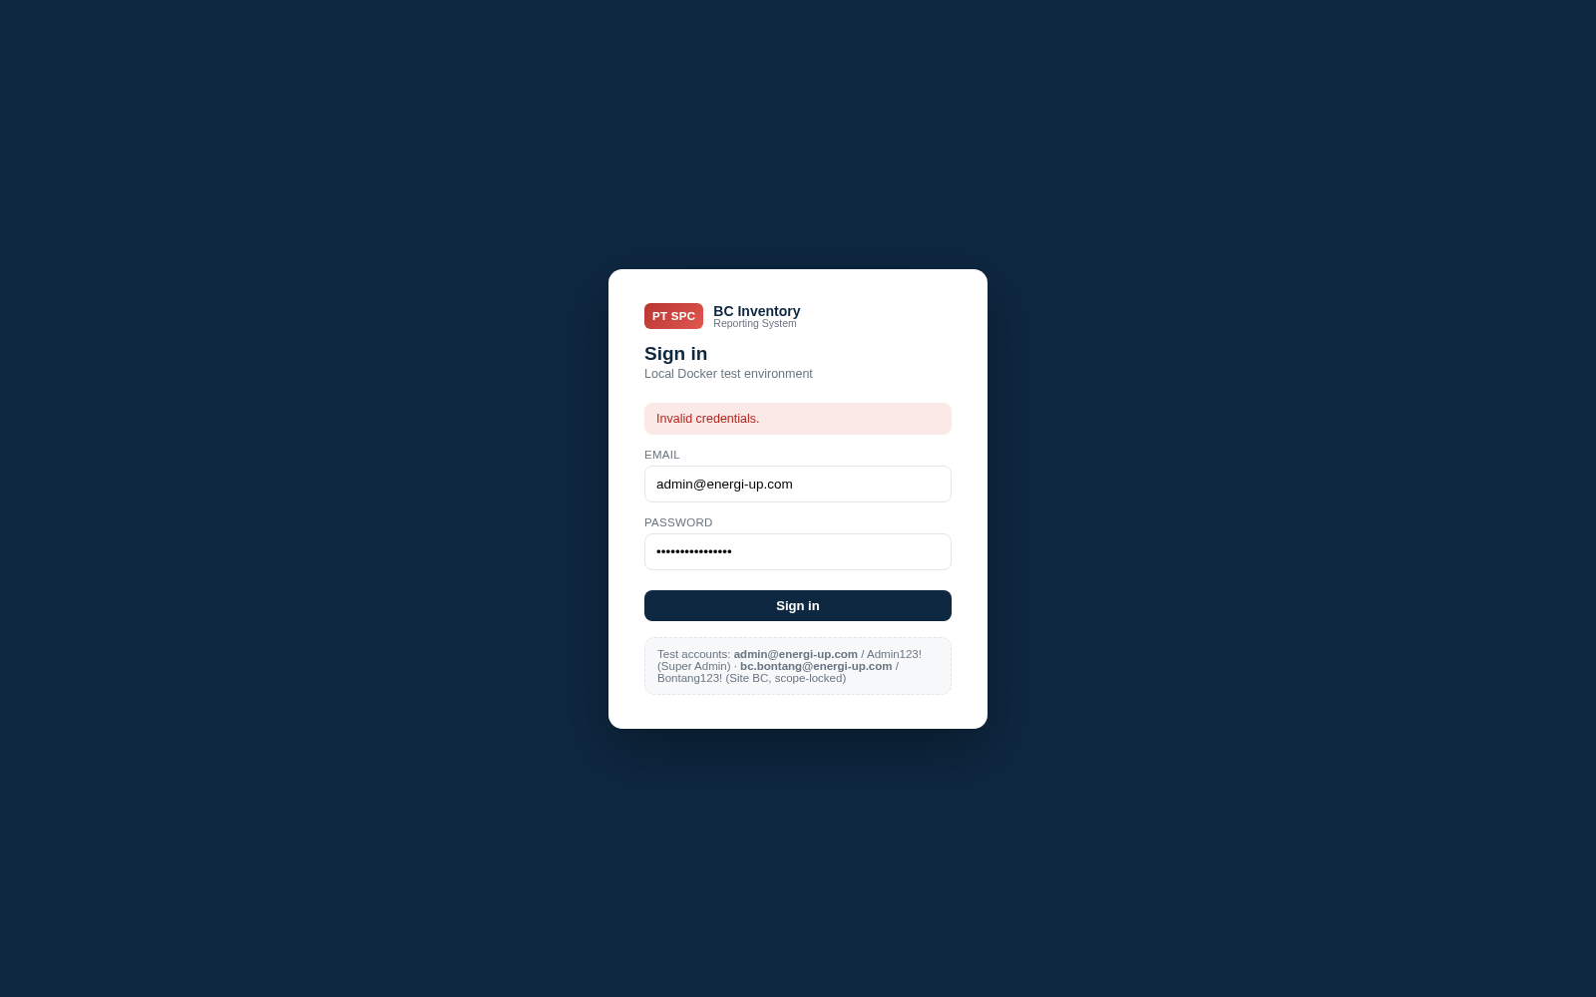

Evidence 2 — dashboard
TC-01-01 / TC-03-01 / TC-17-01 — Super Admin dashboard. Indonesian number format throughout, and all seven pages in the sidebar.
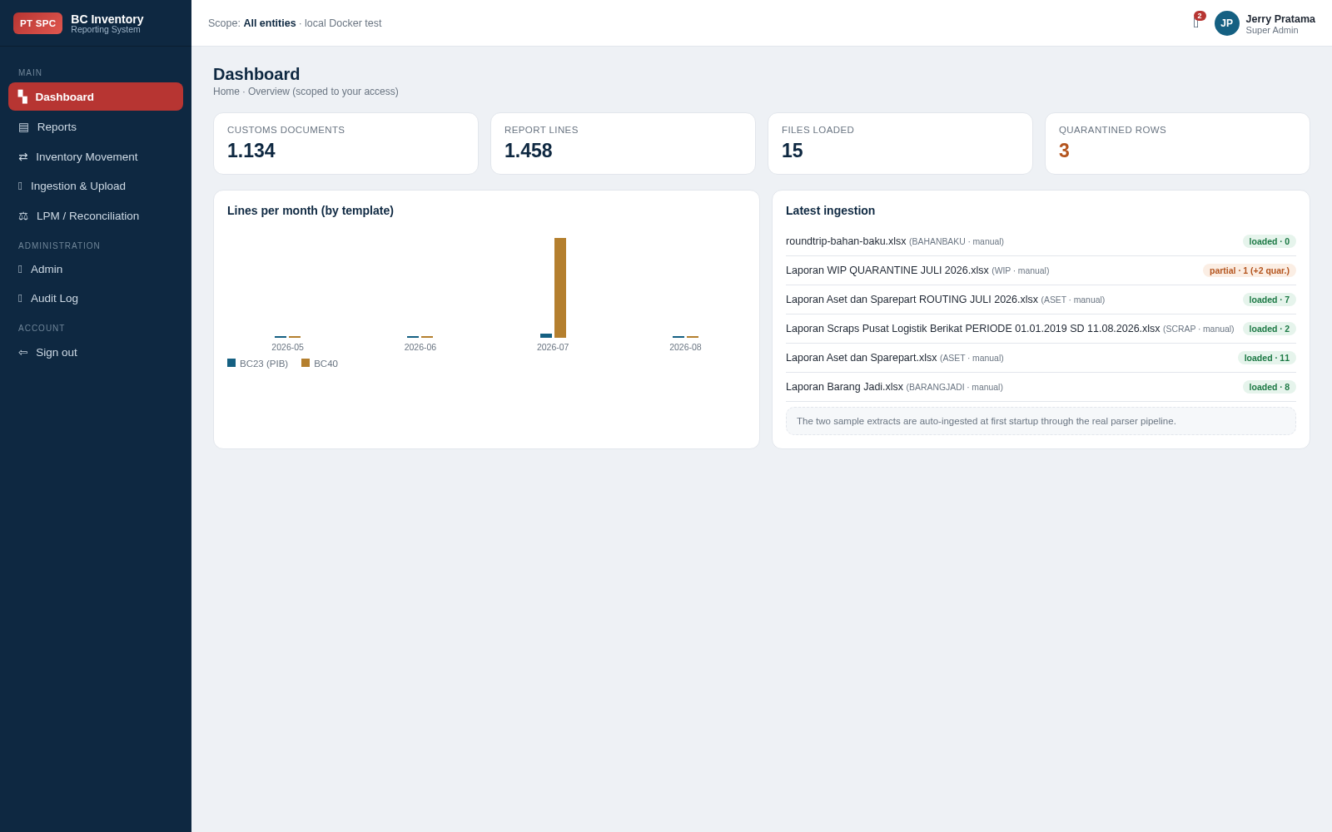

Evidence 3 — landing no dashboard
TC-01-02 — with Dashboard view revoked, the Auditor lands on Reports and Dashboard is absent from the sidebar.
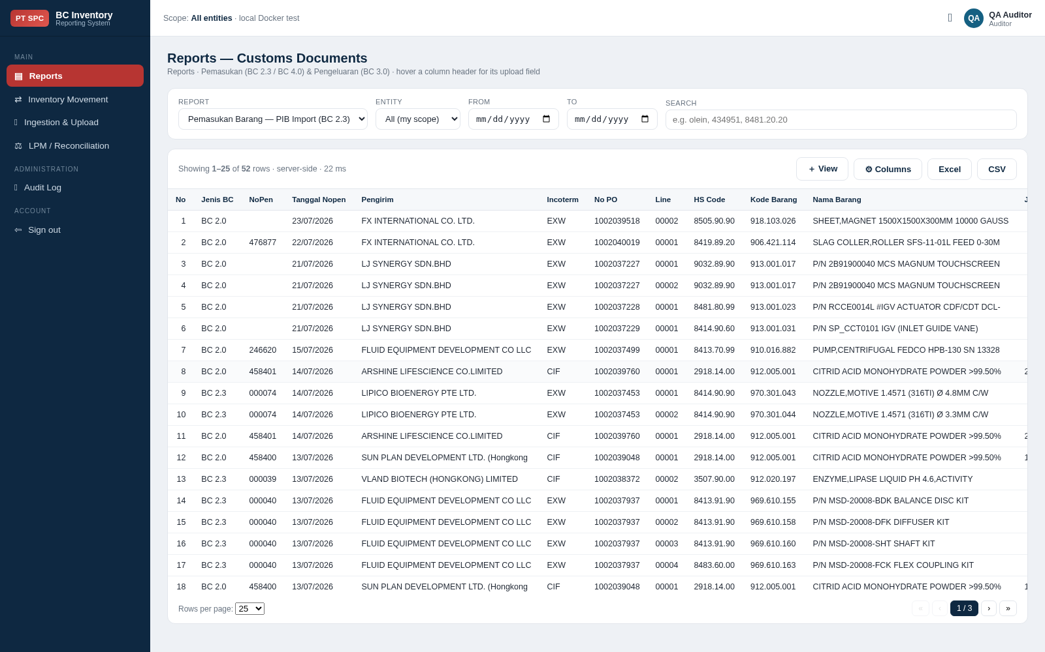

Evidence 4 — scoped user
TC-02-01 / TC-03-03 — the Site BC User. Scope reads "Entity #1 · Site #1", the sidebar is reduced to four pages, and the figures are lower than the Super Admin view.
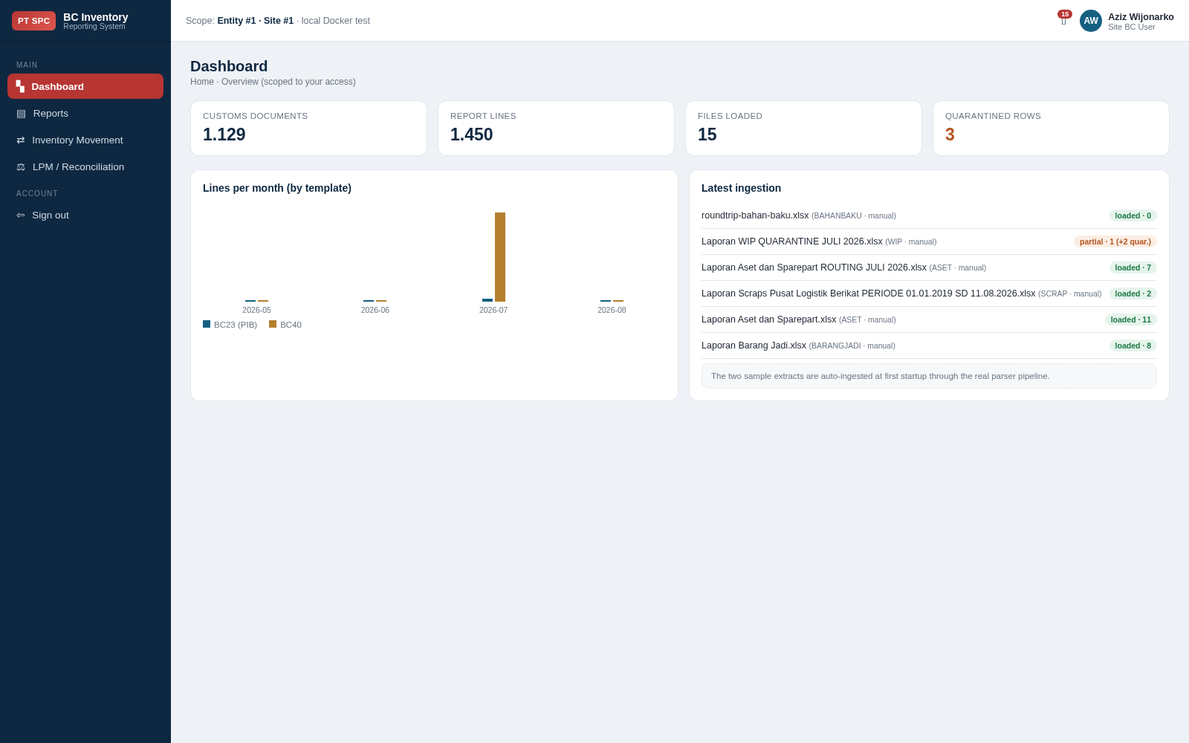

Evidence 5 — reports default
TC-04-01 / TC-17-04 — Reports with the catalogue default columns and the agreed BC 2.3 headings.
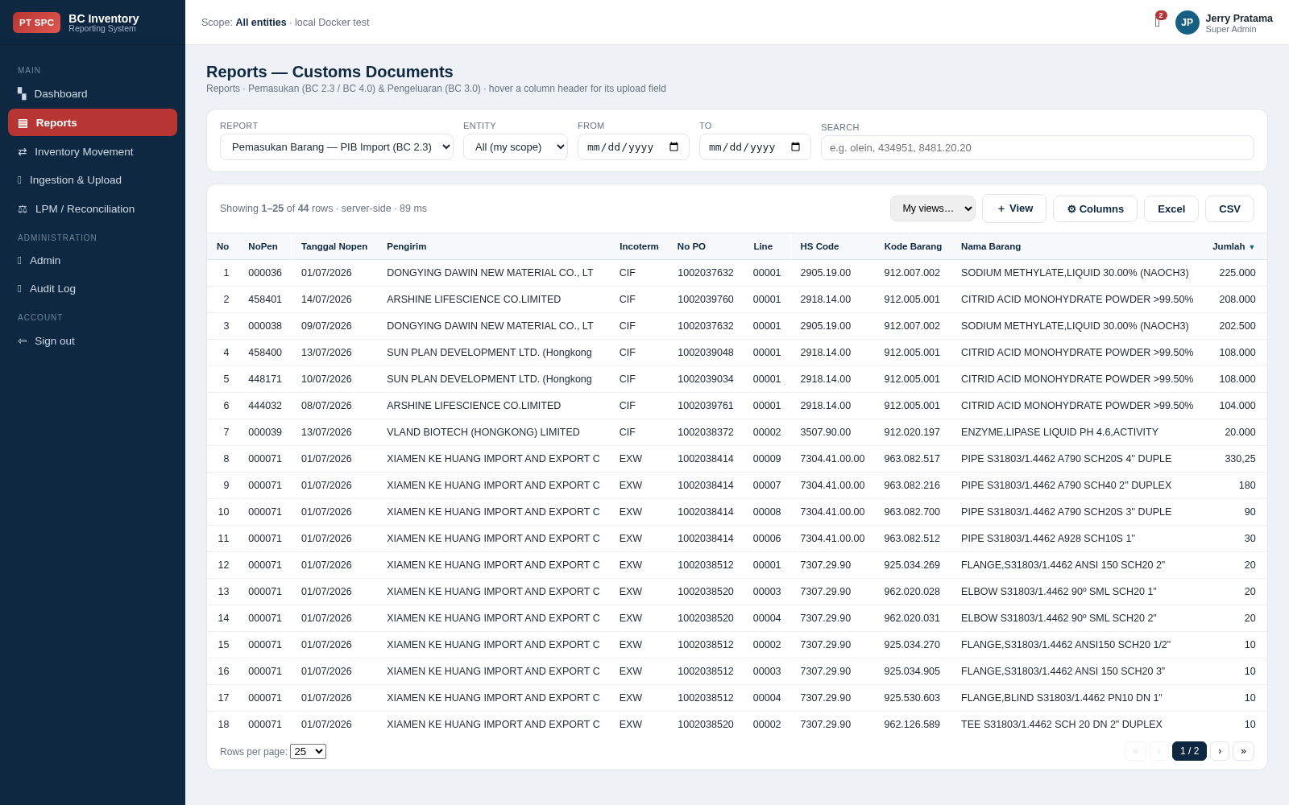

Evidence 6 — reports columns
TC-06-01 / TC-06-03 — the column chooser: every field with a checkbox, grouped, each with up/down reorder controls.
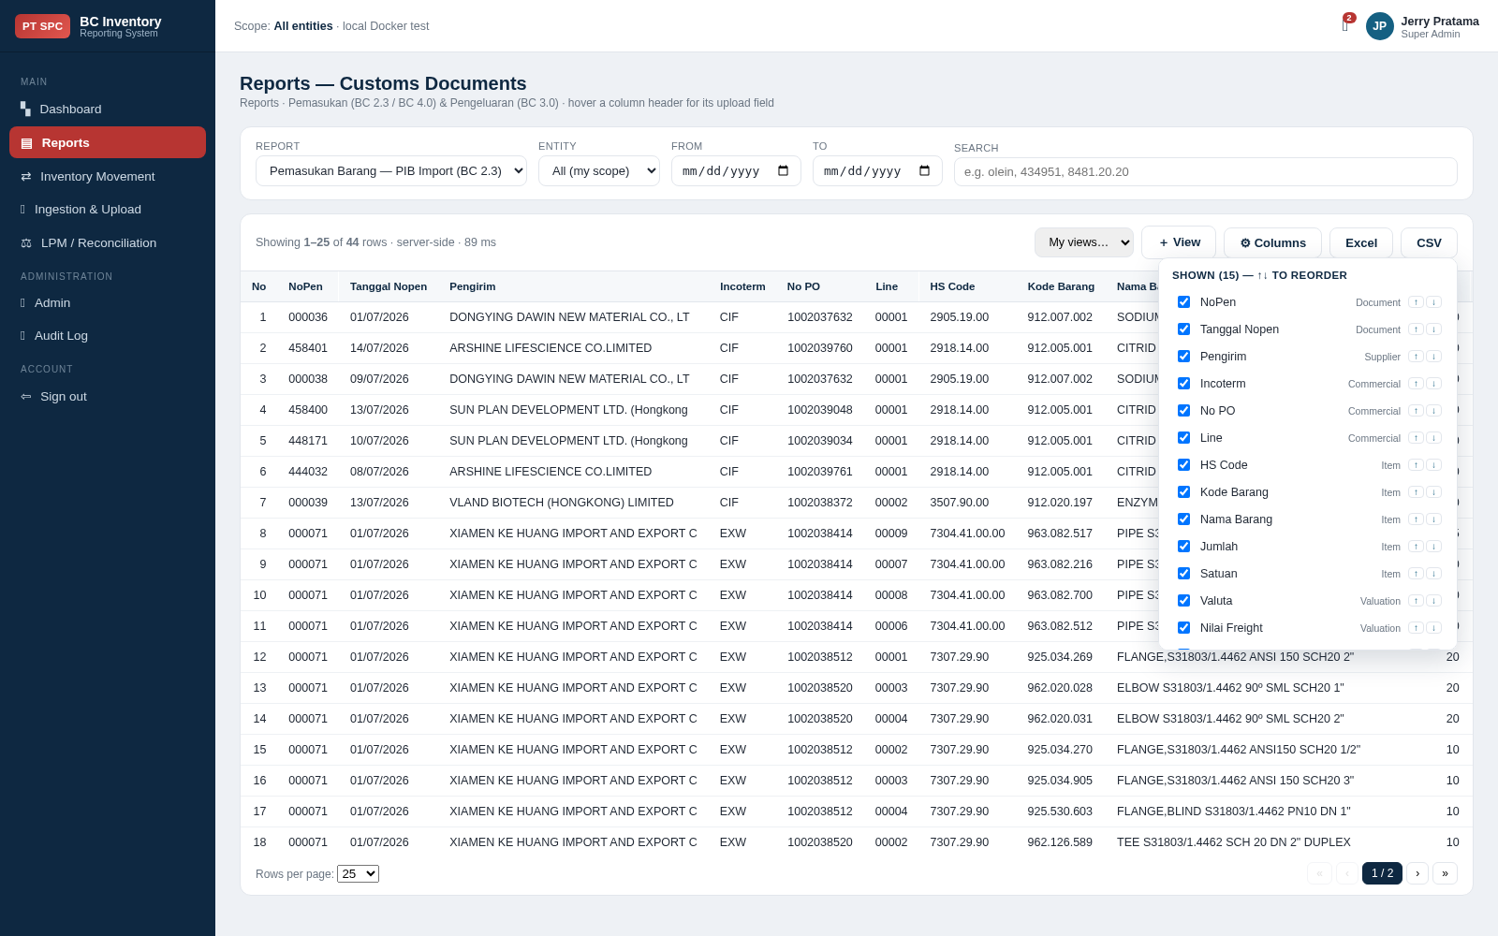

Evidence 7 — movement picker
TC-05-01 / TC-05-02 — exactly six browsable movement reports; Laporan Aset dan Sparepart is not among them.
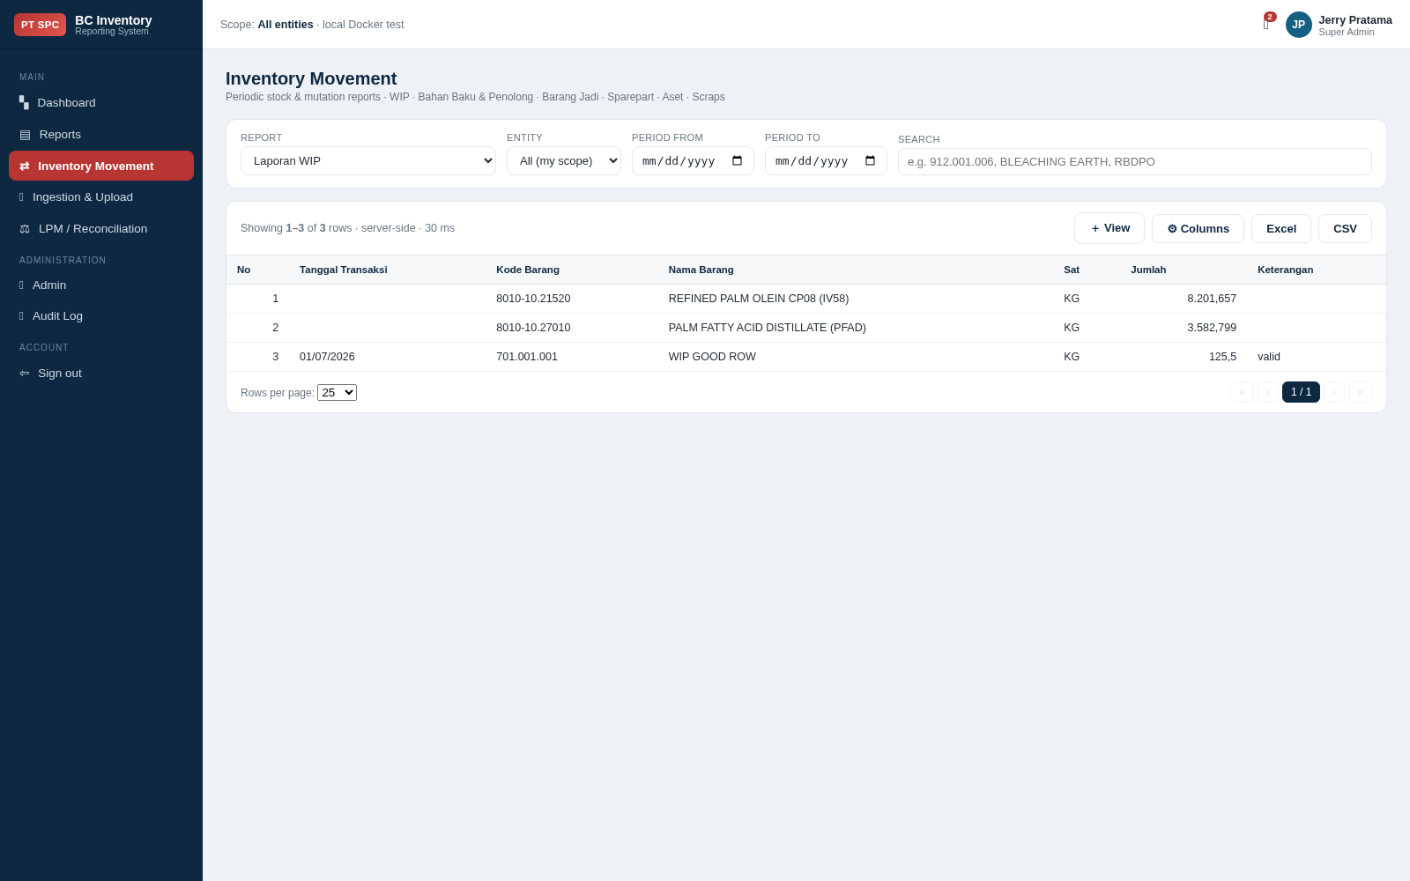

Evidence 8 — laporan sparepart
TC-05-04 / TC-17-02 — Laporan Sparepart: 13 rows, all 901 / 902 / 903, none 912. Tanggal Transaksi is the first data column.
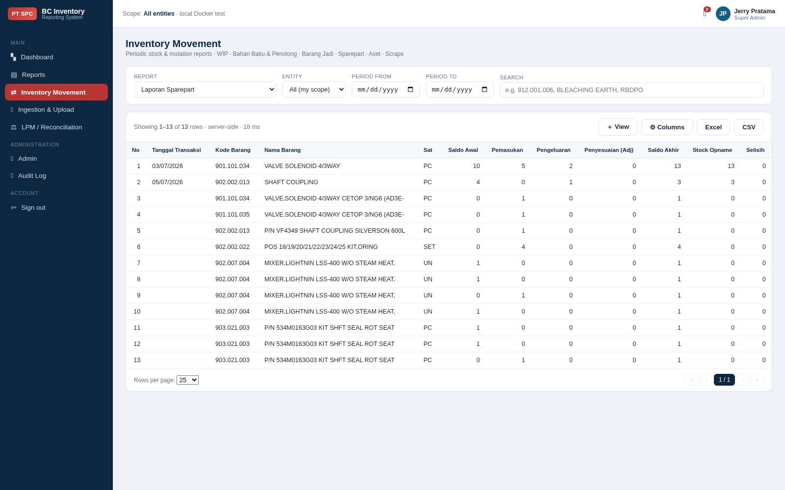

Evidence 9 — laporan aset
TC-05-05 / TC-05-07 / TC-05-08 — Laporan Aset: only non-9 codes, and the blank-code row is visible rather than lost.
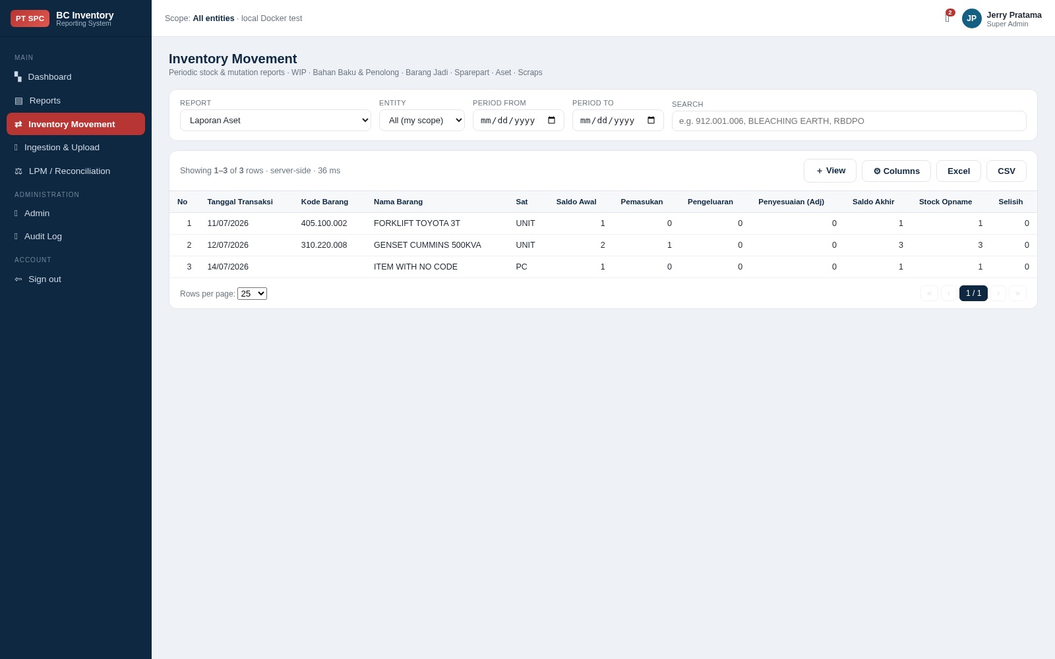

Evidence 10 — laporan bahan baku
TC-05-06 — the 912 rows uploaded inside the Aset dan Sparepart file are reported here, alongside the Bahan Baku file’s own rows.
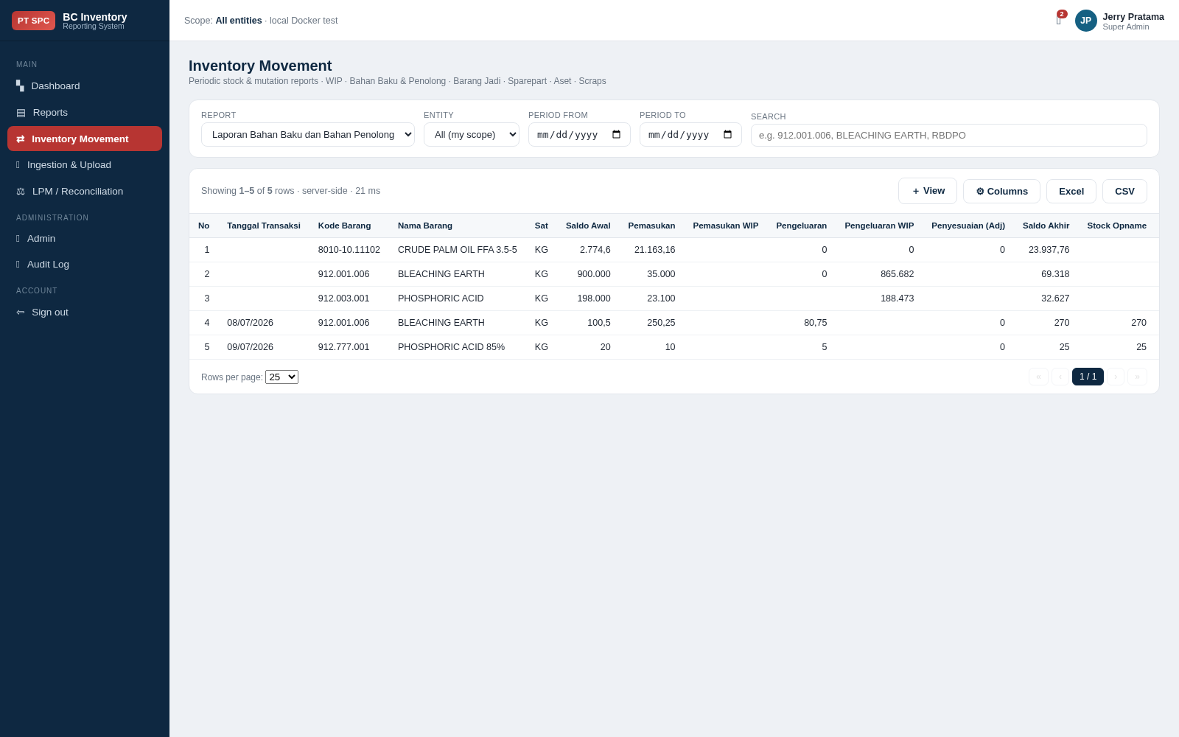

Evidence 11 — laporan wip
TC-05-11 — quantities keep full stored precision: 8.201,657 rather than a rounded 8.202.
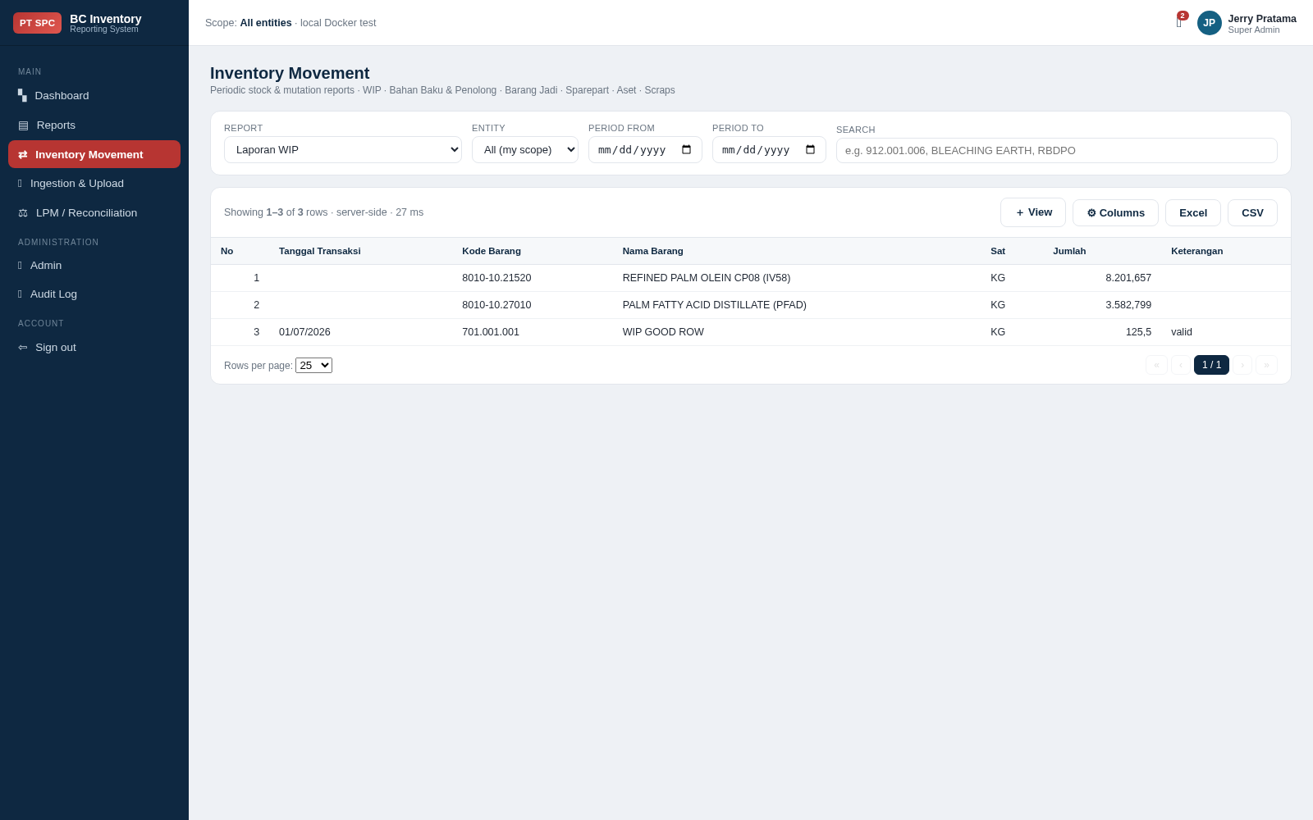

Evidence 12 — ingestion
TC-08-05 — upload templates with format and load status, and the ingested files list.
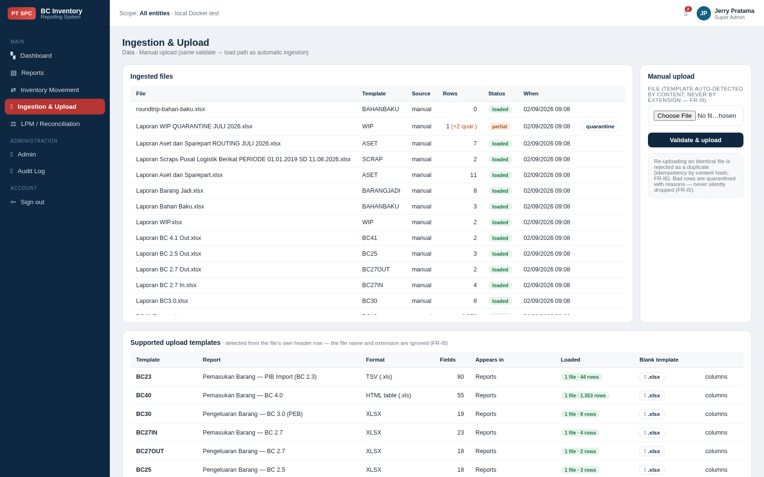

Evidence 13 — lpm
TC-10-01 — LPM / Reconciliation.
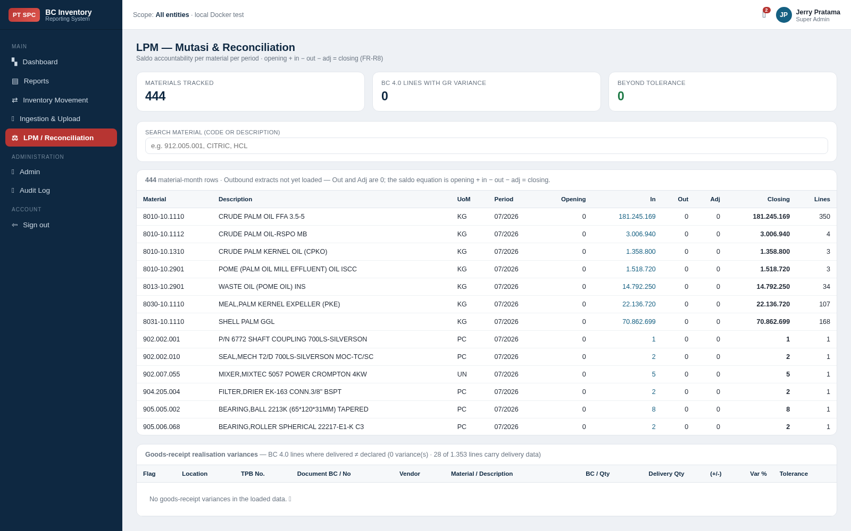

Evidence 14 — admin users
TC-11-01 — user management: role, scope, status, and Disable / Reset actions.
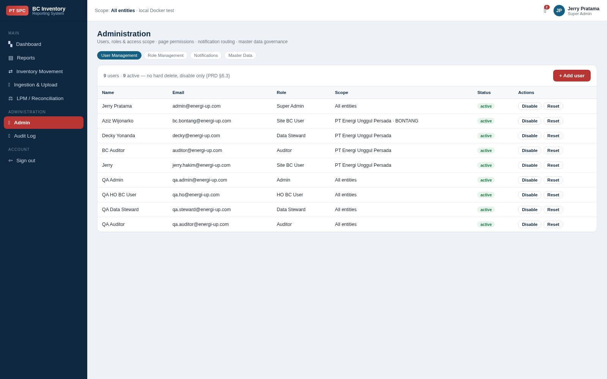

Evidence 15 — admin roles
TC-12-01 / TC-12-02 — the role matrix, with the Super Admin row marked as always full access.
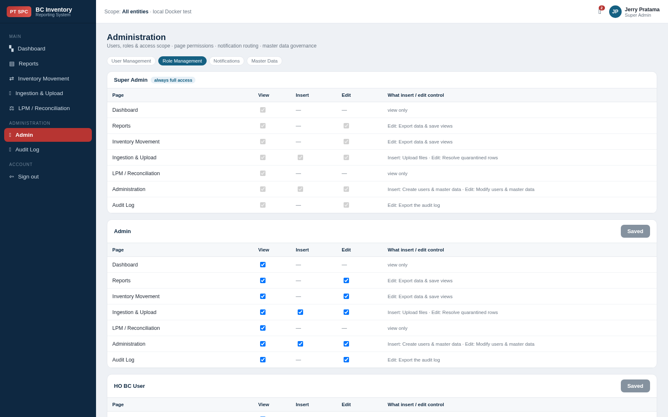

Evidence 16 — admin notifications
TC-13-01 / TC-13-03 — per-user notification routing. QA Data Steward shows the saved change: In-app off, Email on, default marker gone.
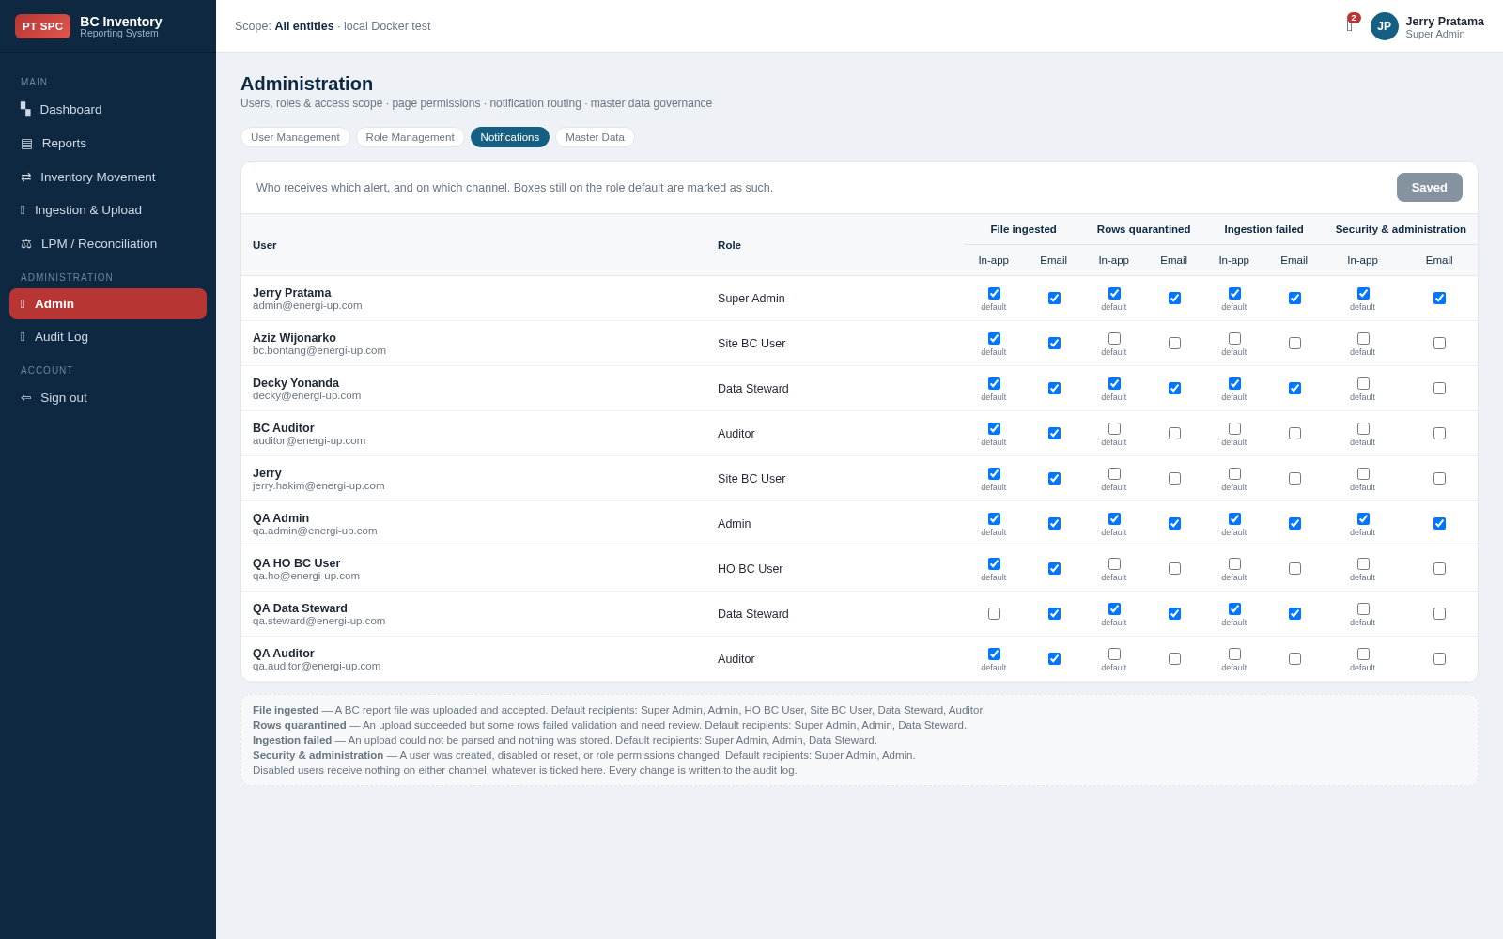

Evidence 17 — admin master
TC-14-01 — master data: entities, sites and TPB permits.
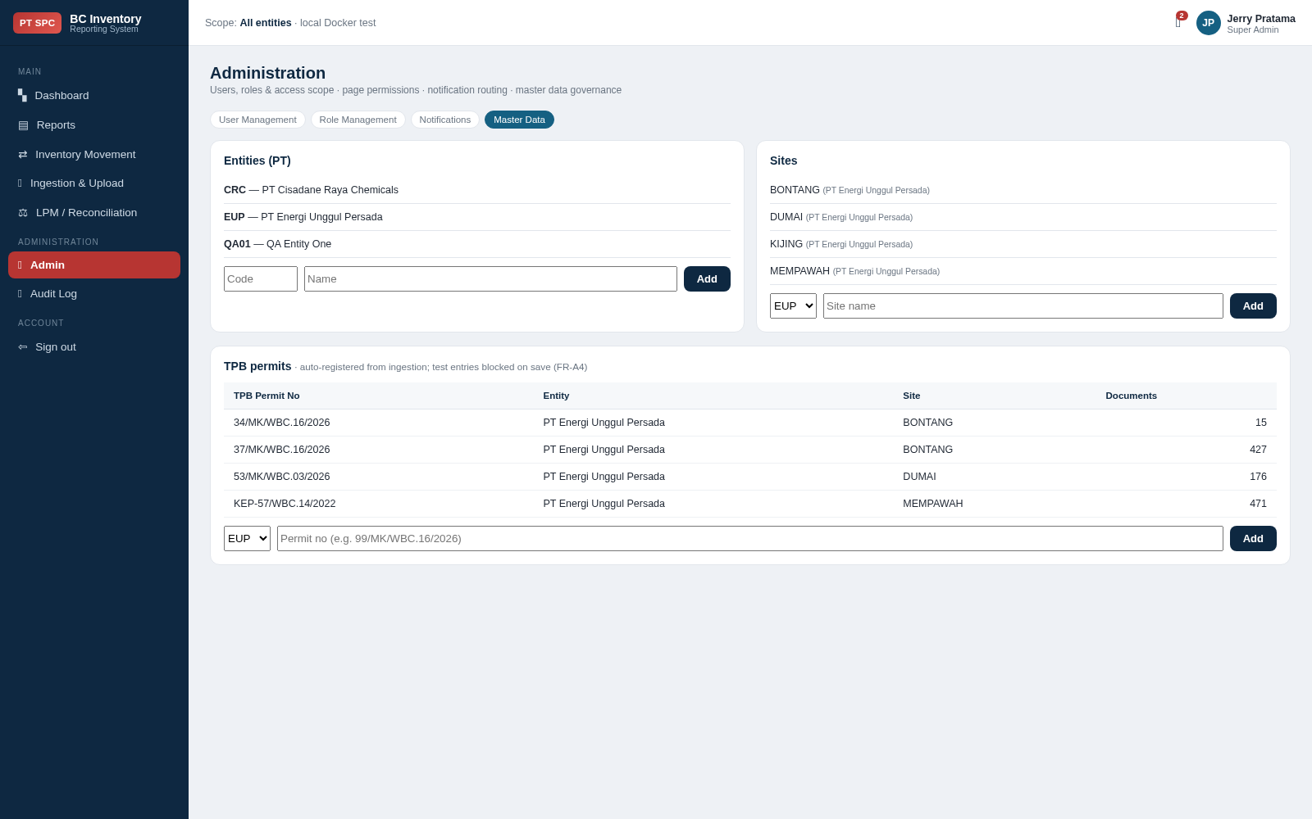

Evidence 18 — audit
TC-15-01 — the audit log.
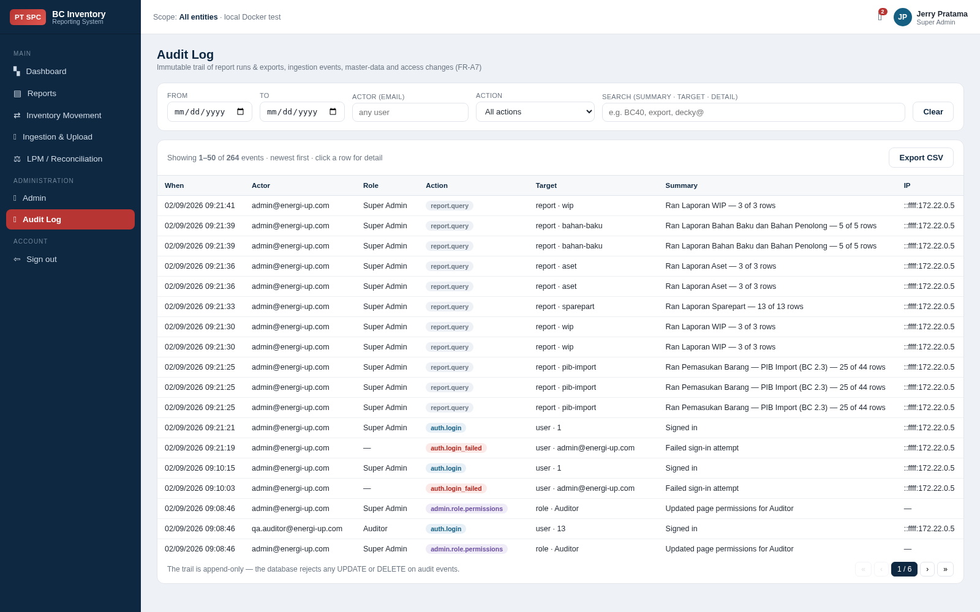

7. Findings
No critical or major defect was found. None of the following blocks user testing.
Ref | Severity | Finding | Evidence | Suggested action
F-01 | Minor | An unknown report key returns HTTP 400 from the query endpoint but HTTP 404 from the blank-template endpoint. Both are safe and both carry code RPT-001, but two endpoints disagree on the status for the same class of error. | TC-04-09: POST /reports/not-a-report/query returned 400 "Unknown report key 'not-a-report'." while GET /reports/{key}/template returns 404 for the same condition. | Align on 404
F-02 | Minor | A file larger than the reverse-proxy limit is refused with a bare nginx HTML error page instead of the application's readable message. Files between the application cap and the proxy limit do get the readable message, so only very large files are affected. | TC-08-12: a 105 MB file returned the API's VAL-001 message. TC-08-12b: a 120 MB file returned an nginx "413 Request Entity Too Large" HTML page. | Custom 413 page
F-03 | Observation | Two of the four Dashboard tiles are not entity-scoped. Customs documents and Report lines correctly narrow to the signed-in user's entity; Files loaded and Quarantined rows show group-wide totals on a page captioned "scoped to your access". Only aggregate counts are exposed, no row data. | TC-03-03: with data in two entities, Super Admin saw 1.134 / 1.458 / 15 / 3 and the Site BC User saw 1.129 / 1.450 / 15 / 3. | Scope or re-label

8. Corrections to the test pack
Four scenarios in the pack asserted behaviour the system does not have, and were corrected during the run. These were errors in the pack, not in the application; the pack should be updated before the next cycle.
Test ID | What the pack said | What the system actually does — and why it is right
TC-04-12 | An empty column list should be refused with VAL-001. | A query with no columns falls back to the report's default columns. That is deliberate and is the more useful behaviour; the "columns required" guard applies to exports.
TC-14-07 | A blocked test entry should return HTTP 400. | It returns HTTP 409 with the correct message and the entry is blocked. Only the status differs.
TC-10-07 | The Auditor role lacks LPM access. | The Auditor has LPM view by default. The case was re-run by revoking that permission first, which then correctly returned 403.
TC-04-08, 04-13, 04-14, 06-03, 06-04, 07-02, 07-05 | These used Kode Barang and Nama Barang against BC 2.3. | Those are movement-report columns; BC 2.3 has NoPen, Pengirim and so on. The cases were re-run against each report's real default columns.

9. Not covered by this run
The following need conditions this run could not create, and should be scheduled before go-live:
- E-mail delivery to real mailboxes (TS-16). The in-app channel and the recording of delivery status were verified; sending was exercised against a local mail catcher, not the corporate relay.
- Concurrency with several real users on staging (TC-18-03). Response times here were measured single-user and were between 9 and 89 ms, far inside the 2-second target, but that is not a load test.
- Saved views created and deleted through the UI (TC-06-05, TC-06-06). The ownership guard was verified at the API.
- Export file contents opened and compared column by column (TC-07-01, TC-07-04). The endpoints were verified to return files of the right type and to refuse an unsupported format.
- A re-run of the read-only subset against staging once it is on the current build, to confirm the deployed environment behaves identically.

10. Conclusion
133 of 134 executed cases passed. The one failure is the status-code inconsistency recorded as F-01.
Access control held everywhere it was tested, at the API as well as in the browser: cross-entity requests were refused with SCOPE-001, revoked pages returned 403 even when called directly, an Admin could not create a Super Admin or grant all-entities scope, and the Super Admin role could not be restricted. The append-only audit trail rejected both UPDATE and DELETE.
On that basis the build is fit for user testing, with the three findings tracked and none of them blocking.

Role | Name | Signature and date
Executed by
Reviewed by
Approved by

