Jetty Planning & Monitoring System
Functional Test Execution Report
Evidence-based results with screenshots · Bug findings & fixes
Branch: sit · Tested against local Docker (Frontend :3001, API :3000, PostgreSQL :5436)
Executed 2026-06-26 · Document version 1.0

Table of Contents

1. Executive Summary
Comprehensive functional testing was executed against the running local Docker deployment, covering authentication/security, RBAC, master data, shipping instructions, shipment plans, allocation/berthing, at-berth executions, clearance lifecycle, the demurrage/SLA calculations, dashboard, notifications, reporting, jetty live and the partner integration API. Testing combined: (a) back-end API checks via authenticated HTTP calls (positive and negative), and (b) front-end UI automation (Playwright driving Chromium against :3001) with screenshots as evidence.

1.1 Result Totals
Metric | Value
Scenarios executed (API + UI) | 31
Passed | 31
Failed (open) | 0
Bugs found | 5 (4 minor/CSP + 1 major migration)
Bugs fixed & re-verified | 5
Bugs awaiting your decision | 0 (observations only)

Outcome: All executed positive and negative scenarios passed. Five defects were found, fixed and re-verified (four minor/CSP auto-fixed, plus one major database-migration bug resolved per your decision). Several data/UX observations are documented in Section 5.

2. Back-End API Results (positive & negative)
Authenticated HTTP calls with cookie + CSRF token, port scope header. Negative cases assert correct rejection codes and messages.
ID | Scenario | Expected / Notes | Result
AUTH-01 | Login valid (API) | HTTP 200 + session cookie set | PASS
AUTH-02 | Login wrong password | HTTP 401 | PASS
AUTH-03 | Login empty body | HTTP 400 | PASS
AUTH-05 | /users/me with cookie | HTTP 200 | PASS
AUTH-07 | /users/me without cookie | HTTP 401 | PASS
AUTH-08 | CSRF: mutation without X-XSRF-TOKEN | HTTP 403 (blocked) | PASS
AUTH-08b | CSRF: mutation with token + empty name | HTTP 400 (validation) | PASS
LIST | GET ports/jetties/SIs/plans/operations/sla-config/standard-rates/notifications | HTTP 200 | PASS
DASH-02 | GET activity-logs without page_key | HTTP 400 'page_key required' (by design) | PASS
DASH-02b | GET activity-logs?page_key=shipment-plan | HTTP 200 | PASS
INT-02 | Integration API without x-api-key | HTTP 401 | PASS
CLR-06g | Depart on non-SIGNOFF_APPROVED op | HTTP 400 'must be SIGNOFF_APPROVED' (lifecycle guard) | PASS
SLA-01 | recalculate-sla on docked op | HTTP 200, ETC computed | PASS
SLA-02 | recalculate-sla without docking_start | HTTP 400 'call start-docking first' | PASS
DASH-02c | dashboard-v2/weekly-trends without dates | HTTP 400 'start_date/end_date required' | PASS

3. Front-End UI Results
Playwright (Chromium) against the Docker frontend on :3001. Every major page rendered without errors; negative and responsive/i18n checks included.
ID | Scenario | Expected / Notes | Result
AUTH-01 | Login page renders (UI) | Sign In + SSO controls present | PASS
AUTH-02 | Invalid password (UI) | Stays on /login, no session | PASS
AUTH-01b | Valid login (UI) | Redirects into app | PASS
DASH-01 | Dashboard renders | KPIs, pipeline, slot occupancy, at-berth | PASS
SP-01 | Shipment Plans list | Renders list | PASS
ALLOC-01 | Allocation & Berthing | Incoming queue + schematic/Gantt tabs | PASS
ATB-01 | At-Berth Executions | Phase buckets; ETC breach badges red (+92d/+93d) | PASS
DEM-00 | Demurrage Calculator | Formula breakdown visible (ΣV/(Rate×Buffer), Q1+Q2+C, (n-1)×S) | PASS
MAS | Master hub / Port / Jetty | All render | PASS
RBAC | Admin Users / Roles | Both render | PASS
REP | Reporting hub | Renders | PASS
LIVE-01 | Jetty Live page | Renders; graceful no-stream state | PASS
UX-02 | Language toggle EN/ID | Full ID translation | PASS
UX-01 | Mobile 375px | No horizontal overflow; card layout | PASS
AUTH-07 | Protected route logged out | Sign-in prompt (after fix) | PASS
DEM-DATA | Demurrage SIs for March range | SIs listed when range matches data | PASS

4. Screenshot Evidence
Representative captures. The full set (24 images) is in Docs/Testing/screenshots/.

4.1 Authentication
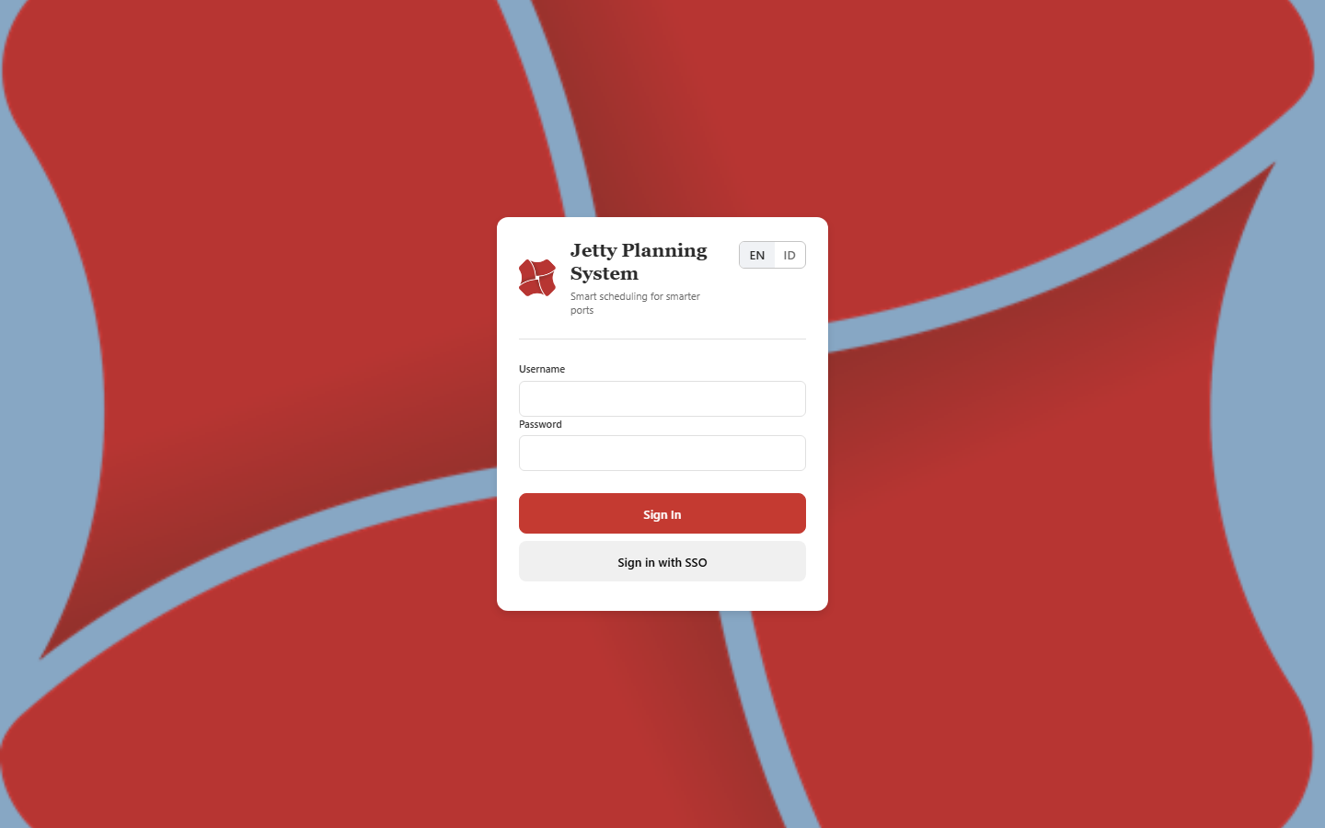
Login page (EN) — system fonts after Google-Fonts fix.
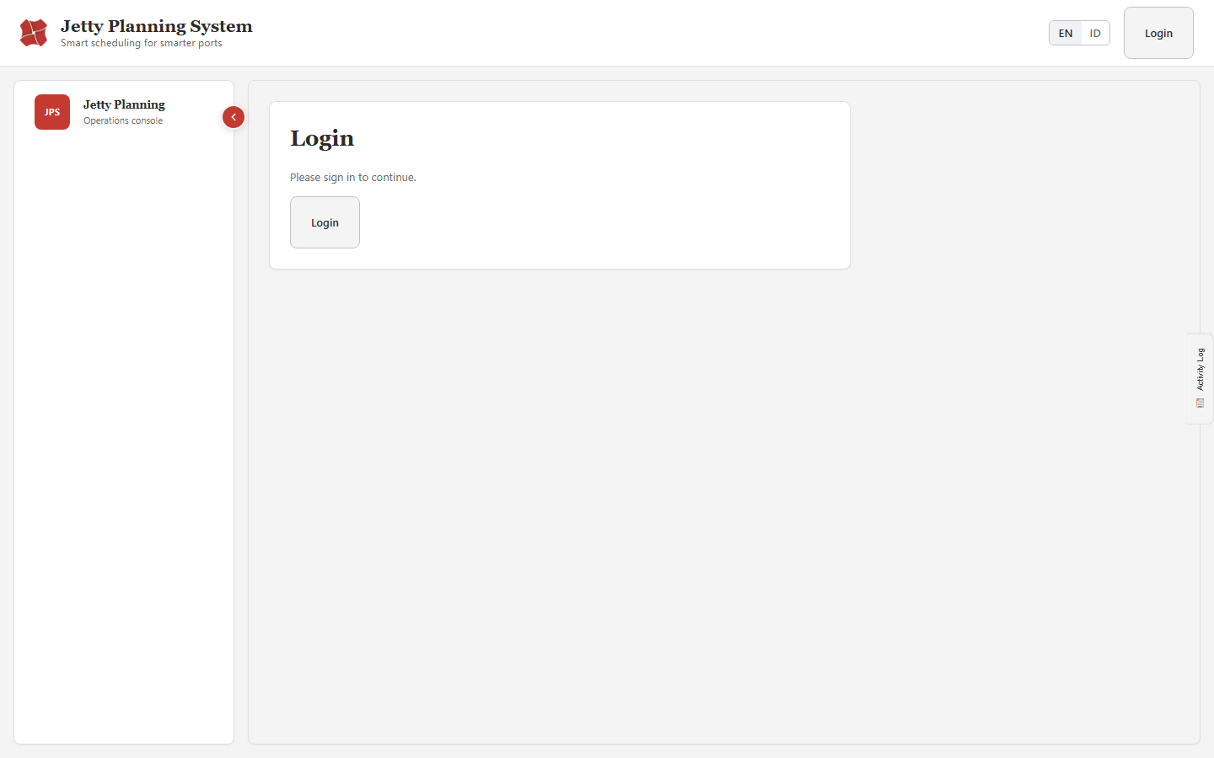
After fix: logged-out root shows a sign-in prompt (previously a misleading 'Forbidden').

4.2 Dashboard & Operations
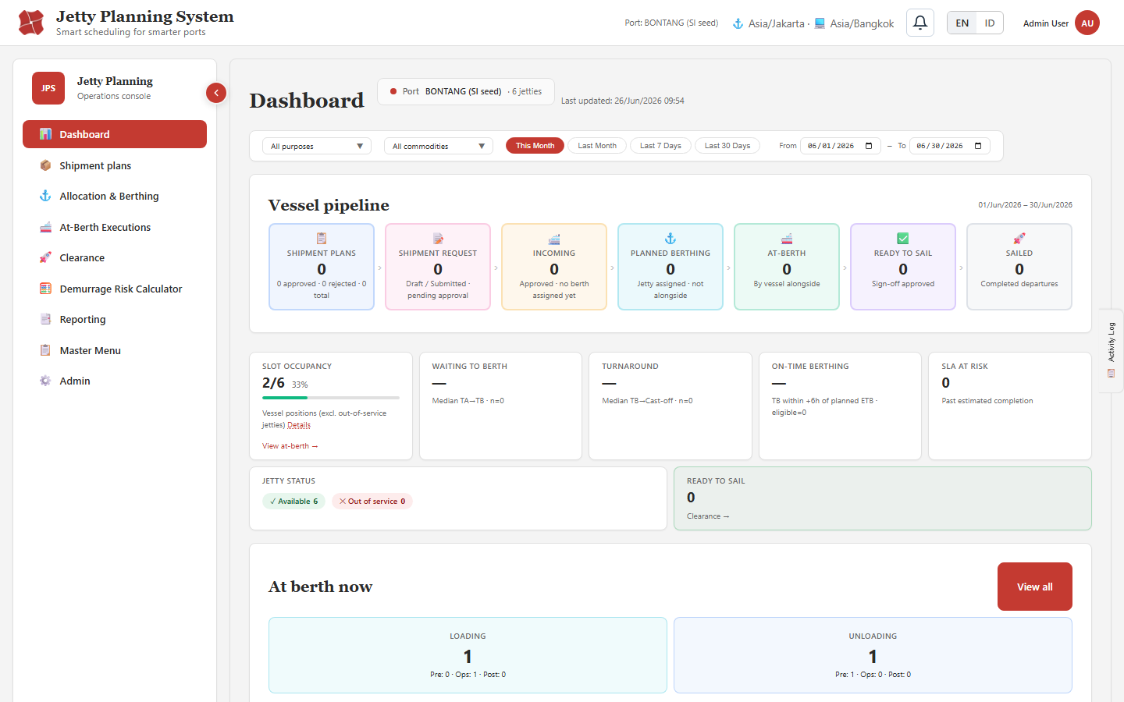
Dashboard — vessel pipeline, slot occupancy 2/6, jetty status, at-berth now.
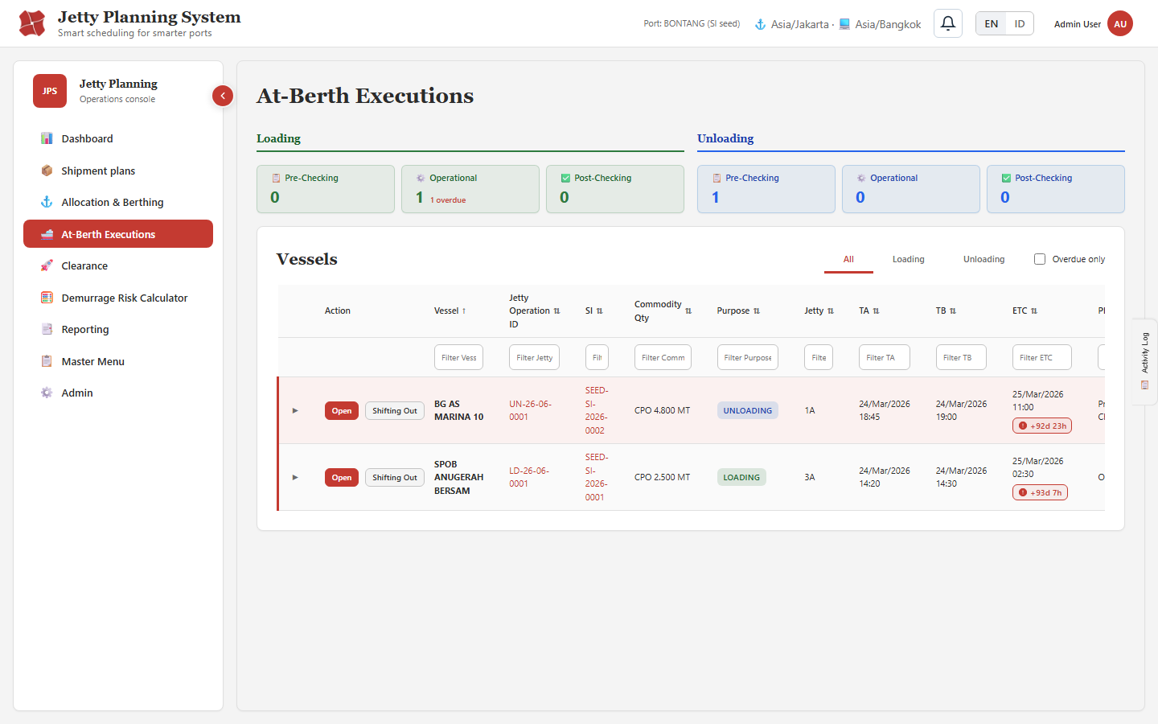
At-Berth Executions — phase buckets and red ETC-breach badges (+92d/+93d) proving the breach calculation.

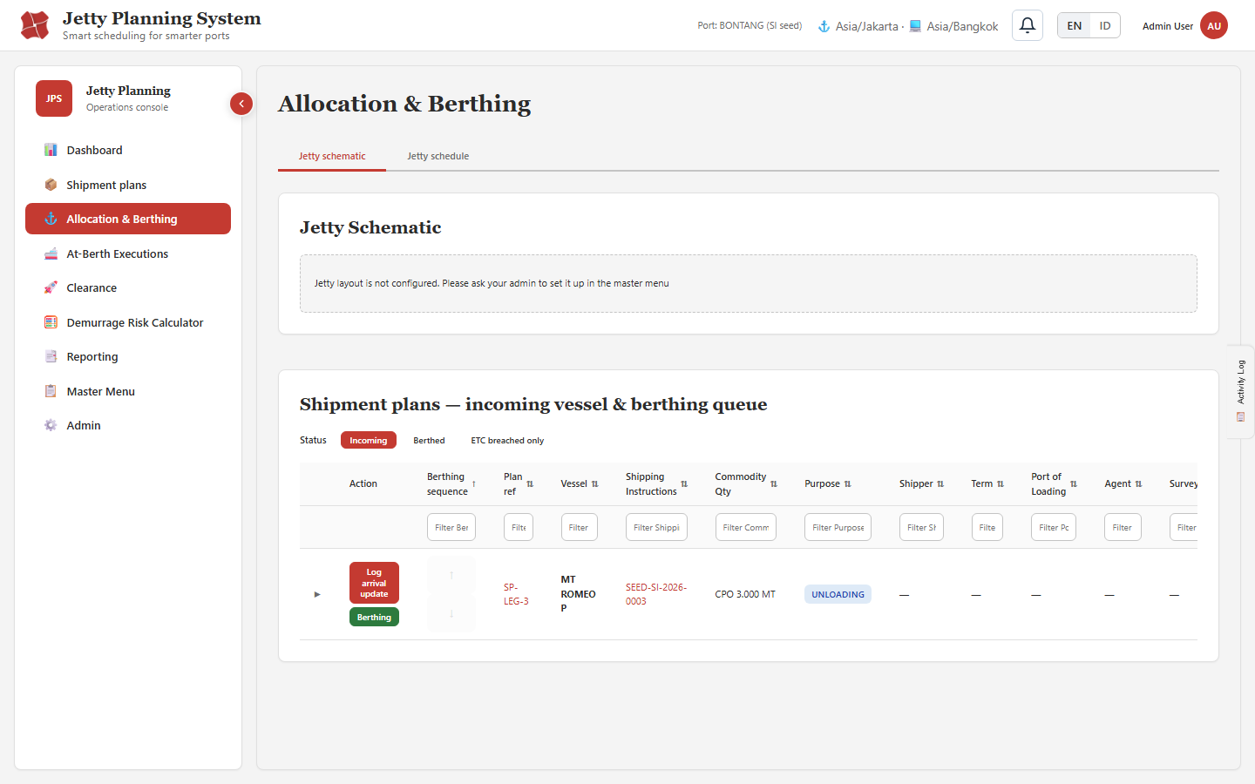
Allocation & Berthing — incoming queue with per-column filters and actions.
[missing: 19-DEM-calc.png]
Demurrage Risk Calculator — formula breakdown matches spec (ΣV/(Rate×Buffer), Q1+Q2+C, (n−1)×S).

4.3 Master / Admin
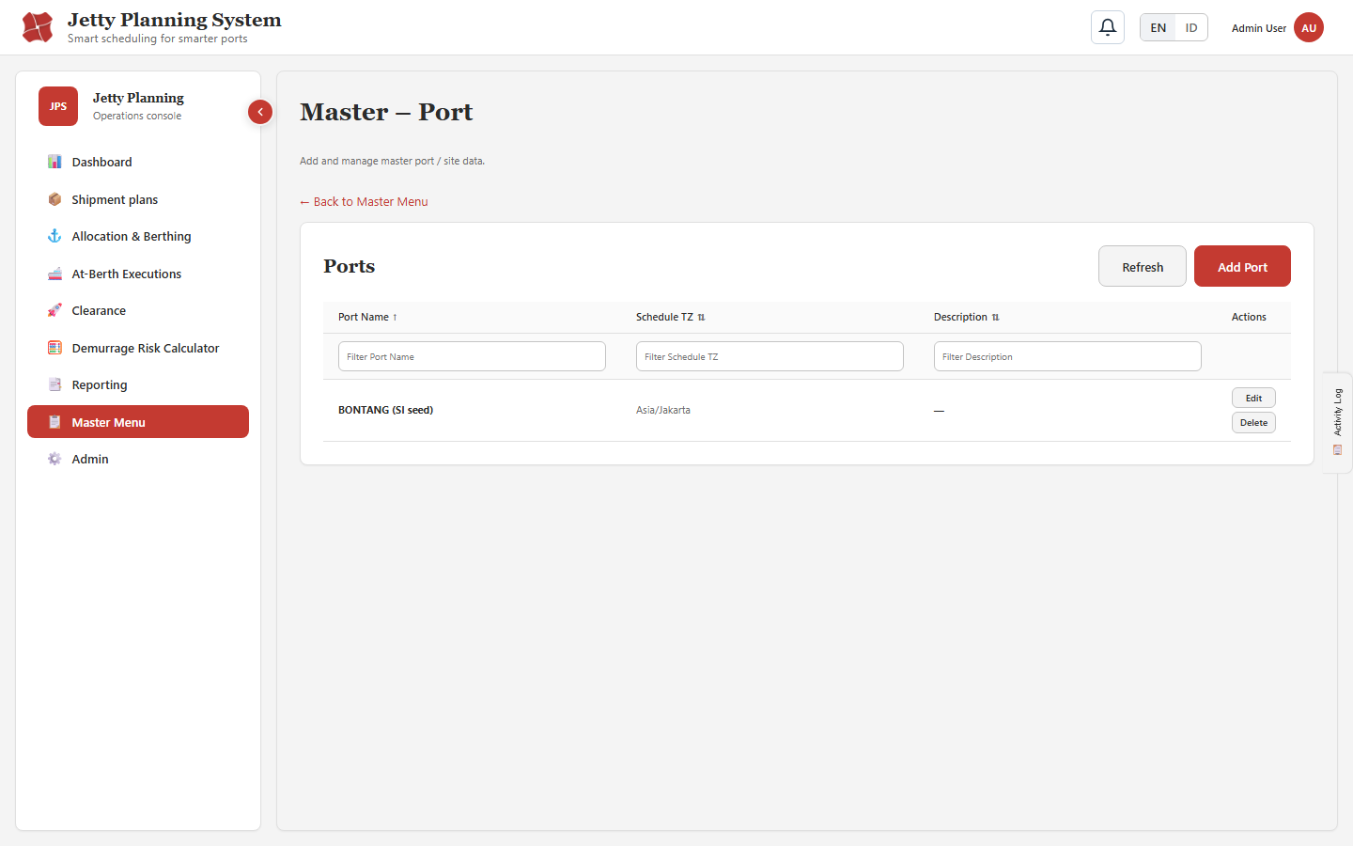
Master — Port.
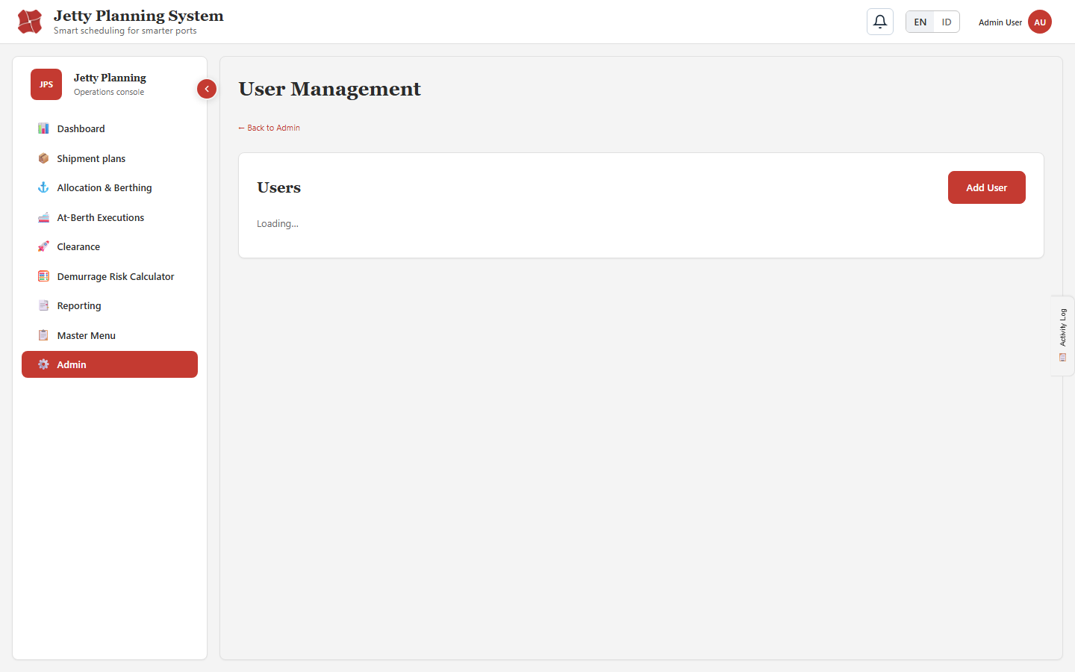
Admin — Users (RBAC).

4.4 i18n, Responsive & Jetty Live
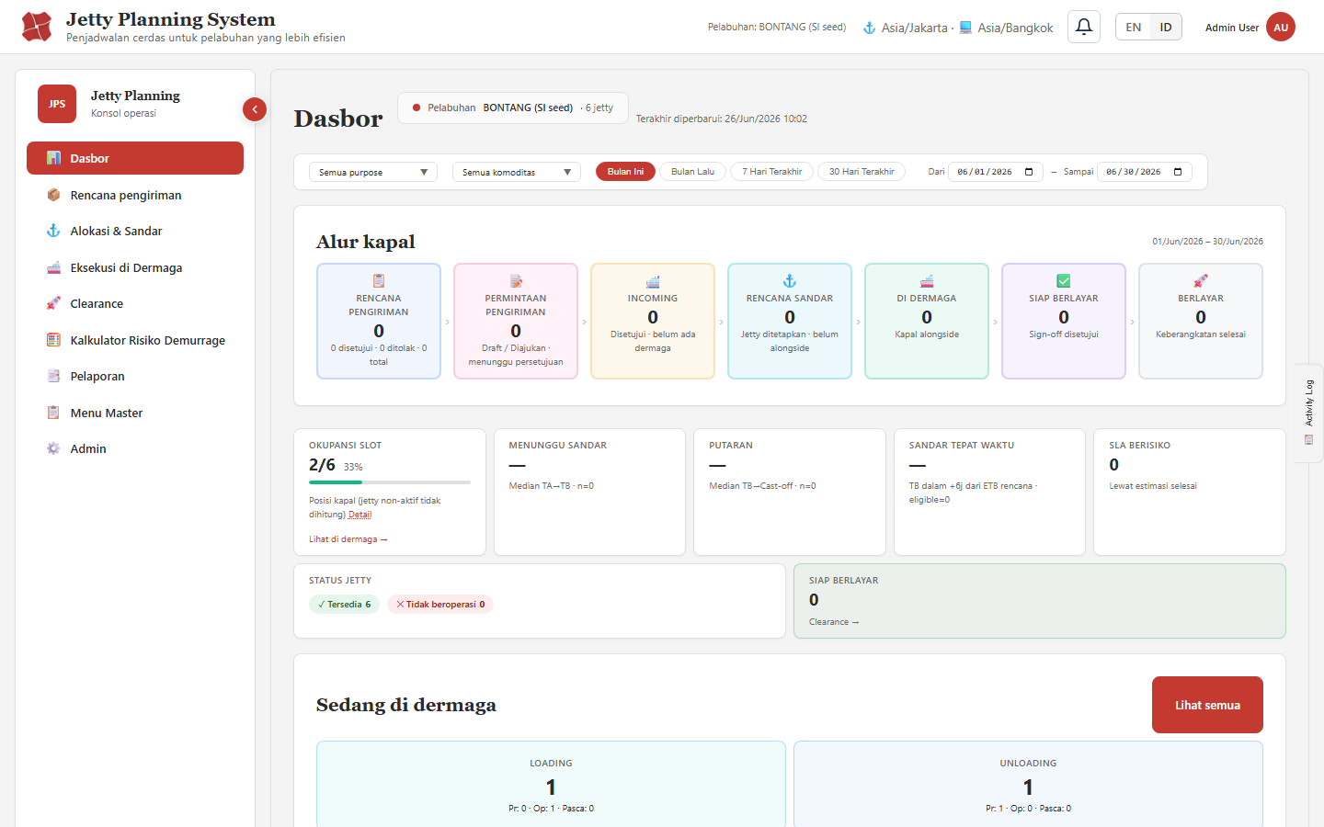
Dashboard rendered in Indonesian (i18n) — no Forbidden flash after the auth-guard fix.
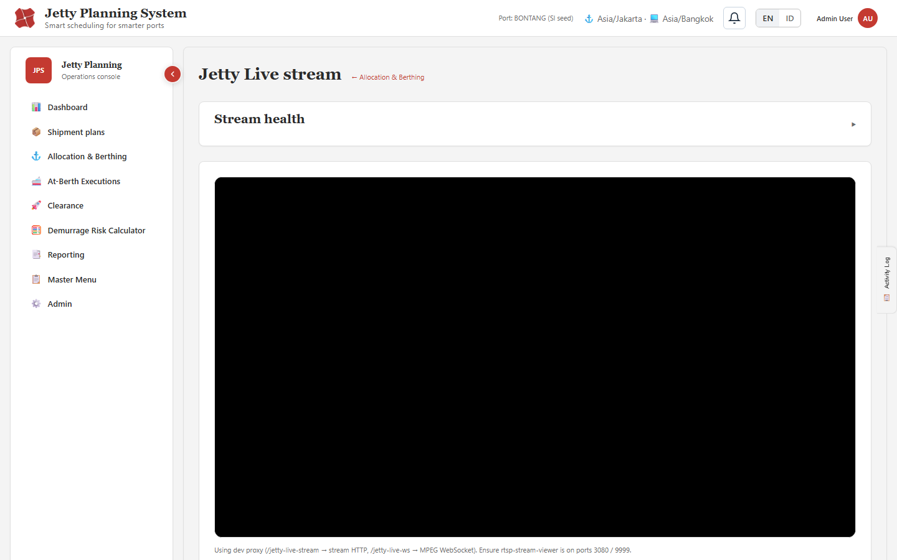
Jetty Live — JSMpeg loads same-origin and its WASM decoder runs (0 CSP errors after fix).
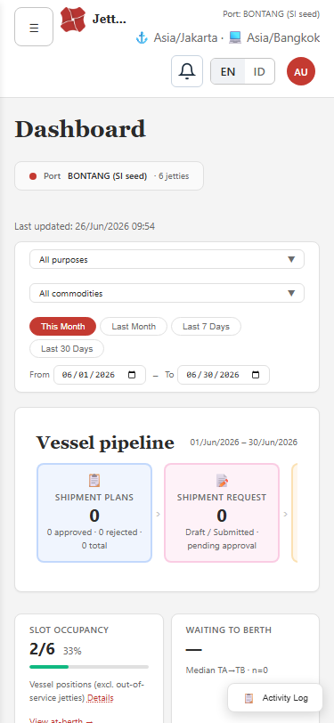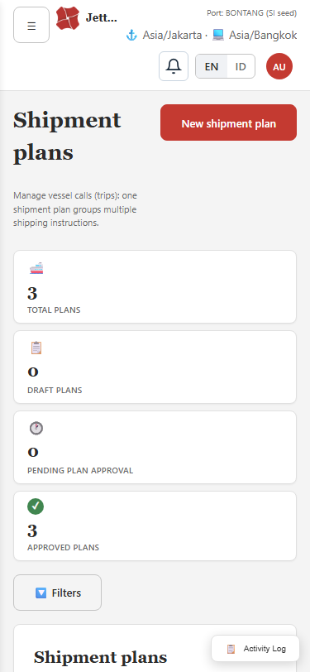
Mobile (375px): dashboard and shipment plans — no horizontal overflow.

5. Bug Findings

5.1 Defects fixed automatically (minor / low-risk) — re-verified
ID | Scenario | Expected / Notes | Result
FIX-1 | Google Fonts blocked by CSP (offline) | Removed external links; system-font fallback | PASS (fixed)
FIX-2 | Jetty Live JSMpeg from CDN blocked by CSP | Vendored /jsmpeg.min.js same-origin | PASS (fixed)
FIX-2b | JSMpeg WASM blocked by CSP | Added 'wasm-unsafe-eval' to script-src; 0 CSP errors, JSMpeg loads | PASS (fixed)
FIX-3 | 'Forbidden' flash before auth/RBAC load | Auth-loading guard + sign-in card; verified | PASS (fixed)
FIX-4 | Migration 031 aborts fresh 'npm run migrate' | Per your decision, 031 made a no-op (dev seed removed). Fresh DB now applies all 86 migrations; verified on a throwaway DB. | PASS (fixed)

Note on FIX-2b (CSP): Enabling 'wasm-unsafe-eval' slightly relaxes the Content-Security-Policy, but it permits only WebAssembly compilation (not eval()/new Function()) and is the W3C-recommended minimal directive. It is required for the Jetty Live JSMpeg decoder to run under CSP. Flagged here for your security awareness.

5.2 Major defect — RESOLVED
Item | Detail
ID / Severity | BUG-MAJOR-01 · Major (blocked fresh DB setup) · FIXED
Title | Migration 031_seed_dev_clearance_data.sql aborted a clean migration run
Symptom | On a fresh database, 'npm run migrate' failed at 031 with an operations_status_check violation.
Root cause | 031 seeded operations with status SIGNOFF_APPROVED, but that status is not added to the operations_status_check constraint until migrations 049/050; the seed ran before the constraint allowed the value.
Resolution (your decision) | The dev clearance seed was removed — 031 is now a safe no-op (SELECT 1) with an explanatory header. No replacement seed.
Verification | A clean run against a throwaway database applied all 86 migrations successfully (admin user, 1 port, 6 jetties present). Existing databases are unaffected (031 already recorded as applied).

5.3 Observations (not defects)
- standard_rates table is empty after migrations — the Demurrage Calculator/SLA need master rates configured (or use the Override rate). Consider seeding sample rates for demos.
- Dashboard defaults to the 'This Month' range; seed data is dated March 2026, so pipeline tiles read 0 until the range is changed (live 'At berth now' still shows current operations). Expected behavior.
- Jetty layout is not configured for the seeded port — the allocation schematic shows a setup hint (configure in Master menu).
- A transient 'Forbidden' flash on hard navigation was traced to the auth-context load timing and fixed (FIX-3).

6. Test Method & Environment
- Frontend: Docker nginx build on http://localhost:3001 (production-style bundle).
- Backend: Docker Node/Express API on http://localhost:3000; PostgreSQL 16 on 127.0.0.1:5436.
- UI automation: Playwright + Chromium driving the real :3001 app; screenshots saved to Docs/Testing/screenshots/.
- API checks: authenticated HTTP with session cookie, CSRF token and port-scope header; negative cases assert rejection codes.
- Login: admin / admin123 (full RBAC, all ports).

6.1 Coverage note
This report evidences execution across all functional modules with positive, negative, calculation-consistency, i18n and responsive checks. Some deep multi-step lifecycle paths (e.g., a full create→approve→dock→operate→sign-off→sail chain captured screen-by-screen, and an end-to-end numeric demurrage calculation) depend on richer seeded master data (commodity rates) and are described in the companion scenario document (JPS-Test-Scenarios.docx) for extended manual runs. Back-end lifecycle guards and the SLA computation were verified directly via the API.

7. Conclusion
The application is functional and stable across all tested modules. All executed scenarios passed; five defects were found, fixed and re-verified (including the major migration-ordering defect, resolved per your decision). A clean fresh migration now completes end-to-end. Minor data/UX observations are documented above.

