PLANTATION RAINFALL DASHBOARD
Technical Design
Architecture, processes, data model and operations for version 2.0 (PostgreSQL 18)
Document control
Document | Technical Design (TD)
System | Plantation Rainfall Dashboard 2.0
Version / status | 1.2 · Draft for review
Change in 1.2 | Separate frontend (nginx) and backend containers (L0, section 4.3), DWS Hub single sign-on with OIDC code + PKCE (L1.5, section 4.6), sso_subject and sso_login_request in the data model, new settings, security, deployment on the staging servers with Apsara RDS (section 9), verification (93 tests) and limitations.
Change in 1.1 | Sign-in, sessions, role-based access and user administration: L1.4 (section 4.5), access-control tables in the ERD and section 5, configuration, security, verification and limitations.
Date | 20 October 2026
Prepared by | Jerry Pratama Hakim
Repository | dwsitproject-hub/Plantation-Rainfall-Dashboard · branch restructure/production-layout
Related documents | Product Requirements Document (PRD) · docs/DEPLOYMENT_STAGING.md · docs/OPERATIONS_GUIDE.md · docs/README_REVIEW.md · backend/database/schema.sql

Contents
1. Introduction 4
1.1 Purpose and audience 4
1.2 Design principles 4
1.3 Technology stack 4
2. Architecture overview (L0) 5
2.1 Components 6
3. Repository structure 7
4. Detailed design (L1) 8
4.1 L1.1 All Regions pipeline 8
4.2 L1.2 In-house plantation pipeline 10
4.3 L1.3 Request handling 12
4.4 Calculation logic 15
4.5 L1.4 Authentication and access control 16
4.6 L1.5 DWS Hub single sign-on 21
5. Data design 25
5.1 Schema overview 29
5.2 Relationships 30
5.3 weather_region 31
5.4 weather_daily 31
5.5 forecast_snapshot 32
5.6 dashboard_cache 33
5.7 refresh_run 34
5.8 estate 34
5.9 sap_rainfall_raw 35
5.10 plantation_rainfall_daily 36
5.11 plantation_forecast_run 37
5.12 plantation_forecast_location 38
5.13 plantation_forecast_daily 38
5.14 app_role 39
5.15 app_role_section 39
5.16 app_user 40
5.17 app_session 41
5.18 auth_audit 42
5.19 sso_login_request 43
5.20 Data lifecycle and retention 43
5.21 Migration from the file-based version 44
6. Configuration 44
7. Security design 47
8. Error handling and resilience 48
9. Deployment and operations 49
9.1 Installation 49
9.2 Containers (docker compose) 49
9.3 Staging deployment 49
9.4 Scheduling 50
9.5 Backup and recovery 50
9.6 Monitoring queries 51
10. Verification performed 51
11. Known limitations and recommendations 52

Right-click the table and choose Update Field (or press F9) to refresh page numbers after editing.

1. Introduction

1.1 Purpose and audience
This document describes how the Plantation Rainfall Dashboard is built: system context (L0), detailed processing flows (L1), the PostgreSQL 18 data model (ERD and table details), configuration, security, resilience, container deployment and operations. It is written for developers, database administrators and IT operations. Business requirements and user stories are in the PRD.

1.2 Design principles
- Single system of record: all data in PostgreSQL 18; files are only temporary staging.
- All-or-nothing publishing: a refresh never leaves in-house data half updated; every step is audited.
- Configuration outside code: one .env file (real environment variables override it).
- Minimal attack surface: the web server publishes only frontend/ and named APIs.
- Deny by default: every request is authenticated and authorised on the server against the user's role; the browser only hides what the server already refuses.
- One place for access rules: in the container deployment nginx serves pages only after asking the backend (/api/auth/check), so the frontend holds no access logic of its own.
- Identity from the company Hub, roles from the dashboard: DWS Hub proves who the user is (OIDC); the dashboard account decides what they may open.
- Minimal dependencies: Python standard library HTTP server and urllib; psycopg2, pandas/openpyxl, python-dotenv, and PyJWT[crypto] for ID token signatures.

1.3 Technology stack
Layer | Technology | Notes
Database | PostgreSQL 18 (Apsara RDS for PostgreSQL on staging) | Schema rainfall in database plantation_rainfall; application role owns the schema. SSL per DATABASE_SSLMODE.
Backend | Python 3.10+ (tested 3.12) | http.server ThreadingHTTPServer; urllib for HTTP; psycopg2 2.9; pandas + openpyxl for the workbook; python-dotenv. Passwords use hashlib.scrypt from the standard library. PyJWT[crypto] 2.8+ verifies DWS Hub ID tokens.
Web tier (containers) | nginx 1.27-alpine | Serves the static site, proxies /api/* and /inhouse/data/*, checks page access with auth_request.
Tests | pytest | tests/ against a throwaway PostgreSQL 18 cluster with outbound calls blocked (requirements-dev.txt, pytest.ini).
Frontend | HTML, CSS, vanilla JavaScript | SVG charts drawn in the browser; no build step.
External | Open-Meteo (archive, forecast, ecmwf); SAP Syncera REST API v1; DWS Hub (OIDC provider) | HTTPS to Open-Meteo and Syncera; Syncera uses client ID + secret → bearer token. Hub: discovery, token and JWKS from the backend, authorize page from the browser.
Host | Windows (single host) · Docker 20.10+ with Compose v2 on Linux (containers, staging) | The Windows launcher uses PowerShell to stop its own previous server. Containers: python:3.12-slim backend and nginx frontend.

2. Architecture overview (L0)
Browsers call the nginx frontend container with a session cookie. nginx asks the backend whether each page may be shown and forwards API calls to the backend container, which authenticates (password or DWS Hub) and authorises every request and computes JSON from PostgreSQL (Apsara RDS on staging). Refresh pipelines run in the backend image, started by cron or an operator, and write to PostgreSQL in transactions.
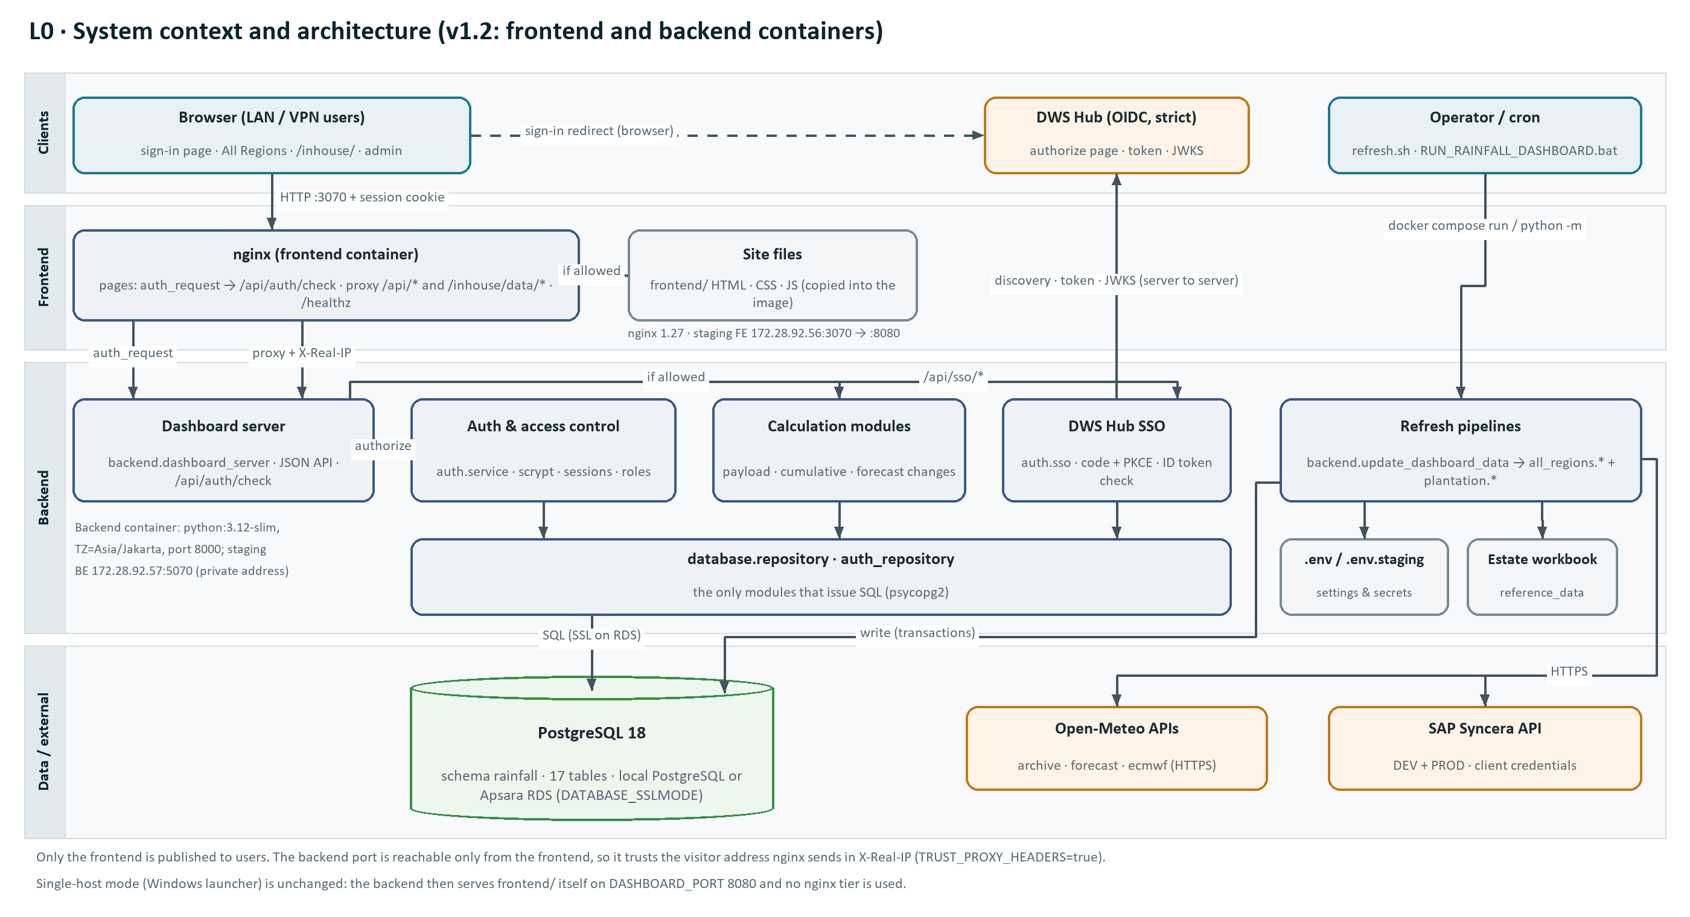
Figure 1: L0 system context and architecture.

2.1 Components
Component | Location | Responsibility
Launcher | RUN_RAINFALL_DASHBOARD.bat → backend/run_dashboard.py | Runs the refresh, restarts the server, opens the browser.
Refresh orchestrator | backend/update_dashboard_data.py | Runs init_db, the All Regions pipeline and the plantation pipeline in order.
All Regions pipeline | backend/all_regions/* | Open-Meteo pulls, forecast archive, payload build.
Plantation pipeline | backend/plantation/* | Syncera pull, estate forecast, cleaning, transactional load.
Calculation modules | dashboard_payload.py, cumulative_rainfall_data.py, forecast_changes.py | Aggregations served by the APIs.
Frontend container | frontend/Dockerfile, frontend/nginx/default.conf.template | nginx: site files, proxy of /api/* and /inhouse/data/*, page check through /api/auth/check, /healthz.
Backend container | backend/Dockerfile | Python 3.12 image running backend.dashboard_server; also runs refreshes and admin commands (docker compose run).
Compose files | docker-compose.yml, deploy/staging/{frontend,backend}/ | Local two-container stack; one compose file per staging server, refresh.sh for cron.
Dashboard server | backend/dashboard_server.py | JSON endpoints (and static files from frontend/ in single-host mode); path normalisation and the access check for every request; /api/auth/check for nginx; SSO endpoints.
Authentication & access | backend/auth/service.py, passwords.py, create_admin.py | Sign-in, sessions, roles, password hashing and policy, user administration.
DWS Hub single sign-on | backend/auth/sso.py | OIDC code + PKCE flow, ID token verification, user matching, linking and provisioning.
Configuration | backend/config.py + .env | Loads and validates settings.
Data access | backend/database/db.py, repository.py, auth_repository.py | Connections, transactions and all SQL (auth_repository holds the access-control SQL).
Schema management | backend/database/schema.sql, init_db.py, bootstrap.py | Idempotent DDL, seeding, one-time role/database creation.
Migration | backend/database/import_legacy_files.py | Imports CSV/JSON files from the file-based version.
Frontend | frontend/*.html, css/, js/, inhouse/, admin/, account/ | 12 All Regions pages, the in-house single-page app, sign-in, User management and Change password.

3. Repository structure
Path | Contents
README.md | Short overview and quick start.
.env.example / .env | Settings template (committed) / live settings and secrets (git-ignored).
requirements.txt | openpyxl, pandas, psycopg2-binary, python-dotenv, PyJWT[crypto].
docker-compose.yml | Local stack: frontend (published 8080) and backend (internal 8000).
deploy/staging/ | frontend/docker-compose.yml; backend/docker-compose.yml, .env.staging.example, refresh.sh.
RUN_RAINFALL_DASHBOARD.bat | Operator shortcut: python -m backend.run_dashboard.
backend/ | Dockerfile, config.py, dashboard_server.py, run_dashboard.py, update_dashboard_data.py.
backend/auth/ | service.py (sign-in, sessions, roles, administration), passwords.py (scrypt, policy), sso.py (DWS Hub OIDC), create_admin.py (CLI).
backend/all_regions/ | rainfall_common, soil_moisture_common, pull_historical_rainfall, pull_historical_soil_moisture, update_rainfall_forecast, update_soil_moisture_forecast, forecast_changes, cumulative_rainfall_data, dashboard_payload, update_all_regions_data.
backend/plantation/ | pull_sap_rainfall (Syncera client), pull_sap_rainfall_all_regions, update_location_forecast, build_dashboard_data, update_all_rainfall_dashboard.
backend/database/ | schema.sql, db.py, repository.py, auth_repository.py, init_db.py, bootstrap.py, import_legacy_files.py.
backend/reference_data/ | koordinat_estate_update.xlsx.
frontend/ | Dockerfile, nginx/default.conf.template, *.html (including login.html), css/*.css, js/*.js, inhouse/{index.html, css/, js/app.js}, admin/users.html, account/password.html.
tests/ | pytest suite: auth, SSO (fake Hub), refresh lock, location forecast, repository, SAP cleaning, SAP rate limit, legacy import; conftest.py starts a throwaway PostgreSQL cluster.
docs/ | DEPLOYMENT_STAGING.md, OPERATIONS_GUIDE.md, README_REVIEW.md, PRD and TD (.docx), diagrams/.
data/work/ | Runtime staging only (git-ignored).
All Python modules are run as packages from the repository root (python -m backend.<module>), so imports are absolute (from backend.… import …).

4. Detailed design (L1)

4.1 L1.1 All Regions pipeline
Entry point python -m backend.all_regions.update_all_regions_data. Each step runs as a separate process and commits its own transaction.
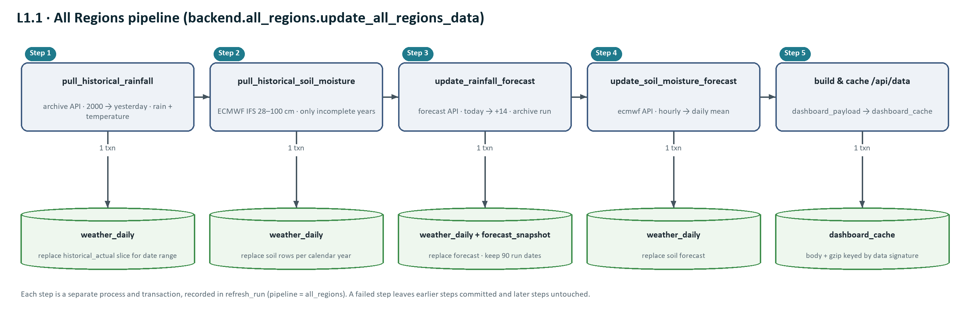
Figure 2: L1.1 All Regions pipeline, steps and the tables each step writes.

Step | Module | External call | Database effect
1 | pull_historical_rainfall | archive API, 18 locations in one request: daily precipitation_sum and temperature_2m_mean, 2000-01-01 → yesterday, timezone auto. | DELETE + INSERT weather_daily for both metrics, historical_actual, in the date range.
2 | pull_historical_soil_moisture | archive API, hourly soil_moisture_28_to_100cm, model ecmwf_ifs, one request per incomplete calendar year (1.5 s pause). | Per year: DELETE + INSERT soil_moisture_m3_m3 historical_actual; daily value = mean of hourly values by local day.
3 | update_rainfall_forecast | forecast API, today → today + 14, rain and temperature. | Replace forecast rows for both metrics; save forecast_snapshot run (only_if_missing seed of the previous forecast first); prune to the newest 90 run dates.
4 | update_soil_moisture_forecast | ecmwf API, hourly soil moisture today → today + 14. | Replace soil_moisture_m3_m3 forecast rows.
5 | dashboard_payload.build_payload | — | Read all weather_daily; write dashboard_cache.

Retry policy (fetch_json)
Up to 4 attempts. HTTP 429: wait 10 s × attempt. HTTP 5xx, network errors, timeouts (90 s) and invalid JSON: wait 1, 2, 4 s. Other 4xx: fail immediately. Responses must contain exactly one item per requested location and equal-length date/value arrays.

4.2 L1.2 In-house plantation pipeline
Entry point python -m backend.plantation.update_all_rainfall_dashboard. Steps 1–3 write only to a temporary folder in WORK_DIR; step 4 is the only database write.
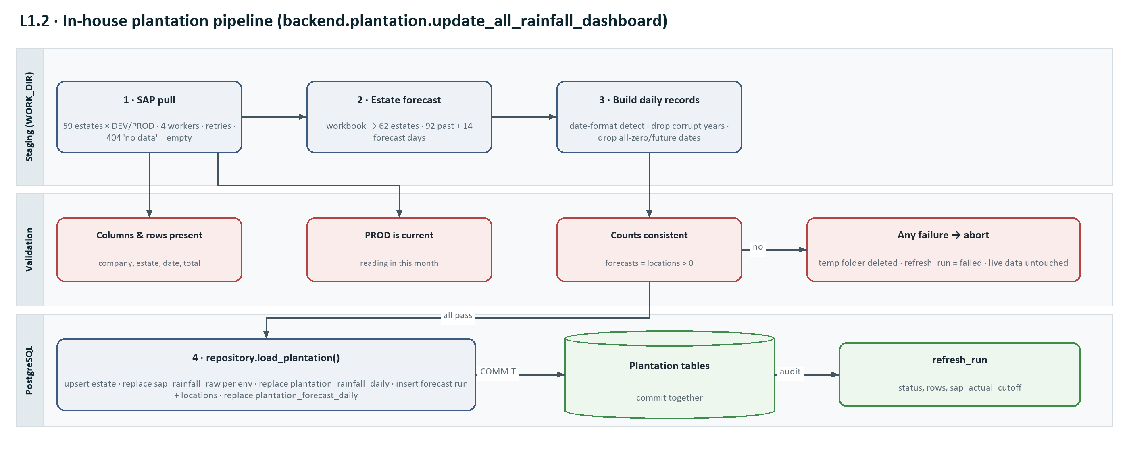
Figure 3: L1.2 plantation pipeline with staging, validation and a single load transaction.

Step | Module | Detail
0 | validate_setup | Syncera settings for dev and prod, SAP_ESTATES parse, workbook exists. Failure → exit code 2. --check stops here.
1 | pull_sap_rainfall_all_regions | Per environment: POST {base}/auth with clientId/clientSecret → accessToken; GET {base}/rain-data?company_code=&estate= for each pair in a 4-worker pool, 8 retries (Retry-After honoured, max 60 s). 404 "No data found" → empty. Rows flattened and headers translated; one CSV per environment.
V1 | validate_csv | Columns company_code, estate, posting_date, total_rainfall_measurement present; at least one row.
V2 | latest_actual_date | Latest PROD date with rainfall > 0 and ≤ today must be ≥ first day of the current month.
2 | update_location_forecast | Read workbook (Region, Estate, Nama Kebun, CentroidX, CentroidY); map estate → province; one forecast API call for all estates: precipitation_sum, past_days 92, forecast_days 14. Split at today into actual_* and forecast_* arrays.
3 | build_dashboard_data | Detect date order per file (a component > 12 decides; mixed → error); skip years < 2000 or > next year; drop duplicate rows; keep only dates ≤ today on which any estate has rainfall > 0; record the cutoff.
V3 | validate_json | records, locations and forecasts non-empty; forecasts = locations.
4 | repository.load_plantation | One transaction: upsert estate and deactivate missing ones; replace sap_rainfall_raw per environment; replace plantation_rainfall_daily; insert plantation_forecast_run and locations; replace plantation_forecast_daily. refresh_run(load) records rows and sap_actual_cutoff.

4.3 L1.3 Request handling
backend.dashboard_server uses ThreadingHTTPServer (one thread per request, 30 s socket timeout) with a handler rooted at frontend/. authorize() runs before any routing (section 4.5). In the container deployment nginx sits in front (below).
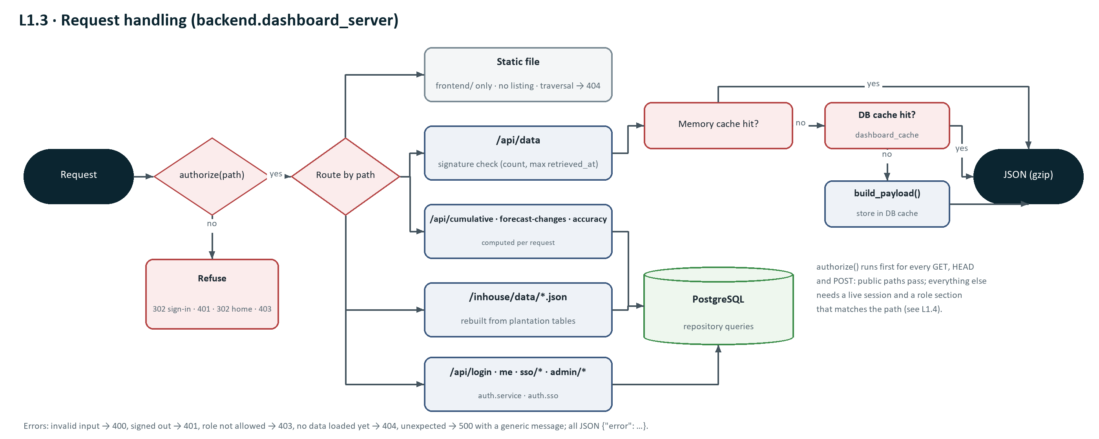
Figure 4: L1.3 request routing and the /api/data cache path.

Frontend proxy (nginx container)
In the container deployment users reach nginx (frontend/nginx/default.conf.template, image nginx:1.27-alpine), not the Python server. nginx serves the site files that frontend/Dockerfile copied into the image and forwards data calls to BACKEND_URL. Access rules stay in one place: before serving any page nginx asks the backend, using the same page_redirect() rules the backend applies itself.
nginx location | Behaviour
= /healthz | Returns 200 "ok" without calling the backend (Docker HEALTHCHECK, load balancers).
/api/ and /inhouse/data/ | proxy_pass to BACKEND_URL with Host, X-Real-IP, X-Forwarded-For and X-Forwarded-Proto; 120 s read timeout. The backend authorises these itself (401 / 403 JSON).
= /_auth (internal) | Sub-request to BACKEND_URL/api/auth/check without the body, with X-Original-URI = the requested URI and the browser's cookie.
/ (all pages) | auth_request /_auth. 2xx → try_files from the site folder (index dashboard.html). 401 or 403 → @auth_redirect.
@auth_redirect | 302 to the X-Auth-Redirect value the backend returned, with Cache-Control: no-store.
= /admin, = /admin/ | 302 /admin/users.html.
- Server settings: server_tokens off, client_max_body_size 64k, gzip for CSS/JS/JSON/SVG, absolute_redirect off (relative Location headers keep the host and port the browser used), and X-Content-Type-Options, X-Frame-Options: DENY and Referrer-Policy: same-origin on every response.
- The image contains only *.html, css/, js/, inhouse/, admin/ and account/ — never the Dockerfile or the nginx folder. The backend also refuses /nginx/* and /dockerfile when it serves frontend/ itself.
- Client address: behind nginx every request comes from the proxy. With TRUST_PROXY_HEADERS=true the backend uses X-Real-IP (first 64 characters) for auth_audit, app_session and the per-IP sign-in throttle; otherwise it uses the socket address. Enable it only when the backend port is reachable from the frontend alone.
- Single-host mode is unchanged: python -m backend.dashboard_server serves frontend/ and the API on DASHBOARD_PORT, and authorize() redirects pages itself.

API specification
Every endpoint below except /api/health needs a signed-in user whose role grants the endpoint's section (section 4.5): HTTP 401 when signed out, 403 when the role does not allow it. Authentication and administration endpoints are listed in section 4.5, DWS Hub and page-check endpoints in section 4.6.
Endpoint | Parameters (default) | Response | Caching | Errors
GET /api/data | — | All Regions payload: generated, lastActual, rain/soil/temperature LastActual, forecastEnd, regions, daily, rainDaily, soilDaily, temperatureDaily, monthly, weekly, seasonality, soil metadata. | Memory → dashboard_cache → rebuild; gzip when accepted | 500
GET /api/cumulative-rainfall | region (Country|Region or "Overall <Country>"), startMonth 1–12 (7), from (2015), to (last year) | Weekly points: day, week, date, average, min, max, minYears, maxYears, actual, forecast; historicalPeriods; actualThrough; forecastThrough. | None (computed) | 400 invalid input, 500
GET /api/forecast-changes | — | latestRun, previousRun, regions[] with daysCompared, latestTotal, previousTotal, delta, percent, daily[]. | None | 500
GET /api/last-week-forecast-accuracy | — | weekStart, weekEnd, forecastRun, errorDefinition, regions[] with actual, forecast, errorPercent, included/excluded/missing regions, daily[]. | None | 500
GET /inhouse/data/rainfall_daily.json | — | generated, sap_actual_cutoff, fields, companies, records [company, estate, plant, tool, date, rainfall_mm]. | None | 404 not loaded, 500
GET /inhouse/data/plantations.json | — | source, locations [id, company, estate, name, region, business_region, latitude, longitude]. | None | 404, 500
GET /inhouse/data/forecast_14day.json | — | source, generated_utc, as_of_date, past/forecast days, forecasts [id, lat/lon, timezone, actual_* and forecast_* arrays]. | None | 404, 500
GET /api/health | — | {"status": "ok", "plantationVersion": "<run id>"} | None | 500 if DB unreachable
GET /<file> | — | Static file from frontend/ ("/" → dashboard.html, or the user's home page without all_regions). Folders are never listed. In the container deployment nginx serves these after /api/auth/check. | no-cache; images 1 h | 404

Response headers
- API and HTML: Cache-Control: no-cache. Images and fonts: public, max-age=3600. All responses: X-Content-Type-Options: nosniff, X-Frame-Options: DENY, Referrer-Policy: same-origin.
- Sign-in and sign-out responses carry Set-Cookie for rainfall_session (section 4.5).
- /api/data: Vary: Accept-Encoding; Content-Encoding: gzip when the client accepts it (8.5 MB → 0.7 MB).

4.4 Calculation logic

/api/data payload (dashboard_payload.build_payload)
- Reads all three metrics. Legacy Malaysian source regions Johor, Pahang and Perak are merged into Pennisular (a direct Pennisular row wins).
- Per metric, forecast rows dated on or before that metric's latest actual date are dropped.
- daily: last 365 days plus forecast, only days with all three metrics. monthly and weekly (ISO) aggregates: rain summed, soil and temperature averaged.
- Country rows "Overall <country>": simple average of major-plantation member regions.
- seasonality: per region and month, current year vs the previous 10 years (avg, min, max).
- regions summary: forecast rain total, average soil and temperature, wet days (≥ 10 mm), max daily rain.

Cumulative rainfall (cumulative_rainfall_data)
- Daily values by region; for "Overall <country>" a day counts only when every basket member has a value (average of members).
- Current period starts in the configured month of the year containing the latest actual; baseline must end before it.
- Historical periods need every day; the current actual line stops at the first gap and continues with forecast values until the next gap.
- Points every 7 days plus the period end and the last actual day; min/max carry the years that produced them.

Forecast changes and last week accuracy (forecast_changes)
- Changes: latest vs previous run date over dates both runs contain; percent = delta ÷ previous total (none if previous total is 0).
- Accuracy: week = last completed Monday–Sunday; forecast run = latest run_date ≤ week start that covers the week; Error % = (forecast − actual) ÷ actual × 100 (none if actual is 0). Country rows use only members with all 7 forecast and actual days.

4.5 L1.4 Authentication and access control
Users sign in with email and password (or with DWS Hub, section 4.6); sessions are kept in PostgreSQL and identified by an HttpOnly cookie. Every request is checked against the sections of the user role on the normalised path.
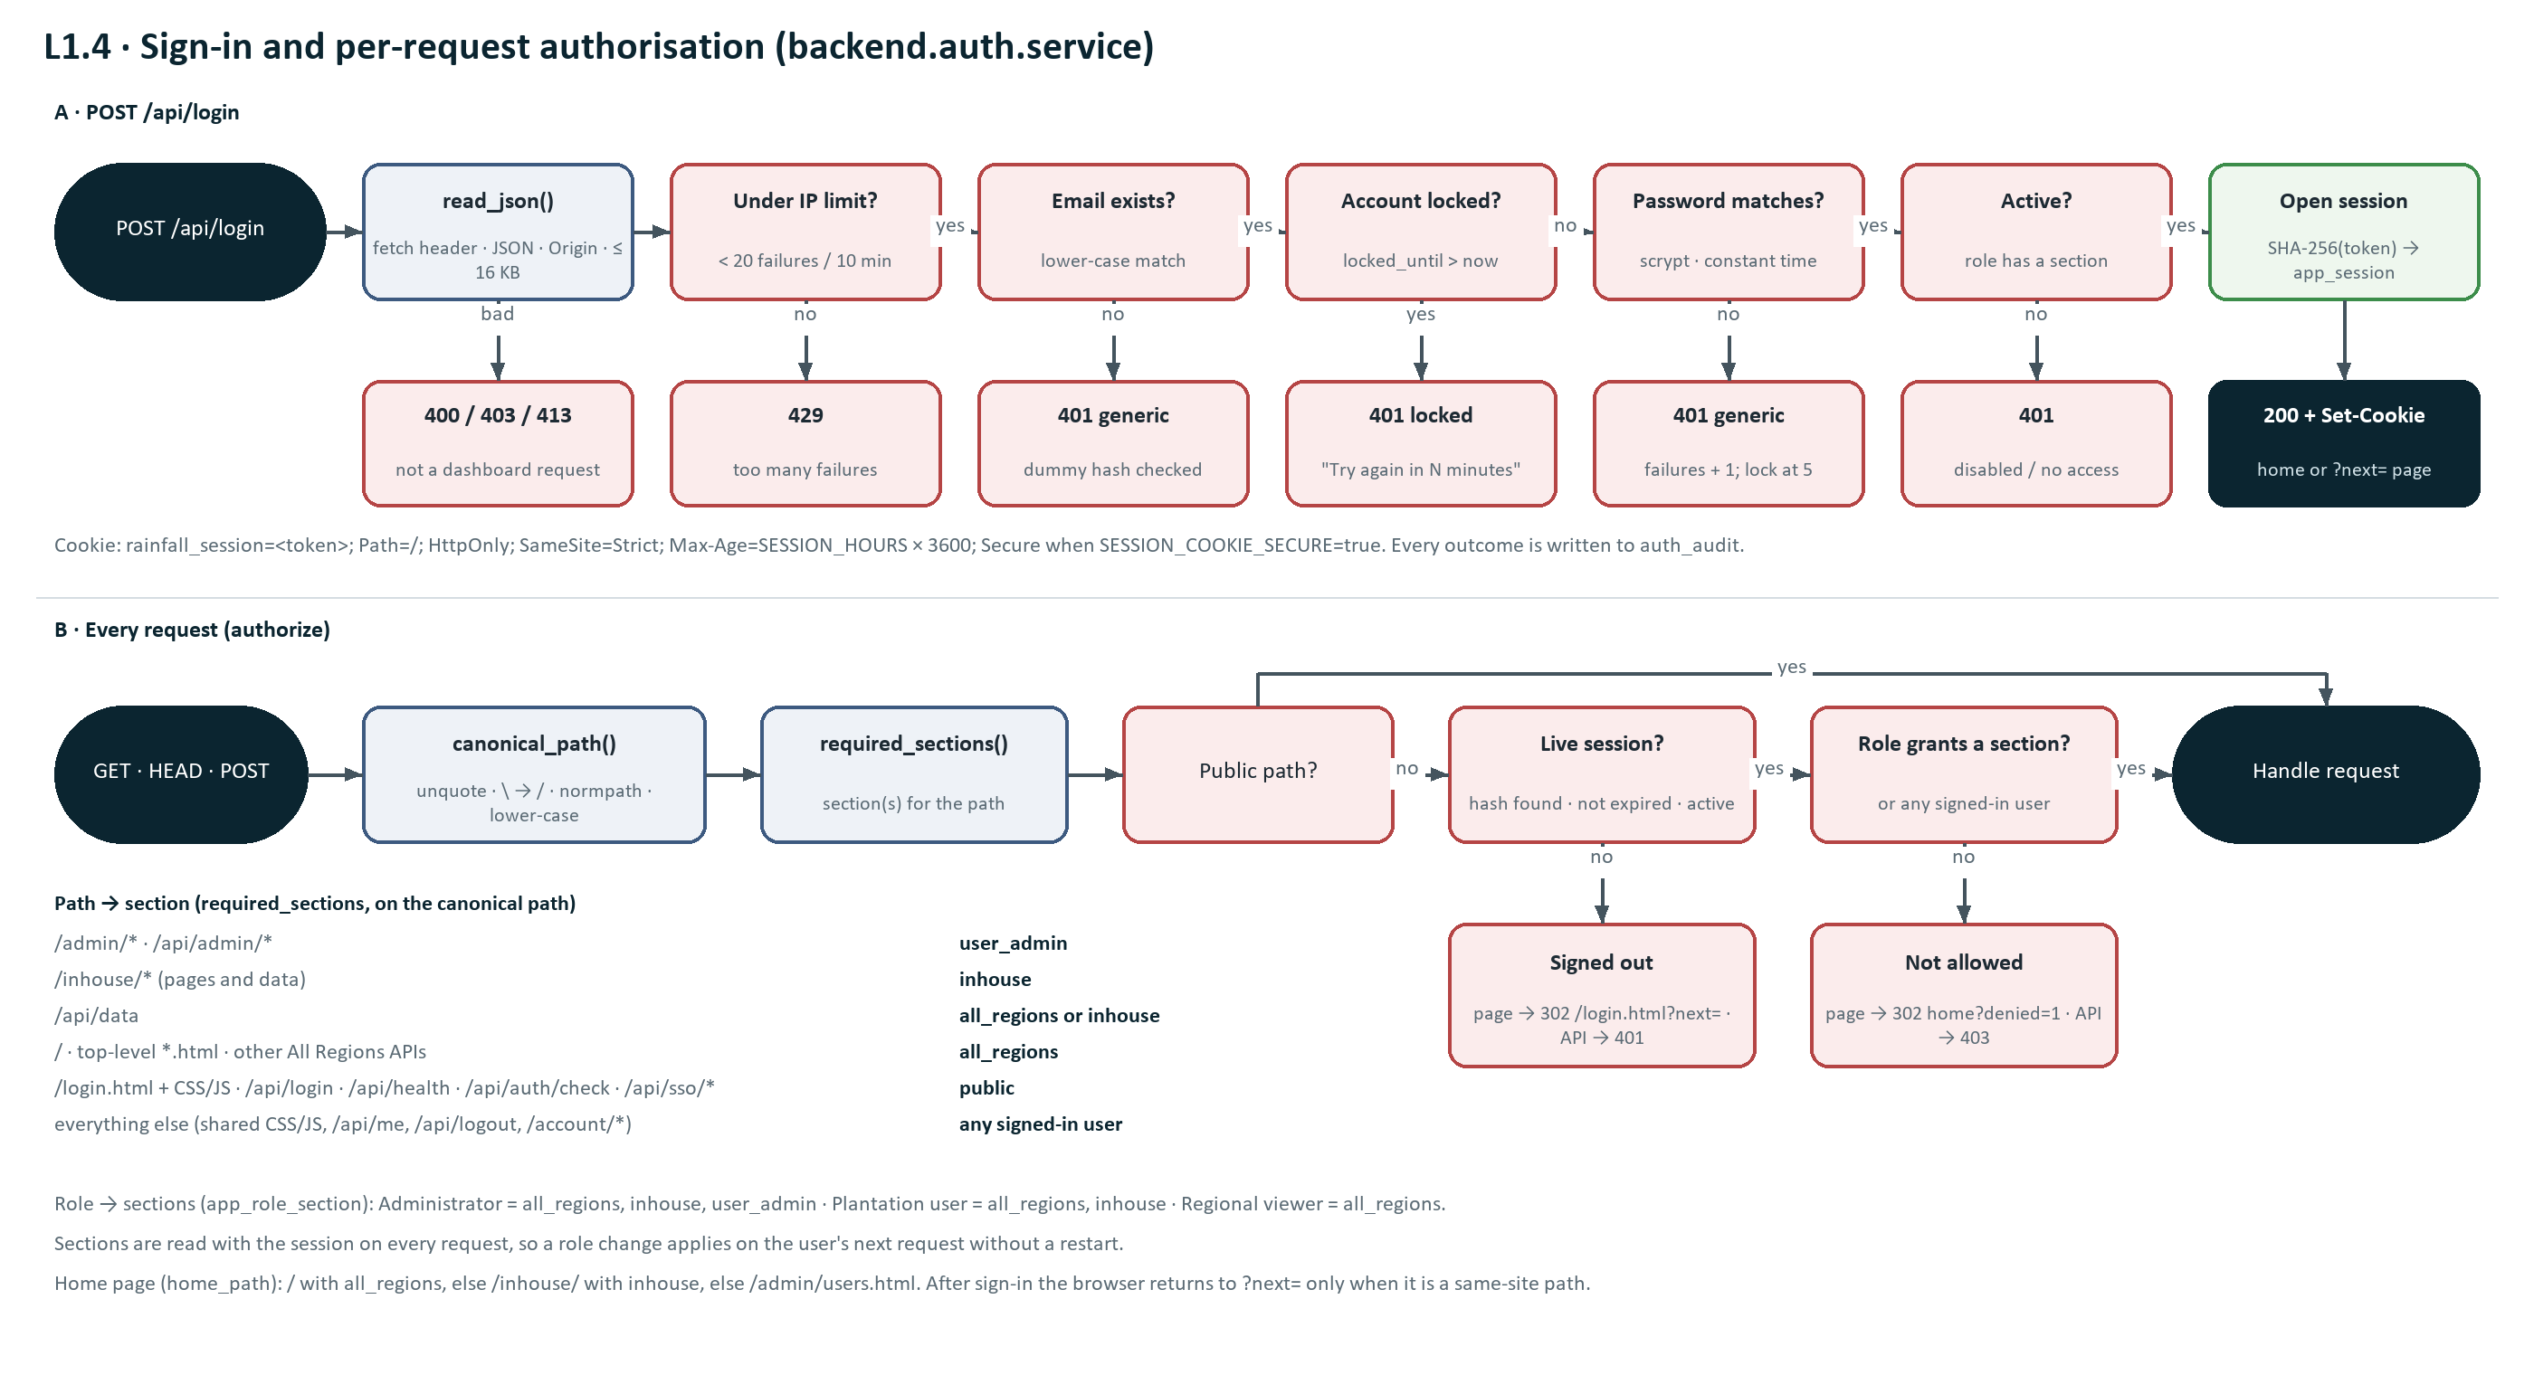
Figure 5: L1.4 sign-in checks and the per-request authorisation path.

Components
Module | Responsibility
backend/auth/service.py | Sign-in, sessions, role checks (can, home_path) and user administration rules; raises AuthError (400/401, safe to show) or AccessDenied (403).
backend/auth/passwords.py | scrypt hashing and verification, the dummy hash for unknown emails, and the password policy.
backend/auth/create_admin.py | Command-line creation of the first or a recovery administrator (hidden password input).
backend/database/auth_repository.py | All SQL for app_role, app_role_section, app_user, app_session and auth_audit.
backend/dashboard_server.py | canonical_path, required_sections, page_redirect and authorize for every request; /api/auth/check for nginx; read_json checks; the per-IP throttle (client_ip honours X-Real-IP only with TRUST_PROXY_HEADERS); cookie handling; the auth and SSO endpoints.
frontend/login.html, js/login.js | Sign-in form and the Sign in with DWS Hub button (from /api/sso/config); returns to ?next= only for same-site paths (a path starting with one "/", not "//" or "/\", and not /login).
frontend/js/sidebar.js | Builds the sidebar from GET /api/me (only granted sections, name, email, role, Change password, Sign out); sends the browser to sign-in on any HTTP 401.
frontend/admin/users.html, js/admin_users.js | User management page.
frontend/account/password.html | Change own password.

Session and cookie design
- At sign-in the server draws a token with secrets.token_urlsafe(32) (256 bits) and stores only sha256(token) in app_session.token_hash, with expires_at = now + SESSION_HOURS.
- Cookie: rainfall_session=<token>; Path=/; HttpOnly; SameSite=Strict; Max-Age=<SESSION_HOURS × 3600>, plus Secure when SESSION_COOKIE_SECURE=true. JavaScript cannot read it and the browser never sends it on cross-site requests.
- Every request hashes the cookie value (tokens longer than 100 characters are ignored) and looks up a session that has not expired and whose user is active. The same query returns the role's sections, so role changes apply on the next request.
- Sign-out deletes the session and returns the cookie with Max-Age=0. Disabling a user deletes all their sessions; a password reset deletes all of them; a change of one's own password deletes all except the current one.
- Expired sessions are purged whenever a new session is created; ix_app_session_expires supports the purge and ix_app_session_user the per-user deletes.

Password hashing and policy
- hashlib.scrypt from the Python standard library: N = 2^14, r = 8, p = 1, 32-byte key, 16-byte random salt per password. Stored as scrypt$16384$8$1$<salt base64>$<hash base64>, so the cost can be raised later without breaking existing hashes.
- Verification recomputes the hash with the stored parameters and compares with hmac.compare_digest (constant time). A malformed stored value never verifies.
- Unknown emails are verified against a dummy hash generated at start-up, so the response time does not reveal whether an account exists; both cases return "Incorrect email or password."
- Policy (policy_problem), applied to registration, reset and change: PASSWORD_MIN_LENGTH (12) to 128 characters; at least one letter and one digit; must not contain the part of the email before "@" when it is 3 or more characters.
- The administrator page offers Generate, which makes an 18-character random password in the browser with crypto.getRandomValues.

Lockout and per-IP throttle
Control | Rule | Where
Account lockout | Each wrong password increments failed_login_count; at LOGIN_MAX_FAILED_ATTEMPTS (5) locked_until = now + LOGIN_LOCKOUT_MINUTES (15). While locked, even the right password is refused (login_blocked). Success, unlock, reset and change clear it. | auth_repository.record_failed_login (single UPDATE, so concurrent failures count correctly)
Per-IP throttle | Failed sign-ins per client IP are kept in a sliding 10-minute window; at 20 the server answers 429 before checking credentials. A successful sign-in clears that IP's list. | dashboard_server.handle_login (in memory, guarded by a lock; resets on restart)
Equal responses | Unknown email and wrong password give the same 401 message and similar timing. | auth.service.login

Request forgery (CSRF) and response hardening
- SameSite=Strict: the session cookie is not sent with requests started from another site.
- read_json accepts a POST only with X-Requested-With: fetch and Content-Type: application/json (otherwise 400). Another site cannot add that header without a CORS preflight, which this server never approves.
- If an Origin header is present, its host must equal the Host header (otherwise 403 "Cross-site request refused."). Bodies over 16 KB return 413; invalid JSON or a non-object body returns 400.
- All responses: X-Content-Type-Options: nosniff, X-Frame-Options: DENY (no framing, so no click-jacking), Referrer-Policy: same-origin.
- Directory listing is disabled (404). Unexpected errors return a generic message ("The request could not be completed."); the exception is written only to the server log.

Path normalisation
Access is decided on canonical_path(path): URL-decode, turn backslashes into slashes, posixpath.normpath, keep a trailing slash, then lower-case (Windows file names ignore case). Examples:
Request path | Canonical path | Section required
/ADMIN/users.html | /admin/users.html | user_admin
/%61dmin/users.html | /admin/users.html | user_admin
/js/../admin/users.html | /admin/users.html | user_admin
/inhouse\data\plantations.json | /inhouse/data/plantations.json | inhouse
/Cumulative-Rainfall.html | /cumulative-rainfall.html | all_regions
/css/login.css | /css/login.css | public

Role-to-section mapping
Section | Paths (canonical) | Administrator | Plantation user | Regional viewer
all_regions | / · top-level *.html · /api/cumulative-rainfall · /api/forecast-changes · /api/last-week-forecast-accuracy · /api/data | Yes | Yes | Yes
inhouse | /inhouse and /inhouse/* (pages and /inhouse/data/*.json) · /api/data | Yes | Yes | No
user_admin | /admin, /admin/* · /api/admin/* | Yes | No | No
(any signed-in) | shared CSS/JS · /api/me · /api/logout · /api/me/password · /account/* | Yes | Yes | Yes
(public) | /login.html · /css/login.css · /js/login.js · /api/login · /api/health · /api/auth/check · /api/sso/config · /api/sso/login · /api/sso/callback | — | — | —
/api/data needs all_regions OR inhouse because the in-house Plantation Rainfall Seasonality page compares with the All Regions series. A refused page redirects to home_path(user) with ?denied=1; a refused API path (/api/* or /inhouse/data/*) returns 403. "/" for a user without all_regions redirects to their home page.

User administration rules
- Only users whose role grants user_admin pass the route check, and auth.service checks again (AccessDenied → 403) so the rule holds even if called from elsewhere.
- Email: trimmed, lower-cased, valid format, at most 200 characters, unique ignoring case. Full name: whitespace collapsed, 2–100 characters. Role must exist.
- An administrator cannot disable their own account or move themselves to a role without user_admin; a change that would leave no active administrator is refused.
- user_updated audits the changed fields; unlock and reset are separate events. Passwords never appear in audit details or logs.

Authentication and administration API
All bodies are JSON. POST requests must pass the read_json checks above. "Any" means any signed-in user.
Endpoint | Access | Request | Response | Errors
POST /api/login | Public | {email, password} | 200 {ok, home, user} + Set-Cookie | 400 / 403 / 413 request checks, 403 "Sign in with DWS Hub." when LOCAL_LOGIN_ENABLED=false, 401 wrong credentials / locked / disabled / no section, 429 throttled, 500
POST /api/logout | Any | {} | 200 {ok}; cookie cleared (Max-Age=0) | 401
GET /api/me | Any | — | userId, email, fullName, role, roleName, sections[], isActive, isLocked, ssoLinked, lastLoginAt, createdAt, home | 401
POST /api/me/password | Any | {currentPassword, newPassword} | 200 {ok}; other sessions of the user deleted | 400 wrong current password / policy, 401
GET /api/admin/users | user_admin | — | users[] (as /api/me without home), roles[] {role_code, role_name, description, sections}, passwordMinLength, ssoEnabled | 401, 403
POST /api/admin/users | user_admin | {email, fullName, role, password} (password may be empty when SSO is enabled → Hub-only account) | 200 new user | 400 validation, 401, 403
POST /api/admin/users/{id} | user_admin | any of {fullName, email, role, isActive, unlock} | 200 updated user | 400 validation / safeguards, 401, 403, 404
POST /api/admin/users/{id}/password | user_admin | {password} | 200 {ok}; the user's sessions deleted, lockout cleared | 400 policy, 401, 403, 404
GET /api/admin/audit | user_admin | — | events[] (latest 50): occurred_at, action, actor, target, email, ip_address, detail | 401, 403

4.6 L1.5 DWS Hub single sign-on
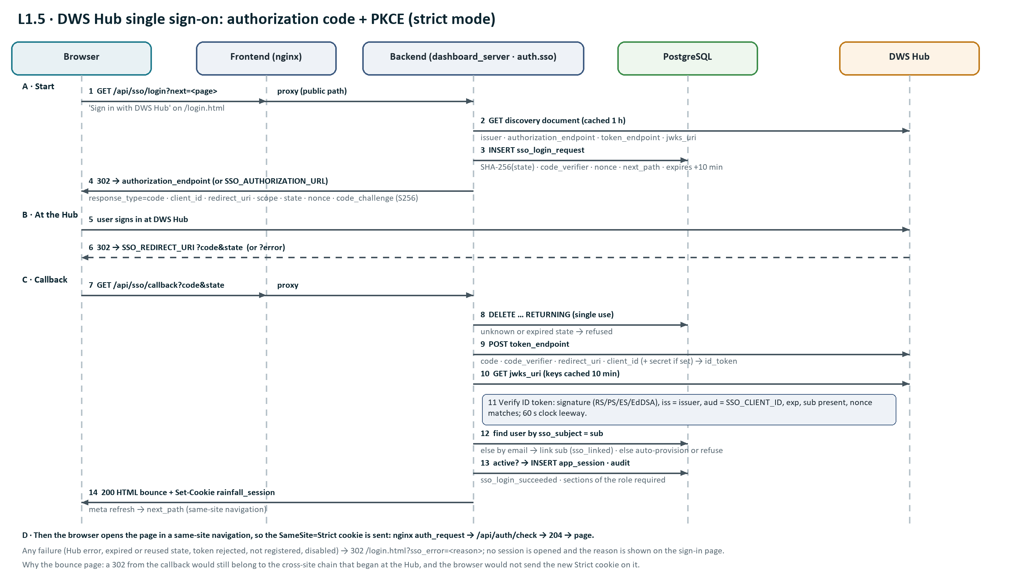
Figure 6: L1.5 DWS Hub sign-in (OIDC authorization code + PKCE) across browser, nginx, backend, database and Hub.

When SSO_ENABLED=true the sign-in page offers Sign in with DWS Hub. The backend acts as an OIDC relying party in the Hub's strict mode: authorization code flow with PKCE (S256), state and nonce, server-to-server code exchange and ID token verification against the Hub JWKS. The Hub proves identity; the dashboard account (role, active flag) still decides access.

Components
Module | Responsibility
backend/auth/sso.py | discovery() (cached 1 h), start_login(), exchange_code(), verify_id_token() with PyJWT and a PyJWKClient per jwks_uri (keys cached 10 min), _dashboard_user() (match, link or provision), complete_login(); SsoError is an AuthError, so its message is safe to show.
backend/dashboard_server.py | /api/sso/config, handle_sso_login, handle_sso_callback (HTML bounce + cookie), sso_failed (302 /login.html?sso_error=), LOCAL_LOGIN_ENABLED check in handle_login.
backend/database/auth_repository.py | save_sso_request, take_sso_request (DELETE … RETURNING), get_user_by_sso_subject, link_sso_subject.
backend/auth/passwords.py · service.py | NO_PASSWORD ("!sso-only", never verifies) for Hub-only accounts; open_session() shared by password and Hub sign-in; ssoLinked in public_user().
frontend/js/login.js · admin_users.js | Hub button from /api/sso/config and ?sso_error= message; optional password and "DWS Hub" badge on User management.

Authorization request
GET /api/sso/login draws state = token_urlsafe(32), nonce = token_urlsafe(24) and code_verifier = token_urlsafe(64) (86 characters), stores SHA-256(state), the verifier, the nonce and safe_next(next) in sso_login_request for 10 minutes, and redirects to SSO_AUTHORIZATION_URL or the discovery authorization_endpoint with:
Parameter | Value
response_type · client_id · redirect_uri | code · SSO_CLIENT_ID · SSO_REDIRECT_URI
scope | SSO_SCOPES (openid profile email)
state · nonce | the random values above (only their hash / the nonce are stored)
code_challenge · code_challenge_method | base64url(SHA-256(code_verifier)) · S256

Callback, token exchange and ID token checks
- ?error from the Hub → "DWS Hub did not sign you in: <error_description>". Missing code or state → "The DWS Hub sign-in response was incomplete."
- take_sso_request(SHA-256(state)) deletes and returns the pending row; unknown or expired → "This sign-in link has expired or was already used. Please sign in again." A replayed callback therefore always fails.
- POST token_endpoint (JSON) with grant_type authorization_code, code, redirect_uri, client_id, code_verifier and client_secret when set; 15 s timeout. No id_token → "DWS Hub did not return an ID token".
Check | Rule | On failure
Signature | Key from the Hub JWKS by kid; algorithms RS256/384/512, PS256/384/512, ES256/384/512, EdDSA (never none or HS*). | "The sign-in token from DWS Hub was rejected: …"
Issuer · audience | iss = discovery issuer; aud = SSO_CLIENT_ID. | as above
Lifetime | exp required; 60 s leeway for clock skew. | as above
Subject | sub required and not blank. | "… has no user id (sub)."
Nonce | Must equal the nonce stored for this state. | "… does not belong to this sign-in (nonce)."
Keys unavailable | JWKS cannot be fetched or has no matching key. | "DWS Hub signing keys could not be used: …"

User matching, linking and provisioning
- 1. app_user.sso_subject = sub → that user (email changes in the Hub do not matter).
- 2. Otherwise the lower-cased email claim matches a registered account → link_sso_subject and audit sso_linked {sub}. If that account is already linked to another sub → "This email is already linked to a different DWS Hub account."
- 3. Otherwise SSO_AUTO_PROVISION_ROLE set and an email present → create the user (name from the name claim, at most 100 characters; password_hash = NO_PASSWORD; created_by null), link the sub, audit user_created {role, via: "sso auto-provision"}.
- 4. Otherwise audit login_failed {reason: "sso user not registered", sub} and refuse with "<email> has no access to this dashboard yet. Ask an administrator to register you."
- Then: inactive → login_failed {reason: inactive, via: sso} and "This account is disabled."; a role without sections is refused by open_session(). Success creates the app_session row and cookie exactly like a password sign-in and audits sso_login_succeeded {sub}. The password lockout does not block a Hub sign-in (it guards password guessing only), and a successful Hub sign-in clears failed_login_count and locked_until like any successful sign-in.

Why the callback answers with an HTML page
The callback request belongs to a navigation that started on the Hub, so the browser treats it as cross-site and would not send the new SameSite=Strict cookie on a following 302. The callback therefore returns 200 with Set-Cookie and a small page whose meta refresh (and link) opens next_path. That navigation starts on the dashboard, the cookie is sent, and nginx's auth_request lets the page through.

Hub registration (strict mode)
Hub field | Staging value
sso_mode | oidc
oauth_client_id | plantation-rainfall-staging (= SSO_CLIENT_ID)
oidc_redirect_uris | http://172.28.92.56:3070/api/sso/callback (exact, = SSO_REDIRECT_URI)
App / launch URL | http://172.28.92.56:3070/api/sso/login
Discovery (backend side) | http://172.28.92.57:4000/api/sso/.well-known/openid-configuration

DWS Hub and page-check API
All are public paths (they are used before a session exists). They are GET requests, so the JSON POST checks do not apply; the callback is protected by the single-use state, PKCE and the ID token checks instead.
Endpoint | Access | Request | Response | Errors
GET /api/auth/check | Public (called by nginx) | Header X-Original-URI (page path); session cookie | 204 page allowed; 401 signed out or 403 role not allowed, each with X-Auth-Redirect (/login.html?next=… or home?denied=1) | 400 without X-Original-URI
GET /api/sso/config | Public | — | {ssoEnabled, ssoLabel, localLoginEnabled} | —
GET /api/sso/login | Public | ?next=<same-site path> | 302 to the Hub authorize URL; failures 302 /login.html?sso_error= | 404 when SSO is off
GET /api/sso/callback | Public | ?code&state (or ?error&error_description) | 200 HTML bounce page + Set-Cookie rainfall_session (meta refresh to next_path) | 302 /login.html?sso_error=<reason>; 404 when SSO is off

5. Data design
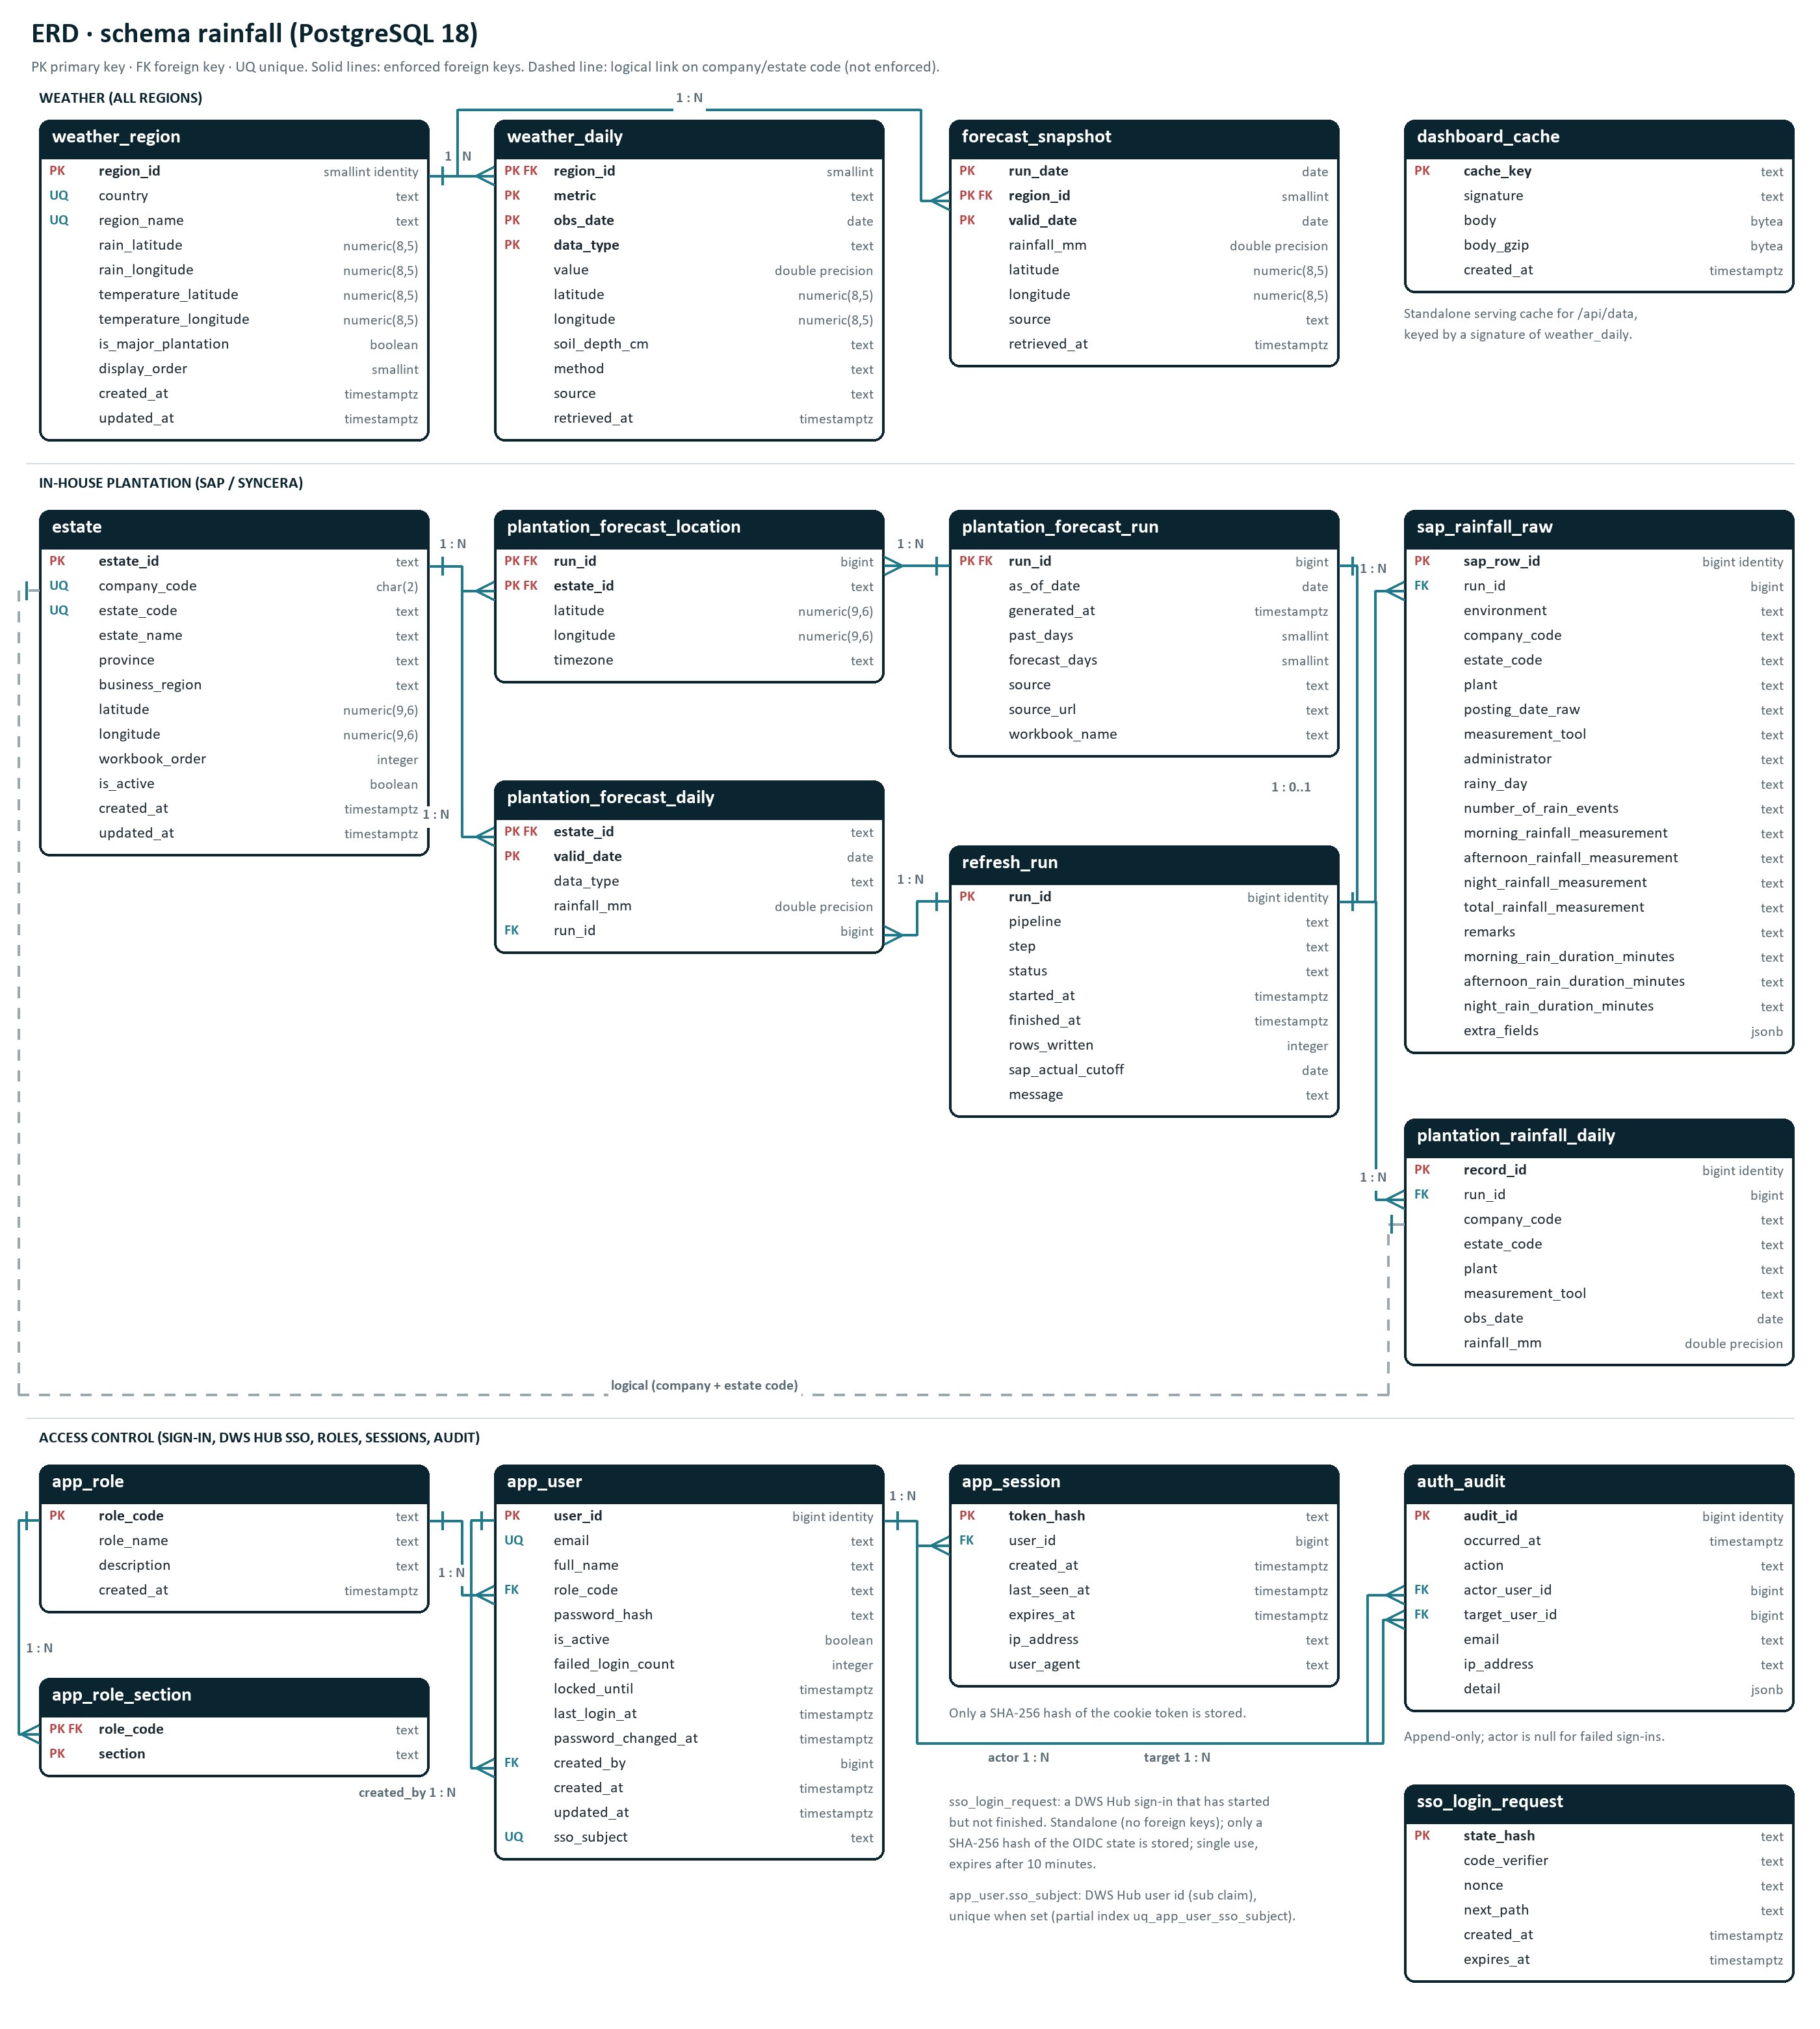
Figure 7: entity relationship diagram of schema rainfall (overview; enlarged views follow).

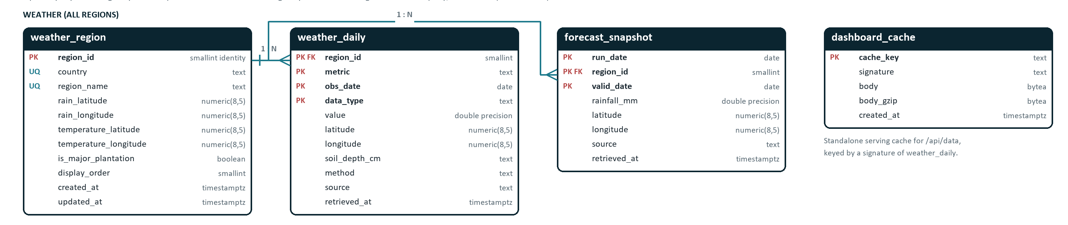
Figure 8: ERD detail: All Regions weather and serving tables.

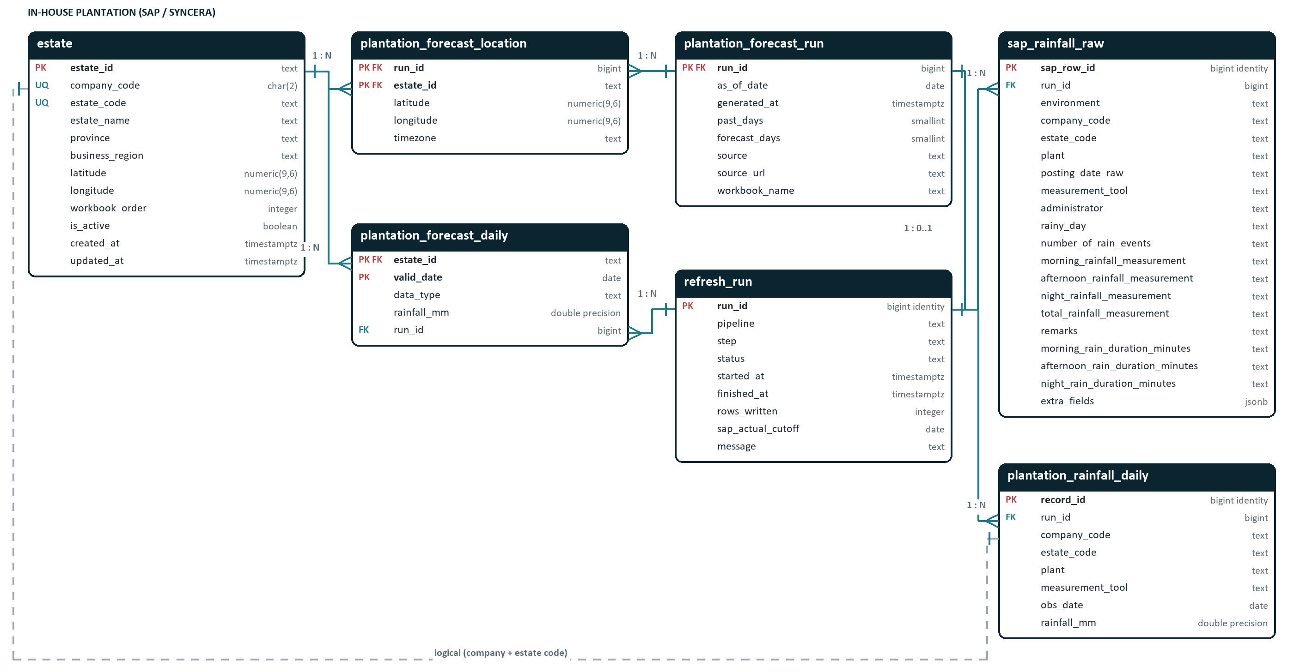
Figure 9: ERD detail: in-house plantation and refresh audit tables.

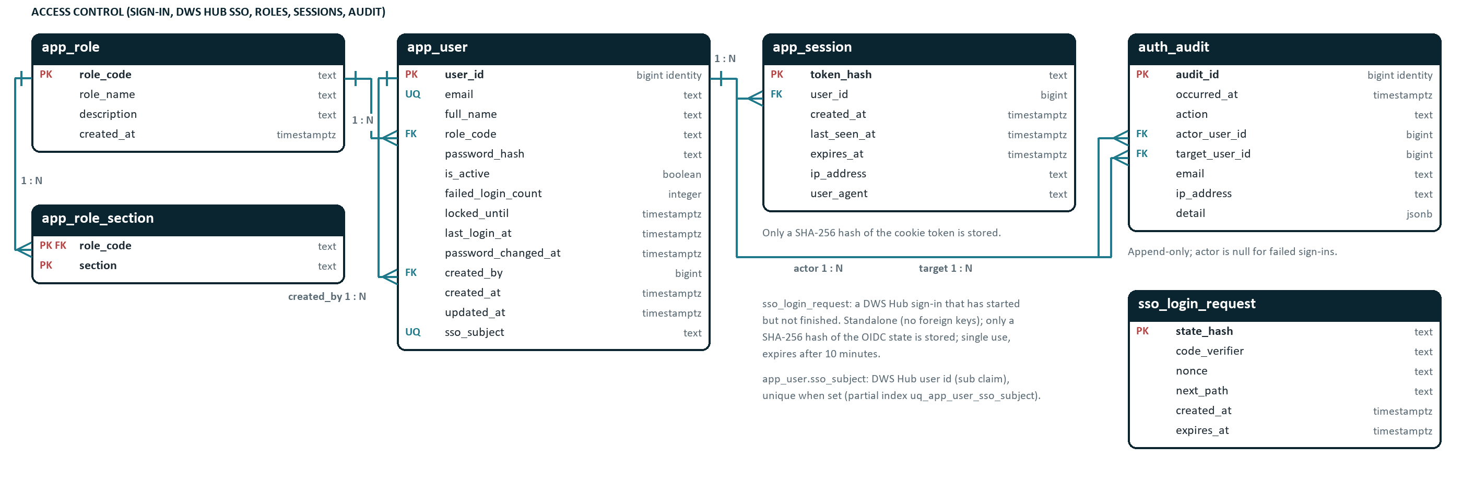
Figure 10: ERD detail: access control (roles, users, DWS Hub link, pending Hub sign-ins, sessions, authentication audit).

5.1 Schema overview
All objects are in schema rainfall of database plantation_rainfall, owned by the application role. schema.sql is idempotent (CREATE … IF NOT EXISTS) and is applied by init_db at the start of every refresh. Generated identity columns are used for surrogate keys. The 17 tables form four groups: All Regions weather, serving cache and refresh audit, in-house plantation, and access control. Version 1.2 added app_user.sso_subject and sso_login_request at the end of schema.sql (ALTER TABLE … ADD COLUMN IF NOT EXISTS and CREATE TABLE IF NOT EXISTS), so existing databases are upgraded by init_db without data loss.
Table | Group | Purpose | Volume
weather_region | All Regions | Reference list of the 18 monitored Open-Meteo regions and their coordinates. | 18 rows
weather_daily | All Regions | Daily rainfall, mean temperature and 28–100 cm soil moisture per region, historical and forecast. | ≈ 417,000 rows today; grows ≈ 26,000 per year
forecast_snapshot | All Regions | Archive of daily rainfall forecast runs for revisions (Forecast changes) and Last week accuracy. | ≤ 90 runs × 270 rows ≈ 24,300 rows
dashboard_cache | Serving | Pre-built /api/data JSON (plain and gzip) shared by all server instances. | 1 row (≈ 8.5 MB body, 0.7 MB gzip)
refresh_run | Audit | One row per refresh step: status, timing, volume and errors. | ≈ 6 rows per daily refresh
estate | In-house | Plantation estates from the coordinate workbook, with province mapping. | 62 rows
sap_rainfall_raw | In-house | Raw SAP/Syncera rain records with English column names, kept for audit and re-processing. | All SAP records for 59 estates (DEV + PROD)
plantation_rainfall_daily | In-house | Cleaned daily SAP rainfall used by the in-house dashboard (rainfall_daily.json). | One row per estate / plant / tool / valid date
plantation_forecast_run | In-house | Metadata of each estate forecast pull. | 1 row per successful load
plantation_forecast_location | In-house | Grid cell and time zone Open-Meteo used for each estate in a run. | 62 rows per run
plantation_forecast_daily | In-house | Open-Meteo daily rainfall at each estate: recent modelled actuals (gap fill) and the forecast. | 62 estates × 106 days ≈ 6,600 rows
app_role | Access control | Named roles that users are assigned to. | 3 rows
app_role_section | Access control | Role-to-section mapping: which dashboard sections each role grants. | 6 rows
app_user | Access control | Dashboard user accounts. The email address is the sign-in identifier; sso_subject links the account to its DWS Hub user. | Tens of rows
app_session | Access control | Server-side sign-in sessions, one per signed-in browser. | One row per signed-in browser
auth_audit | Access control | Append-only record of sign-ins and account changes. | A few rows per user per working day
sso_login_request | Access control | DWS Hub sign-ins that have started but not finished (OIDC state, PKCE verifier and nonce). | A handful of rows; each lives at most 10 minutes

5.2 Relationships
Parent | Child | Cardinality | Enforcement
weather_region.region_id | weather_daily.region_id | 1 : N | Foreign key
weather_region.region_id | forecast_snapshot.region_id | 1 : N | Foreign key
refresh_run.run_id | sap_rainfall_raw.run_id | 1 : N | Foreign key
refresh_run.run_id | plantation_rainfall_daily.run_id | 1 : N | Foreign key
refresh_run.run_id | plantation_forecast_run.run_id | 1 : 0..1 | Foreign key (shared primary key)
refresh_run.run_id | plantation_forecast_daily.run_id | 1 : N | Foreign key
plantation_forecast_run.run_id | plantation_forecast_location.run_id | 1 : N | Foreign key, ON DELETE CASCADE
estate.estate_id | plantation_forecast_location.estate_id | 1 : N | Foreign key
estate.estate_id | plantation_forecast_daily.estate_id | 1 : N | Foreign key
estate (company_code, estate_code) | plantation_rainfall_daily, sap_rainfall_raw | 1 : N | Logical only: SAP may return estates not in the workbook
app_role.role_code | app_role_section.role_code | 1 : N | Foreign key, ON DELETE CASCADE
app_role.role_code | app_user.role_code | 1 : N | Foreign key (a role in use cannot be deleted)
app_user.user_id | app_session.user_id | 1 : N | Foreign key, ON DELETE CASCADE
app_user.user_id | auth_audit.actor_user_id / target_user_id | 1 : N (each) | Foreign keys, nullable
app_user.user_id | app_user.created_by | 1 : N | Self-referencing foreign key, nullable
DWS Hub user (sub claim) | app_user.sso_subject | 1 : 0..1 | Logical (external system); unique partial index uq_app_user_sso_subject
— | sso_login_request | — | Standalone: no foreign keys; rows are deleted when used or expired

5.3 weather_region
Purpose: Reference list of the 18 monitored Open-Meteo regions and their coordinates.
Write pattern: Upserted by init_db on every refresh from REGIONS / TEMPERATURE_REGIONS in rainfall_common.py.
Expected volume: 18 rows
Column | Type | Null | Key / default | Description
region_id | smallint identity | No | PK | Surrogate key, generated.
country | text | No | UQ | Indonesia, Malaysia or Thailand (CHECK).
region_name | text | No | UQ | Region label as shown on the dashboard (e.g. "Pennisular" keeps the source spelling).
rain_latitude | numeric(8,5) | No |  | Latitude queried for rainfall and soil moisture.
rain_longitude | numeric(8,5) | No |  | Longitude queried for rainfall and soil moisture.
temperature_latitude | numeric(8,5) | No |  | Lowland reference latitude used for temperature.
temperature_longitude | numeric(8,5) | No |  | Lowland reference longitude used for temperature.
is_major_plantation | boolean | No | default false | True when the region belongs to its country's "Major Plantation Area" basket.
display_order | smallint | No |  | Order of the region in the source list.
created_at | timestamp with time zone | No | default now() | Row creation time.
updated_at | timestamp with time zone | No | default now() | Last upsert time.

Constraints and indexes
Name | Kind | Definition
ck_weather_region_country | Check | CHECK ((country = ANY (ARRAY['Indonesia'::text, 'Malaysia'::text, 'Thailand'::text])))
uq_weather_region | Unique | UNIQUE (country, region_name)
weather_region_pkey | Primary key | PRIMARY KEY (region_id)

5.4 weather_daily
Purpose: Daily rainfall, mean temperature and 28–100 cm soil moisture per region, historical and forecast.
Write pattern: Slice replaced per step: historical by date range, soil history per calendar year, forecast fully replaced.
Expected volume: ≈ 417,000 rows today; grows ≈ 26,000 per year
Column | Type | Null | Key / default | Description
region_id | smallint | No | PK, FK → weather_region(region_id) | FK to weather_region.
metric | text | No | PK | rainfall_mm, temperature_mean_c or soil_moisture_m3_m3 (CHECK).
obs_date | date | No | PK | Local calendar date of the value.
data_type | text | No | PK | historical_actual (reanalysis) or forecast (CHECK).
value | double precision | No |  | Daily value in the metric's unit (mm, °C, m³/m³). Days with no value are not stored.
latitude | numeric(8,5) | No |  | Coordinate actually queried.
longitude | numeric(8,5) | No |  | Coordinate actually queried.
soil_depth_cm | text | Yes |  | Soil layer, "28-100" for soil moisture; null otherwise.
method | text | Yes |  | Soil aggregation method (hourly values averaged by local day); null otherwise.
source | text | No |  | Open-Meteo API that supplied the value.
retrieved_at | timestamp with time zone | No |  | UTC time of the download.

Constraints and indexes
Name | Kind | Definition
ck_weather_daily_data_type | Check | CHECK ((data_type = ANY (ARRAY['historical_actual'::text, 'forecast'::text])))
ck_weather_daily_metric | Check | CHECK ((metric = ANY (ARRAY['rainfall_mm'::text, 'temperature_mean_c'::text, 'soil_moisture_m3_m3'::text])))
pk_weather_daily | Primary key | PRIMARY KEY (region_id, metric, obs_date, data_type)
weather_daily_region_id_fkey | Foreign key | FOREIGN KEY (region_id) REFERENCES weather_region(region_id)
ix_weather_daily_metric_type_date | Index | ON weather_daily (metric, data_type, obs_date)

5.5 forecast_snapshot
Purpose: Archive of daily rainfall forecast runs for revisions (Forecast changes) and Last week accuracy.
Write pattern: One run date replaced per forecast refresh; only the newest FORECAST_SNAPSHOT_RETENTION_RUNS run dates are kept.
Expected volume: ≤ 90 runs × 270 rows ≈ 24,300 rows
Column | Type | Null | Key / default | Description
run_date | date | No | PK | Local date the forecast was retrieved.
region_id | smallint | No | FK → weather_region(region_id), PK | FK to weather_region.
valid_date | date | No | PK | Date the forecast applies to.
rainfall_mm | double precision | No |  | Forecast daily rainfall (mm).
latitude | numeric(8,5) | No |  | Coordinate queried.
longitude | numeric(8,5) | No |  | Coordinate queried.
source | text | No |  | Open-Meteo API.
retrieved_at | timestamp with time zone | No |  | UTC download time.

Constraints and indexes
Name | Kind | Definition
forecast_snapshot_region_id_fkey | Foreign key | FOREIGN KEY (region_id) REFERENCES weather_region(region_id)
pk_forecast_snapshot | Primary key | PRIMARY KEY (run_date, region_id, valid_date)
ix_forecast_snapshot_valid_date | Index | ON forecast_snapshot (valid_date)

5.6 dashboard_cache
Purpose: Pre-built /api/data JSON (plain and gzip) shared by all server instances.
Write pattern: Written after the All Regions pipeline and whenever a server finds the signature changed.
Expected volume: 1 row (≈ 8.5 MB body, 0.7 MB gzip)
Column | Type | Null | Key / default | Description
cache_key | text | No | PK | Cache entry name ("api_data").
signature | text | No |  | Data version: weather_daily count + max(retrieved_at) + forecast_snapshot count + max(run_date).
body | bytea | No |  | Uncompressed JSON payload.
body_gzip | bytea | No |  | Gzip-compressed payload.
created_at | timestamp with time zone | No | default now() | Time the entry was written.

Constraints and indexes
Name | Kind | Definition
dashboard_cache_pkey | Primary key | PRIMARY KEY (cache_key)

5.7 refresh_run
Purpose: One row per refresh step: status, timing, volume and errors.
Write pattern: Inserted when a step starts (autocommit) and updated on success or failure, independent of the data transaction.
Expected volume: ≈ 6 rows per daily refresh
Column | Type | Null | Key / default | Description
run_id | bigint identity | No | PK | Surrogate key, generated.
pipeline | text | No |  | all_regions or plantation (CHECK).
step | text | No |  | Step name, e.g. historical_rainfall_temperature, load, legacy_import.
status | text | No | default 'running'::text | running, succeeded or failed (CHECK).
started_at | timestamp with time zone | No | default now() | Step start time.
finished_at | timestamp with time zone | Yes |  | Step end time.
rows_written | integer | Yes |  | Rows written by the step.
sap_actual_cutoff | date | Yes |  | Latest valid SAP date (plantation load only).
message | text | Yes |  | Summary or error text (≤ 2,000 characters).

Constraints and indexes
Name | Kind | Definition
ck_refresh_run_pipeline | Check | CHECK ((pipeline = ANY (ARRAY['all_regions'::text, 'plantation'::text])))
ck_refresh_run_status | Check | CHECK ((status = ANY (ARRAY['running'::text, 'succeeded'::text, 'failed'::text])))
refresh_run_pkey | Primary key | PRIMARY KEY (run_id)
ix_refresh_run_pipeline_started | Index | ON refresh_run (pipeline, started_at DESC)

5.8 estate
Purpose: Plantation estates from the coordinate workbook, with province mapping.
Write pattern: Upserted on every plantation load; estates no longer in the workbook are marked is_active = false.
Expected volume: 62 rows
Column | Type | Null | Key / default | Description
estate_id | text | No | PK | Company + estate code, e.g. TH3A.
company_code | character(2) | No | UQ | Two-letter company code.
estate_code | text | No | UQ | Estate code within the company.
estate_name | text | No |  | Estate name (Nama Kebun).
province | text | No |  | Geographic province (PROVINCE_BY_ESTATE mapping).
business_region | text | No |  | Internal operating region from the workbook.
latitude | numeric(9,6) | No |  | Centroid latitude (CHECK −90…90).
longitude | numeric(9,6) | No |  | Centroid longitude (CHECK −180…180).
workbook_order | integer | No |  | Row order in the workbook; drives display order.
is_active | boolean | No | default true | False when removed from the workbook.
created_at | timestamp with time zone | No | default now() | Row creation time.
updated_at | timestamp with time zone | No | default now() | Last upsert time.

Constraints and indexes
Name | Kind | Definition
ck_estate_latitude | Check | CHECK (((latitude >= ('-90'::integer)::numeric) AND (latitude <= (90)::numeric)))
ck_estate_longitude | Check | CHECK (((longitude >= ('-180'::integer)::numeric) AND (longitude <= (180)::numeric)))
estate_pkey | Primary key | PRIMARY KEY (estate_id)
uq_estate_company_estate | Unique | UNIQUE (company_code, estate_code)

5.9 sap_rainfall_raw
Purpose: Raw SAP/Syncera rain records with English column names, kept for audit and re-processing.
Write pattern: Whole environment replaced on each successful plantation load.
Expected volume: All SAP records for 59 estates (DEV + PROD)
Column | Type | Null | Key / default | Description
sap_row_id | bigint identity | No | PK | Surrogate key, generated.
run_id | bigint | No | FK → refresh_run(run_id) | FK to the refresh_run that loaded the row.
environment | text | No |  | dev (historical) or prod (current) (CHECK).
company_code | text | No |  | SAP company_code.
estate_code | text | No |  | SAP estate.
plant | text | Yes |  | SAP plant.
posting_date_raw | text | Yes |  | Posting date exactly as received (DD.MM.YYYY or MM.DD.YYYY).
measurement_tool | text | Yes |  | meas-tools.
administrator | text | Yes |  | admin.
rainy_day | text | Yes |  | rainy-day.
number_of_rain_events | text | Yes |  | jumlah-hujan-dalam-s.
morning_rainfall_measurement | text | Yes |  | hasil-pengukuran-pagi.
afternoon_rainfall_measurement | text | Yes |  | hasil-pengukuran-siang.
night_rainfall_measurement | text | Yes |  | hasil-pengukuran-malam.
total_rainfall_measurement | text | Yes |  | hasil-pengukuran (daily total, decimal comma possible).
remarks | text | Yes |  | keterangan.
morning_rain_duration_minutes | text | Yes |  | lamanya-hujan-dalam-pagi.
afternoon_rain_duration_minutes | text | Yes |  | lamanya-hujan-dalam-siang.
night_rain_duration_minutes | text | Yes |  | lamanya-hujan-dalam-malam.
extra_fields | jsonb | No | default '{}'::jsonb | Any field the API returns that is not mapped above (JSON).

Constraints and indexes
Name | Kind | Definition
ck_sap_rainfall_raw_environment | Check | CHECK ((environment = ANY (ARRAY['dev'::text, 'prod'::text])))
sap_rainfall_raw_pkey | Primary key | PRIMARY KEY (sap_row_id)
sap_rainfall_raw_run_id_fkey | Foreign key | FOREIGN KEY (run_id) REFERENCES refresh_run(run_id)
ix_sap_rainfall_raw_env_estate | Index | ON sap_rainfall_raw (environment, company_code, estate_code)

5.10 plantation_rainfall_daily
Purpose: Cleaned daily SAP rainfall used by the in-house dashboard (rainfall_daily.json).
Write pattern: Fully replaced on each plantation load.
Expected volume: One row per estate / plant / tool / valid date
Column | Type | Null | Key / default | Description
record_id | bigint identity | No | PK | Surrogate key, generated.
run_id | bigint | No | FK → refresh_run(run_id) | FK to the loading refresh_run.
company_code | text | No |  | Company code.
estate_code | text | No |  | Estate code.
plant | text | No | default ''::text | Plant code (empty string if none).
measurement_tool | text | No | default 'Unspecified'::text | Gauge / tool ("Unspecified" if none).
obs_date | date | No |  | Valid posting date (ISO).
rainfall_mm | double precision | No |  | Daily total rainfall as reported by SAP.

Constraints and indexes
Name | Kind | Definition
plantation_rainfall_daily_pkey | Primary key | PRIMARY KEY (record_id)
plantation_rainfall_daily_run_id_fkey | Foreign key | FOREIGN KEY (run_id) REFERENCES refresh_run(run_id)
ix_plantation_rainfall_daily_estate_date | Index | ON plantation_rainfall_daily (company_code, estate_code, obs_date)

5.11 plantation_forecast_run
Purpose: Metadata of each estate forecast pull.
Write pattern: Inserted on each plantation load (history kept).
Expected volume: 1 row per successful load
Column | Type | Null | Key / default | Description
run_id | bigint | No | PK, FK → refresh_run(run_id) | PK and FK to refresh_run.
as_of_date | date | No |  | Local date of the pull; earlier dates are recent actuals, later ones forecast.
generated_at | timestamp with time zone | No |  | UTC time of the pull.
past_days | smallint | No |  | Days of recent modelled actuals requested (92).
forecast_days | smallint | No |  | Forecast days requested (14).
source | text | No |  | API name.
source_url | text | No |  | API documentation URL.
workbook_name | text | No |  | Estate workbook file name used.

Constraints and indexes
Name | Kind | Definition
plantation_forecast_run_pkey | Primary key | PRIMARY KEY (run_id)
plantation_forecast_run_run_id_fkey | Foreign key | FOREIGN KEY (run_id) REFERENCES refresh_run(run_id)

5.12 plantation_forecast_location
Purpose: Grid cell and time zone Open-Meteo used for each estate in a run.
Write pattern: Inserted with each plantation_forecast_run.
Expected volume: 62 rows per run
Column | Type | Null | Key / default | Description
run_id | bigint | No | PK, FK → plantation_forecast_run(run_id) ON DELETE CASCADE | FK to plantation_forecast_run (cascade delete).
estate_id | text | No | PK, FK → estate(estate_id) | FK to estate.
latitude | numeric(9,6) | No |  | Grid-cell latitude returned by Open-Meteo.
longitude | numeric(9,6) | No |  | Grid-cell longitude returned by Open-Meteo.
timezone | text | Yes |  | Time zone returned by Open-Meteo.

Constraints and indexes
Name | Kind | Definition
pk_plantation_forecast_location | Primary key | PRIMARY KEY (run_id, estate_id)
plantation_forecast_location_estate_id_fkey | Foreign key | FOREIGN KEY (estate_id) REFERENCES estate(estate_id)
plantation_forecast_location_run_id_fkey | Foreign key | FOREIGN KEY (run_id) REFERENCES plantation_forecast_run(run_id) ON DELETE CASCADE

5.13 plantation_forecast_daily
Purpose: Open-Meteo daily rainfall at each estate: recent modelled actuals (gap fill) and the forecast.
Write pattern: Fully replaced on each plantation load.
Expected volume: 62 estates × 106 days ≈ 6,600 rows
Column | Type | Null | Key / default | Description
estate_id | text | No | PK, FK → estate(estate_id) | FK to estate.
valid_date | date | No | PK | Date of the value.
data_type | text | No |  | recent_actual (before as_of_date) or forecast (CHECK).
rainfall_mm | double precision | Yes |  | Daily rainfall (mm); null when Open-Meteo has no value.
run_id | bigint | No | FK → refresh_run(run_id) | FK to the loading refresh_run.

Constraints and indexes
Name | Kind | Definition
ck_plantation_forecast_data_type | Check | CHECK ((data_type = ANY (ARRAY['recent_actual'::text, 'forecast'::text])))
pk_plantation_forecast_daily | Primary key | PRIMARY KEY (estate_id, valid_date)
plantation_forecast_daily_estate_id_fkey | Foreign key | FOREIGN KEY (estate_id) REFERENCES estate(estate_id)
plantation_forecast_daily_run_id_fkey | Foreign key | FOREIGN KEY (run_id) REFERENCES refresh_run(run_id)

5.14 app_role
Purpose: Named roles that users are assigned to.
Write pattern: Seeded by schema.sql with admin, plantation and regional using ON CONFLICT DO NOTHING, so later edits in the database are kept.
Expected volume: 3 rows
Column | Type | Null | Key / default | Description
role_code | text | No | PK | Role key: admin, plantation or regional.
role_name | text | No |  | Display name: Administrator, Plantation user, Regional viewer.
description | text | No |  | What the role can open; shown on User management.
created_at | timestamp with time zone | No | default now() | Row creation time.

Constraints and indexes
Name | Kind | Definition
app_role_pkey | Primary key | PRIMARY KEY (role_code)

5.15 app_role_section
Purpose: Role-to-section mapping: which dashboard sections each role grants.
Write pattern: Seeded only for roles that have no sections yet, so sections changed in the database survive schema updates and refreshes.
Expected volume: 6 rows
Column | Type | Null | Key / default | Description
role_code | text | No | FK → app_role(role_code) ON DELETE CASCADE, PK | FK to app_role (ON DELETE CASCADE).
section | text | No | PK | all_regions, inhouse or user_admin (CHECK ck_app_role_section).

Constraints and indexes
Name | Kind | Definition
app_role_section_role_code_fkey | Foreign key | FOREIGN KEY (role_code) REFERENCES app_role(role_code) ON DELETE CASCADE
ck_app_role_section | Check | CHECK ((section = ANY (ARRAY['all_regions'::text, 'inhouse'::text, 'user_admin'::text])))
pk_app_role_section | Primary key | PRIMARY KEY (role_code, section)

5.16 app_user
Purpose: Dashboard user accounts. The email address is the sign-in identifier; sso_subject links the account to its DWS Hub user.
Write pattern: Created by an administrator on User management, by create_admin or by Hub auto-provisioning, and changed only through auth.service and auth.sso. Accounts are disabled, never deleted, so audit references stay valid.
Expected volume: Tens of rows
Column | Type | Null | Key / default | Description
user_id | bigint identity | No | PK | Surrogate key, generated.
email | text | No | UQ (ignoring case) | Sign-in identifier, stored in lower case; unique ignoring case (uq_app_user_email); format and length CHECK.
full_name | text | No |  | Display name, 2–100 characters (validated in auth.service).
role_code | text | No | FK → app_role(role_code) | FK to app_role; exactly one role per user.
password_hash | text | No |  | scrypt$N$r$p$salt$hash with base64 salt and hash, or "!sso-only" for Hub-only accounts (never verifies). The password itself is never stored.
is_active | boolean | No | default true | False = disabled: sign-in refused and all sessions deleted.
failed_login_count | integer | No | default 0 | Wrong passwords in a row; reset by a successful sign-in, unlock or password change/reset.
locked_until | timestamp with time zone | Yes |  | End of the lockout set when failed_login_count reaches LOGIN_MAX_FAILED_ATTEMPTS.
last_login_at | timestamp with time zone | Yes |  | Time of the last successful sign-in.
password_changed_at | timestamp with time zone | No | default now() | Time the password was last set.
created_by | bigint | Yes | FK → app_user(user_id) | FK to the administrator who created the account; null for create_admin.
created_at | timestamp with time zone | No | default now() | Row creation time.
updated_at | timestamp with time zone | No | default now() | Last change by an administrator or a password change.
sso_subject | text | Yes | UQ (when not null) | DWS Hub user id (sub claim), set on the first Hub sign-in (link by email) or at auto-provisioning; unique when set (partial index uq_app_user_sso_subject). Null for accounts that never used the Hub.

Constraints and indexes
Name | Kind | Definition
app_user_created_by_fkey | Foreign key | FOREIGN KEY (created_by) REFERENCES app_user(user_id)
app_user_pkey | Primary key | PRIMARY KEY (user_id)
app_user_role_code_fkey | Foreign key | FOREIGN KEY (role_code) REFERENCES app_role(role_code)
ck_app_user_email | Check | CHECK (((email ~ '^[^@[:space:]]+@[^@[:space:]]+\.[^@[:space:]]+$'::text) AND (length(email) <= 200)))
uq_app_user_email | Unique index | ON app_user (lower(email))
uq_app_user_sso_subject | Unique index | ON app_user (sso_subject) WHERE (sso_subject IS NOT NULL)

5.17 app_session
Purpose: Server-side sign-in sessions, one per signed-in browser.
Write pattern: Inserted at sign-in, when expired rows are also purged; deleted at sign-out, when the user is disabled and when the password is changed or reset. last_seen_at is refreshed at most once a minute.
Expected volume: One row per signed-in browser
Column | Type | Null | Key / default | Description
token_hash | text | No | PK | SHA-256 (hex) of the 256-bit cookie token; the token itself is not stored.
user_id | bigint | No | FK → app_user(user_id) ON DELETE CASCADE | FK to app_user (ON DELETE CASCADE).
created_at | timestamp with time zone | No | default now() | Sign-in time.
last_seen_at | timestamp with time zone | No | default now() | Last request time (one-minute resolution).
expires_at | timestamp with time zone | No |  | created_at + SESSION_HOURS; later requests are refused.
ip_address | text | Yes |  | Client IP address at sign-in.
user_agent | text | Yes |  | Browser user agent at sign-in (first 300 characters).

Constraints and indexes
Name | Kind | Definition
app_session_pkey | Primary key | PRIMARY KEY (token_hash)
app_session_user_id_fkey | Foreign key | FOREIGN KEY (user_id) REFERENCES app_user(user_id) ON DELETE CASCADE
ix_app_session_expires | Index | ON app_session (expires_at)
ix_app_session_user | Index | ON app_session (user_id)

5.18 auth_audit
Purpose: Append-only record of sign-ins and account changes.
Write pattern: Inserted by auth.service for every event; the latest 50 are shown on User management.
Expected volume: A few rows per user per working day
Column | Type | Null | Key / default | Description
audit_id | bigint identity | No | PK | Surrogate key, generated.
occurred_at | timestamp with time zone | No | default now() | Event time.
action | text | No |  | login_succeeded, login_failed, login_blocked, logout, user_created, user_updated, user_unlocked, password_reset, password_changed, and for DWS Hub sso_login_succeeded and sso_linked.
actor_user_id | bigint | Yes | FK → app_user(user_id) | FK to app_user: who did it. Null for failed sign-ins and for create_admin.
target_user_id | bigint | Yes | FK → app_user(user_id) | FK to app_user: the account affected (null when the email is unknown).
email | text | Yes |  | Email as typed for sign-in events, or the new account's email for user_created (first 200 characters).
ip_address | text | Yes |  | Client IP address.
detail | jsonb | No | default '{}'::jsonb | JSON context, e.g. {"reason": "wrong password", "locked": true}, the role of a new user, the changed fields, or the Hub sub and "via": "sso" for Hub events.

Constraints and indexes
Name | Kind | Definition
auth_audit_actor_user_id_fkey | Foreign key | FOREIGN KEY (actor_user_id) REFERENCES app_user(user_id)
auth_audit_pkey | Primary key | PRIMARY KEY (audit_id)
auth_audit_target_user_id_fkey | Foreign key | FOREIGN KEY (target_user_id) REFERENCES app_user(user_id)
ix_auth_audit_occurred | Index | ON auth_audit (occurred_at DESC)

5.19 sso_login_request
Purpose: DWS Hub sign-ins that have started but not finished (OIDC state, PKCE verifier and nonce).
Write pattern: Inserted by /api/sso/login (expired rows are deleted in the same transaction); deleted by /api/sso/callback with DELETE … RETURNING, so each row is used at most once.
Expected volume: A handful of rows; each lives at most 10 minutes
Column | Type | Null | Key / default | Description
state_hash | text | No | PK | SHA-256 (hex) of the random state sent to the Hub; the state itself is not stored.
code_verifier | text | No |  | PKCE code verifier (86 characters); its S256 hash was sent to the Hub as code_challenge.
nonce | text | No |  | Random value sent to the Hub; the ID token must carry the same nonce.
next_path | text | No | default '/'::text | Same-site page to open after sign-in (safe_next: a path starting with one "/", not /login).
created_at | timestamp with time zone | No | default now() | Time the sign-in started.
expires_at | timestamp with time zone | No |  | created_at + 10 minutes; later callbacks are refused.

Constraints and indexes
Name | Kind | Definition
sso_login_request_pkey | Primary key | PRIMARY KEY (state_hash)
ix_sso_login_request_expires | Index | ON sso_login_request (expires_at)

5.20 Data lifecycle and retention
Data | Retention | Mechanism
Weather history | From 2000 (soil from 2017), kept indefinitely | Re-pulled daily by date range
Weather forecast | Latest run only | Replaced each refresh
Forecast run archive | Newest 90 run dates | Pruned in save_snapshot
SAP raw / daily rainfall | Latest successful pull | Replaced in the load transaction
Estate forecast | Latest run (metadata of every run kept) | Replaced in the load transaction
refresh_run | Indefinite | Recommend purging rows older than 2 years
app_user | Indefinite (disabled, never deleted) | Keeps audit references valid
app_session | Until sign-out, expiry (SESSION_HOURS) or disable / password reset | Expired rows purged at each new sign-in
auth_audit | Indefinite | Recommend purging rows older than 2 years (PRD open issue 10)
sso_login_request | Until used or 10 minutes | Deleted by the callback (single use); expired rows deleted whenever a new Hub sign-in starts

5.21 Migration from the file-based version
Legacy file | Target
rainfall_/temperature_/soil_moisture_historical.csv | weather_daily (historical_actual)
rainfall_/temperature_/soil_moisture_forecast.csv | weather_daily (forecast)
rainfall_forecast_snapshots.csv | forecast_snapshot (one save per run_date)
SAP_rainfall/SAP rainfall data historical.csv / current.csv | sap_rainfall_raw (dev / prod)
rainfall-dashboard/dist/data/rainfall_daily.json | plantation_rainfall_daily
rainfall-dashboard/dist/data/plantations.json, forecast_14day.json | estate, plantation_forecast_run, _location, _daily
*_combined.csv, .dashboard_data_cache.* | Not migrated (derived)
sap_credentials.py | SYNCERA_*_CLIENT_SECRET in .env

6. Configuration
backend/config.py loads .env from the repository root with override disabled, so real environment variables win. Required values raise ConfigError naming the key; the placeholder REPLACE_ME counts as missing. Relative paths are resolved from the repository root.
Key | Default | Description
DATABASE_HOST / DATABASE_PORT | localhost / 5432 | PostgreSQL server.
DATABASE_NAME | plantation_rainfall | Application database.
DATABASE_USER / DATABASE_PASSWORD | rainfall_app / (required) | Application role; created by bootstrap.
DATABASE_SSLMODE | prefer | libpq sslmode: disable, prefer, require or verify-full; require for Apsara RDS with SSL on.
DASHBOARD_HOST / DASHBOARD_PORT | 0.0.0.0 / 8080 | Listen address and port.
DASHBOARD_PUBLIC_URL | http://localhost:8080/ | Address opened by the launcher and printed for users.
SYNCERA_{DEV|PROD}_BASE_URL | Syncera v1 URLs | API base URLs.
SYNCERA_{DEV|PROD}_CLIENT_ID | issued IDs | Client IDs.
SYNCERA_{DEV|PROD}_CLIENT_SECRET | (required) | Client secrets; REPLACE_ME is treated as missing.
SYNCERA_{DEV|PROD}_DEFAULT_ESTATE | 3A / 3B | Default estate for the single-pull diagnostic CLI.
SAP_ESTATES | 59 COMPANY:ESTATE pairs | Estates pulled from SAP (deduplicated, order kept).
SAP_WORKERS / SAP_REQUEST_DELAY_SECONDS | 4 / 0 | Parallel SAP requests and optional delay per request.
OPEN_METEO_ARCHIVE_URL / _FORECAST_URL / _ECMWF_URL | Open-Meteo v1 | Weather API endpoints.
HTTP_USER_AGENT | plantation-rainfall-dashboard/2.0 | User-Agent for outbound calls.
HISTORICAL_RAINFALL_START_DATE | 2000-01-01 | Start of rainfall/temperature history.
SOIL_MOISTURE_START_DATE | 2017-01-01 | Start of soil-moisture history (ECMWF IFS limit).
ALL_REGIONS_FORECAST_DAYS | 14 | All Regions forecast runs to today + N.
FORECAST_SNAPSHOT_RETENTION_RUNS | 90 | Archived forecast run dates kept.
PLANTATION_FORECAST_DAYS / PLANTATION_PAST_DAYS | 14 / 92 | Estate forecast horizon and recent-actual window.
ESTATE_WORKBOOK | backend/reference_data/​koordinat_estate_update.xlsx | Estate master workbook.
WORK_DIR | data/work | Temporary staging folder (git-ignored).
SESSION_HOURS | 12 | Session lifetime; also the cookie Max-Age.
SESSION_COOKIE_SECURE | false | Adds the Secure cookie flag; set true when users reach the dashboard over HTTPS.
LOGIN_MAX_FAILED_ATTEMPTS / LOGIN_LOCKOUT_MINUTES | 5 / 15 | Account lockout after this many wrong passwords in a row, for this long.
PASSWORD_MIN_LENGTH | 12 | Minimum password length (maximum is fixed at 128).
TRUST_PROXY_HEADERS | false | Use X-Real-IP from the frontend proxy as the client address (audit, per-IP throttle). True only when the backend is reachable solely through nginx (compose files set it).
LOCAL_LOGIN_ENABLED | true | Email + password sign-in. false → POST /api/login returns 403 and the sign-in page shows only the Hub button.
SSO_ENABLED | false | Turns DWS Hub sign-in on; off → /api/sso/login and /api/sso/callback return 404.
SSO_LABEL | Sign in with DWS Hub | Text of the sign-in button.
SSO_DISCOVERY_URL | (required when enabled) | Hub OpenID discovery document, as reachable from the backend container.
SSO_CLIENT_ID | (required when enabled) | oauth_client_id registered in Hub Admin; the ID token audience must equal it.
SSO_CLIENT_SECRET | (empty) | Only if the Hub registration has a secret; otherwise a public client with PKCE.
SSO_REDIRECT_URI | (required when enabled) | <frontend address>/api/sso/callback; must exactly match oidc_redirect_uris in Hub Admin.
SSO_AUTHORIZATION_URL | (empty) | Browser-facing authorize URL when the discovery document's authorization_endpoint is not reachable from user PCs.
SSO_SCOPES | openid profile email | Scopes requested from the Hub.
SSO_AUTO_PROVISION_ROLE | (empty) | Role (admin, plantation, regional) for Hub users without an account; empty = only registered users.

Container and staging settings
These are set in the Dockerfiles and compose files rather than in .env. The staging backend reads all settings above from deploy/staging/backend/.env.staging.
Key / file | Default | Description
BACKEND_URL (frontend) | http://backend:8000; staging http://172.28.92.57:5070 | Backend address nginx proxies to; filled into default.conf.template at container start.
DASHBOARD_HOST / DASHBOARD_PORT (backend image) | 0.0.0.0 / 8000 | Set in backend/Dockerfile and the compose files (8080 remains the single-host default).
TZ (backend image) | Asia/Jakarta | Local time for run dates and "today" (tzdata installed in the image).
DOCKER_DATABASE_HOST (docker-compose.yml) | host.docker.internal | Database host when PostgreSQL runs on the Docker host.
DASHBOARD_PORT (docker-compose.yml) | 8080 | Host port published for the frontend in the local compose file.
FRONTEND_HOST_PORT / BACKEND_HOST_PORT (staging) | 3070 / 5070 | Host ports in deploy/staging/{frontend,backend}/docker-compose.yml; the backend binds 172.28.92.57 only.
.env.staging (staging backend) | copy of .env.staging.example | All backend settings and secrets on 172.28.92.57 (chmod 600, git-ignored); DATABASE_SSLMODE=require, SSO_ENABLED=true.

7. Security design
Area | Control
Secrets | .env only (git-ignored); .env.example holds placeholders. The bootstrap superuser password and create_admin passwords are read with getpass and never stored.
Authentication | Email and password (LOCAL_LOGIN_ENABLED) or DWS Hub sign-in for every page and API except /login.html, its CSS/JS, POST /api/login, GET /api/health, /api/auth/check and /api/sso/*. Server-side sessions of SESSION_HOURS (12) (sections 4.5, 4.6).
Single sign-on | OIDC authorization code + PKCE (S256); random state (only its SHA-256 stored), nonce and verifier per sign-in, single use, 10 minutes; code exchanged server to server; ID token signature from the Hub JWKS (asymmetric algorithms only), iss, aud = SSO_CLIENT_ID, exp (60 s leeway), sub and nonce checked. Accounts keyed by sub (unique); email used only for the first link; Hub-only accounts store a password value that never verifies.
Passwords | scrypt (N = 2^14, r = 8, p = 1, 16-byte salt), constant-time compare, dummy hash for unknown emails; policy 12–128 characters with letters and digits, not containing the email name.
Sessions | 256-bit random token in an HttpOnly, SameSite=Strict cookie (Secure when SESSION_COOKIE_SECURE=true); only its SHA-256 hash is stored. Sessions end on sign-out, expiry, disable and password reset.
Brute force | Lockout after 5 wrong passwords for 15 minutes; 20 failed sign-ins per IP per 10 minutes → 429; identical messages for unknown email and wrong password.
Authorisation | Role → sections in app_role_section; every request is checked by authorize() on the canonical (decoded, normalised, lower-case) path; refused pages redirect home, refused APIs return 403. Admin rules are checked again in auth.service.
Request forgery | SameSite=Strict cookie; POSTs need X-Requested-With: fetch and JSON content type; Origin must match Host when sent; 16 KB body limit.
Web exposure | Handler directory is frontend/; no directory listing; /.env, /backend/*, /.git/* and ../ traversal are never served (sign-in redirect when signed out, 404 when signed in). Unknown /api/* → 404. The nginx image holds only the site files; /nginx/* and /dockerfile are refused by the backend.
Network and proxy trust | Only the frontend port is published to users; the staging backend port binds 172.28.92.57 and the security group allows it from 172.28.92.56 only. The backend uses X-Real-IP only when TRUST_PROXY_HEADERS=true, which is safe only under that rule.
Containers | No settings or secrets in images (env_file at run time, .env.staging chmod 600); backend runs as uid 10001; nginx server_tokens off and 64 KB body limit; restart unless-stopped; log rotation 10 MB × 5.
Headers | X-Content-Type-Options: nosniff, X-Frame-Options: DENY and Referrer-Policy: same-origin on every response; generic 500 messages.
Database access | Dedicated login role owns only its database and schema; PUBLIC privileges revoked on the database; all SQL parameterised (psycopg2); identifiers in bootstrap quoted with psycopg2.sql. Apsara RDS: whitelist of the backend server and DATABASE_SSLMODE=require.
Accountability | auth_audit records sign-ins, failures, blocks, sign-outs and account changes with actor, account and IP; accounts are disabled, not deleted.
Transport | Open-Meteo and Syncera calls use HTTPS; the database uses SSL on RDS. The dashboard (nginx :3070) and the staging Hub endpoints are plain HTTP on the private network, so passwords, cookies and authorization codes are not encrypted in transit: terminate TLS at nginx, use HTTPS Hub endpoints and set SESSION_COOKIE_SECURE=true before production.

8. Error handling and resilience
Scenario | Behaviour
Open-Meteo transient error | Retries with back-off; then the step fails, refresh_run = failed, earlier steps stay committed.
Syncera auth or estate error | SAP pull exits 1 listing estates in error; plantation refresh aborts before any database write.
Stale PROD data | Abort with "PROD SAP data is stale"; live data unchanged.
Database unavailable | Pipelines fail at connect (10 s timeout); APIs return 500 JSON.
No plantation data yet | /inhouse/data/* return 404 {"error": "... Run the data refresh."}.
Concurrent refreshes | A PostgreSQL advisory lock allows one refresh at a time; a second run stops at once with a message naming the running one (exit code 75).
Database unavailable at sign-in | POST /api/login returns 500 "Sign-in is unavailable. Try again shortly."; the error is logged.
Session expired while a page is open | APIs return 401; sidebar.js sends the browser to /login.html?next=<page>.
Role changed or user disabled | Applies on the user's next request; disabling deletes the user's sessions immediately.
All administrators locked out | Run python -m backend.auth.create_admin on the server (docker compose run --rm backend … on staging) to create a new administrator.
DWS Hub unreachable (discovery, token or JWKS) | Back to /login.html with "DWS Hub could not be reached …" or "DWS Hub sign-in is unavailable. Try again shortly."; details in the server log. Password sign-in still works while LOCAL_LOGIN_ENABLED=true.
Hub callback replayed, too late or forged state | "This sign-in link has expired or was already used. Please sign in again."
ID token rejected | "The sign-in token from DWS Hub was rejected: <reason>" (signature, iss, aud, exp, sub) or the nonce message; no session.
Hub user not registered | "<email> has no access to this dashboard yet. Ask an administrator to register you." unless SSO_AUTO_PROVISION_ROLE is set; audited login_failed.
Backend down or unreachable from nginx | Pages and APIs return 502 from nginx; the frontend container starts only after the backend is healthy in docker-compose.yml.
Backend unhealthy at start (database) | Docker HEALTHCHECK on /api/health fails; check DATABASE_* , the RDS whitelist and DATABASE_SSLMODE (staging guide, troubleshooting).
Server restart | Launcher stops only python.exe processes whose command line contains backend.dashboard_server or dashboard_server.py on the configured port.

9. Deployment and operations

9.1 Installation
- Install Python 3.10+ and PostgreSQL 18; python -m pip install -r requirements.txt.
- Copy .env.example to .env and fill in the secrets and DASHBOARD_PUBLIC_URL.
- python -m backend.database.bootstrap (once; prompts for the superuser).
- Upgrade only: python -m backend.database.import_legacy_files "<old folder>".
- python -m backend.auth.create_admin (once) to create the first administrator; register other users on /admin/users.html.
- python -m backend.plantation.update_all_rainfall_dashboard --check, then RUN_RAINFALL_DASHBOARD.bat.

9.2 Containers (docker compose)
Image | Built from | Contents and runtime
plantation-rainfall-frontend | frontend/Dockerfile (context frontend/) | nginx:1.27-alpine; default.conf.template → /etc/nginx/templates (BACKEND_URL substituted at start); site files only; port 8080; HEALTHCHECK wget /healthz every 30 s.
plantation-rainfall-backend | backend/Dockerfile (context repository root) | python:3.12-slim + tzdata, TZ=Asia/Jakarta; pip install -r requirements.txt; backend/ only; runs as user dashboard (uid 10001); data/work writable; port 8000; HEALTHCHECK GET /api/health; CMD python -m backend.dashboard_server. No settings or secrets in the image.
- docker-compose.yml (local): backend with env_file .env, DATABASE_HOST=${DOCKER_DATABASE_HOST:-host.docker.internal}, TRUST_PROXY_HEADERS=true and only expose 8000; frontend publishes ${DASHBOARD_PORT:-8080}:8080 and starts after the backend is healthy. Both restart unless-stopped.
- Refresh inside Docker: docker compose run --rm backend python -m backend.update_dashboard_data (the advisory lock still allows only one run).

9.3 Staging deployment
The full runbook is docs/DEPLOYMENT_STAGING.md; per-server compose files are in deploy/staging/. Each server runs one new container and nothing existing is changed.
Item | Frontend server |  | Backend server
Address · port | 172.28.92.56 · 3070 → 8080 (users open http://172.28.92.56:3070/) |  | 172.28.92.57 · 5070 → 8000, bound to the private address only
Compose file | deploy/staging/frontend/docker-compose.yml (BACKEND_URL default http://172.28.92.57:5070) |  | deploy/staging/backend/docker-compose.yml (env_file .env.staging, TRUST_PROXY_HEADERS=true)
Container | plantation-rainfall-frontend-staging |  | plantation-rainfall-backend-staging
Logs | json-file, 10 MB × 5 |  | json-file, 10 MB × 5; refresh logs in logs/refresh-*.log, 30 days
Inbound rule | TCP 3070 from office / VPN ranges |  | TCP 5070 from 172.28.92.56/32 only
Dependency |  | Staging setting
Apsara RDS for PostgreSQL |  | pgm-d9jx9o06qae8gf3h.pgsql.ap-southeast-5.rds.aliyuncs.com:5432, database plantation_rainfall, account rainfall_app; whitelist 172.28.92.57; DATABASE_SSLMODE=require (prefer only while RDS SSL is off). Schema created by bootstrap or init_db in the backend container.
DWS Hub |  | API http://172.28.92.57:4000 (discovery, token, JWKS, reached from the backend container); web http://172.28.92.56:3100 (authorize page for browsers, via SSO_AUTHORIZATION_URL if needed).
Forecast archive |  | rainfall_forecast_snapshots.csv imported once with import_legacy_files --only snapshots (cannot be downloaded again).
Daily refresh |  | cron on the backend server: CRON_TZ=Asia/Jakarta, 30 6 * * 1-6 deploy/staging/backend/refresh.sh (docker compose run --rm -T backend python -m backend.update_dashboard_data; logs kept 30 days; non-zero exit on failure).
Break-glass administrator |  | docker compose run --rm backend python -m backend.auth.create_admin, with the same email as the administrator's Hub account so the first Hub sign-in links to it.
Updates and rollback |  | git pull, docker compose up -d --build, then init_db (schema changes are additive and idempotent); rollback = check out the previous commit and rebuild.

9.4 Scheduling
Schedule python -m backend.update_dashboard_data with Windows Task Scheduler on business days (for example 07:00, after SAP posting), and run python -m backend.dashboard_server as a start-up task or service. Manual and scheduled runs can coexist: the refresh lock lets only one run at a time (a second exits with code 75). On staging, cron runs deploy/staging/backend/refresh.sh at 06:30 Asia/Jakarta, Monday to Saturday (section 9.3).

9.5 Backup and recovery
- Nightly: pg_dump -Fc -n rainfall plantation_rainfall > rainfall_YYYYMMDD.dump (keep 14 days).
- The forecast_snapshot archive is the only data that cannot be re-downloaded; everything else can be rebuilt by a refresh.
- Restore: pg_restore -d plantation_rainfall --clean rainfall_YYYYMMDD.dump.
- Staging (Apsara RDS): automated RDS backups kept at least 7 days (console → Backup and Restoration).

9.6 Monitoring queries
Purpose | SQL
Latest status per step | SELECT DISTINCT ON (pipeline, step) pipeline, step, status, finished_at, message FROM rainfall.refresh_run ORDER BY pipeline, step, run_id DESC;
Data freshness | SELECT metric, data_type, max(obs_date) FROM rainfall.weather_daily GROUP BY 1, 2;
Latest SAP cutoff | SELECT max(sap_actual_cutoff) FROM rainfall.refresh_run WHERE status = 'succeeded';
Failures in last 7 days | SELECT * FROM rainfall.refresh_run WHERE status = 'failed' AND started_at > now() - interval '7 days';
Failed sign-ins in last 24 h | SELECT email, ip_address, count(*) FROM rainfall.auth_audit WHERE action IN ('login_failed', 'login_blocked') AND occurred_at > now() - interval '1 day' GROUP BY 1, 2 ORDER BY 3 DESC;
Locked accounts | SELECT email, locked_until FROM rainfall.app_user WHERE locked_until > now();
Signed-in sessions | SELECT u.email, s.created_at, s.last_seen_at, s.ip_address FROM rainfall.app_session s JOIN rainfall.app_user u USING (user_id) WHERE s.expires_at > now();
Hub sign-ins and links in last 7 days | SELECT action, count(*) FROM rainfall.auth_audit WHERE action IN ('sso_login_succeeded', 'sso_linked') AND occurred_at > now() - interval '7 days' GROUP BY 1;
Users not yet linked to DWS Hub | SELECT email, last_login_at FROM rainfall.app_user WHERE is_active AND sso_subject IS NULL ORDER BY email;
Container health (each server) | docker compose ps in deploy/staging/* (Up (healthy)); curl http://172.28.92.56:3070/healthz and /api/health.

10. Verification performed
Rows up to the role-based access tests were recorded on 16 October 2026 against a disposable PostgreSQL 18.0 instance with live Open-Meteo data. The automated suite and the DWS Hub rows were re-run on 20 October 2026.
Test | Result
Schema applied twice (idempotency) | Pass: 18 regions seeded both times.
All Regions pipeline end to end | Pass in 4 min 47 s: 176,130 rain + 176,130 temperature + 64,350 soil historical rows; 270 forecast rows per metric; 1 archived run.
Soil history incremental re-run | Pass: 0 rows refreshed in 0.4 s.
Plantation load (live estate forecast + synthetic SAP fixture) | Pass: 62 estates, 92 + 14 days each; corrupt date and placeholder rows removed; single-transaction load.
Live Syncera pull | Not tested: Syncera secrets not available in the test environment.
All API endpoints and 15 pages | Pass: JSON shapes unchanged from the file-based version; pages render without script errors.
Optimised queries vs previous output | Identical results; last-week accuracy 8.3 s → 0.24 s; cumulative 3.1 s → 1.1 s.
Secret exposure | Pass: /.env, /backend/config.py, /../.env, /.git/config are never served: 404 when signed in, redirect to sign-in when signed out.
Missing secret detection | Pass: setup check exits 2 naming SYNCERA_DEV_CLIENT_SECRET.
Automated test suite (python -m pytest) | Pass: 93 tests passed on 20 October 2026 (2 min 42 s) against a throwaway PostgreSQL 18 cluster, with Open-Meteo and Syncera blocked.
Sign-in and sessions (tests/test_auth.py) | Pass: scrypt round trip and salting; password policy; success creates a session and audit row; same message for unknown email and wrong password; lockout after repeated failures; disabled and expired sessions refused; HttpOnly + SameSite=Strict cookie; sign-out ends the session; per-IP 429 throttle.
Role-based access (tests/test_auth.py) | Pass: anonymous users are sent to sign-in (pages) or get 401 (APIs); a Regional viewer sees only All Regions; a Plantation user cannot reach the admin page by case, URL-encoding or ../ tricks; POSTs need the dashboard headers and same Origin.
User administration (tests/test_auth.py) | Pass: only administrators manage users; validation and duplicate email (any case) refused; no self-disable or self-demotion; at least one administrator kept; password reset ends sessions; own password change keeps the current session only; email change; a registered user can sign in.
DWS Hub sign-in (tests/test_sso.py, 13 tests) | Pass, against a fake strict-mode Hub with real RSA-signed tokens: a registered user is linked by email and gets an HttpOnly, SameSite=Strict session and the bounce page; later found by sub after an email change; state is single use and forged state refused; unregistered users refused unless auto-provisioning; tokens with wrong aud, wrong iss, expired, wrong nonce, no sub or another signing key rejected; Hub refusing the code reported; disabled and Hub-only accounts (no password sign-in); LOCAL_LOGIN_ENABLED=false; SSO endpoints 404 when off.
Container images and staging deployment | Not verified in this document: run the checklist in docs/DEPLOYMENT_STAGING.md section 10 on the servers (both containers healthy, Hub sign-in, real PC address in Recent activity, backend port unreachable from user PCs).

11. Known limitations and recommendations
# | Item | Recommendation
1 | Resolved: refresh lock | pg_try_advisory_lock in update_dashboard_data (exit code 75 when already running).
2 | Resolved: estate forecast retry | update_location_forecast uses fetch_json (retries, 120 s timeout).
3 | Authentication and DWS Hub SSO done; no TLS | Terminate TLS in the nginx frontend, use https SSO_REDIRECT_URI and Hub endpoints, and set SESSION_COOKIE_SECURE=true before production.
4 | Historical rainfall re-downloads 26 years daily | Pull only the last 30 days daily and full history weekly.
5 | SAP DEV used for history; PROD freshness rule blocks early-month refreshes | Business decisions (PRD open issues 1–2).
6 | Estate list mismatch (AM3B, BU9A, IU3A) | Align SAP_ESTATES with the workbook.
7 | Resolved: automated tests | 93 pytest tests (20 October 2026); extend with aggregation tests for dashboard_payload.
8 | frontend/js/searchable_selects.js unused | Remove after confirmation.
9 | Per-IP sign-in throttle is in server memory | Resets on restart and is not shared between instances; move to the database if more than one server runs.
10 | auth_audit grows without limit | Purge rows older than the agreed retention (for example 2 years).
11 | No self-service password reset | Administrators reset passwords; add email reset only with an approved mail service.
12 | Sign-out does not end the DWS Hub session | Add RP-initiated logout (end_session_endpoint) when the Hub supports it.
13 | Change password is shown to Hub-only users | Hide the sidebar link when the account has no password (sidebar.js).
14 | Discovery cached 1 h and keys 10 min in each backend process | After a Hub key rotation the first token with a new kid fetches the JWKS again; restart the backend if the issuer or endpoints change.
15 | Per-IP throttle relies on X-Real-IP behind nginx | Keep the backend port closed to everything except the frontend server; otherwise set TRUST_PROXY_HEADERS=false.
16 | Apsara RDS version not confirmed | Run the pytest suite against the RDS major version before production; PostgreSQL 18 is the tested version.

