PLANTATION RAINFALL DASHBOARD
Product Requirements Document
Plantation weather intelligence: All Regions and In-house Plantation dashboards
Document control
Document | Product Requirements Document (PRD)
Product | Plantation Rainfall Dashboard 2.0 (PostgreSQL 18 edition)
Version / status | 1.1 · Draft for review
Change in 1.1 | Sign-in with email and password, three roles with section-based access, administrator-only User management and change own password (F-19 to F-22, L1.6, NFR-12 to NFR-18).
Date | 16 October 2026
Prepared by | Jerry Pratama Hakim
Repository | dwsitproject-hub/Plantation-Rainfall-Dashboard · branch restructure/production-layout
Related documents | Technical Design (TD) · docs/OPERATIONS_GUIDE.md · docs/README_REVIEW.md

Contents
1. Introduction 4
1.1 Purpose 4
1.2 Background 4
1.3 Problem statement 4
2. Goals, non-goals and success metrics 4
2.1 Goals 4
2.2 Non-goals (this release) 5
2.3 Success metrics 5
3. Users and personas 5
3.1 Roles 6
4. Scope 6
4.1 In scope 6
4.2 Out of scope 6
5. Business process: L0 (high level) 7
6. Business processes: L1 (detail) 9
6.1 L1.1 Daily data refresh 9
6.2 L1.2 All Regions weather monitoring 11
6.3 L1.3 Forecast verification 13
6.4 L1.4 In-house plantation monitoring 15
6.5 L1.5 Platform setup and administration 17
6.6 L1.6 Sign-in, access control and user administration 19
7. Functional requirements and user stories 20
F-01 One-click refresh and launch 21
F-02 All Regions weather data pipeline 22
F-03 In-house plantation (SAP) data pipeline 23
F-04 Weather overview (All Regions) 24
F-05 Weekly and monthly seasonality (rainfall and soil) 25
F-06 Cumulative rainfall (custom 12-month period) 26
F-07 Historical comparison (rainfall) 26
F-08 Last week forecast accuracy 27
F-09 Forecast changes (run-to-run revisions) 28
F-10 July–September rainfall summary 28
F-11 Temperature analytics 29
F-12 In-house weather overview 29
F-13 Plantation rainfall seasonality 30
F-14 In-house cumulative rainfall 30
F-15 Navigation 31
F-16 Configuration and secrets 31
F-17 Database setup and legacy migration 32
F-18 Refresh audit trail, health check and web exposure 33
F-19 Sign-in and session management 34
F-20 Role-based access control 35
F-21 User registration and management (administrators only) 36
F-22 Change own password 38
8. Non-functional requirements 39
9. Business rules and definitions 40
10. Assumptions, dependencies and constraints 41
11. Risks and open issues 41
12. Acceptance and release 42
Appendix A. Page and endpoint inventory 42
A.1 Pages 43
A.2 API endpoints 43

Right-click the table and choose Update Field (or press F9) to refresh page numbers after editing.

1. Introduction

1.1 Purpose
This document defines what the Plantation Rainfall Dashboard must do, for whom, and how each capability is accepted. It covers the business process at two levels (L0 end-to-end and L1 detailed), every functionality with positive and negative user stories, non-functional requirements, business rules and open issues.

1.2 Background
Rainfall drives oil-palm yield, harvesting logistics, fertiliser timing and the commodity outlook. The organisation monitors weather in two ways:
- All Regions: modelled daily rainfall, temperature and soil moisture from Open-Meteo / ECMWF IFS for 18 plantation regions in Indonesia, Malaysia and Thailand, with 15-day forecasts.
- In-house Plantation: rain-gauge readings recorded in SAP and exposed through the Syncera API for 59 company/estate pairs, combined with Open-Meteo forecasts at each estate centroid (62 estates in the master workbook).
Until now the solution ran from CSV/JSON files on one PC, with secrets in a Python file and a web server that exposed the whole folder. Version 2.0 restructures it for production: PostgreSQL 18 as the single system of record, all configuration in .env, and separate backend, frontend and docs folders. Every page now requires sign-in, and each user sees only the dashboards their role allows.

1.3 Problem statement
- Decision makers need one trusted, daily-refreshed view of measured and forecast rainfall across the portfolio and the wider growing regions.
- The previous file-based setup was fragile (partial refreshes, no audit), insecure (secrets downloadable over the LAN) and tied to one machine and IP address.
- Estate rain-gauge data is internal business information, but anyone on the LAN could open every page. Access must be limited to named staff, by role, with a record of who signed in.

2. Goals, non-goals and success metrics

2.1 Goals
- G1: Publish a daily, validated view of rainfall, soil moisture and temperature for all regions and in-house estates.
- G2: Make forecasts actionable with simple screening signals, seasonality context, revisions and accuracy.
- G3: Run reliably in production: transactional loads, an audit trail, externalised configuration, no exposed secrets.
- G4: Show data only to signed-in staff, limit each user to the dashboards their role allows, and let administrators manage accounts without IT changes.

2.2 Non-goals (this release)
- HTTPS and company single sign-on (SSO): the dashboard serves plain HTTP on the LAN; see open issues.
- Self-service registration and password reset by email: administrators create accounts and reset passwords.
- Email or PDF report generation and hosted-site deployment.
- Editing SAP data or the estate master from the dashboard.

2.3 Success metrics
Metric | Target | Measured at release
Daily refresh success rate (business days) | ≥ 95 % | Tracked in refresh_run
Refresh duration (steady state) | ≤ 15 min | All Regions full first load 4 min 47 s; soil step 0.4 s when up to date
Dashboard page data load on LAN | ≤ 3 s | /api/data 1.1 s (8.5 MB, 706 KB gzip); cumulative 1.1 s; accuracy 0.24 s
Secrets reachable over HTTP | 0 | 0 (tested /.env, /backend/*, /.git/*)
Partial in-house loads after a failure | 0 | Single transaction by design
Pages and APIs reachable without sign-in | Only the sign-in page and its assets, /api/login, /api/health | As targeted (tests/test_auth.py)
Data reachable outside the user's role | 0 | 0 for the three default roles, including URL-encoding, case and ../ variants
Passwords stored in readable form | 0 | 0: scrypt hashes only

3. Users and personas
Persona | Needs | Main functionalities
Data operator | Run the daily refresh without technical knowledge; know if it worked. | F-01, F-02, F-03
Estate / operations manager | Measured rainfall for own estates vs history and region; near-term outlook. | F-12, F-13, F-14, F-04
Agronomist | Rainfall, soil moisture and temperature context for field decisions. | F-04, F-05, F-11
Management & commodity analyst | Portfolio and country-basket view, season ranking, forecast reliability. | F-06, F-07, F-08, F-09, F-10
IT administrator | Secure, repeatable install; configuration; monitoring; first administrator account. | F-16, F-17, F-18, F-21
Dashboard administrator | Register colleagues with the right role, reset passwords, unlock and disable accounts, see who signed in. | F-20, F-21
All signed-in users | Sign in once per working day, see only their dashboards, keep their password private. | F-15, F-19, F-22

3.1 Roles
Each user has exactly one role. Roles grant dashboard sections; personas map to roles as follows.
Role | All Regions | In-house Plantation | User management | Typical personas
Administrator | Yes | Yes | Yes | Dashboard administrator, IT administrator
Plantation user | Yes | Yes | No | Estate / operations managers, data operator, agronomists
Regional viewer | Yes | No | No | Management & commodity analysts outside plantation operations

4. Scope

4.1 In scope
- Data pipelines: Open-Meteo (archive, forecast, ECMWF) and SAP/Syncera (DEV historical, PROD current).
- PostgreSQL 18 storage, audit trail, serving cache and legacy import.
- Web dashboard: 12 All Regions pages and the 3-page In-house Plantation app, plus JSON API.
- Sign-in with email and password, server-side sessions, three roles with section-based access, the administrator-only User management page, change own password and an authentication audit trail.

4.2 Out of scope
- Changes to SAP, Syncera or Open-Meteo; procurement of a commercial weather feed.
- Mobile-native apps; public internet exposure.

5. Business process: L0 (high level)
The L0 view shows the end-to-end value chain from data capture to decisions. Each stage is detailed in an L1 process in section 6.
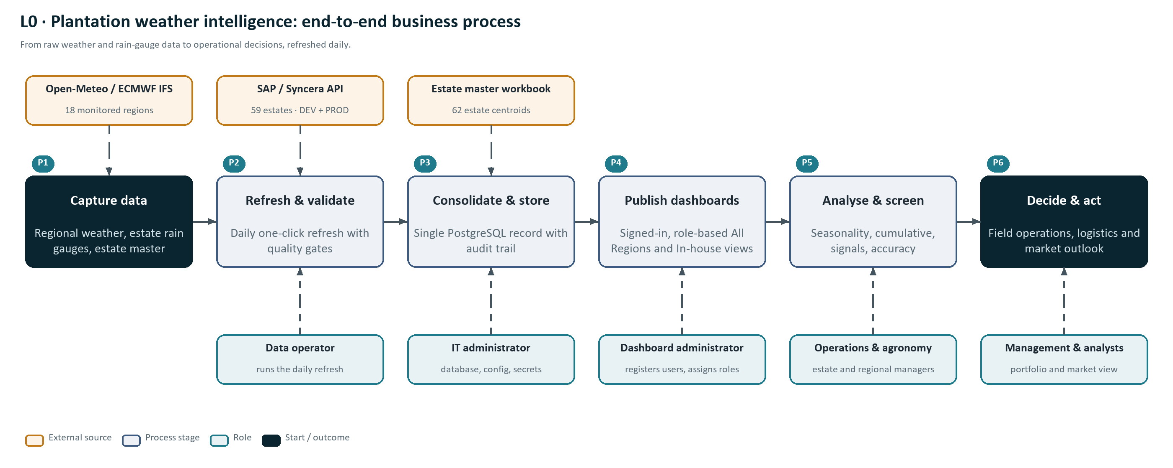
Figure 1: L0 end-to-end business process (P1–P6) with data sources and roles.

Stage | Description | Owner | L1 detail
P1 Capture data | Open-Meteo regional weather (18 regions), SAP/Syncera rain gauges (59 estates), estate master workbook (62 estates). | External systems | 6.1
P2 Refresh & validate | Daily one-click refresh with quality gates and retries. | Data operator | 6.1
P3 Consolidate & store | Single PostgreSQL 18 record with audit trail; secrets in .env. | IT administrator | 6.1, 6.5
P4 Publish dashboards | All Regions pages and In-house app served on the LAN behind sign-in; each role sees only its sections. | System, dashboard administrator | 6.2, 6.4, 6.6
P5 Analyse & screen | Signals, seasonality, cumulative, comparison, forecast revisions and accuracy. | Managers, analysts | 6.2, 6.3, 6.4
P6 Decide & act | Field operations, logistics, fertiliser timing, market outlook (outside the system). | Management | n/a

6. Business processes: L1 (detail)

6.1 L1.1 Daily data refresh
Refreshes both data domains and republishes the dashboard. The in-house load is all-or-nothing; All Regions steps are individually atomic.
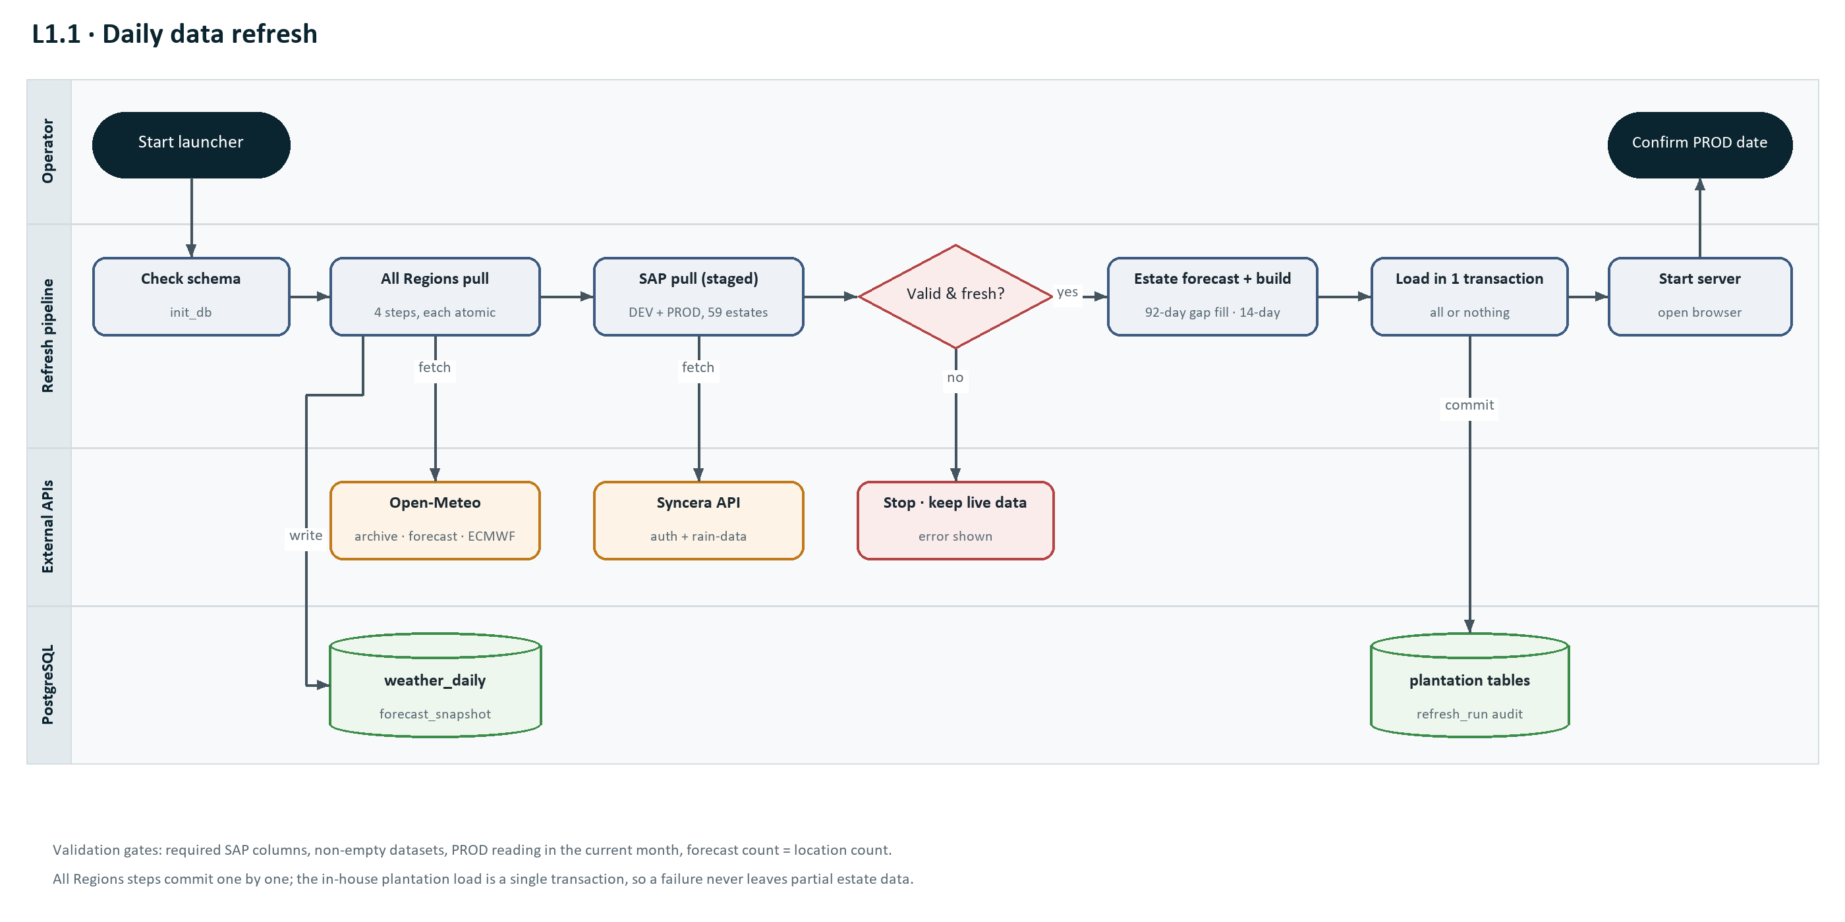
Figure 2: L1.1 daily refresh swimlane with validation gates.

# | Actor | Activity | Output / control
1 | Operator | Starts RUN_RAINFALL_DASHBOARD.bat (or python -m backend.run_dashboard). | Network/VPN available
2 | Pipeline | Applies the database schema (idempotent) and seeds the 18 weather regions. | Schema current
3 | Pipeline | All Regions: historical rain + temperature, historical soil (missing years), rain + temperature forecast (archived), soil forecast; each step commits on its own. | weather_daily, forecast_snapshot updated
4 | Pipeline | Rebuilds and caches the /api/data payload. | dashboard_cache updated
5 | Pipeline | Validates settings and workbook, then pulls SAP DEV and PROD for every estate into a temporary folder. | Staged CSVs
6 | Pipeline | Quality gates: columns, non-empty data, PROD current-month reading. On failure: stop, keep live data. | Pass / fail
7 | Pipeline | Pulls estate 92-day recent actuals and 14-day forecast; builds cleaned daily SAP records; checks counts. | Staged JSON
8 | Pipeline | Loads estates, SAP raw, daily rainfall and forecasts in one transaction; records refresh_run. | Live in-house data replaced
9 | Pipeline | Restarts the dashboard server and opens the browser. | Dashboard available
10 | Operator | Confirms "Latest PROD actual date" is reasonable. | Refresh accepted

6.2 L1.2 All Regions weather monitoring
How a viewer moves from the overview to context pages and a decision.
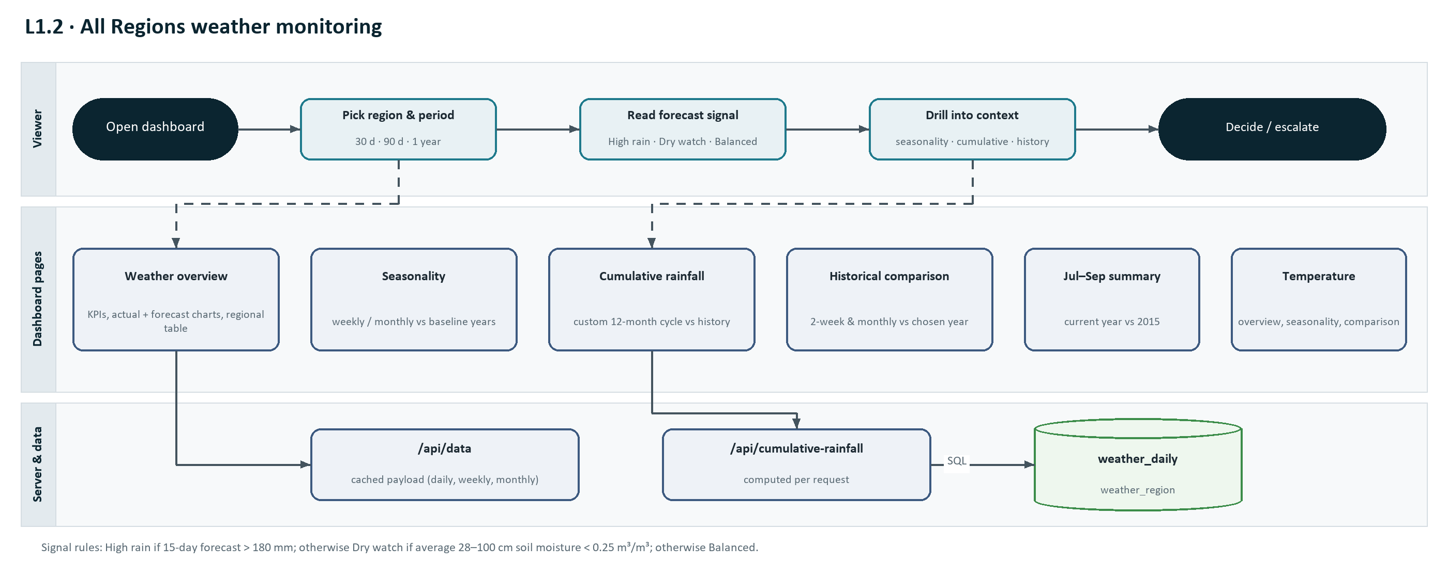
Figure 3: L1.2 All Regions monitoring flow and the pages and APIs involved.

# | Actor | Activity | Output / control
1 | Viewer | Opens the dashboard (Weather overview). | Coverage line shows actual and forecast end dates
2 | Viewer | Selects region (or a country plantation basket) and period. | KPIs and charts for selection
3 | Viewer | Reads the regional comparison signals (High rain / Dry watch / Balanced). | Priority regions identified
4 | Viewer | Opens context pages: weekly/monthly seasonality, cumulative rainfall, historical comparison, Jul–Sep summary, temperature. | Anomaly confirmed or dismissed
5 | Viewer | Decides or escalates (field operations, logistics, market view). | Action recorded outside the system

6.3 L1.3 Forecast verification
Each forecast run is archived so the organisation can see how forecasts change and how accurate they were.
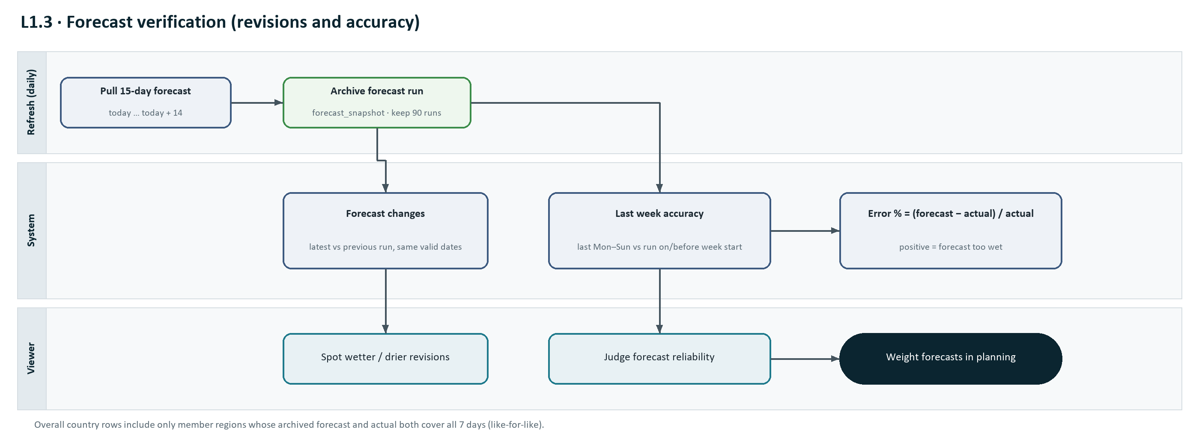
Figure 4: L1.3 forecast archive, revisions and accuracy.

# | Actor | Activity | Output / control
1 | Refresh | Pulls the rainfall forecast (today to today + 14) and archives it under today's run date. | forecast_snapshot
2 | System | Forecast changes: compares latest and previous runs on dates both cover. | Revisions per region
3 | System | Last week accuracy: finds the latest run on or before last Monday and compares it with last week's actuals. | Error % per region
4 | Viewer | Reviews revisions and accuracy to weight forecasts in planning. | Confidence in forecast

6.4 L1.4 In-house plantation monitoring
Estate-level monitoring combining SAP gauge readings, Open-Meteo gap fill and forecast, and the regional series.
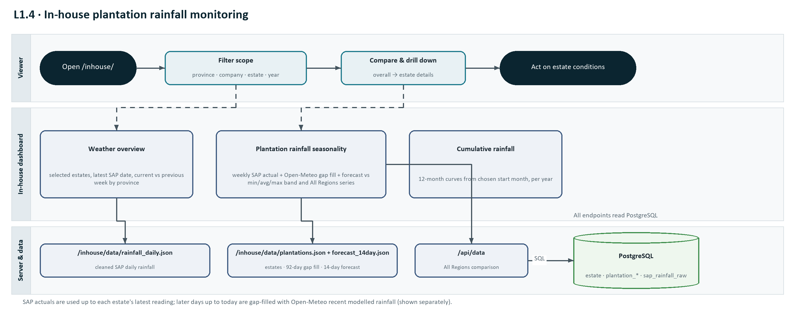
Figure 5: L1.4 in-house plantation monitoring flow.

# | Actor | Activity | Output / control
1 | Viewer | Opens /inhouse/ (default page: Weather overview). | Data-through date shown
2 | Viewer | Filters by province, company, estate and year. | Selection label and record count
3 | Viewer | Reviews KPIs and the province table (current vs previous week). | Recent conditions understood
4 | Viewer | Opens Plantation Rainfall Seasonality; compares with All Regions; drills into estates. | Outlier estates identified
5 | Viewer | Opens Cumulative rainfall for crop-year comparison. | Season ranked

6.5 L1.5 Platform setup and administration
Installation, configuration, migration and monitoring by IT.
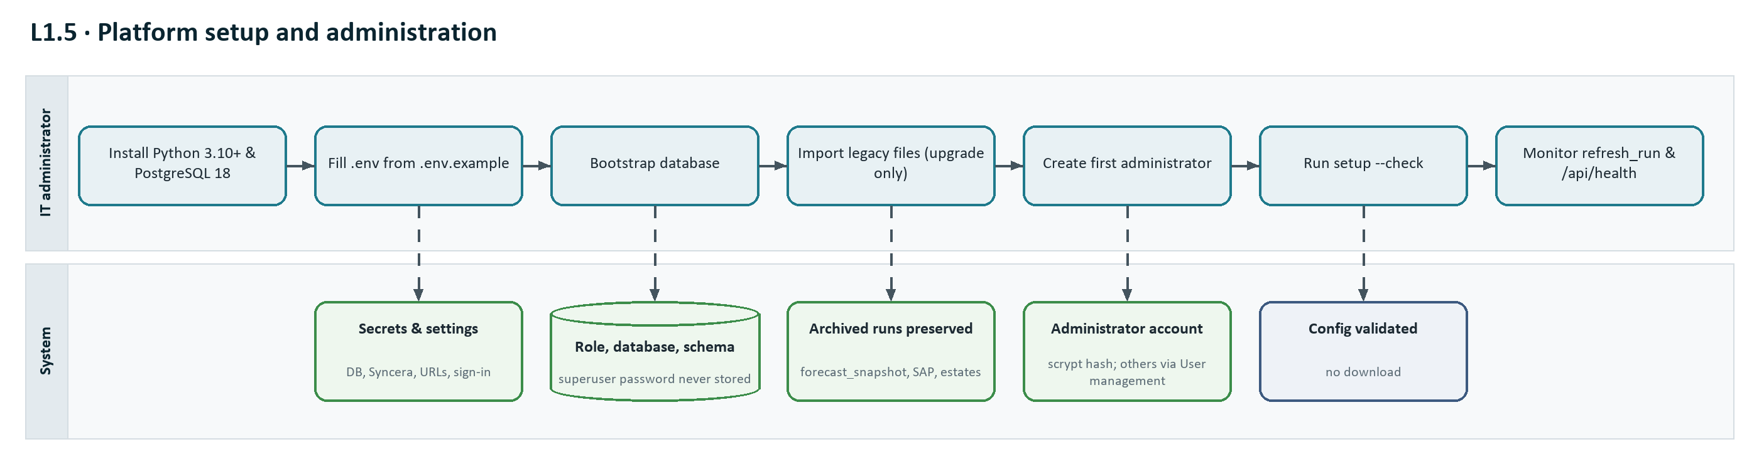
Figure 6: L1.5 setup and administration steps.

# | Actor | Activity | Output / control
1 | IT administrator | Installs Python 3.10+, PostgreSQL 18 and the requirements. | Runtime ready
2 | IT administrator | Copies .env.example to .env and fills in secrets and URLs. | Configuration complete
3 | IT administrator | Runs python -m backend.database.bootstrap. | Role, database, schema
4 | IT administrator | Upgrades only: imports legacy files from the old installation. | History preserved
5 | IT administrator | Creates the first dashboard administrator: python -m backend.auth.create_admin. | Administrator can register other users (L1.6)
6 | IT administrator | Runs the SAP setup --check, then the first refresh. | Configuration validated
7 | IT administrator | Monitors refresh_run and /api/health. | Operational assurance

6.6 L1.6 Sign-in, access control and user administration
How users get an account, sign in, reach only the dashboards their role allows, and how administrators keep accounts current.
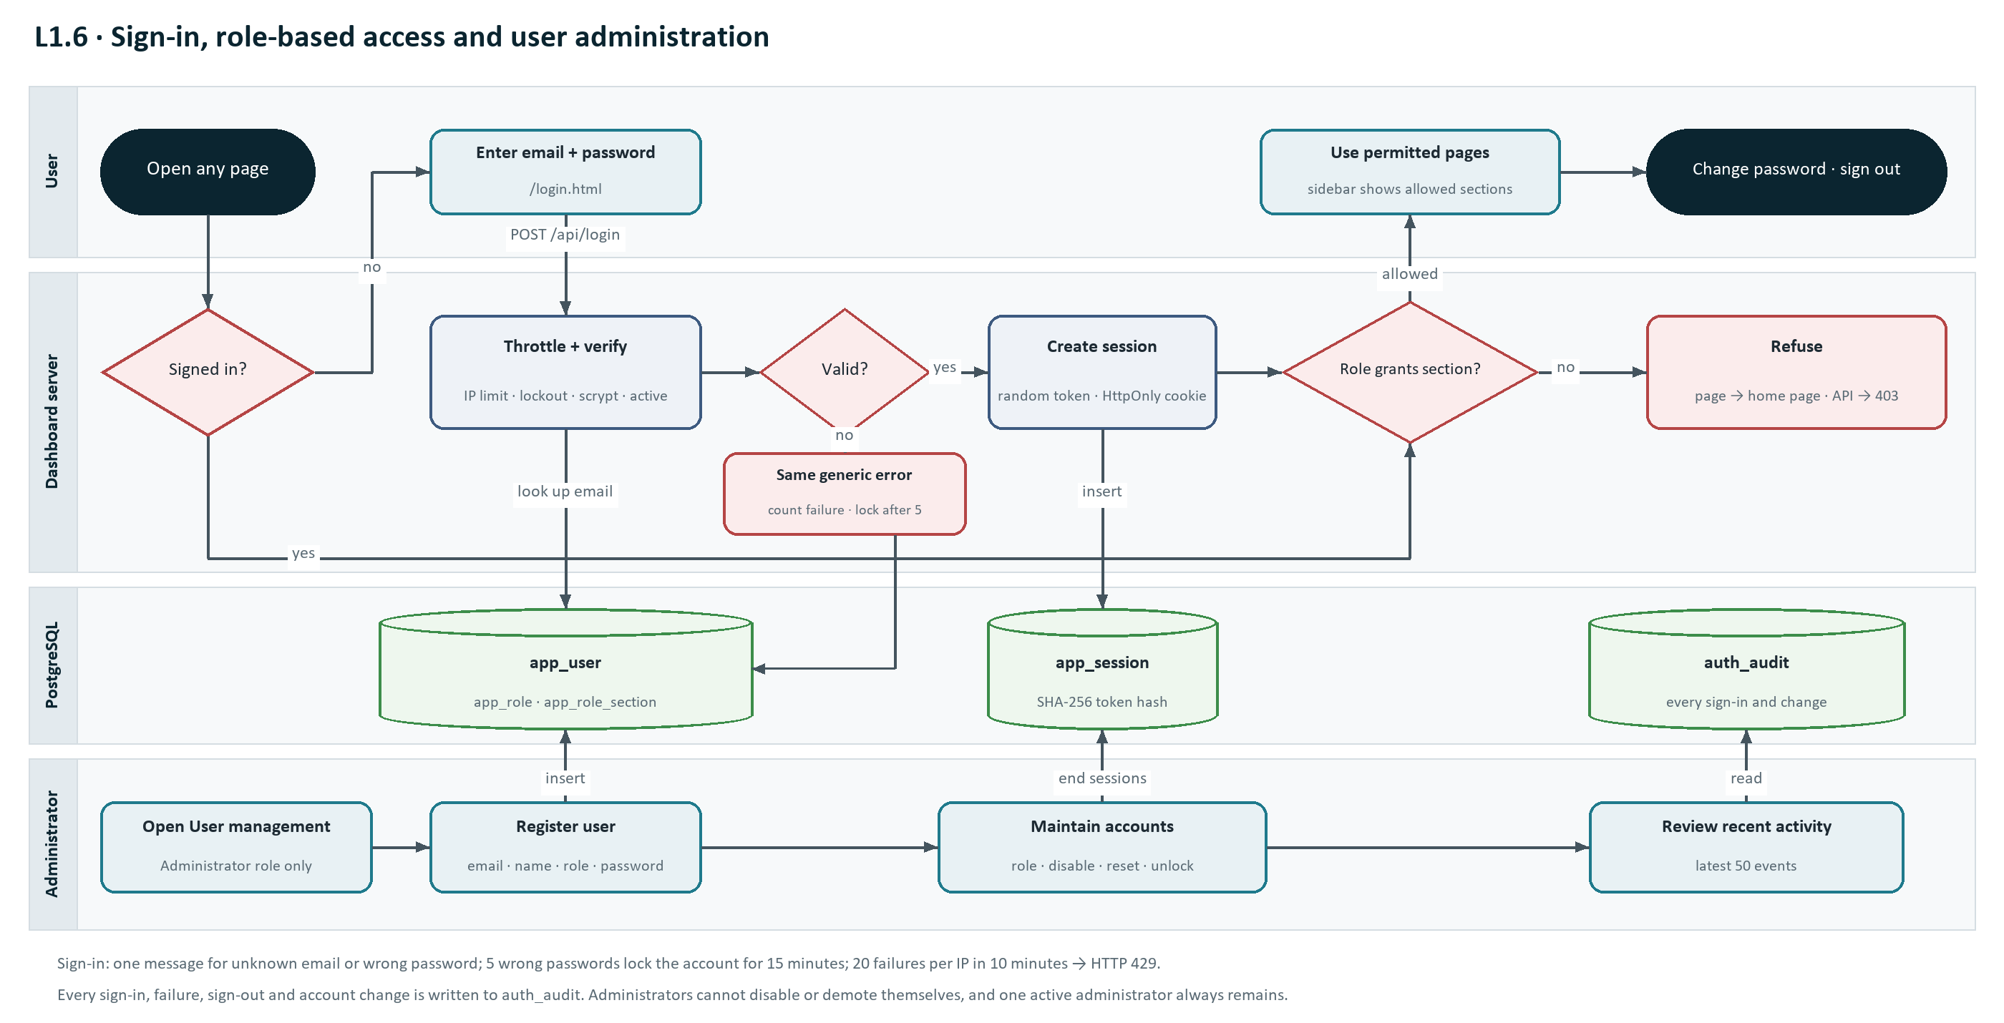
Figure 7: L1.6 sign-in, role-based access and user administration.

# | Actor | Activity | Output / control
1 | User | Opens any dashboard page or bookmark. | No valid session → /login.html?next=<page>
2 | User | Enters work email and password on the sign-in page. | POST /api/login
3 | Server | Checks the per-IP limit (20 failures in 10 minutes → HTTP 429). | Request accepted or throttled
4 | Server | Looks up the email, refuses locked accounts, verifies the scrypt password hash, checks the account is active and the role grants a section. Failure: generic message, failure counted (lock after 5 for 15 minutes), audited. | Pass / refuse
5 | Server | Creates the session (token hash in app_session), sets the HttpOnly cookie, audits login_succeeded. | User on home page or the requested page
6 | Server | On every request: finds the session and the role's sections, maps the path to a section, then serves it or refuses it (page → home page, API → HTTP 403). | Only permitted data delivered
7 | Administrator | Opens User management and registers a user with email, name, role and initial password; hands the password over securely. | Account active
8 | Administrator | Changes role, email or name, disables leavers, resets passwords, unlocks accounts. Safeguards keep at least one active administrator. | Access matches job; sessions ended where needed
9 | User | Changes own password (other sessions end) and signs out when finished. | Session closed
10 | IT administrator | Creates the first or a recovery administrator with python -m backend.auth.create_admin; reviews Recent activity / auth_audit. | Access accountable

7. Functional requirements and user stories
The product has 22 functionalities with 109 user stories: 53 positive (expected use) and 56 negative (errors, invalid input and edge cases). Story IDs use P for positive and N for negative. Acceptance criteria are written as Given/When/Then.
ID | Functionality | Persona | Priority | Stories
F-01 | One-click refresh and launch | Data operator | Must | 5
F-02 | All Regions weather data pipeline | Data operator | Must | 6
F-03 | In-house plantation (SAP) data pipeline | Data operator | Must | 7
F-04 | Weather overview (All Regions) | Operations & agronomy managers | Must | 5
F-05 | Weekly and monthly seasonality (rainfall and soil) | Analysts, agronomy | Must | 4
F-06 | Cumulative rainfall (custom 12-month period) | Analysts, management | Must | 5
F-07 | Historical comparison (rainfall) | Analysts | Should | 3
F-08 | Last week forecast accuracy | Forecast users, analysts | Should | 4
F-09 | Forecast changes (run-to-run revisions) | Forecast users | Should | 3
F-10 | July–September rainfall summary | Management | Could | 2
F-11 | Temperature analytics | Agronomy | Should | 4
F-12 | In-house weather overview | Estate & operations managers | Must | 4
F-13 | Plantation rainfall seasonality | Estate & operations managers | Must | 4
F-14 | In-house cumulative rainfall | Estate & operations managers | Should | 2
F-15 | Navigation | All viewers | Must | 3
F-16 | Configuration and secrets | IT administrator | Must | 4
F-17 | Database setup and legacy migration | IT administrator | Must | 5
F-18 | Refresh audit trail, health check and web exposure | IT administrator | Should | 4
F-19 | Sign-in and session management | All dashboard users | Must | 11
F-20 | Role-based access control | All users; security officer | Must | 8
F-21 | User registration and management (administrators only) | Dashboard administrator | Must | 12
F-22 | Change own password | All dashboard users | Must | 4

F-01 One-click refresh and launch
Primary persona: Data operator · Priority: Must
A single launcher (RUN_RAINFALL_DASHBOARD.bat or python -m backend.run_dashboard) checks the database schema, refreshes All Regions and in-house plantation data, restarts the dashboard server and opens the dashboard.

Requirements
- F-01.R1 Run the refresh steps in a fixed order: schema check → All Regions pipeline → plantation pipeline.
- F-01.R2 Print a numbered banner per step and a final success line.
- F-01.R3 Print the latest confirmed SAP PROD actual date.
- F-01.R4 Stop only a dashboard server previously started by this package (matched on port and command line), then start a new one.
- F-01.R5 Open the address configured in DASHBOARD_PUBLIC_URL.

User stories
ID | Type | User story | Acceptance criteria
F-01-P1 | Positive | As a data operator, I want to refresh everything and open the dashboard with one double-click, so that the daily update needs no technical knowledge. | Given network access and a valid .env, when I run the launcher, then all steps complete, "All dashboard data was refreshed successfully." is printed, the server listens on DASHBOARD_PORT and the browser opens DASHBOARD_PUBLIC_URL.
F-01-P2 | Positive | As a data operator, I want to see the latest SAP PROD actual date at the end of the refresh, so that I can confirm the estate data is current. | Given a successful refresh, then the terminal shows "Latest PROD actual date: <dd Mon yyyy>" and the same date is stored in refresh_run.sap_actual_cutoff.
F-01-P3 | Positive | As a data operator, I want to re-run the launcher at any time, so that I can pick up late SAP postings the same day. | Given a dashboard server started earlier by the launcher, when I run it again, then the old server is stopped before the new one starts and only one server listens on the port.
F-01-N1 | Negative | As a data operator, I want the window to stay open and name the failed step when a refresh fails, so that I can report the cause. | Given any step exits with an error, then "Update stopped at a failed step (exit code N)" is shown, the window waits for Enter, and the dashboard server is not restarted.
F-01-N2 | Negative | As a data operator, I want a clear message when the server cannot start, so that I know data was refreshed but the site is down. | Given the port is held by another program, when the server is not reachable within 10 seconds, then "Data was updated, but the local server could not start." is shown, and processes not started by this package are never stopped.

F-02 All Regions weather data pipeline
Primary persona: Data operator · Priority: Must
Downloads Open-Meteo daily rainfall and mean temperature (2000 → yesterday), ECMWF IFS 28–100 cm soil moisture (2017 → yesterday), and the forecast to today + 14 days for 18 regions in Indonesia, Malaysia and Thailand.

Requirements
- F-02.R1 Store all series in PostgreSQL (weather_daily), replacing the refreshed slice atomically.
- F-02.R2 Download soil-moisture history only for calendar years that are incomplete in the database.
- F-02.R3 Archive every rainfall forecast run in forecast_snapshot, keeping the newest FORECAST_SNAPSHOT_RETENTION_RUNS run dates (default 90).
- F-02.R4 Retry temporary Open-Meteo failures (HTTP 429, 5xx, timeouts) up to 4 attempts with back-off.
- F-02.R5 Rebuild and cache the /api/data payload at the end of the pipeline.

User stories
ID | Type | User story | Acceptance criteria
F-02-P1 | Positive | As a regional analyst, I want historical rainfall and temperature from 2000 to yesterday for every monitored region, so that seasonal baselines cover more than 20 years. | Given a successful refresh, then weather_daily holds historical_actual rows for each of the 18 regions from 2000-01-01 to yesterday for rainfall_mm and temperature_mean_c.
F-02-P2 | Positive | As a data operator, I want soil-moisture history to download only missing years, so that the daily refresh stays fast. | Given soil-moisture history is complete, when the step runs again, then it reports "0 rows refreshed" and makes no archive request for complete years.
F-02-P3 | Positive | As a forecaster, I want every daily forecast run archived, so that revisions and accuracy can be measured later. | Given the forecast step runs on date D, then forecast_snapshot contains run_date D for all 18 regions and run dates beyond the newest 90 are removed.
F-02-N1 | Negative | As a data operator, I want temporary Open-Meteo errors retried and permanent ones reported, so that one bad response does not corrupt stored data. | Given Open-Meteo returns HTTP 429 or 5xx, then the request is retried up to 4 times; if it still fails, the step stops, refresh_run.status = failed with the error message, and that step's stored data is unchanged.
F-02-N2 | Negative | As a data operator, I want malformed responses rejected, so that regions are never mixed up. | Given the response contains a different number of locations than requested, or mismatched date/value arrays, then the step fails with "Expected 18 locations, received N" (or the mismatch message) and nothing is written.
F-02-N3 | Negative | As an administrator, I want invalid manual date ranges refused, so that history is not overwritten by mistake. | Given --start-date is after --end-date, or the end date is today or later, then the script exits with an explanatory message before calling the API.

F-03 In-house plantation (SAP) data pipeline
Primary persona: Data operator · Priority: Must
Pulls SAP/Syncera rain-gauge readings for every company/estate pair in SAP_ESTATES from DEV (historical) and PROD (current), refreshes the Open-Meteo 92-day recent actuals and 14-day forecast for each estate centroid in the estate workbook, cleans the readings and loads everything into PostgreSQL in one transaction.

Requirements
- F-03.R1 Authenticate to each Syncera environment with the client ID and secret from .env and request estates in parallel (SAP_WORKERS, default 4) with retries.
- F-03.R2 Treat HTTP 404 "No data found" for an estate as an empty result, not a failure.
- F-03.R3 Stage all downloads in a temporary folder and validate them before any database change.
- F-03.R4 Validate: required columns present; datasets not empty; PROD contains a reading in the current month; forecast count equals estate count.
- F-03.R5 Clean readings: detect DD.MM.YYYY vs MM.DD.YYYY, skip corrupt years (< 2000 or > next year), remove dates with no rainfall above zero anywhere in the portfolio, remove exact duplicates.
- F-03.R6 Load estates, raw SAP rows, cleaned daily rainfall and estate forecasts in a single transaction.

User stories
ID | Type | User story | Acceptance criteria
F-03-P1 | Positive | As an estate manager, I want my estate's rain-gauge readings in the dashboard every day, so that decisions use measured rainfall. | Given SAP PROD has readings for my estate, when the refresh succeeds, then plantation_rainfall_daily contains those readings and /inhouse/ shows them.
F-03-P2 | Positive | As a data operator, I want placeholder and corrupt SAP rows filtered automatically, so that the dashboard does not show false dry days. | Given SAP returns all-zero future dates or a posting date such as 01.01.0100, then those rows are excluded, the number removed is printed, and up to 10 invalid dates are listed.
F-03-P3 | Positive | As an IT administrator, I want the plantation load to be all-or-nothing, so that users never see a mix of old and new estate data. | Given all validations pass, then estates, SAP raw rows, daily rainfall and forecasts are committed together and refresh_run records step "load" as succeeded.
F-03-N1 | Negative | As a data operator, I want missing credentials detected before any download, so that I can fix the configuration quickly. | Given SYNCERA_DEV_CLIENT_SECRET is empty or still REPLACE_ME, then the setup check fails with exit code 2 and names the missing key and the .env file.
F-03-N2 | Negative | As an estate manager, I want stale PROD data rejected, so that last month's figures are not presented as current. | Given the latest PROD reading with rainfall above zero is before the first day of the current month, then the refresh stops with "PROD SAP data is stale …" and the live dashboard data is not replaced.
F-03-N3 | Negative | As a data operator, I want an estate-level API error to fail the refresh visibly, so that silent gaps are avoided. | Given one estate returns an error other than 404 "No data found", then the refresh fails, lists the company/estate and error, and no plantation data is changed.
F-03-N4 | Negative | As an IT administrator, I want unknown estates in the workbook rejected, so that every estate is mapped to a province. | Given the workbook contains an estate without a province mapping, then the refresh fails with "No Indonesian province mapping configured for <estate>".

F-04 Weather overview (All Regions)
Primary persona: Operations & agronomy managers · Priority: Must
Landing page with region selector (including the three country plantation baskets), KPI cards, actual-plus-forecast charts, the regional comparison table with forecast signals, monthly history and weekly/monthly seasonal benchmarks.

Requirements
- F-04.R1 KPI cards: 15-day forecast rainfall, wet days (≥ 10 mm/day), average daily mean temperature, average 28–100 cm soil moisture, peak daily rainfall.
- F-04.R2 Period switch for the actual-plus-forecast charts: 30 days, 90 days, 1 year.
- F-04.R3 Signal per region: High rain if 15-day forecast > 180 mm; otherwise Dry watch if average soil moisture < 0.25 m³/m³; otherwise Balanced.
- F-04.R4 Seasonal benchmarks compare the current year with a user-selected baseline year range (average and min–max band).
- F-04.R5 Forecast values on or before the latest actual date are never mixed into series.
- F-04.R6 Available to every role with the All Regions section (all three default roles); see F-20.

User stories
ID | Type | User story | Acceptance criteria
F-04-P1 | Positive | As an operations manager, I want each region flagged High rain, Dry watch or Balanced, so that I can see where to act first. | Given forecast data, when I open the dashboard, then each region in the comparison table shows the signal produced by the documented rules, with High rain taking priority.
F-04-P2 | Positive | As an agronomist, I want to switch between 30 days, 90 days and 1 year, so that I can see short- and long-term context. | When I choose a period, then the rainfall/soil and temperature charts redraw for that window, ending with the forecast.
F-04-P3 | Positive | As an analyst, I want to choose the baseline years for the seasonal benchmark, so that comparisons exclude unusual years. | When I change From/To, then the weekly and monthly benchmark averages and min–max bands are recalculated for that range only.
F-04-N1 | Negative | As a viewer, I want a clear message when data cannot be loaded, so that I do not read an empty page as "no rain". | Given /api/data fails, then the header shows "Data unavailable" and an error banner reads "Dashboard data could not be loaded: <reason>".
F-04-N2 | Negative | As an analyst, I want forecast and actual values for the same day never double-counted, so that weekly totals are correct. | Given a forecast row dated on or before the latest actual date, then it is excluded from daily series and weekly/monthly aggregates.

F-05 Weekly and monthly seasonality (rainfall and soil)
Primary persona: Analysts, agronomy · Priority: Must
All-region small multiples comparing the current year with selected years, by ISO week (Monday–Sunday) and by calendar month, for rainfall totals and soil moisture, grouped by Indonesia, Malaysia and Thailand.

Requirements
- F-05.R1 Weekly view plots complete seven-day ISO weeks only and marks the latest actual date.
- F-05.R2 Monthly view shows current-year points only when every day of the month is covered by actual and/or forecast data.
- F-05.R3 Soil-moisture history starts in 2017 (ECMWF IFS availability).

User stories
ID | Type | User story | Acceptance criteria
F-05-P1 | Positive | As an analyst, I want every region's current-year weekly rainfall against the range of selected years, so that I can spot anomalies across the portfolio at a glance. | When I open Weekly seasonality, then each region shows current-year weekly totals, the selected-year average and min–max band, grouped by country with jump links.
F-05-P2 | Positive | As an agronomist, I want soil moisture on the same page, so that I can relate rainfall anomalies to soil conditions. | Then each region also shows weekly mean 28–100 cm soil moisture (m³/m³) against its baseline.
F-05-N1 | Negative | As an analyst, I want incomplete weeks and months left out, so that partial totals do not look like dry periods. | Given the current ISO week or month is not fully covered, then that point is not plotted.
F-05-N2 | Negative | As an analyst, I want to know soil-moisture baselines cannot go before 2017, so that I do not misread an empty band. | Given a baseline range starting before 2017, then soil-moisture statistics use only years from 2017, as stated on the page.

F-06 Cumulative rainfall (custom 12-month period)
Primary persona: Analysts, management · Priority: Must
Weekly accumulated rainfall for a chosen region and start month, current period (actual then forecast) against the historical average and min–max of a chosen year range, plus a table of final 12-month totals.

Requirements
- F-06.R1 Inputs: region, start month (1–12), historical From and To years (2000 ≤ From ≤ To < current period start year).
- F-06.R2 Historical periods with any missing day are excluded.
- F-06.R3 The current line stops at the first missing day and continues with the forecast where available.
- F-06.R4 Min and max points identify the year(s) that produced them.

User stories
ID | Type | User story | Acceptance criteria
F-06-P1 | Positive | As a manager reporting on a July–June crop year, I want to start the cumulative curve in July, so that it matches our reporting period. | When I select start month July, then week 1 starts on 1 July and all historical periods run July–June.
F-06-P2 | Positive | As an analyst, I want to see how the current period compares with each historical year, so that I can rank this season. | Then the Historical periods table lists each complete period's total and its difference from the historical average.
F-06-N1 | Negative | As an analyst, I want an invalid year range rejected with a reason, so that I can correct it. | Given To is in or after the current period's start year, then the API returns HTTP 400 "The historical range must end before the current period." and the page shows it.
F-06-N2 | Negative | As an analyst, I want data gaps never bridged, so that the curve does not jump. | Given a missing day in the current period, then the actual line ends on the previous day and no interpolation is drawn.
F-06-N3 | Negative | As a viewer, I want an unknown region handled safely, so that a bad link does not crash the page. | Given region=<unknown>, then the API returns HTTP 400 {"error": "Unknown region."}.

F-07 Historical comparison (rainfall)
Primary persona: Analysts · Priority: Should
Region table comparing the forward two weeks (current + next ISO week, actual + forecast) with the previous two completed weeks (WoW) and with the same weeks of a chosen historical year; plus current month vs last month (MoM) vs the same month of the historical year.

Requirements
- F-07.R1 User-selectable historical comparison year.
- F-07.R2 Country rows are simple averages of the monitored regional locations.

User stories
ID | Type | User story | Acceptance criteria
F-07-P1 | Positive | As an analyst, I want the next two weeks compared with the last two, so that I can see whether conditions are getting wetter or drier. | Then each region shows Forward 2W, Previous 2W and the WoW change.
F-07-P2 | Positive | As an analyst, I want to choose the comparison year (for example an El Niño year), so that I can benchmark against a known season. | When I change Historical comparison year, then the Historical 2W/month columns and "Vs historical" recalculate.
F-07-N1 | Negative | As an analyst, I want missing values shown as unavailable rather than zero, so that comparisons are not distorted. | Given a period without complete data, then the value is shown as not available and no percentage is computed.

F-08 Last week forecast accuracy
Primary persona: Forecast users, analysts · Priority: Should
Compares the last completed Monday–Sunday week of actual rainfall with the latest archived forecast run made on or before that Monday, per region and country basket, with a seven-day detail chart.

Requirements
- F-08.R1 Error % = (forecast − actual) ÷ actual × 100; positive means the forecast was too wet.
- F-08.R2 Country basket rows include only member regions whose archived forecast and actual both cover all 7 days; excluded members are listed.

User stories
ID | Type | User story | Acceptance criteria
F-08-P1 | Positive | As a planner, I want to know how accurate last week's forecast was, so that I can decide how much to trust this week's. | Then each region shows actual, forecast and Error % for last week, and the forecast run date used is stated.
F-08-P2 | Positive | As an analyst, I want the daily detail for one region, so that I can see on which days the forecast missed. | When I select a region, then a seven-day actual-vs-forecast chart is shown.
F-08-N1 | Negative | As a planner, I want a clear "unavailable" when no forecast was archived before the week started, so that I do not read a blank as zero error. | Given no forecast run exists on or before the week start (for example the first week after deployment), then forecast and Error % are shown as unavailable.
F-08-N2 | Negative | As an analyst, I want no percentage when actual rainfall was zero, so that division by zero never appears. | Given the actual weekly total is 0 mm, then Error % is not calculated.

F-09 Forecast changes (run-to-run revisions)
Primary persona: Forecast users · Priority: Should
Compares the latest forecast run with the previous archived run over the valid dates both runs cover: previous total, latest total, change (mm) and change (%), with a daily chart for the selected region.

Requirements
- F-09.R1 Positive change means a wetter forecast.
- F-09.R2 Only the same future dates in both runs are compared.

User stories
ID | Type | User story | Acceptance criteria
F-09-P1 | Positive | As a planner, I want to see how the forecast changed since yesterday, so that I can react to big revisions. | Then each region shows previous and latest totals for matching dates, the change in mm and the change in %.
F-09-N1 | Negative | As a viewer, I want a sensible display when only one run exists, so that the page still works after a fresh install. | Given only one archived run, then previousRun is empty and change values are shown as unavailable.
F-09-N2 | Negative | As an analyst, I want no percentage when the previous total was zero. | Given the previous total is 0 mm, then "Percentage change unavailable" is shown.

F-10 July–September rainfall summary
Primary persona: Management · Priority: Could
Current-year July–September cumulative rainfall (actual plus available forecast) against complete July–September 2015 actuals, per region. Reachable by URL (/rainfall-summary.html); not in the sidebar.

Requirements
- F-10.R1 Clearly separate historical actual and forecast contributions.

User stories
ID | Type | User story | Acceptance criteria
F-10-P1 | Positive | As a manager, I want this season's July–September rainfall compared with 2015, so that I can relate it to a known dry year. | Then each region shows current Jul–Sep (mm), 2015 Jul–Sep (mm) and the change.
F-10-N1 | Negative | As a manager, I want to know when the current season is incomplete, so that partial totals are not misread. | Given the season has not ended, then the page states the date through which actual and forecast data are included.

F-11 Temperature analytics
Primary persona: Agronomy · Priority: Should
Temperature overview (forecast average/min/max/coverage, actual-plus-forecast chart, regional table, monthly history), weekly and monthly temperature seasonality, and temperature historical comparison, all using daily mean 2 m air temperature.

Requirements
- F-11.R1 Temperature uses separate lowland reference coordinates so regions are comparable in elevation.
- F-11.R2 Changes are shown in °C, not percent.

User stories
ID | Type | User story | Acceptance criteria
F-11-P1 | Positive | As an agronomist, I want the 15-day mean temperature outlook per region, so that I can anticipate heat stress. | Then the Temperature overview shows forecast average, minimum and maximum daily mean and the number of forecast days available.
F-11-P2 | Positive | As an analyst, I want temperature changes in degrees, so that comparisons are meaningful. | Then Temperature historical comparison shows differences in °C.
F-11-N1 | Negative | As an analyst, I want to know temperature points differ from rainfall points, so that I do not expect identical coordinates. | Then the documentation and footers state that temperature uses lowland reference coordinates.
F-11-N2 | Negative | As a viewer, I want an error message if data is missing. | Given /api/data fails, then "Data unavailable" and an error banner are shown.

F-12 In-house weather overview
Primary persona: Estate & operations managers · Priority: Must
In-house dashboard landing page (/inhouse/): filters for province, company code, estate code and year; KPIs for selected estates, latest SAP date, current-week and previous-week average daily rainfall; regional table by province.

Requirements
- F-12.R1 Daily values are averaged across measurement tools, then across selected estates.
- F-12.R2 Week-to-date is compared with the same number of elapsed days of the previous week.
- F-12.R3 The In-house Plantation pages and their data are available only to roles with the In-house section (Administrator, Plantation user); see F-20.

User stories
ID | Type | User story | Acceptance criteria
F-12-P1 | Positive | As an estate manager, I want to filter to my company and estate, so that I see only my rainfall. | When I choose company and estate, then all KPIs, tables and charts recalculate for that selection and the selection label updates.
F-12-P2 | Positive | As an operations manager, I want this week compared with last week on equal days, so that a partial week is not compared with a full one. | Then the Current week and Previous week averages use the same number of elapsed days.
F-12-N1 | Negative | As a viewer, I want a clear message when filters match nothing. | Given a filter combination with no estates, then "No records match the selected filters." is shown.
F-12-N2 | Negative | As a viewer, I want a message if plantation data has not been loaded yet. | Given no successful plantation load, then the data endpoints return HTTP 404 with a JSON error and the page shows an error instead of empty charts.

F-13 Plantation rainfall seasonality
Primary persona: Estate & operations managers · Priority: Must
Weekly rainfall of the selected estates (SAP actual, Open-Meteo gap fill, Open-Meteo forecast) against the historical min–max band and average of a chosen year range, alongside the matching All Regions Open-Meteo series; drill down to a grid of every matching estate.

Requirements
- F-13.R1 SAP readings are used up to each estate's latest reading; later days up to today are filled with Open-Meteo recent modelled rainfall and drawn in a distinct style.
- F-13.R2 Historical weekly rainfall uses complete Monday–Sunday weeks.

User stories
ID | Type | User story | Acceptance criteria
F-13-P1 | Positive | As an operations manager, I want our gauge readings next to the regional model, so that I can judge whether our estates are wetter or drier than the region. | Then the overview shows the selection's SAP actual + gap fill + forecast and the aligned All Regions series with the same baseline.
F-13-P2 | Positive | As an estate manager, I want to drill into every estate, so that I can find outliers. | When I click View estate details, then a grid of weekly seasonality charts for each matching estate replaces the overview, with a Back button.
F-13-N1 | Negative | As an estate manager, I want modelled gap-fill values clearly separated from SAP readings, so that I never mistake them for measurements. | Given an estate's SAP readings stop before today, then the days after are drawn as "External actual gap fill" with a different legend entry.
F-13-N2 | Negative | As a viewer, I want a message when no plantations match. | Given no estates match the filters, then "No plantations match the selected filters." is shown.

F-14 In-house cumulative rainfall
Primary persona: Estate & operations managers · Priority: Should
One-year cumulative rainfall curves per year from a chosen start month for the selected estates (overall average across visible estates, or a single estate).

Requirements
- F-14.R1 Curves with no reading during the first month are excluded.

User stories
ID | Type | User story | Acceptance criteria
F-14-P1 | Positive | As an estate manager, I want cumulative rainfall per crop year from my chosen month, so that I can compare seasons. | When I choose a start month, then one curve per year is drawn starting in that month with a legend by year.
F-14-N1 | Negative | As an estate manager, I want years without readings in the first month excluded, so that late-starting curves do not look dry. | Given a year has no reading in its first month, then that year's curve is not drawn; if none qualify, "No records match the selected filters." is shown.

F-15 Navigation
Primary persona: All viewers · Priority: Must
Left sidebar with accordion sections In-house Plantation, All Regions (Rainfall and Temperature categories) and Administration, showing only the sections the signed-in user's role grants, and highlighting the current page.

Requirements
- F-15.R1 Only one top-level section is expanded at a time.
- F-15.R2 The active page is marked with aria-current.
- F-15.R3 Sections the user's role does not grant are not shown (the server still enforces access; see F-20).
- F-15.R4 The sidebar footer shows the user's name, email and role, with Change password and Sign out.

User stories
ID | Type | User story | Acceptance criteria
F-15-P1 | Positive | As a viewer, I want to move between in-house and regional views in one click, so that I can compare them. | Then each sidebar link opens the page and the link of the current page is highlighted.
F-15-P2 | Positive | As a viewer, I want to see who I am signed in as, so that I notice when a shared computer uses someone else's account. | Then the sidebar footer shows my full name, email and role name, with Change password and Sign out.
F-15-N1 | Negative | As a viewer, I want pages that are not in the sidebar to remain reachable, so that bookmarks keep working. | Given a direct link to monthly-seasonality.html, temperature-monthly-seasonality.html or rainfall-summary.html and a role with All Regions access, then the page loads with the sidebar.

F-16 Configuration and secrets
Primary persona: IT administrator · Priority: Must
All environment-specific settings and secrets are held in one .env file (template: .env.example); real environment variables override it.

Requirements
- F-16.R1 Settings: database connection, dashboard host/port/public URL, Syncera URLs/IDs/secrets, SAP estate list and workers, Open-Meteo URLs and horizons, workbook and work folder paths.
- F-16.R2 Sign-in settings: SESSION_HOURS, SESSION_COOKIE_SECURE, LOGIN_MAX_FAILED_ATTEMPTS, LOGIN_LOCKOUT_MINUTES, PASSWORD_MIN_LENGTH.
- F-16.R3 A missing value or the placeholder REPLACE_ME is reported with the key name.
- F-16.R4 .env is git-ignored and never served over HTTP.

User stories
ID | Type | User story | Acceptance criteria
F-16-P1 | Positive | As an IT administrator, I want to change the LAN address or SAP estate list without editing code, so that changes are safe and reviewable. | When I edit DASHBOARD_PUBLIC_URL or SAP_ESTATES in .env and re-run, then the new value is used.
F-16-P2 | Positive | As an IT administrator, I want environment variables to override .env, so that a scheduler can inject secrets. | Given a variable set in the process environment, then it takes precedence over .env.
F-16-N1 | Negative | As an IT administrator, I want a clear error naming any missing setting. | Given DATABASE_PASSWORD is empty, then the error "DATABASE_PASSWORD is not set. Add it to <path>\.env (see .env.example)." is raised.
F-16-N2 | Negative | As a security officer, I want secrets never downloadable from the dashboard. | Given a request for /.env, /backend/config.py or /.git/config, then the file is never returned: a signed-out request is redirected to sign-in and a signed-in request gets 404.

F-17 Database setup and legacy migration
Primary persona: IT administrator · Priority: Must
One-time bootstrap creates the application role, database and schema on PostgreSQL 18; init_db applies the idempotent schema on every refresh; a legacy import moves data from the previous file-based installation. The first dashboard administrator is then created with create_admin (F-21).

Requirements
- F-17.R1 The superuser password is asked with hidden input and never stored.
- F-17.R2 The legacy import preserves the archived forecast runs, which cannot be downloaded again.
- F-17.R3 Missing legacy files are skipped without deleting existing database data.

User stories
ID | Type | User story | Acceptance criteria
F-17-P1 | Positive | As an IT administrator, I want one command to create the database, so that installation is repeatable. | When I run python -m backend.database.bootstrap and enter the superuser login, then the role, database and 16 tables exist, 18 weather regions are seeded and the three default dashboard roles exist.
F-17-P2 | Positive | As an IT administrator upgrading an existing PC, I want old CSV/JSON data imported, so that forecast-accuracy history is not lost. | When I run the legacy import with the old folder, then weather rows, forecast runs and plantation data are loaded and each file is reported "ok" or "skip".
F-17-N1 | Negative | As an IT administrator, I want a wrong superuser password to change nothing. | Given an invalid password, then the connection fails and no role or database is created.
F-17-N2 | Negative | As an IT administrator, I want missing legacy files skipped safely. | Given a legacy file is absent, then it is reported as "skip" and the corresponding database data is not cleared.
F-17-N3 | Negative | As an IT administrator, I want to be warned about an older PostgreSQL server. | Given server_version_num < 180000, then bootstrap prints a warning.

F-18 Refresh audit trail, health check and web exposure
Primary persona: IT administrator · Priority: Should
Every refresh step is recorded in refresh_run; /api/health reports service status without sign-in; the web server publishes only the frontend folder and the defined API endpoints. User access is covered by F-19 to F-22.

Requirements
- F-18.R1 refresh_run captures pipeline, step, status, start/finish time, rows written, SAP actual cutoff and error message.
- F-18.R2 Unknown /api paths return 404 JSON for signed-in users; path traversal returns 404; folder contents are never listed.
- F-18.R3 Unexpected server errors return a generic message; exception details are only written to the server log.

User stories
ID | Type | User story | Acceptance criteria
F-18-P1 | Positive | As an IT administrator, I want a history of refresh runs, so that I can prove when data was last updated and diagnose failures. | Then each step has a refresh_run row with status succeeded or failed, duration and message.
F-18-P2 | Positive | As an IT administrator, I want a health endpoint for monitoring. | When I call GET /api/health, then it returns {"status": "ok", "plantationVersion": <latest successful plantation run id>}.
F-18-N1 | Negative | As a security officer, I want only dashboard files served. | Given any path outside frontend/ (including ../ traversal) requested by a signed-in user, then the server returns 404; signed-out requests are sent to sign-in first.
F-18-N2 | Negative | As a developer, I want unknown API calls to fail clearly. | Given a signed-in GET /api/unknown, then the server returns 404 {"error": "Unknown API endpoint"}; signed out, it returns 401.

F-19 Sign-in and session management
Primary persona: All dashboard users · Priority: Must
Every page and API requires a signed-in user. Users sign in on /login.html with their work email and password; the server keeps the session and the browser holds only a random token in an HttpOnly cookie. Users sign out from the sidebar.

Requirements
- F-19.R1 Only /login.html, its CSS and JavaScript, POST /api/login and GET /api/health are public. A signed-out request for a page is redirected to /login.html?next=<page>; a signed-out API call returns HTTP 401 JSON.
- F-19.R2 Sign in with email (letter case ignored) and password. An unknown email and a wrong password give the same message, "Incorrect email or password.", and take the same time.
- F-19.R3 On success the server creates a session that lasts SESSION_HOURS (default 12) and sets the cookie rainfall_session (HttpOnly, SameSite=Strict, Path=/, Secure when SESSION_COOKIE_SECURE=true). Only a SHA-256 hash of the token is stored.
- F-19.R4 Account lockout: after LOGIN_MAX_FAILED_ATTEMPTS (default 5) wrong passwords in a row the account is locked for LOGIN_LOCKOUT_MINUTES (default 15). A successful sign-in resets the count.
- F-19.R5 Per-computer throttle: after 20 failed sign-ins from one IP address within 10 minutes, further attempts get HTTP 429 until the window passes.
- F-19.R6 After sign-in the user returns to the requested page when it is a path on this site, otherwise to their home page (All Regions overview, else In-house, else User management).
- F-19.R7 Sign out deletes the server session and clears the cookie. When a page finds its session expired (HTTP 401), the browser goes to the sign-in page and returns to the same page afterwards.
- F-19.R8 Every sign-in, failed or blocked attempt and sign-out is recorded in auth_audit with the time and IP address.

User stories
ID | Type | User story | Acceptance criteria
F-19-P1 | Positive | As a dashboard user, I want to sign in with my work email and password, so that only authorised staff can see plantation data. | Given an active account, when I enter my email in any letter case and the correct password, then I land on my home page, a rainfall_session cookie is set and auth_audit records login_succeeded.
F-19-P2 | Positive | As a user opening a bookmark, I want to reach the page I asked for after signing in, so that links shared by colleagues keep working. | Given I am signed out, when I open /cumulative-rainfall.html, then I am redirected to /login.html?next=%2Fcumulative-rainfall.html, and after signing in I land on Cumulative rainfall.
F-19-P3 | Positive | As a user on a shared computer, I want to sign out, so that the next person cannot use my session. | When I click Sign out in the sidebar, then my session is deleted on the server, the cookie is cleared, logout is audited, and opening any page asks me to sign in again.
F-19-P4 | Positive | As a user, I want to stay signed in for a working day, so that I do not have to sign in on every page. | Given I signed in less than SESSION_HOURS (12) ago, then every page I am allowed to see opens without signing in again; after that time my next request asks me to sign in.
F-19-N1 | Negative | As a user who mistyped, I want a clear but non-revealing message, so that nobody can find out which emails have accounts. | Given an unknown email or a wrong password, then HTTP 401 "Incorrect email or password." is shown for both, the password field is cleared, and login_failed is audited with the reason.
F-19-N2 | Negative | As a security officer, I want accounts locked after repeated wrong passwords, so that passwords cannot be guessed. | Given 5 wrong passwords in a row, then the account is locked for 15 minutes: even the correct password returns "Too many failed attempts. Try again in N minutes." and login_blocked is audited.
F-19-N3 | Negative | As a security officer, I want one computer that keeps failing to be slowed down, so that guessing across many accounts is blocked. | Given 20 failed sign-ins from one IP address within 10 minutes, then further attempts return HTTP 429 "Too many failed sign-in attempts. Wait a few minutes." whatever email is used.
F-19-N4 | Negative | As an administrator, I want a disabled user to be refused, so that leavers lose access at once. | Given my account was disabled, when I sign in, then "This account is disabled. Contact an administrator." is shown, and any session I still had stopped working when I was disabled.
F-19-N5 | Negative | As a user whose session expired with a page open, I want to be sent to sign in, so that I do not read an empty page as missing data. | Given my session has expired, when the page calls an API, then it returns HTTP 401 and the browser goes to /login.html?next=<this page>.
F-19-N6 | Negative | As a security officer, I want sign-in links to never forward users to another site, so that phishing links cannot misuse the sign-in page. | Given a sign-in link with next=//other.example or next=https://other.example, then after signing in I land on my home page on this dashboard.
F-19-N7 | Negative | As a user, I want empty fields caught before anything is sent. | Given the email or password is empty, then "Enter your email and password." is shown and no request is sent.

F-20 Role-based access control
Primary persona: All users; security officer · Priority: Must
Each user has one role. A role grants one or more dashboard sections: All Regions, In-house Plantation and User management. The server checks the section for every page and API call; the sidebar shows only the sections the role grants.

Requirements
- F-20.R1 Three default roles: Administrator (All Regions, In-house Plantation, User management), Plantation user (All Regions, In-house Plantation) and Regional viewer (All Regions only).
- F-20.R2 Roles and their sections are stored in the database (app_role, app_role_section). They can be changed there without code changes, take effect on each user's next request, and are not overwritten by refreshes or schema updates.
- F-20.R3 Every path belongs to a section: /admin/* and /api/admin/* → User management; /inhouse/* (pages and data) → In-house; top-level pages and All Regions APIs → All Regions; /api/data → All Regions or In-house (the in-house seasonality page compares with it); shared CSS/JS, /api/me, /api/logout and /account/* → any signed-in user.
- F-20.R4 The section is decided on the decoded, normalised, lower-case path, so URL encoding, ../ segments, backslashes or capital letters cannot reach a page under a different rule.
- F-20.R5 A refused page redirects to the user's home page; a refused API call returns HTTP 403 JSON. Hiding a link is never the only control.
- F-20.R6 A user whose role grants no section cannot sign in.

User stories
ID | Type | User story | Acceptance criteria
F-20-P1 | Positive | As a regional viewer, I want to see all All Regions dashboards, so that I can follow regional weather without seeing estate data. | Given my role is Regional viewer, then the sidebar shows only All Regions, and / and every All Regions page and API open normally.
F-20-P2 | Positive | As a plantation user, I want both the All Regions and the In-house Plantation dashboards, so that I can compare estate readings with the region. | Given my role is Plantation user, then the sidebar shows In-house Plantation and All Regions, Plantation Rainfall Seasonality loads its All Regions comparison, and Administration is not shown.
F-20-P3 | Positive | As an administrator, I want every section including User management, so that I can support all users. | Given my role is Administrator, then the sidebar shows In-house Plantation, All Regions and Administration → User management.
F-20-P4 | Positive | As an IT administrator, I want to change what a role can open without a release, so that access can follow business decisions. | Given I add the row (regional, inhouse) to app_role_section, then Regional viewers can open /inhouse/ on their next request without a code change or server restart.
F-20-N1 | Negative | As a data owner, I want estate data refused to roles without In-house access, even by typed URL. | Given I am a Regional viewer, when I open /inhouse/ I am redirected to my home page, and GET /inhouse/data/rainfall_daily.json returns HTTP 403 "Your role does not allow access to this data."
F-20-N2 | Negative | As a security officer, I want URL tricks to be refused, so that the admin page cannot be reached by a non-administrator. | Given I am a Plantation user, when I request /ADMIN/users.html, /%61dmin/users.html or /js/../admin/users.html, then I am redirected to my home page, and GET /api/admin/users returns HTTP 403.
F-20-N3 | Negative | As a security officer, I want administration calls refused for non-administrators, so that nobody can create an account for themselves. | Given I am not an administrator, when my browser sends POST /api/admin/users, then HTTP 403 is returned and no user is created.
F-20-N4 | Negative | As an IT administrator, I want a role with no sections to be unusable, so that a misconfigured role does not open an empty dashboard. | Given a user whose role has no sections, when they sign in with the correct password, then "Your role does not give access to any dashboard. Contact an administrator." is shown and no session is created.

F-21 User registration and management (administrators only)
Primary persona: Dashboard administrator · Priority: Must
The User management page (/admin/users.html) lets administrators register users, change their name, email, role and status, reset passwords, unlock accounts and review recent sign-in activity. The first administrator is created on the server with python -m backend.auth.create_admin.

Requirements
- F-21.R1 The page shows user counts (total, active, administrators, locked), a searchable user list with role, status and last sign-in, the Register new user form, the role-and-access table and the latest 50 audit events.
- F-21.R2 Register: email (valid format, at most 200 characters, unique ignoring case, stored in lower case), full name (2 to 100 characters), role and an initial password that meets the password policy. Generate creates a random 18-character password.
- F-21.R3 Edit name, email, role and the active flag; unlock a locked account; reset a password. Users are disabled rather than deleted, so their audit history stays complete.
- F-21.R4 Disabling a user or resetting their password ends all of their sessions at once; a reset also clears any lockout.
- F-21.R5 Safeguards: administrators cannot disable themselves or remove their own administrator role, and at least one active administrator must always remain.
- F-21.R6 Every change is audited (user_created, user_updated, user_unlocked, password_reset) with the administrator and IP address.
- F-21.R7 Recovery: python -m backend.auth.create_admin on the server creates an administrator with a hidden password prompt.

User stories
ID | Type | User story | Acceptance criteria
F-21-P1 | Positive | As an administrator, I want to register a new colleague with a role, so that they can sign in with the right access. | When I register siti.rahma@company.com with a full name, role Plantation user and a valid initial password, then the user appears as Active, user_created is audited, and they can sign in with that email and password.
F-21-P2 | Positive | As an administrator, I want to change a user's role, so that access follows their job. | When I change a user from Regional viewer to Plantation user and save, then on their next request the In-house Plantation section is available to them.
F-21-P3 | Positive | As an administrator, I want to reset a forgotten password, so that the user can work again. | When I set a new valid password in Reset password, then the user is signed out everywhere, any lockout is cleared, they can sign in with the new password, and password_reset is audited.
F-21-P4 | Positive | As an administrator, I want to unlock a locked account, so that the user does not wait 15 minutes. | Given a user shows Locked, when I click Unlock, then the failure count is cleared and they can sign in immediately.
F-21-P5 | Positive | As an administrator, I want to disable a leaver's account without losing history, so that access ends but the audit trail remains. | When I click Disable and confirm, then the user's sessions end at once, they cannot sign in, and the account and its audit events stay in the list.
F-21-P6 | Positive | As an administrator, I want to correct a user's email, so that they sign in with their current address. | When I change a user's email and save, then they sign in with the new email, and the old email no longer works.
F-21-P7 | Positive | As an IT administrator, I want to create the first administrator on the server, so that a new installation can be set up. | When I run python -m backend.auth.create_admin and enter an email, full name and a valid password twice (hidden input), then an Administrator account is created and only the password hash is stored.
F-21-N1 | Negative | As an administrator, I want duplicate accounts refused, so that one person has one account. | Given a user with Siti.Rahma@company.com exists, when I register siti.rahma@company.com, then HTTP 400 "A user with that email address already exists." is shown and nothing is created.
F-21-N2 | Negative | As an administrator, I want invalid details refused with a reason, so that I can correct them. | Given an invalid email, a name shorter than 2 characters, an unknown role or a weak password, then the matching message ("Enter a valid email address.", "Full name must be 2 to 100 characters.", "Choose a valid role." or the password rule) is shown and nothing is saved.
F-21-N3 | Negative | As an administrator, I want to be stopped from locking myself out. | When I try to disable my own account or change my own role to one without User management, then "You cannot disable your own account or remove your own administrator role." is shown and nothing changes.
F-21-N4 | Negative | As an IT administrator, I want the last administrator protected, so that the system can always be managed. | Given any change that would leave no active administrator, then it is refused with "At least one active administrator must remain." Administrators can still demote or disable other administrators while they themselves remain.
F-21-N5 | Negative | As an administrator, I want a clear error for a user that no longer exists. | Given a user id that does not exist, when an edit or reset is sent, then HTTP 404 "User not found." is returned.

F-22 Change own password
Primary persona: All dashboard users · Priority: Must
Every signed-in user can change their password on /account/password.html, linked from the sidebar. The current password is required, and other signed-in sessions of the same user are ended.

Requirements
- F-22.R1 The current password must be correct; the new password is typed twice.
- F-22.R2 Password policy (also applied to registration and reset): at least PASSWORD_MIN_LENGTH characters (default 12), at most 128, contains letters and digits, and does not contain the name part of the user's email.
- F-22.R3 On success the user stays signed in on this browser; all their other sessions end. password_changed is audited.

User stories
ID | Type | User story | Acceptance criteria
F-22-P1 | Positive | As a user given an initial password, I want to replace it with my own, so that only I know it. | When I enter my current password and a valid new password twice, then "Your password has been changed." is shown, I stay signed in here, my sessions on other computers end and password_changed is audited.
F-22-N1 | Negative | As a user, I want my password protected if I leave my computer unlocked, so that someone else cannot change it. | Given a wrong current password, then "Your current password is incorrect." is shown and the password is not changed.
F-22-N2 | Negative | As a user, I want typing mistakes caught. | Given the two new passwords differ, then "The new passwords do not match." is shown and nothing is sent.
F-22-N3 | Negative | As a security officer, I want weak passwords refused. | Given a new password that is shorter than 12 characters, has no digit or no letter, or contains my email name, then the matching rule is shown (for example "Password must be at least 12 characters.") and the password is not changed.

8. Non-functional requirements
ID | Category | Requirement
NFR-01 | Performance | Dashboard API responses ≤ 3 s on the LAN; /api/data served from a shared cache and gzip-compressed when the browser accepts it.
NFR-02 | Performance | Daily refresh ≤ 15 minutes in steady state (soil history downloads only missing years).
NFR-03 | Reliability | In-house plantation data is replaced in a single transaction; any failure leaves the previous data live.
NFR-04 | Reliability | External calls retry temporary failures (Open-Meteo 4 attempts; Syncera 3, or 8 per estate) with back-off.
NFR-05 | Auditability | Every refresh step is recorded with status, timing, row count and error message.
NFR-06 | Security | Secrets only in .env or environment variables; .env git-ignored; only frontend/ and defined APIs are served; folder contents are never listed.
NFR-07 | Security | Least privilege: the application role owns only its database; PUBLIC access is revoked; the superuser password is never stored.
NFR-08 | Data retention | Weather history from 2000 (soil from 2017); 90 archived forecast run dates; latest SAP dataset per environment.
NFR-09 | Compatibility | Windows host with Python 3.10+ and PostgreSQL 18; current Chrome or Edge browsers.
NFR-10 | Maintainability | All SQL lives in one repository module; the schema is idempotent and applied on every refresh; settings are documented in .env.example.
NFR-11 | Usability | Pages show the data coverage dates and a clear "Data unavailable" message on failure; signals use plain language.
NFR-12 | Security: authentication | Every page and API except the sign-in page and its assets, POST /api/login and GET /api/health requires a valid server-side session; sessions expire after SESSION_HOURS (default 12).
NFR-13 | Security: passwords | Passwords are stored only as salted scrypt hashes (N = 2^14, r = 8, p = 1, 16-byte random salt) and compared in constant time; they are never logged. Policy: 12 to 128 characters, letters and digits, not containing the email name.
NFR-14 | Security: brute force | Account lockout after 5 wrong passwords for 15 minutes; 20 failed sign-ins per IP address per 10 minutes; the same message and timing for unknown emails and wrong passwords.
NFR-15 | Security: sessions | The cookie holds only a random 256-bit token (HttpOnly, SameSite=Strict, Secure when served over HTTPS); the database holds only its SHA-256 hash. Disabling a user or resetting a password ends their sessions at once.
NFR-16 | Security: request forgery | State-changing calls must be same-origin JSON POSTs with the X-Requested-With: fetch header, at most 16 KB; pages cannot be framed (X-Frame-Options: DENY); Referrer-Policy: same-origin.
NFR-17 | Security: authorisation | Least privilege by role, enforced on the server for every request on the normalised path; the user interface only hides what the server already refuses.
NFR-18 | Accountability | Every sign-in, failed or blocked attempt, sign-out and account change is recorded in auth_audit with time, actor, account and IP address; accounts are disabled, not deleted.

9. Business rules and definitions
Term / rule | Definition
historical_actual | Open-Meteo archive values. These are modelled reanalysis, not rain-gauge measurements.
SAP actual | Rain-gauge reading from SAP (total_rainfall_measurement) for a company/estate/plant/tool and posting date.
SAP DEV / PROD | DEV supplies the historical dataset and PROD the current dataset (as configured; see open issue 1).
Valid SAP date | A date on which at least one estate in the portfolio recorded rainfall above zero and that is not in the future.
Gap fill | Open-Meteo recent modelled rainfall used after an estate's latest SAP reading, up to yesterday.
Major plantation area (country basket) | Average of member regions. Indonesia: Riau, North Sumatra, South Sumatra, Jambi, West Sumatra, Central/West/East/South Kalimantan. Malaysia: Pennisular, Sabah, Sarawak. Thailand: Surat Thani, Krabi, Chumphon, Nakhon Si Thammarat.
Wet day | A forecast day with ≥ 10 mm rainfall.
Forecast signal | High rain: 15-day forecast > 180 mm. Dry watch: otherwise, average 28–100 cm soil moisture < 0.25 m³/m³. Balanced: neither.
ISO week | Monday–Sunday week; seasonality plots only complete weeks.
Run date / valid date | Run date = local date a forecast was retrieved; valid date = date the forecast is for.
Error % | (forecast − actual) ÷ actual × 100; positive = forecast too wet.
Section | A part of the dashboard that a role can grant: all_regions (All Regions pages and APIs), inhouse (In-house Plantation pages and data), user_admin (User management).
Role | A named set of sections assigned to a user: Administrator, Plantation user or Regional viewer. Each user has exactly one role.
Home page | Where a user lands after sign-in: the All Regions overview if the role grants it, otherwise In-house Plantation, otherwise User management.
Locked account | An account that reached LOGIN_MAX_FAILED_ATTEMPTS wrong passwords in a row; it cannot sign in until LOGIN_LOCKOUT_MINUTES pass or an administrator unlocks it.
Disabled account | An account an administrator switched off; it cannot sign in and its sessions are ended. It is kept for the audit trail.

10. Assumptions, dependencies and constraints
- Open-Meteo free APIs remain available within fair-use limits.
- Syncera DEV and PROD credentials are issued and the host can reach them (company network or VPN).
- PostgreSQL 18 runs on the application host or a reachable server.
- The estate workbook remains the master for estate names, provinces and coordinates.
- The launcher uses PowerShell to stop its own previous server, so the host is Windows.
- Every user has a work email address. The dashboard does not send email; administrators hand over initial passwords through a secure channel.

11. Risks and open issues
# | Issue | Impact | Proposed action | Owner
1 | SAP DEV is used as the production historical source. | DEV data may change or be reset. | Confirm with Syncera that DEV is supported, or move history to PROD. | Business / Syncera
2 | Refresh fails until PROD has a current-month reading. | No refresh on the first days of a month. | Agree a grace period (e.g. latest reading within N days). | Business
3 | AM3B, BU9A, IU3A are in the workbook but not in SAP_ESTATES. | Forecasts without gauge readings. | Confirm and add to SAP_ESTATES if they have gauges. | Plantation ops
4 | Resolved: refresh lock. | A second refresh now stops with a clear message (PostgreSQL advisory lock). | None. | IT
5 | Resolved: login and roles. Open: no HTTPS. | Sign-in, roles and the audit trail are in place (F-19 to F-22), but passwords and session cookies cross the LAN unencrypted. | Put the dashboard behind a TLS reverse proxy (IIS / nginx) and set SESSION_COOKIE_SECURE=true before any access beyond the trusted LAN. Consider company SSO later. | IT security
6 | Resolved: estate forecast retry. | The estate forecast pull now uses the shared retry helper. | None. | IT
7 | Three pages are not in the sidebar. | Low discoverability. | Decide to add or retire them. | Product owner
8 | No self-service password reset. | Users who forget a password depend on an administrator. | Accept for the LAN rollout; add email reset only with an approved mail service. | Product owner
9 | Per-IP sign-in throttle is kept in server memory. | It resets when the server restarts and is not shared between server instances. | Acceptable for one server; move to the database if several instances run. | IT
10 | auth_audit has no retention rule. | The table grows slowly without limit. | Agree a retention period (for example 2 years) and purge older rows. | IT security

12. Acceptance and release
- Install on the target host and run bootstrap (F-17).
- Import legacy files from the current production PC (F-17).
- Create the first administrator with python -m backend.auth.create_admin, then register the users with their roles on User management (F-21).
- Run the SAP setup --check, then the full refresh; confirm the latest PROD date (F-01 to F-03).
- Execute every positive and negative story in section 7 and record the results.
- From another LAN PC: verify every page asks for sign-in when signed out, each role sees only its sections, and /.env, /backend/config.py and /.git/config are never returned (F-16, F-18, F-19, F-20).
- Sign-off by the product owner and IT, then schedule the daily refresh.

Appendix A. Page and endpoint inventory
Access: AR = All Regions section, IH = In-house section, UM = User management section, Any = any signed-in user, Public = no sign-in.

A.1 Pages
URL | Page | Data source | Access
/login.html | Sign in | /api/login | Public
/ | Weather overview | /api/data | AR
/weekly-seasonality.html | Weekly seasonality (rain, soil) | /api/data | AR
/monthly-seasonality.html | Monthly seasonality (not in sidebar) | /api/data | AR
/cumulative-rainfall.html | Cumulative rainfall | /api/data, /api/cumulative-rainfall | AR
/two-week-comparison.html | Historical comparison | /api/data | AR
/last-week-accuracy.html | Last week accuracy | /api/last-week-forecast-accuracy | AR
/forecast-changes.html | Forecast changes | /api/forecast-changes | AR
/rainfall-summary.html | Jul–Sep summary (not in sidebar) | /api/data | AR
/temperature.html | Temperature overview | /api/data | AR
/temperature-weekly-seasonality.html | Weekly temperature seasonality | /api/data | AR
/temperature-monthly-seasonality.html | Monthly temperature seasonality (not in sidebar) | /api/data | AR
/temperature-historical-comparison.html | Temperature historical comparison | /api/data | AR
/inhouse/?page=overview|seasonality|cumulative | In-house Plantation app | /inhouse/data/*.json, /api/data | IH
/admin/users.html | User management | /api/admin/users, /api/admin/audit | UM
/account/password.html | Change password | /api/me/password | Any

A.2 API endpoints
Endpoint | Purpose | Tables | Access
GET /api/data | All Regions payload | weather_daily (cached) | AR or IH
GET /api/cumulative-rainfall · /api/forecast-changes · /api/last-week-forecast-accuracy | All Regions calculations | weather_daily, forecast_snapshot | AR
GET /inhouse/data/*.json | In-house data files | estate, plantation_* | IH
POST /api/login | Sign in | app_user, app_session, auth_audit | Public
POST /api/logout | Sign out | app_session, auth_audit | Any
GET /api/me | Signed-in user, role, sections and home page | app_user, app_role_section | Any
POST /api/me/password | Change own password | app_user, app_session | Any
GET /api/admin/users · POST /api/admin/users | List users and roles · register a user | app_user, app_role | UM
POST /api/admin/users/{id} · POST /api/admin/users/{id}/password | Edit, disable, unlock · reset password | app_user, app_session | UM
GET /api/admin/audit | Latest 50 sign-in and account events | auth_audit | UM
/api/health | Health check | refresh_run | Public

