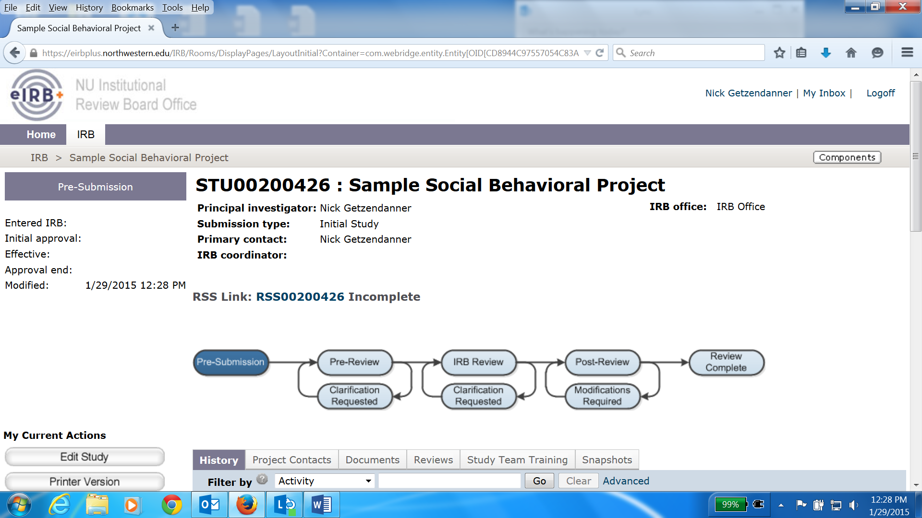

The RSS Form will need to be completed before the PI can submit the study to the IRB. A link to the form will display on the main screen for your study once you have filled out the application. To pull up the form, first click “RSS00XXXXXX” (X’s are unique to your study number)

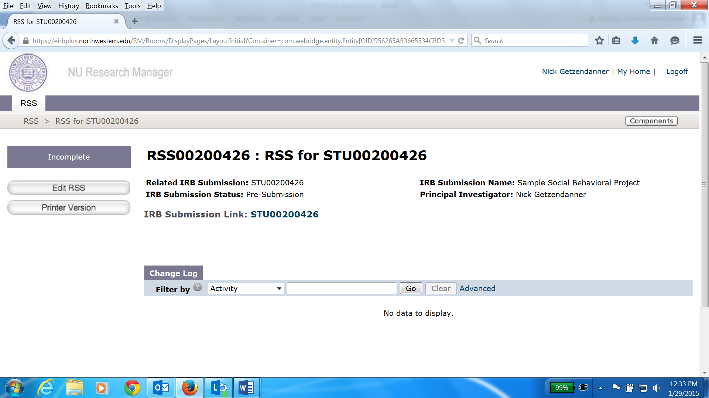

You will be routed to the above screen. From here, click the “Edit RSS” button on the left

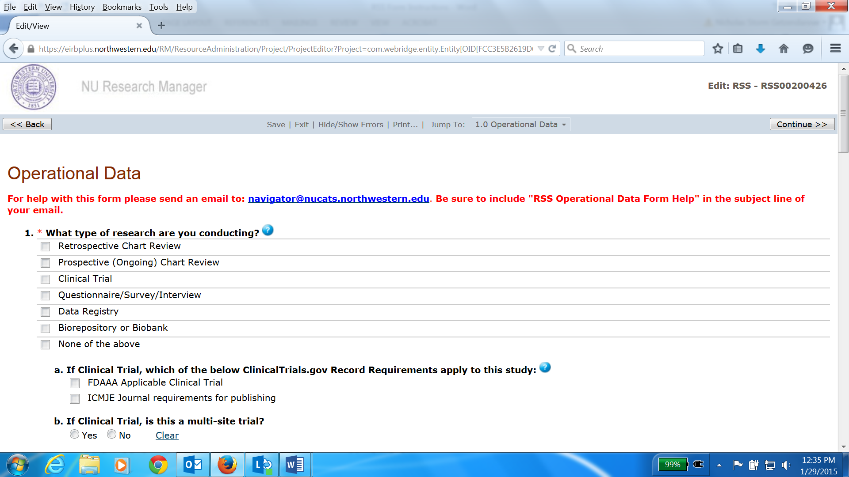

This form is not reviewed by the IRB Office. Once complete, it is routed to the Data Security team at the Feinberg School of Medicine. As you’ll see, many questions are only relevant to medical studies. “None of the above” will be the appropriate answer to Questions 1-5 unless there is a medical component to your study or Northwestern Memorial Healthcare is a study site.

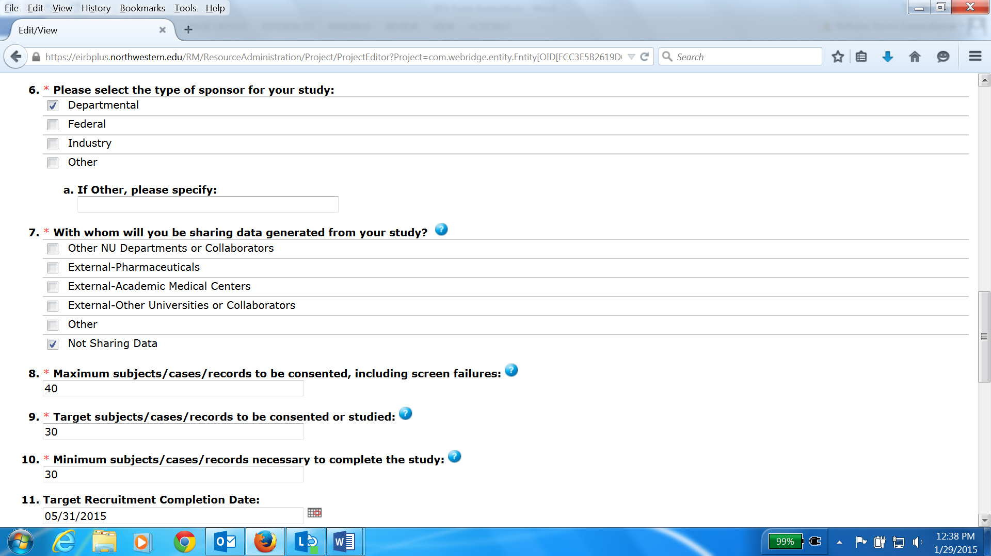

Questions 6-11 are relevant to all studies. Choose “Departmental” as the funding source for question 6, as “None” is not an option. Click the “Continue” button on the bottom right once you responded to each required question.

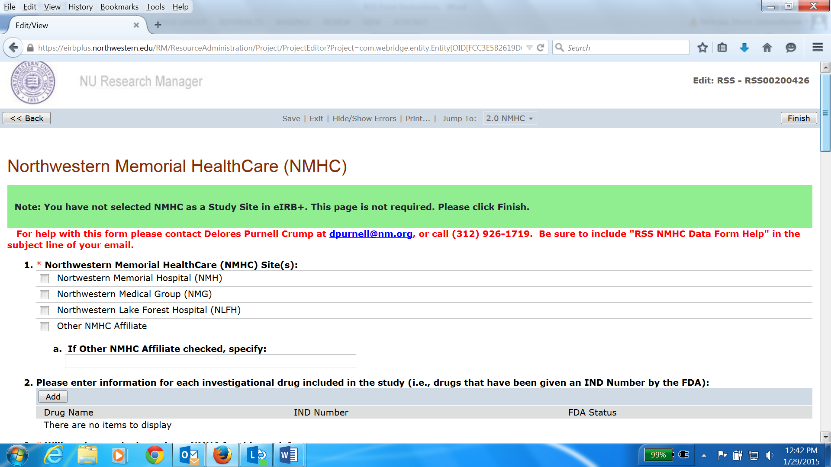

The second page has some asterisked questions, but follow the Instructions in green: You can simply click the “Finish” button on the top right if Northwestern Memorial HealthCare is not a study site.

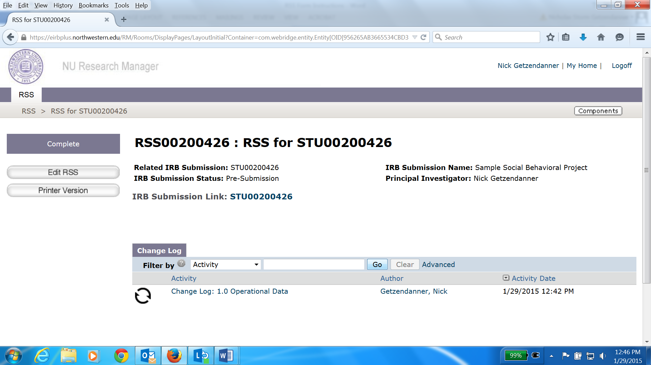

You are now done with the RSS. To return to your study application, click on the IRB Submission Link. From there, you can click the “Notify PI to Submit” button, which will trigger an email notification to your PI letting them know your study is ready for them to submit.