🧩 Estrutura modular sugerida no PostgreSQL
Abaixo segue uma proposta de modelagem evolutiva e coerente com os módulos que você listou.
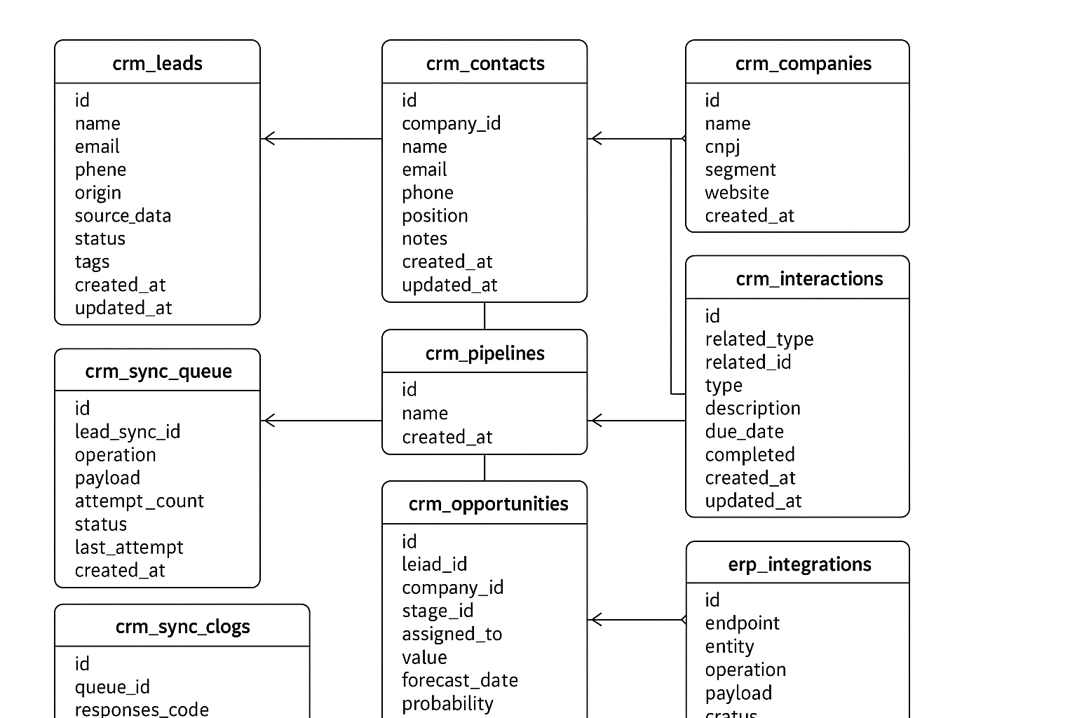

1. Módulo de Leads
CREATE TABLE crm_leads (
id SERIAL PRIMARY KEY,
name VARCHAR(150),
email VARCHAR(150) UNIQUE,
phone VARCHAR(30),
origin VARCHAR(50), -- origem: "Dinamize", "Manual", "CSV"
source_data JSONB, -- payload original se veio da API
status VARCHAR(30) DEFAULT 'new', -- new | contacted | converted | lost
tags TEXT[], -- array de tags
created_at TIMESTAMP DEFAULT NOW(),
updated_at TIMESTAMP DEFAULT NOW()
);
📥 Integração com Dinamize
CREATE TABLE crm_lead_sync (
id SERIAL PRIMARY KEY,
lead_id INTEGER REFERENCES crm_leads(id) ON DELETE CASCADE,
dinamize_contact_id VARCHAR(50),
list_id VARCHAR(50),
status VARCHAR(20) DEFAULT 'pending',
last_sync TIMESTAMP,
UNIQUE (lead_id, list_id)
);

2. Módulo de Contatos & Empresas
CREATE TABLE crm_companies (
id SERIAL PRIMARY KEY,
name VARCHAR(150) NOT NULL,
cnpj VARCHAR(20),
segment VARCHAR(100),
website VARCHAR(150),
created_at TIMESTAMP DEFAULT NOW()
);

CREATE TABLE crm_contacts (
id SERIAL PRIMARY KEY,
company_id INTEGER REFERENCES crm_companies(id) ON DELETE CASCADE,
name VARCHAR(150),
email VARCHAR(150),
phone VARCHAR(30),
position VARCHAR(100),
notes TEXT,
created_at TIMESTAMP DEFAULT NOW()
);

CREATE TABLE crm_interactions (
id SERIAL PRIMARY KEY,
contact_id INTEGER REFERENCES crm_contacts(id) ON DELETE CASCADE,
type VARCHAR(30), -- email | call | meeting | task
description TEXT,
occurred_at TIMESTAMP DEFAULT NOW()
);

3. Módulo de Vendas (Pipeline)
CREATE TABLE crm_pipelines (
id SERIAL PRIMARY KEY,
name VARCHAR(100),
created_at TIMESTAMP DEFAULT NOW()
);

CREATE TABLE crm_stages (
id SERIAL PRIMARY KEY,
pipeline_id INTEGER REFERENCES crm_pipelines(id) ON DELETE CASCADE,
name VARCHAR(100),
position INTEGER,
created_at TIMESTAMP DEFAULT NOW()
);

CREATE TABLE crm_opportunities (
id SERIAL PRIMARY KEY,
lead_id INTEGER REFERENCES crm_leads(id),
company_id INTEGER REFERENCES crm_companies(id),
stage_id INTEGER REFERENCES crm_stages(id),
assigned_to INTEGER, -- usuário responsável
value NUMERIC(12,2),
forecast_date TIMESTAMP,
probability INTEGER, -- 0-100%
status VARCHAR(30) DEFAULT 'open',
created_at TIMESTAMP DEFAULT NOW(),
updated_at TIMESTAMP DEFAULT NOW()
);

4. Módulo de Tarefas e Atividades
CREATE TABLE crm_tasks (
id SERIAL PRIMARY KEY,
related_type VARCHAR(20), -- lead | opportunity
related_id INTEGER,
type VARCHAR(30), -- reunião | ligação | follow-up
description TEXT,
due_date TIMESTAMP,
completed BOOLEAN DEFAULT FALSE,
created_at TIMESTAMP DEFAULT NOW(),
updated_at TIMESTAMP DEFAULT NOW()
);

5. Integração com Dinamize
(Complementa o modelo do arquivo Banco.odt)
CREATE TABLE crm_sync_queue (
id SERIAL PRIMARY KEY,
lead_sync_id INTEGER REFERENCES crm_lead_sync(id) ON DELETE CASCADE,
operation VARCHAR(20) NOT NULL, -- create | update | delete
payload JSONB NOT NULL,
attempt_count INTEGER DEFAULT 0,
status VARCHAR(20) DEFAULT 'queued',
last_attempt TIMESTAMP,
created_at TIMESTAMP DEFAULT NOW()
);

CREATE TABLE crm_sync_logs (
id SERIAL PRIMARY KEY,
queue_id INTEGER REFERENCES crm_sync_queue(id) ON DELETE CASCADE,
response_code VARCHAR(20),
response_detail TEXT,
response_body JSONB,
created_at TIMESTAMP DEFAULT NOW()
);

CREATE TABLE crm_auth_tokens (
id SERIAL PRIMARY KEY,
auth_token TEXT NOT NULL,
obtained_at TIMESTAMP DEFAULT NOW(),
expires_at TIMESTAMP,
active BOOLEAN DEFAULT TRUE
);

6. Módulo de Integração com ERP
CREATE TABLE erp_integrations (
id SERIAL PRIMARY KEY,
endpoint VARCHAR(200),
entity VARCHAR(50), -- cliente | pedido | fatura
operation VARCHAR(20), -- send | receive
payload JSONB,
status VARCHAR(20) DEFAULT 'queued',
last_sync TIMESTAMP,
created_at TIMESTAMP DEFAULT NOW()
);

🔁 Fluxo operacional unificado
- Novo lead entra → crm_leads
- Integração cria entrada em crm_lead_sync e crm_sync_queue
- Worker Node.js consome a fila → envia via API Dinamize
- Registra resultado em crm_sync_logs
- Atualiza status em crm_lead_sync ou agenda retry

🧠 Observações finais
Tema | Recomendação
Timezone | UTC no Postgres; America/Sao_Paulo no backend
Data types | Sempre TIMESTAMP WITH TIME ZONE se possível
Fila de reprocesso | Pode evoluir para RabbitMQ ou Redis Stream
Escalabilidade | Adicione colunas tenant_id se for multiempresa
ERP genérico | Mantenha payloads em JSONB para flexibilidade

Se quiser, posso montar o diagrama ER completo (com relações 1:N e N:N) ou gerar o SQL final compatível com Sequelize ou Prisma.
👉 Deseja que eu gere o modelo ER visual (diagrama) ou o script SQL completo formatado para execução?

