Splinters of Akatosh
Chapter 2: Bruma

The City of Bruma

City Overview
One of the first cities of men built after the Alessian Revolt, Bruma is the oldest city-state in Cyrodiil. Built into the side of a mountain, the city is layered into four major steps. At the highest step you have Castle Bruma (1), where Count Fraking runs the business of the city and outlying lands. Beneath Castle Bruma are the main estates of the four houses of Bruma (2): the wealthiest families in the region, each with historical ties to the city.

Below you have the main living quarters (8) for the citizens of Bruma. There's the Bruma Temple (3) where priests of the One hold service and prayers. There's the graveyard (4) where citizens visit to honor their fallen loved ones.
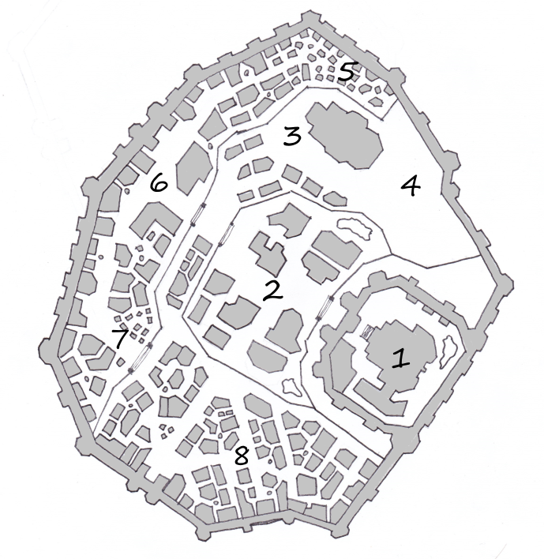
Figure 1: Map of Bruma

On the bottom level of the city you have the main southern entrance (6) where travelers can stay at the nearby Sleeping Bear Inn or have a drink with the locals at the Dripping Mead Tavern. In the shadow of the temple lie the homes (5) of the various derelict servants and unemployed beggars of Bruma. Towards the eastern gate to the city lies the various markets and merchant stalls traders will set up to attract city buyers.

District 1: Castle Bruma
Castle Bruma was built shortly after the establishment of the Alessian Empire. Situated near the border with Skyrim, Bruma was a common point of interaction between the emerging Nibanese and Nordic cultures. During it's construction, Nordic and Nibanese architects collaborated, resulting in a style that is a fusion of Nordic and Nibanese styles.

Description
Situated on the highest tier of Bruma, the castle overlooks the rest of the city. Watchmen patrols regularly emerge from the barracks located to the southwest of the main structure. The castle itself is fairly modest; it's purpose far more functional than formal. Inside there is an entrance hall, the count's throne room, a library, a servants' quarters wing to the west, a dining hall, and an assortment of guests' quarters.

People of Interest
Count Fraking the Bloody (Nord m.) is the Count of Bruma. He got his title when his brother – the heir apparent – died on his wedding night a week before his father passed away. He has been grieving ever since. His predilection for alcohol leaves him drunk most of the daylight hours, making him incapable of serving in any serious capacity as ruler. In his drunkenness he will speak with agonizing slowness, possibly frustrating the part members, especially since he knows nothing about the affairs of his city.

“A fat, drunken Nord sits the throne. His head is bare except for the count's crown, but his face is adorned with a long, messy red beard full of crumbs and sticky with mead. His tunic is too tight and his trousers too wide, exposing his midsection and leaving too little to the imagination… Not that there's anything pleasant to imagine.”

Steward Olfeig Bare-Legs (Nord m.) is the steward to the count. Due to the count's perpetually-inebriated state, Olfeig ultimately handles all the affairs of state at his desk off to the side of the throne. As such, he is a very busy man will act very distracted when the adventurers talk to him, forgetting names and details.

“A short, well-dressed Nordic man is busy reading, signing, and stamping various parchments as they come across his desk. It is clear he is quite preoccupied; he does not acknowledge you as you approach.”

Arcanist Methri Olrandottir (Nord f.) is the librarian / arcanist for the count. Hungover from dining with the king the previous evening, she is in too much pain to focus on doing any research. However if the group procures her a hangover remedy – more mead – from Methri's aunt, Grosorta Little-Hilt, she will be willing and able to help them with their research.

“A tall, thin, severe-looking Nordic woman sits behind her desk in the castle library, head in her hands as she looks down at a book. Why she bothers with the book is unclear; her eyes are closed.”

District 2: The Noble Houses
Over the years, four families have amassed enough wealth and political capital to earn a prominent spot in Bruma: the Habren (southwest), Djern (northwest), Ingrald (northeast) ,and Enren (southeast) families. While the families' land holdings extend outside the city, the heads of the households each reside on estate properties inside Bruma.

Note: This section only includes a rough outline of the families. Each family has their own quest, which describes them further

Description
Artfully crafted will care and concern, the beauty of the four estates serves two purposes. Obviously they breed envy; no house wants to admit it owns the second most elegant estate. But beneath the surface the distracting refinement of the buildings preserve the secrets and mysteries that each house keeps.

The Habren House
One of the first houses to rally troops together, House Habren boasts a long line of generals and military officers. However over the decades they diversified and went into the business of brewing the finest mead south of Skyrim.

Quest: A Mighty Meaty Mead
Patriarch: Torniid Habrensen (Nord m.)
Matriarch: Angsa Ironback (Nord f.)
Sons: Rafir, Hjangr, Fjerak (Nord m.)
Daughters: Rane, Fyra, Alena, Katra (Nord f.)
Butler: Avoras Ivathro (Dunmer m.)
Maid: Tilora Ivathro (Dunmer f.)
Other Help: Nareeza (Saxhleel m.), Balaard Gumaine (Breton m.), Nanela Barouche (Breton f.), Vigsla the Tall (Nord f.)

The Djern House
The original settlers of the region, the Djern family earned its prestige by being the property owners to most of the city of Bruma.

Quest: The Key to Piukanda
Patriarch: Jervar Djernsen (Nord m.)
Matriarch: Inalga Genadottir (Nord f., deceased)
Sons: Jolsym, Araldi (Nord m.)
Daughter-in-Law: Ysfra Voicewarden (Nord f.)
Butler: Tolfgar Seven-Brand (Nord m.)
Maid: Daeriel (Bosmer f.), Makes-Gems-Sparkle (Saxhleel f.)

The Ingrald House
The Ingrald house is descended from a noble family in Skyrim that was exiled for supporting the Alessian Empire centuries ago. Even with the Alessian-Nord relationship normalized, the Ingrald family sees itself as belonging to Cyrodiil, and has not moved back to Skyrim.

Quest: He Just Lays There
Patriarch: Geitur Ingraldsen (Nord m.)
Matriarch: Geralda Heavensbottom (Nord f.)
Son: Frenmar (Nord m.)
Daughter-in-Law: Laneia Enrendottir (Nord f.)
Guest: Elammu Vedas (Dunmer m.)
Butler: Ja-Leel (Saxhleel m.)
Maid: Hates-the-Dirt (Saxhleel f.)

The Enren House
No one quite knows how the Enren family gained as much power as it did. It seems they just had an uncanny knack for knowing just the right deals to make and wheels to grease in order to get what they wanted. After a few generations no one questioned their right to be on the second tier.

Quest: No Strings Attached
Patriarch: Holgar Enrensen (Nord m.)
Matriarch: Haema Axe-Mate (Nord f.)
Son: Toldun (Nord m.)
Daughters: Voria, Ursa, Bresa (Nord f.)
Butler: Jo'Rak (Khajiit m.)
Maid: Urmanaji (Khajiit f.)

District 3: The Temple of the One
Every major city in Cyrodiil has a temple to worship the One God of the Alessian religion. Here the citizens gather every Sundas to participate in services honoring the One.

Description
Looking exactly like every other Temple to the One in Cyrodiil, the architectural style of Bruma's temple contrasts sharply with the Nedic/Nordic city surrounding it.
The temple building itself is adorned with nine stained-glass windows. Eight of them depict the eight supreme spiritual aspects of the One. The ninth window depicts the sanctification of Alessia and the start of the Slave Revolt. The main floor consists of two long rows of pews facing the central ritual alter. Beneath the main floor lies the catacombs, where the honored dead are buried. Above lies the bell tower, from which a priest or priestess of the One will call the city to worship.

To the southeast of the temple there are various buildings for the priests and priestesses to live in. These homes, while modest by noble standards, are certainly larger than most citizens will own. It is usual for a priest to keep his family in his home.

People of Interest
Sapprio Flavello (Imperial m.) is a devoutly religious man, secretly an agent of the Marukhati Selectives tasked with finding the Blades agent in Bruma. Transferred against his will, he hates Bruma. He is very severe, finding religious fault in everyone. As well he is decisively racist against any and all elves. Normally he will roam around the city trying to criticize people into following a holier path, but recently he's been quieter than usual.

“You see a tall Imperial man wearing religious garments walking your way. His stare is stern and cold; it is as obvious that he's about to chastise you as it is clear he's very experienced at scolding others”

