This manuscript has been accepted for publication at Perspectives of Psychological Science.

A Description–Experience Framework of the Psychology of Risk

Ralph Hertwig

Max Planck Institute for Human Development, Berlin, Germany
Dirk U. Wulff
University of Basel, Switzerland

Author Note
Ralph Hertwig, Center for Adaptive Rationality, Max Planck Institute for Human Development, Berlin, Germany; Dirk Wulff, Center for Adaptive Rationality, Max Planck Institute for Human Development, Berlin, Germany, and Center for Cognitive and Decision Science, University of Basel, Switzerland.
We thank Deb Ain and Susannah Goss for editing the manuscript, Linda Kerbl for curating the references, and Tomás Lejarraga, Christina Leuker, Rui Mata, Thorsten Pachur, Christin Schulze, and Odette Wegwarth for many helpful comments.
Correspondence to concerning this article should be directed to Ralph Hertwig, Center for Adaptive Rationality (ARC), Max Planck Institute for Human Development, Lentzeallee 94, 14195 Berlin, Germany. Email: hertwig@mpib-berlin.mpg.de

Abstract

The modern world holds countless risks for humanity, both large-scale and intimately personal—from cyber warfare, pandemics, and climate change to sexually transmitted diseases and drug use and abuse. Many risks have prompted institutional, regulatory, and technological countermeasures, the success of which depends to some extent on how individuals learn about the risks in question. We distinguish between two powerful but imperfect teachers of risk. First, people may learn by consulting symbolic and descriptive material, such as warnings, statistics, and images. More often than not, however, a risk’s fluidity defies precise description. Second, people may learn about risks through personal experience. Responses to risk can differ systematically depending on whether people learn through one mode, both, or neither. One reason for these differences—and by no means the only reason—is the discrepancy in the cognitive impact that rare events (typically the risk event) and common events (typically the non-occurrence of the risk event) have on the decision maker. We propose a description–experience framework that highlights the impact of each mode of learning but also their interplay on individuals’ and collectives’ responses to risk. We outline numerous research questions and themes suggested by this framework.
Keywords: description–experience gap, information sampling, probability weighting, risk behavior, risk communication, risk perception

A Description–Experience Framework of the Dynamic Response to Risk
Some stories have to be experienced to fully grasp — the Korea crisis is one of them. I arrived in Seoul on the evening of May 28. As I was dressing for breakfast the next morning, I was jarred by a news alert ringing on my phone: North Korea had just fired a short-range ballistic missile that had landed in the sea off its east coast. I waited for the sirens to tell us to go to the hotel shelter, as happened when I was in Israel during a Hamas rocket attack. But there were no sirens. Nothing. The breakfast buffet was packed. The mood was: Another North Korean missile test? Oh, pay no attention to our crazy cousins. Could you pass the kimchi, please? (Friedman, 2017)
As Friedman’s (2017) eyewitness testimony illustrates, people’s understanding of and behaviors toward risks can sometimes be perplexing. One key factor in South Koreans’ nonchalance about missile tests may be their experience of living in the shadow of North Korea’s nuclear threat: Between the first test in 1984 and March 2020, North Korea carried out 147 missile tests, conducted six nuclear test explosions, and repeatedly verbally abused its neighbor to the south (Arms Control Association, 2020). Having experienced over three decades of tests and bluster, most South Koreans seem to agree that a barking dog never really bites. Yet despite collectively shrugging at missile launches, South Koreans responded vigilantly and forcefully to the COVID-19 threat while most other countries and their citizens were still idling (Sang-Hun, 2020). According to The Wall Street Journal, the “key to South Korea’s success came from blending technology and testing like no other country, centralized control and communication—and a constant fear of failure” (T. W. Martin & Yoon, 2020). Many observers pointed out that these rapid and concerted efforts were probably a result of the country previously having found itself on the brink of a pandemic after an outbreak of the Middle East respiratory syndrome coronavirus (MERS-CoV) in 2015, when the authorities’ blundering response—characterized by government secrecy, poor infection control, and a general lack of preparedness—sparked panic (Jack, 2015).
Experience matters. Yet it is not the only way of learning about risks and their magnitude. Another powerful teacher is description, in the form of written warnings, media coverage, health and accident statistics, fact boxes, or infographics. Figure 1 shows a paradigmatic description-based form of risk communication, a fact box. Fact boxes are simple tools that summarize the best available evidence about the harms and benefits of a medical intervention or health behavior—here, the prescription of antibiotic treatment in children with an acute middle ear infection (Brick, McDowell, & Freeman, 2020)—in table form. Like experience-based learning, learning about risks from descriptions can also trigger a variety of responses, from compliance to backfire effects (Andrews, 2011; Steinhart, Carmon, & Trope, 2013).

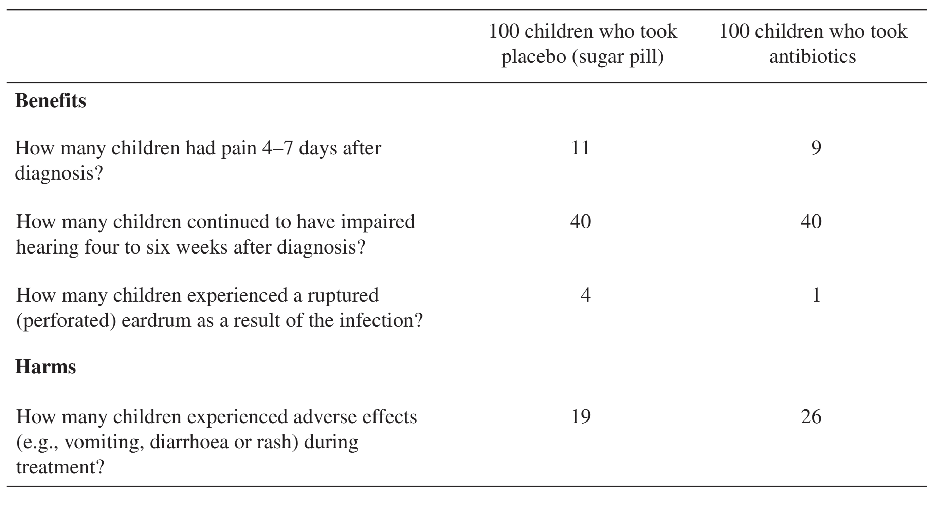

Figure 1. Example of a fact box. A fact box is a simple tabular summary of the best available evidence about the benefits and harms of a medical procedure, treatment, or health behavior. This fact box describes the outcomes for children 0–15 years of age with an acute middle ear infection who received either antibiotics or placebo (sugar pill) over a period of 7–14 days. Adapted from “Risk Communication in Tables Versus Text: A Registered Report Randomized Trial on ‘Fact Boxes’” by C. Brick, M. McDowell, and A. L. Freeman (2020), Royal Society Open Science, 7(3), 190876. Copyright will be obtained at acceptance.

As these examples show, the human response to risk is not of one kind. People respond in distinct and sometimes bewildering ways to one and the same risk; their responses can change over time, and behaviors can comply with or fly in the face of expert recommendations. We propose that one insight that can help discern a structure behind this behavioral diversity is that laypeople and experts alike learn about risks and their magnitude via two distinct modes: description and experience. In some circumstances, people have recourse to both learning modes; in others, they must rely on just one. For instance, physicians can both consult health statistics to evaluate the risks of a medical intervention and draw on their own experience of treating patients and monitoring the effects of the intervention in question. Patients, on the other hand, initially have no experience with the intervention; they can only refer to summary descriptions of benefits and harms such as fact boxes (Figure 1); with time, however, they move from being an ‘experiential blank slate’ to an ‘experiential authority’ (e.g., experiencing the consequences of long-term use of strong opioids; Schulte et al., 2021). Furthermore, the lessons that description and experience convey do not necessarily converge; they sometimes contradict each other. The opinions of experts and laypeople often diverge when one group draws on experience and the other on descriptions of risks. We suggest that research into the description–experience distinction and the effects of these two powerful but imperfect teachers of risk will help provide a clearer picture of how people perceive and respond to risk.
This description–experience view on human responses to risk complements other frameworks of risk perception, such as the psychometric approach (Slovic, 1987), social amplification of risk (Kasperson et al., 1988), and information framing (Peters, Hart, & Fraenkel, 2011), by drawing attention to the process of learning about risks and to the statistical properties of risk events (see also Rogers, 1997). To shed light on learning and the sometimes collaborative, sometimes competitive interplay of symbolic descriptions and personal experience, we turn to a longstanding line of research: risky choice between monetary gambles. Although our ultimate concern is with the psychological response to real-world risks, and not with choice in experimental contexts, this line of research has accumulated valuable evidence for predicting human response to risk, particularly through its innovative investigation of the description–experience gap.

The Description–Experience Perspective in Risky Choice
There is a time-honored tradition of using monetary gambles to examine how people respond to risk—whether by means of thought experiments (e.g., Bernoulli, 1738/1954) or behavioral experiments (e.g., Allais, 1953). This fondness for gambles is understandable. Monetary gambles embody what many consider to be the building blocks of real-world choice options: an option’s potential outcomes and the probabilities of those outcomes (Lopes, 1983). These are the pillars of influential choice models such as expected value theory, expected utility theory, and cumulative prospect theory. When studying human choice between monetary gambles, most scholars have relied on gambles in which all information about the options’ outcomes and their probabilities is explicitly stated or symbolically represented (e.g., in pie charts). Consider the following gamble pair (from Kahneman & Tversky, 1979):
A: 50% chance to win 1,000 [shekels], B: 459 [shekels] for sure.
50% chance to win nothing.
All possible information is stated, leaving people to make a decision from description (see Hertwig & Erev, 2009). Such decisions from description are sometimes also possible in the real world: Weather forecasts, actuarial tables, and mutual-fund brochures all offer descriptions of possible outcomes and their probabilities. Yet many human behaviors—falling in love, conducting job interviews, crossing the street—come without a manual detailing the possible outcomes and their probabilities. Instead, people can draw on their personal experiences, thereby making decisions from experience (Hertwig, 2015; Hertwig & Erev, 2009; Wulff, Mergenthaler Canseco, & Hertwig, 2018).

The Description–Experience Gap
Experimental research on decisions from experience has typically involved a simple experimental tool: a “computerized money machine” (Wulff & Hertwig, 2019; Wulff, Markant, Pleskac, & Hertwig, 2019) in which people are usually shown two buttons on a computer screen, each one representing an initially unknown payoff distribution. Each click of a button implements a random draw from one distribution (such as option A or B in the choice problem above). Figure 2 shows the three main variants of this money machine (see Hertwig & Erev, 2009). The choices that people make in these experimental paradigms are then compared with choices made from stated outcomes and probabilities (decisions from description).
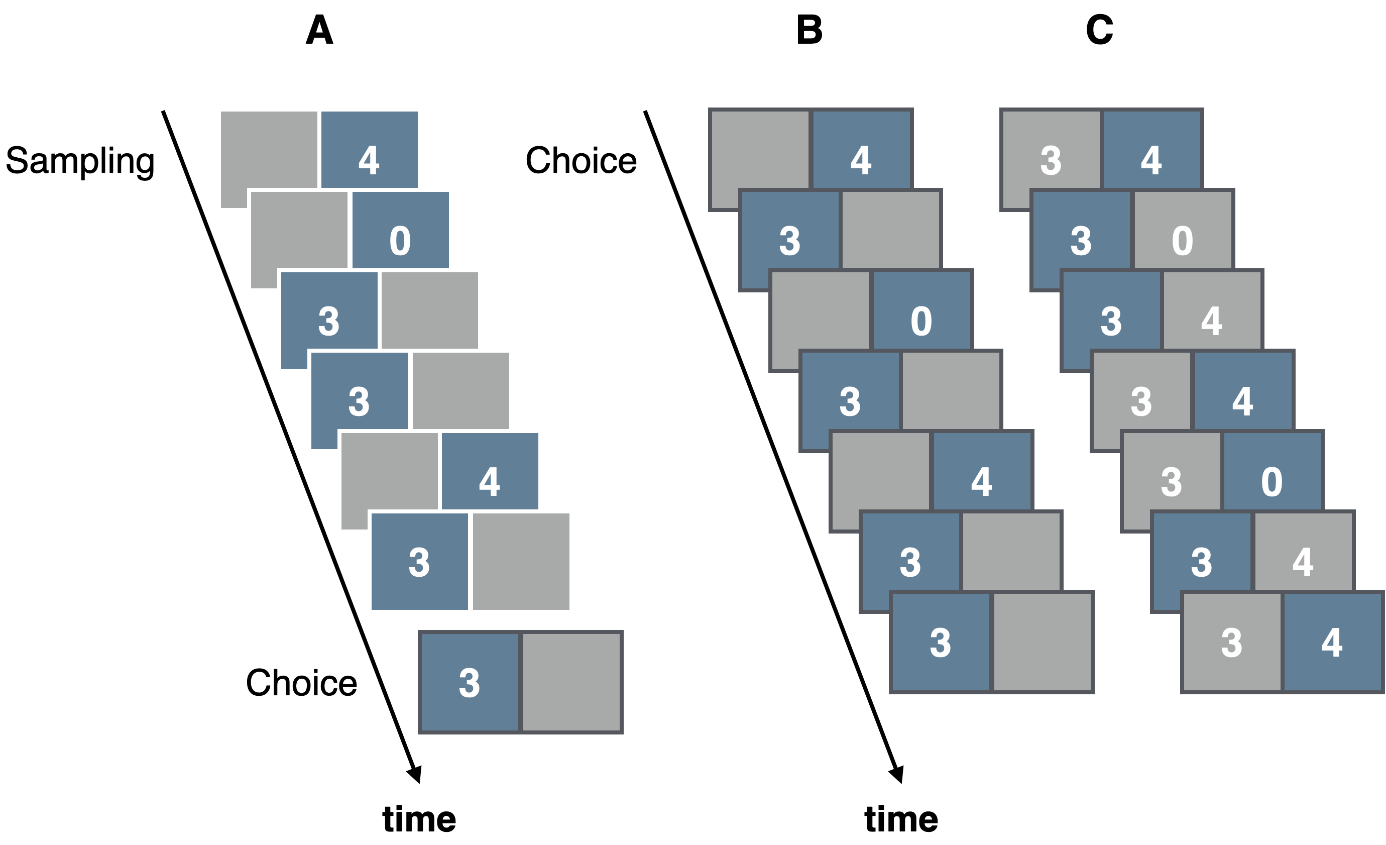
Figure 2. The three main paradigms for investigating decisions from experience: the sampling paradigm (A), the partial-feedback paradigm (B), and the full-feedback paradigm (C). The sampling paradigm consists of an initial sampling stage (represented by six fictitious draws, shown in blue) in which a person explores two payoff distributions without costs by clicking on one of the two buttons on the computer screen. After completing sampling, the person sees a choice screen (framed in black) and is asked to make a final choice. The partial-feedback paradigm collapses sampling and choice; thus, each draw represents an act of both information seeking (exploration) and taking advantage of what one has learned (exploitation). The full-feedback paradigm is identical to the partial-feedback paradigm, except that it also provides feedback on the forgone payoff—that is, the payoff the person would have received, had they chosen the other option (shown in grey).

As a substantial body of research has shown, decisions from description and decisions from experience can lead to systematically different choices. While there are different ways to define and illustrate this description–experience gap (see Rakow & Newell, 2010; Wulff et al., 2018), the results are surprisingly similar. One approach is shown in Figure 3. The graph plots the differences in choice proportions from experienced-based and description-based gambles across a large set of choices with different outcomes and probabilities (in the sampling paradigm). The choice proportions differ systematically as a function of the true probability of the rarest outcome in the choice problem: In decisions from description, people choose as if they give more weight to (“overweight”) rare events than these events deserve in light of their objective probabilities. For illustration, consider a choice between two options:
A: 10% chance to lose 32, B: 100% to lose 3.
90% chance to lose nothing.
In this choice, most people choose B, the safe option (e.g., Hertwig et al., 2004), consistent with the weighting of rare events as postulated by cumulative prospect theory (Tversky & Kahneman, 1992). Here, overweighting the 10% chance of losing 32 renders option A less attractive than it would be otherwise, thus boosting the relative attractiveness of option B. In decisions from experience, in contrast, people choose as if they give less weight to (“underweight”) rare events than they deserve in light of their objective probability. In the choice task above, this translates into most people choosing the risky option A (Hertwig et al., 2004) and thus acting as if they underweight the chance of losing 32. Let us emphasize that the notion of weighting as used in this illustration is meant in an as-if sense—that is, people choose as if rare events had more or less impact than they deserve. Furthermore, as-if weights refer to the objective probabilities of the outcome distributions and not to the relative frequencies with which people actually experience the events (see also Regenwetter & Robinson, 2017); in sampled experience, objective probabilities and experienced frequencies can differ. Having said this, the as-if weighting pattern observed in decisions from experience has attracted much attention because it contradicts the pattern assumed in (cumulative) prospect theory (CPT). CPT’s key assumption of overweighting of low-probability events has been invoked to explain a wide range of tangible real-world behaviors, such as the purchase of lottery tickets (suggesting overweighing of the low probability of a win) and—somewhat paradoxically because the two behaviors signal opposite risk attitudes—the purchase of insurance policies (suggesting overweighing of the low probability of a loss; e.g., Camerer, 2000).

Figure 3. The description–experience gap as a function of the probability of a rare event. The figure displays the differences in the proportion of description- and experienced-based choices. Values larger than zero indicate more as-if underweighting in experience than in description. The blue dots show the aggregate results for bins of size .04 in terms of the true probability of the rarest event and standard errors based on random effects meta-analysis. Adapted from “A Meta-Analytic Review of Two Modes of Learning and the Description–Experience Gap,” by D. U. Wulff, M. Mergenthaler-Canseco, and R. Hertwig, 2018, Psychological Bulletin, 144(2), Figure 3. Copyright will be obtained at acceptance.

The systematic gap in choice proportions from experienced-based and description-based gambles can be substantial (see Figure 3); for probabilities of 5% and lower, the average gap amounted to 13.3 percentage points. More generally, Wulff et al.’s (2018) meta-analysis of studies with the sampling paradigm found that when a choice involves a risky and a safe option—the type of choice often used to measure risk preference behaviorally in economics and psychology (see Hertwig, Wulff, & Mata, 2019)—the average gap size amounts to 18.7 percentage points; when a choice involves two risky options, the gap is 7 percentage points. Similar gap sizes of 22.7 and 7.9 percentage points, respectively, for the two problem types have been observed for the partial-feedback paradigm (see Wulff et al., 2018, Appendix C). Furthermore, the description–experience gap is not limited to risky choice. It has been observed in diverse reasoning and choice domains, including intertemporal choice (Dai, Pachur, Pleskac, & Hertwig, 2019), social interaction in strategic games (Isler, Kopsacheilis, & van Dolder, 2020; J. M. Martin, Gonzalez, Juvina, & Lebiere, 2014), ambiguity aversion (Dutt, Arló-Costa, Helzner, & Gonzalez, 2014; Güney & Newell, 2015), consumer choice (Wulff, Hills, & Hertwig, 2015), financial risk taking (Lejarraga, Woike, & Hertwig, 2016), medical judgments and decisions (Armstrong & Spaniol, 2017; Fraenkel, Peters, Tyra, & Oelberg, 2016; Lejarraga, Pachur, Frey, & Hertwig, 2016; Wegier & Shaffer, 2017), adolescent risk taking (van den Bos & Hertwig, 2017), categorization (Nelson, McKenzie, Cottrell, & Sejnowski, 2010), confidence estimates (Camilleri & Newell, 2019; Lejarraga & Lejarraga, 2020), causal reasoning (Rehder & Waldmann, 2017), and visual search (Zhang & Houpt, 2020).
These findings suggest that the distinction between description and experience is relevant for cognition and behavior more generally, although not all of the above instances are necessarily characterized by over- and underweighting of rare events (see, e.g., Lejarraga, Woike, et al., 2016; van den Bos & Hertwig, 2017). The systematic gap in the implied impact of described and experienced rare events can thus be expected to be relevant for risk perception and behavior beyond monetary gambles, to the extent that rarity is a key property of real-world risks (see also J. M. Martin et al., 2014). Pandemics, serious side effects of vaccination, and car accidents are—fortunately—all rare events, although their fatality rates may follow different distributions (e.g., thin-tailed vs. fat-tailed; Cirillo & Taleb, 2020) and impact individuals or collectives. Before we explore the implications of the experience–description distinction for risk perception and risk behavior, let us take a closer look at some key properties of experience and description.
Attributes and Ambiguities of Description and Experience
In this section, we draw on Hertwig, Hogarth, and Lejarraga’s (2018) conceptual (and admittedly incomplete) characterization of description and experience as two major paths to knowledge. In their view, descriptions can be understood as externalized symbolic representations of knowledge—written or spoken words, numbers, or images that can pertain to any kind of knowledge (e.g., propositional, causal, procedural, or episodic). Of particular relevance in the context of risk communication, descriptions need not be bounded by time and place and can inform individuals about unlikely events, things that have not (yet) materialized (e.g., the long-term consequences of climate change), or things that nobody will ever experience (Pinker, 2007). Equally important, people can refer to descriptions to learn about the possible detrimental consequences of actions without needing to pay the price of experiencing them. Learning from description is one of the key engines of cultural evolution and the sharing of knowledge (Richerson & Boyd, 2005) and is a quintessentially human competence.
Descriptions are abstractions in that they necessarily reduce and summarize the multidimensionality of individual or collective experience; without such reduction they could not be efficient representations of knowledge. But not all abstractions of the world are descriptions: Internal representations in terms of mental models, for instance, are not descriptions. Yet when those representations travel from the mind of the individual to the world in the form of stories, warnings, or testimony, they become descriptions and thereby accessible to others. Descriptions need authors—speakers, writers, or users of symbols. Whereas the spoken word fades quickly, the written word may be permanent. What is more, the mere symbolic presentation of an event can (unduly) increase its psychological impact—a phenomenon again of particular relevance in the context of risk communication that Erev, Glozman, and Hertwig (2008) referred to as the mere-presentation effect. For instance, Gregory, Cialdini, and Carpenter (1982) demonstrated that asking people, through the use of external representations, to imagine certain events (e.g., committing an armed robbery and getting arrested) led to an increase in the estimated likelihood of those events and sometimes even influenced people’s behavior. Relatedly, Hasher, Goldstein, and Toppino (1977) observed that confidence in the truth of an assertion increases after the repeated presentation of that assertion, independent of its truth or falsity (Hertwig, Gigerenzer, and Hoffrage, 1997, dubbed this the reiteration effect). In short, despite their key role in the transfer of knowledge, descriptions are not without ambiguities. They typically require interpretation and can sometimes be misleading. Gigerenzer, Gaissmaier, Kurz-Milcke, Schwartz, and Woloshin (2007) highlighted some paradigmatic cases of misleading descriptions in the communication of health risks.
Experience is the process and result of living through events (see Hertwig et al., 2018; March, 2010). It can have physiological (e.g., pain or pleasure), cognitive (e.g., information) and subjective (e.g., unpleasantness) aspects; sometimes it has predominately informational value and sometimes informational and material effects co-occur and conflict (i.e., the exploration–exploitation trade-off; Sutton & Barto, 1998; see also Figure 2). Experience can be used to evaluate past actions and guide future ones (March, 2010). Positive experience with an option increases the probability of that option being chosen in the future; negative experience has the opposite effect (Denrell & March, 2001). Although undergoing an experience may require effort, learning from experience is often relatively effortless and immediately authoritative for the individual concerned. Organisms automatically make inferences, abstractions, or generalizations based on their experiences. Sometimes gathering experience of the risk of harm is voluntary (e.g., going downhill skiing and potentially getting injured); sometimes the environment imposes the risk (e.g., experiencing the health risks of record temperatures in a heatwave).
Although anchored in the reality of the individual, the interpretation of experience can be ambiguous for several reasons (March, 2010), such as noise due to errors in observation, truly stochastic structures in the world, and the importance of learning not only from actual events but also from those that could have occurred, but did not. Among the many open issues surrounding experience is the question of what should count as personal experience and, relatedly, to what extent vicarious experience has the attributes of personal experience. A vicarious experience is commonly understood as an empathetic state in response to the observation of others’ sensations, emotions, and actions (Keysers & Gazzola, 2009). Vicarious experiences appear to recruit neural processes similar to those involved in the primary experience of a sensation, emotion, or action (e.g., Singer et al., 2004).
Another source of ambiguity is that experience typically represents a momentary sample. Just how representative this sample is for the risk event in question depends on many factors, including the risk event’s statistical structure (e.g., Cirillo & Taleb, 2020), people’s ability to take into account biases in the sampling process and the sample (e.g., Fiedler & Juslin, 2006; Hogarth, Lejarraga, & Soyer, 2015), the risk event’s temporal dynamic (e.g., immediate or delayed consequences or gradual change in the risk), the extent to which people are disinterested observers or act in the pursuit of goals that may impact a risk’s likelihood (Le Mens & Denrell, 2011), and the strength and detectability of an experiential signal (e.g., rising yearly temperature) relative to the noise of random fluctuation around a central trend (Weber & Stern, 2011).
Let us conclude by emphasizing that although we have presented description and experience in terms of as a dichotomy, and one that carries substantial heuristic value, we actually see them as poles on a continuum—for example, learning on the basis of a description can also form an experiential episode. It follows that some descriptive formats retain more of the qualities of the original experience than others (e.g., stories vs. statistics; natural frequencies vs. probabilities; consumer reviews vs. ratings; see also Wulff, Hills, & Hertwig, 2015).

The Description–Experience Distinction and a Fourfold Pattern of Epistemic States
In principle—if we work with the model of a description–experience dichotomy (see Hertwig et al., 2018)—there are four epistemic states in which people can find themselves when faced with a decision involving risk. In this section, we outline these epistemic states and draw on empirical findings on the description–experience gap to suggest specific regularities in people’s responses to risk within each of those states. This exercise in extrapolation promises to yield interesting insights and to reveal research questions that would benefit from systematic investigation.
Consider the decision of whether to vaccinate a child against measles, mumps, and rubella (MMR). Both options—to vaccinate or not to vaccinate—carry potential benefits and harms. Parents and physicians can learn about the statistical probabilities of these outcomes through description, experience, both, or neither. The result is a fourfold pattern of epistemic states (see Figure 4).

Description Only: As-If Overweighting of Rare Events
The first epistemic state (Figure 4, upper left cell) could represent the knowledge state of a first-time parent who lacks personal experience with the probabilistic consequences of having a child vaccinated and therefore needs to consult descriptions of possible outcomes and their probabilities. But not all descriptions are the same. Let us assume that a parent is unwittingly directed—via algorithm recommender systems and through motivated reasoning—to vaccine-critical websites that focus on severe reactions to vaccination (see Betsch, Renkewitz, Betsch, & Ulshöfer, 2010), including the refuted link with autism (Taylor, Swerdfeger, & Eslick, 2014). Generalizing the as-if probability weighting pattern introduced earlier, rare risks will loom larger than they ought to in light of their objective probabilities. For instance, 2–16 children in every 10,000 receiving the MMR vaccination (p = .0002 to .0016) are reported to experience febrile seizures (Harding Center for Risk Literacy, 2016). All other things being equal, a parent exposed to this information may overweight the rare harm of the vaccine relative to its linear weighting, and be more inclined to decide against vaccinating their child. Alternatively, a parent may come across a fact box (as introduced in Figure 1), which would also report another rare risk: that of dying from the measles virus. It is estimated that 9–28 out of every 10,000 people exposed to the measles virus who are not vaccinated die, relative to 0–2 of those who are vaccinated. Assuming that the rare risk of dying from the virus (without vaccination) and the rare risk of harm triggered by the vaccination are now both overweighted, and all other things being equal, the psychological impact of the latter will no longer be selectively amplified.

Figure 4. Fourfold pattern of epistemic states for the risk event of vaccinating one’s child against measles, mumps, and rubella (MMR vaccine). The fourfold pattern arises from the absence/presence of experience (vaccination icon) or description (fact box) of the benefits and harms of vaccination. The stylized MMR fact box was modeled on the original MMR fact box (Harding Center for Risk Literacy, 2016) with permission from the Harding Center for Risk Literacy.

From a public health point of view, the overweighting of rare side effects in the vaccination scenario is an undesirable outcome. However, overweighting rare events can also result in desirable policy outcomes. Consider the risk of secondhand smoke, which is estimated to have caused more than 7,300 lung cancer deaths in the United States each year from 2005 to 2009 (Centers for Disease Control and Prevention, 2018). This is a relatively rare outcome given that approximately 58 million people in the United States were exposed to secondhand smoke in 2013–2014 (Tsai et al., 2018). Explicit descriptions of the threat of secondhand smoke and its risks (e.g., lung cancer) may lead people to overweight these relatively rare risks. This, in turn, may make smokers, nonsmokers, and policymakers more likely to act—for instance, by endorsing restrictions on smoking areas.
Not all descriptions contain information on probabilities. Consider a simple warning that secondhand smoke is detrimental to a person’s health. According to support theory (Rottenstreich & Tversky, 1997), the judged probability (or frequency) of health risks of secondhand smoke will, all other things being equal, increase when this generic warning is unpacked into its components (sudden infant death syndrome, asthma attacks, lung cancer, heart disease, etc.; Centers for Disease Control and Prevention, 2019b). People would thus tend to overestimate the likelihood of each component risk relative to the probability of the inclusive event ‘health risks of secondhand smoke.’ In principle, as-if overweighting of stated small probabilities and overestimating of small probabilities of stated events (e.g., lung cancer due to secondhand smoke) can collude to boost the psychological impact of a rare risk (see also Viscusi, 1990; Viscusi & Hakes, 2008; but also Slovic, 2000a,b). When this amplified risk represents a harm, and all other things being equal, people will be more risk averse than they would otherwise be.

Experience Only: Varying Weighting Patterns of Rare Events
The second epistemic state (Figure 4, lower right cell) could represent the knowledge state of a physician who prefers to ignore statistics in favor of making decisions based on their own experience of administering the MMR vaccine. How much experience is required for that physician to encounter the side effect of a vaccine-related seizure a single time? Figure 5 plots the data. On average, a physician would need to administer 3,466 MMR shots (assuming a prevalence of 2 in 10,000; Harding Center for Risk Literacy, 2016) to experience a child having a vaccine-related seizure with 50% probability. To experience this side effect with near certainty (99%), they would have to administer a whopping 23,024 MMR shots. Because the side effects of the MMR vaccine are rare, the physician is thus unlikely to have ever experienced them first hand.
Figure 5. What rarity means in experience: The probability of experiencing a child having the side-effect of a vaccine-related seizure as a function of MMR vaccine shots administered (assuming a prevalence of 2 in 100,000; Harding Center for Risk Literacy, 2016).

As-if underweighting of rare events
Generalizing the common probability-weighting pattern from research on the description–experience gap to this epistemic state, one may expect this physician to behave as if they underweight rare risks (and also possibly delayed risks; De La Maza, Davis, Gonzalez, & Azevedo, 2019). Their experience tells them that rare events are indeed rare. Consequently, when this attenuated risk represents a harm, and all other things being equal, they will be less risk averse than they would otherwise be. This behavior may also contribute to phenomena such as post-surgery opioid overprescription (Thiels et al., 2017). Underweighting is most pronounced with very limited experience, since a rare event is particularly unlikely to arise in a small sample. But as-if underweighting of rare events can occur even with ample experience—for instance, when a physician’s small sample of recent relevant experience has more sway than their ample past experience (e.g., because it is better remembered) or when a physician has ample experience but relies on just a few episodes (see Stewart, Chater, & Brown, 2006) when making a decision. Finally, a cognitive process according to which a person makes choices by focusing on similar clusters of experience also implies reliance on small samples (Plonsky, Teodorescu, & Erev, 2015).

As-if overweighting of rare events: The hot-stove effect and experiential refractory periods
Although, on the aggregate level, as-if underweighting of rare events in experience is a robust pattern (see Hertwig et al., 2019), experiential dynamics can also create the opposite effect. The hot-stove effect refers to a behavior that initially yielded a very adverse outcome and can therefore give rise to a powerful bias that prevents the organism from repeating this behavior (Denrell, 2005, 2007; Denrell & March, 2001). A cat that sits on a hot stove-lid may never approach another one, regardless of its temperature (Twain, 1897, p. 124). The cat behaves as if it overweights the (possibly) rare event of getting burned. The likelihood of a hot-stove effect depends on a number of factors, such as whether the organism can take precautionary actions (e.g., turning off the stove), the causal model the organism employs (e.g., believing that lightning never strikes twice), and the kind of feedback they receive (e.g., whether they get feedback on what would have happened had they chosen the forgone action). On a related note, the Depression-babies effect (Malmendier & Nagel, 2011) describes the phenomenon that people who live through macroeconomic shocks (e.g., the Great Depression) subsequently take fewer financial risks. Experimental research has also demonstrated that extreme negative outcomes, once experienced, may have disproportionate sway on people’s decisions (Ludvig, Madan, & Spetch, 2014; Lejarraga, Woike & Hertwig, 2016; Spitzer, Waschke, & Summerfield, 2017), making people more risk averse then they would otherwise be. The coronavirus pandemic may be such a negative outcome that profoundly changes the risk preferences of those who live through it.
Importantly, experience-induced risk aversion for harmful events can be transient, especially if the action in question is unavoidable (Le Mens & Denrell, 2011) or a person has the chance to observe outcomes for an option they did not choose. After an action has resulted in harm, a person is likely to be on the alert and behave as if they overweight the risk, at least during what could be called an experiential refractory period (see also Plonsky et al.’s, 2015, notion of a wavy recency effect). The duration of this period likely depends on factors such as the magnitude of the experienced harm. For instance, a study of young drivers found that the likelihood that a driver engaged in behaviors indicative of risky driving (i.e., rapid starts, hard stops, and sharp turns) dropped significantly after a severe collision, relative to a pre-collision period, and that this difference persisted for at least two months after this event (O’Brien, Bible, Liu, & Simons-Morton, 2017), with psychological distress remaining elevated for up to three years post-collision if they were injured (Craig et al., 2016). In the third month after the collision, risky behaviors rebounded significantly (though remaining lower than before the collision), even though both groups of drivers, with and without experience of a collision, displayed a gradual decrease in the rate of risky behavior across time. One interpretation of the rebound effect is that the psychological impact of the rare event appears to wane as the driver accumulates safe driving experience after the collision. Of course, there are likely to be substantial individual differences in how people respond to accidents (Spektor & Wulff, 2021).

Experience and Description: Does One Overrule the Other?
The third epistemic state (Figure 4, upper right cell) features both description and experience. This could be the epistemic state of a physician who has read the MMR health statistics and also has a wealth of experience administering the vaccine, or of a person who is aware of statistics on the risk of sexually transmitted diseases (STDs) and has had unprotected sex. Do these two types of risk representation—description and personal experience—integrate, or does one drown out the other? It is commonly thought that descriptive warnings are often ignored and may even backfire (Andrews, 2011; Steinhart et al., 2013). Meta-analyses on the efficacy of warnings have highlighted factors that shape their success, such as intended behavioral outcome, audience characteristics, message content, and delivery modes (e.g., Argo & Main, 2004; Purmehdi, Legoux, Carrillat, & Senecal, 2017). While such analyses are important for designing more effective warnings, it is also important to consider the target audience’s experiential starting point.
In the context of syphilis, for example, the proper use of condoms reduces the risk of contracting the disease. But a warning about the risks of unprotected sex may run counter to a person’s experience of having had unprotected sex without negative repercussions. Indeed, in 2018, there were 10.8 cases of syphilis per 100,000 people in the United States (Centers for Disease Control and Prevention, 2019a). Assuming that someone needs to come into direct contact with a syphilis sore just once to become infected, they would need to have sex with 6,418 people to reach a 50% probability of contracting syphilis. Experience of safe encounters can thus potentially thwart a warning’s ability to shape behavior. This dynamic may also help explain why early climate change warnings were relatively ineffective (Weber, 2006; Weber & Stern, 2011).
Several key factors determine the relative impact of description and experience in decision making. Timing is one: When a warning coincides with the start of a decision-making process, it receives more weight than when it follows safe experiences (Barron, Leider, & Stack, 2008). Warnings at the outset of a decision-making process can also induce safer behaviors in future decisions because the first instance is established as the default. Complexity is another factor: The impact of description on experience-based choice decreases when the tasks—and thus the task descriptions—become too complex (Weiss-Cohen, Konstantinidis, Speekenbrink, & Harvey, 2018; see also Lejarraga, 2010). Generally speaking, experience often seems to take precedence over description, which sometimes gets ignored altogether in decision making (Erev, Ert, Plonsky, Cohen, & Cohen, 2017; Lejarraga, 2010; Lejarraga & Gonzalez, 2011; Weiss-Cohen, Konstantinidis, Speekenbrink, & Harvey, 2016). In a powerful analysis of 14 choice anomalies (e.g., reflection effect, certainty effect, Petersburg paradox), most of the well-known description-based choice phenomena were found to be eliminated or reversed after a few experienced-based choices with feedback; the authors concluded that “the quantitative effect of experience can be large … even when the decision makers can rely on complete description of the incentive structure” (Erev et al., 2017, p. 393; see also Jessup, Bishara, & Busemeyer, 2008; Lejarraga & Gonzalez, 2011). Finally, moving from the lab to the field, a review of the risk perception of natural hazards showed that personal experience and the lack thereof constitute “a strong factor in risk perception” (Wachinger, Renn, Begg, & Kuhlicke, 2013, p. 1059).

Neither Experience Nor Description: Unknown Territory
In this epistemic state, neither descriptions nor experience exist (Figure 4, lower left cell). This state is perhaps best captured by the notion of ‘unmeasurable uncertainty’ initially developed by Knight (1921) and Keynes (1937, 1973; see also Kozyreva & Hertwig, 2021). Unmeasurable uncertainty arises when there is no valid system of classification and no empirical evidence on the basis of which numerical measures can be assigned to one’s degrees of belief. This is unknown territory—no experience has been gathered and no description of the probability structure of the risky phenomenon in question is possible. Here, research on the description–experience gap is mute. This may have been the epistemic state in which researchers in Wuhan found themselves when reports of a new infectious disease (COVID-19) began to emerge. Initially, there was no valid basis for testing and classifying patients or tabulated evidence allowing epidemiologists to judge the disease’s key parameters. In situations of unmeasurable uncertainty, one may hope to draw on simple heuristics (e.g., win-stay, lose-shift) and on knowledge gathered in the past or by others (vicarious learning). But any kind of mapping and similarity relationship—is the new virus more like a common cold or more like MERS?—or other cognitive process (e.g., analogical reasoning, construction of mental models) involves navigating the twilight of uncertainty.

New Research Questions and Themes
Our key point is that human responses to risks—complex, sometimes contradictory, sometimes self-defeating—will be better understood and predicted if researchers begin to systematically examine and model the two modes of learning about risk and their interplay. The description–experience framework we have outlined suggests a number of interesting lines of research, including the following.

Cherchez l’Expérience: A Heuristic For Understanding Perplexing Risk Behaviors
Examples of puzzling human responses to risk abound. South Koreans who have vigilantly fought COVID-19 while blithely brushing aside the prospect of nuclear annihilation are just one example (Sang-Hun, 2020). And it is often the case that experts and laypeople do not see eye to eye about a given risk (e.g., Bostrom, 1997; Sjöberg, 1999; Slovic, Fischhoff, & Lichtenstein, 1985). For instance, nearly 800,000 residents live in the red zone of Mount Vesuvius, Europe’s “ticking time bomb” (Barnes, 2011, p. 140), ignoring both dire warnings from volcanologists (Mastrolorenzo, Petrone, Pappalardo, & Guarino, 2010; Mastrolorenzo, Petrone, Pappalardo, & Sheridan, 2006) and the incentive of cash payouts for moving (Barberi, Davis, Isaia, Nave, & Ricci, 2008; Bruni, 2003).
One approach to understanding these calm responses in the face of Armageddon is to analyze individual and collective experience with the risk in question. For instance, most residents of the red zone have never experienced Mount Vesuvius erupting—the last eruption was in March 1944. One illustrative but admittedly simplistic way to think about the impact of such a long ‘all-clear experience’ on a person’s risk beliefs is in terms of Laplace’s rule of succession. For instance, ‘modeling’ the experience of a resident who has lived in the red zone for the last 20 years, the rule would suggest that the resident can be nearly certain (.999) of the next day being another ‘all-clear’ day.
Given people’s seemingly perplexing behaviors in the face of risk, including the striking divergences between experts and laypeople, we suggest that a promising research heuristic would be to consider the parties’ history of experience. At least three structural properties of experience may guide and inform such a ‘historical’ analysis:
Asymmetry in experience. Both experts and laypeople can have—and are likely to have—different states of personal experience of a risk (and its non-occurrence): from no experience at all to ample experience. For instance, a physician may regularly administer a medical intervention (e.g., a vaccine) and accumulate experience with its harms and benefits, whereas a patient may not have had a single encounter with the intervention. Yet this asymmetry may also be reversed—for example, when a physician prescribes a medication for a rare disease for the first time, but the patient has many years of daily experience with the medication, its benefits and harms. Such experiential asymmetries are likely to be at the root of many expert–laypeople disagreements. They also imply that experiential expertise does not necessarily coincide with expert status.
A risk’s statistical nature and the accumulation of experience. Insight into the statistical nature of the risk in question can be very helpful when it comes to describing a person’s experiential history and even predicting their experiential future: How frequent or rare is the risk? Is its growth linear or exponential? How severe are its consequences? What is the delay between exposure to the risk and the experience of consequences? Is there cumulative risk with repeated exposure? For instance, smoking carries cumulative risks (see, e.g., Bosetti et al., 2008). Figure 6 plots the cumulative risk (in %) of dying from lung cancer associated with smoking for men of different ages and depending on when and if they quit (based on Peto et al., 2000). In the early stages of experience, the large majority of smokers will share the same experience (and the same experience as nonsmokers): that there is no great cause for concern. This uniformity of experience changes with increasing age (i.e., length of exposure): The risk of dying from lung cancer increases much more steeply with age for those who previously smoked than for nonsmokers, even more so for those who continue smoking into old age. A, (2000a,b; see also Slovic, Fischhoff, & Lichtenstein, 1978) suggested that the initial window of ‘all-clear experience’ may explain why young smokers perceive themselves as being at little to no risk from each cigarette smoked, especially if they have not yet experienced the difficulty of quitting.
Figure 6. Stages of experience: Effects of stopping smoking at various ages on the cumulative risk (%) of dying from lung cancer up to age 75. Data are from Peto et al., 2000, and represent death rates for men in the UK in 1990. Early, middle, and late stage indicate periods during which the possibility of risk of dying of lung cancer is absent, emerging, and in full effect.

The dynamic nature of experience. Experience and its potential sway on behavior is not static. Traumatic experiences of a catastrophic event—a crime, a financial disaster, a life-threatening disease—can have lasting impact. Even after their repercussions have receded, these experiences shape behavior (remember the Depression-babies effect; Malmendier & Nagel, 2011), especially when new experiences that might offset the traumatic experience are systematically avoided (Denrell, 2005, 2007; Denrell & March, 2001) or otherwise unavailable. One important research avenue for the future is therefore to track the temporally dynamic psychological weight of a risk event across time (Figure 7). For instance, a recent analysis of nearly 1,300 settlements and their experience of major floods found that “respect for floods waned in the second generation” (Fanta, Šálek, & Sklenicka, 2019, p. 2), which is when people moved from safer sites back toward to the river.
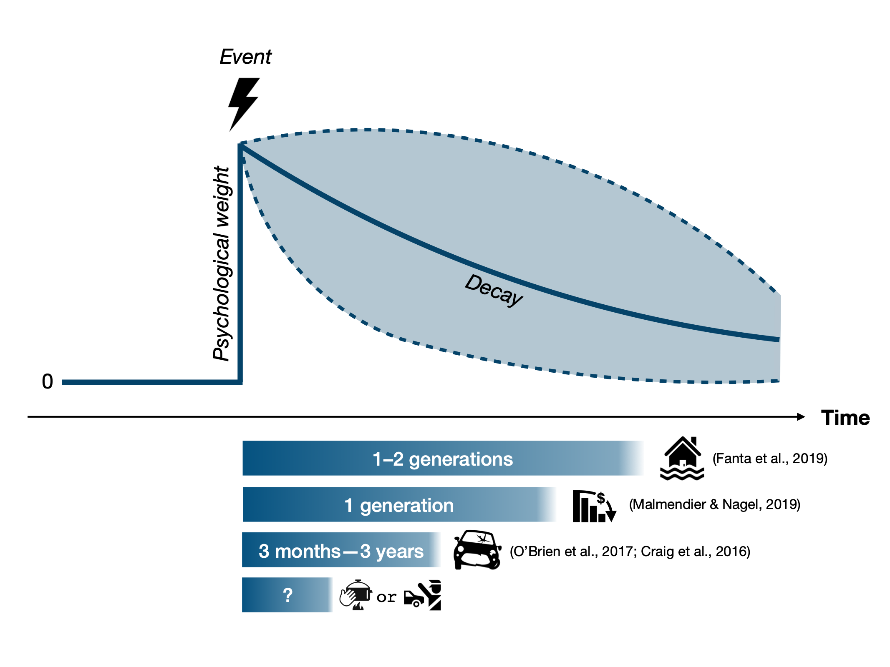

Figure 7: Psychological weight across time. The prototypical time course of psychological weight assigned to an event by an individual or a group in response to having experienced it. Psychological weight decays differently depending on the type of event. For instance, decay in collective memory of cultural goods, such as music, typically follows a bi-exponential form (Candia, Jara-Figueroa, Rodriguez-Sickert, Barabási, & Hidalgo, 2019), whereas individual memory decay is typically assumed to follow a simple exponential form (Schooler & Hertwig, 2005). Recent empirical evidence also highlights that memory biases in favor of extreme events contribute to the description–experience gap (Madan, Ludvig, & Spetch, 2017).

Another important direction for future research is to extend the decision field theory with learning model to dynamic decision tasks. The experiments discussed above all involve single stage decisions (perhaps played repeatedly) but many important decisions involve sequences in which previous actions influence future states and future actions. Dynamic decisions require planning several steps ahead. Reinforcement learning models, such as temporal difference learning or Q-learning, have been developed for learning in dynamic settings (Sutton & Barto, 1998; Fu & Anderson, 2006). The decision field theory with learning model would need to be extended by learning probability distributions of states and outcomes over a finite length future horizon of a dynamic decision problem.

Experiential Traps: When and Why Do Descriptive Risk Warnings Fail?
Another insight offered by the description–experience framework is that warnings need to work for people with very different degrees of experience—from none at all to ample experience with the risk in question. This probably explains why one-size-fits-all warnings fail for at least some portion of the audience. As Barron et al. (2008) demonstrated experimentally, warning effectiveness can be reduced when recipients have previously had safe (and possibly highly enjoyable) experience with a (rare) risk before being warned—for instance, having had unprotected sex without experiencing negative health consequences or having illegally downloaded copyrighted material without being caught. Early warnings (i.e., prior to the accumulation of ‘safe’ experiences) may have the desired effect; however, their effects may wane if they are followed by many safe experiences. Zohar and Erev (2007) proposed this to be a key reason why workplace accidents and injuries continue to occur despite ample warnings, regulations, and personal protective equipment; in 2019, 2.8 million nonfatal workplace injuries and illnesses occurred in private industry in the United States, and one worker died every 99 minutes from a work-related injury (U.S. Bureau of Labor Statistics). The warning of a risk (e.g., hazardous noise levels at work) and its potentially delayed consequences (e.g., hearing loss, tinnitus) inevitably competes with repeated experience of seemingly safe exposure to that risk. The more that experience accumulates, the more likely it is to eclipse the effects of the warning and to undercut compliance with safety measures—even more so when disregarding the warning allows workers to get their routine tasks done faster and more comfortably.
These considerations raise a number of questions for future research. For example, what is the optimal timing of a warning? And how can warnings be adapted to flexibly fit the experiential state of the audience? There appears to be a basic regularity that a description’s impact on behavior is stronger the less experience people have with a task, and that more experience—especially of ‘safe’ episodes—attenuates the effect of warnings (Barron et al., 2008; Weiss-Cohen, Konstantinidis, & Harvey, 2021). This dynamic may change if warnings explicitly acknowledge people’s state of experience, and if they introduce and explain the “ambiguities of experience” (March, 2010, pp. 106–109) and “experiential traps” such as the lure of experience of ‘safe’ episodes (before and after a warning) and time delays in the manifestation of a risk.
Another potential trap is that the rarity of a risk often implies a ‘primacy-halo’ effect: Even if the probability of a risk occurring in a given time period is very small (e.g., a fatal car accident on a single trip), the probability of at least one risk event actualizing becomes much larger over repeated exposure to that risk (e.g., a lifetime of car trips; Slovic et al., 1978). This means again that, on average, multiple safe episodes especially at the outset of a sequence of experiences carry the danger of a risk being underestimated.
In our view, it is important to acknowledge and study the real-world consequences of such experiential traps. A better understanding of these patterns may help risk researchers and public health officials to anticipate behaviors that are otherwise difficult to fathom, highly undesirable, and possibly preventable. Take, for instance, another experiential trap that may be dubbed the ‘curse of success’: the erosion of public support for preventive health measures that prove successful. This phenomenon has been observed in the context of the coronavirus pandemic (Cayetano & Crandall, 2020) and more generally in declining rates of vaccination uptake (UNICEF, 2019). In the first 6 months of 2019, 364,808 measles cases were recorded across 182 countries—the highest figures since 2006 (Korn et al., 2020). According to the World Health Organization (WHO), vaccine hesitancy was one of the ten major threats to public health in 2019 (WHO, 2019). Vaccine hesitancy may be at least partly due to an unfortunate collusion of experience and vaccine-critical description. Thanks to the success of preventive measures taken in previous decades, few people in recent generations have experienced measles or its effects. From this, they may conclude either that vaccination is a successful public health strategy that should be continued or that measles is nothing to worry about. In addition, the description–experience framework would suggest that people may overweight the small risk of serious side effects of vaccination, which further erodes their willingness to vaccinate.
When Is Description Discounted?
As much as experience appears key to how people respond to risks, decriptions and the psychological processes underlying their effects also matter. Numerous factors that weaken the impact of description-based risk communication have been identifed, including repeated exposure (e.g., to alcohol warning labels or graphic visual tobacco warnings; Kim & Wogalter, 2009) or intransparent presentations of health statistics (Gigerenzer et al., 2007). Warnings that could be perceived to threaten personal freedoms may also backfire as they induce stress and reactance (Hall et al., 2016). Such perceptions can trigger the urge to reclaim one’s freedom by engaging in the potentially harmful behaior (Pham, Mandel, & Morales, 2016). In other cases, warnings may inadvertently invoke an experiential dimension. Many warnings begin by identifying the undesirable behavior and noting its high prevalence. For instance, “61% of Americans have no money saved for their healthcare expenses” (see https://www.2020research.com/articles-and-case-studies/new-carepayment-research-conducted-2020-indicates-concerns-regarding-healthcare-expenses/); “most Americans with diabetes skip annual sight-saving exams” (see https://www.scottsdaleeye.com/americans-diabetes-skip-annual-sight-saving-exams/), or “most people wait more than a year before telling friends and family about a mental health problem” (see https://www.time-to-change.org.uk). By using such framings, warnings communicate descriptive social norms—perceptions of what most other people actually do—and may thus send the message that “if a lot of people are doing this, it’s probably a wise thing to do” (Cialdini, 2007, p. 264). Thus, by describing the frequency of the very behavior it aims to change, a warning may normalize that behavior and thus prove counterproductive (Schultz & Tabianco, 2009).

Can Simulated Experience Enrich Risk Communication?
As we have shown, personal and direct experience of a risk can be misleading, especially (but not only) if the risks are rare, delayed, noisy, and there is no feedback on risk events that did not occur. But experience may also offer a solution in situations where descriptions fail. In a letter to his siblings, the English poet John Keats (1819) wrote: “Nothing ever becomes real till it is experienced—Even a Proverb is no proverb to you till your Life hast illustrated it” (see http://www.john-keats.com/briefe/140219.htm). If it were strictly true that only experience can lend realism to words, thoughts, and descriptions, this would bode ill for any attempt to communicate the danger of risks through descriptions—especially to audiences who have not yet experienced them or when the risk to the individual remain opaque and unobservable (e.g., the risk of overdiagnosis; see Carter et al., 2015). However, research showing that warnings can successfully communicate benefits and risks if they are appropriately designed on numerous dimensions (Andrews, 2011) suggests that Keats’s words should not be taken to mean that descriptions of risk are doomed to fail.
But sometimes, experience can make things feel more real or foster better insight than description—and it may be worth harnessing this quality in risk communication. Indeed, inspired by work on the description–experience gap, researchers have recently begun to investigate the potential benefits of “simulated experience” (e.g., Armstrong & Spaniol, 2017; Hogarth & Soyer, 2015; Wegier, Armstrong, & Shaffer, 2019; Wegier & Shaffer, 2017) for communicating statistical information about risks. For example, financial institutions that offer investment products are by law required to provide information about the key properties of those products (e.g., risks, costs, past performance history). This information can be presented to clients in different ways. The default approach is in terms of numerical and graphic descriptions (e.g., historical returns in fact sheets). A very different approach is for clients to interactively sample possible outcomes, that is, possible returns on an investment—what Kaufmann, Weber, and Haisley (2013) have called “experience sampling.” Each sampled outcome contributes to the return distribution, which is displayed at the end of the sampling process. Kaufmann et al. (2013) designed a simple “risk tool” that enabled undergraduate students at a German university to experience the distribution of a risky financial product. Figure 8 represents the description condition and the experienced-sampling condition that they examined (along with two other conditions that will not be addressed here). The authors observed differences between experience and description on various dimensions. For instance, experienced-sampling investors allocated a larger percentage of their endowment to the risky fund than did description investors; they were more accurate in their understanding of the options’ expected return and, importantly, in the estimated probability of a loss. Others have built on the work of Kaufmann et al. (e.g., Bradbury, Hens, & Zeisberger, 2015, 2019) and also pointed to the boundaries of this intervention. Abel, Cole, and Zia (2020) recently found that a simple interactive game that experientially simulates the odds of winning the South African Lottery via dice rolling (equivalent to rolling a six with all nine dice) appears to offer a way of giving people “brief experiences that correct biases in their beliefs” (p. 1).

Description Condition
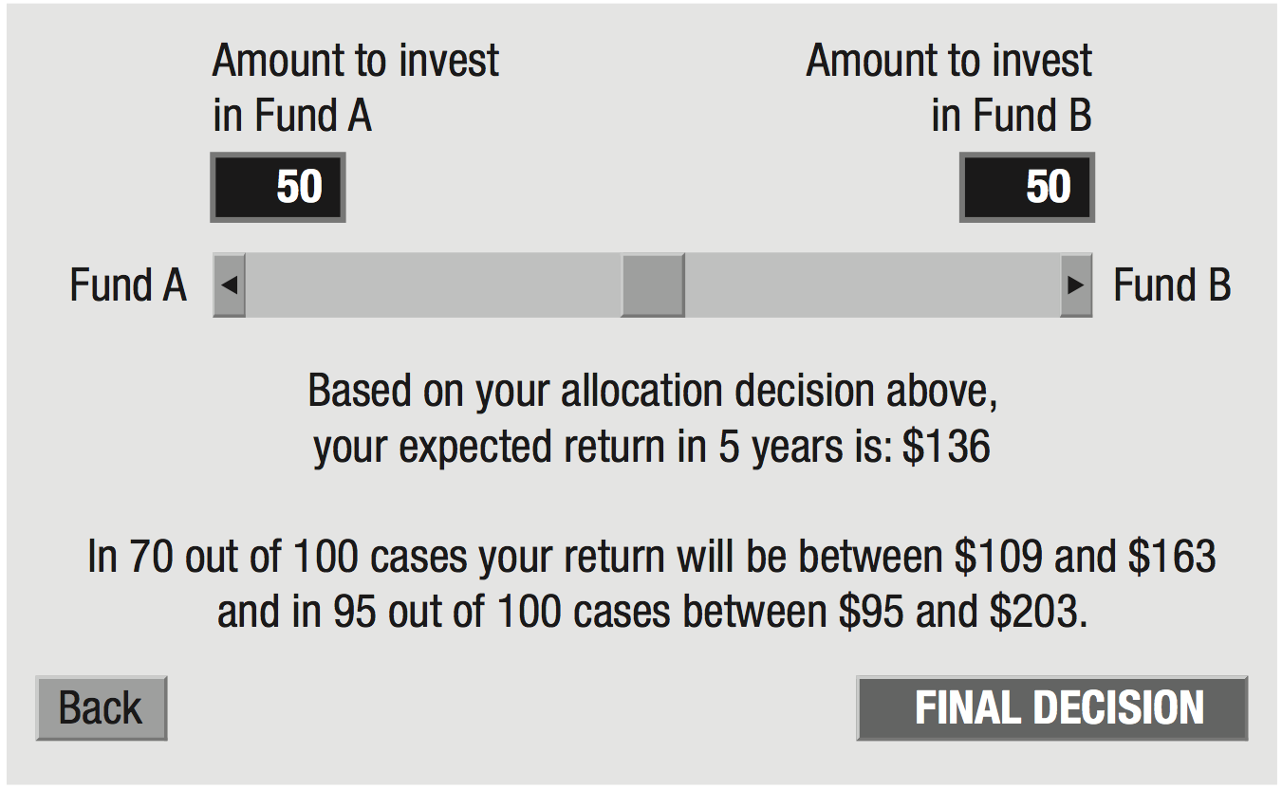
Risk Tool Condition
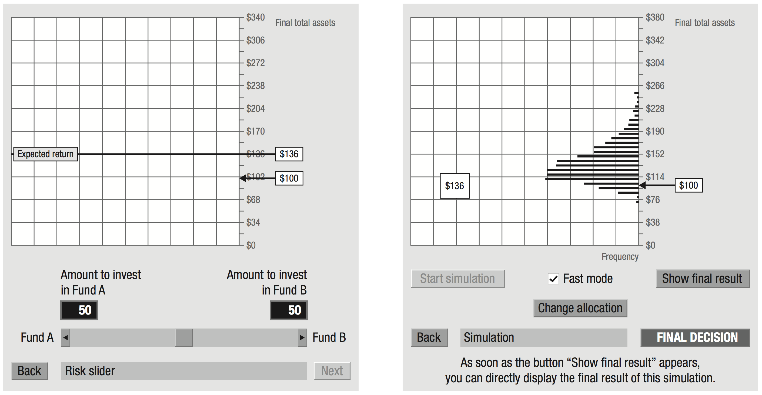

Figure 8. The description condition and the risk tool condition, as examined by Kaufmann, Weber, and Haisley (2013). Participants were asked to allocate an endowment of $100 between two funds: the risk-free fund A and the risky fund B. In the description condition, participants were given a numeric description stating the expected return. Participants read the description after making an allocation (in percentages) with the risk slider, and could try different allocations (and read about their effects) before deciding on a final one. In the risk tool condition, participants made an allocation with the risk slider and saw the simulated expected returns of their investment on a graphical interface. To simulate experience sampling, participants used the tool to draw potential returns randomly from a distribution based on historical data. Each random draw contributed to a sampling distribution function that was displayed gradually on the screen. Adapted from “The Role of Experience Sampling and Graphical Displays on One’s Investment Risk Appetite,” by C. Kaufmann, M. Weber, and E. Haisley, 2013, Management Science, 59, p. 337–338. Copyright will be obtained at acceptance.

The possibility of “simulated experience” raises a number of questions that are highly relevant for risk communication and for boosting people’s ability to navigate real-world risks (Hertwig & Grüne-Yanoff, 2017). For instance, which dimensions of the statistical properties of a risk are better communicated—meaning that the target audience gains more insight—through simulated experience than through description alone? Candidate properties here include information about the variance (volatility) of outcomes (as in Kaufmann et al., 2013), the rarity of events, the temporal dynamics of a process (e.g., the accumulation of risks with repeated exposure; Wegwarth et al., 2021), or exponential versus linear growth processes. In addition, which ‘qualia’ of a risk—meaning the way things seem to decision makers (e.g., the perceived sensation of pain caused by a headache)—may be communicated and approximated by means of simulated experience but are lacking in descriptions? For instance, can the earthquake simulators used in disaster training centers throughout Japan and recommended for use elsewhere (e.g., in Nepal; Uprety & Poudel, 2012) convey the visceral dimensions of the threat and its swift temporal dynamic that in a way that even the best descriptions cannot? Last but not least, simulated experience scenarios may give people a more ‘realistic’ sense of what they will encounter once a hazard strikes, as well as space to practice the appropriate behaviors.

Conclusions

The COVID-19 pandemic is a forceful reminder that coping with risks requires not only evidence-based protective interventions, but also an informed and cooperative public that accepts and adheres to those interventions. Yet individual and public responses to risks are often perplexing and even maladaptive. One reason is that people’s mental models of risks are richer than those assumed in the common technological definitions (see Slovic, 1987). Another, and this has been our focus, is that people’s knowledge of risks stems from two imperfect teachers: descriptions and experience. Each implies distinct ambiguities and psychological effects. We believe that a better understanding of the two, as well as of the effects that emerge when description and experience co-occur, will enrich the understanding of people’s responses to risks—as well as the ability to predict and guide those responses.

References
Abel, M., Cole, S., & Zia, B. (2020). Changing gambling behavior through experiential learning. The World Bank Economic Review, lhaa016. doi:10.1093/wber/lhaa016
Allais, M. (1953). Le comportement de l’homme rationnel devant le risque: Critique des postulats et axiomes de l’ecole Américaine [The behavior of rational man facing risk: Criticism of the postulates and axioms of the American School]. Econometrica, 21(4), 503–546. doi:10.2307/1907921
Andrews, J. C. (2011). Warnings and disclosures. In B. Fischhoff, N. T. Brewer, & J. S. Downs (Eds.), Communicating risks and benefits: An evidence-based user’s guide (pp. 149–161). Silver Spring, MD: US Department of Health and Human Services, Food and Drug Administration.
Argo, J. J., & Main, K. J. (2004). Meta-analyses of the effectiveness of warning labels. Journal of Public Policy and Marketing, 23(2), 193–208. doi:10.1509/jppm.23.2.193.51400
Arms Control Association. (2020, July). Chronology of U.S.–North Korean nuclear and missile diplomacy. Retrieved from https://www.armscontrol.org/factsheets/dprkchron
Armstrong, B., & Spaniol, J. (2017). Experienced probabilities increase understanding of diagnostic test results in younger and older adults. Medical Decision Making, 37(6), 670–679. doi:10.1177/0272989x17691954
Barberi, F., Davis, M. S., Isaia, R., Nave, R., & Ricci, T. (2008). Volcanic risk perception in the Vesuvius population. Journal of Volcanology and Geothermal Research, 172(3), 244–258. doi:10.1016/j.jvolgeores.2007.12.011
Barnes, K. (2011). Volcanology: Europe’s ticking time bomb. Nature, 473(7346), 140–141. doi:10.1038/473140a
Barron, G., Leider, S., & Stack, J. (2008). The effect of safe experience on a warnings’ impact: Sex, drugs, and rock-n-roll. Organizational Behavior and Human Decision Processes, 106(2), 125–142. doi:10.1016/j.obhdp.2007.11.002
Bernoulli, D. (1954). Exposition of a new theory on the measurement of risk. Econometrica, 22(1), 23–36. doi:10.2307/1909829 (Original work published 1738)
Betsch, C., Renkewitz, F., Betsch, T., & Ulshöfer, C. (2010). The influence of vaccine-critical websites on perceiving vaccination risks. Journal of Health Psychology, 15(3), 446–455. doi:10.1177/1359105309353647
Bosetti, C., Gallus, S., Peto, R., Negri, E., Talamini, R., Tavani, A., Franceschi, S., & La Vecchia, C. (2008). Tobacco smoking, smoking cessation, and cumulative risk of upper aerodigestive tract cancers. American Journal of Epidemiology, 167(4), 468–473. doi: 10.1093/aje/kwm318
Bostrom, A. (1997). Risk perceptions: Experts vs. lay people. Duke Environmental Law & Policy Forum, 8, 101–113.
Bradbury, M. A. S., Hens, T., & Zeisberger, S. (2015). Improving investment decisions with simulated experience. Review of Finance, 19(3), 1019–1052. doi:10.1093/rof/rfu021
Bradbury, M. A., Hens, T., & Zeisberger, S. (2019). How persistent are the effects of experience sampling on investor behavior? Journal of Banking & Finance, 98, 61–79. doi:10.1016/j.jbankfin.2018.10.014
Brick, C., McDowell, M., & Freeman, A. L. (2020). Risk communication in tables versus text: A registered report randomized trial on ‘fact boxes’. Royal Society Open Science, 7(3), 190876. doi:10.1098/rsos.190876
Bruni, F. (2003, August 26). San Giuseppe Vesuviano journal; who’s afraid of Vesuvius? (Pompeii is history). The New York Times. Retrieved from https://www.nytimes.com/2003/08/26/world/san-giuseppe-vesuviano-journal-who-s-afraid-of-vesuvius-pompeii-is-history.html
Camerer, C. F. (2000). Prospect theory in the wild: Evidence from the field. In D. Kahneman & A. Tversky (Eds.), Choices, values, and frames (pp. 288–300). Cambridge, UK: Cambridge University Press.
Camilleri, A. R., & Newell, B. R. (2019). Better calibration when predicting from experience (rather than description). Organizational Behavior and Human Decision Processes, 150, 62–82. doi:10.1016/j.obhdp.2018.10.006
Candia, C., Jara-Figueroa, C., Rodriguez-Sickert, C., Barabási, A.-L., & Hidalgo, C. A. (2019). The universal decay of collective memory and attention. Nature Human Behaviour, 3(1), 82–91. doi:10.1038/s41562-018-0474-5
Carter, S. M., Rogers, W., Heath, I., Degeling, C., Doust, J., & Barratt, A. (2015). The challenge of overdiagnosis begins with its definition. BMJ, 350, h869. doi:10.1136/bmj.h869
Cayetano, S. M., & Crandall, L. (2020). Paradox of success and public perspective: COVID-19 and the perennial problem of prevention. Journal of Epidemiology and Community Health, 74(8), 679–679.
Centers for Disease Control and Prevention. (2018, January 17). Secondhand smoke (SHS) facts. Retrieved from https://www.cdc.gov/tobacco/data_statistics/fact_sheets/secondhand_smoke/general_facts/
Centers for Disease Control and Prevention. (2019a, September 10). Sexually transmitted disease surveillance 2018. Retrieved from https://www.cdc.gov/std/stats18/figures/35.htm
Centers for Disease Control and Prevention. (2019b, September 18). What are the risk factors for lung cancer? Retrieved from https://www.cdc.gov/cancer/lung/basic_info/risk_factors.htm
Cialdini, R. B. (2007). Descriptive social norms as underappreciated sources of social control. Psychometrika, 72(2), 263–268. doi:10.1007/s11336-006-1560-6
Cirillo, P., & Taleb, N. N. (2020). Tail risk of contagious diseases. Nature Physics, 16(6), 606–613. doi:10.1038/s41567-020-0921-x
Craig, A., Tran, Y., Guest, R., Gopinath, B., Jagnoor, J., Bryant, R. A., . . . Cameron, I. (2016). Psychological impact of injuries sustained in motor vehicle crashes: Systematic review and meta-analysis. BMJ Open, 6(9), e011993. doi:10.1136/bmjopen-2016-011993
Dai, J., Pachur, T., Pleskac, T. J., & Hertwig, R. (2019). What the future holds and when: A description–experience gap in intertemporal choice. Psychological Science, 30(8), 1218–1233. doi:10.1177/0956797619858969
De La Maza, C., Davis, A., Gonzalez, C., & Azevedo, I. (2019). Understanding cumulative risk perception from judgments and choices: An application to flood risks. Risk Analysis, 39(2), 488–504. doi:10.1111/risa.13206
Denrell, J. (2005). Why most people disapprove of me: Experience sampling in impression formation. Psychological Review, 112(4), 951–978. doi:10.1037/0033-295x.112.4.951
Denrell, J. (2007). Adaptive learning and risk taking. Psychological Review, 114(1), 177–187. doi:10.1037/0033-295x.114.1.177
Denrell, J., & March, J. G. (2001). Adaptation as information restriction: The hot stove effect. Organization Science, 12(5), 523–538. doi:10.1287/orsc.12.5.523.10092
Dutt, V., Arló-Costa, H., Helzner, J., & Gonzalez, C. (2014). The description–experience gap in risky and ambiguous gambles. Journal of Behavioral Decision Making, 27(4), 316–327. doi:10.1002/bdm.1808
Erev, I., Glozman, I., & Hertwig, R. (2008). What impacts the impact of rare events. Journal of Risk and Uncertainty, 36(2), 153–177. doi:10.1007/s11166-008-9035-z
Erev, I., Ert, E., Plonsky, O., Cohen, D., & Cohen, O. (2017). From anomalies to forecasts: Toward a descriptive model of decisions under risk, under ambiguity, and from experience. Psychological Review, 124(4), 369–409. doi:10.1037/rev0000062
Fanta, V., Šálek, M., & Sklenicka, P. (2019). How long do floods throughout the millennium remain in the collective memory? Nature Communications, 10(1), 1–9. doi:10.1038/s41467-019-09102-3
Fiedler, K., & Juslin, P. (2006). Taking the interface between mind and environment seriously. In K. Fiedler & P. Juslin (Eds.), Information sampling and adaptive cognition (pp. 3–29). Cambridge, UK: Cambridge University Press.
Fraenkel, L., Peters, E., Tyra, S., & Oelberg, D. (2016). Shared medical decision making in lung cancer screening: Experienced versus descriptive risk formats. Medical Decision Making, 36(4), 518–525. doi:10.1177/0272989x15611083
Friedman, T. L. (2017, June 14). Solving the Korea crisis by teaching a horse to sing. The New York Times. Retrieved from https://www.nytimes.com/2017/06/14/opinion/north-korea-crisis-foreign-policy.html
Gigerenzer, G., Gaissmaier, W., Kurz-Milcke, E., Schwartz, L. M., & Woloshin, S. (2007). Helping doctors and patients make sense of health statistics. Psychological Science in the Public Interest, 8(2), 53–96. doi:10.1111/j.1539-6053.2008.00033.x
Gregory, W. L., Cialdini, R. B., & Carpenter, K. M. (1982). Self-relevant scenarios as mediators of likelihood estimates and compliance: Does imagining make it so? Journal of Personality and Social Psychology, 43(1), 89–99. doi:10.1037/0022-3514.43.1.89
Güney, Ş., & Newell, B. R. (2015). Overcoming ambiguity aversion through experience. Journal of Behavioral Decision Making, 28(2), 188–199. doi:10.1002/bdm.1840
Harding Center for Risk Literacy. (2016, April). Combined MMR vaccine in childhood—measles. Retrieved from https://www.hardingcenter.de/en/vaccines/combined-mmr-vaccine-childhood-measles
Hall, M. G., Sheeran, P., Noar, S. M., Ribisl, K. M., Bach, L. E., & Brewer, N. T. (2016). Reactance to health warnings scale: Development and validation. Annals of Behavioral Medicine, 50(5), 736–750. doi:10.1007/s12160-016-9799-3
Hasher, L., Goldstein, D., & Toppino, T. (1977). Frequency and the conference of referential validity. Journal of Verbal Learning and Verbal Behavior, 16(1), 107–112. doi:10.1016/S0022-5371(77)80012-1
Hertwig, R. (2015). Decisions from experience. In G. Keren & G. Wu (Eds.), The Wiley Blackwell handbook of judgment and decision making (Vol. 1, pp. 240–267). Malden, MA: Wiley Blackwell. doi:10.1002/9781118468333.ch8
Hertwig, R., & Erev, I. (2009). The description–experience gap in risky choice. Trends in Cognitive Sciences, 13(12), 517–523. doi:10.1016/j.tics.2009.09.004
Hertwig, R., Gigerenzer, G., & Hoffrage, U. (1997). The reiteration effect in hindsight bias. Psychological Review, 104(1), 194–202. doi: 10.1037/0033-295X.104.1.194
Hertwig, R., & Grüne-Yanoff, T. (2017). Nudging and boosting: Steering or empowering good decisions. Perspectives on Psychological Science, 12(6), 973–986. doi:10.1177/1745691617702496.
Hertwig, R., Hogarth, R. M., & Lejarraga, T. (2018). Experience and description: Exploring two paths to knowledge. Current Directions in Psychological Science, 27(2), 123–128. doi:10.1177/0963721417740645
Hertwig, R., Wulff, D. U., & Mata, R. (2019). Three gaps and what they may mean for risk preference. Philosophical Transactions of the Royal Society B: Biological Sciences, 374(1766), 20180140. doi:10.1098/rstb.2018.0140
Hogarth, R. M., Lejarraga, T., & Soyer, E. (2015). The two settings of kind and wicked learning environments. Current Directions in Psychological Science, 24(5), 379–385. doi:10.1177/0963721415591878
Hogarth, R. M., & Soyer, E. (2015). Providing information for decision making: Contrasting description and simulation. Journal of Applied Research in Memory and Cognition, 4(3), 221–228. doi:10.1016/j.jarmac.2014.01.005
Isler, O., Kopsacheilis, O., & van Dolder, D. (2020). The description–experience gap in cooperation. Manuscript in preparation.
Jack, A. (2015). Why the panic? South Korea’s MERS response questioned. BMJ, 350, h3403. doi:10.1136/bmj.h3403
Jessup, R. K., Bishara, A. J., & Busemeyer, J. R. (2008). Feedback produces divergence from prospect theory in descriptive choice. Psychological Science, 19(10), 1015–1022. doi:10.1111/j.1467-9280.2008.02193.x
Kahneman, D., & Tversky, A. (1979). Prospect theory: An analysis of decision under risk. Econometrica, 47(2), 263–291. doi:10.2307/1914185
Kasperson, R. E., Renn, O., Slovic, P., Brown, H. S., Emel, J., Goble, R., . . . Ratick, S. (1988). The social amplification of risk: A conceptual framework. Risk Analysis, 8(2), 177–187. doi:10.1111/j.1539-6924.1988.tb01168.x
Kaufmann, C., Weber, M., & Haisley, E. (2013). The role of experience sampling and graphical displays on one’s investment risk appetite. Management Science, 59(2), 323–340. doi:10.1287/mnsc.1120.1607
Keynes, J. M. (1937). The general theory of employment. The Quarterly Journal of Economics, 51(2), 209–223. doi:10.2307/1882087
Keynes, J. M. (1973). A treatise on probability: The collected writings of John Maynard Keynes (Vol. 8). London, UK: Macmillan.
Keysers, C., & Gazzola, V. (2009). Expanding the mirror: Vicarious activity for actions, emotions, and sensations. Current Opinion in Neurobiology, 19(6), 666–671. doi:10.1016/j.conb.2009.10.006
Kim, S., & Wogalter, M. S. (2009). Habituation, dishabituation, and recovery effects in visual warnings. Proceedings of the Human Factors and Ergonomics Society Annual Meeting, 53(20), 1612–1616. doi:10.1177/154193120905302015
Knight, F. H. (1921). Risk, uncertainty, and profit. Boston, MA: Houghton Mifflin Co.
Korn, L., Böhm, R., Meier, N. W., & Betsch, C. (2020). Vaccination as a social contract. Proceedings of the National Academy of Sciences of the United States of America, 117(26), 14890–14899. doi:10.1073/pnas.1919666117
Kozyreva, A., & Hertwig, R. (2021). The interpretation of uncertainty in ecological rationality. Synthese, 198, 1517–1547. doi:10.1007/s11229-019-02140-w
Le Mens, G., & Denrell, J. (2011). Rational learning and information sampling: On the “naivety” assumption in sampling explanations of judgment biases. Psychological Review, 118(2), 379–392. doi:10.1037/a0023010
Lejarraga, T. (2010). When experience is better than description: Time delays and complexity. Journal of Behavioral Decision Making, 23(1), 100–116. doi:10.1002/bdm.666
Lejarraga, T., & Gonzalez, C. (2011). Effects of feedback and complexity on repeated decisions from description. Organizational Behavior and Human Decision Processes, 116(2), 286–295. doi:10.1016/j.obhdp.2011.05.001
Lejarraga, T., & Lejarraga, J. (2020). Confidence and the description–experience distinction. Organizational Behavior and Human Decision Processes, 161, 201–212. doi:10.1016/j.obhdp.2020.07.003
Lejarraga, T., Pachur, T., Frey, R., & Hertwig, R. (2016). Decisions from experience: From monetary to medical gambles. Journal of Behavioral Decision Making, 29(1), 67–77. doi:10.1002/bdm.1877
Lejarraga, T., Woike, J. K., & Hertwig, R. (2016). Description and experience: How experimental investors learn about booms and busts affects their financial risk taking. Cognition, 157, 365–383. doi:10.1016/j.cognition.2016.10.001
Lopes, L. L. (1983). Some thoughts on the psychological concept of risk. Journal of Experimental Psychology: Human Perception and Performance, 9(1), 137–144. doi:10.1037/0096-1523.9.1.137
Ludvig, E. A., Madan, C. R., & Spetch, M. L. (2014). Extreme outcomes sway risky decisions from experience. Journal of Behavioral Decision Making, 27(2), 146–156. doi:10.1002/bdm.1792
Madan, C. R., Ludvig, E. A., & Spetch, M. L. (2017). The role of memory in distinguishing risky decisions from experience and description. Quarterly Journal of Experimental Psychology, 70(10), 2048–2059. doi:10.1080/17470218.2016.1220608
Malmendier, U., & Nagel, S. (2011). Depression babies: Do macroeconomic experiences affect risk taking? The Quarterly Journal of Economics, 126(1), 373–416. doi:10.1093/qje/qjq004
March, J. G. (2010). The ambiguities of experience. Ithaca, NY: Cornell University Press.
Martin, J. M., Gonzalez, C., Juvina, I., & Lebiere, C. (2014). A description–experience gap in social interactions: Information about interdependence and its effects on cooperation. Journal of Behavioral Decision Making, 27(4), 349–362. doi:10.1002/bdm.1810
Martin, T. W., & Yoon, D. (2020, September 25). How South Korea successfully managed coronavirus. The Wall Street Journal. Retrieved from https://www.wsj.com/articles/lessons-from-south-korea-on-how-to-manage-covid-11601044329
Mastrolorenzo, G., Petrone, P., Pappalardo, L., & Guarino, F. M. (2010). Lethal thermal impact at periphery of pyroclastic surges: Evidences at Pompeii. PLOS ONE, 5(6), e11127. doi:10.1371/journal.pone.0011127
Mastrolorenzo, G., Petrone, P., Pappalardo, L., & Sheridan, M. F. (2006). The Avellino 3780-yr-B.P. catastrophe as a worst-case scenario for a future eruption at Vesuvius. Proceedings of the National Academy of Sciences of the United States of America, 103(12), 4366–4370. doi:10.1073/pnas.0508697103
Nelson, J. D., McKenzie, C. R. M., Cottrell, G. W., & Sejnowski, T. J. (2010). Experience matters: Information acquisition optimizes probability gain. Psychological Science, 21(7), 960–969. doi:10.1177/0956797610372637
O’Brien, F., Bible, J., Liu, D., & Simons-Morton, B. G. (2017). Do young drivers become safer after being involved in a collision? Psychological Science, 28(4), 407–413. doi:10.1177/0956797616688118
Peters, E., Hart, P. S., & Fraenkel, L. (2011). Informing patients: The influence of numeracy, framing, and format of side effect information on risk perceptions. Medical Decision Making, 31(3), 432–436. doi:10.1177/0272989X10391672
Peto et al. 2000
Pham, N., Mandel, N., & Morales, A. C. (2016). Messages from the food police: How food-related warnings backfire among dieters. Journal of the Association for Consumer Research, 1(1), 175–190. doi:10.1086/684394
Pinker, S. (2007). The stuff of thought: Language as a window into human nature. New York, NY: Viking.
Plonsky, O., Teodorescu, K., & Erev, I. (2015). Reliance on small samples, the wavy recency effect, and similarity-based learning. Psychological Review, 122(4), 621–647. doi:10.1037/a0039413
Purmehdi, M., Legoux, R., Carrillat, F., & Senecal, S. (2017). The effectiveness of warning labels for consumers: A meta-analytic investigation into their underlying process and contingencies. Journal of Public Policy & Marketing, 36(1), 36–53. doi:10.1509/jppm.14.047
Rakow, T., & Newell, B. R. (2010). Degrees of uncertainty: An overview and framework for future research on experience‐based choice. Journal of Behavioral Decision Making, 23(1), 1–14. doi:10.1002/bdm.681
Regenwetter, M., & Robinson, M. M. (2017). The construct–behavior gap in behavioral decision research: A challenge beyond replicability. Psychological Review, 124(5), 533–550. doi:10.1037/rev0000067
Rehder, B., & Waldmann, M. R. (2017). Failures of explaining away and screening off in described versus experienced causal learning scenarios. Memory & Cognition, 45(2), 245–260. doi:10.3758/s13421-016-0662-3
Richerson, P. J., & Boyd, R. (2005). Not by genes alone: How culture transformed human evolution. Chicago, IL: The University of Chicago Press.
Rogers, G. O. (1997). The dynamics of risk perception: How does perceived risk respond to risk events? Risk Analysis, 17(6), 745–757. doi:10.1111/j.1539-6924.1997.tb01280.x
Rottenstreich, Y., & Tversky, A. (1997). Unpacking, repacking, and anchoring: Advances in support theory. Psychological Review, 104(2), 406–415. doi:10.1037/0033-295x.104.2.406
Sang-Hun, C. (2020, February 23). As coronavirus cases spiral, South Korea raises threat alert level. The New York Times. Retrieved from https://www.nytimes.com/2020/02/23/world/asia/south-korea-coronavirus-moon.html
Schooler, L., & Hertwig, R. (2005). How forgetting aids heuristic inference. Psychological Review, 112, 610–628. doi:10.1037/0033-295X.112.3.610
Schulte, E., Spies, C., Denke, C., Meerpohl, J. J., Donner-Banzhoff, N., Petzke, F., Hertwig, R., . . . & Wegwarth, O. (2021). Long-term use of strong opioids: Self-reported outcome measures from German patients with chronic noncancer pain. Manuscript submitted for publication.
Schultz, P. W., & Tabanico, J. J. (2009). Criminal beware: A social norms perspective on posting public warning signs. Criminology, 47(4), 1201–1222. doi:10.1111/j.1745-9125.2009.00173.x
Singer, T., Seymour, B., Doherty, J., Kaube, H., Dolan, R. J., & Frith, C. D. (2004). Empathy for pain involves the affective but not sensory components of pain. Science, 303(5661), 1157–1162. doi:10.1126/science.1093535
Sjöberg, L. (1999). Risk perception by the public and by experts: A dilemma in risk management. Human Ecology Review, 6, 1–9.
Slovic, P. (1987). Perception of risk. Science, 236(4799), 280–285. doi:10.1126/science.3563507
Slovic, P. (2000a). What does it mean to know a cumulative risk? Adolescents’ perceptions of short‐term and long‐term consequences of smoking. Journal of Behavioral Decision Making, 13(2), 259–266. doi:10.1002/(SICI)1099-0771(200004/06)13:2<259::AID-BDM336>3.0.CO;2-6
Slovic, P. (2000b). Rejoinder: The perils of Viscusi’s analyses of smoking risk perceptions. Journal of Behavioral Decision Making, 13(2), 273–276. doi:10.1002/(sici)1099-0771(200004/06)13:2<273::Aid-bdm338>3.0.Co;2-g
Slovic, P., Fischhoff, B., & Lichtenstein, S. (1978). Accident probabilities and seat belt usage: A psychological perspective. Accident Analysis & Prevention, 10(4), 281–285. doi:0.1016/0001-4575(78)90030-1
Slovic, P., Fischhoff, B., & Lichtenstein, S. (1979). Rating the risks. Environment, 2(3), 14–20. doi:0.1080/00139157.1979.9933091 [not in text]
Slovic, P., Fischhoff, B., & Lichtenstein, S. (1985). Rating the risks: The structure of expert and lay perceptions. In V. T. Covello, J. L. Mumpower, P. J. M. Stallen, V. R. R. Uppuluri, Environmental impact assessment, technology assessment, and risk analysis (pp. 131–156). Berlin, Germany: Springer.
Spektor, M. S., & Wulff, D. U. (2021). Myopia drives reckless behavior in response to over-taxation. Judgment and Decision Making, 16(1), 114–130. doi: 10.31234/osf.io/34gzp
Spitzer, B., Waschke, L., & Summerfield, C. (2017). Selective overweighting of larger magnitudes during noisy numerical comparison. Nature Human Behaviour, 1(8), 0145. doi:10.1038/s41562-017-0145
Steinhart, Y., Carmon, Z., & Trope, Y. (2013). Warnings of adverse side effects can backfire over time. Psychological Science, 24(9), 1842–1847. doi:10.1177/0956797613478948
Stewart, N., Chater, N., & Brown, G. D. A. (2006). Decision by sampling. Cognitive Psychology, 53(1), 1–26. doi:10.1016/j.cogpsych.2005.10.003
Sutton, R. S., & Barto, A. G. (1998). Reinforcement learning: An introduction. Cambridge, MA: MIT Press.
Taylor, L. E., Swerdfeger, A. L., & Eslick, G. D. (2014). Vaccines are not associated with autism: An evidence-based meta-analysis of case-control and cohort studies. Vaccine, 32(29), 3623–3629. doi:10.1016/j.vaccine.2014.04.085
Thiels, C. A., Anderson, S. S., Ubl, D. S., Hanson, K. T., Bergquist, W. J., Gray, R. J., . . . Habermann, E. B. (2017). Wide variation and overprescription of opioids after elective surgery. Annals of Surgery, 266(4), 564–573. doi:10.1097/sla.0000000000002365
Tsai, J., Homa, D. M., Gentzke, A. S., Mahoney, M., Sharapova, S. R., Sosnoff, C. S., . . . Trivers, K. F. (2018). Exposure to secondhand smoke among nonsmokers—United States, 1988–2014. Morbidity and Mortality Weekly Report, 67(48), 1342–1346. doi:10.15585/mmwr.mm6748a3
Tversky, A., & Kahneman, D. (1992). Advances in prospect theory: Cumulative representation of uncertainty. Journal of Risk and Uncertainty, 5(4), 297–323. doi:10.1007/978-3-319-20451-2_24
Twain, M. (1897). Following the equator: A journey around the world. Hartford, CT: American Publishing Co.
UNICEF. (2019, December 5). Measles outbreaks continue unabated: Five countries accounted for nearly half of all measles cases in 2018. Retrieved from https://www.unicef.org/press-releases/measles-outbreaks-continue-unabated-five-countries-accounted-nearly-half-all-measles
U.S. Bureau of Labor Statistics. (2020, December 16). National census of fatal occupational injuries in 2019 [News release]. https://www.bls.gov/news.release/pdf/cfoi.pdf
Uprety, P., & Poudel, A. (2012). Earthquake risk perception among citizens in Kathmandu, Nepal. Australasian Journal of Disaster and Trauma Studies, 2012-1, 3–10.
van den Bos, W., & Hertwig, R. (2017). Adolescents display distinctive tolerance to ambiguity and to uncertainty during risky decision making. Scientific Reports, 7(1), 40962. doi:10.1038/srep40962
Viscusi, W. K. (1990). Do smokers underestimate risks? Journal of Political Economy, 98(6), 1253–1269. doi:10.1086/261733
Viscusi, W. K., & Hakes, J. K. (2008). Risk beliefs and smoking behavior. Economic Inquiry, 46(1), 45–59. doi:10.1111/j.1465-7295.2007.00079.x
Wachinger, G., Renn, O., Begg, C., & Kuhlicke, C. (2013). The risk perception paradox: Implications for governance and communication of natural hazards. Risk Analysis, 33(6), 1049–1065. doi:10.1111/j.1539-6924.2012.01942.x
Weber, E. U. (2006). Experience-based and description-based perceptions of long-term risk: Why global warming does not scare us (yet). Climatic Change, 77(1), 103–120. doi:10.1007/s10584-006-9060-3
Weber, E. U., & Stern, P. C. (2011). Public understanding of climate change in the United States. American Psychologist, 66(4), 315–328. doi:10.1037/a0023253
Wegier, P., Armstrong, B. A., & Shaffer, V. A. (2019). Aiding risk information learning through simulated experience (ARISE): A comparison of the communication of screening test information in explicit and simulated experience formats. Medical Decision Making, 39(3), 196–207. doi:10.1177/0272989X19832882
Wegier, P., & Shaffer, V. A. (2017). Aiding risk information learning through simulated experience (ARISE): Using simulated outcomes to improve understanding of conditional probabilities in prenatal Down syndrome screening. Patient Education and Counseling, 100(10), 1882–1889. doi:10.1016/j.pec.2017.04.016
Wegwarth, O., Hertwig, R., Wolf Dieter Ludwig, W. D., Spies, C. & Schulte, E. (2021). The role of experience and description on perceiving risks of strong opioids: A randomized controlled trial with chronic noncancer pain patients. Manuscript submitted for publication. Weinstein N. D. (1989). Effects of personal experience on self-protective behavior. Psychological Bulletin, 105(3), 31–50. doi:10.1037/0033-2909.105.1.31
Weiss‐Cohen, L., Konstantinidis, E., & Harvey, N. (2021). Timing of descriptions shapes experience‐based risky choice. Journal of Behavioral Decision Making, 34(1), 66–84. doi:10.1002/bdm.2197
Weiss-Cohen, L., Konstantinidis, E., Speekenbrink, M., & Harvey, N. (2016). Incorporating conflicting descriptions into decisions from experience. Organizational Behavior and Human Decision Processes, 135, 55–69. doi:10.1016/j.obhdp.2016.05.005
Weiss-Cohen, L., Konstantinidis, E., Speekenbrink, M., & Harvey, N. (2018). Task complexity moderates the influence of descriptions in decisions from experience. Cognition, 170, 209–227. doi:10.1016/j.cognition.2017.10.005
WHO. (2019). Ten threats to global health in 2019. Retrieved from https://www.who.int/news-room/spotlight/ten-threats-to-global-health-in-2019
Wulff, D. U., & Hertwig, R. (2019). Uncovering the anatomy of search without technology. In M. Schulte-Mecklenbeck, A. Kuehberger, & J. G. Johnson (Eds.), Handbook of process tracing methods (2nd ed., pp. 313–325). New York, NY: Routledge.
Wulff, D. U., Hills, T. T., & Hertwig, R. (2015). Online product reviews and the description–experience gap. Journal of Behavioral Decision Making, 28(3), 214–223. doi:10.1002/bdm.1841
Wulff, D. U., Markant, D., Pleskac, T. J., & Hertwig, R. (2019). Adaptive exploration: What you see is up to you. In R. Hertwig, T. Pleskac, T. Pachur, & the Center for Adaptive Rationality (Eds.), Taming uncertainty (pp. 131–152). Cambridge, MA: MIT Press.
Wulff, D. U., Mergenthaler-Canseco, M., & Hertwig, R. (2018). A meta-analytic review of two modes of learning and the description–experience gap. Psychological Bulletin, 144(2), 140–176. doi:10.1037/bul0000115
Zabell, S. L. (1989). The rule of succession. Erkenntnis, 31(2), 283–321. doi:10.1007/BF01236567
Zhang, H., & Houpt, J.W. (2020). Exaggerated prevalence effect with the explicit prevalence information: The description–experience gap in visual search. Attention, Perception, & Psychophysics, 82(7), 3340–3356. doi:10.3758/s13414-020-02045-8
Zohar, D., & Erev, I. (2007). On the difficulty of promoting workers’ safety behaviour: Overcoming the underweighting of routine risks. International Journal of Risk Assessment and Management, 7(2), 122–136. doi:10.1504/IJRAM.2007.011726

As of February 3, 2021, South Korea had registered 79,311 coronavirus cases and 1,441 deaths relative to, for instance, Germany’s 2,240,814 cases and 59,459 deaths; see https://www.worldometers.info/coronavirus.
For an early and thorough discussion of the methodological problems of studies that examine the effects of personal experience on self-protective behavior but cannot randomly assign participants to accident or victim conditions, see Weinstein (1989).
Laplace’s rule of succession (see Zabell, 1989) states, in brief, that if an event (e.g., the sun’s daily rising) has occurred m times in successive trials, then the probability that this event will occur in the next trial is (m + 1)/(m + 2). Note that our use of Laplace’s rule as one way of enumerative induction is simply to illustrate the power of repetitive experience. We do not suggest that the rule’s assumptions are met in the lives of Neapolitans, namely, that their trials (days) are independent, that the (non-)occurrence of the event is equally likely to occur, or that their experience corresponds to sampling balls from an urn. Last but not least, the rule does not take into account that residents are also exposed to expert warnings.
In an experimental gambling paradigm in which people also received feedback about foregone payoffs, this relationship was reversed (Weiss-Cohen et al., 2021); however, information about foregone payoffs is rarely available outside controlled experimental settings.

