**AGENDA**

**July 21 7:00 pm. – 8 p.m. +**

1. **Introductions and Welcome - Brady and Marty -10 Minutes**
   1. Topic: Best Cocktail/Mocktail Recipe we are drinking, (award will be bragging rights)
2. **SE/Appalachia Climate Conference Update- 10 Minutes Jan**
3. **Lobby Day Updates – 7 Minutes -Andrea, Jan, and Gabriela**
4. **Reclaim Act – 3 Minutes- Marty**
5. **Green Act – 3 Minutes – Marty**
6. **ACT on KUB charter amendment - 3 Minutes – Brady**
7. **American Promise Reminder – 2 Minutes – Marty or Chet**  
   Great Article : <https://www.tennessean.com/story/opinion/2020/06/27/amend-constitution-expel-corrupting-influence-big-money-politics/3254880001/> **Webinar July 28** : <https://americanpromise.net/event/the-conservative-case-to-get-money-out/>
8. **Roundtable/Announcements** – **5 minutes**
9. **Adjourn**

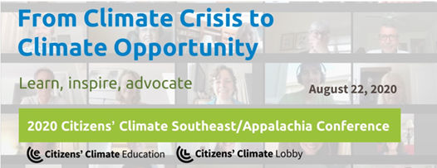

Please join us for our **virtual 2020 Citizens' Climate Southeast / Appalachia Conference**

on Saturday, August 22nd, from 8:15 a.m. to 3:35 p.m.

[REGISTER HERE](https://2020seappalachia.eventbrite.com)