**AGENDA**

**August 18th, 7:00 pm. – 8 p.m. +**

1. **Introductions and Welcome – Brady and Marty -5 Minutes**
2. **SE/Appalachia Conference Update- 5 Minutes - Jan**
3. **Climate Trivia – Testing our Knowledge for Fun and Prizes – We need a Laugh!**
4. **Roundtable/Announcements** – **5 minutes**
5. **Adjourn**

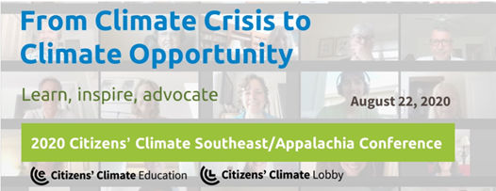

Please join us for our **virtual 2020 Citizens' Climate Southeast / Appalachia Conference**

on Saturday, August 22nd, from 8:15 a.m. to 3:35 p.m.