**AGENDA**

**June 15 7:00 p.m. – 8 p.m.**

1. **Introductions – Marty/Ryan -5 Minutes**
2. **On Boarding New Members –** **Ryan** **– 5 Minutes**
3. **Conference Take Aways – All** **– 10 Minutes**
4. **Renewal of 5 Pillars – Ryan/Marty/All – 15 Minutes**
5. **Future Social Events – Ryan/Marty-5 Minutes**
6. **Roundtable/Announcements** – **5 minutes**
7. **Adjourn**

**Additional Reading/Viewing**

1.The Executive Summary: Climate change an ‘existential threat’ says Secretary of Defense

<https://www.armytimes.com/news/your-military/2021/04/27/climate-change-an-existential-threat-says-secdef/>

2. **Subject:** Vertical garden

Taipei is getting a vertical forest with 23,000 trees, shrubs and plants that clean the air and help lower city temps, and it's coming this year! The 21-story residential building's twisted shape is inspired by the double helix of DNA, and every apartment comes with its own garden! Different species of trees with better carbon absorption are planted in the park, balconies, and terraces that can absorb up to 130 tons of carbon annually! The greenery cleans the air, lowers ground-level temperatures, and also mitigates the noise from the city. As if that wasn't enough, it's also powered by wind and solar energy and recycles rainwater for watering gardens. Natural ventilation chimneys filter the air inside the building to reduce indoor temps and AC usage. It's called Tao Zhu Yin Yuan, and the building is expected to be finished in 2021! Is this what the future of sustainable housing should look like?  
  
📸 Vincent Callebaut Architectures

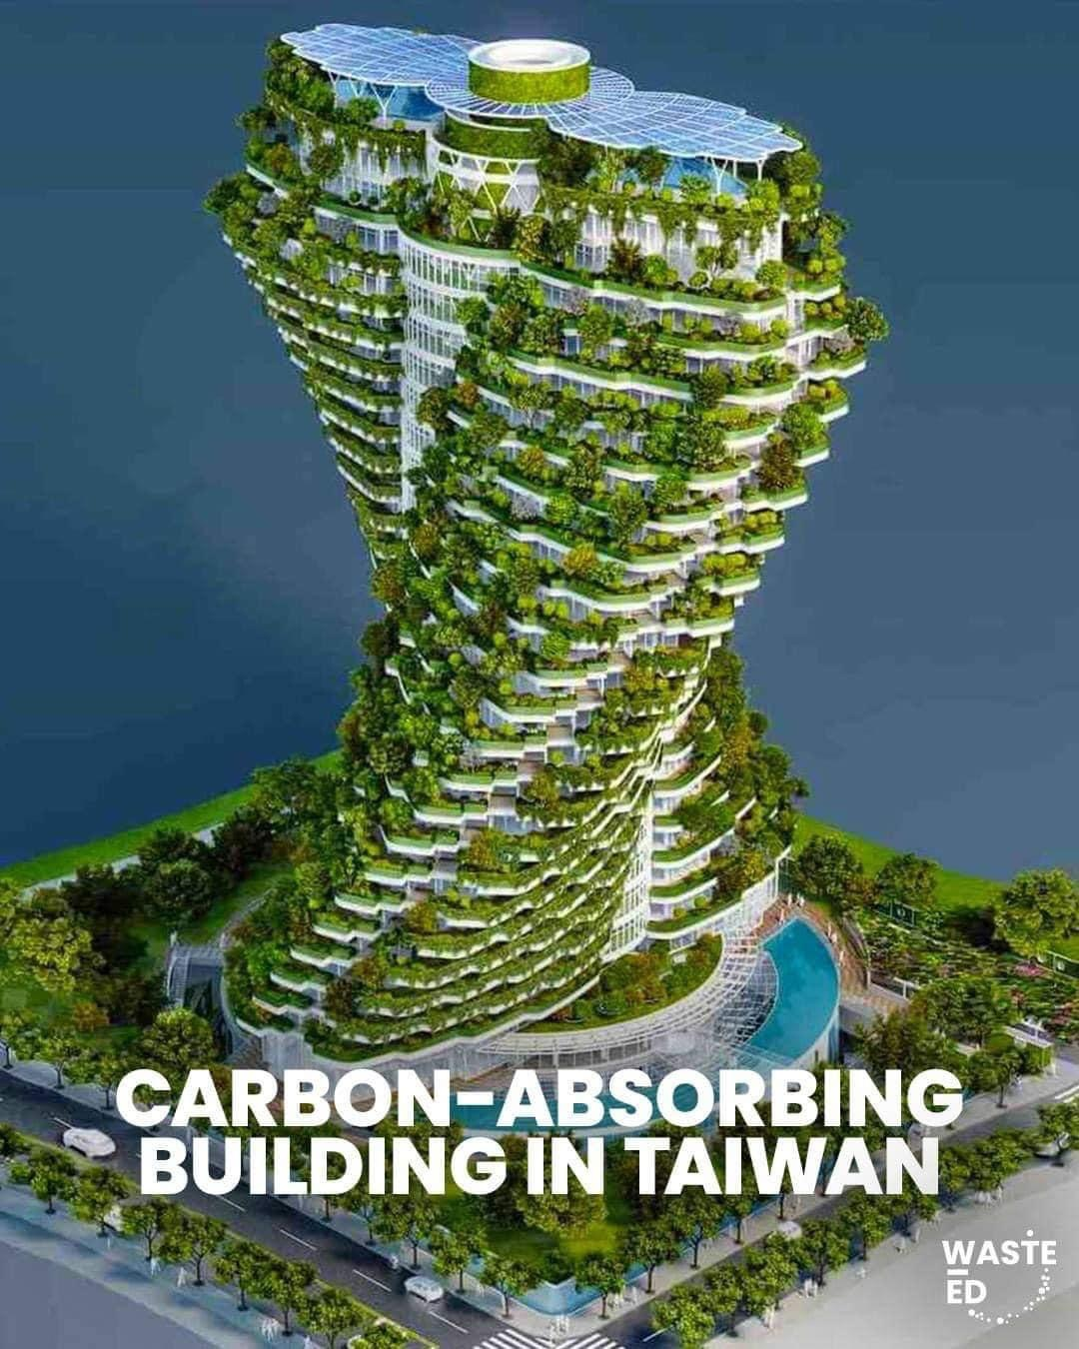

Ryan Their and Marty Pierce, Co-Leads Knoxville CCL

Marty.pierce@ix.netcom.com