This is the title

First Author1*, Second Author2

1Usually I use this for the affiliation text 2For all the affiliations and change the styles afterward

* Corresponding author: my.email@address.com

# This is a level1 heading

## This is a level 2 heading

### This is a level 3 heading

#### This is a level 4 heading

#### This is a level 5 heading (does anybody use this?)

# This is another level 1 heading

This is the first paragraph under a heading, classed with the style ‘First Paragraph’. This is the first paragraph under a heading, classed with the style ‘First Paragraph’. This is the first paragraph under a heading, classed with the style ‘First Paragraph’. This is the first paragraph under a heading, classed with the style ‘First Paragraph’. This is the first paragraph under a heading, classed with the style ‘First Paragraph’. This is the first paragraph under a heading, classed with the style ‘First Paragraph’.

This is all the other paragraphs under a heading, classed with the style ‘Body Text’. This is all the other paragraphs under a heading, classed with the style ‘Body Text’. This is all the other paragraphs under a heading, classed with the style ‘Body Text’. This is all the other paragraphs under a heading, classed with the style ‘Body Text’. This is all the other paragraphs under a heading, classed with the style ‘Body Text’. This is all the other paragraphs under a heading, classed with the style ‘Body Text’. This is all the other paragraphs under a heading, classed with the style ‘Body Text’.

This was created using R Core Team (2017). R is great (R Core Team 2017).

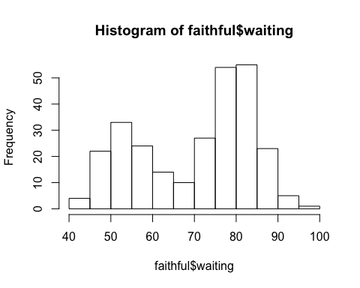

Fig 1. This is a figure caption, with the style ‘Figure Caption’.

**Table 1.** This is text in a table caption, styled as ‘Table Caption’

|  |  |  |
| --- | --- | --- |
| Column Header 1 | Column Header 2 | Column Header 3 |
| This is text in a table | This is also text in a table | 3 |

# Bulletted Lists

* This is a bulleted list, which has text styled as ‘Compact’
* This is a bulleted list, which has text styled as ‘Compact’
* This is a bulleted list, which has text styled as ‘Compact’
* This is a bulleted list, which has text styled as ‘Compact’
  1. This is an indented numbered list
  2. This is another indented numbered list
* This is a bulleted list, which has text styled as ‘Compact’
  + This is an indented bulleted list
  + This is an indented bulleted list

1. This is a numbered bulleted list
2. This is a numbered bulleted list
3. This is a numbered bulleted list
4. This is a numbered bulleted list
   * This is an indented list
   * This is an indented list
5. This is a numbered bulleted list
   1. This is an indented list
   2. This is an indented list
6. This is a numbered bulleted list
   1. This is an indented list
   2. This is an indented list

# References

R Core Team. 2017. *R: A Language and Environment for Statistical Computing*. Vienna, Austria: R Foundation for Statistical Computing. <https://www.R-project.org/>.