3因子2状态
状态 \ 因子 | 1 | 2 | 3
1 | 1 | 1 | 1
2 | 1 | 2 | 2
3 | 2 | 1 | 2
4 | 2 | 2 | 1

4因子3状态
状态 \ 因子 | 1 | 2 | 3 | 4
1 | 1 | 1 | 1 | 1
2 | 1 | 2 | 2 | 2
3 | 1 | 3 | 3 | 3
4 | 2 | 1 | 2 | 3
5 | 2 | 2 | 3 | 1
6 | 2 | 3 | 1 | 2
7 | 3 | 1 | 3 | 2
8 | 3 | 2 | 1 | 3
9 | 3 | 3 | 2 | 1

7因子2状态
状态 \ 因子 | 1 | 2 | 3 | 4 | 5 | 6 | 7
1 | 1 | 1 | 1 | 1 | 1 | 1 | 1
2 | 1 | 1 | 1 | 2 | 2 | 2 | 2
3 | 1 | 2 | 2 | 1 | 1 | 2 | 2
4 | 1 | 2 | 2 | 2 | 2 | 1 | 1
5 | 2 | 1 | 2 | 1 | 2 | 1 | 2
6 | 2 | 1 | 2 | 2 | 1 | 2 | 1
7 | 2 | 2 | 1 | 1 | 2 | 2 | 1
8 | 2 | 2 | 1 | 2 | 1 | 1 | 2

5因子4状态
状态 \ 因子 | 1 | 2 | 3 | 4 | 5
1 | 1 | 1 | 1 | 1 | 1
2 | 1 | 2 | 2 | 2 | 2
3 | 1 | 3 | 3 | 3 | 3
4 | 1 | 4 | 4 | 4 | 4
5 | 2 | 1 | 2 | 3 | 4
6 | 2 | 2 | 1 | 4 | 3
7 | 2 | 3 | 4 | 1 | 2
8 | 2 | 4 | 3 | 2 | 1
9 | 3 | 1 | 3 | 4 | 2
10 | 3 | 2 | 4 | 3 | 1
11 | 3 | 3 | 1 | 2 | 4
12 | 3 | 4 | 2 | 1 | 3
13 | 4 | 1 | 4 | 2 | 3
14 | 4 | 2 | 3 | 1 | 4
15 | 4 | 3 | 2 | 4 | 1
16 | 4 | 4 | 1 | 3 | 2

11因子2状态
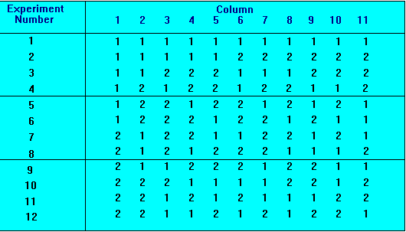

15因子2状态
1 | 2 | 3 | 4 | 5 | 6 | 7 | 8 | 9 | 10 | 11 | 12 | 13 | 14 | 15
- | - | - | - | - | - | - | - | - | - | - | - | - | - | -
1 | 1 | 1 | 1 | 1 | 1 | 1 | 1 | 1 | 1 | 1 | 1 | 1 | 1 | 1
1 | 1 | 1 | 1 | 1 | 1 | 1 | 2 | 2 | 2 | 2 | 2 | 2 | 2 | 2
1 | 1 | 1 | 2 | 2 | 2 | 2 | 1 | 1 | 1 | 1 | 2 | 2 | 2 | 2
1 | 1 | 1 | 2 | 2 | 2 | 2 | 2 | 2 | 2 | 2 | 1 | 1 | 1 | 1
1 | 2 | 2 | 1 | 1 | 2 | 2 | 1 | 1 | 2 | 2 | 1 | 1 | 2 | 2
1 | 2 | 2 | 1 | 1 | 2 | 2 | 2 | 2 | 1 | 1 | 2 | 2 | 1 | 1
1 | 2 | 2 | 2 | 2 | 1 | 1 | 1 | 1 | 2 | 2 | 2 | 2 | 1 | 1
1 | 2 | 2 | 2 | 2 | 1 | 1 | 2 | 2 | 1 | 1 | 1 | 1 | 2 | 2
2 | 1 | 2 | 1 | 2 | 1 | 2 | 1 | 2 | 1 | 2 | 1 | 2 | 1 | 2
2 | 1 | 2 | 1 | 2 | 1 | 2 | 2 | 1 | 2 | 1 | 2 | 1 | 2 | 1
2 | 1 | 2 | 2 | 1 | 2 | 1 | 1 | 2 | 1 | 2 | 2 | 1 | 2 | 1
2 | 1 | 2 | 2 | 1 | 2 | 1 | 2 | 1 | 2 | 1 | 1 | 2 | 1 | 2
2 | 2 | 1 | 1 | 2 | 2 | 1 | 1 | 2 | 2 | 1 | 1 | 2 | 2 | 1
2 | 2 | 1 | 1 | 2 | 2 | 1 | 2 | 1 | 1 | 2 | 2 | 1 | 1 | 2
2 | 2 | 1 | 2 | 1 | 1 | 2 | 1 | 2 | 2 | 1 | 2 | 1 | 1 | 2
2 | 2 | 1 | 2 | 1 | 1 | 2 | 2 | 1 | 1 | 2 | 1 | 2 | 2 | 1

8因子2状态
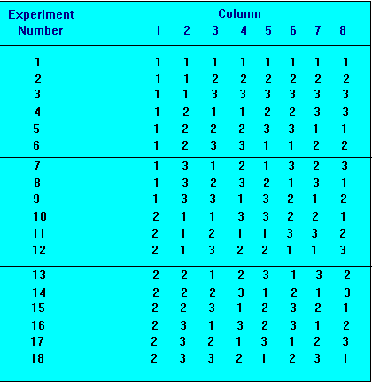

6因子5状态
X1 | X2 | X3 | X4 | X5 | X6
- | - | - | - | - | -
1 | 1 | 1 | 1 | 1 | 1
1 | 2 | 2 | 2 | 2 | 2
1 | 3 | 3 | 3 | 3 | 3
1 | 4 | 4 | 4 | 4 | 4
1 | 5 | 5 | 5 | 5 | 5
2 | 1 | 2 | 3 | 4 | 5
2 | 2 | 3 | 4 | 5 | 1
2 | 3 | 4 | 5 | 1 | 2
2 | 4 | 5 | 1 | 2 | 3
2 | 5 | 1 | 2 | 3 | 4
3 | 1 | 3 | 5 | 2 | 4
3 | 2 | 4 | 1 | 3 | 5
3 | 3 | 5 | 2 | 4 | 1
3 | 4 | 1 | 3 | 5 | 2
3 | 5 | 2 | 4 | 1 | 3
4 | 1 | 4 | 2 | 5 | 3
4 | 2 | 5 | 3 | 1 | 4
4 | 3 | 1 | 4 | 2 | 5
4 | 4 | 2 | 5 | 3 | 1
4 | 5 | 3 | 1 | 4 | 2
5 | 1 | 5 | 4 | 3 | 2
5 | 2 | 1 | 5 | 4 | 3
5 | 3 | 2 | 1 | 5 | 4
5 | 4 | 3 | 2 | 1 | 5
5 | 5 | 4 | 3 | 2 | 1

具体有哪些 因子/状态表
http://www.york.ac.uk/depts/maths/tables/orthogonal.htm

