**Wicked Sovereignty  
A Game For Personal Computer  
Copyright 2013 Fish 4 Entertainments**

I. GENERAL INFORMATION

Have you ever played turn-based strategy game? Do you hate when you can only watch and do nothing during opponents’ turn? Wicked Sovereignty is a "simultaneous" turn-based tactical game where you and your opponent(s) need to make the order at the same time so that you can look at your own order and say "that is exactly what I predict!" Other aspect of this game is the RPG (Role-Playing-Game) element, such as skill-system, which essentially allows player to adjust their characters within the game, so players can adjust their style according to the game they are playing. Moreover, player may specify their character to counter enemy's strategy. In short, Wicked Sovereignty is a game which player needs to make strategical and tactical choices based on their assumption within the game.

II. DETAILED GAME DESCRIPTION

* Basic Concept *–*

Simultaneous Turn-Based Tactical Game, where player all input their orders at the planning phase together and execute their orders at execution phase simultaneously. By doing this "simultaneous execution," it creates a lot of spaces for players to make tactical and strategical decisions on each turn. For example, it might bring developers a unit collision problem, but the problem can easily solved by defining correct phase manager. Furthermore, by solving this, it increases the tactical element of the game as well. On the other hand, players can also make some strategy decision by the second winning objectives as well. In short, the design of this game is aiming at tactics and strategies.

* Background Story *–*

Before the city in Atlantis sank into the ocean, Atlantis tried to acquire many strong warriors in order to invade Athens. One of the ways to get strong warriors is by letting competitors getting through the arena. Wicked Sovereignty was the city used this mythology to get elite warriors. Players are either lower class citizens or criminals. They joined the arena to seek a chance to improve their life since the lord of Wicked Sovereignty promised them a reward after the war against Athens. Therefore, these players were willing to take the chance even it might be deadly for them.

After characters decided to take chance to join this arena, they will need to accept the deadly cursed spell on them to prevent any further rebellions. On one hand, they are also slaves under the lord in a sense even they will receive a better life. This curse is also like a bomb inside their body which can be activated by the Altar of Poseidon in the middle of arena (one of the objectives of the game). For instance, if one team activates the Altar of Poseidon, the other team will die in random magic, such as dying from the flying rock. Anyway, the main purpose of this curse for the Atlantis is to control his army and be ready to fight Athens. Within the arena, besides the Altar of Poseidon, there are also other two altars to enhance characters. They are the Altar of Atlas and the Altar of Phoebe. Atlas and Phoebe are both paired to govern the power of the moon. By capturing the Altar (secondary objective of the game), they will grant the blessing onto the owner. The winner of this arena is proved to be a strong warrior; therefore, the winner is also recruited to the army of Atlantis and to be trained later on in order to fight Athens.

* What is the tone? What is the basic narrative? What is the "heart" of the story? Is it a linear story?

The story is based on strategical and tactical point of view, since the lord wants the elite warriors who can fight as team in order to fight Athens.

* Objective *–*

The game has two main objectives, first, kill all enemy and be the last team standing; second, capture the altar of Poseidon (middle capturing point) to cast black magic onto enemy team and enjoy the random death animation. Furthermore, there is also one more secondary objective for player to gain advantage of the game which is the Altar of Atlas and Phoebe. These two Altars will give player experience points for player to adjust their character in game.

* Gameplay *--*

The game’s menu will come up centered on the monitor the choices on the menu are: multiplayer, and quit game.

Multiplayer: Will change the menu, and possibly the background picture. The new menu will show: create game and join game.

Create game: the will take you to a lobby where one other person may join to play against you. There is a ready button, a chat box, text field and a kick button. The text field is to enter the name of the lobby. Once a player joins and clicks on the ready button, the game will take you to the team organizer screen.

Join game: the menu displays a list of lobbies one may join. It displays them in a list that shows the name of the room. The user has the ability to return to the main menu, or refresh the list of hosts to join. When you join a room and both the host and you click on the ready button, the game will go to the team organizer screen.

Team Organizer Screen: this is where players select the classes they would like their team to consist of. It displays the three classes: assasin, ranger, and melee that the user can then click in order to select the number of each unit class he/she would like. On the top right corner of the screen, there will be a timer displayed that tells the user how long they have left to choose their units. The game begins once either both users click on the ready button or the timer runs out.

In-Game: the players first sees his three units and the playable field which ends abruptly with a fog of war blocking any vision past the sight of the units. Each of the units has a number and sword icon next to them which represents the attack of the unit. They also have the health bar and name above each unit. When a character gains a level, a start will appear on the other side of the unit from where the attack is located. On the center bottom side of the screen was the number of turns that have passed.

* AI component –

AI components for the game engine will be mainly on dealing with order executions. For example, if two users move to the same spot or have the unit collision problem, game AI will deal with it. Other AI component will be path finding. Extra AI component to be done if developers have time will be recommend-skill system.

* What is the planned interface?

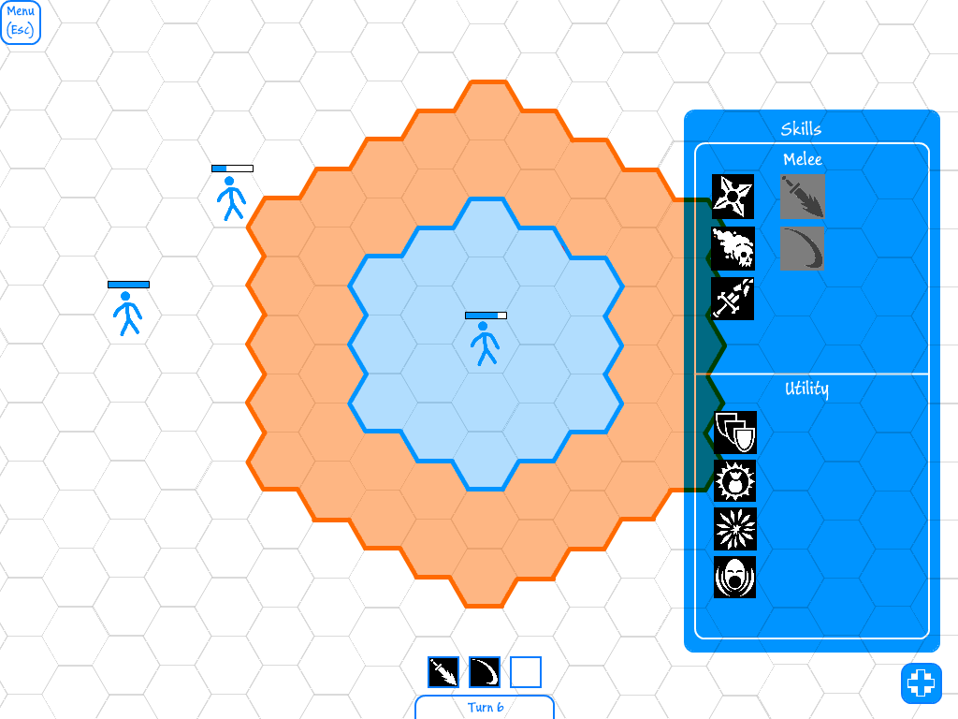This is a general look at what the overall interface would look like. Stick figures used as placeholder.

C:\Users\Infynite\Documents\CS 454\Document\Img\EscapeMenu.png

The rounded gui emphasizes the cartoonish style of the game. Overall primary colors are being used to make it easy to emphasize what the user should be looking at while creating a very simple aesthetic.

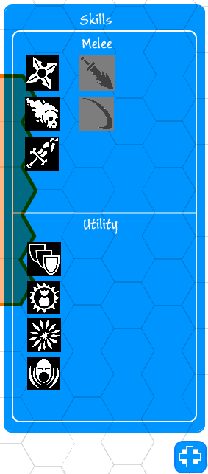

The skill menu is bolder in appearance to draw the user's attention to it. However, it maintains the simplified coloring scheme. In this iteration available skills stand out visually while unavailable skills are grey. The background is transparent as the main screen is still the priority.

The skill button at the bottom opens and closes the skill menu. It is unassuming and is not distracting when playing.

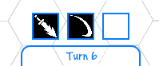

The ui at the bottom displays the available skills that the user can use. Using the more passive scheme similar to the escape button shows that this area is intended to be less prominent and important for the user to see. The skill buttons show available skills and make them stand out.

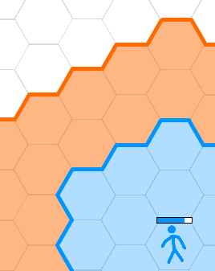

The movement options have two layers. The blue layer is an option within the standard movement. The more visually striking orange indicates that moving here will require more than a single movenet.

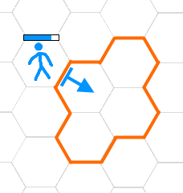

When choosing a direction to face the interface changes to make it easy for the user to see what direction the character will face and the areas which that character will attack.

* What is the planned perspective (1st person vs. 3rd person)?

Perspective will be traditional point of view for strategy games, which is 3rd Person Perspective, so that the player can watch the map and make better strategy decisions.

* What is the basic interactive structure? (e.g. Chapters vs. Great Middle Section, Levels, etc.).

Players will play on single level on the map over all games.

* What is the "heart" of the gameplay? (e.g. speed, actions, style, continuous, turnbased, etc.?

Turn-Based Tactical Game is what we are aiming for.

* Does multi-player work?

Main feature of this game is based on PVP (Player-Versus-Player); therefore, multi-player mode is needed.

* How difficult is the game? How long will it take the average player to complete?

Hopefully, casual gamers can find this strategy game interested since most strategy games are more preferred by hard-core gamer. However, as developers, we are trying to make game to have fewer variables to decide and more possible outcome to happen. Average game time should be around 10 minute per game.

III. OTHER ASPECTS OF THE PRODUCT DESIGN

* Characters --

There are three characters player can pick, Ranger, Assassin, and Melee. Melee class has the faith of believing the power of Ares and Athena and their strength. They usually carry one-hand-weapon with the shield into the battlefield, also known as the warrior. As their personality, they tend to be greedy and take the risk for the great reward, which is opposite to the Ranger. On one hand, rangers do not have as much strength as warrior or speed as assassin. That is why they tend to stay out of distance and snipe enemy. On the other hand, Assassins are usually agile and tricky; they know the weakness of the human body. Most of them were thief, rouge, or even robber before they called themselves assassins. Assassins believe the beauty of the thieves from the god Hermes.

* Single/multi player? Are there other key characters?

Key characters are the only three characters that players can pick in the game, which are ranger, melee, and assassin. They are just a general class for the character. However, these styles of characters will be different from player to player.

* License Exploitation --

License of this game is like the arena of gladiator in one sense, only the winner will be praised and receive the reward.

* World *--*

The world is living at the generation of Greek mythology where people believe in all these gods are individuals with strong personality just like human beings. The Wicked Sovereignty is inside of the island of Atlantis which the city has enough economic to support this event and recruit the elite warriors. Since the war between Athens and Atlantis was about to happen, it was also reasonable for the Atlantis to invest more money onto recruiting warriors. However, as the mysterious story described by Plato, the island disappear and sank into ocean right after this invasion to Athens.

* Controls --

Games will be controlled by mouse based with some keyboard short-cut.

* Describe the on-screen interface*,* and how it works.

Pictures, pictures, and more pictures... (We are hiring Photoshop or paint specialist).



Menus:

Placeholders until design scheme is set.

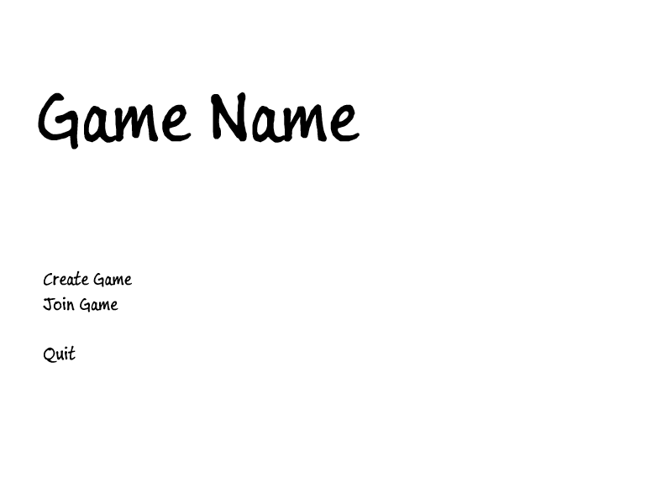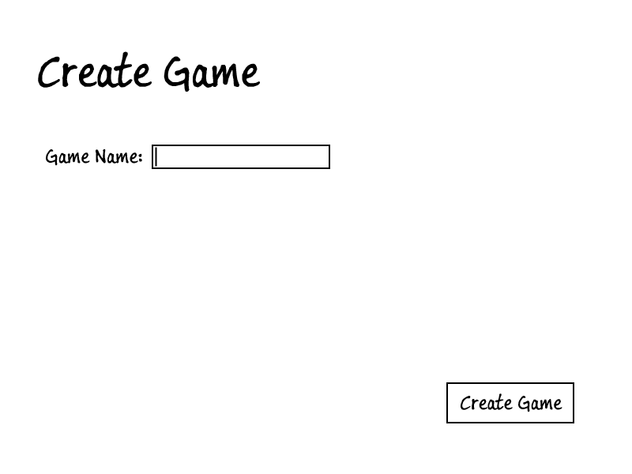

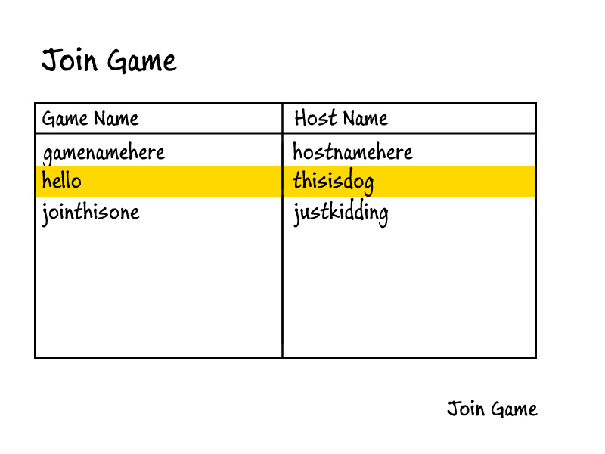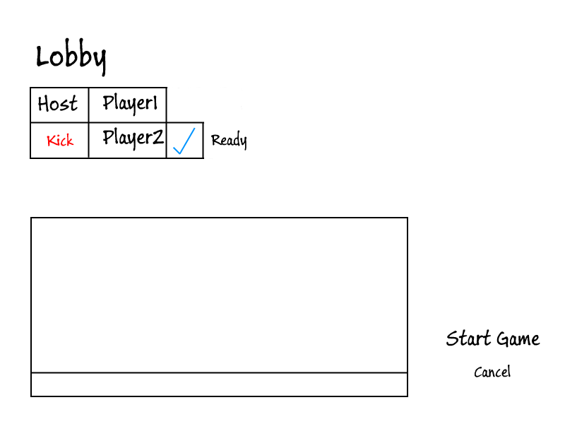

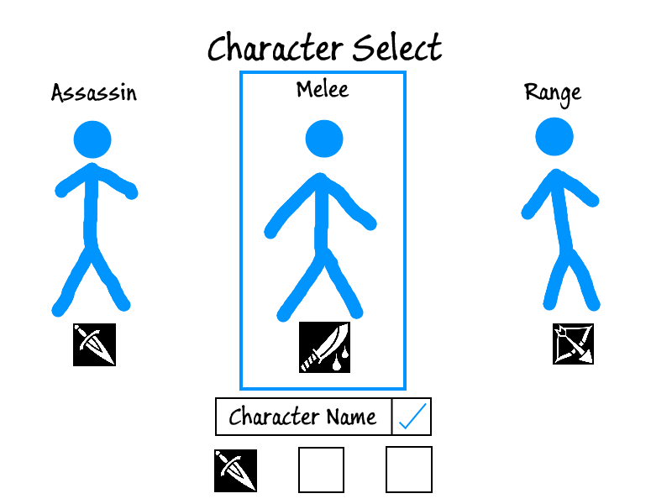

* Describe all menus in detail, and chart out the "shell" structure.

Title screen menu, in game menu.

* Onscreen text messages

There are a few text messages on screen to display game information to user. First character attributes (e.g. HP or Attack) will be displayed around the character for both you and enemy case. Turn number will be displayed on the top.

* Graphics *-- Describe the general style of the graphics.*

Cartographic graphic.

* Sounds and *Music --*

There will be single background-music for gameplay and title screen so far.