Pete FioRito Stadium at McKinzie Field

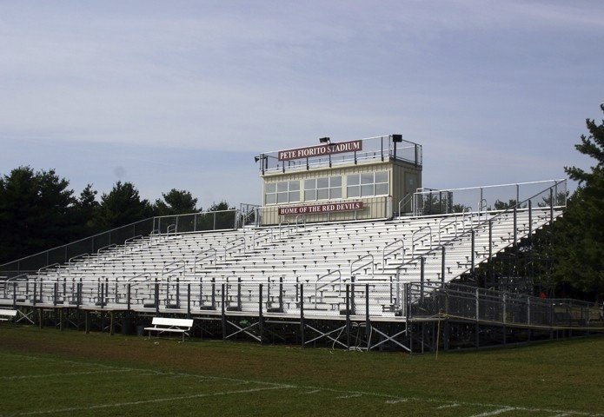

Pete FioRito Stadium at McKinzie Field opened in 1930.

The Eureka College football team calls Pete FioRito Stadium at McKinzie Field its home. Regularly boasting high attendance numbers and a festive game-day atmosphere, Saturday afternoons in the fall at McKinzie Field have long been the marquee attraction and experience of Eureka College athletics.

Opened in 1930, the natural grass playing field is named after legendary Eureka student-athlete and coach Ralph McKinzie.

McKinzie starred for the Eureka football squad in the early 1920s, earning all-conference accolades as a halfback. McKinzie, who also played as an all-conference performer for the EC basketball squad, was inducted into the NAIA Hall of Fame in 1963.

The Eureka College athletics Hall of Famer, who coached Ronald Reagan during his football playing days, is the all-time wins leader in Eureka football history, guiding the Red Devils to 36 victories between 1921 and 1937. McKinzie returned to Eureka after his retirement and remained on staff as a volunteer football assistant coach until the 1989 season.

Former Eureka football player Pete FioRito, who passed away from cancer at age 45 in 2003, had his name placed on the stadium during a halftime ceremony on Oct. 14, 2006. FioRito starred as a defensive back and team captain for the Red Devils during the 1970s. He was a member of the 1977 squad that set what was then a school record with seven victories and was inducted into the Eureka College athletics Hall of Fame in 2006. FioRito’s fundraising efforts prior to his death raised money for renovations at the facility, as well as scholarships for Eureka College students.

In the summer of 2011, Eureka began "The McKinzie Project" to renovate several aspects of the facility. Construction crews broke ground in early August 2011 to install a 4-foot brick wall that runs along Reagan Drive at the north boundary of the facility. A new chain-link fence and windscreen were installed behind the visiting bleachers along the east boundary of the stadium.

Prior to "The McKinzie Project", the stadium received a new and improved look in the summer of 2006 with the addition of an entirely renovated grandstand along the Eureka sideline and a three-room press box for game day operations and working media.

The Red Devils enjoyed tremendous success on their home field during their run as an NAIA national powerhouse in the 1990s. Eureka posted a 29-21 record at home during the decade, including a perfect 5-0 mark in 1991 and back-to-back 4-1 home records in 1994 and 1995.

Henry Sand Field

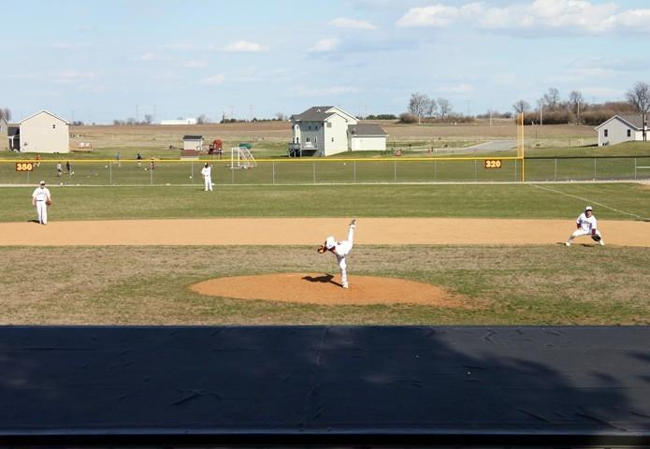

The Eureka College baseball team calls Henry Sand Field its home. Settled into one of the most picturesque settings in all of Division III baseball, Henry Sand Field offers one of the finest venues to watch a sporting event on the campus of Eureka College.

Named after the 1932 graduate of Eureka College, Henry “Heinie” Sand, the facility boasts a two-level press box, including a spacious area for game operations and media. Sand was a three-sport student-athlete at Eureka, participating in football, basketball and baseball. He was a three-time All-Little 19 Conference selection in baseball as a catcher and went on to a career in professional baseball following his graduation. Sand was inducted into the Eureka College Athletics Hall of Fame in 1972.

Reagan Center

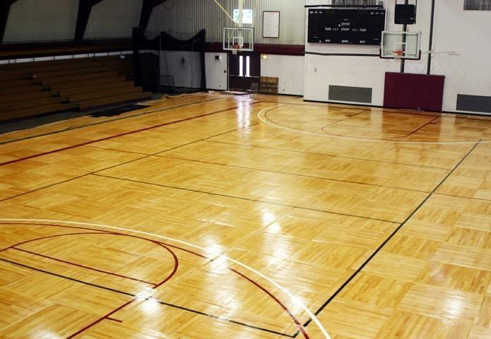

The Reagan Center, the building that serves as home to the Eureka College athletics department, will play host to Eureka volleyball, basketball and swimming in 2012-13. The facility has seen significant upgrades in recent years, including a new hardwood playing surface in the arena in June 2011 and a pair of new state-of-the-art scoreboards in December 2010.

The multi-purpose facilty, named after alums Ronald Reagan (‘32) and Neil Reagan (‘33), opened in 1970 and hosts the offices for the Eureka athletics department. The building also houses Eureka’s on-campus athletic training facility, a weight-training area for Eureka student-athletes and classrooms for the Eureka College physical education department. The weight-training facility was revamped in July 2012 with a new rubber floor and a large array of new weights for EC student-athletes.

Featuring a 1,500-seat arena for basketball and volleyball, the Reagan Center arena plays host to more than 30 games each year. The building also boasts a competition-sized pool that serves as the home to the Eureka swim team and hosts the Eureka College Sprint Swim Meet each January.

A hardwood floor was installed in the arena in June 2011, a surface formerly used as a practice floor by the NBA’s Minnesota Timberwolves. The portable surface features a parquet design and was installed in pieces and painted by Clarkston, Mich.-based Game Day Athletics. The installation crew, headed by Tom Petrie, also installed and painted the Reagan Center’s previous playing surface. The hardwood floor was placed on top of the synthetic playing surface that was installed during the summer of 2008.

Dedicated for Ronald P. Bonati on Oct. 4, 2007, the the Bonati Fitness Center is the on-campus training facility for the campus and community. Named for Bonati and funded by his wife Christine Bonati Bollwinkle, the facility provides the campus and community a state-of-the-art fitness center. Bonati attended Eureka College from 1957 until 1960 and served as a trustee for Eureka College from 1993 through 1999. He had a 34-year management career with Caterpillar, Inc. where he was the Vice President of the North America Commercial Division from 1993 until 1999.

Also dedicated on Oct. 4, 2007 was the Rigazio Lobby for 1976 Eureka College graduate Steve Rigazio. Named and funded in his memory by his parents Gretchen and Tony Rigazio, Rigazio was the president of Nevada Power Company at the time of his illness and death in 2001. The Rigazio Lobby features a double trophy case displaying Eureka’s finest athletic accomplishments, as well as a high-definition television showcasing the members of the Eureka College Athletics Hall of Fame.

In addition to hosting more than a thousand athletic events over its 42-year history, the arena also hosted commencement addresses from President Ronald Reagan in 1982 and 1992. The facility also served as a location of a visit from former Soviet President Mikhail Gorbachev during his trip to campus in honor of Eureka’s "Ronald Reagan Day" in March 2009.

Softball Field

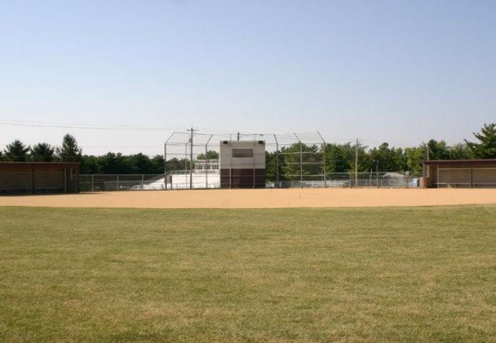

Perhaps the most rapidly improving athletics facility Eureka College has to offer, the Eureka College softball team will play its home games at the same on-campus facility that once served as home for Eureka’s only NCAA Tournament team in school history.

Like Henry Sand Field, the Eureka softball facility has a two-story press box that allows for game operations, media and equipment storage. New for 2011 is a state-of-the-art windscreen along the outfield fence, greatly improving the look of the venue. The facility also includes two spacious covered concrete dugouts.

Tennis Courts

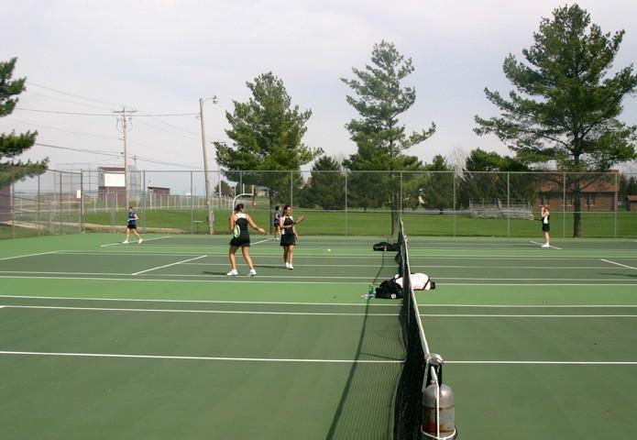

Like many other Eureka College athletic venues, the Eureka College tennis courts offer a gorgeous setting to watch a collegiate tennis match.

Settled among trees across the street from the Reagan Center, the facility offers six hard-surfaced, regulation-sized tennis courts for Eureka men’s and women’s home matches. In addition to serving as the Red Devils’ tennis home, the facility is also open to the public throughout the year.

Traister Field

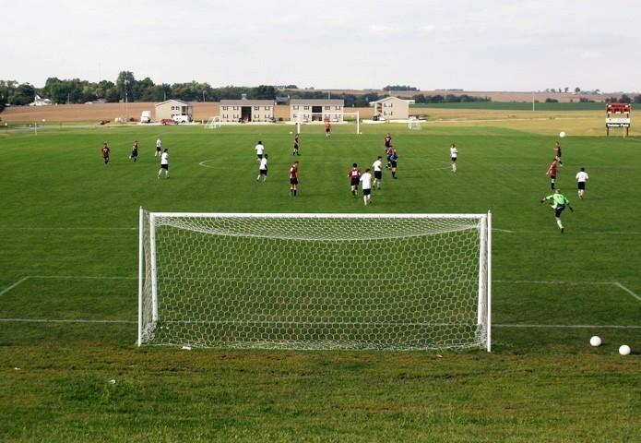

Opened in 2007 as one of the finest NCAA Division III soccer facilities in the Midwest, Traister Field serves as the home of the Eureka College men's and women’s soccer teams.

Located along Dickinson Drive on the far eastern side of campus, Traister Field features a natural grass playing surface, full irrigation system, two-story press box for media and game operations, concession area and sheltered dugout areas for both teams. Fans regularly line the sideline with chairs and blankets and take advantage of the spectacular view of the pitch from the hillside behind the south goal line. A full, regulation-sized practice area is available for the Red Devils just north of the playing pitch.

The facility was dedicated for and named after Eureka Athletics Hall of Famer Leo "Doc" Traister during a ceremony on Oct. 24, 2008. Traister came to Eureka as a student-athlete in 1939, earning four letters in baseball, three letters in football and two letters in track before graduating in 1948. Traister returned to campus in 1956 to serve as Director of Athletics and coach all EC sports until 1966.

Traister remained on various coaching staffs until as late as 1990 and finished his stint on the basketball coaching staff in 1974 as the all-time wins leader at EC with 168. He was inducted into the Eureka College Athletics Hall of Fame in 1977 and remains actively involved with his wife, Betty, as supporters of the Eureka College athletics department.

Traister Field also serves as an occasional home for area high school matches, as well as various summer youth soccer camps conducted by Eureka College and its coaching staffs.

The Eureka women’s soccer team recorded a 5-4 victory over Rockford in the first regular season game played at the facility on Sept. 6, 2007. The EC men’s and women’s squads have combined to win 25 matches on their home pitch in the five-year NCAA Division III history of the program.

Bonati Fitness Center

cross link to /athletics/bonati